Alexander Volynchikov (N01096785)

Contact Us

Alex/contactus_add_form_user.php (User adds a question)

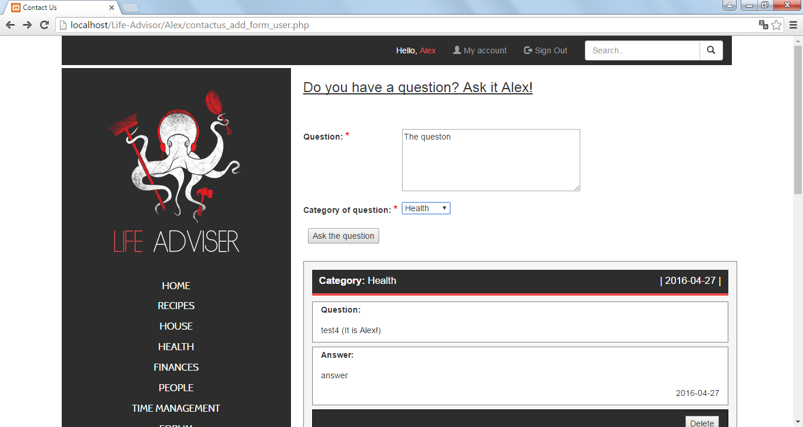

Alex/contactus_admin.php (List of questions for admin)

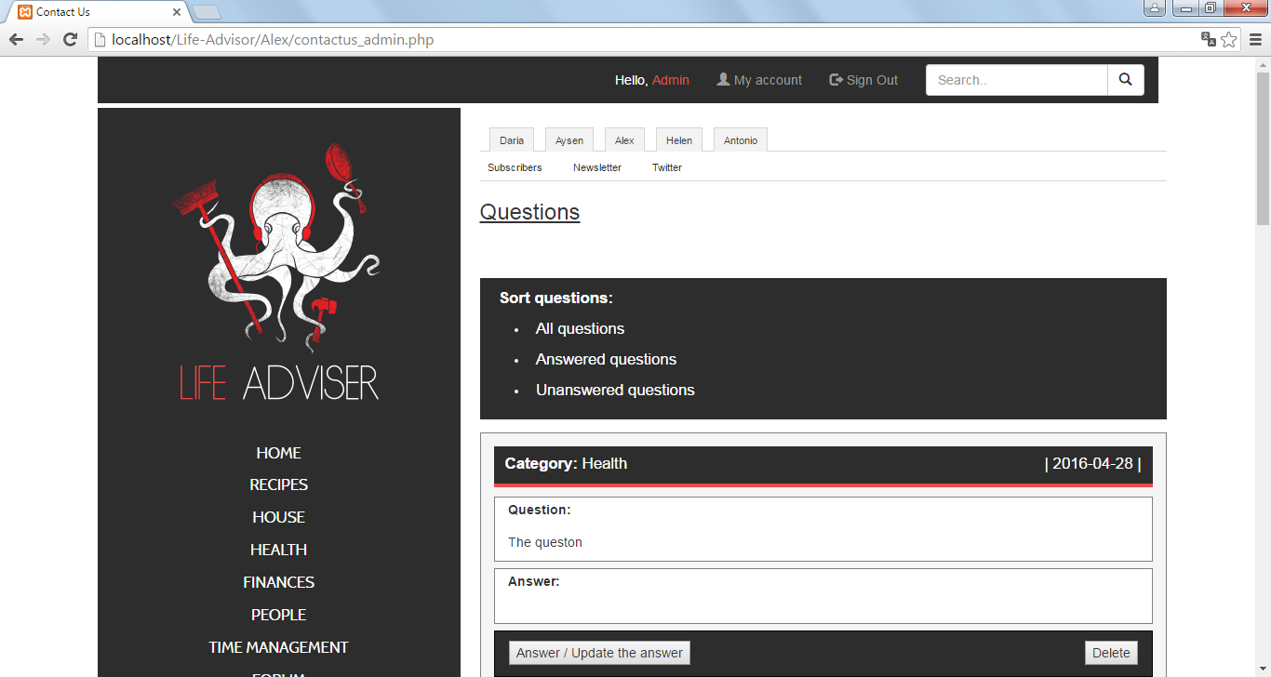

Alex/contactus_update_form_admin.php (Admin answers the question)

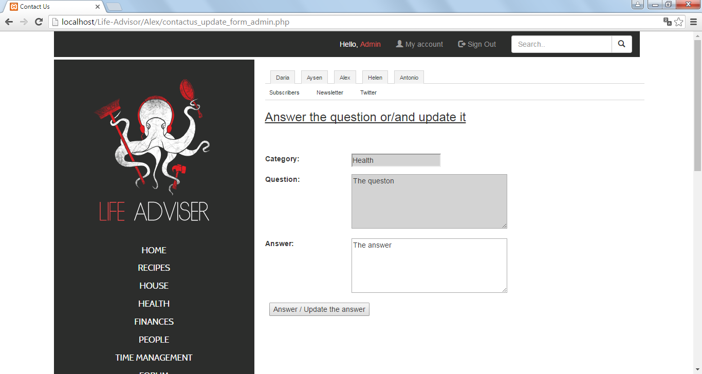

Donation

Alex/donation_add_form.php (The form to donate money)

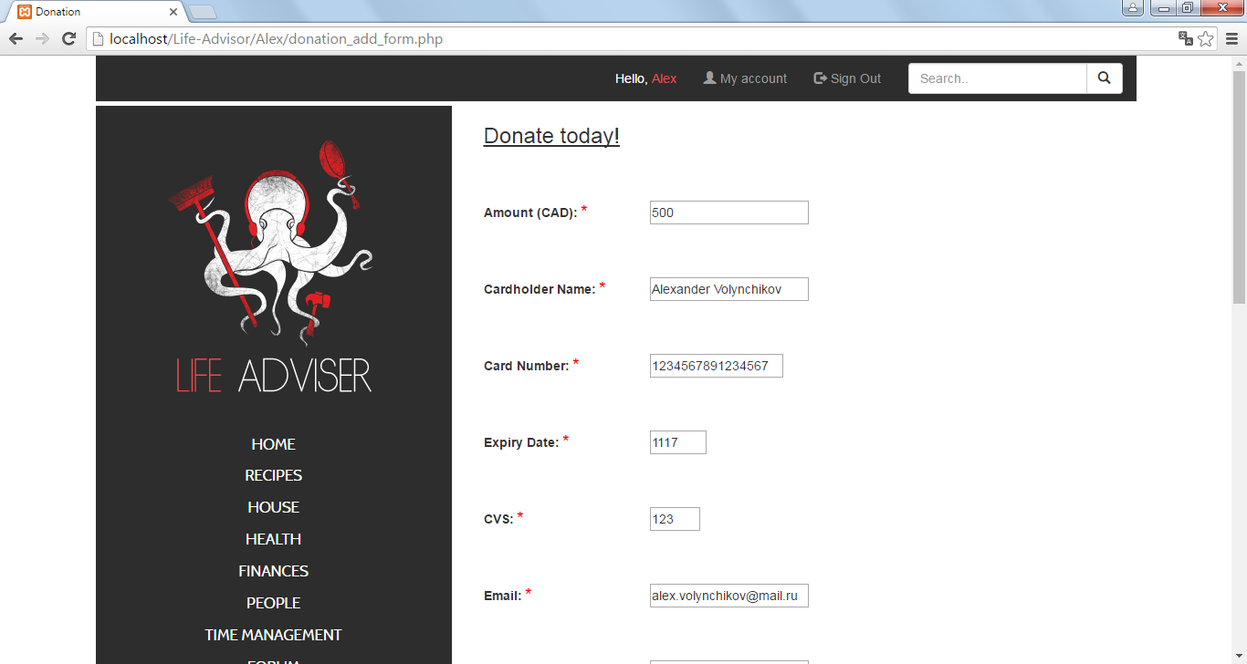

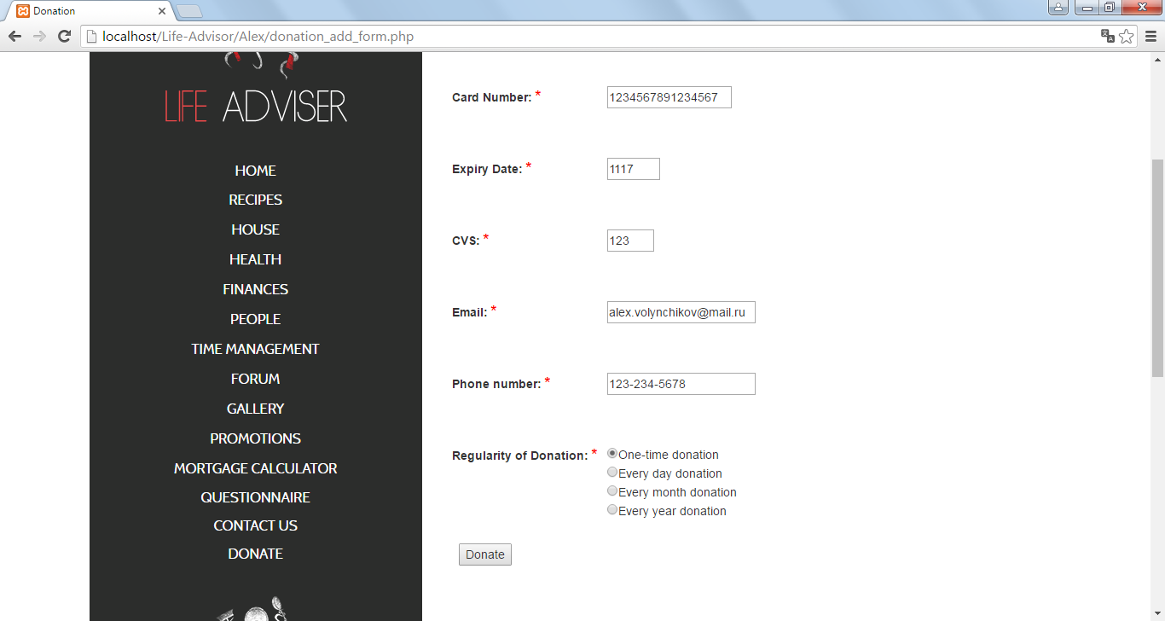

Alex/donation_thanks.php (Thank you for donation page )

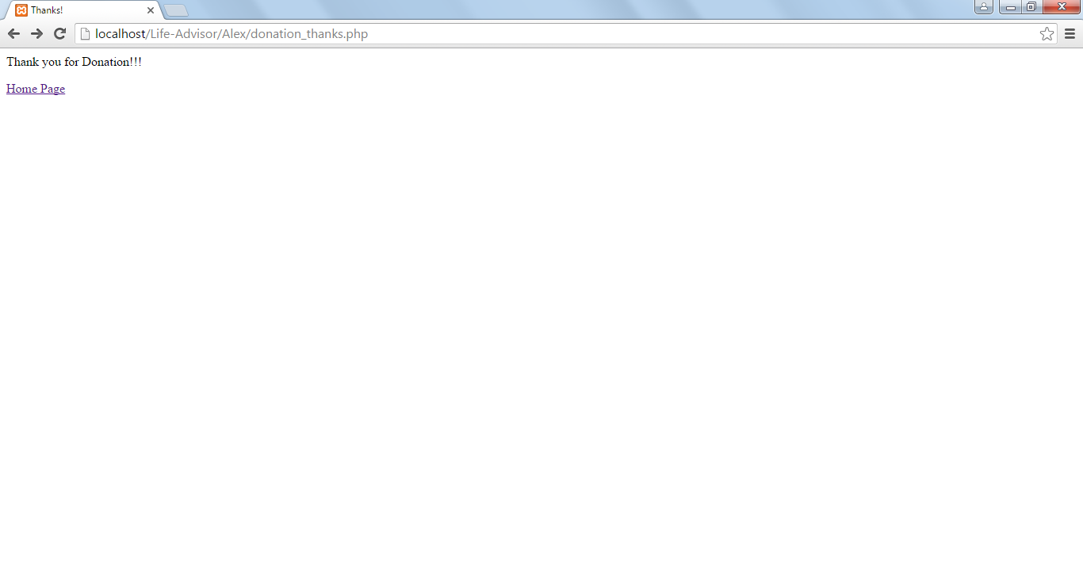

Alex/donation_admin.php (List of donations on Admin page)

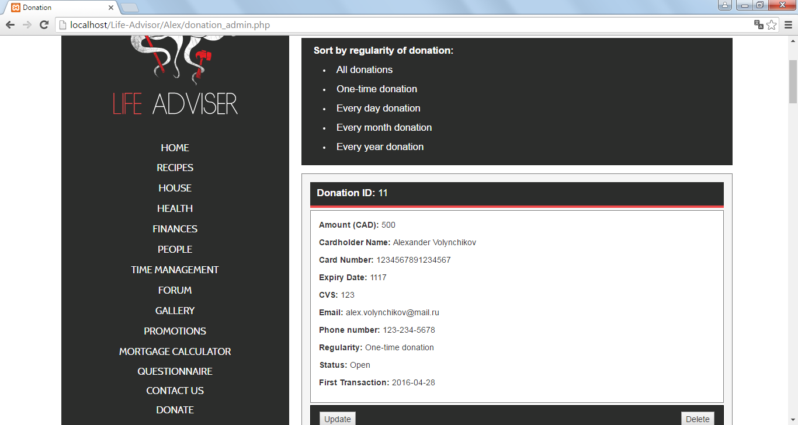

Alex/donation_update_form_admin.php (Admin edits information about donation)

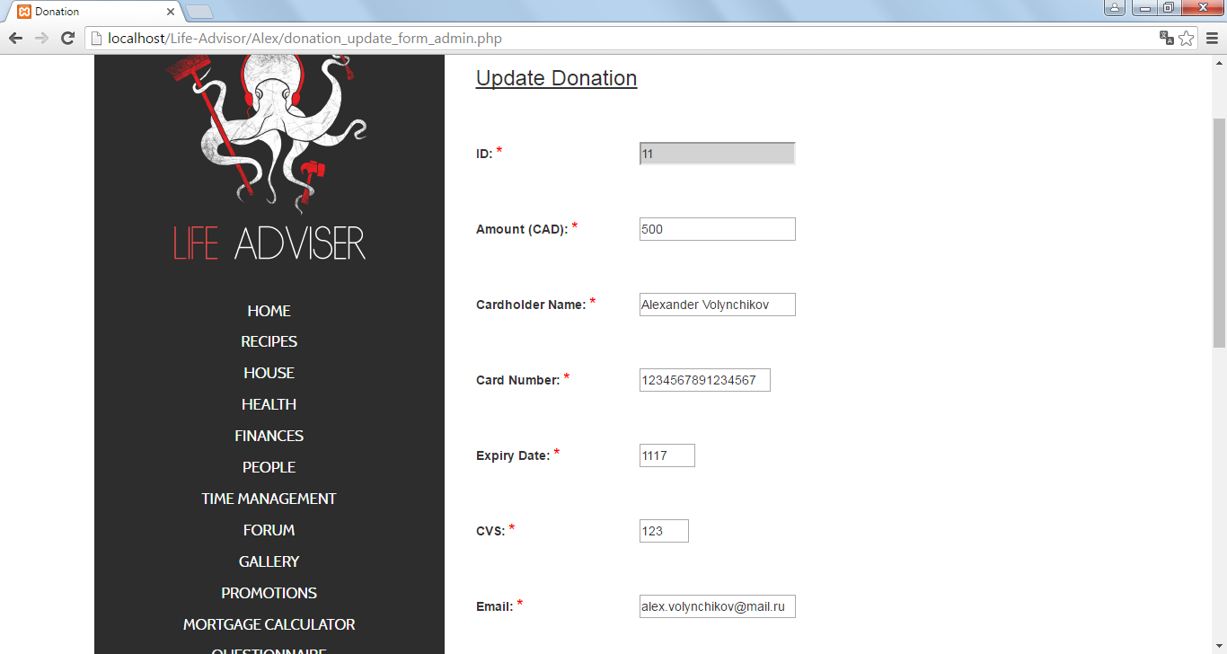

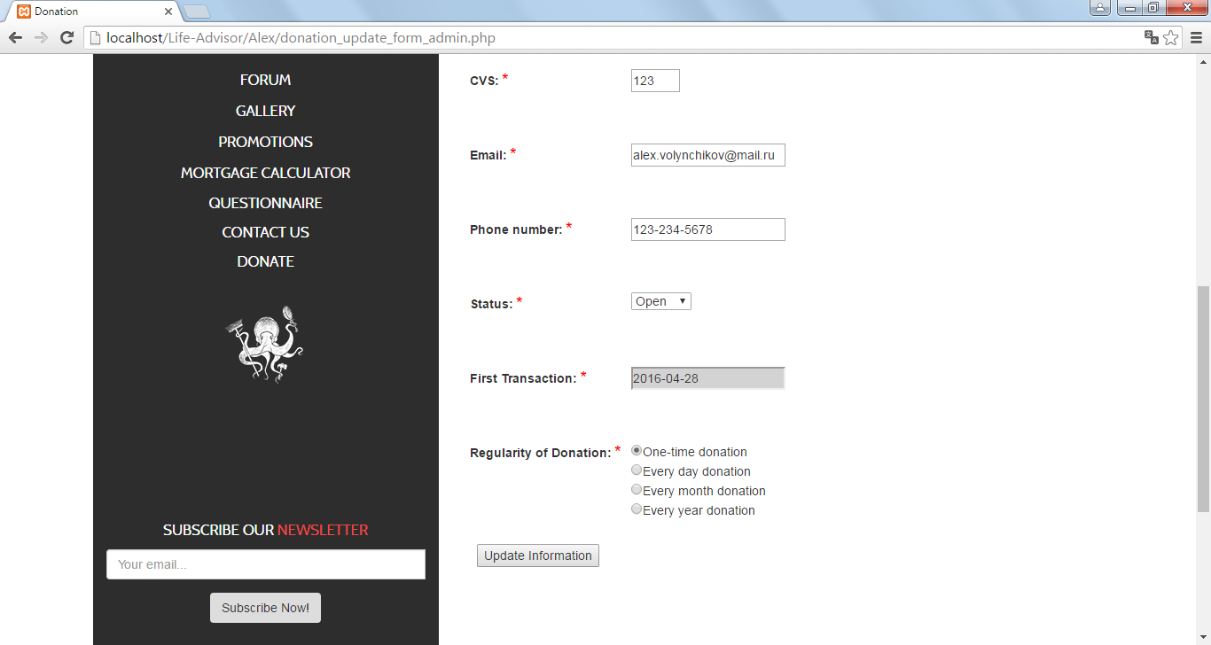

Questionnaire

Alex/questionnaire_add_form_user.php (User page where he or she can answer the questions)

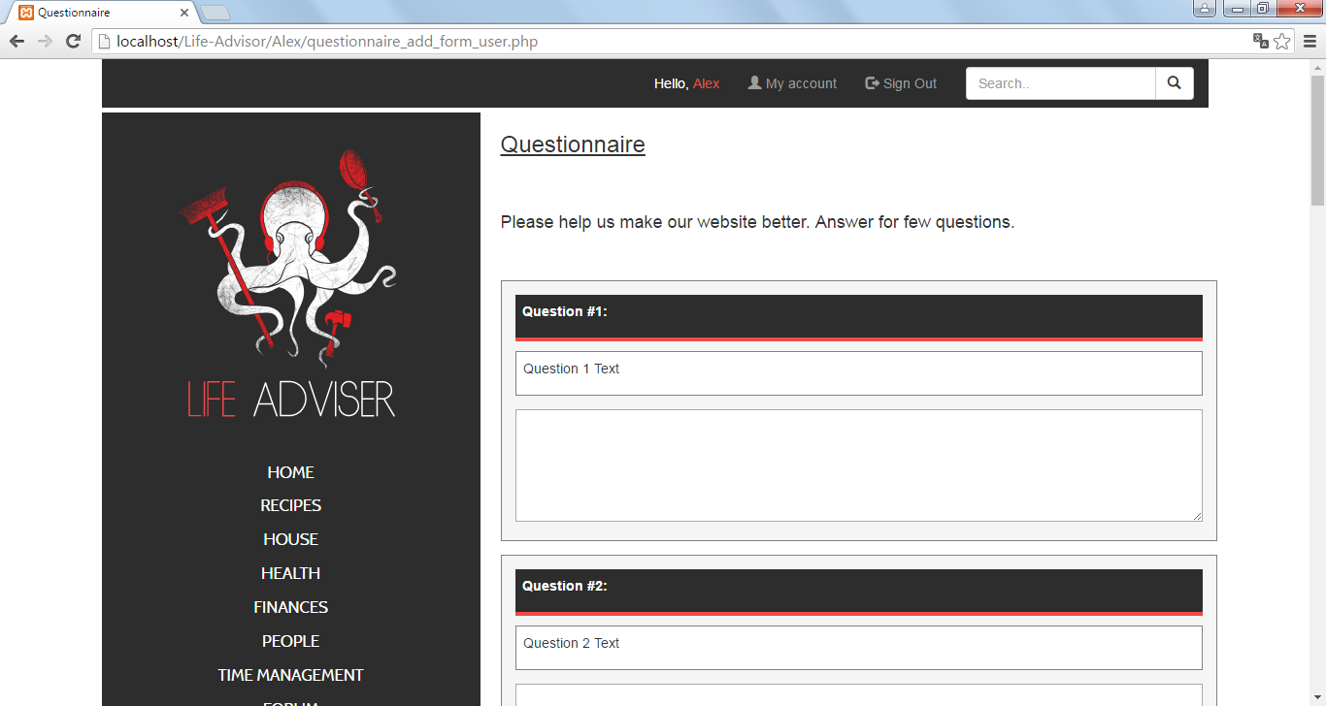

Alex/questionnaire_add_user.php (Thank you for answers page for user)

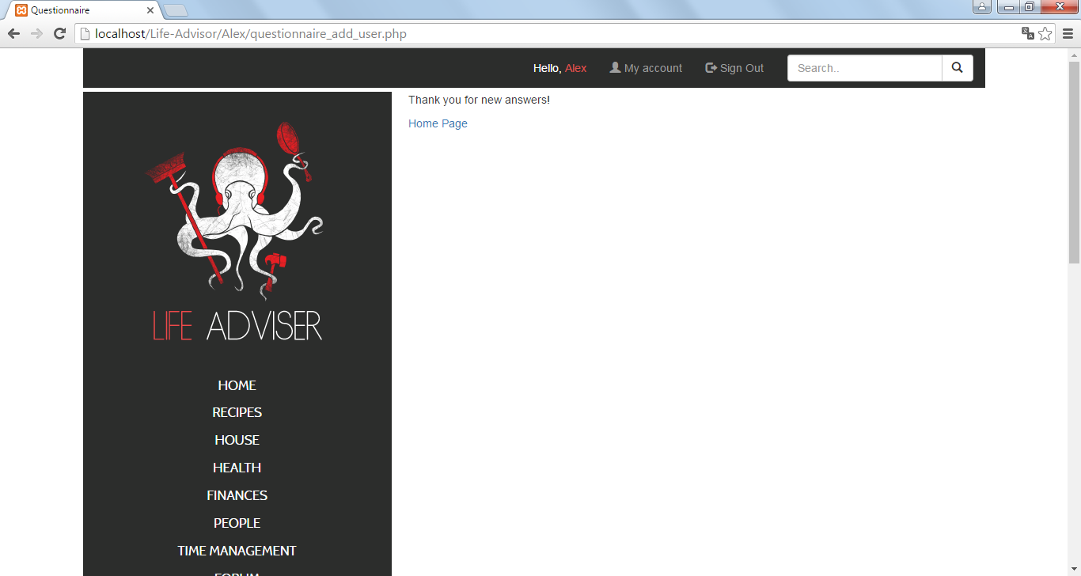

Alex/questionnaire_admin.php (List of questions on Admin Page)

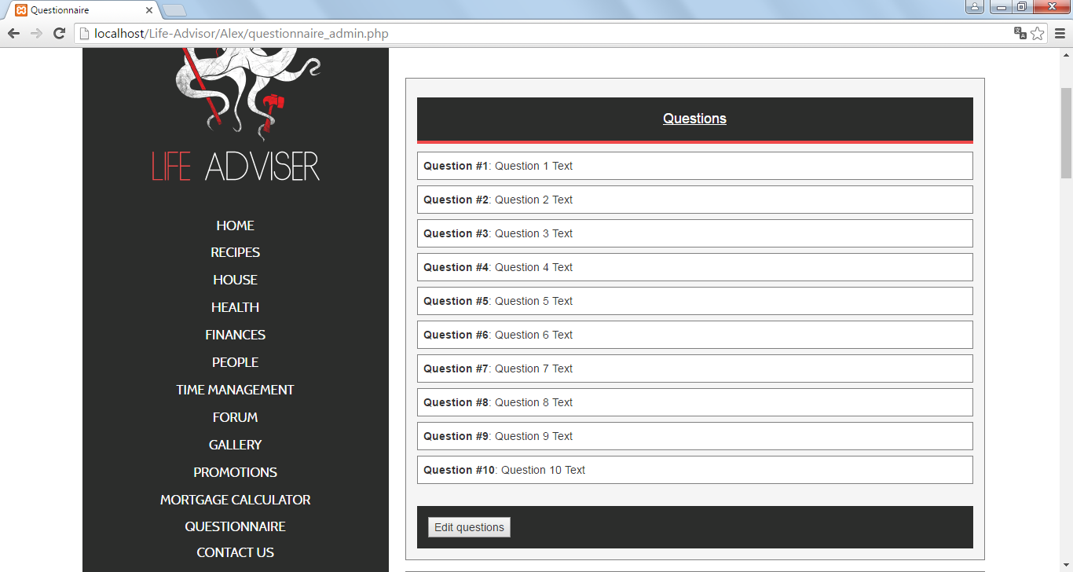

Alex/questionnaire_admin.php (List of answers on Admin Page)

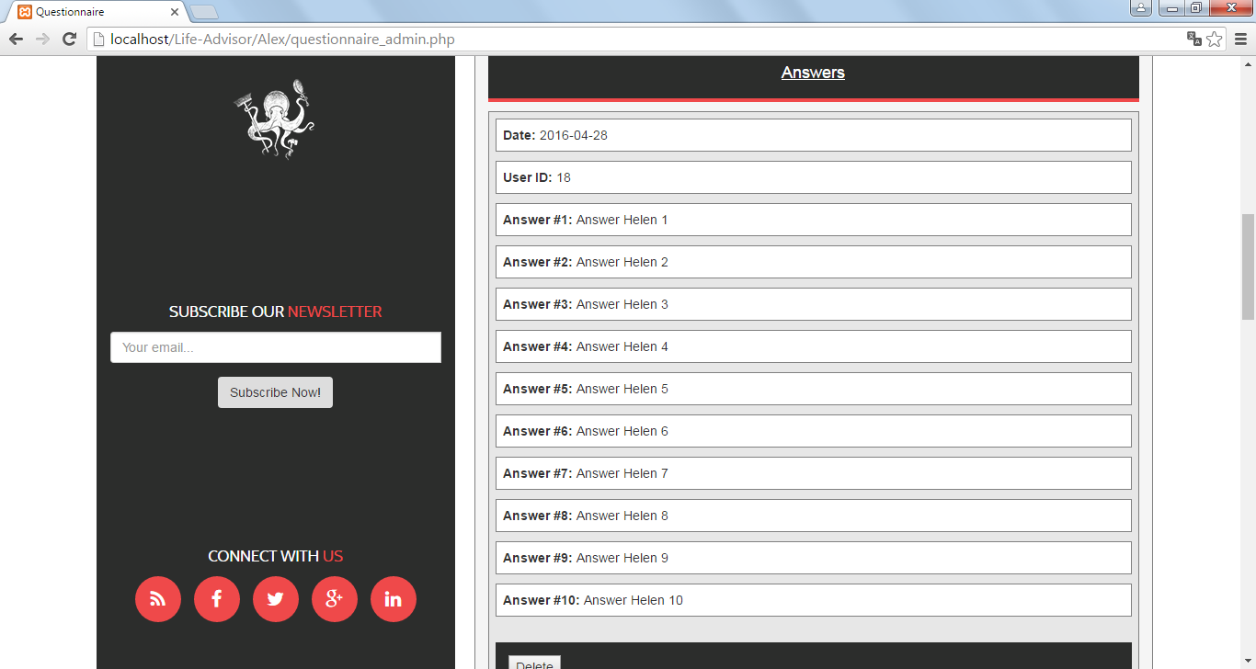

Alex/questionnaire_update_form_admin.php (Admin wants to change questions on Admin page)

