Geant4 Setup and Detector Simulation (Source Build)

This guide provides a complete step-by-step installation of Geant4 from source on Windows systems, including environment configuration, dataset setup, and running a basic simulation example.
The goal is to understand particle interactions and detector physics using Geant4.

- Installation of CMake
- Geant4 source setup
- Build configuration
- Dataset installation
- Running examples

## System Info
- OS: Windows 11
- Compiler: Visual Studio 2022
- CMake: 4.3.1 (latest version at time of installation)
- Geant4: 11.4.1

## Installation Steps
### 1. Install CMake
CMake is used to generate platform-specific build files,
such as Visual Studio solutions, from the Geant4 source code. It acts as a bridge between the source code and the compiler.
CMake is required to configure and build Geant4 from source.

1. Go to the official CMake website:
https://cmake.org/download/

2. Download the latest version of:
"Windows x64 Installer (.msi)"

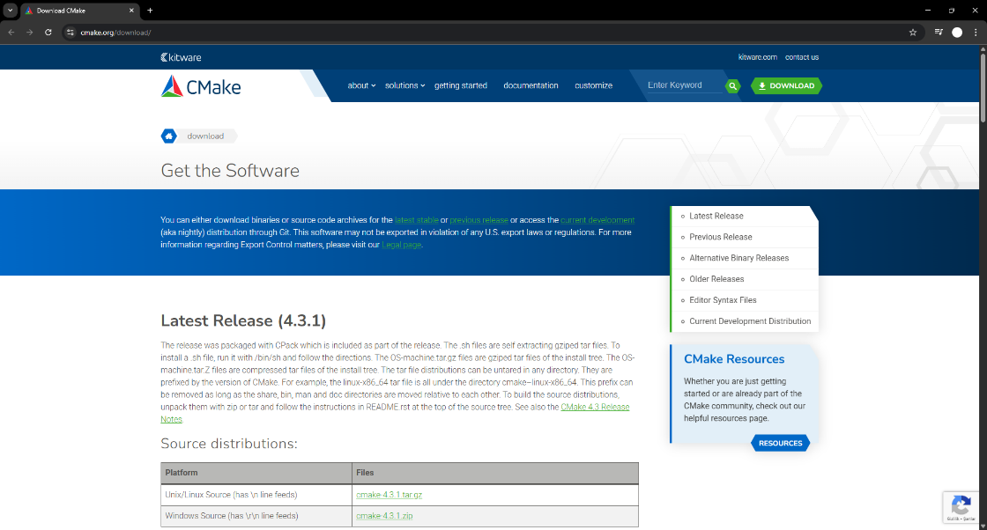
Figure 1: Downloading CMake from the official website

3. Run the installer.

4. During installation, make sure to select the option:
"Add CMake to the system PATH for all users"
This step is very important. Without adding CMake to PATH, it will not be recognized in the command line.

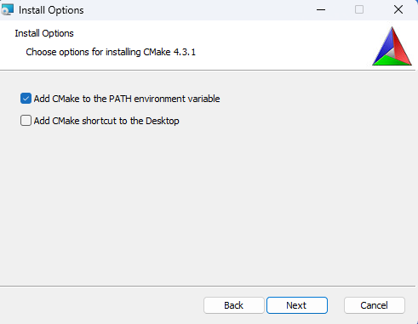
Figure 2: Selecting "Add CMake to system PATH" during installation

5. Complete the installation.

6. After installation, open a new PowerShell window and verify:
cmake --version
If installed correctly, the system should display the installed version of CMake.
If the command is not recognized, it means CMake was not added to the PATH correctly.

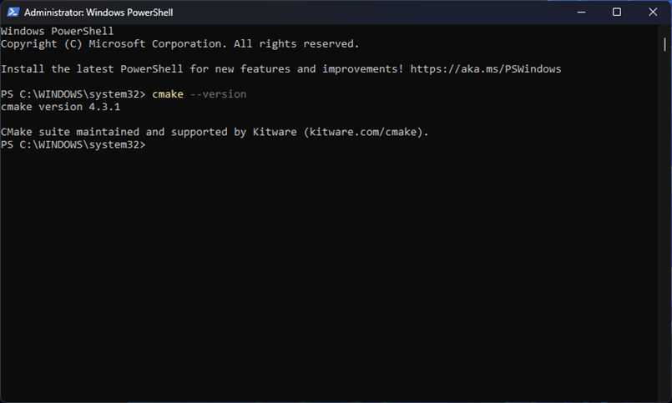
Figure 3: Verifying CMake installation using PowerShell

### 2. Install Visual Studio 2022
Geant4 requires a C++ compiler to build from source. Visual Studio 2022 is recommended as it is fully supported and stable.

1. Go to the official Visual Studio website:
https://visualstudio.microsoft.com/

2. Download Visual Studio 2022 Community Edition.

3. Run the installer.

4. During installation, select the following workload:
- Desktop development with C++

5. Make sure the following components are included:
- MSVC v143 - VS 2022 C++ x64/x86 build tools
- Windows 10/11 SDK

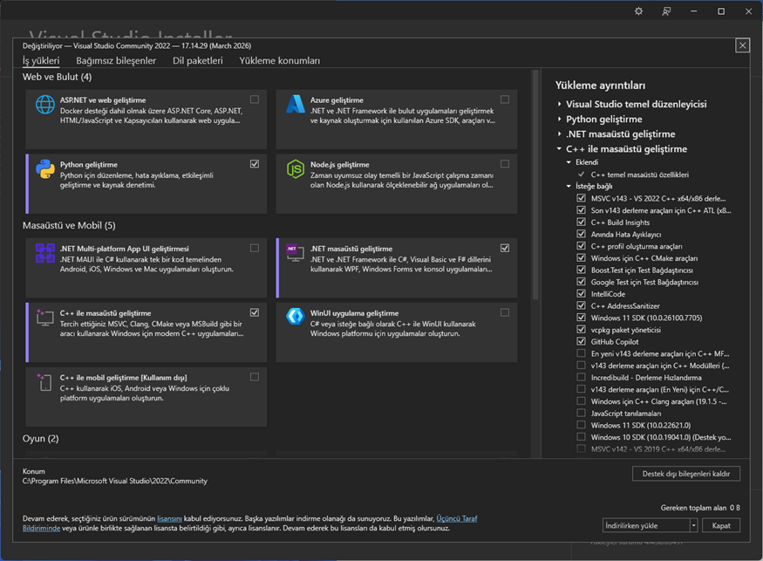
Figure 4: Visual Studio 2022 installation setup showing the "Desktop development with C++" workload and selected components

6. Complete the installation.

### 3. Download Geant4 Source
To build Geant4 from source, the official source code must be downloaded.

1. Go to the official Geant4 download page:
https://geant4.web.cern.ch/support/download

2. Download the latest version of Geant4 source code as a .zip file.
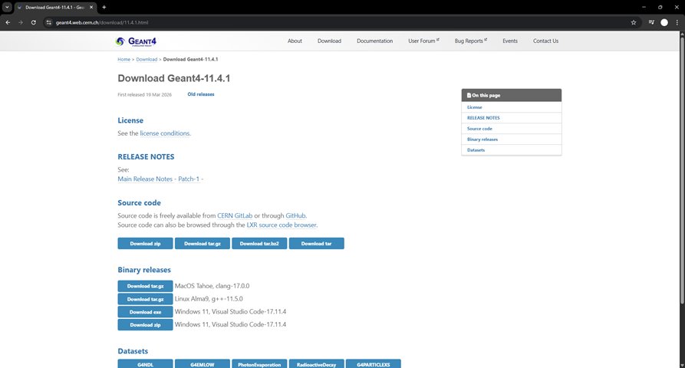
Figure 5: Downloading Geant4 source code from official website

3. Create a working directory for the installation. For example:
C:\Geant4-setup

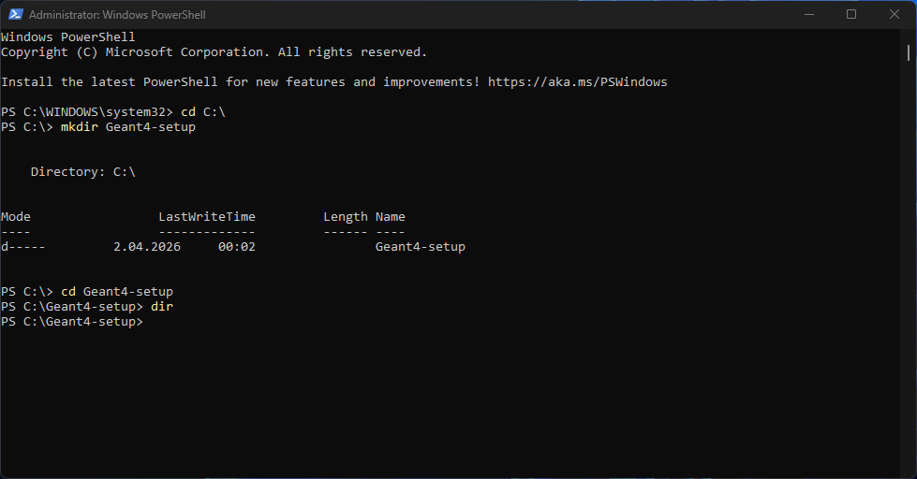
Figure 6: Creating the main Geant4 working directory using PowerShell

4. Inside this directory, create the following folders:
- source
- build
- install
- data
- docs
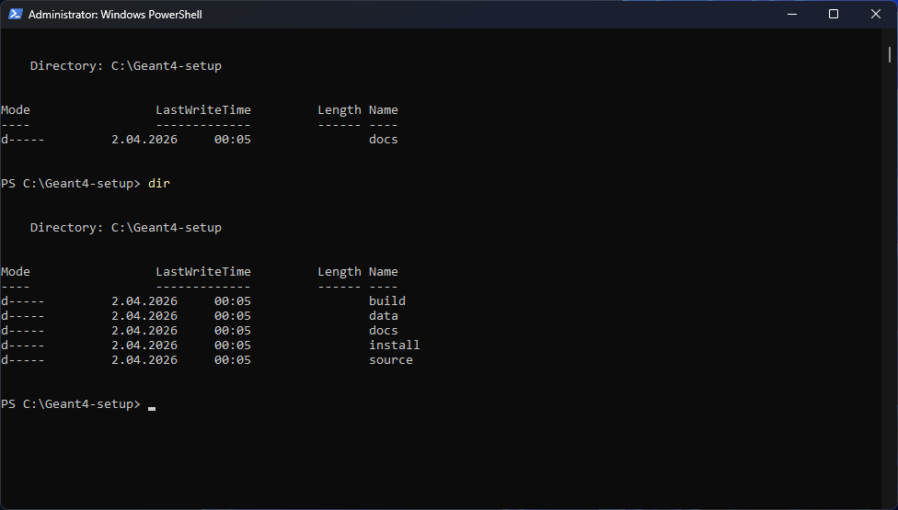
Figure 7: Creating required subdirectories for Geant4 setup

5. Extract the downloaded Geant4 source code into the "source" folder.
This can be done using PowerShell with the following command:
Expand-Archive -Path C:\Geant4-setup\source\geant4-v11.4.1.zip -DestinationPath C:\Geant4-setup\source

After extraction, verify that the folder structure is correct:
dir C:\Geant4-setup\source
dir C:\Geant4-setup\source\geant4-v11.4.1

Important:
Make sure that the folder structure is correct and not nested.
The file "CMakeLists.txt" must be located directly inside the extracted folder.

Correct structure:
C:\Geant4-setup\source\geant4-v11.x.x\CMakeLists.txt

Incorrect structure (avoid this):
C:\Geant4-setup\source\geant4-v11.x.x\geant4-v11.x.x\...

Incorrect folder structures may cause CMake configuration errors such as missing CMakeLists.txt.

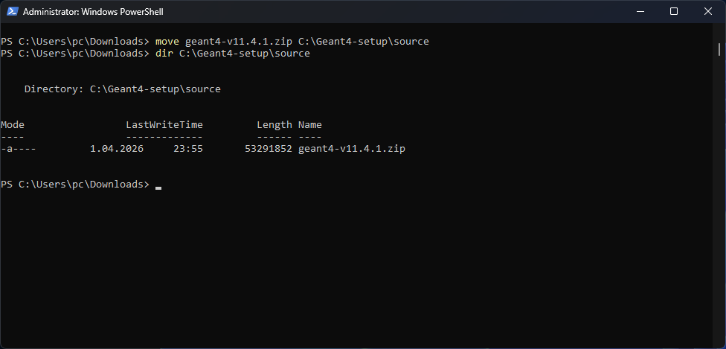
Figure 8: Moving Geant4 source archive into the source directory

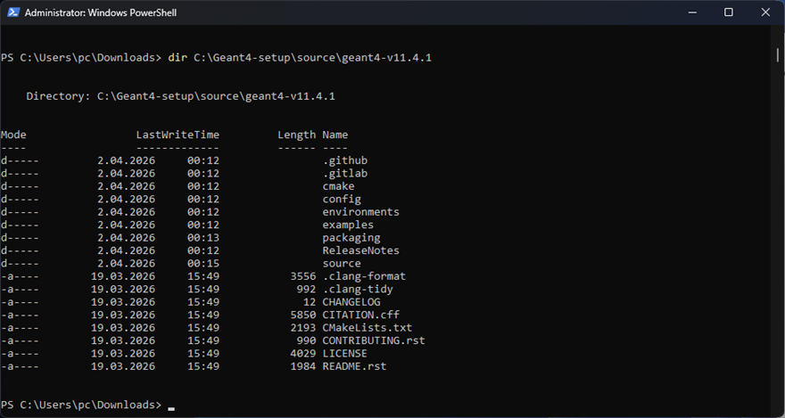
Figure 9: Extracting Geant4 source files and verifying correct folder structure (presence of CMakeLists.txt)

### 4. Configure with CMake
After extracting the source code, the next step is to configure the build using CMake.

1. Navigate to the build directory:
cd C:\Geant4-setup\build

2. Run the CMake configuration command:
cmake ..\source\geant4-v11.4.1 ^
-G "Visual Studio 17 2022" ^
-A x64 ^
-DCMAKE_INSTALL_PREFIX=C:\Geant4-setup\install ^
-DGEANT4_INSTALL_DATA=ON ^
-DGEANT4_USE_OPENGL_WIN32=ON

3. This process will configure the build system and prepare the project files.
CMake configuration generates Visual Studio solution files that will be used to build Geant4.

4. If successful, you should see a message like:
"Configuring done"
"Generating done"

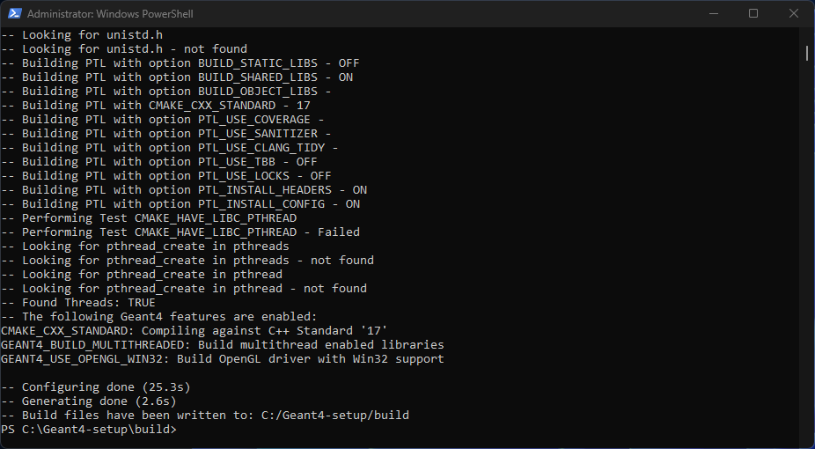
Figure 10: Configuring Geant4 build system using CMake

### 5. Build Geant4
After configuring the project with CMake, the next step is to build Geant4.

1. Navigate to the build directory:
cd C:\Geant4-setup\build

2. Run the following command:
cmake --build . --config Release

3. This process compiles the Geant4 source code and may take a significant amount of time depending on system performance.

4. After the build is completed, verify that the compilation was successful by checking the generated library files:
dir BuildProducts\Release\bin
If the build is successful, multiple ".dll" files will be present in this directory.
These files indicate that the Geant4 libraries have been compiled correctly.

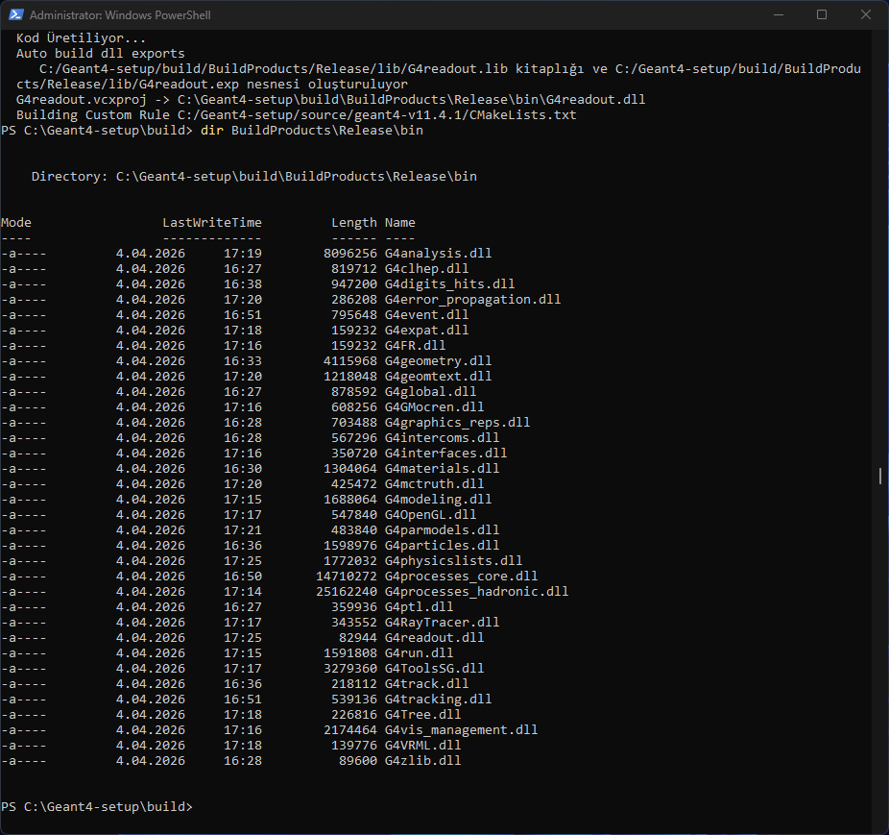
Figure 11: Building Geant4 using CMake (successful compilation of libraries confirmed by generated .dll files)

5. Install Geant4 to the specified installation directory:
cmake --install . --config Release

This step copies the compiled libraries, headers, and resources into the installation folder, making Geant4 ready for use.

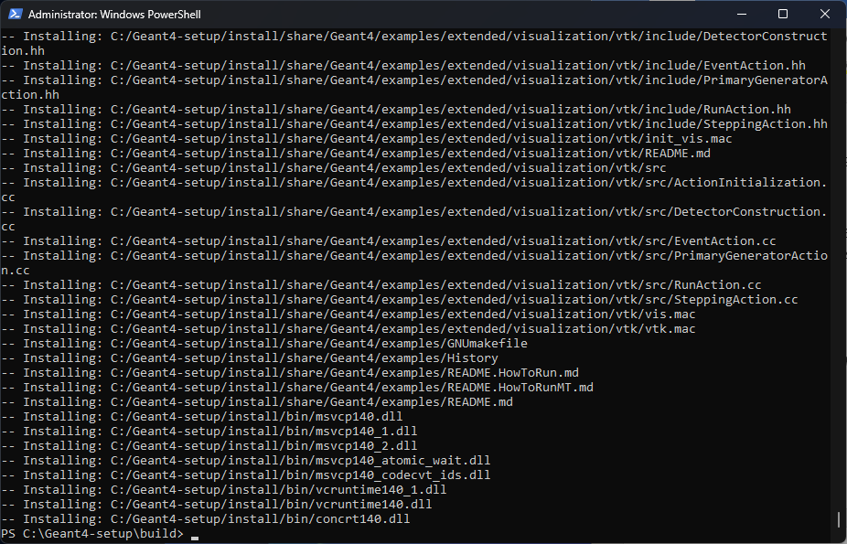
Figure 12: Installing Geant4 using CMake install command

### 6. Setup Environment Variables
After installation, environment variables must be configured to use Geant4 properly.
There are two ways to set up the environment:

1. Temporary setup (per session):

Navigate to the Geant4 installation directory:
cd C:\Geant4-setup\install\bin

Run the following script:
.\geant4.bat
This method sets the required environment variables only for the current terminal session.

2. Permanent setup (recommended):

To avoid setting the environment variables every time, they can be defined permanently using PowerShell:
[System.Environment]::SetEnvironmentVariable(
"GEANT4_DATA_DIR",
"C:\Geant4-setup\install\share\Geant4\data",
"User"
)

After running this command, open a new PowerShell window and verify:
echo $env:GEANT4_DATA_DIR

If configured correctly, the dataset path should be displayed.

This ensures that Geant4 can always locate the required physics datasets.

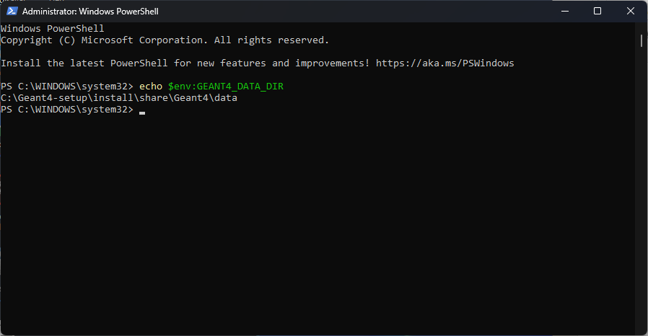
Figure 13: Verifying permanently configured Geant4 dataset environment variable in PowerShell

### 7. Run a Geant4 Example
To verify that Geant4 is installed and working correctly, a basic example can be executed.

1. Navigate to the examples directory:
cd C:\Geant4-setup\install\share\Geant4\examples\basic\B1

2. Create a build directory:
mkdir build
cd build

3. Configure the example:
cmake .. -G "Visual Studio 17 2022" -A x64

If CMake cannot locate Geant4 automatically, specify the installation path manually using the Geant4_DIR variable:

cmake .. -G "Visual Studio 17 2022" -A x64 -DGeant4_DIR=C:\Geant4-setup\install\lib\cmake\Geant4
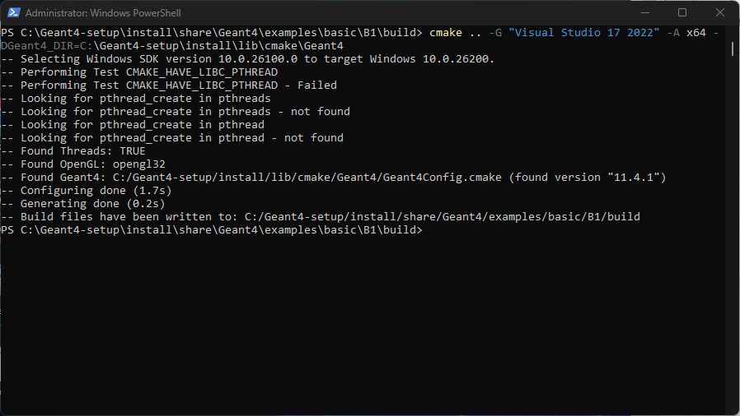
Figure 14: Configuring Geant4 example with manually specified Geant4_DIR

4. Build the example:
cmake --build . --config Release

5. Run the simulation with visualization:
.\Release\exampleB1.exe

If the application starts in interactive mode, a prompt such as "Idle>" will appear. In this case, visualization commands can be entered manually:
/vis/open OGLSWin32
/vis/drawVolume
/run/beamOn 10

Alternatively, the simulation can be started with a macro file:
.\Release\exampleB1.exe ..\init_vis.mac

If everything is configured correctly, a visualization window should appear showing the detector geometry.
Note: In some systems, the application may terminate immediately when first executed without commands. In such cases, running the executable again or using a macro file will start the interactive session correctly.

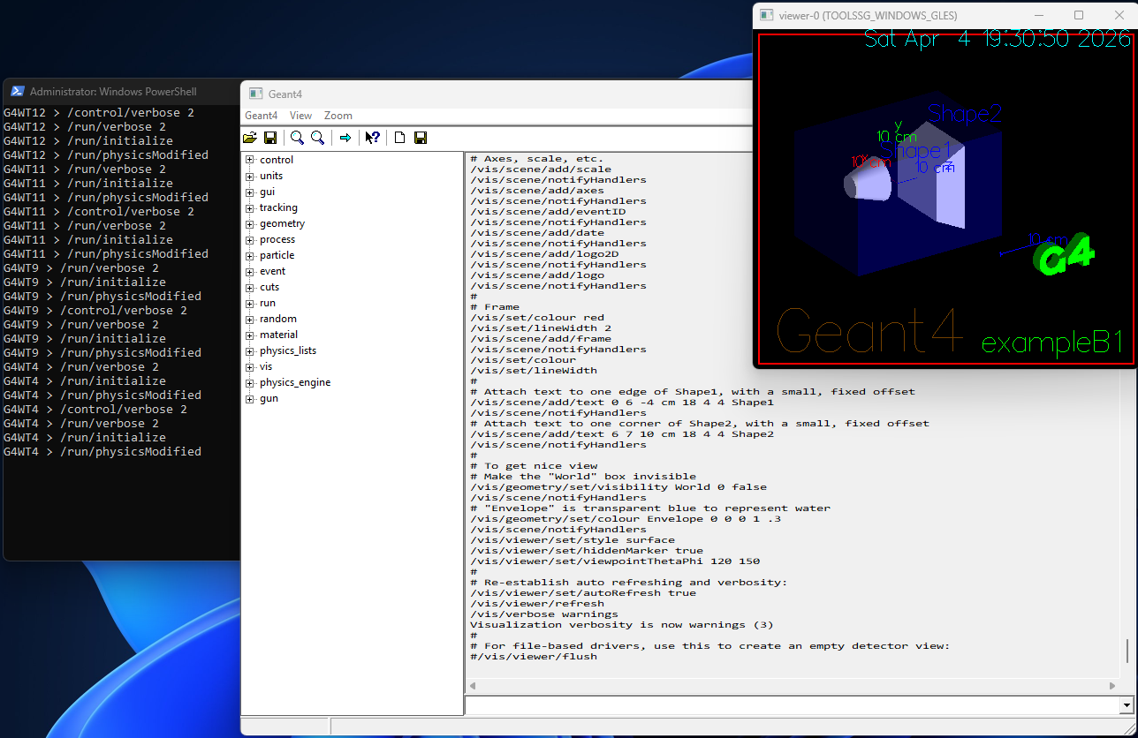
Figure 15: Geant4 B1 example running in interactive mode with OpenGL visualization
## Result
Geant4 was successfully installed, configured, and built from source using CMake and Visual Studio 2022.
The B1 example simulation was executed successfully in interactive mode, and the visualization window was displayed using the OpenGL driver.
This confirms that the Geant4 environment is fully functional and ready for advanced detector simulations.

