DSA 210 – Introduction to Data Science
2025–2026 Spring Term │ Final Project Report
Can Weather Predict Water?
Analysing Istanbul Dam Occupancy Through Meteorological Data
Aysenur Uyar
github.com/aysenuruyar-rgb/DSA210-Proj
May 2026

1. Motivation
Istanbul is a city of over 15 million people whose water supply depends entirely on reservoirs. When those reservoirs drop, the whole city feels it — there have been genuine shortage scares in recent years. So the question I wanted to answer was a simple one: can we look at the weather on a given day and predict how full the dams are?

The intuitive answer is yes — rain fills reservoirs. But hydrology is more complicated than that. Rainfall has to saturate the soil, overcome evaporation, run off into catchment areas and slowly accumulate before reaching a reservoir. A single rainy day might be essentially invisible in the aggregate occupancy figure. This project tests that intuition rigorously with 17 years of real data.

2. Data Sources
Two datasets were collected and merged into a single daily time series covering 2005–2021:

Dam Occupancy — Istanbul Metropolitan Municipality Open Data Portal
Daily reservoir occupancy rate (%) aggregated across Istanbul’s dam network, downloaded from the official IBB open data platform. This is the target variable throughout the project.

Weather Data — Open-Meteo Historical Weather API
Daily rainfall (mm), snowfall (cm), and mean temperature (°C) queried via automated Python API requests for Istanbul coordinates. These represent the primary meteorological inputs into any surface hydrology system.

Both datasets were aligned on a shared date index and saved as data/processed/final_dataset.csv. A feature-engineered version was saved separately as featured_dataset.csv.

3. Data Analysis

3.1 Exploratory Data Analysis
The time series below tells the core story at a glance. Dam occupancy (blue) follows a strong, consistent seasonal cycle year after year, while rainfall (orange) fluctuates with no obvious synchrony.

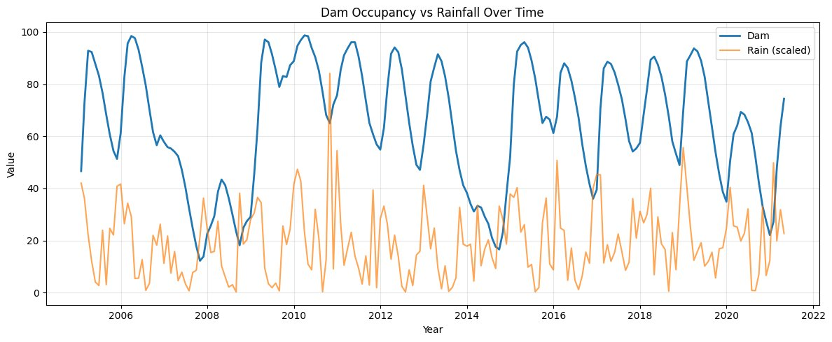
Figure 1. Dam occupancy (%) vs. scaled monthly rainfall, Istanbul 2005–2021. Reservoir levels rise every spring and fall every autumn, regardless of how wet or dry that particular year was.

The correlation matrix confirms this: dam occupancy has near-zero correlation with all three weather variables measured on the same day — r = −0.06 (rain), 0.11 (snow), −0.07 (temperature).

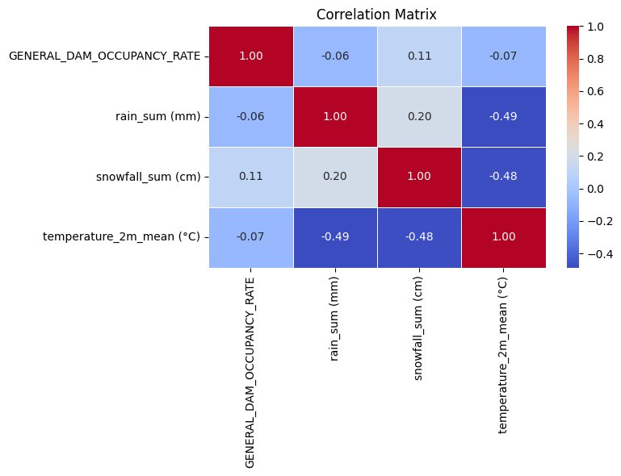
Figure 2. Correlation matrix. No meaningful linear relationship exists between dam occupancy and any of the three weather variables.

3.2 Hypothesis Testing
Four hypotheses were formally tested:

 | Hypothesis | Test | Result
H1 | Daily rainfall significantly affects dam occupancy | Pearson r / t-test | Not significant (p ≈ 0.415)
H2 | Weather variables collectively explain dam levels | Multiple OLS regression | Very weak (R² ≈ 0.02)
H3 | Seasonality significantly affects dam occupancy | ANOVA / Kruskal-Wallis | Confirmed (p < 0.001)
H4 | Rainy seasons have higher occupancy levels than non-rainy seasons | Mann-Whitney U / t-test | Confirmed (p < 0.001)

H1 and H2 tell the same story from different angles: whether you look at rainfall alone or all weather variables together, today’s weather explains almost nothing about today’s dam level. H3 is where the real signal is. The figures below make this visually clear.

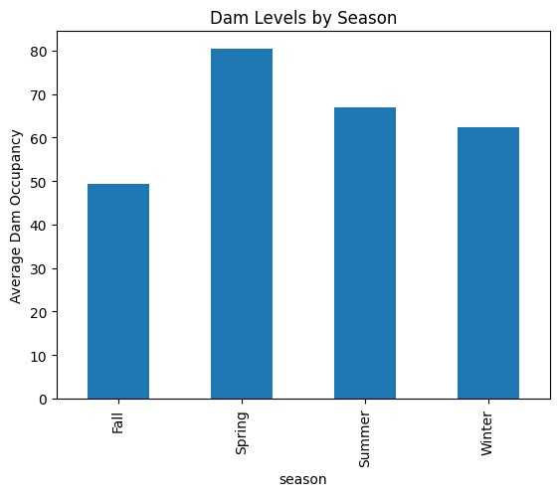 | 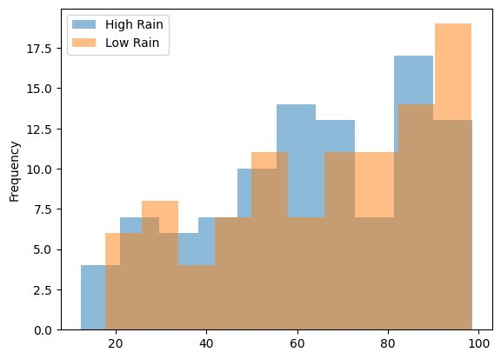
Figure 3. Left: average dam occupancy by season — Spring peaks near 80%, Fall drops to ~50%, a ~30-point swing driven by seasonality. Right: dam occupancy distributions on high-rain vs. low-rain days overlap almost entirely, confirming that same-day rainfall carries no predictive power (H1).

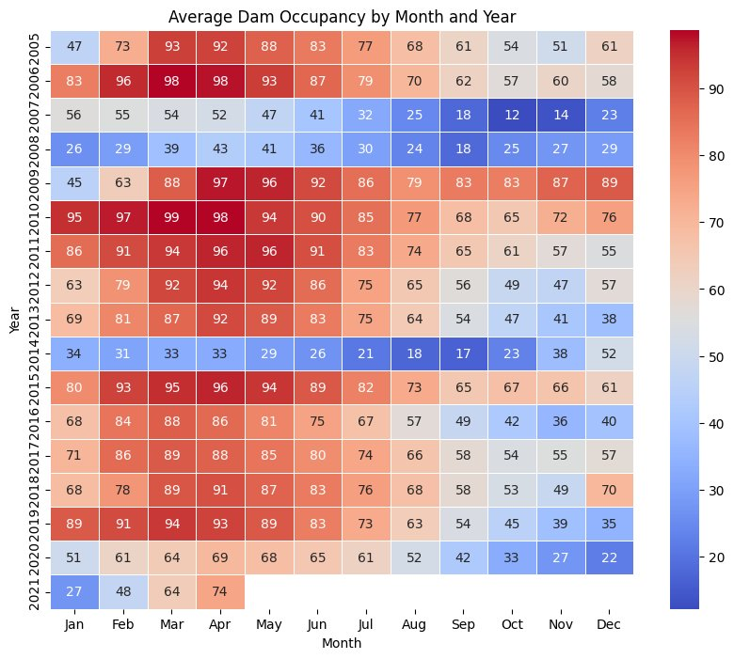
Figure 4. Monthly dam occupancy by year (2005–2021). The seasonal arc — warm reds in Jan–Apr, cool blues in Sep–Nov — repeats with striking consistency across all 17 years, regardless of annual rainfall variation.

3.3 Feature Engineering
Since raw weather variables were weak predictors, additional features were engineered to help models capture the system’s slow dynamics:
- Lag variables — previous dam occupancy (1-, 7-, 30-day lags) and lagged weather values to capture delayed precipitation effects
- Rolling averages — 90-day moving averages to represent accumulated trends rather than daily noise
- Combined precipitation — rain + snow merged into a single total metric
- Seasonal encoding — sine/cosine of day-of-year to represent the annual cycle as continuous features
- Binary rain flag — is_rainy indicator for days with any measurable precipitation

3.4 Machine Learning Modelling
Two models were trained to predict daily dam occupancy — Linear Regression as a parametric baseline, and a Random Forest Regressor to capture non-linear relationships. Both were evaluated using MAE and R².

Model | Feature Set | MAE | R²
Linear Regression (baseline) | Weather variables only | — | ~0.02 (from H2)
Linear Regression (full) | Weather + lags + rolling + seasonal | MAE = 2.99 | 0.955
Random Forest | All engineered features | MSE = 25.18 | 0.937

The results are striking. The baseline model using raw weather variables achieves R² ≈ 0.02 — essentially useless. Adding engineered temporal features pushes Linear Regression to R² = 0.955 (MAE = 2.99%), meaning the model predicts dam occupancy to within about 3 percentage points on average. Random Forest reaches R² = 0.937. In both cases the dominant predictors were lagged dam occupancy and seasonal features, not current-day weather.

4. Key Findings
- Daily weather cannot predict dam levels. With p ≈ 0.415 (H1) and R² ≈ 0.02 (H2), same-day weather variables carry almost no signal for reservoir occupancy.
- Seasonality is the dominant driver. Dam levels swing ~30 percentage points between spring peaks and autumn troughs every year (p < 0.001, H3). Rainy seasons also show significantly higher occupancy than non-rainy seasons (p < 0.001, H4).
- Water systems have memory. The best predictors are lagged dam levels, not today’s rainfall. Reservoirs respond to weeks and months of accumulated precipitation, not individual rain events.
- Temporal features transform model performance. Linear Regression jumps from R² ≈ 0.02 (weather only) to R² = 0.955 (MAE = 2.99%) once lag and seasonal features are added. Random Forest reaches R² = 0.937.

5. Limitations and Future Work

Current Limitations
- No consumption data. Dam occupancy is net inflows minus withdrawals and evaporation. Without demand data, any weather model is structurally incomplete.
- Single-point weather. One coordinate was used for all of Istanbul. Catchment-specific weather data would be more physically accurate.
- Aggregate dam metric. Individual reservoirs likely behave differently; the aggregate percentage masks this variation.
- Train/test split. For time series data a temporal split is essential to prevent data leakage. This should be clearly documented in the modelling notebook.

Future Extensions
- Apply time-series-specific models (SARIMA, Prophet, LSTM) better suited to autoregressive seasonal data.
- Add per-capita consumption and population data to model net inflows directly.
- Use gridded spatial weather matched to each dam’s catchment area rather than a single city-wide observation.
- Study extreme events — storms, multi-year droughts — and their effect on reservoir recovery time.

6. AI Disclosure
ChatGPT (OpenAI) and Claude (Anthropic) were used during this project for improving documentation clarity, refining written explanations of statistical concepts, debugging Python code, and generating this final report document. All data collection, analytical decisions, statistical interpretation, feature engineering, and machine learning implementation were carried out and verified independently by the author.

7. Conclusion
Does weather predict water? The short answer is: not in the way you’d expect. Daily rainfall and snowfall carry almost no information about Istanbul’s reservoir levels on the same day. What actually matters is the slow seasonal rhythm — the gradual build-up of precipitation through winter and spring, and the long dry draw-down through summer. The best model is essentially one that says “the dam is roughly where it was yesterday, adjusted for the time of year.”

For water resource managers, this means short-term weather forecasts are the wrong tool for anticipating reservoir dynamics — long-range seasonal outlooks and demand-side modelling are what’s needed. From a data science perspective, the project is a good reminder that domain knowledge matters: understanding that hydrological systems have memory and seasonality was essential for choosing the right features and interpreting the results correctly.

