1. 1. First you need to set up the SpringBootServer. You could open this spring boot application in and IDE such as eclipse. (I used eclipse EE for development)

2. Then you have to download wampserver (You could use this link to download it: https://www.wampserver.com/en/#download-wrapper)

3. You could connect to wampserver from this link http://localhost/phpmyadmin/index.php. You could pass in the following information in the screen:

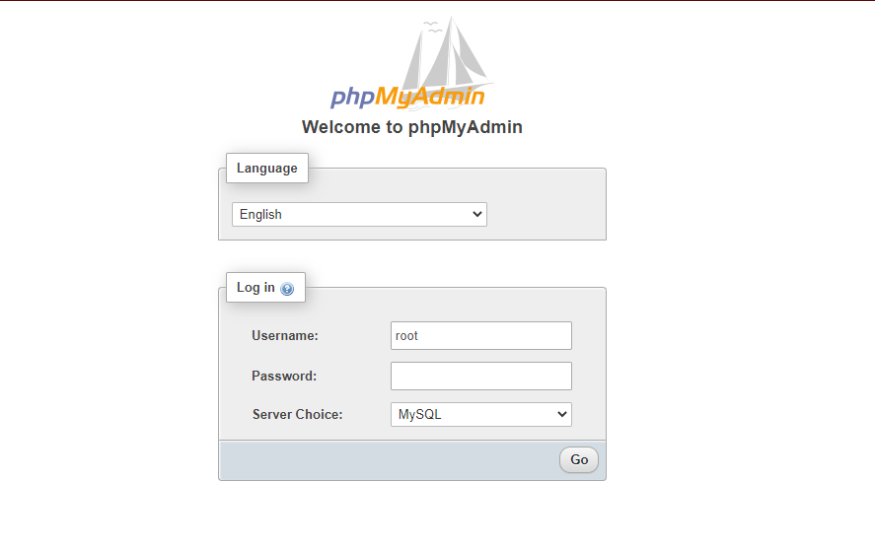

4. You need to then create the tables and the data accordingly for the system to actually be able to fetch these data and present it in the screen. The sql’s to use in order to create the tables and data are presented in step 7. If wanted, additional data could be added to the database from wampserver. (I will also be attaching the scripts to run in the database in the GitLab repository).

5. For the frontend(react app), you need to navigate into the src folder to where App.js is placed in. Then you have to type in "npm start" in the terminal.

6. I will be sharing a demo video to present the resulting system. Thank you.

7.

-- phpMyAdmin SQL Dump

-- version 5.0.2

-- https://www.phpmyadmin.net/

--

-- Host: 127.0.0.1:3306

-- Generation Time: Jan 27, 2021 at 08:47 PM

-- Server version: 5.7.31

-- PHP Version: 7.3.21

SET SQL_MODE = "NO_AUTO_VALUE_ON_ZERO";

START TRANSACTION;

SET time_zone = "+00:00";

/*!40101 SET @OLD_CHARACTER_SET_CLIENT=@@CHARACTER_SET_CLIENT */;

/*!40101 SET @OLD_CHARACTER_SET_RESULTS=@@CHARACTER_SET_RESULTS */;

/*!40101 SET @OLD_COLLATION_CONNECTION=@@COLLATION_CONNECTION */;

/*!40101 SET NAMES utf8mb4 */;

--

-- Database: `home_automation`

--

-- --------------------------------------------------------

--

-- Table structure for table `airconditioner`

--

DROP TABLE IF EXISTS `airconditioner`;

CREATE TABLE IF NOT EXISTS `airconditioner` (

`id` int(11) NOT NULL AUTO_INCREMENT,

`name` varchar(255) DEFAULT NULL,

`room_id` int(11) NOT NULL,

`state` bit(1) DEFAULT NULL,

PRIMARY KEY (`id`)

) ENGINE=MyISAM AUTO_INCREMENT=3 DEFAULT CHARSET=utf8;

--

-- Dumping data for table `airconditioner`

--

INSERT INTO `airconditioner` (`id`, `name`, `room_id`, `state`) VALUES

(1, 'AC1', 1, b'0'),

(2, 'AC2', 2, b'1');

-- --------------------------------------------------------

--

-- Table structure for table `curtain`

--

DROP TABLE IF EXISTS `curtain`;

CREATE TABLE IF NOT EXISTS `curtain` (

`id` int(31) NOT NULL AUTO_INCREMENT,

`name` varchar(31) NOT NULL,

`state` tinyint(1) NOT NULL,

`room_id` int(31) NOT NULL,

PRIMARY KEY (`id`)

) ENGINE=MyISAM AUTO_INCREMENT=2 DEFAULT CHARSET=utf8;

--

-- Dumping data for table `curtain`

--

INSERT INTO `curtain` (`id`, `name`, `state`, `room_id`) VALUES

(1, 'curtain 1', 0, 1);

-- --------------------------------------------------------

--

-- Table structure for table `light`

--

DROP TABLE IF EXISTS `light`;

CREATE TABLE IF NOT EXISTS `light` (

`id` int(31) NOT NULL AUTO_INCREMENT,

`name` varchar(31) NOT NULL,

`state` tinyint(1) NOT NULL,

`room_id` int(31) NOT NULL,

PRIMARY KEY (`id`)

) ENGINE=MyISAM AUTO_INCREMENT=4 DEFAULT CHARSET=utf8;

--

-- Dumping data for table `light`

--

INSERT INTO `light` (`id`, `name`, `state`, `room_id`) VALUES

(1, 'light 1', 1, 1),

(2, 'light 1', 1, 2),

(3, 'light 2', 1, 1);

-- --------------------------------------------------------

--

-- Table structure for table `room`

--

DROP TABLE IF EXISTS `room`;

CREATE TABLE IF NOT EXISTS `room` (

`id` int(31) NOT NULL AUTO_INCREMENT,

`name` varchar(31) NOT NULL,

PRIMARY KEY (`id`)

) ENGINE=MyISAM AUTO_INCREMENT=3 DEFAULT CHARSET=utf8;

--

-- Dumping data for table `room`

--

INSERT INTO `room` (`id`, `name`) VALUES

(1, 'Kitchen'),

(2, 'Living Room');

-- --------------------------------------------------------

--

-- Table structure for table `television`

--

DROP TABLE IF EXISTS `television`;

CREATE TABLE IF NOT EXISTS `television` (

`id` int(31) NOT NULL AUTO_INCREMENT,

`name` varchar(31) NOT NULL,

`state` tinyint(1) NOT NULL,

`room_id` int(31) NOT NULL,

PRIMARY KEY (`id`)

) ENGINE=MyISAM AUTO_INCREMENT=3 DEFAULT CHARSET=utf8;

--

-- Dumping data for table `television`

--

INSERT INTO `television` (`id`, `name`, `state`, `room_id`) VALUES

(1, 'living room television', 1, 2),

(2, 'kitchen TV', 0, 1);

-- --------------------------------------------------------

--

-- Table structure for table `temperature`

--

DROP TABLE IF EXISTS `temperature`;

CREATE TABLE IF NOT EXISTS `temperature` (

`id` int(11) NOT NULL AUTO_INCREMENT,

`degree` int(11) NOT NULL,

`name` varchar(255) DEFAULT NULL,

`room_id` int(11) NOT NULL,

`state` bit(1) DEFAULT NULL,

`temperature` int(11) NOT NULL,

PRIMARY KEY (`id`)

) ENGINE=MyISAM AUTO_INCREMENT=2 DEFAULT CHARSET=utf8;

--

-- Dumping data for table `temperature`

--

INSERT INTO `temperature` (`id`, `degree`, `name`, `room_id`, `state`, `temperature`) VALUES

(1, 25, NULL, 0, NULL, 0);

COMMIT;

/*!40101 SET CHARACTER_SET_CLIENT=@OLD_CHARACTER_SET_CLIENT */;

/*!40101 SET CHARACTER_SET_RESULTS=@OLD_CHARACTER_SET_RESULTS */;

/*!40101 SET COLLATION_CONNECTION=@OLD_COLLATION_CONNECTION */;