FitBuddy – AI Fitness Plan Generator Using Gemini Models

TEAM ID : SWTID-2026-5064
TEAM LEADER : JAIGANESH E (gjai63442@gmail.com)
TEAM MEMBERS: 1. SIMSON (simson2007yt@gmail.com)
TEAM MEMBERS : 2. SAMSON TITUS LOURD.K (samsontitus1515@gmail.com)
TEAM MEMBERS: 3. ALIYA BEGUM S.N (shakilabegum952005@gmail.com)
TEAM MEMBERS: 4. AYSHA SIDDIKA .S (aysha200801@gmail.com)

ABSTRACT
FitBuddy is an AI-based web application developed to generate personalized fitness plans using Gemini AI models.

The application collects basic user information such as name, age, weight, fitness goal and workout intensity. Based on the provided information, the Gemini model generates a customized seven-day workout plan and a nutrition/recovery tip.

The application is developed using FastAPI for the backend, HTML/CSS and Jinja2 for the frontend, Gemini AI for content generation, and SQLite with SQLAlchemy for data storage.

The system also allows users to provide feedback about their generated plan. Based on the feedback, the application can generate an updated workout plan.

The project demonstrates how Generative AI can be integrated into a web application to provide personalized and interactive fitness planning.

INTRODUCTION

Fitness planning normally requires selecting suitable exercises and organizing them into a weekly routine. A general workout plan may not be suitable for every user because people have different goals, experience levels and preferences.

FitBuddy provides a simple web-based solution using Generative AI. The user enters basic information through a web form, and the application sends the information to the Gemini AI model.

The generated result is displayed through a user-friendly web interface. The application also stores the generated information in a SQLite database.

The main features of FitBuddy are:

* Personalized workout generation
* Seven-day workout plan
* Nutrition/recovery tip
* Feedback-based plan update
* Database storage
* Admin dashboard
* Web interface
* FastAPI API endpointsThe project documentation describes the overall workflow as frontend → FastAPI backend → Gemini AI → database → generated result.

PROBLEM STATEMENT

Many fitness applications provide predefined workout plans that may not consider the individual requirements of every user.

The main problems are:

* Lack of personalized workout plans
* Difficulty in creating a weekly workout schedule
* Limited interaction with the generated plan
* Difficulty in modifying a plan based on feedback
* Manual management of user information and plans

Therefore, the project aims to develop an AI-powered web application that can generate personalized fitness plans and update them based on user feedback.

OBJECTIVES

The main objectives of FitBuddy are:

1. To develop a web-based AI fitness planning application.
2. To collect basic user information through a simple form.
3. To generate personalized seven-day workout plans using Gemini AI.
4. To generate nutrition and recovery tips.
5. To allow users to provide feedback.
6. To update workout plans according to feedback.
7. To store user and plan information in a SQLite database.
8. To provide an admin dashboard for viewing stored users.
9. To demonstrate the integration of Generative AI with FastAPI.

EXISTING SYSTEM

In a traditional fitness planning system, users may depend on:

* Predefined workout plans
* Manually created schedules
* General fitness websites
* Human trainers
* Static exercise lists

These systems may not provide dynamic AI-generated plans.

Limitations of Existing System

* Less personalization
* Static workout plans
* Manual modification
* Limited feedback-based changes
* No automatic Generative AI integration

PROPOSED SYSTEM

The proposed system is “FitBuddy – AI Fitness Plan Generator”.

The system uses Gemini AI to generate fitness-related content according to the information entered by the user.
Main Features

* User input form
* AI-generated workout plan
* Seven-day schedule
* Nutrition/recovery tip
* Feedback system
* Updated workout plan
* SQLite database
* Admin dashboard
* FastAPI API
* Responsive frontend

The system architecture consists of:
User → Frontend → FastAPI → Gemini AI → Database → Result

TECHNOLOGIES USED

| Technology | Purpose
| Python | Main programming language
| FastAPI | Backend web framework
| Gemini AI | AI-based workout and tip generation
| Google GenAI | Gemini API integration
| HTML | Web page structure
| CSS | Web page styling
| Jinja2 | Dynamic HTML templates
| SQLite | Database
| SQLAlchemy | Database interaction
| Pydantic | Input validation
| Uvicorn | Application server
| Pytest | Testing

The project documentation identifies FastAPI, Gemini, SQLite, SQLAlchemy, HTML/CSS and Jinja2 as the main technologies used in the system.

9. SYSTEM REQUIREMENTS

Hardware Requirements

* Computer or laptop
* Minimum 4 GB RAM
* Internet connection
* Keyboard and mouse
* Sufficient storage for Python packages and project files

Software Requirements

* Windows/Linux/macOS
* Python
* Visual Studio Code
* Web browser
* Internet connection
* Gemini API key

Python Packages

The project uses packages including:

* FastAPI
* Uvicorn
* Jinja2
* SQLAlchemy
* Pydantic
* Python-dotenv
* Google GenAI
* Pytest
* HTTPX

SYSTEM ARCHITECTURE
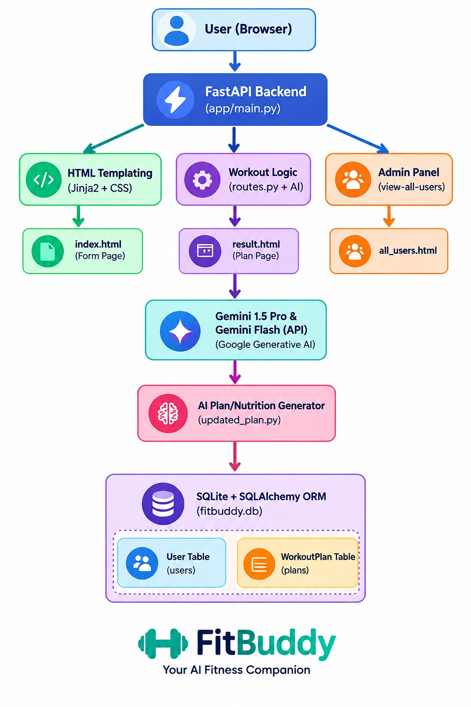
The FitBuddy system follows a simple layered architecture.

Components

Frontend:
Collects user information and displays the generated result.

Backend:
FastAPI handles requests, validation, AI calls and database operations.

AI Layer:
Gemini generates the workout plan and nutrition/recovery tip.

Database:
SQLite stores user information, generated plans and feedback.

The project documentation describes the architecture using HTML/Jinja2 frontend, FastAPI backend, Gemini AI and SQLite/SQLAlchemy database components.

Screenshot to add:
Figure 1: FitBuddy System Architecture

PROJECT WORKFLOW

The working process of FitBuddy is:

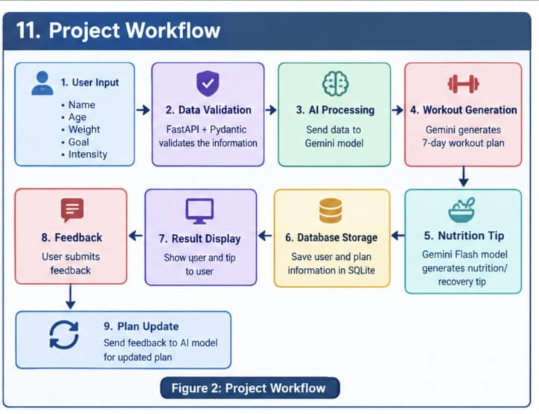

Step 1 – User Input

The user enters:

* Name
* Age
* Weight
* Fitness goal
* Workout intensity

Step 2 – Data Validation

FastAPI and Pydantic validate the submitted information.

Step 3 – AI Processing

The information is sent to the Gemini model.

Step 4 – Workout Generation

Gemini generates a personalized seven-day workout plan.

Step 5 – Nutrition Tip

The Gemini Flash model generates a short nutrition/recovery tip.

Step 6 – Database Storage

The user information and generated results are stored in SQLite.

Step 7 – Result Display

The generated plan is displayed on the result page.

Step 8 – Feedback

The user can submit feedback.

Step 9 – Plan Update

The feedback is sent to the AI model to generate an updated plan.

The original project workflow includes model selection, core functionality, route development, frontend development, deployment and testing.

PROJECT MODULES

The project is divided into several modules.

12.1 Main Application

File: main.py

Responsible for:

* Starting FastAPI
* Initializing the database
* Mounting static files
* Loading application routes

12.2 Configuration

File: config.py

Responsible for loading configuration values and environment variables.

12.3 Database

File: database.py

Responsible for:

* Creating database tables
* Saving user information
* Storing generated plans
* Storing feedback
* Retrieving users

12.4 Schemas

File: schemas.py

Defines input structures and validation rules using Pydantic.

12.5 Routes

File: routes.py

Handles the application's web and API routes.

Important routes include:
- generate-workout
- submit-feedback
- view-all-users
- health

12.6 Gemini Generator

File: gemini_generator.py

Generates the main workout plan using Gemini AI.

12.7 Gemini Flash Generator

File: gemini_flash_generator.py

Generates a concise nutrition/recovery tip.

12.8 Updated Plan

File: updated_plan.py

Uses user feedback to generate an updated workout plan.

The source documentation identifies workout generation, nutrition tip generation, feedback-based updating and storage as the main functional modules.

13. IMPLEMENTATION

13.1 Frontend Implementation

The frontend is developed using:

* HTML
* CSS
* Jinja2 templates

Main templates are:

text
templates/
base.html
index.html
result.html
all_users.html

index.html

Provides the user input form.

result.html

Displays the generated workout plan and nutrition/recovery information.

all_users.html

Displays stored user information for the administrator.

Jinja2 is used to dynamically display information received from the backend. The source documentation describes the frontend as responsive and template-based.

13.2 Backend Implementation

FastAPI is used as the backend framework.

The backend:

1. Receives user information.
2. Validates the information.
3. Calls Gemini AI.
4. Generates the workout plan.
5. Generates the nutrition/recovery tip.
6. Saves the information.
7. Sends the result to the frontend.

13.3 Gemini AI Integration

Gemini is used for Generative AI functionality.

The project documentation describes experimentation with several models and the final use of Gemini models because of API integration, structured output, accuracy and speed.

The main AI functions are:

text
generate_workout_gemini()
generate_nutrition_tip_with_flash()
update_workout_plan()

These functions provide the core Generative AI functionality of the project.

13.4 Database Implementation

SQLite is used as the database.

SQLAlchemy is used to communicate between Python and the database.

The database stores information such as:

* User ID
* Name
* Age
* Weight
* Goal
* Intensity
* Original plan
* Updated plan
* Nutrition tip
* Feedback
* Created date
* Updated date

14. DATABASE DESIGN
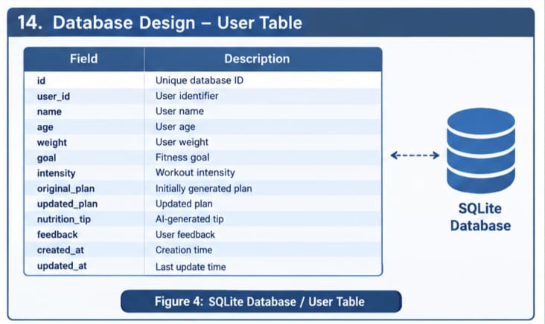
The main database table is the User table.
Database Flow
text
User Input
↓
FastAPI
↓
Validation
↓
SQLite Database
↓
Stored User Information

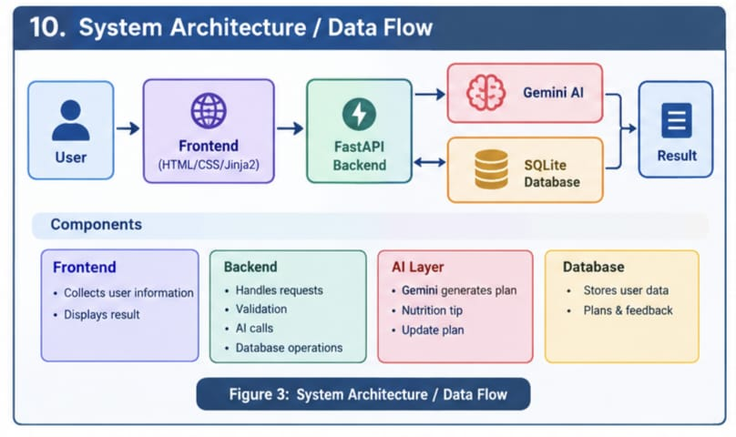

15. TESTING

Testing was performed to check whether the application works correctly.
Test Cases

| Test Case | Expected Result
| Open home page | Home page displayed |
| Submit valid user data | Workout plan generated |
| Submit invalid data | Validation error displayed |
| Check health endpoint | Application status returned |
| Open admin page with correct key | User data displayed |
| Open admin page with wrong key | Access denied |
| Submit feedback | Updated plan generated
Pytest is used for automated testing.

The project documentation also describes local testing through Uvicorn and browser access before deployment
16. SCREENSHOTS / RESULTS
FitBuddy Home Page:
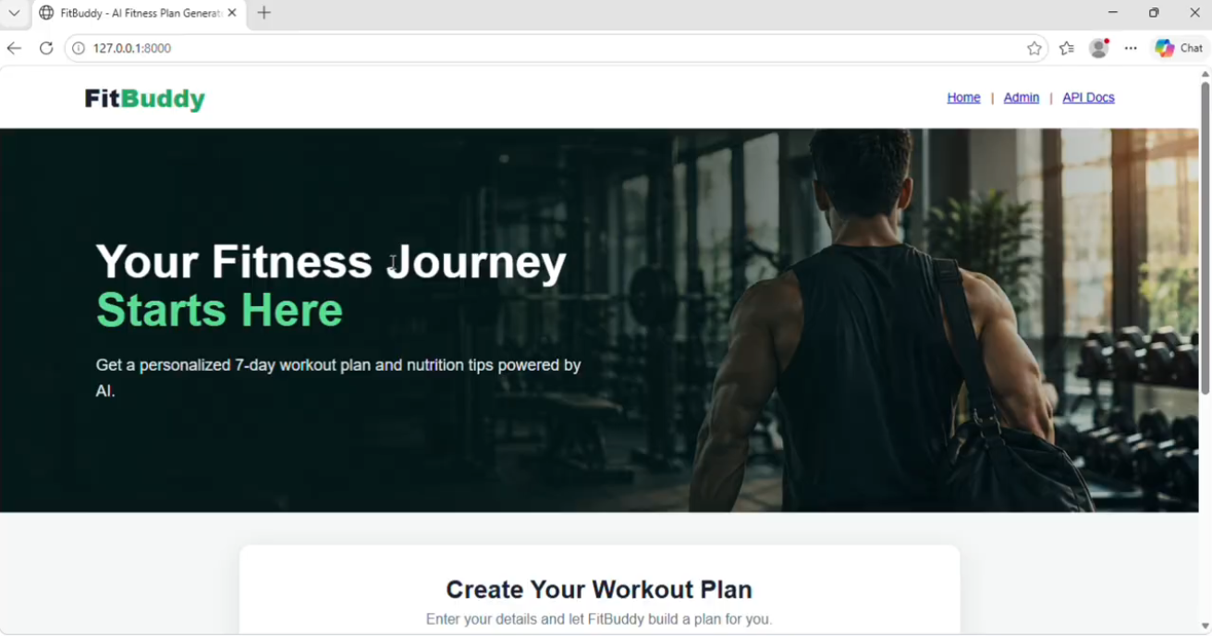

User Input Form:

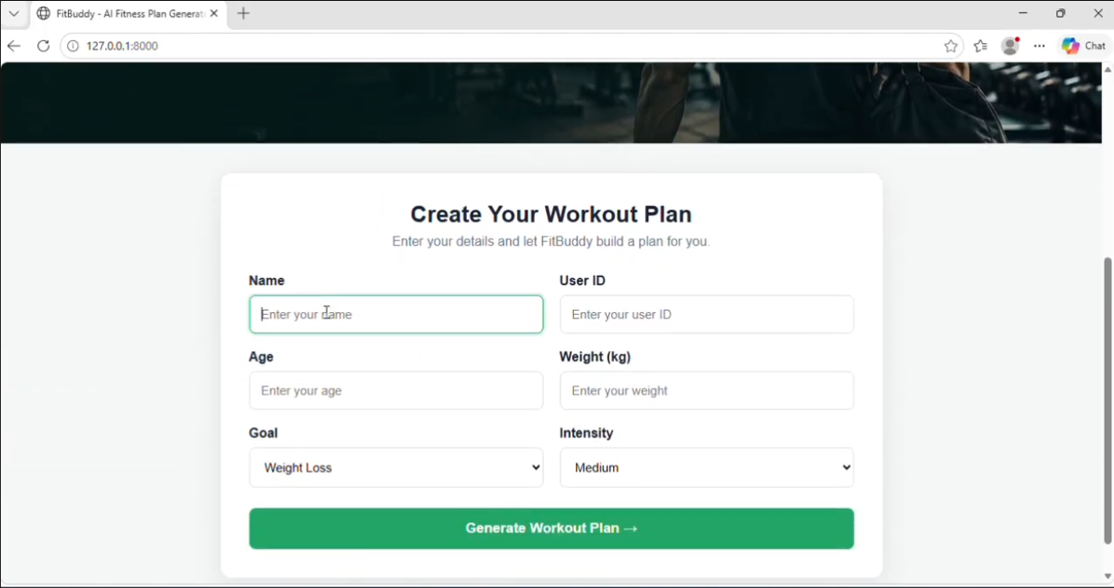

User Information Input Form

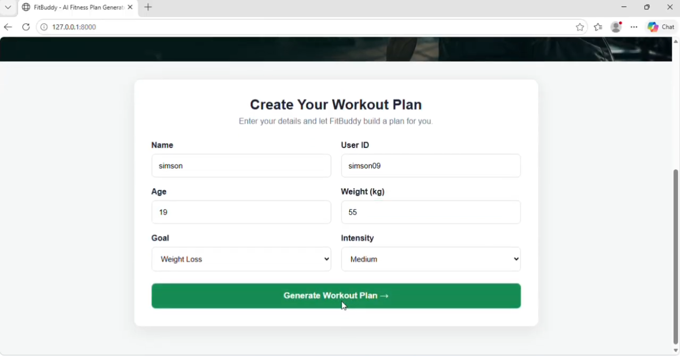

Workout Plan
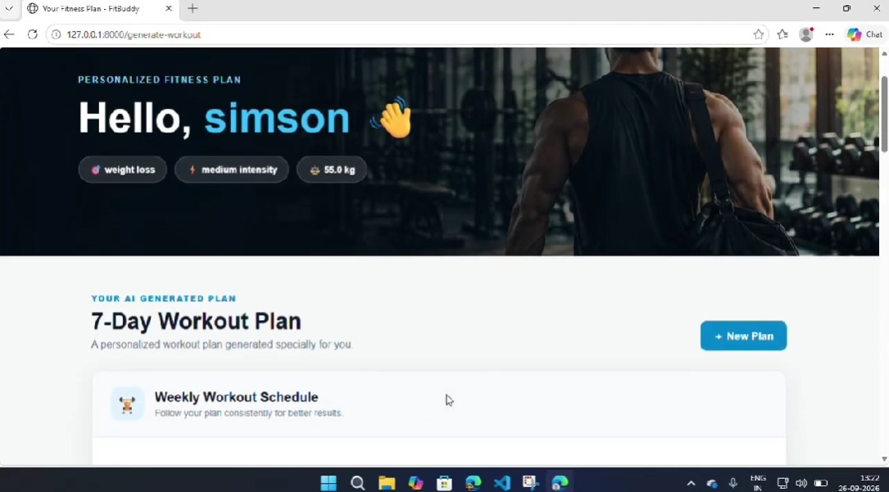

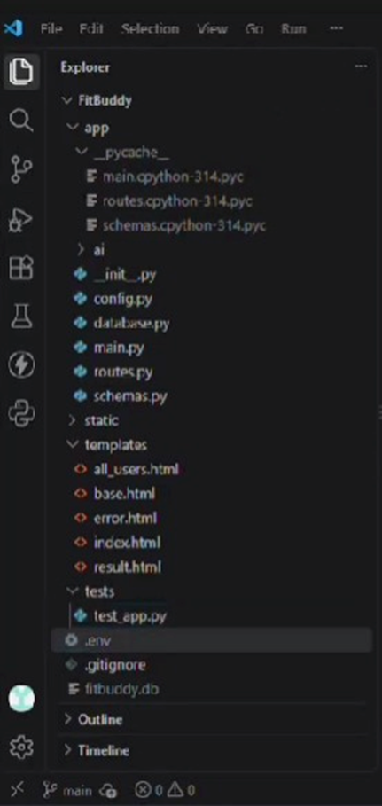
VS Code Project Structure

ADVANTAGES

The main advantages of FitBuddy are:

* AI-based workout generation
* Personalized output
* Simple user interface
* Seven-day workout planning
* Feedback-based plan updates
* Nutrition/recovery tip generation
* Database storage
* FastAPI API support
* Admin dashboard
* Easy local development and testing

The system demonstrates how Generative AI can be connected to a
web application to provide dynamic content.

LIMITATIONS

The current version has some limitations:

* The quality of the generated plan depends on the AI model response.
* Internet connectivity is required for Gemini API access.
* The project is primarily designed as an educational demonstration.
* The generated fitness information should not replace advice from qualified healthcare or fitness professionals.
* The current database is SQLite, which is more suitable for small-scale applications.
* The application does not provide professional medical assessment.

FUTURE ENHANCEMENTS
The project can be improved in the future by adding:

1. User login and authentication.
2. Cloud database support.
3. User profile management.
4. Progress tracking.
5. Workout history.
6. Exercise demonstration videos.
7. Mobile application support.
8. Voice-based interaction.
9. More advanced AI personalization.
10. Deployment on a cloud platform.
11. Improved admin controls.
12. Integration with fitness tracking devices.

These improvements can make the application more interactive and suitable for larger-scale use
CONCLUSION

FitBuddy successfully demonstrates the integration of Generative AI with a modern web application.

The project uses FastAPI as the backend, HTML/CSS and Jinja2 for the frontend, Gemini AI for generating workout and nutrition/recovery content, and SQLite with SQLAlchemy for storing information.

The system can accept user information, generate a seven-day personalized workout plan, provide a nutrition/recovery tip, collect feedback and generate an updated plan.

The project provides a practical example of how Generative AI can be used to build an interactive application. It also demonstrates important software development concepts such as API development, database management, input validation, frontend development, AI integration and application testing.

Overall, the FitBuddy project meets its main objective of developing an AI-powered fitness planning web application and provides a
foundation for future improvements.

REFERENCES

1. FitBuddy Project Documentation provided for the TN Skill Project.
2. Python Documentation.
3. FastAPI Documentation.
4. Google Gemini / Google GenAI Documentation.
5. SQLAlchemy Documentation.
6. Jinja2 Documentation.
7. SQLite Documentation. 8. Pydantic Documentation.
9. Pytest Documentation.

Structure:
text
FitBuddy/
app/
init__.py
main.py
config.py
database.py
schemas.py
routes.py
gemini_generator.py
gemini_flash_generator.py
updated_plan.py

templates/
base.html
index.html
result.html
all_users.html

static/
style.css

tests/
conftest.py
test_app.py
.env
.gitignore
requirements.txt
README.md

GITHUB Link :
https://github.com/simson26/TN-Skills
Demo link :
https://drive.google.com/file/d/1tvasdSJQP6KfQRbYd4pb-UOmAHYOtTqH/view?usp=drivesdk

