Linked-IN Login Test Cases

Test Case 1: Invalid Username, Invalid password

Expected output: Error | Actual output: Error

Status: Failed

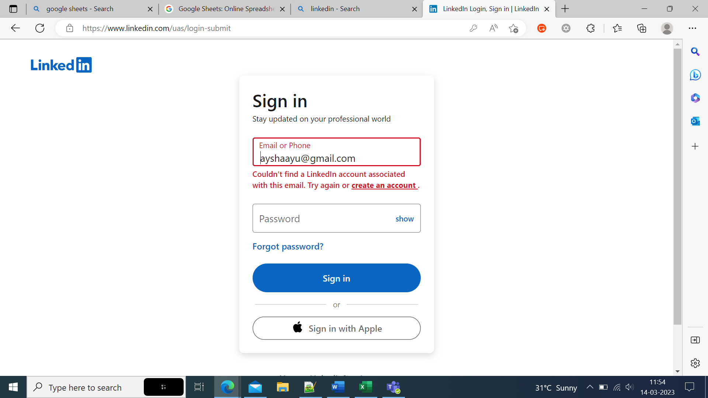

Test Case 2: Valid username, Invalid password

Expected output: Error | Actual output: Error

Status: Failed

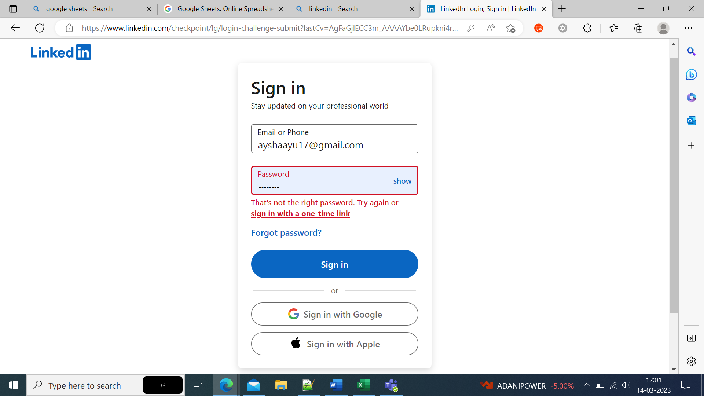

Test Case 3: Invalid username, Valid password

Expected output: Error | Actual output: Error

Status: Failed

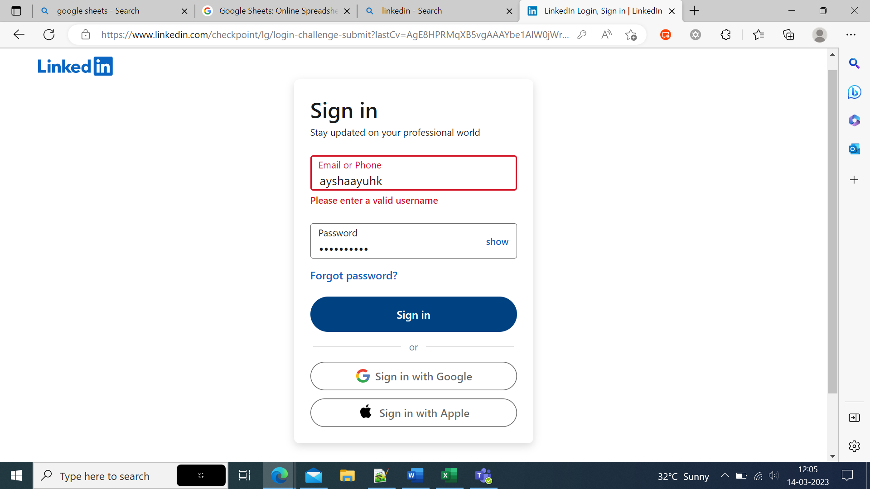

Test Case 4: Valid Username, Valid password

Expected output: Success | Actual output: Success

Status: Pass

