*You are provided with the following data from PayBuddy –*

1. ***Credit data:*** *Data about credit application, approved/declined decision, repayment details and more at the customer level.*
2. ***Marketing data:*** *Transaction level data with details like merchant industry, price, chosen funding instrument and more.*
3. ***AB Testing data:*** *AB testing data for 3 months for transactions with random recommendation (nudge) of Funding Instrument as default (control group) and data-based recommendation (nudge) of Funding Instrument as default (test group). The test/control group tag for every transaction is provided.*
4. ***Visualize and identify the topmost reason for a credit card application to be declined.***

**Answer:** 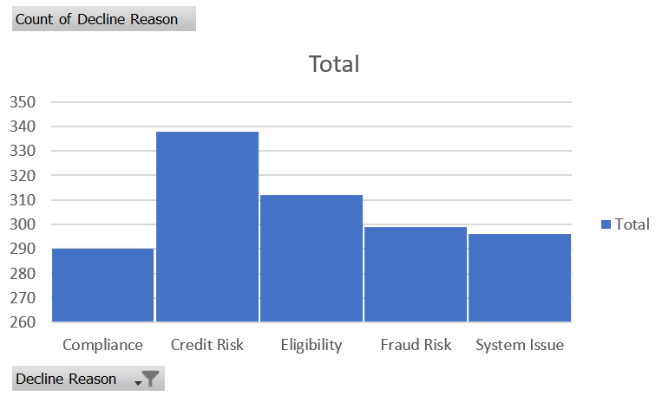

1. ***Identify the following from the data –*** 
   1. ***the month with the lowest credit score cutoff for approval***
   2. ***the month with the highest default rate***
   3. ***the month with the highest approval rate***

***Also identify the trend for each credit score, default rate and approval rate as to whether increasing or decreasing or fluctuating (increase/decrease) month over month.***

**Answer: a)** It’s March with lowest credit score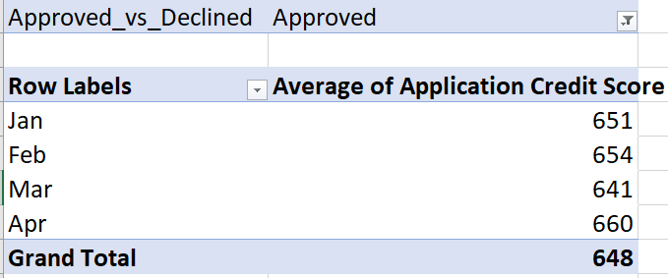

**b)** March being the highest default rate with 49%

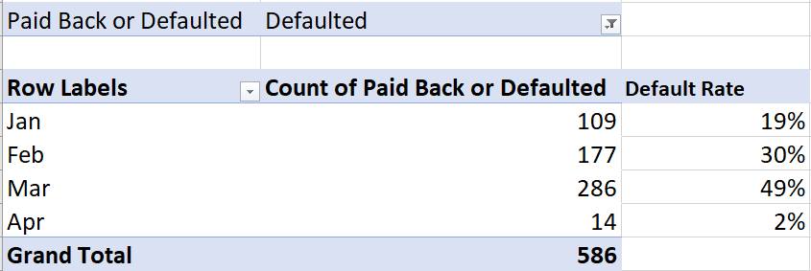

**c)** March being the highest approval rate with 47%

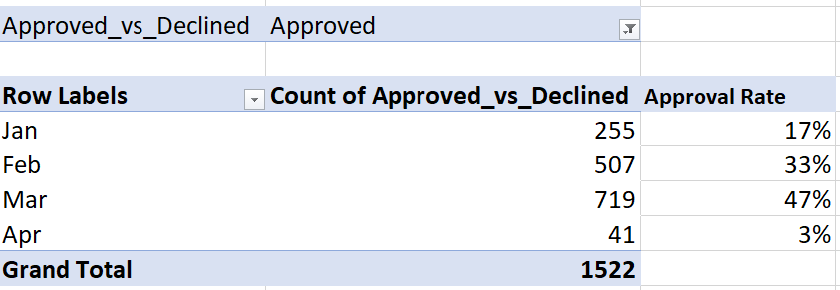

1. ***Plot average transaction amount and approval rate for every month. Identify the following from the plot –*** 
   1. ***the month with highest transaction amount***
   2. ***the month with highest approval rate***

***Also identify if average transaction amount is increasing or decreasing with respect to approval rate? (for e.g. if approval rate increases, average transaction amount decreases or if approval rate increases, average transaction amount increases or vice versa).***

**Answer: a)** April month being the highest transaction amount

**b)** March month being the highest approval rate

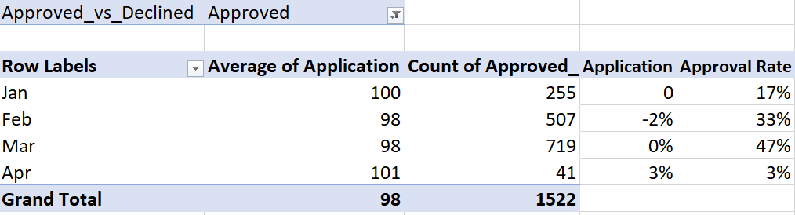

***In Feb, decrease in application amount result in increase in Approval Rate.***

***In Mar, we see no difference in application amount but Approval Rate increase.***

***In Apr, there we have increase in application amount by 3% and decrease in approval rate***

1. ***Report the net revenue for PayBuddy for every month. Do you think the company is making a profit or loss overall?***

**Answer:** Company is making loss for whole the month with the March month highest loss incurred.

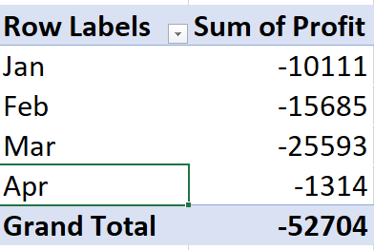

1. ***What is the impact of the data-based nudge on customer engagement? Plot the old and new customer engagement distribution for the test and control group.***

**Answer:**

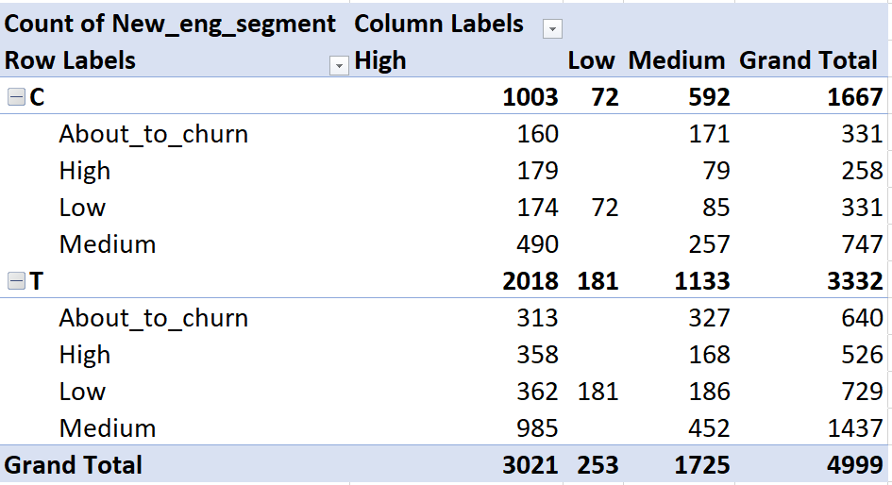

1. ***What is the impact of the data-based nudge on customer spending (credit vs debit card)? Calculate the percentage change in credit and debit spending between the test and control group. Identify if credit spending is increased or decreased after introducing data-based nudges (treatment group).***

**Answer:**

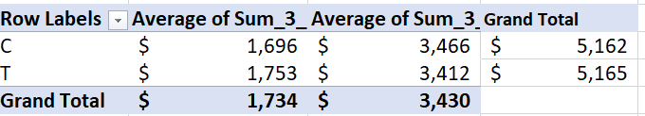

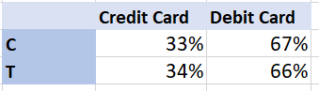

***We can clearly see not much difference between test group and control group.***

1. ***Which Funding Instrument is the most preferred for mobile transactions?***

**Answer: Paypal pay later is most preferred for mobile transaction.**

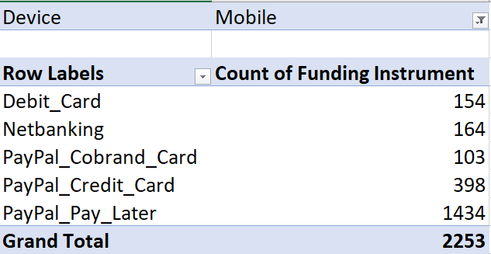

1. ***Find the most frequently used merchant segment for each funding instrument.***

**Answer:**

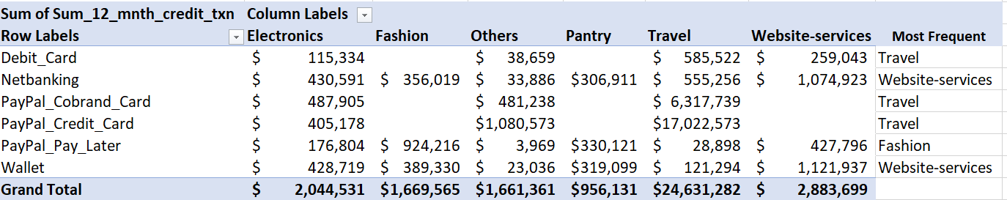

1. ***Which Funding Instrument is preferred by customers with many premium cards?***

**Answer:** *PayPal Cobrand Card*is most preferred by customer.

