COEN807 TERM PROJECT REPORT
Department of Computer Engineering
MSC Artificial intelligence

Machine Learning-Based Breast Cancer Diagnosis Prediction Using Supervised Learning

Name: Aisha Muhammad Nuruddeen
Matriculation Number: P25EGCP8043
Course: COEN807 - Machine Learning
Submission Deadline: June 21, 2026
github Repository: https://github.com/ayshamnur/COEN807-Breast-Cancer-ML-project

Abstract
This project applies supervised machine learning techniques to a real-world medical diagnosis problem: predicting whether a breast tumour is malignant or benign using measurements from digitised cell nuclei. The Breast Cancer Wisconsin Diagnostic dataset contains 569 records, 30 numerical diagnostic features, and a binary target class. The project follows an end-to-end machine learning workflow, including dataset understanding, preprocessing, train-validation-test splitting, model training, comparative evaluation, and ethical reflection. Five algorithms were implemented and compared: Logistic Regression, Support Vector Machine, K-Nearest Neighbors, Decision Tree, and Random Forest. The Support Vector Machine achieved the strongest validation performance and was selected as the best model. On the unseen test set, it achieved 98.84% accuracy, 100.00% precision, 96.88% recall, 98.41% F1-score, and 100.00% ROC-AUC for malignant cancer detection. The results show that machine learning can support early diagnosis, but the model must be used as a clinical decision-support tool, not as a replacement for professional medical judgement.

Introduction and Problem Definition
Breast cancer is one of the most important public health problems affecting women globally. Early detection improves the chance of treatment success, but diagnosis can be delayed when expert screening resources are limited. Machine learning can support clinicians by identifying patterns in diagnostic measurements and estimating whether a tumour is likely to be malignant or benign.
The problem addressed in this project is a binary classification task. Given numerical measurements extracted from breast cell images, the system predicts whether the tumour is malignant or benign. The practical goal is not to replace doctors, but to provide a decision-support tool that can help prioritise further medical investigation.

Project Aim and Objectives
The aim is to develop and evaluate a supervised machine learning model for breast cancer diagnosis prediction.
The objectives are:
(1) To select a credible real-world classification dataset
(2) To examine the dataset structure and class distribution
3) To preprocess the data for model training
(4) To implement and compare multiple machine learning models
(5) To evaluate model performance using clinically meaningful metrics
(6) To discuss limitations, bias, ethical concerns, and future improvements.

Dataset Description and Justification
The selected dataset is the Breast Cancer Wisconsin Diagnostic dataset, originally from the UCI Machine Learning Repository and also available through scikit-learn. The dataset has 569 patient/tumour records, 30 numerical input features, and one target variable representing diagnosis. In this prepared project version, malignant diagnosis is encoded as 1 and benign diagnosis is encoded as 0. The dataset contains 212 malignant cases and 357 benign cases.
The dataset is suitable for this project because it is publicly available, labelled, clean enough for student implementation, and directly relevant to real-world supervised learning. It also allows a meaningful discussion of accuracy, recall, false negatives, and ethical risks in a medical decision-making context.
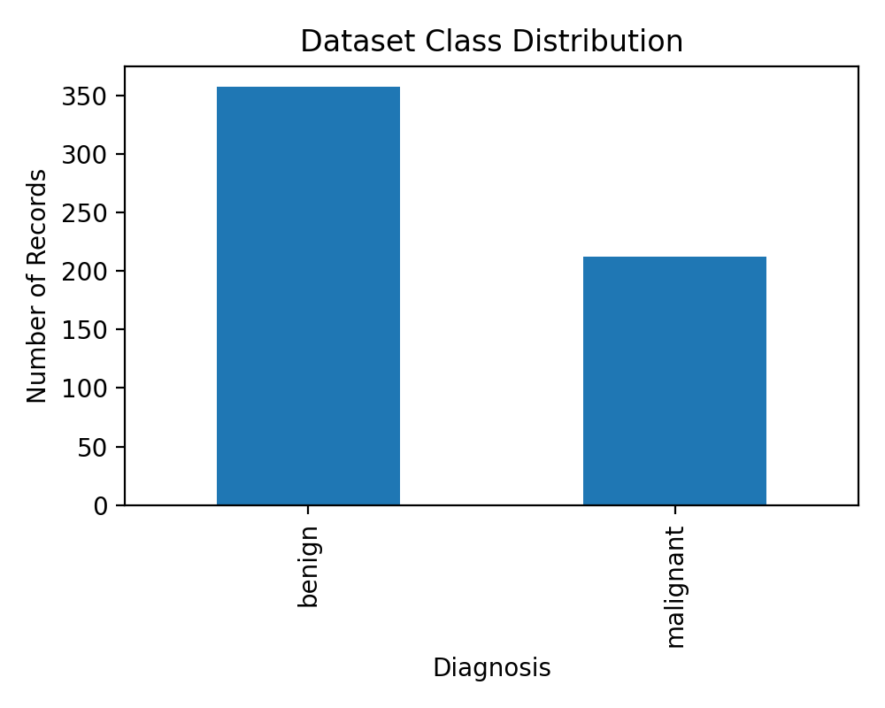
Figure 1: Class distribution of benign and malignant records.
Item | Value
Total records | 569
Input features | 30
Malignant cases | 212
Benign cases | 357
Training records | 398
Validation records | 85
Test records | 86

Data Preprocessing and Feature Engineering
The dataset already contains numerical features, so no text encoding was required. The preprocessing workflow included checking the data structure, separating input features from the target variable, encoding malignant as 1 and benign as 0, and applying stratified train-validation-test splitting. Stratification was important because it preserved the proportion of malignant and benign cases in each split.
For models that are sensitive to feature scale, such as Logistic Regression, Support Vector Machine, and K-Nearest Neighbors, StandardScaler was applied inside a pipeline. Tree-based models were trained without scaling because Decision Trees and Random Forests are not strongly affected by feature magnitude. Feature engineering was kept minimal to avoid introducing artificial complexity into the medical dataset.

Methodology and Model Selection
This project used supervised learning because the dataset has known diagnosis labels. Five models were implemented. Logistic Regression was used as a simple and interpretable baseline. Support Vector Machine was used because it performs well with medium-sized numerical datasets. K-Nearest Neighbors was included as a distance-based classifier. Decision Tree was used because of its interpretability, while Random Forest was included as an ensemble model that usually improves stability and reduces overfitting compared with a single tree.
The selected best model was based mainly on validation F1-score, while also considering recall for malignant cases. In a medical diagnosis setting, recall is very important because a false negative means a malignant case may be missed.

Experimental Design
The data was divided into three parts: 398 records for training, 85 records for validation, and 86 records for final testing. The training set was used to fit the models. The validation set was used to compare model performance and select the best model. The test set was kept separate and used only for final reporting.
This design is stronger than using only one train-test split because it prevents the test set from influencing model selection. The same random seed was used to make the experiment reproducible.

Evaluation Metrics
The metrics used were accuracy, precision, recall, F1-score, ROC-AUC, and confusion matrix. Accuracy measures overall correctness, but it is not enough for medical diagnosis. Precision measures how reliable malignant predictions are. Recall measures how many actual malignant cases were detected. F1-score balances precision and recall, making it useful when both false positives and false negatives matter. ROC-AUC measures the model’s ability to separate malignant and benign cases across possible thresholds.
For this project, recall and F1-score were treated as especially important because missing a malignant case can cause serious patient harm.

Results and Evaluation
Table 2 presents the validation and test performance of all models. The best validation model was the Support Vector Machine. It also performed very strongly on the unseen test data.
Model | Split | Accuracy | Precision | Recall | F1-score | ROC-AUC
Logistic Regression | Validation | 0.9647 | 1.0000 | 0.9062 | 0.9508 | 0.9959
Logistic Regression | Test | 0.9884 | 0.9697 | 1.0000 | 0.9846 | 0.9988
Support Vector Machine | Validation | 0.9765 | 0.9688 | 0.9688 | 0.9688 | 0.9959
Support Vector Machine | Test | 0.9884 | 1.0000 | 0.9688 | 0.9841 | 1.0000
K-Nearest Neighbors | Validation | 0.9647 | 1.0000 | 0.9062 | 0.9508 | 0.9779
K-Nearest Neighbors | Test | 0.9651 | 1.0000 | 0.9062 | 0.9508 | 0.9983
Decision Tree | Validation | 0.9059 | 0.9615 | 0.7812 | 0.8621 | 0.9080
Decision Tree | Test | 0.9186 | 1.0000 | 0.7812 | 0.8772 | 0.9928
Random Forest | Validation | 0.9529 | 1.0000 | 0.8750 | 0.9333 | 0.9947
Random Forest | Test | 0.9884 | 1.0000 | 0.9688 | 0.9841 | 0.9988
Table 2: Model comparison results.
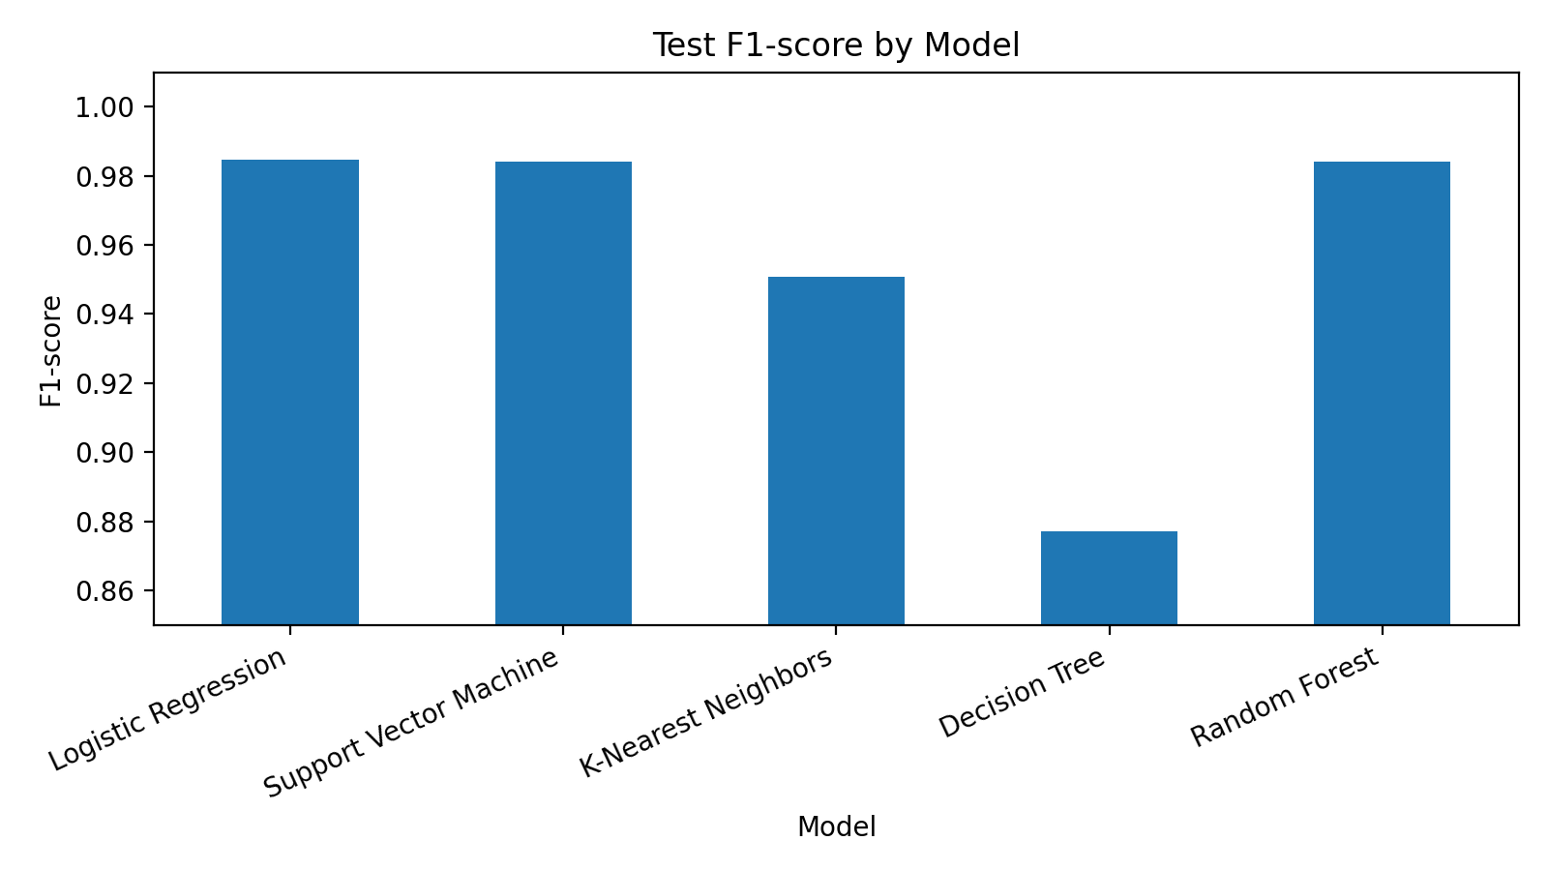
Figure 2: Test F1-score comparison across models.
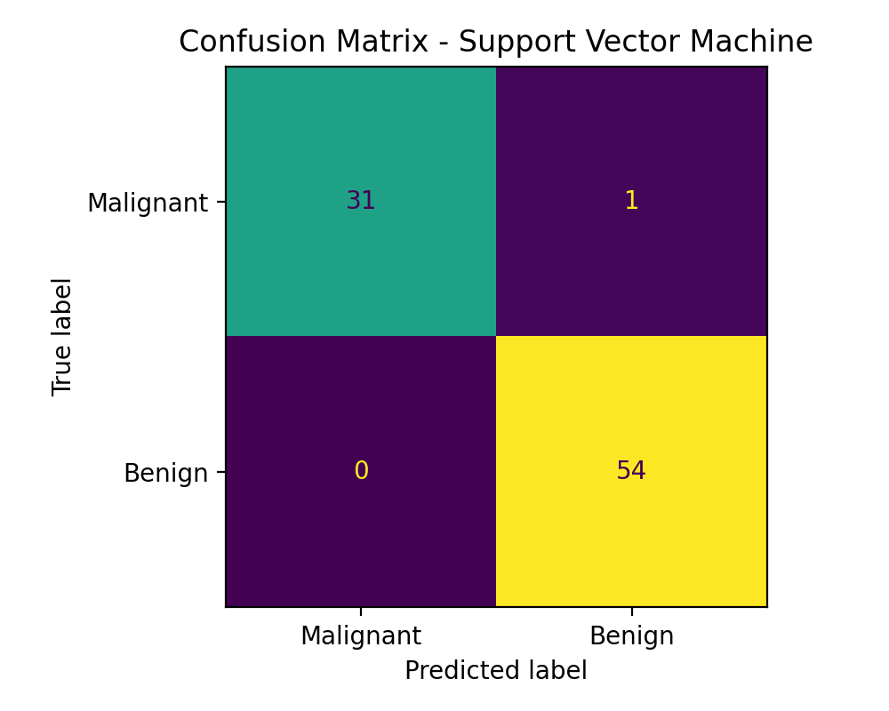
Figure 3: Confusion matrix of the selected best model.
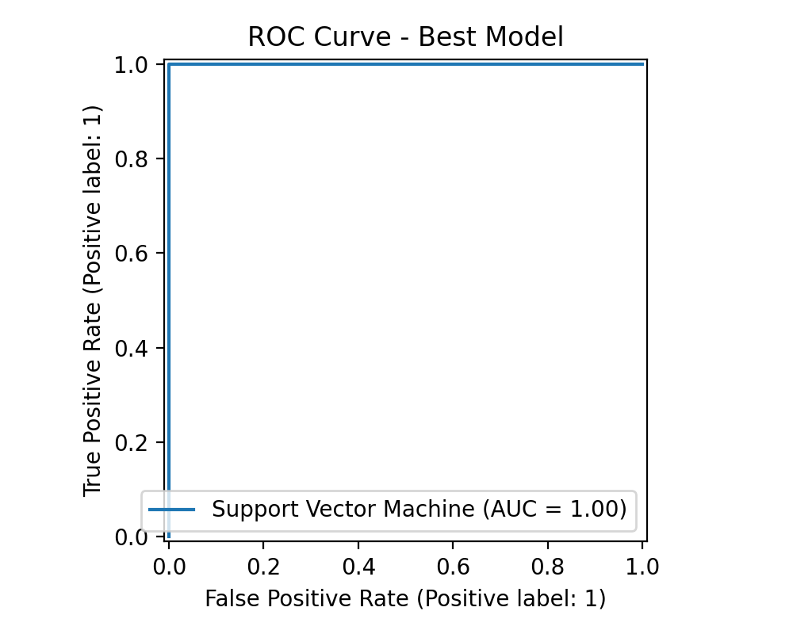
Figure 4: ROC curve of the selected best model.
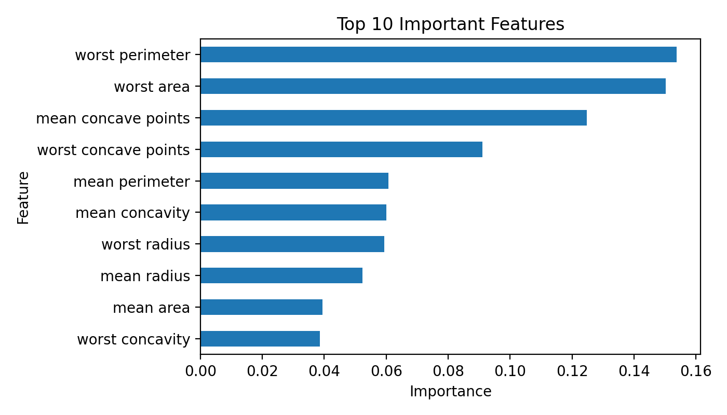
Figure 5: Top important diagnostic features used by the best model or reference model.

Comparative Analysis and Discussion
The Support Vector Machine was selected as the best model because it had the highest validation F1-score. On the test set, it correctly detected 31 out of 32 malignant cases and produced no benign cases wrongly classified as malignant in the positive-first confusion matrix. This means the model had very high precision and strong recall.
Logistic Regression also performed very well and has the advantage of being easier to explain. Random Forest also achieved high performance, but it is less transparent than Logistic Regression or a shallow Decision Tree. The Decision Tree had lower recall, showing that a single tree may miss more malignant cases if it is too simple or if its splits do not capture all important patterns.
In a real hospital context, the final choice would not be based only on the highest score. Clinicians may prefer a model that is both accurate and explainable. Therefore, the Support Vector Machine is recommended for predictive performance, while Logistic Regression may be useful as an interpretable benchmark.

Limitations, Biases, and Lessons Learned
The first limitation is that the dataset is relatively small, with only 569 records. A model trained on this dataset may not generalise perfectly to hospitals in Nigeria or to populations with different demographic and clinical characteristics. The second limitation is that the dataset contains numerical cell measurements, but not patient history, age, lifestyle, imaging context, or genetic risk factors. The third limitation is that the dataset is already clean, while real hospital data often contains missing values, inconsistent formats, and noise.
There are also ethical concerns. A false negative could delay cancer treatment, while a false positive could create fear and lead to unnecessary testing. The model should therefore be used only as a decision-support tool. Doctors should remain responsible for final diagnosis. The project also shows that good machine learning practice requires not only high accuracy, but careful validation, fairness checks, clinical oversight, and continuous monitoring.

Conclusion
This project successfully implemented an end-to-end supervised machine learning workflow for breast cancer diagnosis prediction. The workflow included dataset selection, preprocessing, model training, evaluation, comparison, interpretation, and ethical reflection. Among the five models tested, the Support Vector Machine produced the best validation performance and strong test results. The findings show that supervised machine learning can support medical diagnosis when properly validated, but deployment must be careful, transparent, and guided by healthcare professionals.

Future Work
Future work should include testing the model on larger and more diverse hospital datasets, especially datasets from African clinical settings. Additional patient-level features could be added, such as age, family history, imaging reports, and previous medical history. More advanced explainability tools such as SHAP or LIME could also be used to explain individual predictions. Finally, the model could be deployed as a secure clinical dashboard where doctors can review predictions, confidence scores, and explanations before making decisions.

References
UCI Machine Learning Repository. Breast Cancer Wisconsin Diagnostic Dataset.
Scikit-learn documentation. Breast cancer dataset and supervised learning models.
Pedregosa, F. et al. (2011). Scikit-learn: Machine Learning in Python. Journal of Machine Learning Research, 12, 2825-2830.

