Customer Shopping Behavior Analysis
End-to-End Data Analytics Portfolio Project
Tools: Python · SQL (PostgreSQL) · Power BI
1. Project Overview
This project simulates a corporate-grade, end-to-end data analytics workflow that mirrors the real responsibilities of professional data analysts in modern business environments. Starting from a raw retail customer dataset, the project covers every stage of the analytics lifecycle — from data preparation and exploratory analysis, through SQL-based business querying, to interactive dashboarding and executive reporting.
The project is designed as a portfolio piece suitable for Data Analyst, Data Science, and Product Analytics role interviews. It demonstrates proficiency across the three primary tools used in industry: Python, SQL, and Power BI.
Figure 1: End-to-End Project Workflow
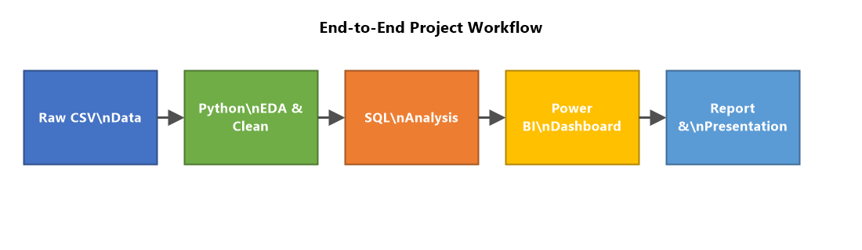
Figure 5: Key Findings at a Glance
2. Business Objectives
The core business questions this project answers include:
- • What is the revenue split between male and female customers?
- • Which customers used discounts yet still spent above average?
- • Which products carry the highest average review ratings?
- • Does shipping type (Standard vs. Express) influence average spend?
- • Do subscribed customers spend more in total and on average?
- • Which products have the highest discount application rates?
- • How can customers be segmented into New, Returning, and Loyal tiers?
- • What are the top 3 products within each category?
- • Are repeat buyers more likely to subscribe?
- • Which age groups contribute most to total revenue?
3. Dataset
Source file: customer_shopping_behavior.csv
The dataset contains retail transaction records with 18 attributes per customer. Each row represents a single purchase event.
Column Name | Type | Description
Customer ID | Integer | Unique customer identifier
Age | Integer | Customer age in years
Gender | String | Male / Female
Item Purchased | String | Name of the product bought
Category | String | Product category (e.g. Clothing, Footwear)
Purchase Amount (USD) | Integer | Transaction value in US dollars
Location | String | US state of the customer
Size | String | Product size (S / M / L / XL)
Color | String | Color of item purchased
Season | String | Season of purchase (Winter, Spring, Summer, Fall)
Review Rating | Float | Customer rating on a 1–5 scale
Subscription Status | String | Yes / No — whether customer has a subscription
Shipping Type | String | Shipping method chosen (Standard, Express, Free Shipping, etc.)
Discount Applied | String | Yes / No — whether a discount was applied
Promo Code Used | String | Yes / No — whether a promo code was redeemed
Previous Purchases | Integer | Number of prior transactions by the customer
Payment Method | String | Payment method used (Credit Card, PayPal, Venmo, Cash, etc.)
Frequency of Purchases | String | Purchase frequency (Weekly, Fortnightly, Monthly, etc.)
Age Group | String | Derived field — age bucket used in revenue segmentation queries
4. Project Workflow
4.1 Phase 1 — Data Preparation & EDA (Python)
Figure 2: Data Preparation Pipeline (Python Phase)
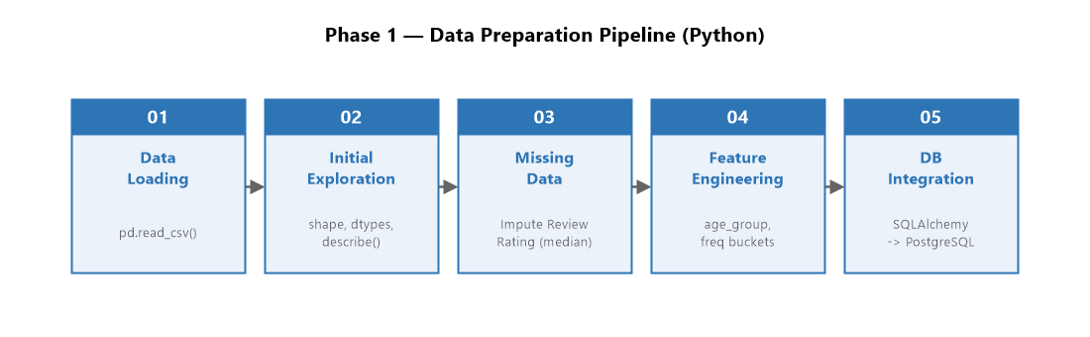
Notebook: AyshaPanda_Customer_Shopping_Behavior_Analysis.ipynb
The Python notebook performs the following steps:
- • Data Import — load customer_shopping_behavior.csv using pandas.
- • Data Exploration — inspect shape, dtypes, and summary statistics.
- • Data Cleaning — handle nulls, standardise column names, and derive new fields (e.g. age_group).
- • EDA Visualisations — distribution plots (matplotlib, seaborn) for age, spend, ratings, and seasonal trends.
- • Database Load — use SQLAlchemy + mysql-connector-python to push the cleaned DataFrame into a MySQL/PostgreSQL/MS SQL Server table named customer.
Key libraries: pandas, numpy, matplotlib, seaborn, sqlalchemy, mysql-connector-python, scikit-learn, openpyxl.
4.2 Phase 2 — Business Analysis (SQL)
Script: customer_behavior_sql_queries.sql
Ten business queries are executed against the customer table. Techniques used include:
- • Aggregate functions — SUM, AVG, COUNT, ROUND
- • Subqueries — filtering against a correlated average
- • CASE / WHEN — customer segmentation (New / Returning / Loyal)
Figure 3: Customer Segmentation Logic (SQL Query 7)
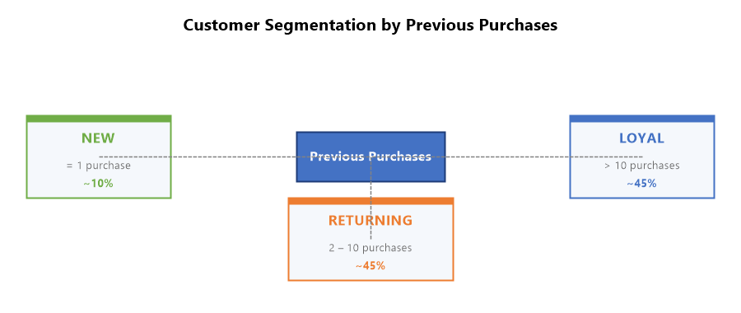
- • Common Table Expressions (CTEs) — multi-step logic isolation
- • Window functions — ROW_NUMBER() OVER (PARTITION BY ...) for ranked product analysis
- • GROUP BY / ORDER BY / LIMIT — summary rollups and top-N results
Figure 9: SQL Query Results Summary (All 10 Business Questions)
Figure 8: Seasonal Revenue & Top Products by Purchase Count
Figure 7: Customer Segmentation & Subscription Revenue Impact
Figure 6: Revenue by Gender & Shipping Type vs Average Spend
4.3 Phase 3 — Visualisation & Dashboard (Power BI)
File: customer_behavior_dashboard.pbix
The SQL database is connected directly to Power BI. An interactive dashboard is built to highlight:
- • Revenue breakdown by gender, age group, and season
- • Customer loyalty tier distribution
- • Top products by category and review rating
- • Subscription vs. non-subscription spend comparison
- • Discount usage patterns and their impact on revenue
4.4 Phase 4 — Reporting & Presentation
Files: Customer Shopping Behavior Analysis.pdf, Customer-Shopping-Behavior-Analysis.pptx, Business Problem Document.pdf
The final deliverables include a written report summarising findings and business recommendations, and a presentation deck built with Gamma AI for communication to non-technical stakeholders.
5. Repository Structure
File / Folder | Purpose
customer_shopping_behavior.csv | Raw source dataset (18 columns, retail transactions)
AyshaPanda_Customer_Shopping_Behavior_Analysis.ipynb | Python notebook — EDA, cleaning, and DB load
customer_behavior_sql_queries.sql | 10 business SQL queries (PostgreSQL dialect)
customer_behavior_dashboard.pbix | Power BI interactive dashboard file
Customer Shopping Behavior Analysis.pdf | Project report — findings and recommendations
Customer-Shopping-Behavior-Analysis.pptx | Stakeholder presentation deck
Business Problem Document.pdf | Problem statement and scope definition
requirements.txt | Python package dependencies
README.md | Project overview and setup instructions
LICENSE | MIT licence
6. Setup & Reproduction
Step 1 — Clone the repository
git clone https://github.com/amlanmohanty1/customer-trends-data-analysis-SQL-Python-PowerBI.git
Step 2 — Install Python dependencies
pip install -r requirements.txt
Step 3 — Run the Python notebook
Open AyshaPanda_Customer_Shopping_Behavior_Analysis.ipynb in Jupyter. Update the database connection string (SQLAlchemy) to point to your MySQL or PostgreSQL instance. Run all cells to clean the data and load it into the customer table.
Step 4 — Execute SQL queries
Open customer_behavior_sql_queries.sql in your SQL client (e.g. pgAdmin, DBeaver, or Azure Data Studio). Connect to the database where the customer table was loaded and run each query to answer the 10 business questions.
Step 5 — Open the Power BI dashboard
Open customer_behavior_dashboard.pbix in Power BI Desktop. Update the data source connection to your SQL database. Refresh the dataset to populate all visuals.
7. Key Technologies
Technology | Version / Stack | Role in Project
Python | 3.x | Data ingestion, EDA, cleaning, DB load
SQL | PostgreSQL dialect | Business querying and customer segmentation
Power BI | Desktop | Interactive dashboarding and reporting
Gamma AI | — | Automated presentation deck generation
Figure 4: Project Technology Stack
