IdentityVault
AI-Powered Digital Identity System for Students

Every student builds a digital footprint throughout their academic and professional journey — certificates, resumes, project reports, internship letters, portfolios, GitHub repositories, achievements, and learning records. Yet most of this information stays scattered across folders, emails, cloud drives, and devices, and becomes harder to locate, connect, and showcase as time passes. Traditional storage tools can save files, but they cannot understand a person's journey.
IdentityVault is not another cloud storage platform. It is an AI-powered Digital Identity System that transforms fragmented data into a structured, searchable, and intelligent knowledge repository — one that understands a student's growth, skills, and experiences, and makes them instantly accessible, while always preserving the original files and formats.

Overall Vision
The vision for IdentityVault is to give every student a single, intelligent home for their entire academic and professional journey. Instead of manually sorting files into folders, students upload freely — certificates, resumes, reports, portfolio links — and the system automatically understands, categorizes, and connects that information into a living digital identity.
This is not tied to a single institution or discipline; any student, from any college, stream, or career stage, can use it to build a knowledge repository that grows with them, from their first certification to their final placement portfolio.

Mission
The mission for the hackathon team is to build an AI-driven, user-centric application that turns scattered documents into a structured and explorable identity. The platform should provide students with intuitive tools to:
- Upload certificates, resumes, project reports, internship letters, and portfolio links in one place
- Have every upload automatically classified into meaningful categories (Projects, Skills, Certifications, Internships, Achievements, Academics)
- See how their skills, projects, certifications, and internships are connected to one another
- View a visual timeline of their growth from year to year
- Instantly retrieve any document or fact using natural-language search, without digging through folders

Problem Statement
Design and develop an AI-Powered Digital Identity System where a student can:
- Upload certificates, resumes, project reports, internship letters, portfolio links, and other academic or professional documents in their original formats
- Have the system automatically classify each upload into categories such as Projects, Skills, Certifications, Internships, Achievements, and Academics, without manual sorting
- Have an AI relationship engine connect related information across categories (e.g. Certification → Skill, Skill → Project, Project → Internship, Internship → Career Path)
- View an auto-generated Digital Journey Timeline showing growth and milestones by year
- Retrieve any document or fact instantly through natural-language search (e.g. "show all my certificates", "show my AI projects"), with the original file always accessible in its original format
The application must demonstrate a clean AI/ERP-style architecture, reusable ingestion and classification modules, secure account handling, and intuitive UI/UX, while correctly handling the relationships between documents, categories, skills, projects, and the timeline they build up.

Key Questions the System Must Answer
- 1. Intelligent Organization — Can the system automatically organize uploaded content without requiring manual sorting?
- 2. Knowledge Connections — Can the system identify and connect related information such as skills, projects, certifications, internships, and achievements?
- 3. Instant Retrieval — Can users retrieve any document or information instantly, without searching through multiple folders?

Features

1. Login / Signup Screen
Purpose: Authenticate users with a simple, secure student account.
- Signup creates a Student account (email & password, or Google OAuth)
- Forgot password flow and session validation
- Optional: institution/college field captured at signup for later filtering

2. Dashboard / Home Screen
Purpose: Give the student a real-time snapshot of their digital identity.
- Summary cards: Total Documents, Skills Identified, Certifications, Projects, Internships, Pending Uploads
- Recently added documents and recently detected connections
- Quick actions: Upload Document, Ask a Question, View Timeline

3. AI Data Ingestion Screen
Purpose: Let students upload any academic or professional document without worrying about sorting.
- Upload: Certificates, Resumes, Project Reports, Internship Letters, Portfolio Links (URL), other academic/professional documents
- Drag-and-drop and bulk upload support; supported formats: PDF, DOCX, images (JPG/PNG), and URLs
- Upload queue with processing status: Uploaded → Extracting → Classifying → Indexed
- OCR fallback automatically applied to scanned or image-based documents

4. Intelligent Categorization & Library Screen
Purpose: Automatically classify and let students browse everything centrally.
- Every document auto-tagged into a category: Projects, Skills, Certifications, Internships, Achievements, Academics
- Search/filter by category, year, keyword, or file type
- Manual override: student can re-tag a document if the AI misclassifies it (feeds back into the model)
- Per-document detail view: extracted metadata, detected entities, and linked original file

5. Relationship Engine / Knowledge Graph Screen
Purpose: Visualize how a student's skills, projects, and experiences connect.
- AI layer identifies relationships across data: Certification → Skill, Skill → Project, Project → Internship, Internship → Career Path
- Interactive graph view: click a node (e.g. a skill) to see every certificate, project, and internship linked to it
- Conflict/gap handling: highlights skills claimed on a resume with no supporting certificate or project evidence

6. Digital Journey Timeline Screen
Purpose: Generate a visual timeline of the student's growth and achievements.
- Auto-generated, year-by-year timeline (e.g. 2023 → Python Certification, 2024 → Data Science Club Lead, 2025 → Internship at XYZ, 2026 → AI/ML Project Portfolio)
- Milestones grouped by category with color coding; clicking a milestone opens the source document
- Exportable as an image or PDF for portfolios and interviews

7. Smart Retrieval / Search Screen
Purpose: Let students access any document instantly through natural language.
- Natural-language query bar (e.g. "show all my certificates", "show my AI projects", "show my latest resume")
- Semantic search across all documents (not just filename/keyword matching)
- Results link back to the original file in its original format for instant download/preview
- Conversational follow-ups (e.g. "which of these are from 2025?")

8. Skill & Career Insights / Reports Screen
Purpose: Give students actionable insight into their own profile.
- Skill frequency and strength summary (how often a skill is backed by projects/certificates)
- Gap analysis: skills mentioned but not evidenced, or evidenced but not on the resume
- Suggested career paths based on the connected skill/project/internship graph
- Exportable summary report (PDF)

9. Portfolio / Profile Sharing Screen
Purpose: Let students showcase a curated view of their identity.
- Auto-generated shareable portfolio page built from categorized documents and the timeline
- Toggle visibility per document/category before sharing a link
- Shareable link or exportable PDF portfolio for recruiters/interviews

10. Activity Logs & Notifications Screen
Purpose: Keep the student informed without digging for updates.
- Notification examples: Document Classified, New Relationship Detected, Timeline Updated, Skill Gap Flagged, Portfolio Viewed
- Full activity log of uploads, edits, re-tags, and searches

User Roles

Student (primary user)
- Uploads certificates, resumes, project reports, internship letters, and portfolio links
- Views auto-categorized documents, the relationship graph, and the growth timeline
- Searches and retrieves any document instantly using natural language
- Corrects mis-classifications and manages what appears on their shared portfolio

Institution / Mentor (optional secondary role)
- Views aggregated, anonymized insight into student skill trends (if the institution opts in)
- Can be granted read-only access to a specific student's shared portfolio

Admin (system)
- Manages categories/taxonomy, monitors ingestion pipeline health, and reviews flagged misclassifications
- Views system-wide analytics (documents processed, most common skills/categories)

Basic Workflow
- Student signs up and lands on an empty Dashboard.
- Student uploads a document (certificate, resume, report, or portfolio link) via the AI Data Ingestion screen.
- The system extracts text (with OCR where needed), classifies the document into a category, and generates embeddings for semantic search.
- The Relationship Engine links the new document to existing skills, projects, certifications, or internships where a connection is detected.
- The Digital Journey Timeline updates automatically with any new milestone.
- The student can search in natural language at any time and instantly retrieve the original file.
- The student reviews Skill & Career Insights and, when ready, publishes a curated Portfolio link.
- All activity — uploads, classifications, corrections, searches — is tracked through notifications and the activity log.

Recommended Tech Stack
The stack below is organized by architectural layer. It is chosen to comfortably support AI ingestion, classification, relationship extraction, semantic search, and a responsive UI within a hackathon timeline, while remaining production-viable afterward.

1. Frontend
Layer / Purpose | Recommended Technology | Why / Notes
Framework | React.js (Next.js) | Component-based UI, fast routing, good for SSR of shared portfolio pages
Styling | Tailwind CSS + shadcn/ui | Rapid, consistent styling; accessible pre-built components
State Management | Redux Toolkit or Zustand | Manages upload queue, auth state, and search/session state
Data Viz | Recharts / D3.js | Renders the Digital Journey Timeline and relationship graph
Graph Visualization | React Flow / Cytoscape.js | Interactive knowledge-graph view for skill/project connections
File Upload UX | react-dropzone | Drag-and-drop, multi-file upload with progress states

2. Backend / API
Layer / Purpose | Recommended Technology | Why / Notes
Primary API | FastAPI (Python) | First-class fit for AI/ML integration, async support, auto-generated docs
Alternative / Gateway | Node.js + Express | Optional lightweight gateway if splitting AI services from core CRUD
Auth | JWT + OAuth 2.0 (Google Sign-In) | Stateless auth; OAuth for frictionless student signup
Task Queue | Celery + Redis (or BullMQ if Node) | Runs ingestion/classification asynchronously so uploads don't block the UI

3. AI / NLP / Intelligence Layer
Layer / Purpose | Recommended Technology | Why / Notes
LLM Reasoning | Claude API / OpenAI GPT API | Document understanding, categorization reasoning, and Q&A over retrieved content
Embeddings | OpenAI text-embedding-3 or sentence-transformers | Converts document text into vectors for semantic search
Orchestration | LangChain or LlamaIndex | Chains extraction → classification → retrieval (RAG) workflows
Retrieval Pattern | RAG (Retrieval-Augmented Generation) | Grounds natural-language search and Q&A in the student's own uploaded documents
OCR | Tesseract OCR (open-source) or AWS Textract / Google Vision | Extracts text from scanned certificates and image-based documents
Named Entity / Skill Extraction | spaCy or LLM-based extraction prompts | Pulls out skills, dates, organizations, and roles from unstructured text

4. Data Storage
Layer / Purpose | Recommended Technology | Why / Notes
Relational DB | PostgreSQL | Stores users, document metadata, categories, timeline events, relationships
Vector Database | Pinecone, Qdrant, or Chroma | Stores embeddings for fast semantic/natural-language search
Graph Storage | Neo4j (or a graph-edges table in Postgres for MVP) | Stores skill/project/certification/internship relationships explicitly
File / Object Storage | AWS S3 (or Cloudinary / Firebase Storage) | Stores original files so they remain accessible in their original format
Cache | Redis | Caches frequent search results and dashboard aggregates

5. Infrastructure / DevOps
Layer / Purpose | Recommended Technology | Why / Notes
Containerization | Docker + Docker Compose | Consistent local/dev environment across services
CI/CD | GitHub Actions | Automated testing and deployment on push
Hosting (Frontend) | Vercel | Zero-config deploys for Next.js
Hosting (Backend/AI) | Render, Railway, or AWS (ECS/EC2) | Hosts FastAPI services and background workers
Monitoring | Sentry (errors) + basic logging (Loguru/Winston) | Tracks failures in the ingestion/classification pipeline

6. Supporting Tools
Layer / Purpose | Recommended Technology | Why / Notes
Notifications | WebSockets (Socket.IO) + SendGrid (email) | Real-time in-app alerts and email notifications
Diagrams / Docs | Mermaid.js / Excalidraw | Architecture and workflow diagrams for deliverables
Testing | Pytest (backend), Jest + React Testing Library (frontend) | Unit/integration coverage for classification and UI logic

MVP note: for a hackathon timeline, Chroma (embedded, no external service) and a Postgres relationship table can substitute for a dedicated vector DB and graph DB respectively, with a migration path to Pinecone/Neo4j once the core flows are proven.

AI Workflow / Architecture Diagram
The diagram below traces a document from upload through AI processing, storage, and back out to the student through search, timeline, and portfolio views.
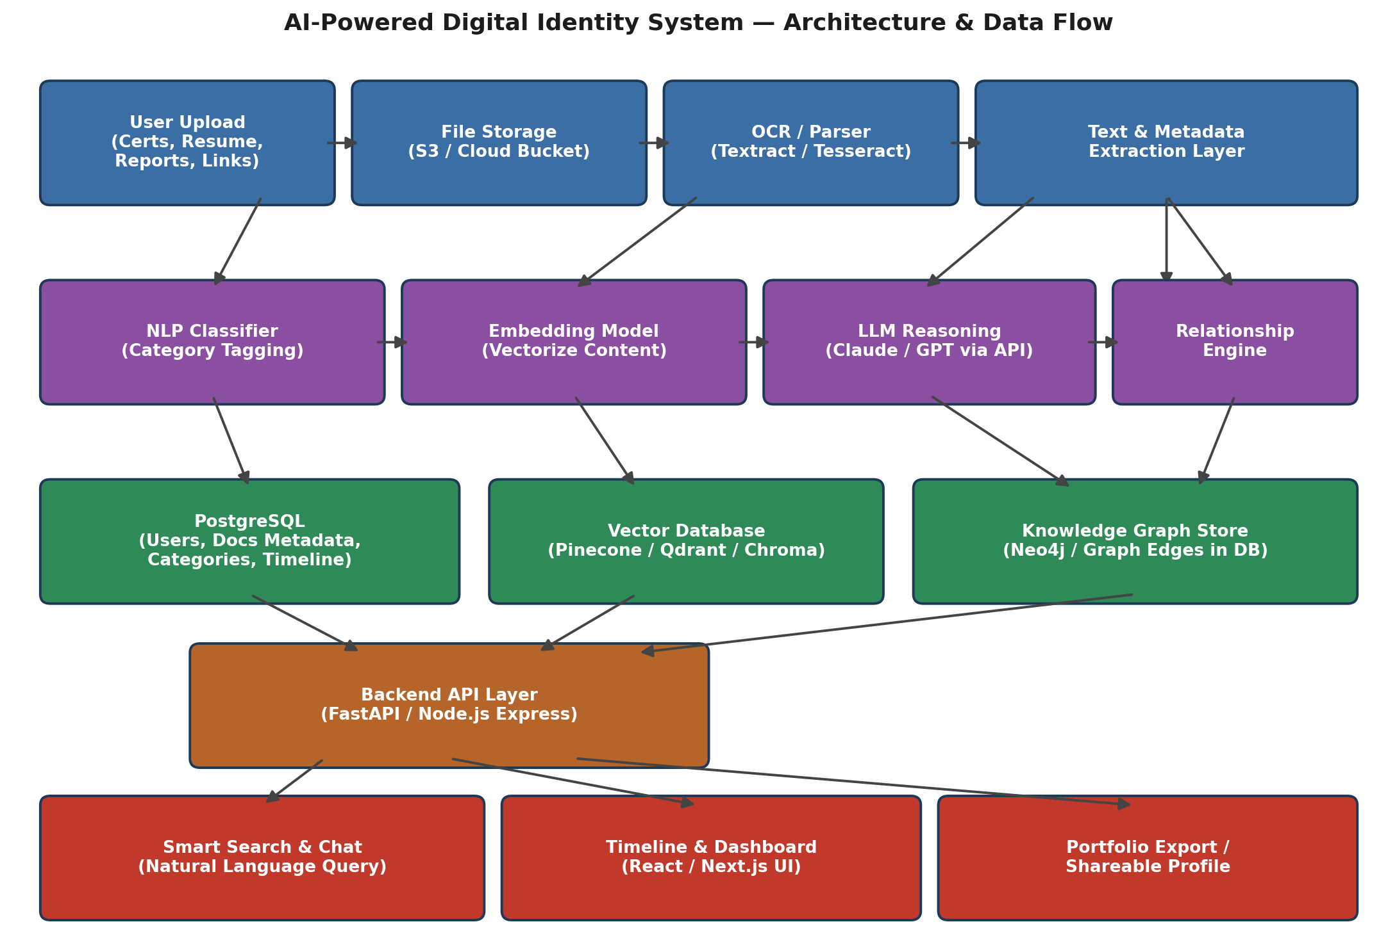

Deliverables
- Working prototype or demo video
- GitHub repository with README
- AI workflow / architecture diagram (see above)
- Thought process sheet
- All four items submitted to the Wooble portfolio for evaluation

What Reviewers Might Look For
- NLP (classification, entity/skill extraction)
- RAG (retrieval-augmented generation for search and Q&A)
- Embeddings (semantic representation of documents)
- Vector Databases (fast similarity search at scale)
- Semantic Search (natural-language retrieval, not just keyword matching)

