H1B VISA CASE STUDY

BIG DATA - HADOOP

AYSHWARYA MUTHURAMAN |Professional Diploma in Digital Transformation – Big Data with Hadoop |

0901.2018

Tools : Apache Hadoop Framework – HDFS, MapReduce, Hive, Pig, Sqoop, MySql and MS Excel for Data Visualization

S180030100261

NIIT

H1B visa Data set Analysis

A PROJECT REPORT

Submitted by

AYSHWARYA MUTHURAMAN

in the partial fulfillment for the award of the course
of

PROFESSIONAL DIPLOMA

in

BIG DATA WITH HADOOP

NIIT, CHENNAI

JANUARY 2018

ACKNOWLEDGEMENT

I find immense pleasure to convey my sincere and grateful thanks to NIIT and the management for providing necessary facilities in carrying out this project.
I greatly indebted to my Tech Mentor Ms. Amirtha, the batch instructor Mr. Annu and the SLT faculty Mr. Sandeep for constant support throughout the course and also for useful suggestions, constant encouragement and kind advice in bringing out this project as a success.
I express my regards and sincere thanks to Mr.Oliver for providing all necessary resource to complete the project. I extend my thanks to all staff members of NIIT for their kind co-operation for the completion of the project successfully. I am grateful to thank my family and all my friends for their valuable feedback, encouragement and suggestions.

BIG DATA
Big data is a term that describes the large volume of data – both structured and unstructured – that inundates a business on a day-to-day basis.The data sets are so voluminous and complex that traditional data processing application software are inadequate to deal with them.

Some of the exciting facts about Big Data are-
- As per Forbes by the year 2020 approximately 1.7 megabytes of information will be generated each second.
- The Hadoop market is expected to cross $ 1 billion by 2020 with a compound growth rate of 58%.
- However lesser than 0.5% of the data is analyzed at the moment.
This clearly specifies the kind of potential the field of Big Data has. After learning these facts you must be curious to know about Big Data. Let’s know the applications of big data briefly –
Areas | Big Data applications
Targeting customers | Big Data helps understanding customers and target them in personalized fashion.
Science and Research | Big Data helps make machines smarter. For example, Google’s Self-driving cars
Security | Big Data is used to keep track of the terrorists and anti-national agencies
Finance | Big Data algorithms are used to analyze market and trading opportunities

5Vs of Big Data
Volume refers to the vast amounts of data generated every second. This increasingly makes data sets too large to store and analyse using traditional database technology. With big data technology we can now store and use these data sets with the help of distributed systems, where parts of the data is stored in different locations and brought together by software.
Velocity refers to the speed at which new data is generated and the speed at which data moves around. Big data technology allows us now to analyse the data while it is being generated, without ever putting it into databases.
Variety refers to the different types of data we can now use. With big data technology we can now harness differed types of data (structured and unstructured) including messages, social media conversations, photos, sensor data, video or voice recordings and bring them together with more traditional, structured data.
Veracity refers to the messiness or trustworthiness of the data. With many forms of big data, quality and accuracy are less but big data and analytics technology now allows us to work with these type of data. The volumes often make up for the lack of quality or accuracy.
Value: It is all well and good having access to big data but unless we can turn it into value it is useless. It is important that businesses make a business case for any attempt to collect and leverage big data. It is so easy to fall into the buzz trap and embark on big data initiatives without a clear understanding of costs and benefits.
APACHE HADOOP
Hadoop is an open source framework from Apache and is used to store process and analyze data which are very huge in volume. Hadoop is written in Java and is not OLAP (online analytical processing). It is used for batch/offline processing.It is being used by Facebook, Yahoo, Google, Twitter, LinkedIn and many more. Moreover it can be scaled up just by adding nodes in the cluster.

HADOOP ECOSYSTEM
Hadoop Distributed File System (HDFS)
It is the most important component of Hadoop Ecosystem. HDFS is the primary storage system of Hadoop. Hadoop distributed file system (HDFS) is a java based file system that provides scalable, fault tolerance, reliable and cost efficient data storage for Big data. HDFS is a distributed file system that runs on commodity hardware. HDFS is already configured with default configuration for many installations. Most of the time for large clusters configuration is needed. Hadoop interact directly with HDFS by shell-like commands.
Map Reduce
Hadoop Map Reduce is the core component of Hadoop which provides data processing. MapReduce is a software framework for easily writing applications that process the vast amount of structured and unstructured data stored in the Hadoop Distributed File system. MapReduce programs are parallel in nature, thus are very useful for performing large-scale data analysis using multiple machines in the cluster. Thus, it improves the speed and reliability of cluster this parallel processing.
YARN
Hadoop YARN (Yet Another Resource Negotiator) provides the resource management. YARN is called as the operating system of Hadoop as it is responsible for managing and monitoring workloads. It allows multiple data processing engines such as real-time streaming and batch processing to handle data stored on a single platform.
YARN has been projected as a data operating system for Hadoop2. Main features of YARN are:
- Flexibility– Enables other purpose-built data processing models beyond MapReduce (batch), such as interactive and streaming.
- Shared – Provides a stable, reliable, secure foundation and shared operational services across multiple workloads
- Efficiency – As many applications run on the same cluster, Hence, efficiency of Hadoop increases without much effect on quality of service.
HIVE
Apache Hive is an open source data warehouse system for querying and analyzing large datasets stored in Hadoop files. Hive do three main functions: data summarization, query, and analysis.Hive use language called HiveQL (HQL), which is similar to SQL. HiveQL automatically translates SQL-like queries into MapReduce jobs which will execute on Hadoop.
PIG
Apache Pig is a high-level language platform for analyzing and querying huge dataset that are stored in HDFS. Pig uses PigLatin language. It is very similar to SQL. It loads the data, applies the required filters and dumps the data in the required format. For Programs execution, pig requires Java runtime environment.
Features of Apache Pig:
- Extensibility – For carrying out special purpose processing, users can create their own function.
- Optimization opportunities – Pig allows the system to optimize automatic execution. This allows the user to pay attention to semantics instead of efficiency.
- Handles all kinds of data – Pig analyzes both structured as well as unstructured.

HBase
Apache HBase is distributed database that was designed to store structured data in tables that could have billions of row and millions of columns. HBase is scalable, distributed, and Nosql database that is built on top of HDFS. HBase, provide real time access to read or write data in HDFS.

HCatalog
It is a table and storage management layer for Hadoop. HCatalog supports different components available in Hadoop like MapReduce, Hive, and Pig to easily read and write data from the cluster. HCatalog is a key component of Hive that enables the user to store their data in any format and structure. By default, HCatalog supports RCFile, CSV, JSON, sequenceFile and ORC file formats

AVRO
It is a most popular Data serialization system. Avro is an open source project that provides data serialization and data exchange services for Hadoop. These services can be used together or independently. Big data can exchange programs written in different languages using Avro.
Using serialization service programs can serialize data into files or messages. It stores data definition and data together in one message or file making it easy for programs to dynamically understand information stored in Avro file or message.

Thrift
It is a software framework for scalable cross-language services development. Thrift is an interface definition language for RPC(Remote procedure call) communication. Hadoop does a lot of RPC calls so there is a possibility of using Apache Thrift for performance or other reasons.

Apache Drill
The main purpose of the drill is large-scale data processing including structured and semi-structured data. It is a low latency distributed query engine that is designed to scale to several thousands of nodes and query petabytes of data. The drill is the first distributed SQL query engine that has a schema-free model.

Apache Mahout
Mahout is open source framework for creating scalable machine learning algorithm and data mining library. Once data is stored in Hadoop HDFS, mahout provides the data science tools to automatically find meaningful patterns in those big data sets.

Apache Sqoop
Sqoop imports data from external sources into related Hadoop components like HDFS, Hbase or Hive. It also exports data from Hadoop to other external sources. Sqoop works with relational databases such as teradata, Netezza, oracle, MySQL.

Apache Flume
Flume efficiently collects, aggregate and moves a large amount of data from its origin and sending it back to HDFS. It is fault tolerant and reliable mechanism. Flume allows the data flow from the source into Hadoop environment. It uses a simple extensible data model that allows for the online analytic application. Using Flume, we can get the data from multiple servers immediately into hadoop.
Zookeeper
Apache Zookeeper is a centralized service for maintaining configuration information, naming, providing distributed synchronization, and providing group services. Zookeeper manages and coordinates a large cluster of machines.
Features of Zookeeper:
- Fast – Zookeeper is fast with workloads where reads to data are more common than writes. The ideal read/write ratio is 10:1.
- Ordered – Zookeeper maintains a record of all transactions.
Oozie
It is a workflow scheduler system for managing apache Hadoop jobs. Oozie combines multiple jobs sequentially into one logical unit of work. Oozie framework is fully integrated with apache Hadoop stack, YARN as an architecture center and supports Hadoop jobs for apache MapReduce, Pig, Hive, and Sqoop.
In Oozie, users can create Directed Acyclic Graph of workflow, which can run in parallel and sequentially in Hadoop. Oozie is scalable and can manage timely execution of thousands of workflow in a Hadoop cluster. Oozie is very much flexible as well. One can easily start, stop, suspend and rerun jobs. It is even possible to skip a specific failed node or rerun it in Oozie.
There are two basic types of Oozie jobs:
- Oozie workflow – It is to store and run workflows composed of Hadoop jobs e.g., MapReduce, pig, Hive.
- Oozie Coordinator – It runs workflow jobs based on predefined schedules and availability of data.
PROJECT: H1B CASE STUDY
The H1B is an employment-based, non-immigrant visa category for temporary foreign workers in the United States. For a foreign national to apply for H1B visa, an US employer must offer a job and petition for H1B visa with the US immigration department. This is the most common visa status applied for and held by international students once they complete college/ higher education (Masters, Ph.D.) and work in a full-time position.

The dataset has nearly 3 million records.

The dataset description is as follows:
The columns in the dataset include:
- CASE_STATUS: Status associated with the last significant event or decision. Valid values include “Certified,” “Certified-Withdrawn,” Denied,” and “Withdrawn”.

Certified: Employer filed the LCA, which was approved by DOL
Certified Withdrawn: LCA was approved but later withdrawn by employer
Withdrawn: LCA was withdrawn by employer before approval
Denied: LCA was denied by DOL

- EMPLOYER_NAME: Name of employer submitting labour condition application.
- SOC_NAME: the Occupational name associated with the SOC_CODE. SOC_CODE is the occupational code associated with the job being requested for temporary labour condition, as classified by the Standard Occupational Classification (SOC) System.

- JOB_TITLE: Title of the job
- FULL_TIME_POSITION: Y = Full Time Position; N = Part Time Position
- PREVAILING_WAGE: Prevailing Wage for the job being requested for temporary labour condition. The wage is listed at annual scale in USD. The prevailing wage for a job position is defined as the average wage paid to similarly employed workers in the requested occupation in the area of intended employment. The prevailing wage is based on the employer’s minimum requirements for the position.
- YEAR: Year in which the H1B visa petition was filed
- WORKSITE: City and State information of the foreign worker’s intended area of employment
- lon: longitude of the Worksite
- lat: latitude of the Worksite

We will be performing analysis on4 the H1B visa applicants between the years 2011-2016. After analyzing the data, we can derive the following facts.

1a) Is the number of petitions with Data Engineer job title increasing over time?

This is analysed using HIVE.
QUERY : select year,COUNT(job_title) from h1b_final where job_title=="DATA ENGINEER" group by year order by year;
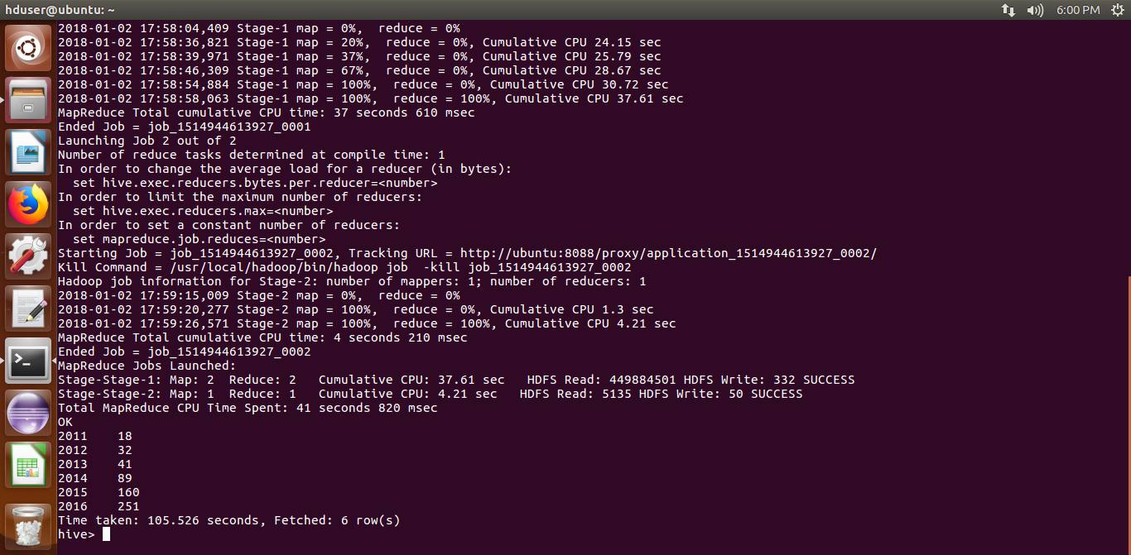
OUTPUT SCREEN SHOT:

1b)Find top 5 job titles who are having highest avg growth in application

This is analyzed using Pig.
CODE:
--Find top 5 job titles who are having highest avg growth in applications.
data = LOAD '/niit/h1b' USING PigStorage('\t') AS ( s_no:int, case_status:chararray,employer_name:chararray, soc_name:chararray, jobtitle:chararray, full_time_position:chararray, wage:long, year:chararray, worksite:chararray, longitude:long, latitude:long );
--dump data;
data = foreach data generate $4 as job, $7 as year;
--dump data;
dat = filter data by year=='2011';
a = group dat by job;
--dump a;
b1 = foreach a generate group as job, (float)COUNT(dat.job) as c1;
--dump b1;
dat = filter data by year=='2012';
a = group dat by job;
--dump a;
b2 = foreach a generate group as job, (float)COUNT(dat.job) as c2;
--dump b2;
dat = filter data by year=='2013';
a = group dat by job;
--dump a;
b3 = foreach a generate group as job, (float)COUNT(dat.job) as c3;
--dump b3;
dat = filter data by year=='2014';
a = group dat by job;
--dump a;
b4 = foreach a generate group as job, (float)COUNT(dat.job) as c4;
--dump b4;
dat = filter data by year=='2015';
a = group dat by job;
--dump a;
b5 = foreach a generate group as job, (float)COUNT(dat.job) as c5;
--dump b5;
dat = filter data by year=='2016';
a = group dat by job;
--dump a;
b6 = foreach a generate group as job, (float)COUNT(dat.job) as c6;
--dump b6;
c = join b1 by $0, b2 by $0;
c = foreach c generate $0, $1 as a11, $3 as a12;
--dump c;
d1 = foreach c generate $0, (a12-a11)/a11 *100 as growth;
--dump d1;
c = join b2 by $0, b3 by $0;
c = foreach c generate $0, $1 as a12, $3 as a13;
--dump c;
d2 = foreach c generate $0, (a13-a12)/a12 *100 as growth;
--dump d2;
c = join b3 by $0, b4 by $0;
c = foreach c generate $0, $1 as a13, $3 as a14;
--dump c;
d3 = foreach c generate $0, (a14-a13)/a13 *100 as growth;
--dump d3;
c = join b4 by $0, b5 by $0;
c = foreach c generate $0, $1 as a14, $3 as a15;
--dump c;
d4 = foreach c generate $0, (a15-a14)/a14 *100 as growth;
--dump d4;
c = join b5 by $0, b6 by $0;
c = foreach c generate $0, $1 as a15, $3 as a16;
--dump c;
d5 = foreach c generate $0, (a16-a15)/a15 *100 as growth;
--dump d1;
final = join d1 by $0, d2 by $0, d3 by $0, d4 by $0, d5 by $0;
final = foreach final generate $0,$1,$3,$5,$7,$9;
--dump final;

final1 = foreach final generate $0, ($1+$2+$3+$4+$5)/5 as avg;
--dump final1;

e = limit( order final1 by avg desc) 5;
dump e;

OUTPUT SCREEN SHOT:
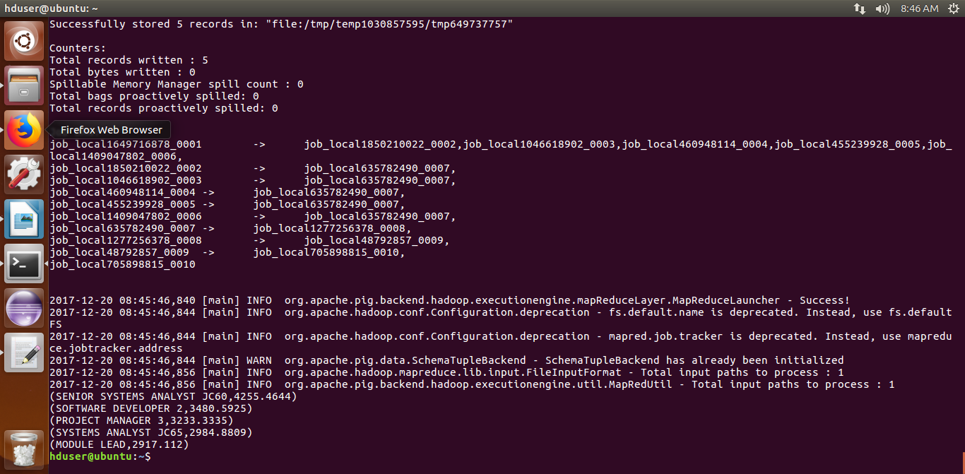
2a)Which part of the US has the most Data Engineer jobs for each year?

This is analyzed using Map Reduce.

CODE:

import java.io.*;
import java.util.TreeMap;

import org.apache.hadoop.io.NullWritable;
import org.apache.hadoop.io.Text;
import org.apache.hadoop.io.LongWritable;
import org.apache.hadoop.mapreduce.Job;
import org.apache.hadoop.mapreduce.Mapper;
import org.apache.hadoop.mapreduce.Partitioner;
import org.apache.hadoop.mapreduce.Reducer;
import org.apache.hadoop.conf.*;
import org.apache.hadoop.fs.*;
import org.apache.hadoop.mapreduce.Reducer.Context;
import org.apache.hadoop.mapreduce.lib.input.*;
import org.apache.hadoop.mapreduce.lib.output.*;
import org.apache.hadoop.io.NullWritable;

public class Proj2a
{

public static class MapClass extends Mapper<LongWritable,Text,Text,Text>
{
public void map(LongWritable key, Text value, Context context)
{
try{
String[] str = value.toString().split("\t");
if(str[4].equals("DATA ENGINEER"))
{

//String jobandyear = str[4]+","+str[7];
//worksite and year
context.write(new Text(str[8]),new Text(str[7]));
}}
catch(Exception e)
{
System.out.println(e.getMessage());
}
}
}
public static class CaderPartitioner extends
Partitioner < Text, Text >
{
public int getPartition(Text key, Text value, int numReduceTasks)
{
String[] str = value.toString().split(",");
int year = Integer.parseInt(str[0]);

if(year==2011)
{
return 0 % numReduceTasks;
}
else if(year==2012)
{
return 1 % numReduceTasks ;
}
else if(year==2013)
{
return 2 % numReduceTasks ;
}
else if(year==2014)
{
return 3 % numReduceTasks ;
}
else if(year==2015)
{
return 4 % numReduceTasks ;
}
else
{
return 5 % numReduceTasks;
}
}
}

public static class ReduceClass extends Reducer<Text,Text,NullWritable,Text>
{
private LongWritable result = new LongWritable();
private TreeMap<Long,Text> repToRecordMap = new TreeMap<Long,Text>();
public void reduce(Text key, Iterable<Text> values,Context context) throws IOException, InterruptedException {
long count=0;
String xx="";
String aa="";

for (Text val : values)
{//String[] str = val.toString().split(",");
//String job = str[0];
//if(job=="DATA ENGINEER")
//{
count++;
aa= val.toString();
//}
//key=new Text(job);
}

//result.set(count);
xx= key.toString();
//aa=values.toString();
xx= xx + ','+count+','+aa;
repToRecordMap.put(new Long(count), new Text(xx));
//repToRecordMap.put(key,result);
if (repToRecordMap.size() > 1) {
repToRecordMap.remove(repToRecordMap.firstKey()); //to remove 1st elements
//repToRecordMap.remove(repToRecordMap.lastKey()); To remove last elements
}
//context.write(key, result);
//context.write(key, new LongWritable(sum));

}
protected void cleanup(Context context) throws IOException,
InterruptedException {
for (Text t : repToRecordMap.descendingMap().values()) {
// Output our five records to the file system with a null key
context.write(NullWritable.get(), t);
}
}
}
public static void main(String[] args) throws Exception {
Configuration conf = new Configuration();
//conf.set("name", "value")
//conf.set("mapreduce.input.fileinputformat.split.minsize", "134217728");
Job job = Job.getInstance(conf, "Volume Count");
job.setJarByClass(Proj2a.class);
job.setMapperClass(MapClass.class);
//job.setCombinerClass(ReduceClass.class);
job.setPartitionerClass(CaderPartitioner.class);
job.setReducerClass(ReduceClass.class);
job.setNumReduceTasks(6);

job.setMapOutputKeyClass(Text.class);
job.setMapOutputValueClass(Text.class);
job.setOutputKeyClass(Text.class);
job.setOutputValueClass(LongWritable.class);
FileInputFormat.addInputPath(job, new Path(args[0]));
FileOutputFormat.setOutputPath(job, new Path(args[1]));
System.exit(job.waitForCompletion(true) ? 0 : 1);
}
}

OUTPUT SCREEN SHOT:
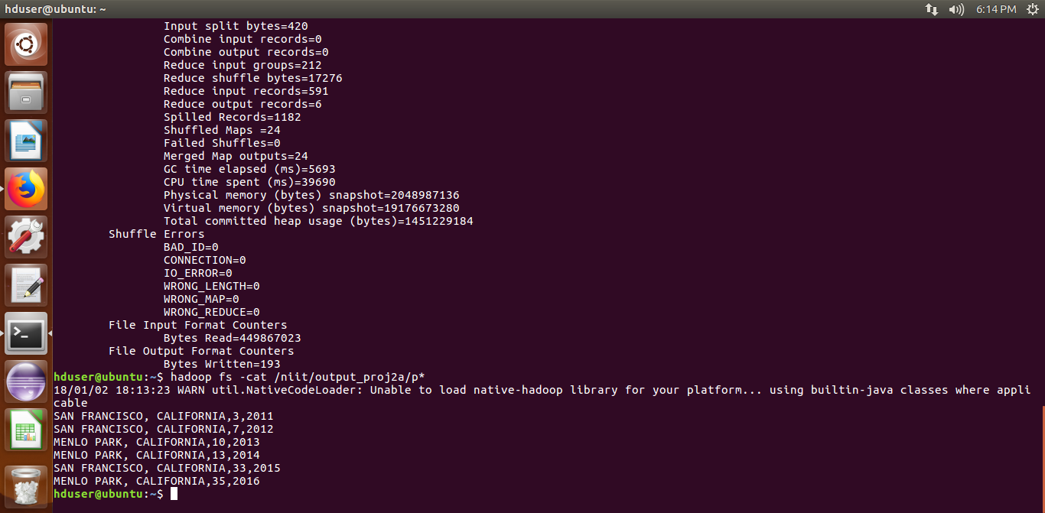

2b)find top 5 locations in the US who have got certified visa for each year

This is analyzed using Hive.

QUERY: select worksite,count(case_status) as c,year from retail.h1b_final where case_status='CERTIFIED' and year==$y group by worksite,year order by c desc limit 5;

OUTPUT SCREEN SHOT:

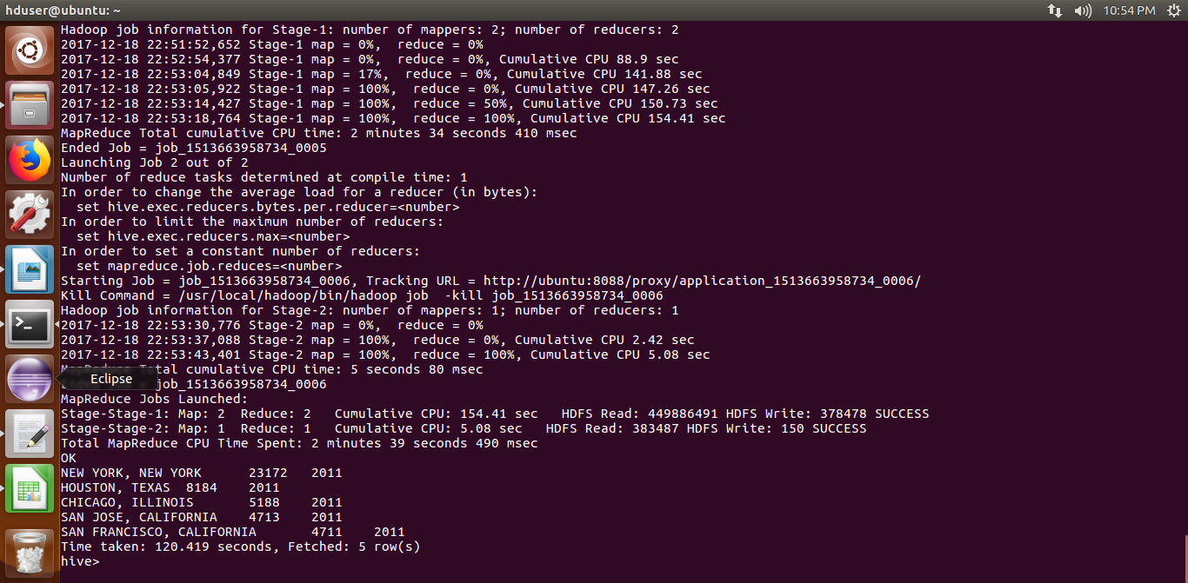

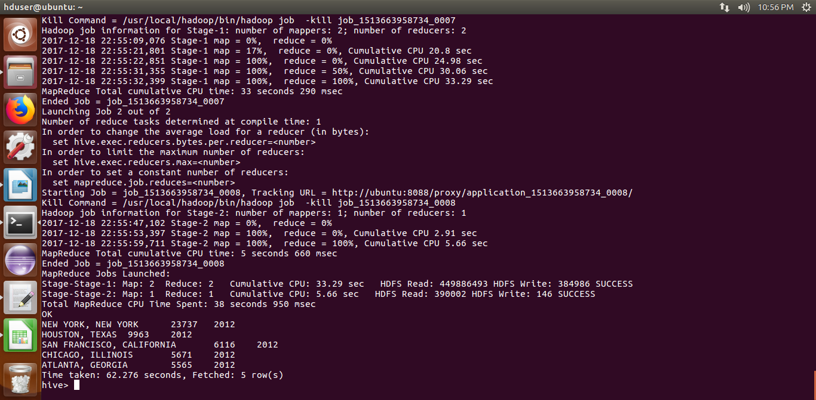

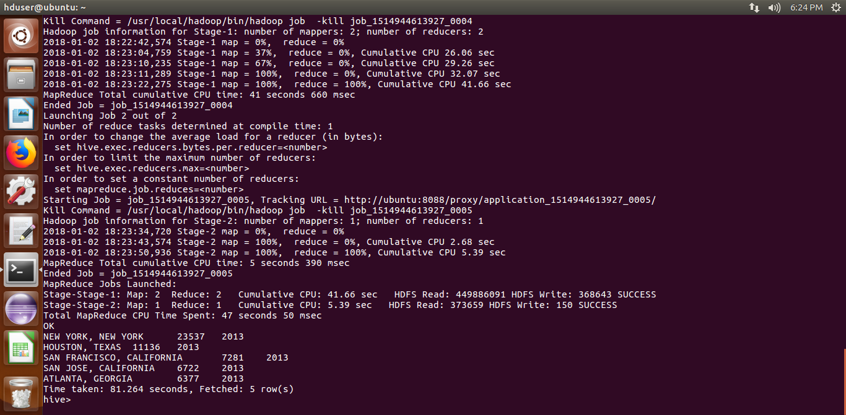

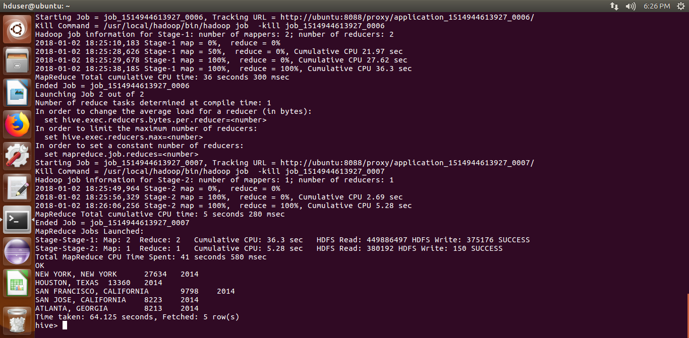

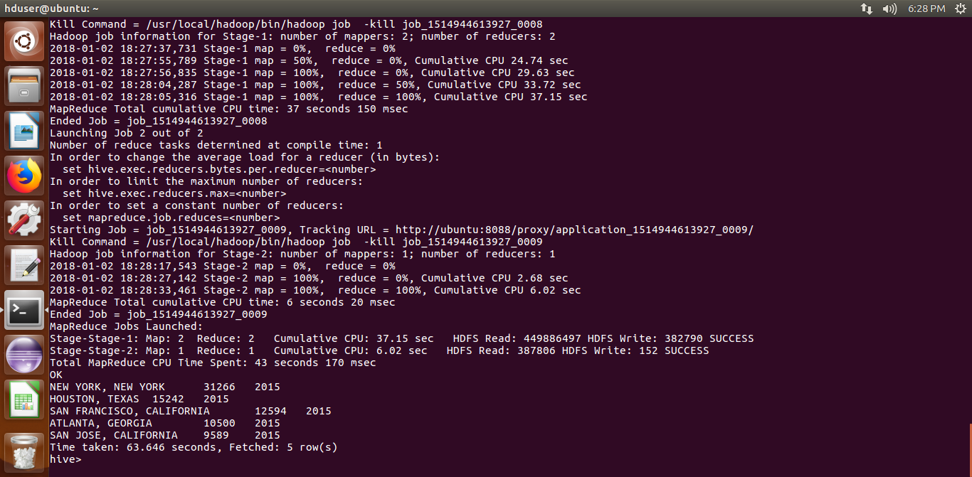

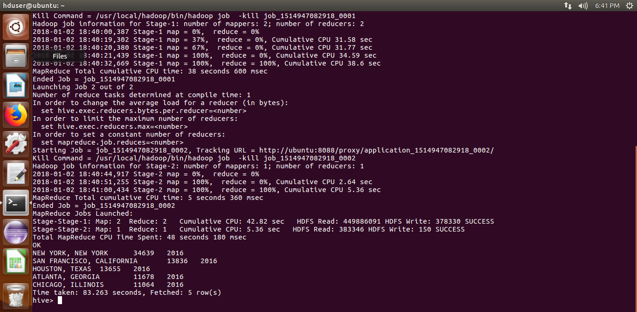

3)Which industry(SOC_NAME) has the most number of Data Scientist positions?

This is analysed using Hive

QUERY:select soc_name,COUNT(job_title) as c from retail.h1b_final where case_status='CERTIFIED' and job_title='DATA SCIENTIST' group by soc_name order by c desc limit 1;
OUTPUT SCREEN SHOT:
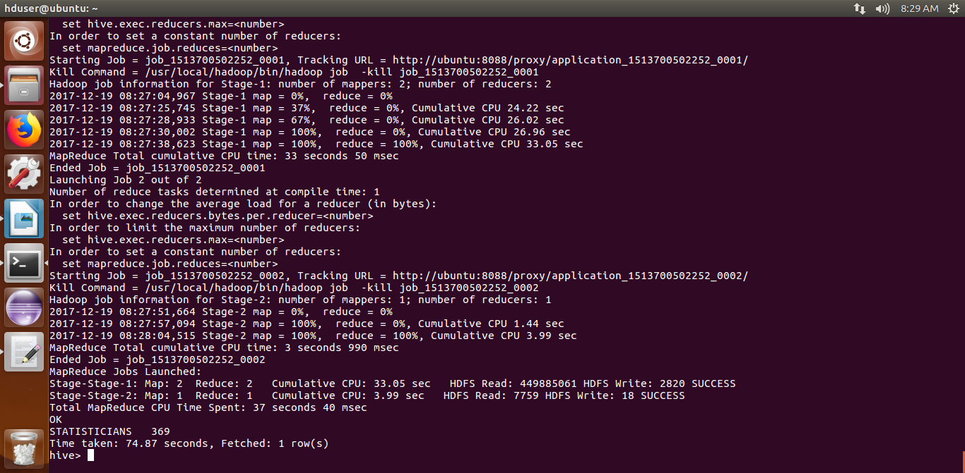
4)Which top 5 employers file the most petitions each year?
This is analyzed using Hive.

QUERY:select employer_name,COUNT(case_status) as ca,year from retail.h1b_final where year==$y group by employer_name,year order by ca desc limit 5;

OUTPUT SCREEN SHOT:

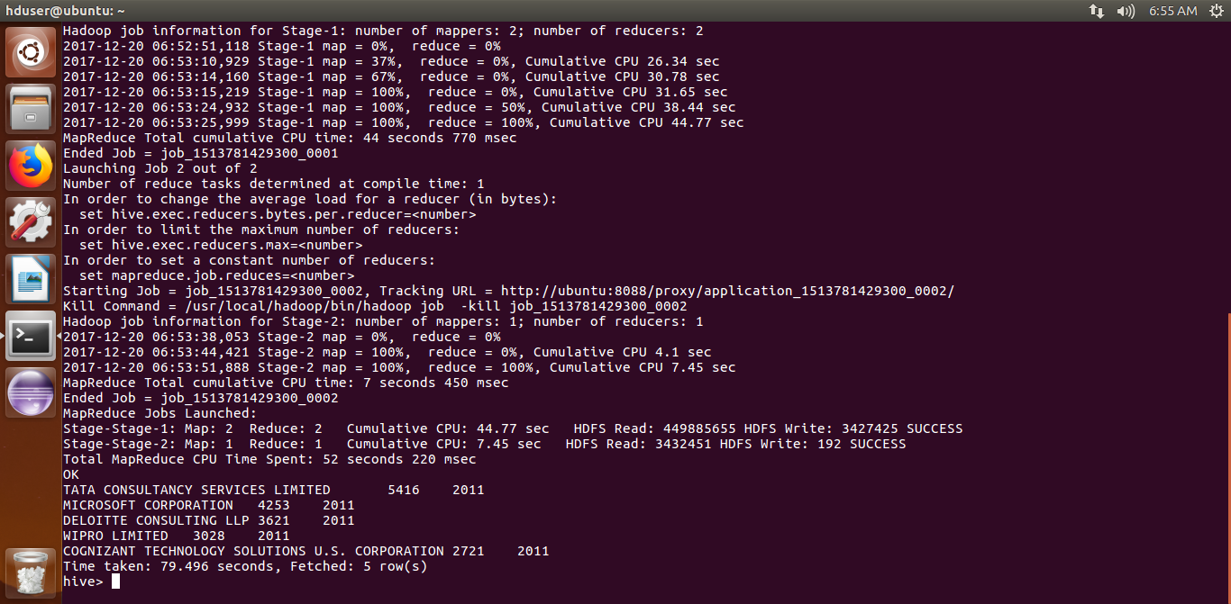

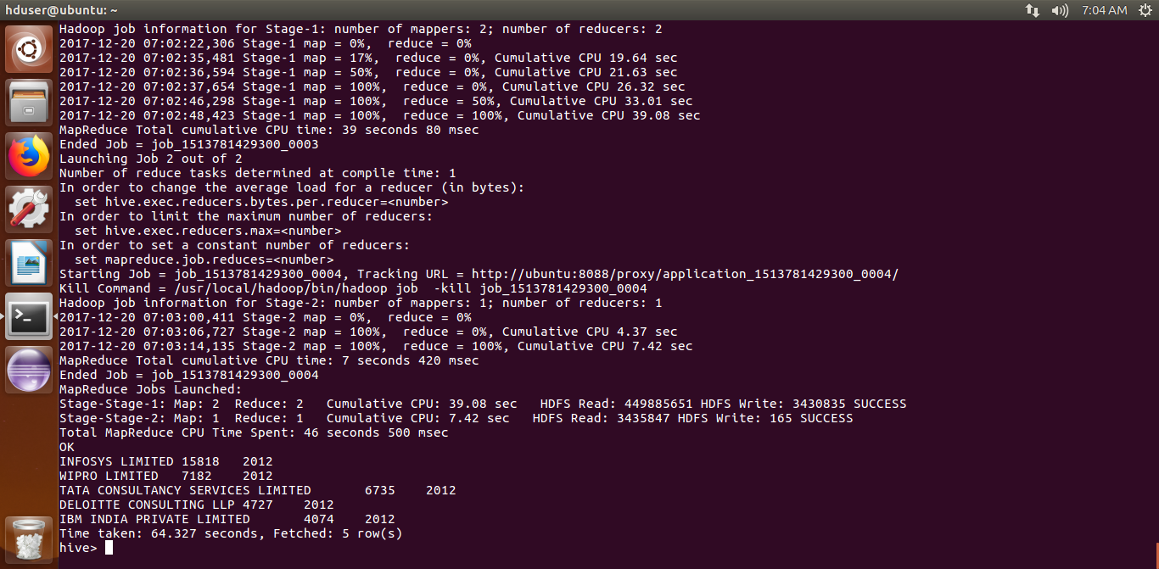

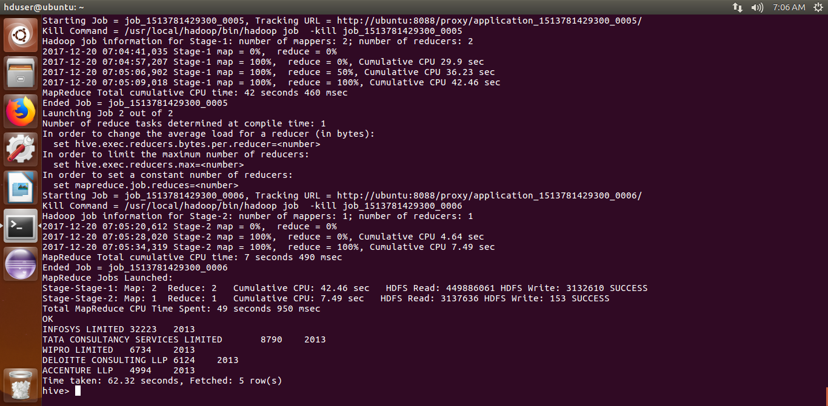

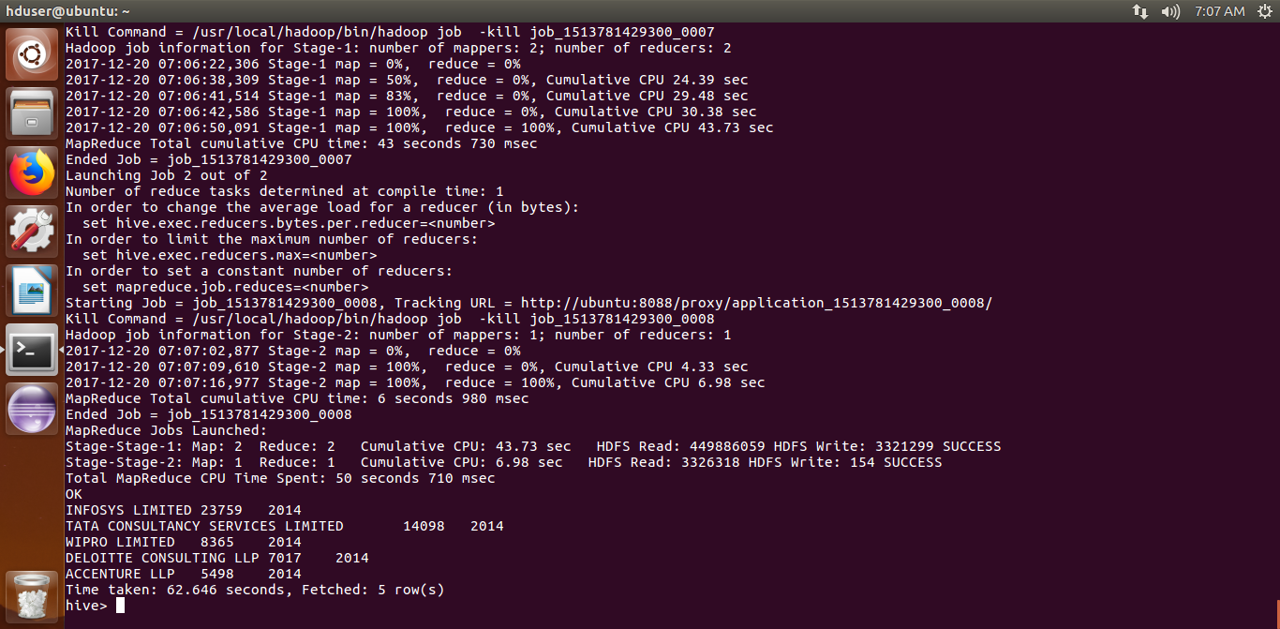

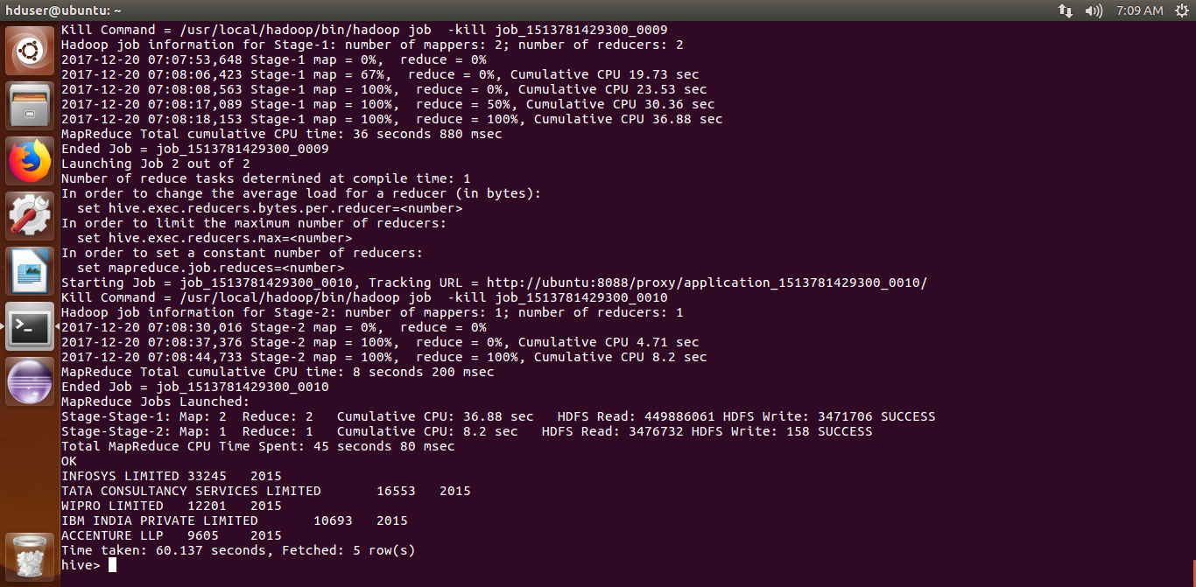

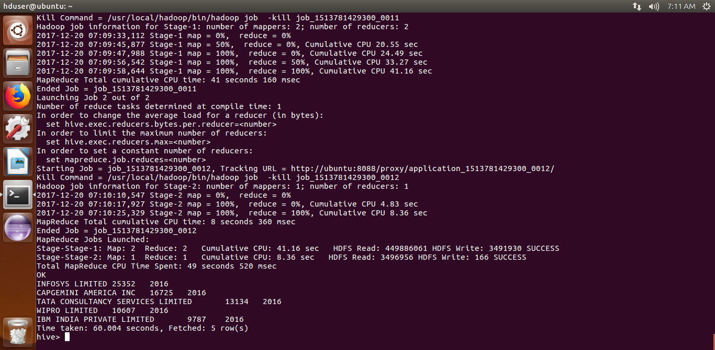

5a)Find the most popular top 10 job positions for H1B visa applications for each year for all the applications?
This is analyzed using MapReduce

CODE:

import java.io.*;
import java.util.TreeMap;

import org.apache.hadoop.io.NullWritable;
import org.apache.hadoop.io.Text;
import org.apache.hadoop.io.LongWritable;
import org.apache.hadoop.mapreduce.Job;
import org.apache.hadoop.mapreduce.Mapper;
import org.apache.hadoop.mapreduce.Partitioner;
import org.apache.hadoop.mapreduce.Reducer;
import org.apache.hadoop.conf.*;
import org.apache.hadoop.fs.*;
import org.apache.hadoop.mapreduce.Reducer.Context;
import org.apache.hadoop.mapreduce.lib.input.*;
import org.apache.hadoop.mapreduce.lib.output.*;
import org.apache.hadoop.io.NullWritable;

public class Proj5
{

public static class MapClass extends Mapper<LongWritable,Text,Text,Text>
{
public void map(LongWritable key, Text value, Context context)
{
try{
String[] str = value.toString().split("\t");
//String job = str[7]+','+str[3];
context.write(new Text(str[4]),new Text(str[7]));
}
catch(Exception e)
{
System.out.println(e.getMessage());
}
}
}
public static class CaderPartitioner extends
Partitioner < Text, Text >
{
public int getPartition(Text key, Text value, int numReduceTasks)
{
String[] str = value.toString().split(",");
int year = Integer.parseInt(str[0]);

if(year==2011)
{
return 0 % numReduceTasks;
}
else if(year==2012)
{
return 1 % numReduceTasks ;
}
else if(year==2013)
{
return 2 % numReduceTasks ;
}
else if(year==2014)
{
return 3 % numReduceTasks ;
}
else if(year==2015)
{
return 4 % numReduceTasks ;
}
else
{
return 5 % numReduceTasks;
}
}
}

public static class ReduceClass extends Reducer<Text,Text,NullWritable,Text>
{
private LongWritable result = new LongWritable();
private TreeMap<Long,Text> repToRecordMap = new TreeMap<Long,Text>();
String xx="";
String aa="";
public void reduce(Text key, Iterable<Text> values,Context context) throws IOException, InterruptedException {
long count=0;

for (Text val : values)
{
count++;
aa= val.toString();
}

//result.set(count);
//context.write(key, result);
xx= key.toString();
xx= xx + ','+count+','+aa;
repToRecordMap.put(new Long(count), new Text(xx));
if (repToRecordMap.size() > 10) {
repToRecordMap.remove(repToRecordMap.firstKey()); //to remove 1st elements
//repToRecordMap.remove(repToRecordMap.lastKey()); To remove last elements
}
}
protected void cleanup(Context context) throws IOException,
InterruptedException {
for (Text t : repToRecordMap.descendingMap().values()) {
// Output our five records to the file system with a null key
context.write(NullWritable.get(), t);
}
}
}
public static void main(String[] args) throws Exception {
Configuration conf = new Configuration();
//conf.set("name", "value")
//conf.set("mapreduce.input.fileinputformat.split.minsize", "134217728");
Job job = Job.getInstance(conf, "Volume Count");
job.setJarByClass(Proj5.class);
job.setMapperClass(MapClass.class);
//job.setCombinerClass(ReduceClass.class);
job.setPartitionerClass(CaderPartitioner.class);
job.setReducerClass(ReduceClass.class);
job.setNumReduceTasks(6);

job.setMapOutputKeyClass(Text.class);
job.setMapOutputValueClass(Text.class);
job.setOutputKeyClass(Text.class);
job.setOutputValueClass(LongWritable.class);
FileInputFormat.addInputPath(job, new Path(args[0]));
FileOutputFormat.setOutputPath(job, new Path(args[1]));
System.exit(job.waitForCompletion(true) ? 0 : 1);
}
}

OUTPUT SCREEN SHOT:
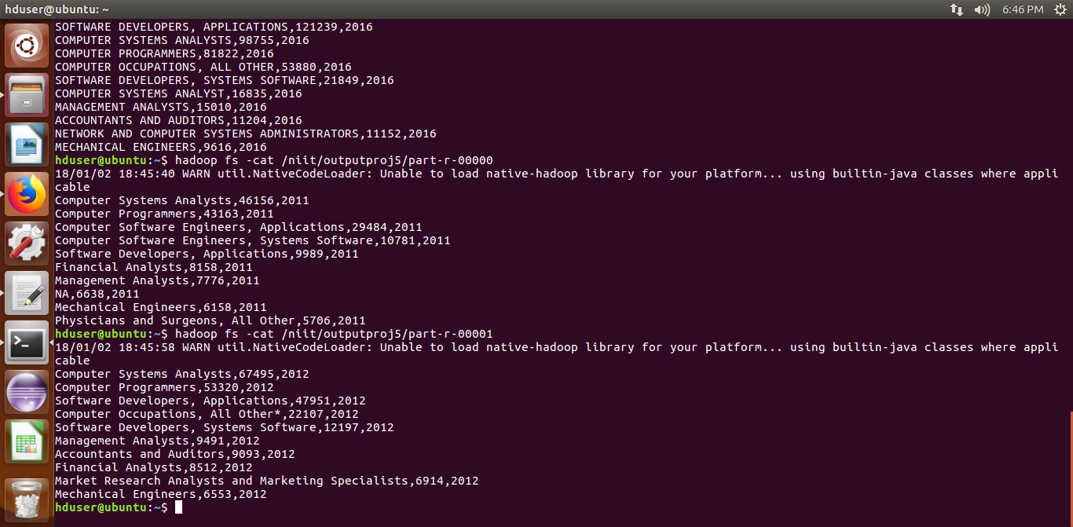
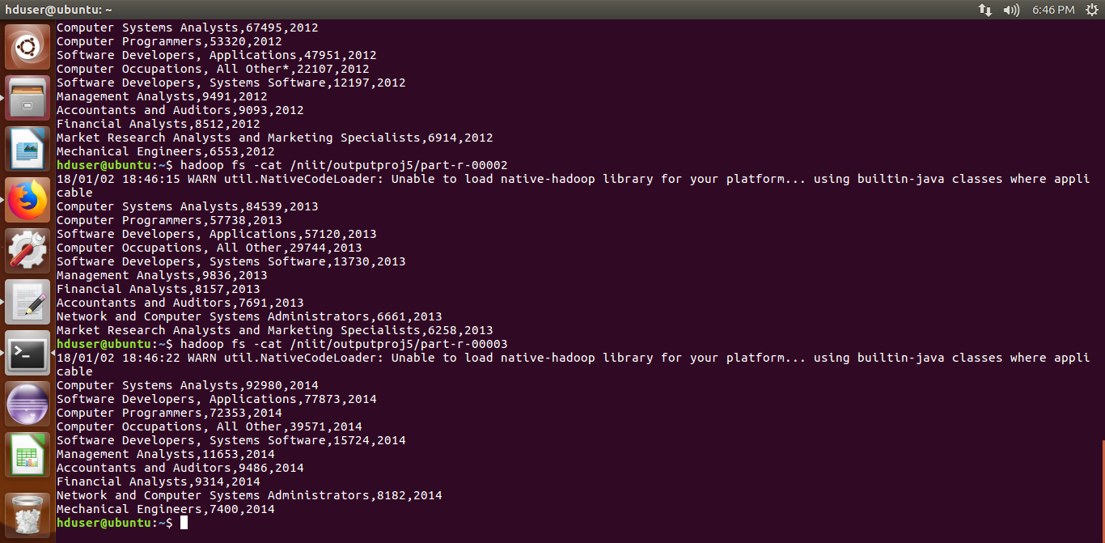
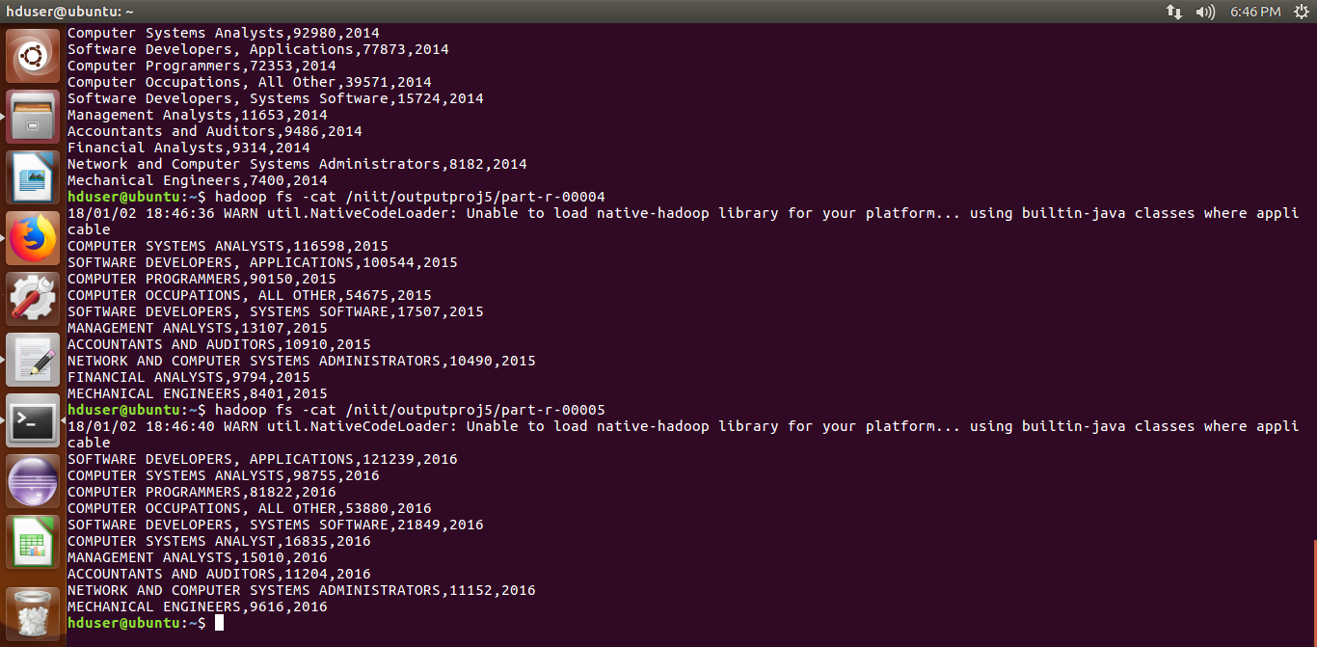

5b)Find the most popular top 10 job positions for H1B visa applications for each year or only certified applications
This is analysed using Map reduce

CODE:
import java.io.*;
import java.util.TreeMap;

import org.apache.hadoop.io.NullWritable;
import org.apache.hadoop.io.Text;
import org.apache.hadoop.io.LongWritable;
import org.apache.hadoop.mapreduce.Job;
import org.apache.hadoop.mapreduce.Mapper;
import org.apache.hadoop.mapreduce.Partitioner;
import org.apache.hadoop.mapreduce.Reducer;
import org.apache.hadoop.conf.*;
import org.apache.hadoop.fs.*;
import org.apache.hadoop.mapreduce.Reducer.Context;
import org.apache.hadoop.mapreduce.lib.input.*;
import org.apache.hadoop.mapreduce.lib.output.*;
import org.apache.hadoop.io.NullWritable;

public class Proj5b
{

public static class MapClass extends Mapper<LongWritable,Text,Text,Text>
{
public void map(LongWritable key, Text value, Context context)
{
try{
String[] str = value.toString().split("\t");
//String job = str[7]+','+str[3];
if(str[1].contains("CERTIFIED"))
{
context.write(new Text(str[4]),new Text(str[7]));
}
}
catch(Exception e)
{
System.out.println(e.getMessage());
}
}
}
public static class CaderPartitioner extends
Partitioner < Text, Text >
{
public int getPartition(Text key, Text value, int numReduceTasks)
{
String[] str = value.toString().split(",");
int year = Integer.parseInt(str[0]);

if(year==2011)
{
return 0 % numReduceTasks;
}
else if(year==2012)
{
return 1 % numReduceTasks ;
}
else if(year==2013)
{
return 2 % numReduceTasks ;
}
else if(year==2014)
{
return 3 % numReduceTasks ;
}
else if(year==2015)
{
return 4 % numReduceTasks ;
}
else
{
return 5 % numReduceTasks;
}
}
}

public static class ReduceClass extends Reducer<Text,Text,NullWritable,Text>
{
private LongWritable result = new LongWritable();
private TreeMap<Long,Text> repToRecordMap = new TreeMap<Long,Text>();
String xx="";
String aa="";
public void reduce(Text key, Iterable<Text> values,Context context) throws IOException, InterruptedException {
long count=0;

for (Text val : values)
{
count++;
aa= val.toString();
}

//result.set(count);
//context.write(key, result);
xx= key.toString();
xx= xx + ','+count+','+aa;
repToRecordMap.put(new Long(count), new Text(xx));
if (repToRecordMap.size() > 10) {
repToRecordMap.remove(repToRecordMap.firstKey()); //to remove 1st elements
//repToRecordMap.remove(repToRecordMap.lastKey()); To remove last elements
}
}
protected void cleanup(Context context) throws IOException,
InterruptedException {
for (Text t : repToRecordMap.descendingMap().values()) {
// Output our five records to the file system with a null key
context.write(NullWritable.get(), t);
}
}
}
public static void main(String[] args) throws Exception {
Configuration conf = new Configuration();
//conf.set("name", "value")
//conf.set("mapreduce.input.fileinputformat.split.minsize", "134217728");
Job job = Job.getInstance(conf, "Volume Count");
job.setJarByClass(Proj5b.class);
job.setMapperClass(MapClass.class);
//job.setCombinerClass(ReduceClass.class);
job.setPartitionerClass(CaderPartitioner.class);
job.setReducerClass(ReduceClass.class);
job.setNumReduceTasks(6);

job.setMapOutputKeyClass(Text.class);
job.setMapOutputValueClass(Text.class);
job.setOutputKeyClass(Text.class);
job.setOutputValueClass(LongWritable.class);
FileInputFormat.addInputPath(job, new Path(args[0]));
FileOutputFormat.setOutputPath(job, new Path(args[1]));
System.exit(job.waitForCompletion(true) ? 0 : 1);
}
}

OUTPUT SCREEN SHOT:
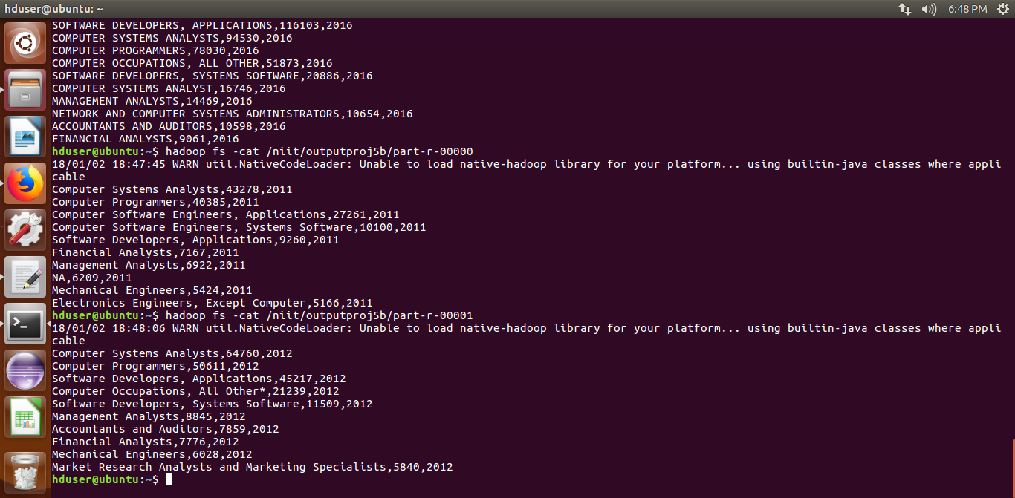

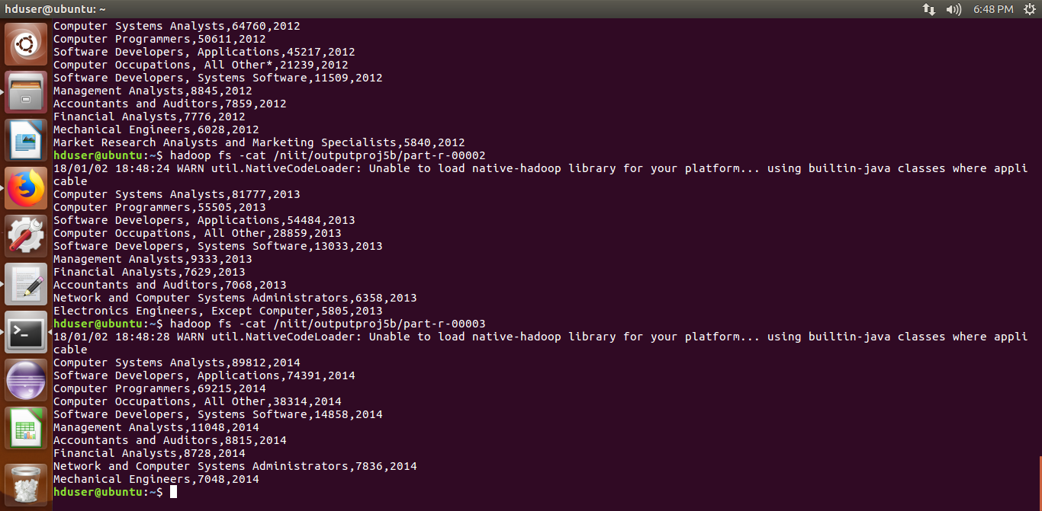
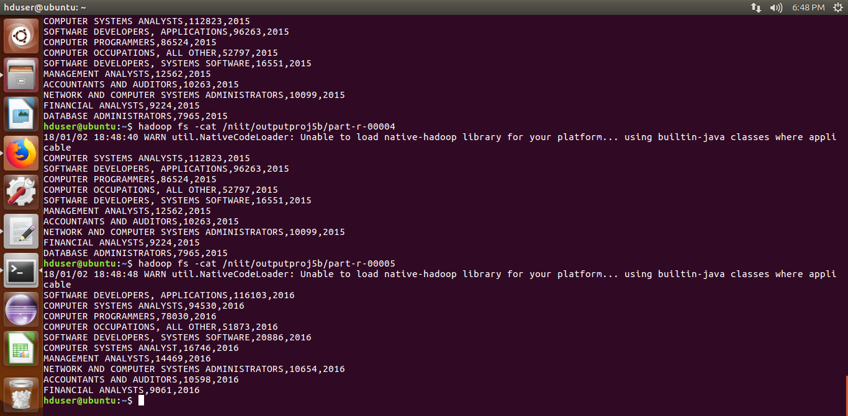

6)Find the percentage and the count of each case status on total applications for each year. Create a line graph depicting the pattern of All the cases over the period of time.
This is analyzed using pig

CODE:
data = LOAD '/home/hduser/h1b' USING PigStorage('\t') AS ( s_no:int, case_status:chararray,employer_name:chararray, soc_name:chararray, jobtitle:chararray, full_time_position:chararray, wage:long, year:chararray, worksite:chararray, longitude:long, latitude:long );
--dump data;
data = foreach data generate $1 as s, $7 as year;
--dump data;
--q = group data all;
--r = foreach q generate (float)COUNT(data.s) as tot;
--dump r;
x = filter data by year=='2011';
--dump x;
q = group x all;
r = foreach q generate (float)COUNT(x.s) as tot;
a = group x by $0;
--dump a;
b = foreach a generate group as status, (float)COUNT(x.s) as c, FLATTEN(x.year);
--dump b;
a11 = DISTINCT b;
--dump a11;
w1 = foreach a11 generate $0, $1 as cc, $2 , ROUND_TO((c*100)/r.tot ,2) ;
--ww = foreach w generate $3/$1;
--dump w1;

x1 = filter data by year=='2012';
--dump x;
q = group x1 all;
r = foreach q generate (float)COUNT(x1.s) as tot;
a = group x1 by $0;
--dump a;
b = foreach a generate group as status, (float)COUNT(x1.s) as c, FLATTEN(x1.year);
--dump b;
a11 = DISTINCT b;
--dump a11;
w2 = foreach a11 generate $0, $1 as cc, $2 , ROUND_TO((c*100)/r.tot ,2) ;
--dump w2;

x = filter data by year=='2013';
--dump x;
q = group x all;
r = foreach q generate (float)COUNT(x.s) as tot;
a = group x by $0;
--dump a;
b = foreach a generate group as status, (float)COUNT(x.s) as c, FLATTEN(x.year);
--dump b;
a11 = DISTINCT b;
--dump a11;
w3 = foreach a11 generate $0, $1 as cc, $2 , ROUND_TO((c*100)/r.tot ,2) ;
--dump w3;

x = filter data by year=='2014';
--dump x;
q = group x all;
r = foreach q generate (float)COUNT(x.s) as tot;
a = group x by $0;
--dump a;
b = foreach a generate group as status, (float)COUNT(x.s) as c, FLATTEN(x.year);
--dump b;
a11 = DISTINCT b;
--dump a11;
w4 = foreach a11 generate $0, $1 as cc, $2 , ROUND_TO((c*100)/r.tot ,2) ;
--dump w4;

x = filter data by year=='2015';
--dump x;
q = group x all;
r = foreach q generate (float)COUNT(x.s) as tot;
a = group x by $0;
--dump a;
b = foreach a generate group as status, (float)COUNT(x.s) as c, FLATTEN(x.year);
--dump b;
a11 = DISTINCT b;
--dump a11;
w5 = foreach a11 generate $0, $1 as cc, $2 , ROUND_TO((c*100)/r.tot ,2) ;

--dump w5;

x = filter data by year=='2016';
--dump x;
q = group x all;
r = foreach q generate (float)COUNT(x.s) as tot;
a = group x by $0;
--dump a;
b = foreach a generate group as status, (float)COUNT(x.s) as c, FLATTEN(x.year);
--dump b;
a11 = DISTINCT b;
--dump a11;
w6 = foreach a11 generate $0, $1 as cc, $2 , ROUND_TO((c*100)/r.tot ,2) ;

--dump w6;
qq = union w1,w2,w3,w4,w5,w6;
--dump qq;
pp = order qq by $0 asc,$2 asc ;
--dump pp;
--ww= order pp by $0 asc;
--dump ww;
a =store pp into '/home/hduser/output_c';

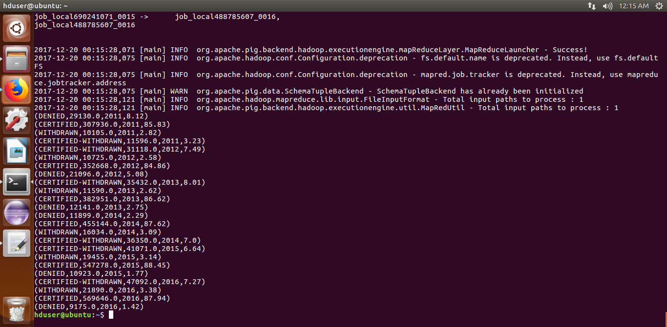
OUTPUT SCREEN SHOT:

LINE GRAPH:
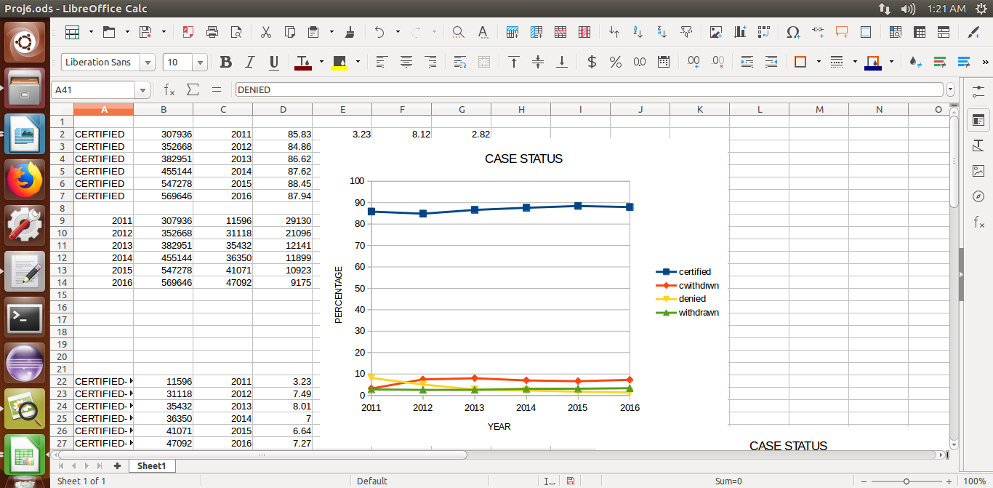

7) Create a bar graph to depict the number of applications for each year

This is analyzed using MapReduce

CODE:
import java.io.*;
//import java.util.TreeMap;

//import org.apache.hadoop.io.NullWritable;
import org.apache.hadoop.io.Text;
import org.apache.hadoop.io.LongWritable;
import org.apache.hadoop.mapreduce.Job;
import org.apache.hadoop.mapreduce.Mapper;
//import org.apache.hadoop.mapreduce.Partitioner;
import org.apache.hadoop.mapreduce.Reducer;
import org.apache.hadoop.conf.*;
import org.apache.hadoop.fs.*;
//import org.apache.hadoop.mapreduce.Reducer.Context;
import org.apache.hadoop.mapreduce.lib.input.*;
import org.apache.hadoop.mapreduce.lib.output.*;
//import org.apache.hadoop.io.NullWritable;

public class Proj7
{

public static class MapClass extends Mapper<LongWritable,Text,Text,Text>
{
public void map(LongWritable key, Text value, Context context)
{
try{
String[] str = value.toString().split("\t");

//String jobandyear = str[4]+","+str[7];
//year and case status
context.write(new Text(str[7]),new Text(str[1]));
}
catch(Exception e)
{
System.out.println(e.getMessage());
}
}
}

public static class ReduceClass extends Reducer<Text,Text,Text,LongWritable>
{
private LongWritable result = new LongWritable();

public void reduce(Text key, Iterable<Text> values,Context context) throws IOException, InterruptedException {
long count=0;
// String xx="";
//String aa="";

for (Text val : values)
{
count++;
// aa= val.toString();
//}
//key=new Text(job);
}

result.set(count);

context.write(key, result);
//context.write(key, new LongWritable(sum));

}

}
public static void main(String[] args) throws Exception {
Configuration conf = new Configuration();
//conf.set("name", "value")
//conf.set("mapreduce.input.fileinputformat.split.minsize", "134217728");
Job job = Job.getInstance(conf, "Volume Count");
job.setJarByClass(Proj7.class);
job.setMapperClass(MapClass.class);
//job.setCombinerClass(ReduceClass.class);
//job.setPartitionerClass(CaderPartitioner.class);
job.setReducerClass(ReduceClass.class);
job.setNumReduceTasks(1);

job.setMapOutputKeyClass(Text.class);
job.setMapOutputValueClass(Text.class);
job.setOutputKeyClass(Text.class);
job.setOutputValueClass(LongWritable.class);
FileInputFormat.addInputPath(job, new Path(args[0]));
FileOutputFormat.setOutputPath(job, new Path(args[1]));
System.exit(job.waitForCompletion(true) ? 0 : 1);
}}
OUTPUT SCREEN SHOT:
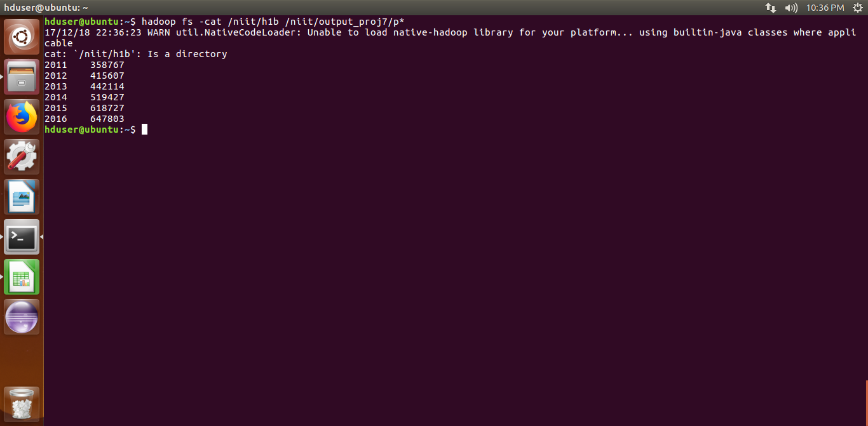

BAR GRAPH:
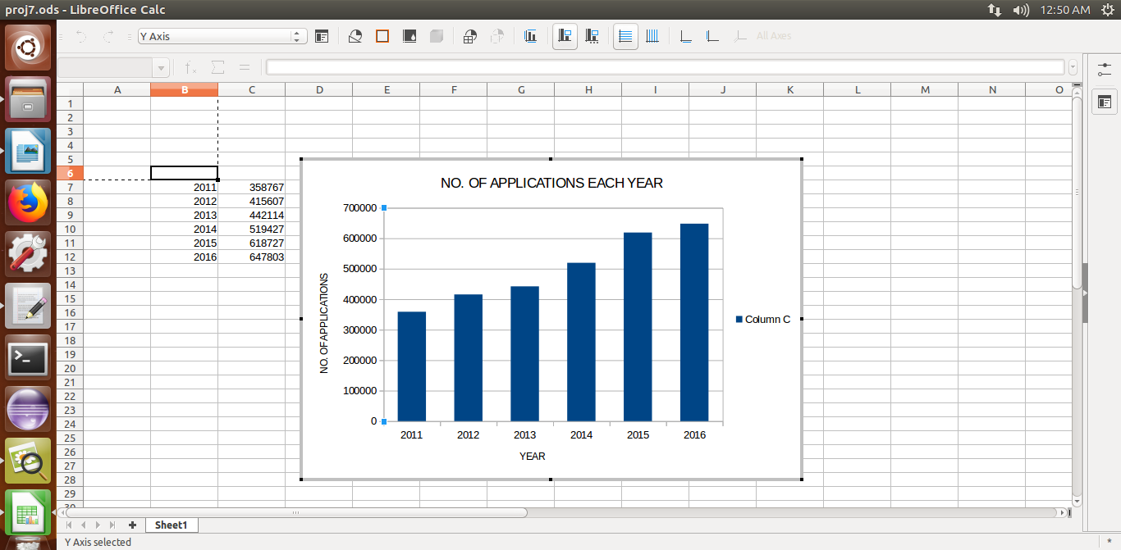

8) Find the average Prevailing Wage for each Job for each YearArrange the output in descending order

This is analyzed using Pig

CODE:
(For full time jobs)
data = LOAD '/niit/h1b' USING PigStorage('\t') AS ( s_no:int, case_status:chararray,employer_name:chararray, soc_name:chararray, jobtitle:chararray, full_time_position:chararray, wage:long, year:chararray, worksite:chararray, longitude:long, latitude:long );
--dump data;
data = foreach data generate $1 as status,$4 as job, $5 as fp, $6 as wage, $7 as year;
--dump data;
x = filter data by status=='CERTIFIED' or status=='CERTIFIED-WITHDRAWN';
--dump x;
c = filter x by fp== 'Y';
--dump c;
d = filter c by year=='2011';
--dump d;
a = group d by job;
--dump a;
b = foreach a generate group as job,AVG(d.wage) as avg,flatten(d.year) as year;
--dump b;
s1 = distinct b;
--dump s1;

d = filter c by year=='2012';
--dump d;
a = group d by job;
--dump a;
b = foreach a generate group as job,AVG(d.wage) as avg,flatten(d.year) as year;
--dump b;
s2 = distinct b;
--dump s2;

d = filter c by year=='2013';
--dump d;
a = group d by job;
--dump a;
b = foreach a generate group as job,AVG(d.wage) as avg,flatten(d.year) as year;
--dump b;
s3 = distinct b;
--dump s3;

d = filter c by year=='2014';
--dump d;
a = group d by job;
--dump a;
b = foreach a generate group as job,AVG(d.wage) as avg,flatten(d.year) as year;
--dump b;
s4 = distinct b;
--dump s4;

d = filter c by year=='2015';
--dump d;
a = group d by job;
--dump a;
b = foreach a generate group as job,AVG(d.wage) as avg,flatten(d.year) as year;
--dump b;
s5 = distinct b;
--dump s5;

d = filter c by year=='2016';
--dump d;
a = group d by job;
--dump a;
b = foreach a generate group as job,AVG(d.wage) as avg,flatten(d.year) as year;
--dump b;
s6 = distinct b;
--dump s6;

xx = union s1, s2,s3,s4,s5,s6;
xx = order xx by $2 asc ,$1 desc;
dump xx;
For part timejobs, the same code is executed with the condition fp==’N’)

SAMPLE OUTPUT:
FOR FULL TIME JOBS:
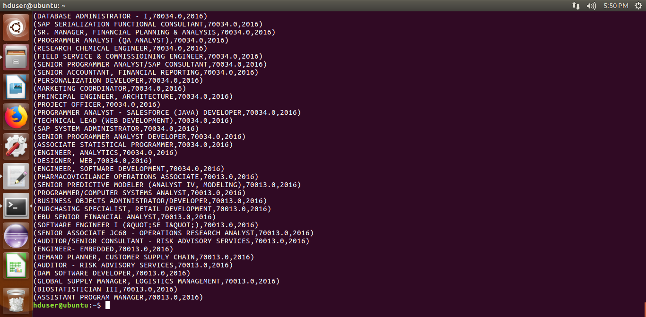

FOR PART TIME JOBS
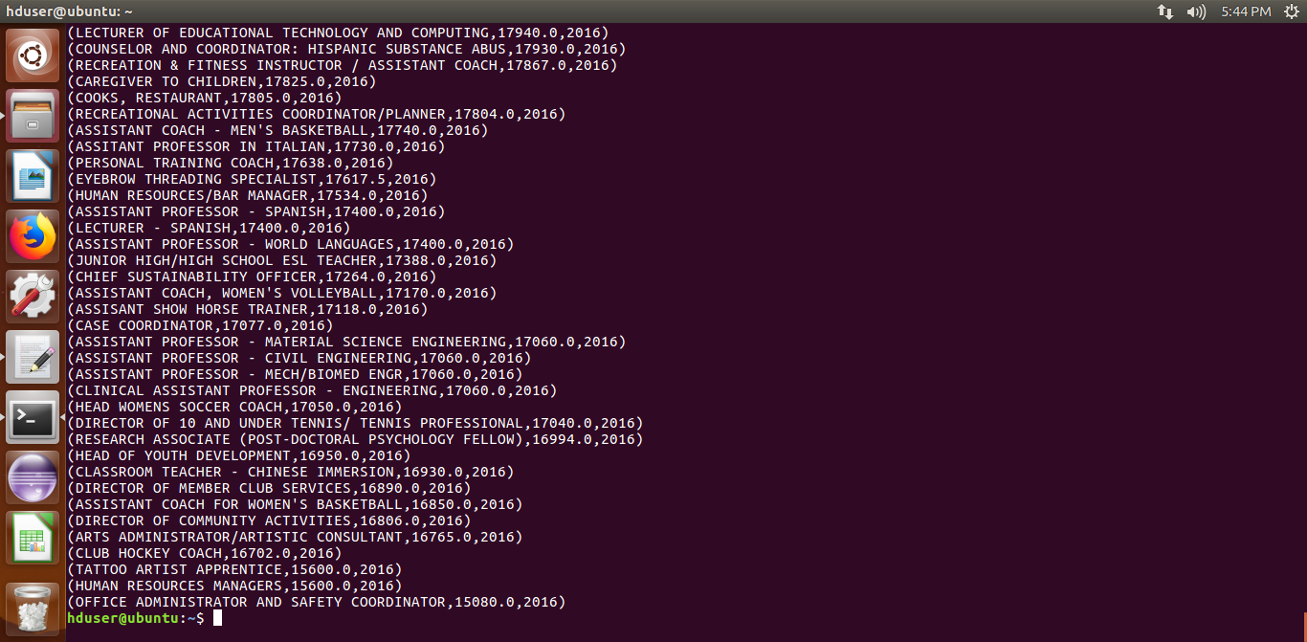

9)Which are the employers along with the number of petitions who have the success rate more than 70% in petitions. (total petitions filed 1000 OR more than 1000) ?

This is analyzed using Pig

CODE:
data = LOAD '/niit/h1b' USING PigStorage('\t') AS ( s_no:int, case_status:chararray,employer_name:chararray, soc_name:chararray, jobtitle:chararray, full_time_position:chararray, wage:long, year:chararray, worksite:chararray, longitude:long, latitude:long );
--dump data
c = group data by employer_name;
--dump c;
--describe c;
g = foreach c generate group as employer, (float)COUNT(data.case_status) as aa;
--dump g;
e = filter g by aa>=1000;
a = filter data by case_status=='CERTIFIED' or case_status=='CERTIFIED-WITHDRAWN';
--dump a;
v = group a by employer_name;
--dump v;
b= foreach v generate group as employer, (float)COUNT(a.case_status) as count2;
--dump b;
d = join e by $0, b by $0 ;
--dump d;
e= foreach d generate $0,$1 as g,$3 as b;
--dump e;
f = foreach e generate $0, $1,(b*100)/g as rate;
--dump f;
q = filter f by rate>70;
--dump q;
q1 = order q by rate desc;
dump q1;

OUTPUT SCREEN SHOT:
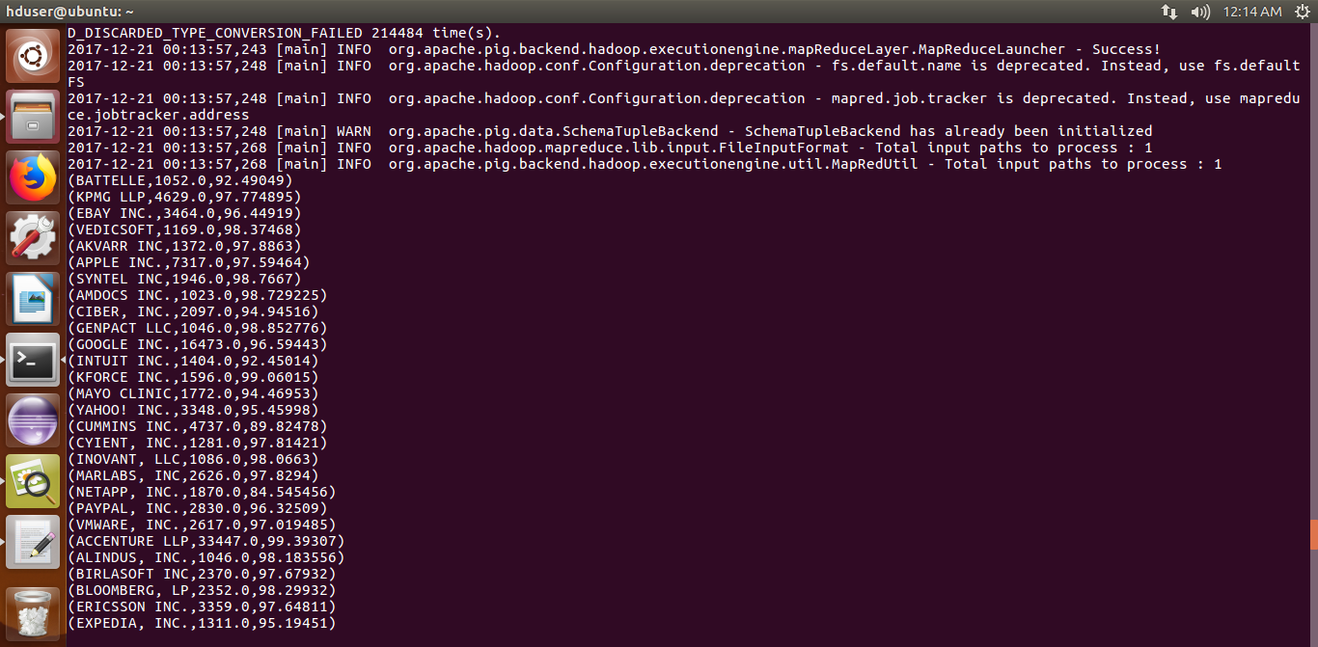

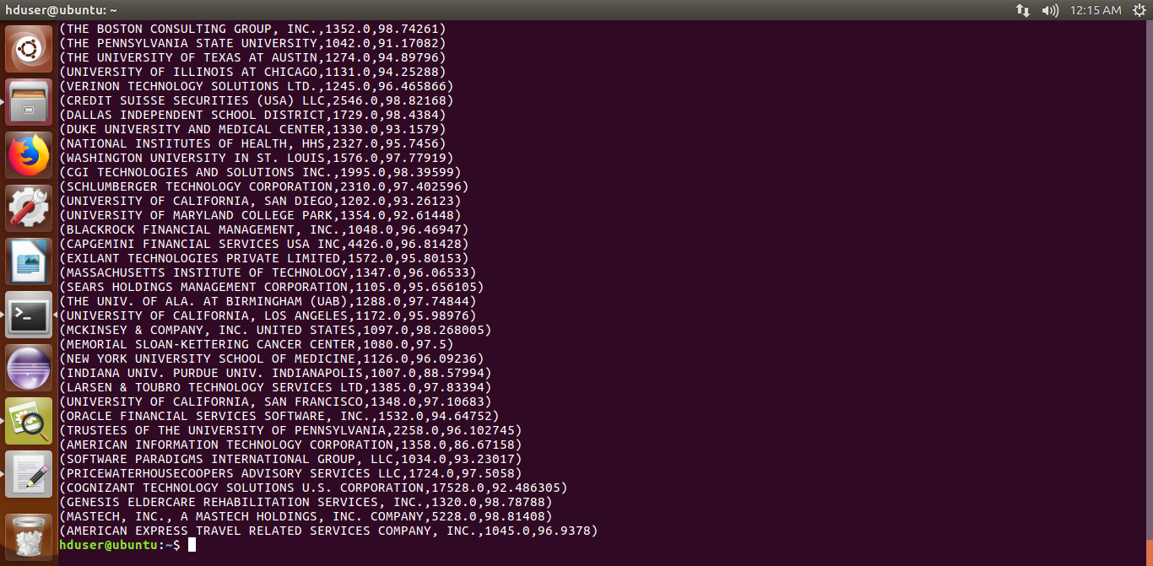
10)Which are the job positions along with the number of petitions which have the success rate more than 70% in petitions (total petitions filed 1000 OR more than 1000)?
This is analyzed using Pig.
CODE:
data = LOAD '/niit/h1b' USING PigStorage('\t') AS ( s_no:int, case_status:chararray,employer_name:chararray, soc_name:chararray, jobtitle:chararray, full_time_position:chararray, wage:long, year:chararray, worksite:chararray, longitude:long, latitude:long );
--dump data
c = group data by jobtitle;
--dump c;
--describe c;
g = foreach c generate group as job, (float)COUNT(data.case_status) as aa;
--dump g;
e = filter g by aa>=1000;
a = filter data by case_status=='CERTIFIED' or case_status=='CERTIFIED-WITHDRAWN';
--dump a;
v = group a by jobtitle;
--dump v;
b= foreach v generate group as job, (float)COUNT(a.case_status) as count2;
--dump b;
d = join e by $0, b by $0 ;
--dump d;
e= foreach d generate $0,$1 as g,$3 as b;
--dump e;
f = foreach e generate $0, $1,(b*100)/g as rate;
--dump f;
q = filter f by rate>70;
q = order q by rate desc;
dump q;
--z = store q into '/home/hduser/output_Proj10';
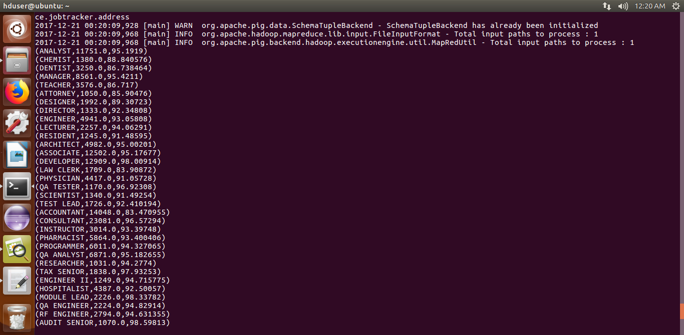
OUTPUT SCREEN SHOT:

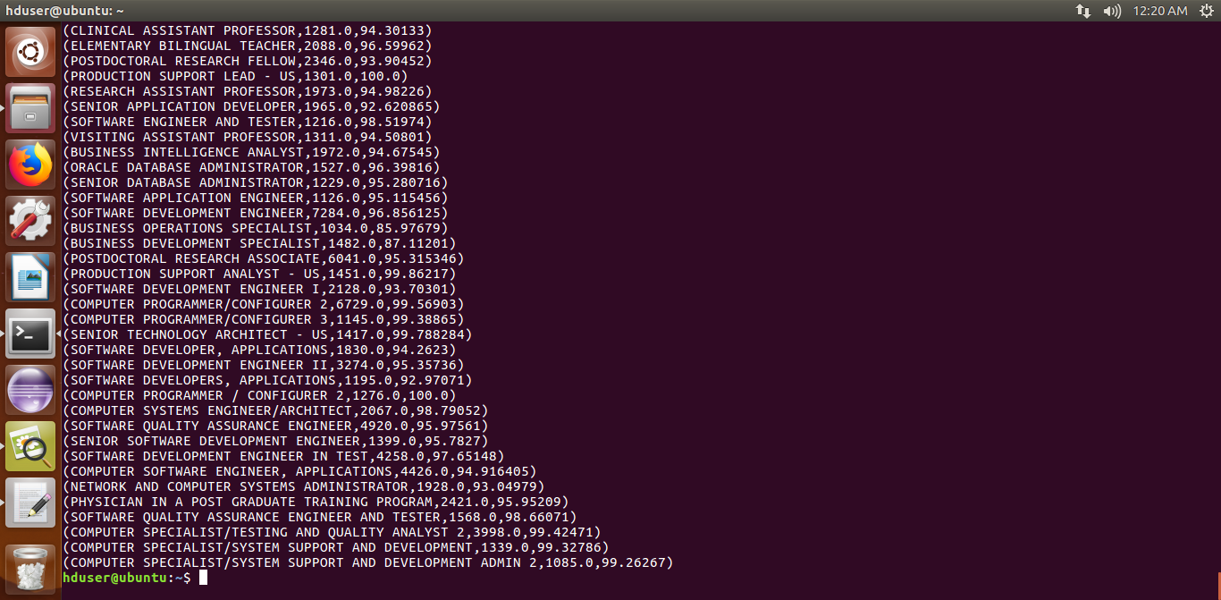

11)Export result for question no 10 to MySql databaser
This is done using Sqoop.
Before executing th eexport command a table is created in sql where the contents are to be exported.
QUERY: sqoop export --connect jdbc:mysql://localhost/retail --username root --password 'aysh02' --table PROJ11 --update-mode allowinsert --update-key Job --export-dir /niit/part-r-00000 --input-fields-terminated-by '\t';

OUTPUT SCREEN SHOT:


