

Hacettepe University - Department of Geomatics Engineering

2019-2020 Fall

## GMT444–Fundamentals of LaserScanning

## LabAssignment–Building Extraction From Lidar Data

## AYSİMA MERVE AKKURT - 21531925

# Figures :

1. Command line script for first step
2. Screenshot for color by elevation-2
3. Screenshot for color by intensity
4. Screenshot for render by first return
5. Screenshot for triangulation and provide a hillshaded display
6. Command line script for second step
7. Screenshot for second question with the following parameters : step\_xy= 4 ,step\_z=4,isolated=20
8. Screenshot for second question with the following parameters : step\_xy= 4 ,step\_z=1,isolated=5
9. Command line script for third step
10. Screenshot for ground filtering
11. Command line script for fourth step
12. Parameters for classify
13. Command line scripts for fifth step
14. Digital Terrain Model Screenshots
15. Command line script for sixth step
16. Digital Surface Model Screenshots
17. What is nDSM?
18. Raster Calculator in Qgis for nDSM generation Screenshot
19. Normalized Digital Surface Model screenshots
20. Screenshots for every different threshold value (I paste threshold value screenshots on Qgis at bottom)
21. Screenshot form my choice (thresholdvalue=7)
22. Screenshot for manually building delineation
23. Command line script for bonus step
24. Figure 23- Map of comparison of Points classified as building and Building boundary delineation

# REPORT

1. **Downloading and Exploring the Data**

-For this step , I used lasview.

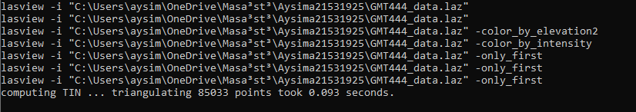

1. ***-Command line script for first step***

Color the point cloud by ;

i)elevation and

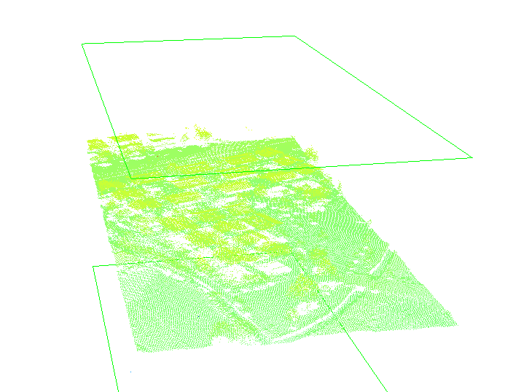

1. ***– Screenshots for color by elevation-2***

-color\_by\_elevation2 : render points by elevation color ramp (blue->yellow->red)

ii)intensity.

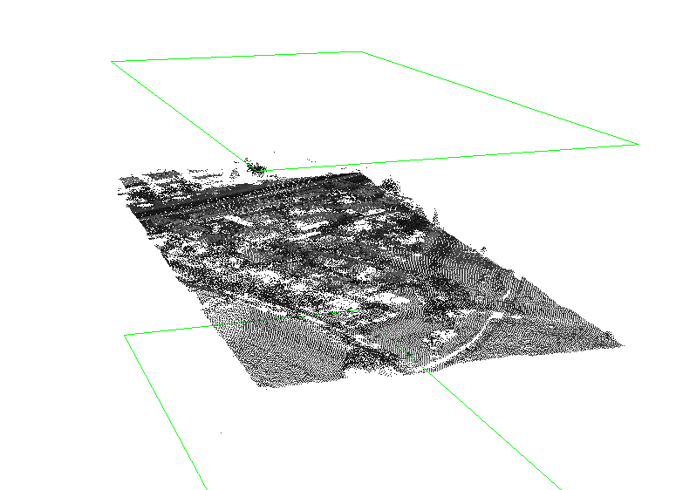

1. ***– Screenshots for color by intensity***

-color\_by\_intensity : render points by intensity

iii)Display only *first returns*, perform *triangulation* and provide a *hill shaded* display.

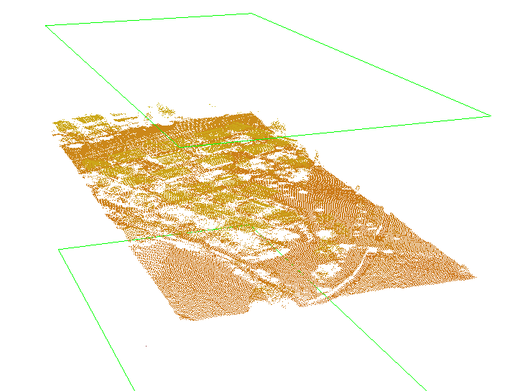

1. ***– Screenshots for render by first return***

-only\_first : render only first returns

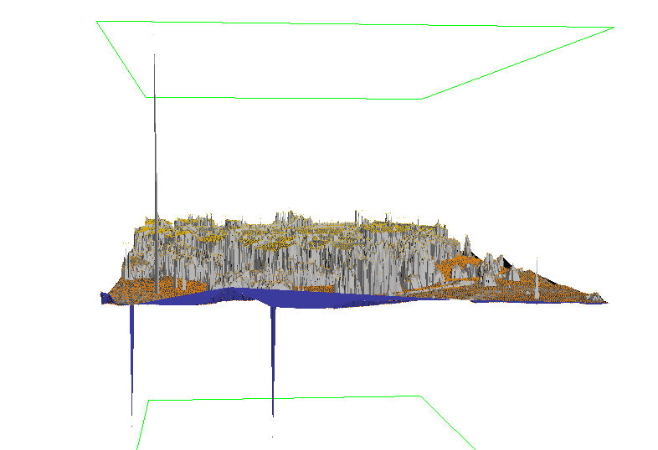

1. ***-Screenshots for triangulation and provide a hillshaded display***

-color\_by\_return : render points by return colors (single = yellow, first of many = red, last of many = blue, intermediate = green)

1. **Classification of the Noise Points**

-For second step , I used lasnoise



1. ***- Command line script for second step***

-step\_xy : set the horizontal x and y spacing of the grid to step\_xy input value.

-step\_z : set the vertical z spacing of the grid to step\_z input value.

-isolated : points are isolated when there is a total of less than isolated input value points in all neighbour cells

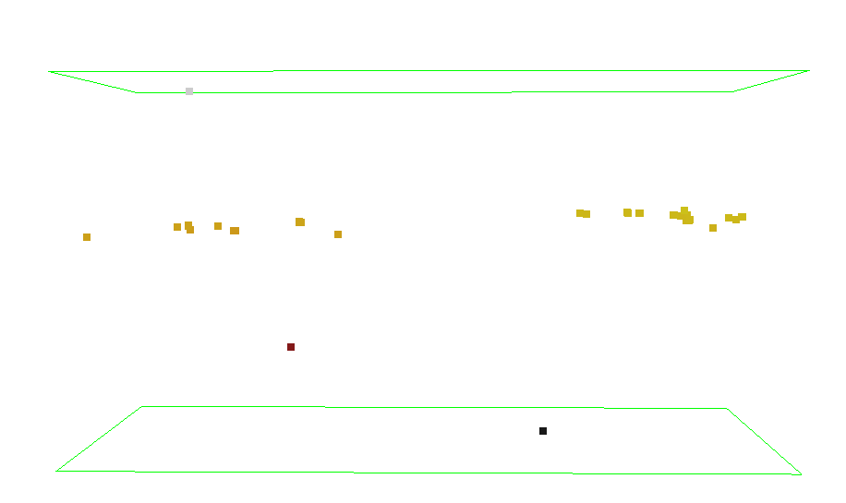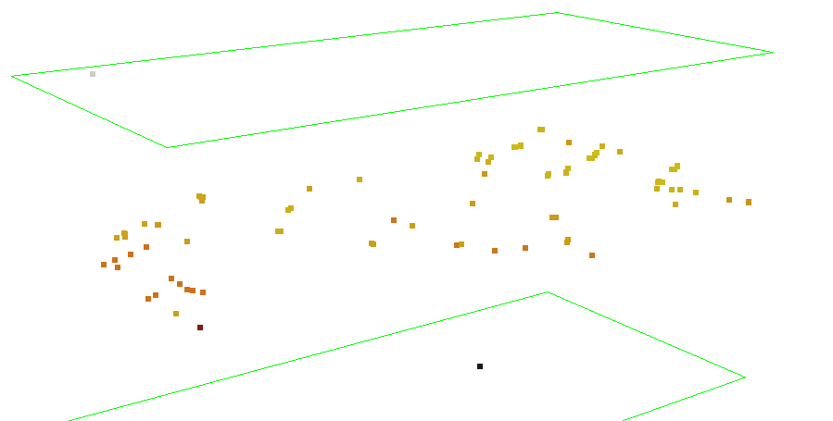

1. ***-Screenshots for second question with the following parameters :***

***-step\_xy : 4***

***-step\_z : 4***

***-isolated : 20***

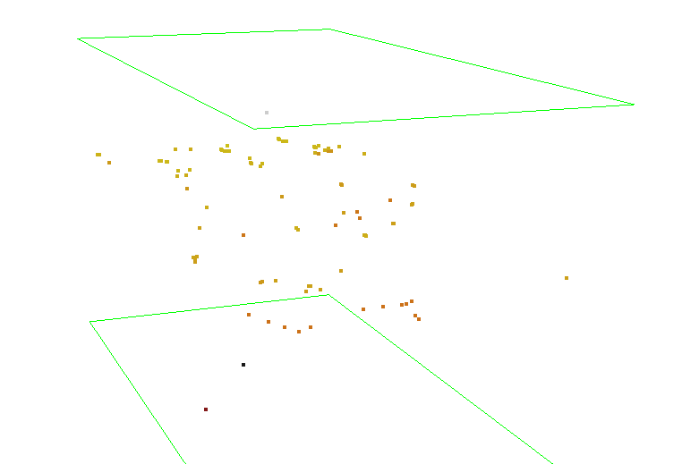

1. ***-Screenshots for second question with the following parameters :***

***-step\_xy : 4***

***-step\_z : 1***

***-isolated : 5***

1. **Ground Filtering**

-For third step , I used lasground



1. ***- Command line script for third step***

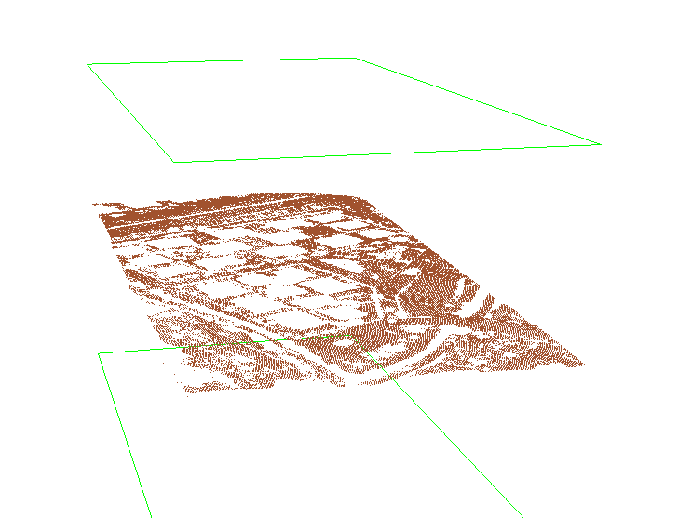

1. ***– Screenshots for ground filtering***

The tool also produces excellent results for town or cities but buildings larger than the step size can be problematic. The default step size is 5 meters, which is good for forest or mountains. For towns or flat terrains '-town' the step size is increased to 10 meters. For city or warehouses '-city' the step size is increased to 25 meters. Fort his point cloud , I choose city or warehouses option.

1. **Classification of buildings and vegetation**

-For fourth step, I used lasclassify.



1. ***-Command line script for fourth step***

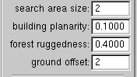

1. ***-Parameters for classify***

Search area size : grid cell size for planar / non-planar analysis

Ground offset : only points that are 2 (my choice) meters above ground are considered

Building planarity : grid cell points up to this standard deviation are potential roofs

Forest ruggedness : grid cell points above this standard deviation are potential vegetation

1. **DTM generation**

-For fifth step, I used las2dem

What is a Digital Terrain Model (DTM) ?

a digital terrain model (DTM) actually has two definitions depending on where you live.

• In some countries, a DTM is actually synonymous with a DEM. This means that a DTM is simply an elevation surface representing the bare earth referenced to a common vertical datum.

• In the United States and other countries, a DTM has a slight different meaning. A DTM is a vector data set composed of regularly spaced points and natural features such as ridges and breaklines. A DTM augments a DEM by including linear features of the bare-earth terrain.

command_line_fifthques.PNG

1. ***-Command line scripts for fifth step***

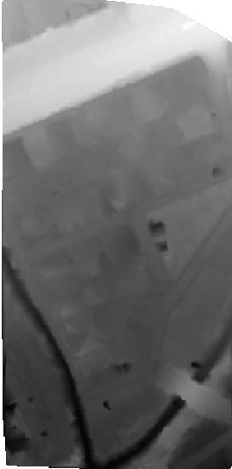

1. ***-Digital Terrain Model Screenshots***

-kill triangles 100 : do not raster triangles with edges longer than 100 meters

1. **DSM generation**

For sixth step,I used las2dem.

What is a Digital Surface Model (DSM) ?

Digital Surface Model (surface elevation, including trees, buildings, houses, etc)

In a LiDAR system, pulses of light travel to the ground. When the pulse of light bounces off its target and returns to the sensor, it gives the range (a variable distance) to the Earth. Hence, how this system earned its name of Light Detection and Ranging. In the end, LiDAR delivers a massive point cloud filled of varying elevation values. But height can come from the top of buildings, tree canopy, powerlines and other features. A DSM captures the natural and built features on the Earth’s surface.

command_line_sixque.PNG

1. ***-Command line script for sixth step***

***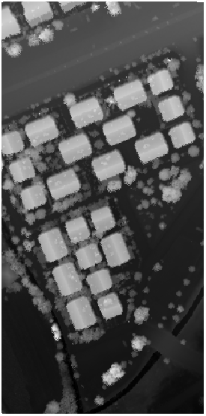***

1. ***-Digital Surface Model Screenshots***
2. **nDSM generation**

For this step , I used QGIS

What is nDSM?

• Top surface visible from above

• Includes – Vegetation (forests, trees,shrubs, crops, etc.) – Buildings

• Normalized DSM (nDSM)

**nDSM = DSM – DTM**

**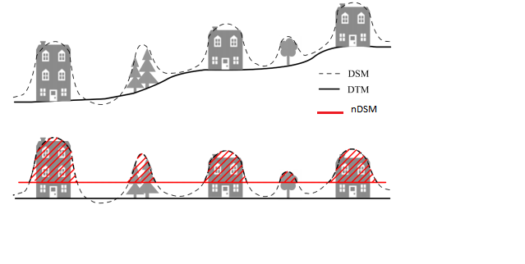**

1. ***–What is nDSM?***

***-***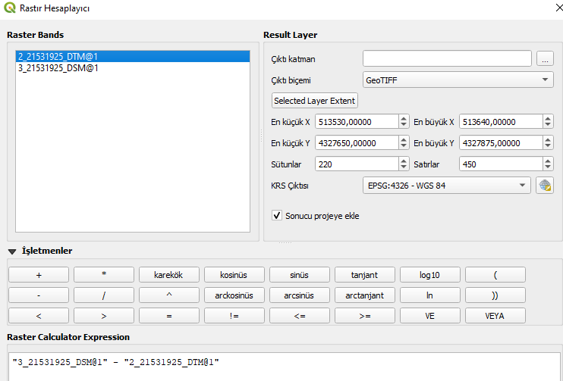

1. ***- Raster Calculator in Qgis for nDSM generation Screenshot***

For this step , I was worked on Qgis and I used raster calculator.Like we learned, if we find differences between

DSM and DTM , we obtained nDSM.

***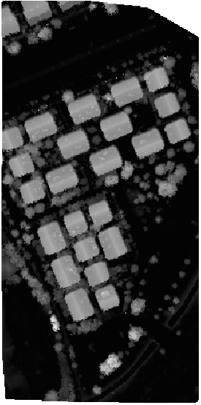***

1. ***- Normalized Digital Surface Model screenshot***
2. **Building Segmentation**

Same in the previous step , I used Qgis’s raster calculator.My input’s were my nDSMmodel. I choosed threshold value for buildings.For optimal threshold value , I tried four number.

When threshold value is 5, all buildings shows but at the same time shows trees.

When threshold value is 7 , all buildings shows and decreasing trees.

When threshold value is 8 , buildings exposed to data loss and final trial , If threshold value is 10 , almost all building disappear.

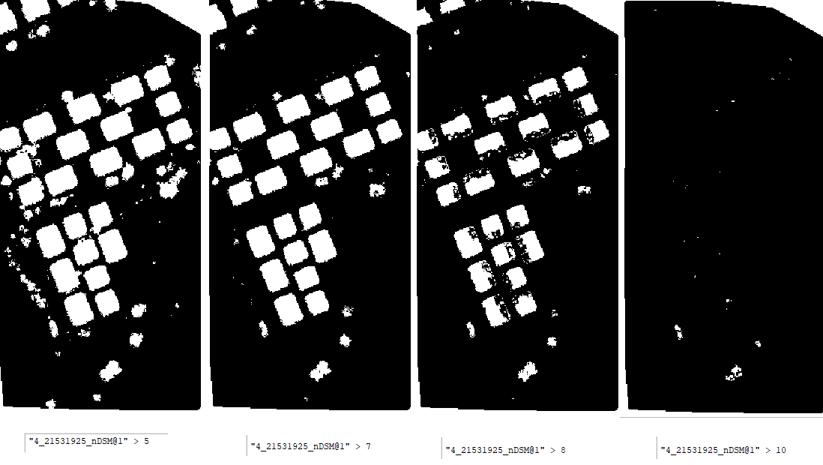

1. ***- Screenshots for every different threshold value (I paste threshold value screenshots on Qgis at bottom)***



1. ***-Screenshot form my choice (thresholdvalue=7)***
2. **Building Boundary Delineation**

***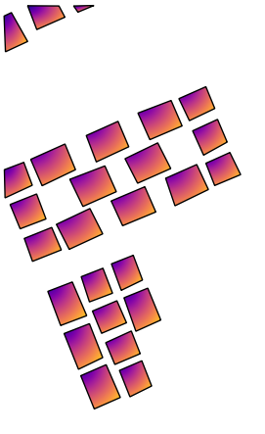***

1. ***– Screenshots for manually building delineation***

For this step , I used Qgis and nDSM with determined threshold value and manually I drawed buildings with create polygon tool.

1. **BONUS**

For this part , I used las2las , cloud compare and Qgis.Firstly, with keep classification filter , I obtained all points classified as building in las format.Later , I used cloud compare and convert las to shp.At the and on Qgis, I put my manually building delineation shp file and las2las output.

99.PNG

1. ***- Command line script for bonus step***

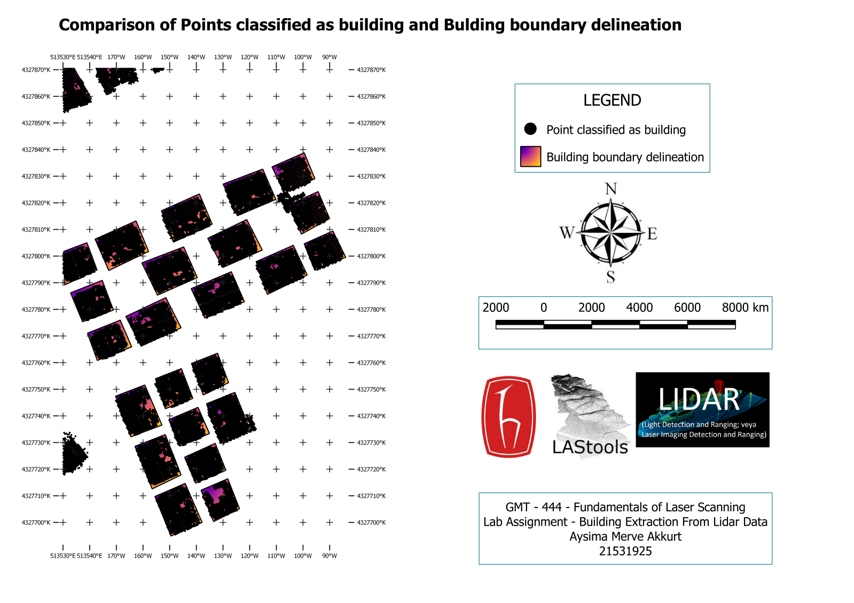

1. ***-Map of comparison of Points classified as building and Building boundary delineation***

As a result ,

Automatic classification of buildings not absolutely true but has a good percentage of success.The biggest shortfall, when the side walls of buildings are visible , program considers it a building.

**AYSİMA MERVE AKKURT**

**21531925**