CPP NOTES
BASICS
- Block diagram of the computer
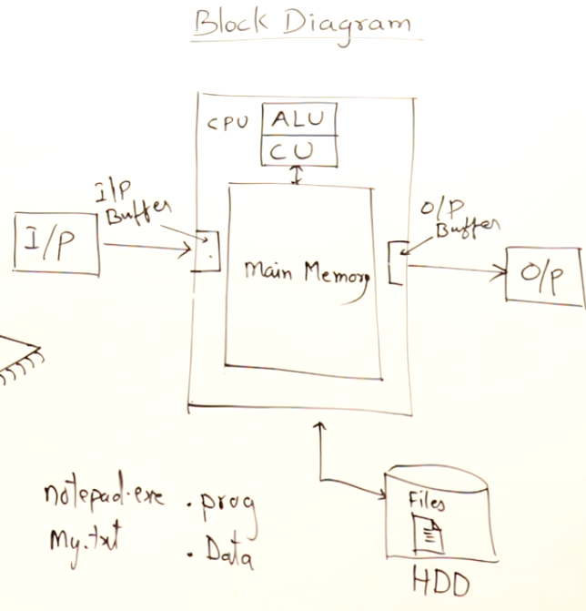
- Low level vs High level language
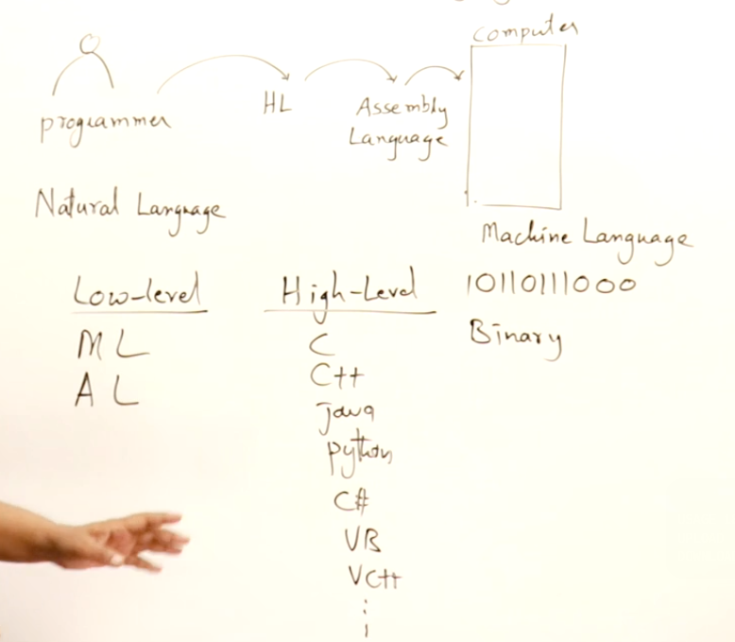
- Compiled vs Interpreted Language vs Hybrid language
  - Compiled Language
    - Donot need the compiler to run.They run independently.
    - Translation is done only once.
  - Interpreted language
    - They need the interpreter every time they need to run.
    - They can be run even if the code has errors.
    - Translation is done every time the program is run.
  - Compiled language
    - The code is first converted into the byte code which is the error free code using the compiler then the byte code is run using the interpreter.

- Programming Paradigm
  - Monolithic
    - All the source code is written in a single file.
    - No teamwork can be done.
    - Very lengthy code.
    - Take more time in development
    - Does not run even if a single error is there.
    - eg. BASIC language
  - Modular/Procedural
    - Functions are used to make the program modular.
    - Increases the reusability of the code in the same as well as other codes.
    - Program can be easily developed as a team.
    - eg. C
  - Object Oriented
    - The data and the functions acting upon the data are kept together and are defined as classes.
    - It is higher level of modularity of the code
    - eg. Java, C++
  - Aspect oriented/Component assembly

- Algorithms, Pseudocode and Programs
  - Algorithms
    - Step by Step procedure for solving a computational problem.
  - Pseudocode
    - Casual way of writing the procedure.
  - Programs
    - Algorithm or procedure written to solve the problem for the computer using a programming language.

- Flowcharts

Start/Stop Input/Output Process Condition Flow
- Development and Execution of Program
  - Editing
  - Compiling
  - Linking Libraries
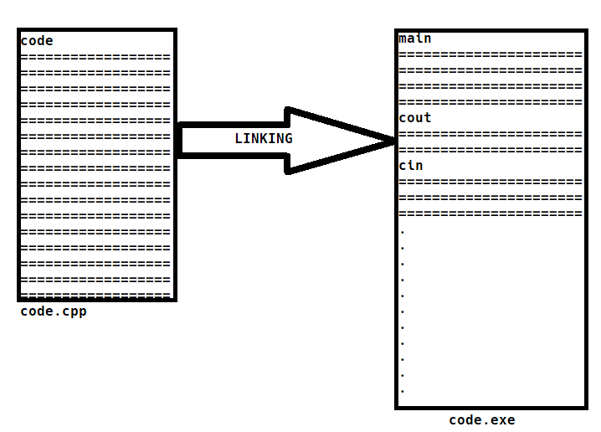
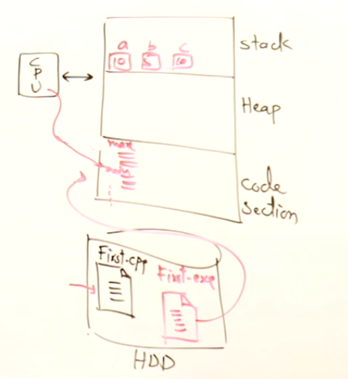
The entire machine code of the header file is copied
Variables and Data is stored in the stack
  - Loading
Heap is used for DMA
  - Execution

C++ BASICS

- The first program
A library
  - #include<iostream>
int main(){
std::cout<<”Hello World”<<std::endl;
return 0;
}
An Object:
Console output
Insertion operator
Scope resolution operator
namespace
  - Namespace: All the built-in things available in the iostream library are grouped under the name std therefore for using them we need to include the word std before them.

- getline(cin,variable_name):cin cannot read strings having spaces in them therefore getline is used to read the strings having spaces in between, It reads until enter is encountered.

- Datatypes in c++
  - Primitive
    - Integral
      - int : 2(turbo c) or 4 bytes; [-32768,32767]; 2¹⁵ =32768 and the one bit is the sign bit. -32767 t0 -0 and 0 to 32767 here -0 is taken as -32768 hence the range becomes from -32768 to 32767
      - char : 1 byte; [-128,127]
    - Bool : Undefined
    - Float
      - float : 4 bytes; [-3.4*10⁻³⁸,3.4*10³⁸]
      - double : 8 bytes; [-1.7*10⁻³⁰⁸,1.7*10³⁰⁸]
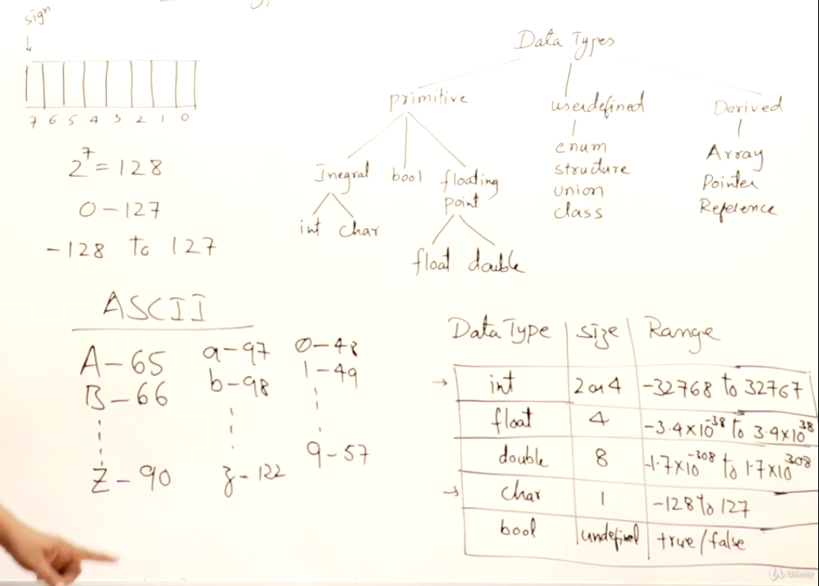
  - Userdefined
    - Enum
    - Structure
    - Union
    - Class
  - Derived
    - Array
    - Pointer
    - Reference

- Modifiers
  - long
    - long int
    - long double
  - unsigned
    - unsigned int
    - unsigned char

unsigned int : range [0 to 65535]
long int : size 4B(if was 2B) or 8B(if was 4B)
unsigned char : range [0 to 255]
long double : size is 10B
- By default any decimal number is taken as a double by the computer therefore it decimal number representing a float value should be written as the number followed by ‘f’. eg. 12.75f
- int a=13,b=5;
float c;
if
c=a/b;
c=2.00
if
c=(float)a/b;[typecasting]
c=2.6000
- float a=13,b=5,c=a/b;
c=2.6000
- char a=13,b=5,c=a/b;
c=2;
it will print the character corresponding to the ascii code ‘2’
OPERATORS
- Arithmetic operations and the precendence
Precedence: (,) > *,/,% > +,-
Associativity: left to right
eg. a+b*c-d/c
execution: b*c,d/c,a+(b*c),(a+(b*c))-(d/c)
- Compound operators
+=, -=, *=, /=, %=, &=, |=, >>=, <<=...
Compound expressions are faster as compared to the normal expressions.
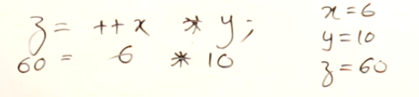
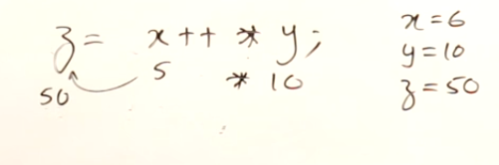
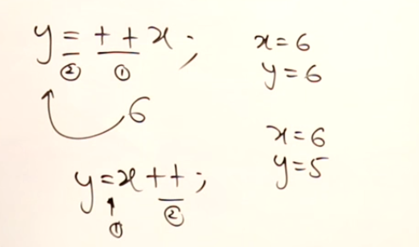
- Increment and Decrement operators
int x=5; int x=5,y=10;
- The concept of Overflow
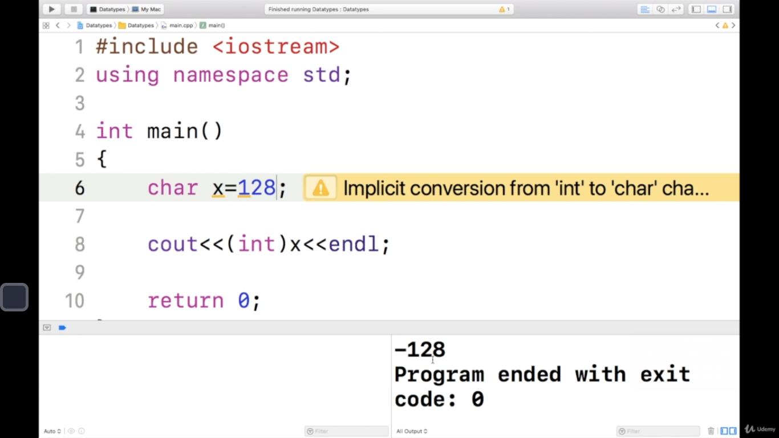
  - According to this concept if we try to go beyond the range of the datatype the we cycle back to the lowest value of the variable.

- Bitwise operators
  - and(&),or(|),xor(^),not(~),leftshift(<<),rightshift(>>).
  - when using the ls or rs the sign bit is not disturbed.
  - ls(<<)=x<<i = x*2^{i}
  - rs(>>)=x>>i = x/(2^{i})

- Enum and Typedef
- Enum: Used for defining a group of constants.
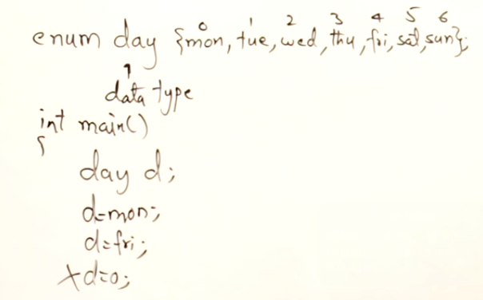
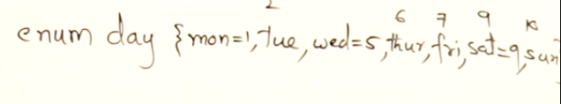
- Typedef : Used for giving meaningful names to the default datatypes.
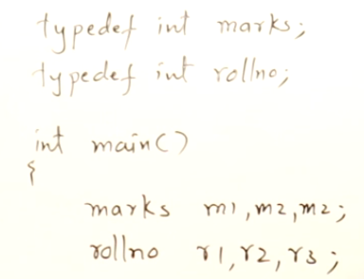
CODITIONAL STATEMENTS

- false=0; True=any non zero value
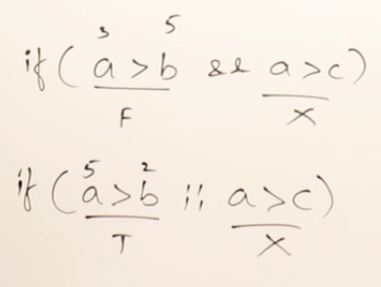
- Short circuit:
- In the second condition of logical operators never use increment or decrement operator because they may or may not get executed due to short circuit.
- Dynamic declaration : The activation record of main function grow and shrink according to the need of new variables.
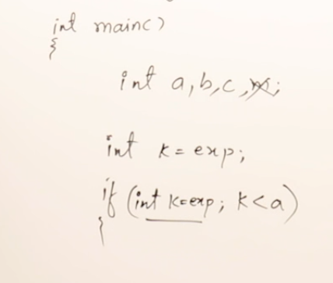

- Limiting the visibility of a variables
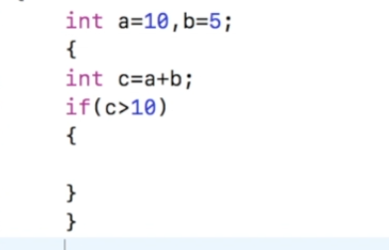
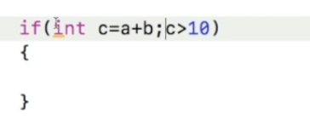
  - Using a dummy block
  - Using Decalaration

ARRAYS

- for each loop
  - for(int x:A)//the value of each element of the array is copied in x, We can
cout<<x<< endl;//manipulate the value of x without changing the original
  - for(int &x:A)
cout<<++x;//changes the original array

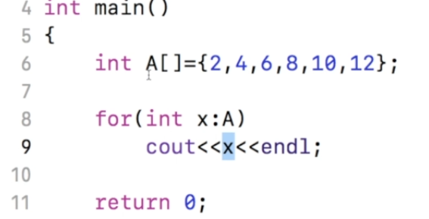
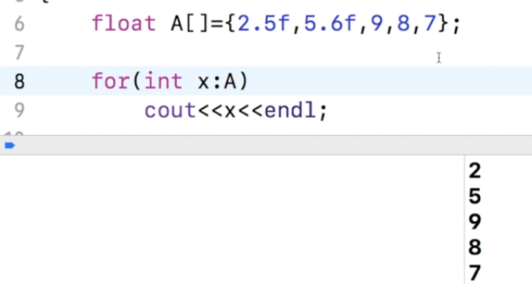
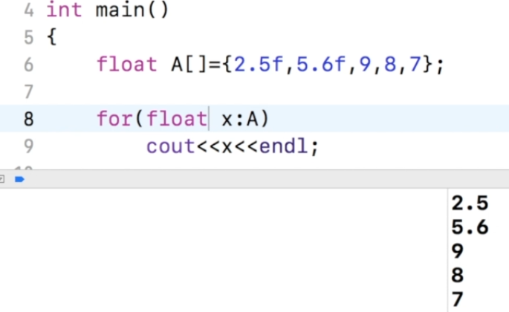
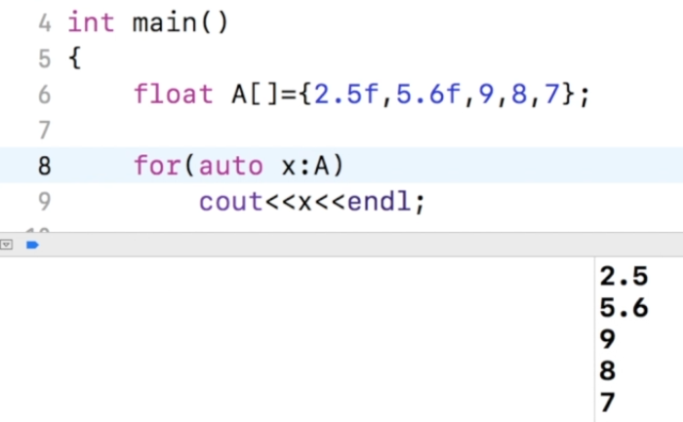
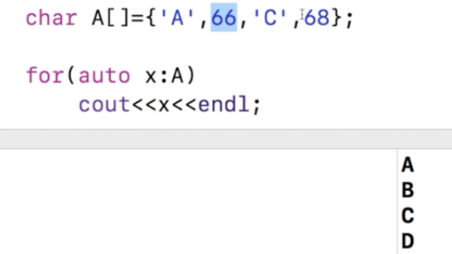
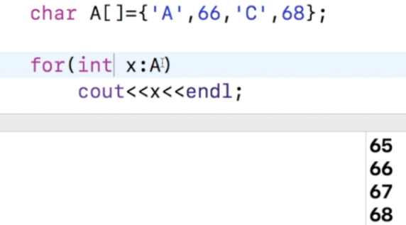

- Linear search{O(n)}
- Binary search{O(log(n))} : Sorted array required

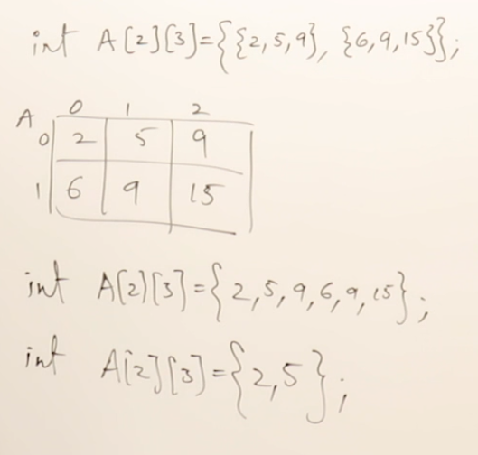
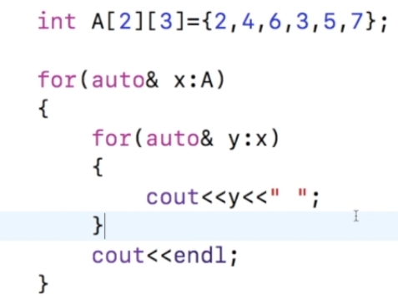
- 2D array :

POINTERS

- Variables
  - Data variable
  - Address variable
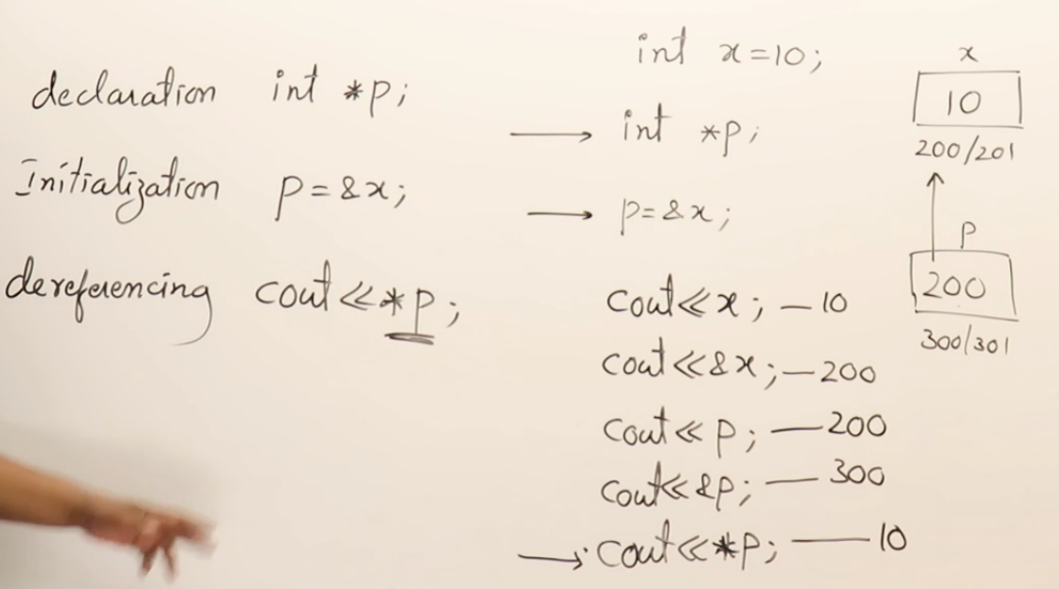
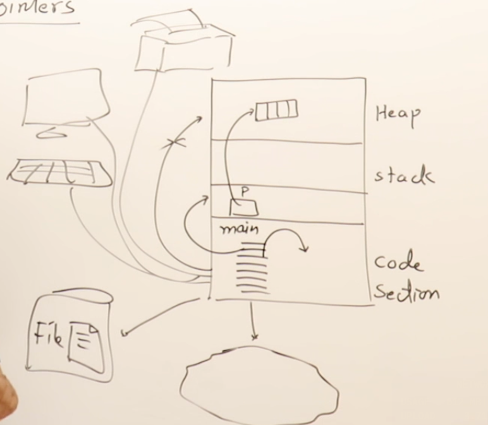
- A code has direct access only to the code section and the stack area. For accessing everything else the program needs a pointer.
- Heap
  - The size of the memory required is calculated at runtime not compile time.
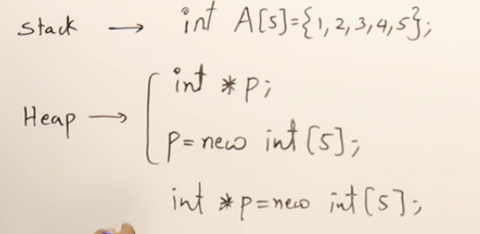
  - Accessing the heap : p[i]=48;...
  - Heap memory will persist as long as the program is running.
  - deallocation
    - delete []p;
    - p=null;//p=nullptr {Pointer not pointing anywhere}
  - Memory leak problem : When the ptr to heap memory is deleted before deallocating the memory.
- Arrays of dynamic size:
    - int size;
cin>>size;//old size
delete []p;//deletes the old array
int *p=new int[size];
cin>>size;//new size
p=new int[size];
- Pointer arithmetic
  - ptr++; ptr--; ptr=ptr+k; ptr=ptr-k; variable=ptr1-ptr2(distance btw the 2 ptr)
- Traversing an array
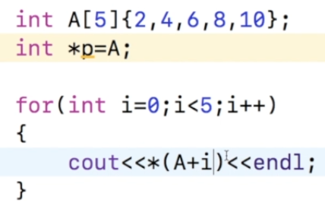
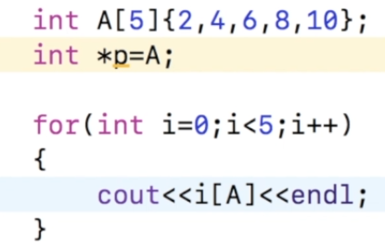
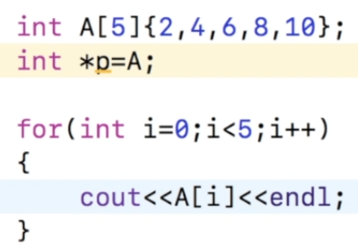
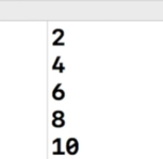
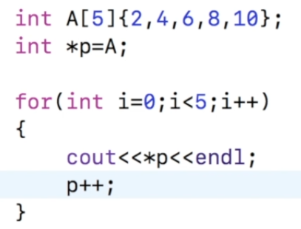
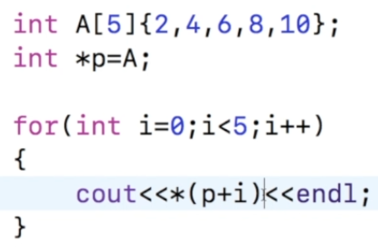
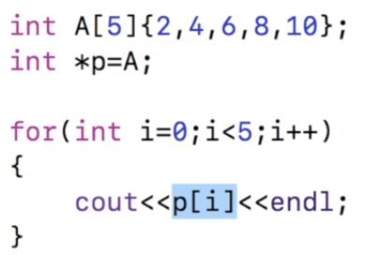
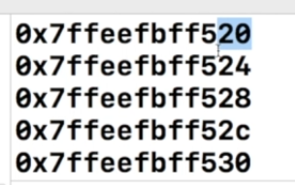
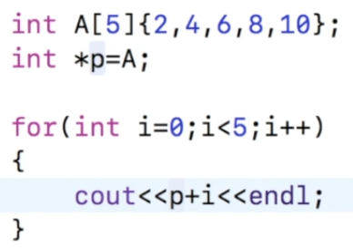
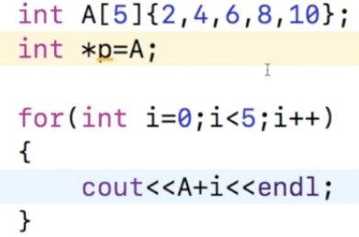
  - A is same as A[0]
- Problems in using pointers
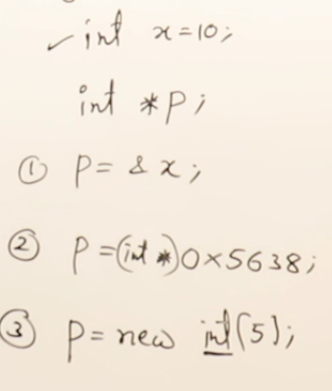
  - 1. Uninitialized pointers
heap memory
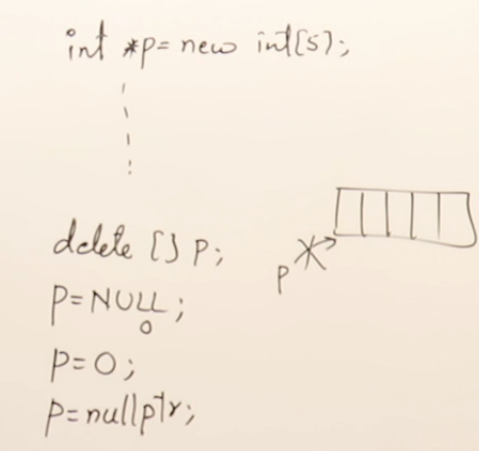
  - 2. Memory leak
Reserved keyword in c++ for the address corresponding to 0
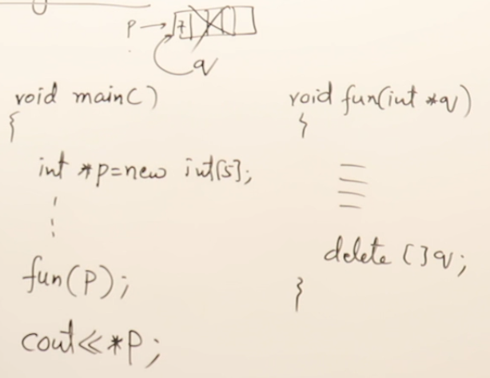
  - 3. Dangling pointer
Gives error as the shared memory has been deallocated, P becomes a dangling pointer
- Reference
  - It must be initialized while declaration.
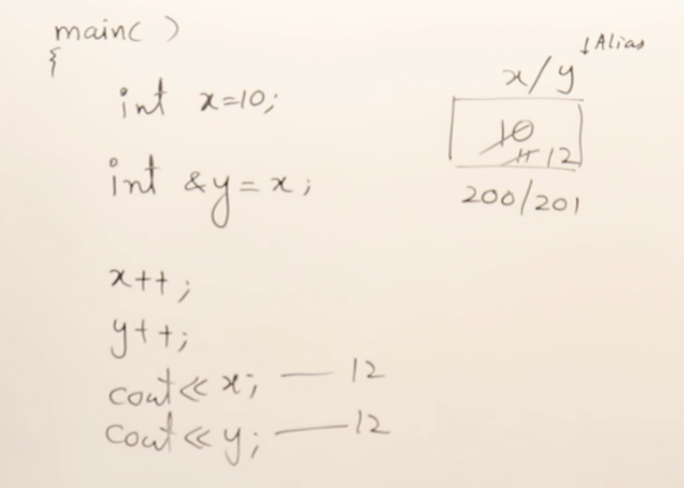
Here x act as Lvalue
y is another name for the variable x
  - Referencing does not allocate any memory.
  - lvalue : address of variable
  - rvalue : data of variables
  - once a variable is set as refrence it can’t be used again in the program to refer to another memory.
- Pointer to a function
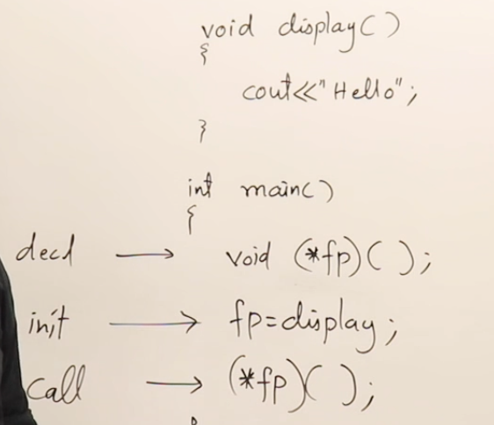
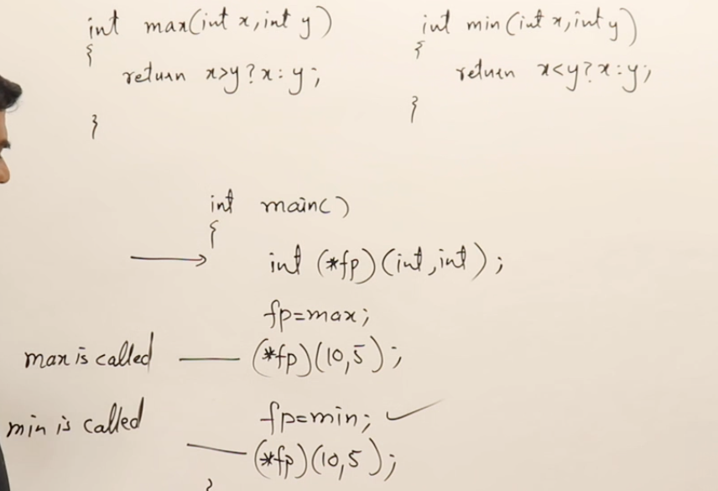
  - A function ptr can point to many functions which have the same signature.
  - It is helpful in achieving runtime polymorphism using function overriding.
FUNCTIONS

- Use of cin and cout should be avoided in a called function(bad function).They should be present inside main function.
- Function overloading
  - Having multiple function with same name but different arguments
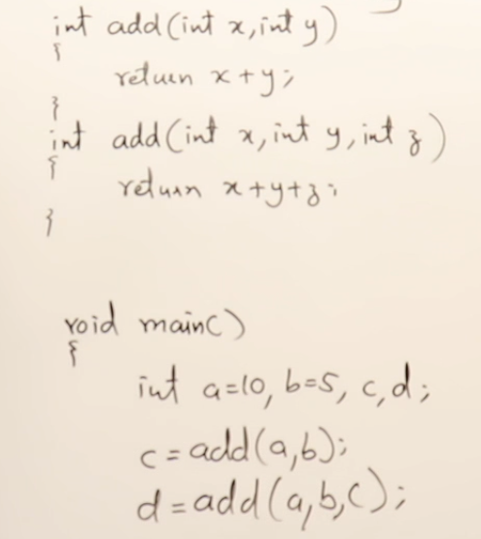
  - Function Template
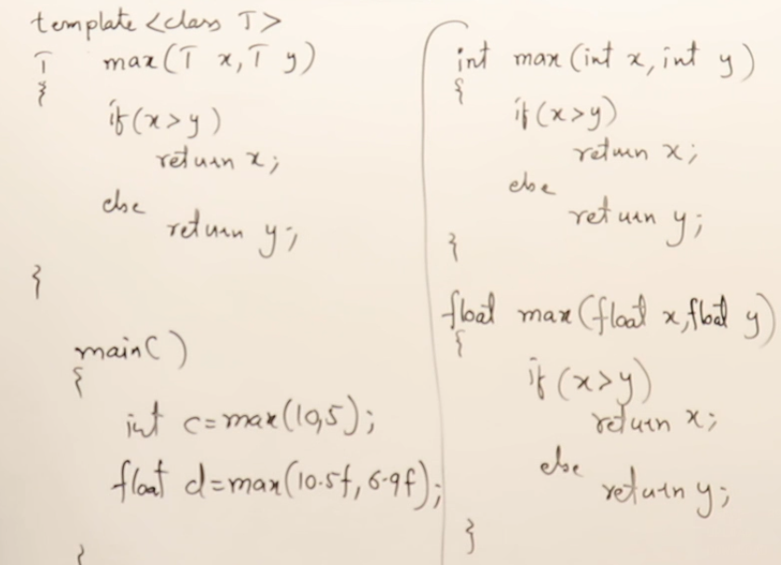
    - Default template
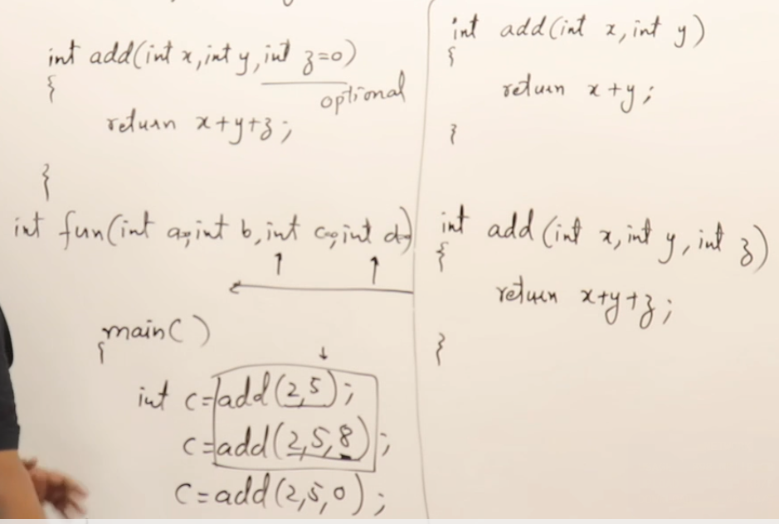
- Parameter passing
  - Call by value
  - Call by address
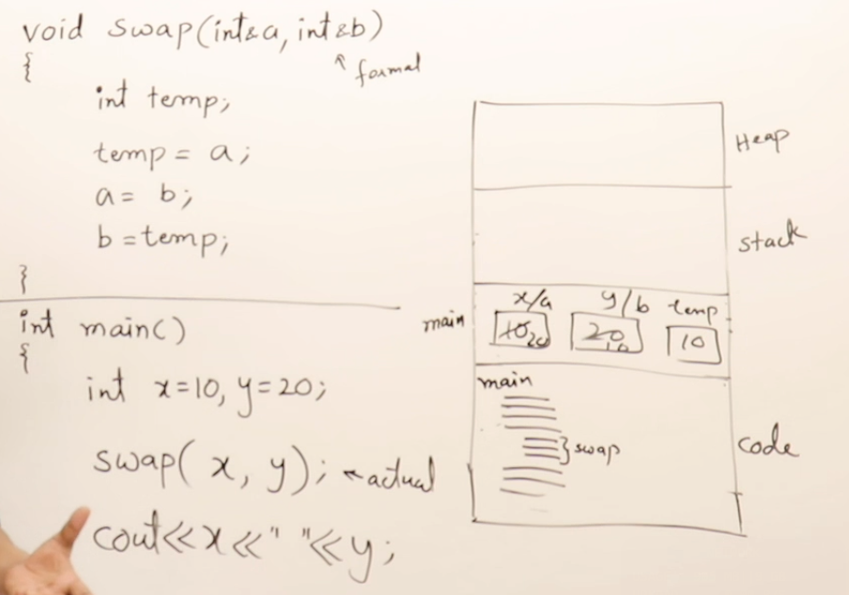
  - Call by reference : The called function automatically becomes an Inline function.
    - Complex code should not be written inside the function if the function is called as call by reference.

- Return by address:
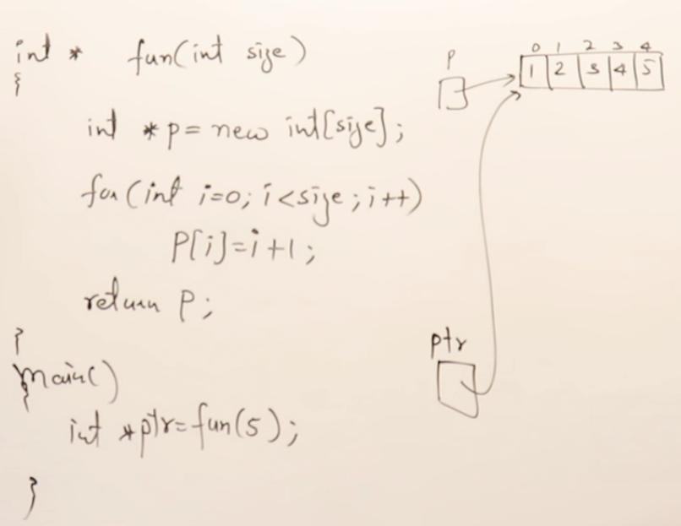
  - The variables used in the called function should be in heap memory as the variables in the stack (local variables) will be deleted as soon as the program will be finished.

- Return by reference
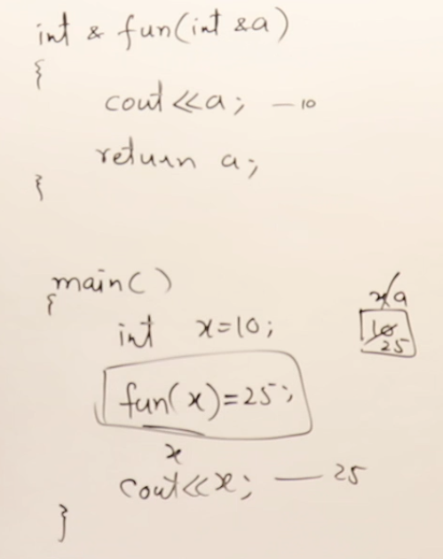
- Local and Global variables
  - The memory for the global variable is allocated in code section. At loading time before the execution.
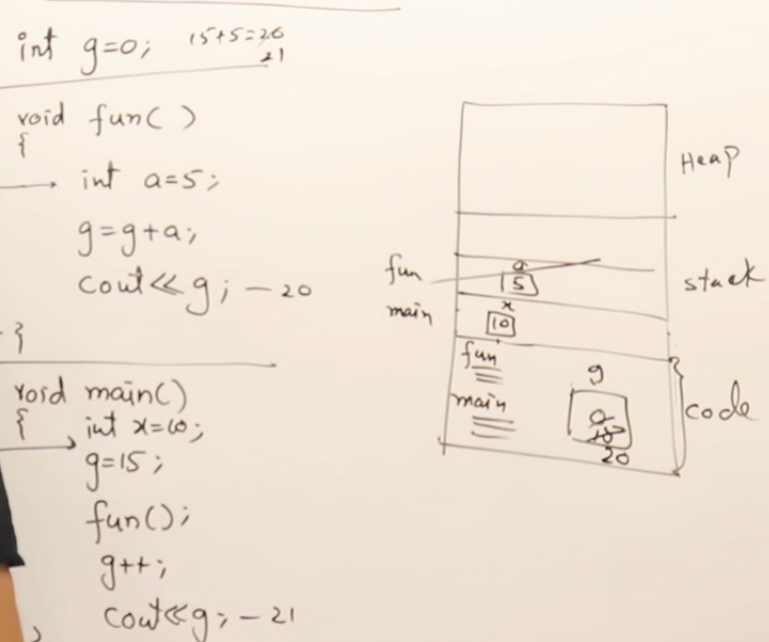
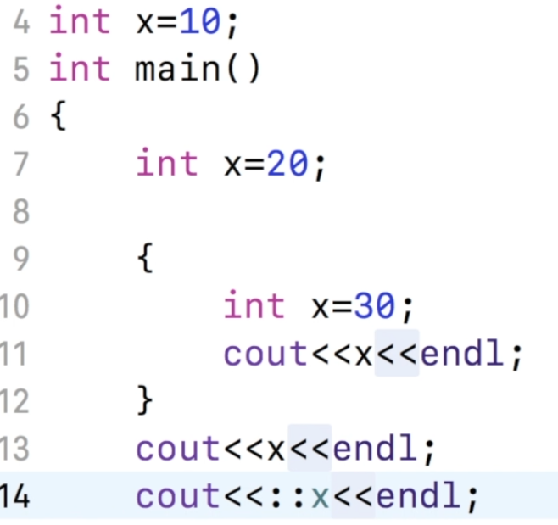
30
20
10=>global variable
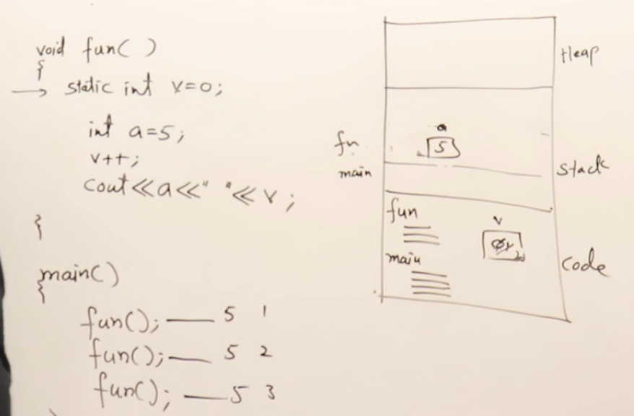
- Static variables : The variables whose life is until the program ends but they are accessible only inside the function in which they are declared.

INTRODUCTION TO OOPS
- A software is a collection of objects which contains all the relevant functions related to that object.
- Priciples of oops
  - Abstraction
  - Encapsulation
    - Data hiding
  - Inheritance
  - Polymorphism
- Classes and Objects
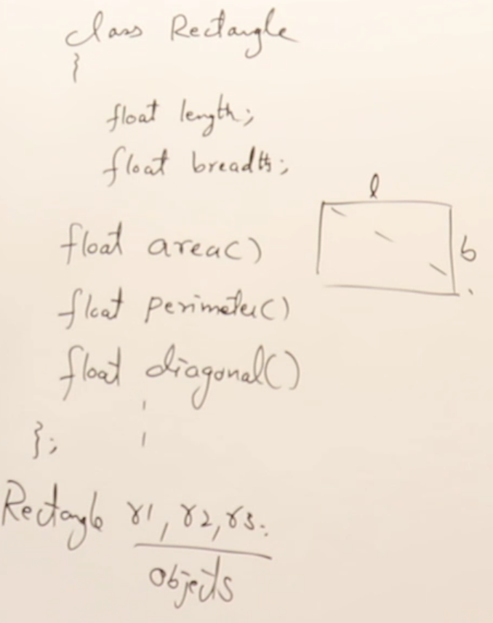
  - Classes:
Properties
Behaviour
- Writing the classes :
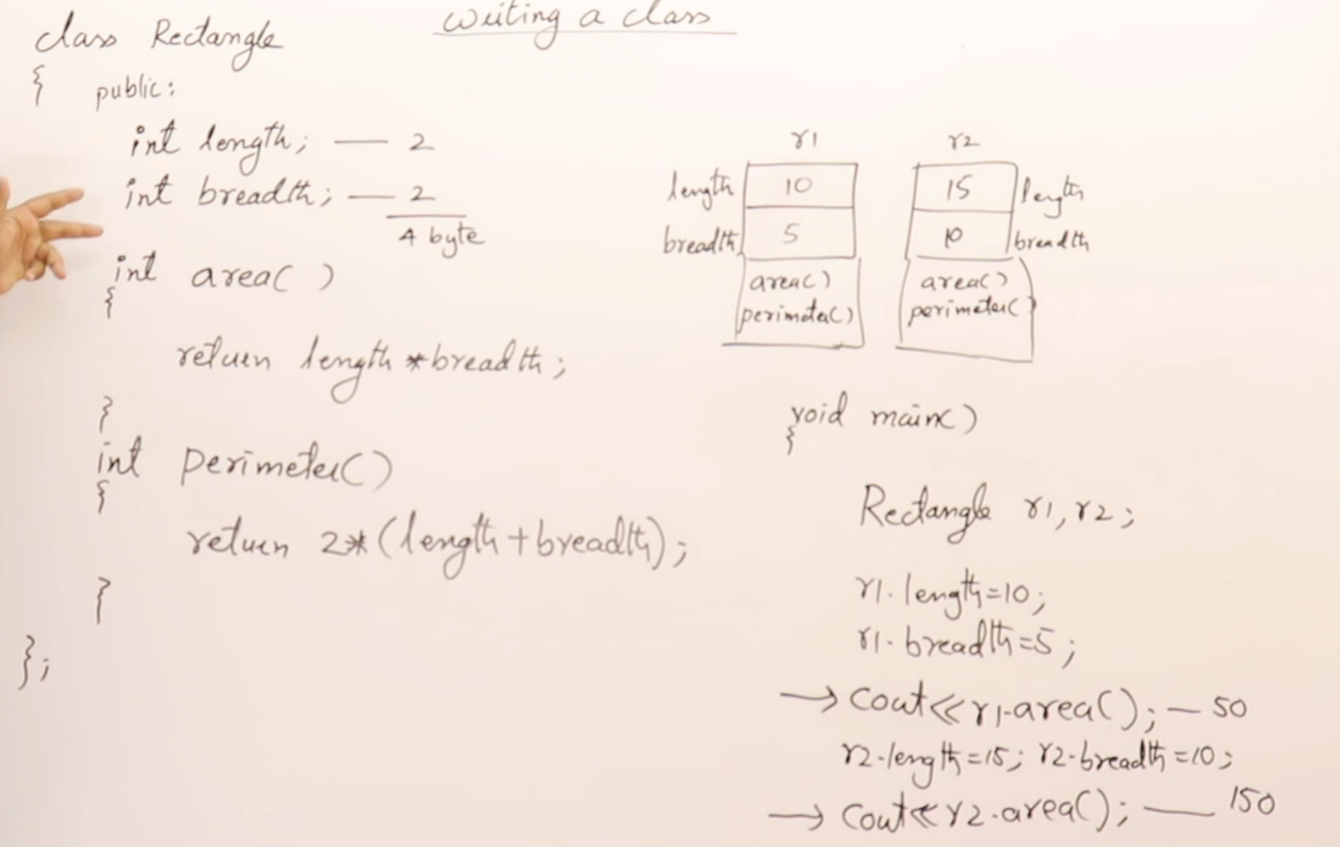
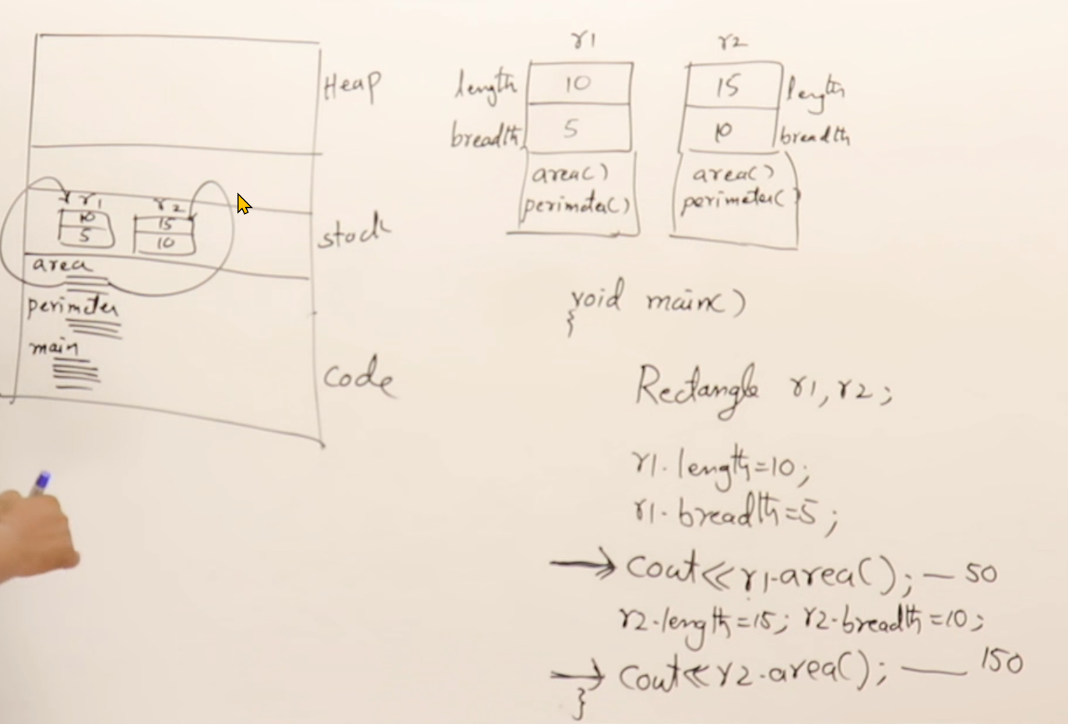
- Pointer to objects :
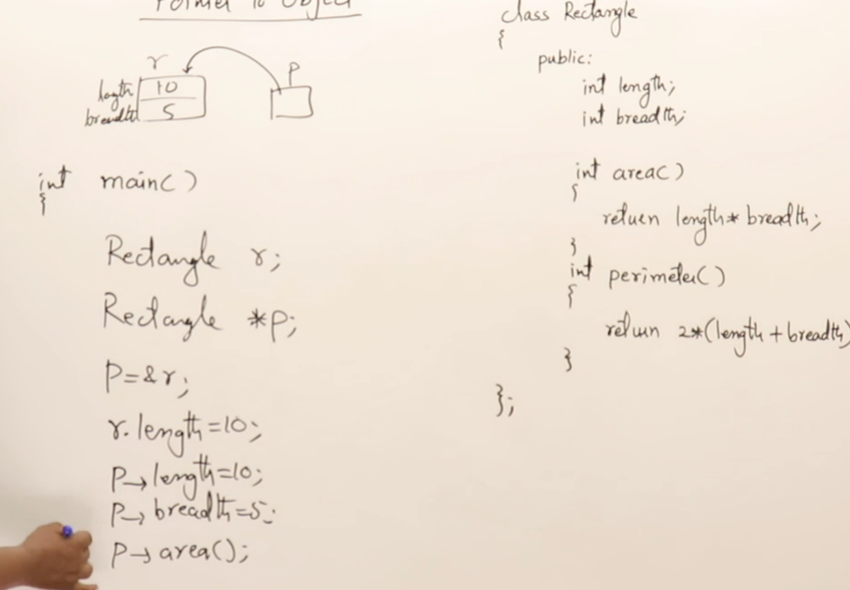
  - Creating an object in heap
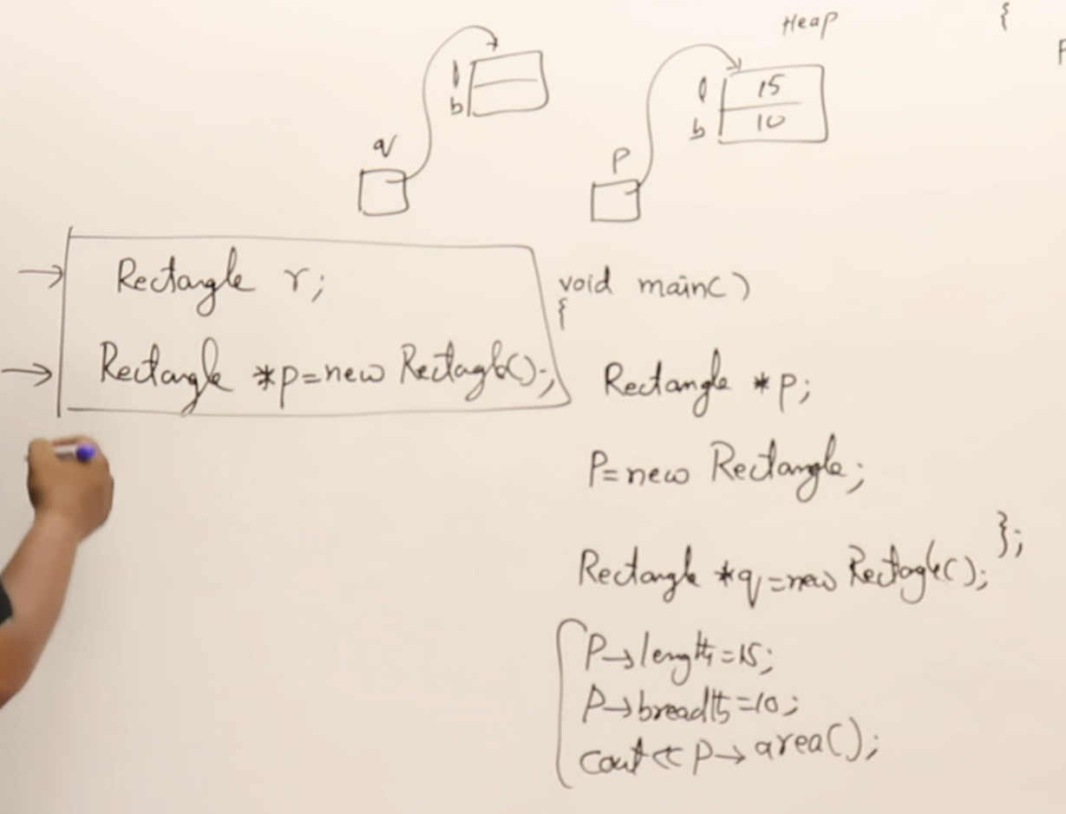
- Data Hiding
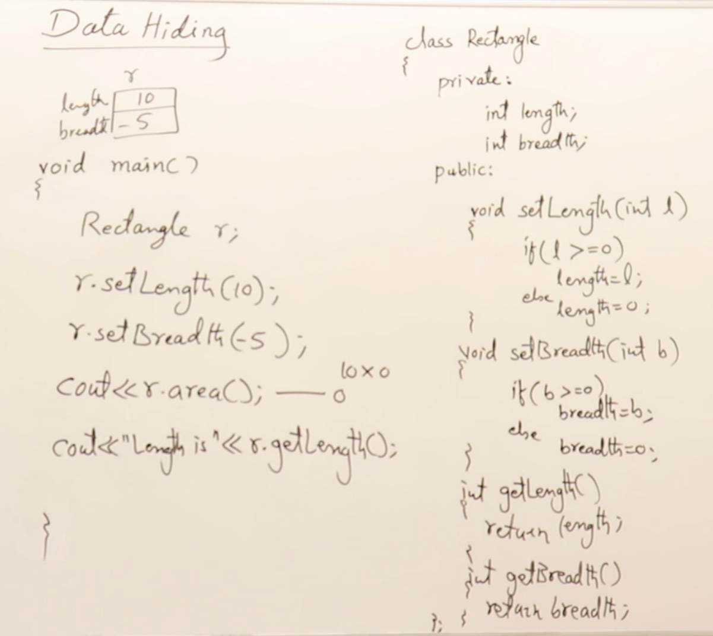
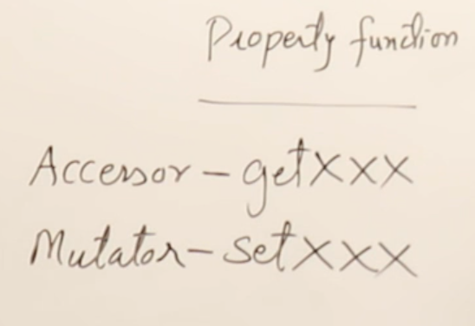

CONSTRUCTORS
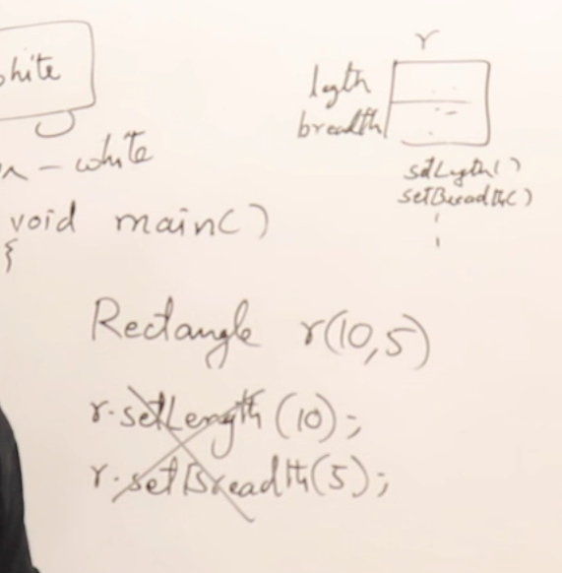
- Types of constructors :
  - Built-in/System(Provided by the compiler)
    - Default constructor
  - User defined:
    - Paramterized
    - Non-parametrized
    - copy constructor
- Constructors are functions that have the same name as the class but have no return type.
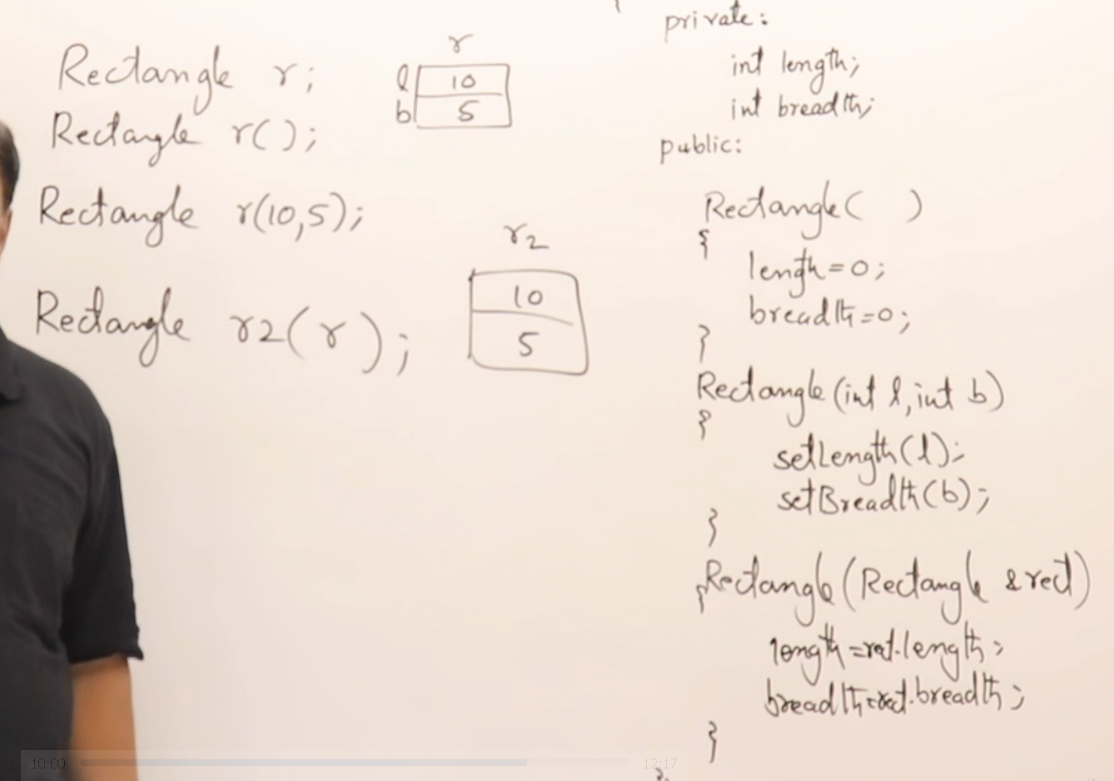
- Using default arguments
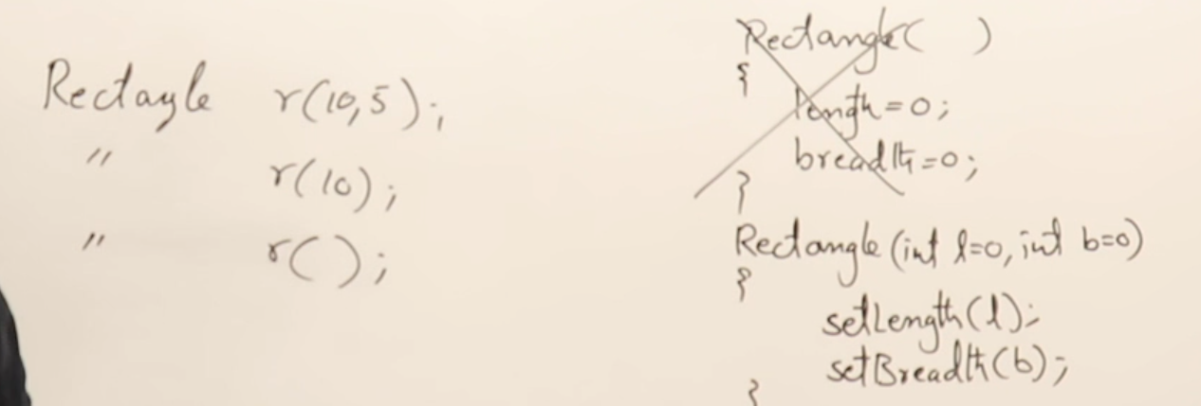
- Deep copy constructor : used when there is dma.
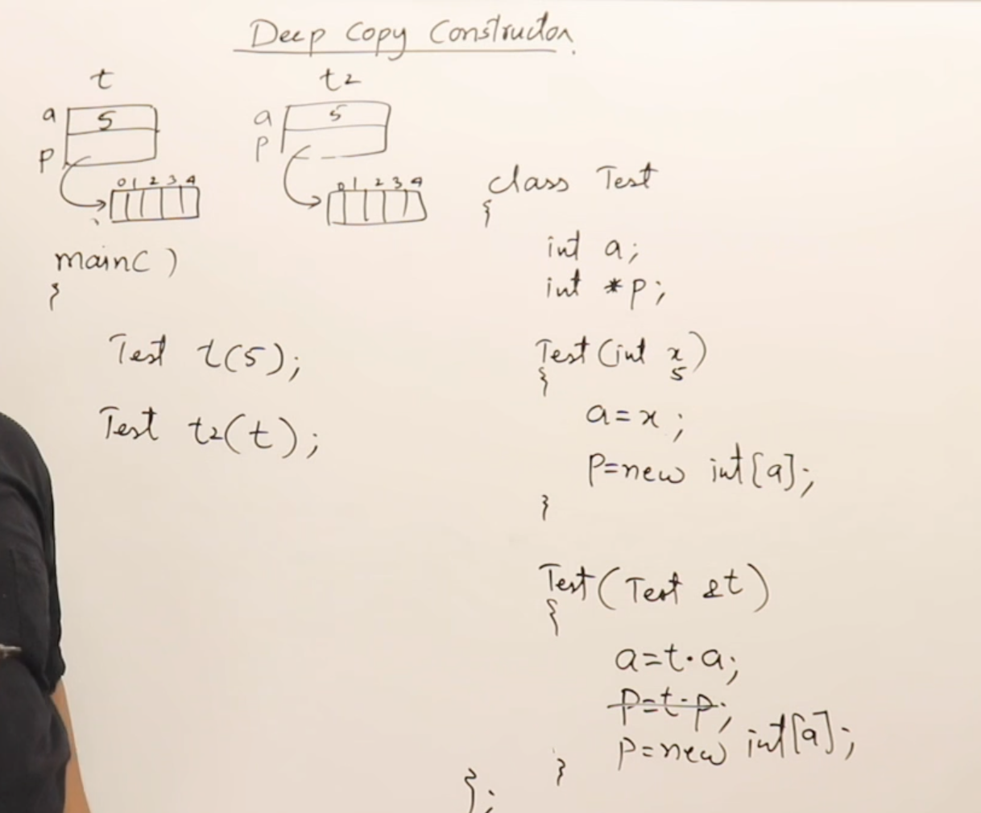
- Types of functions in a class
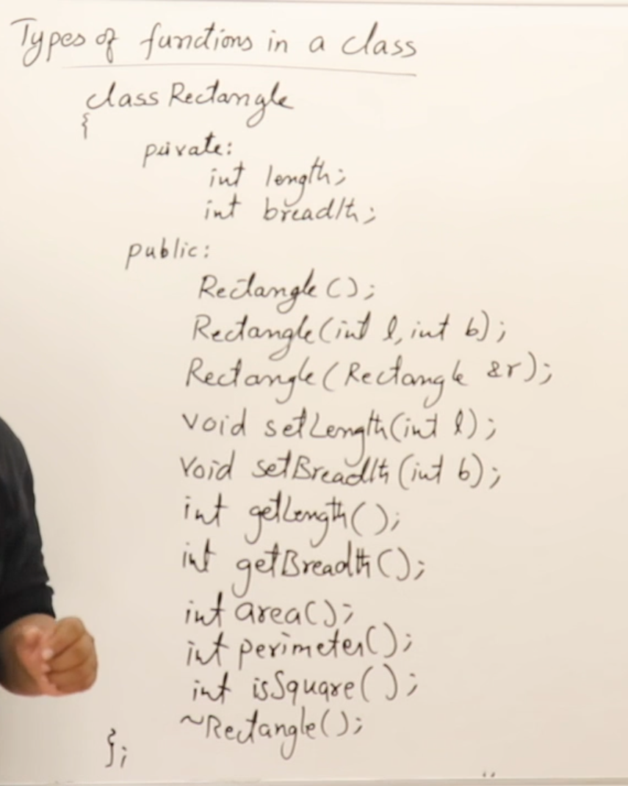
CONSTRUCTORS
MUTATORS
ACCESSORS
FACILITATORS
INSPECTOR/ENQUIRY
DESTRUCTOR
- Methods to write fucntions in a class
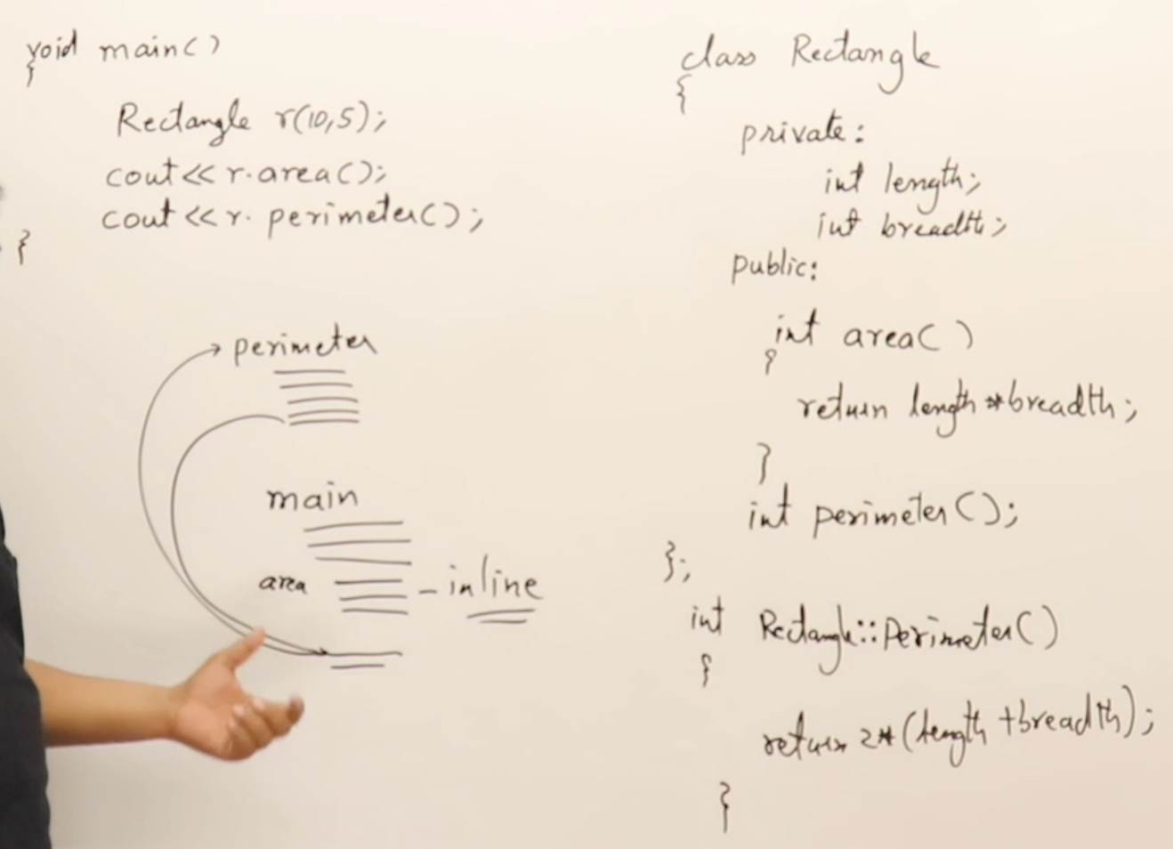
- Inline function
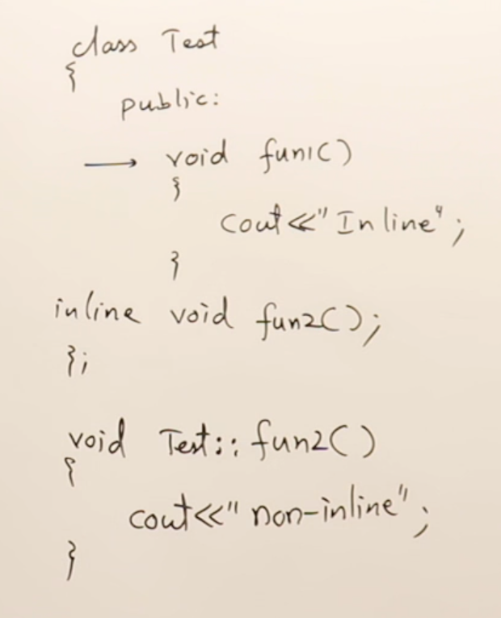
- this
  - used to access the members of the current object
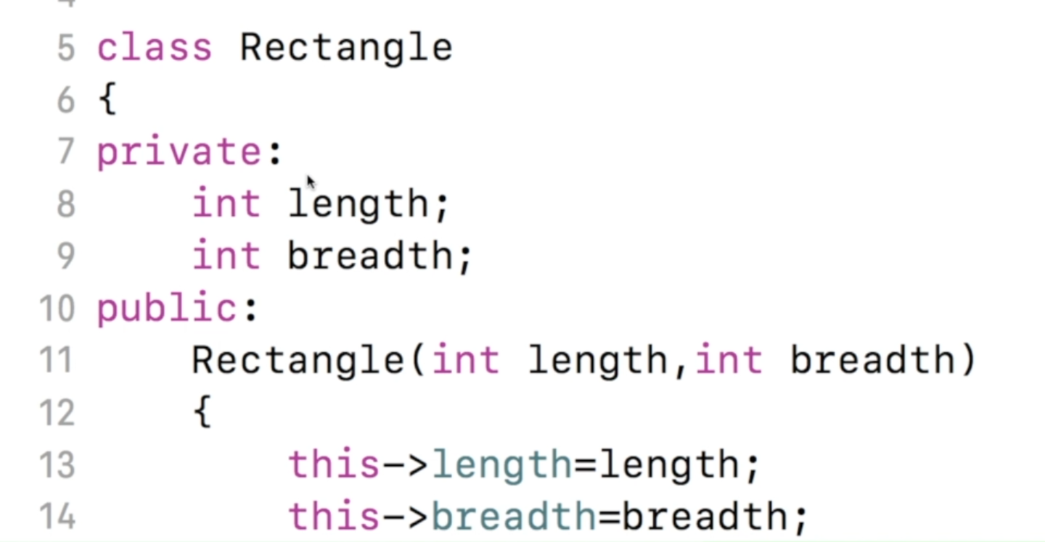
- classes vs struct
  - Bydefault in class all the things are private and in stuct all the thing are public.
OPERATOR OVERLOADING
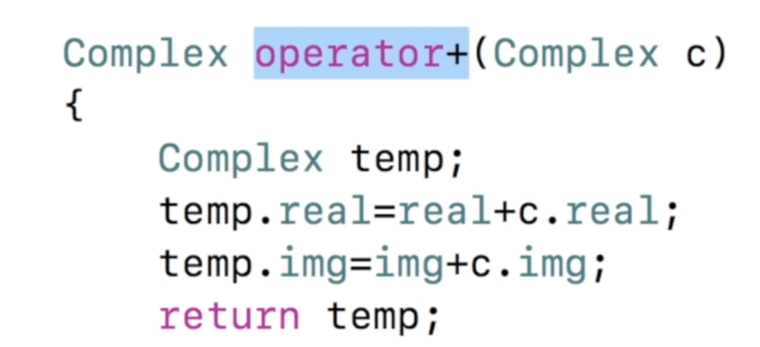
CALL : c=c1+c2;
- Friend operator overloading
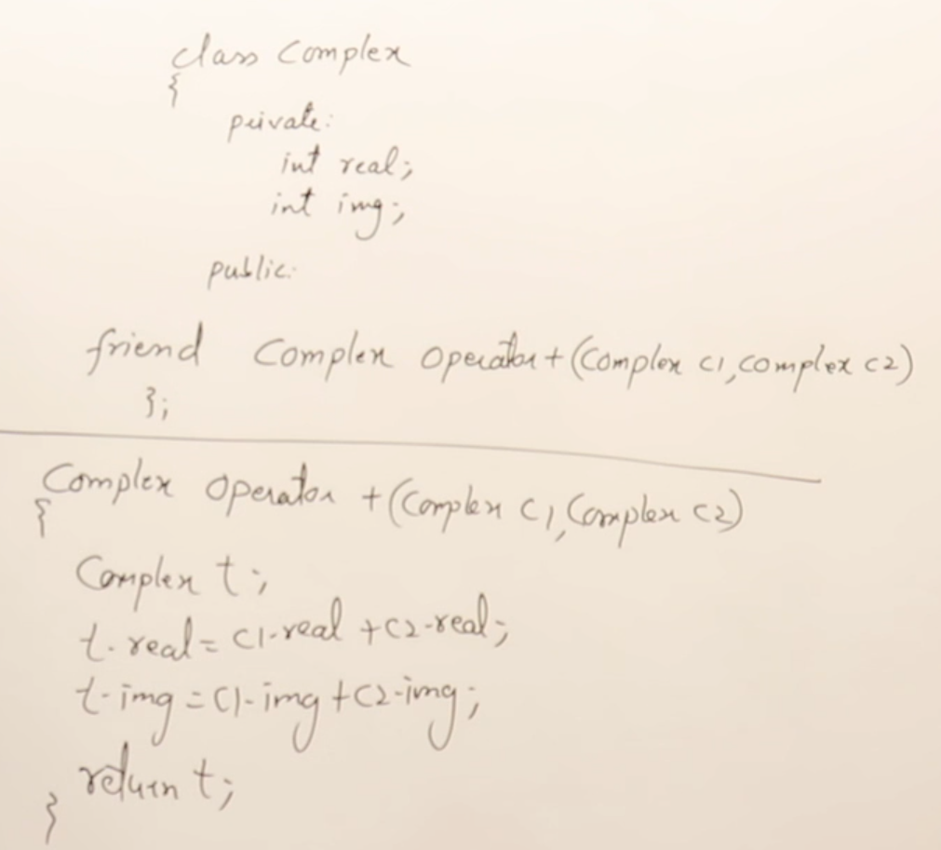
CALL : c=c1+c2;
- Overloading insertion and exertion operators
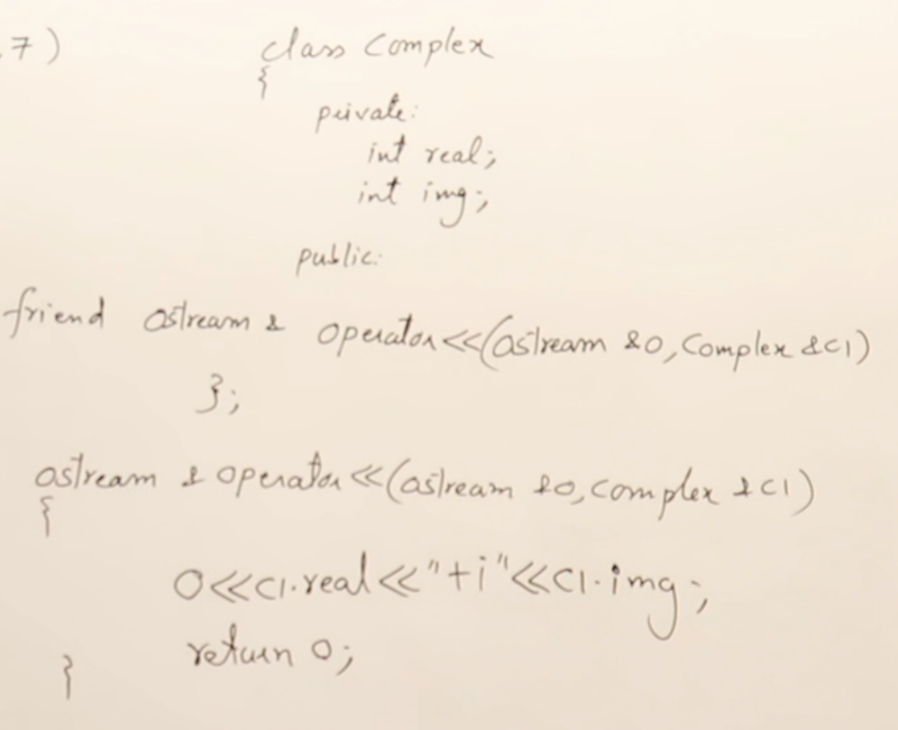
CALL : cout<<c;
OR
operator<<(cout,c)

INHERITANCE

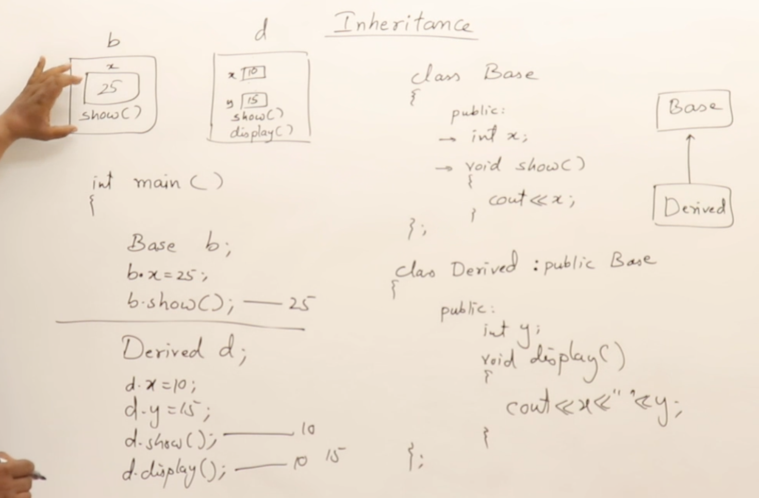
- Constructors in Inheritance
- Always the default constructor of base class is executed first.
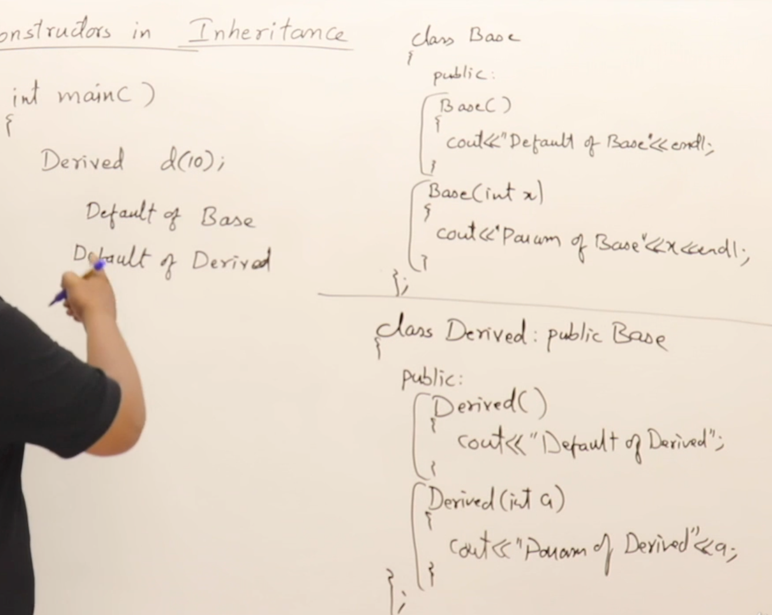
- To execut e the parametrized constructor of base class first
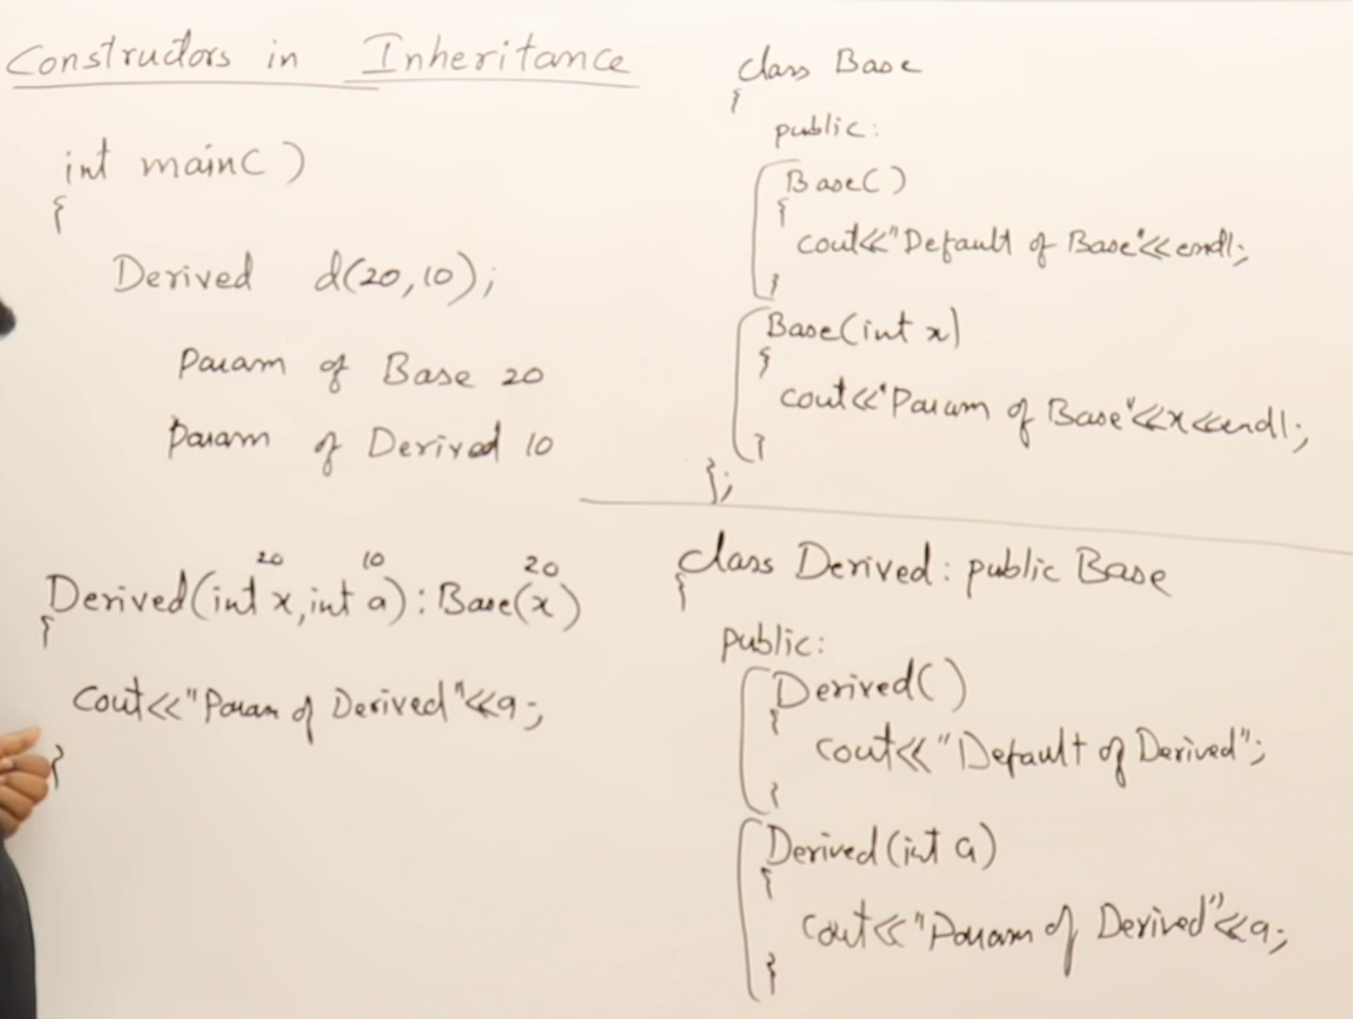
- A class can have a isA and hasA relationships.
- Access specifiers :
  - Private : Accessible only to the parent base class.
  - Protected : Accessible to derived class also.
  - Public : Accessible to everyone
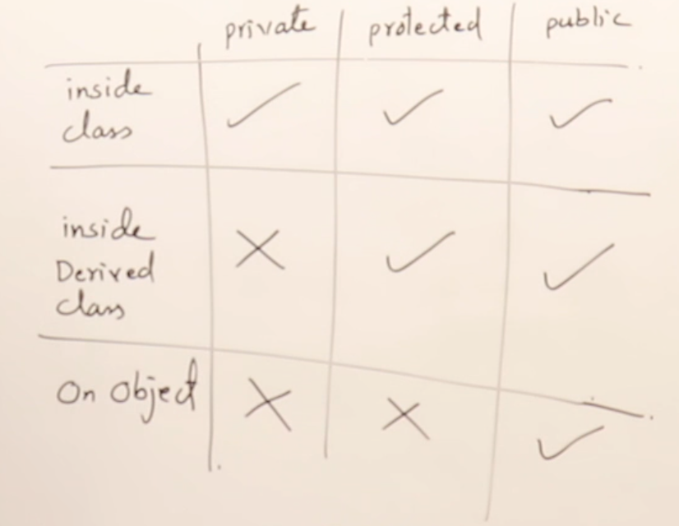
- Types of Inheritance in cpp
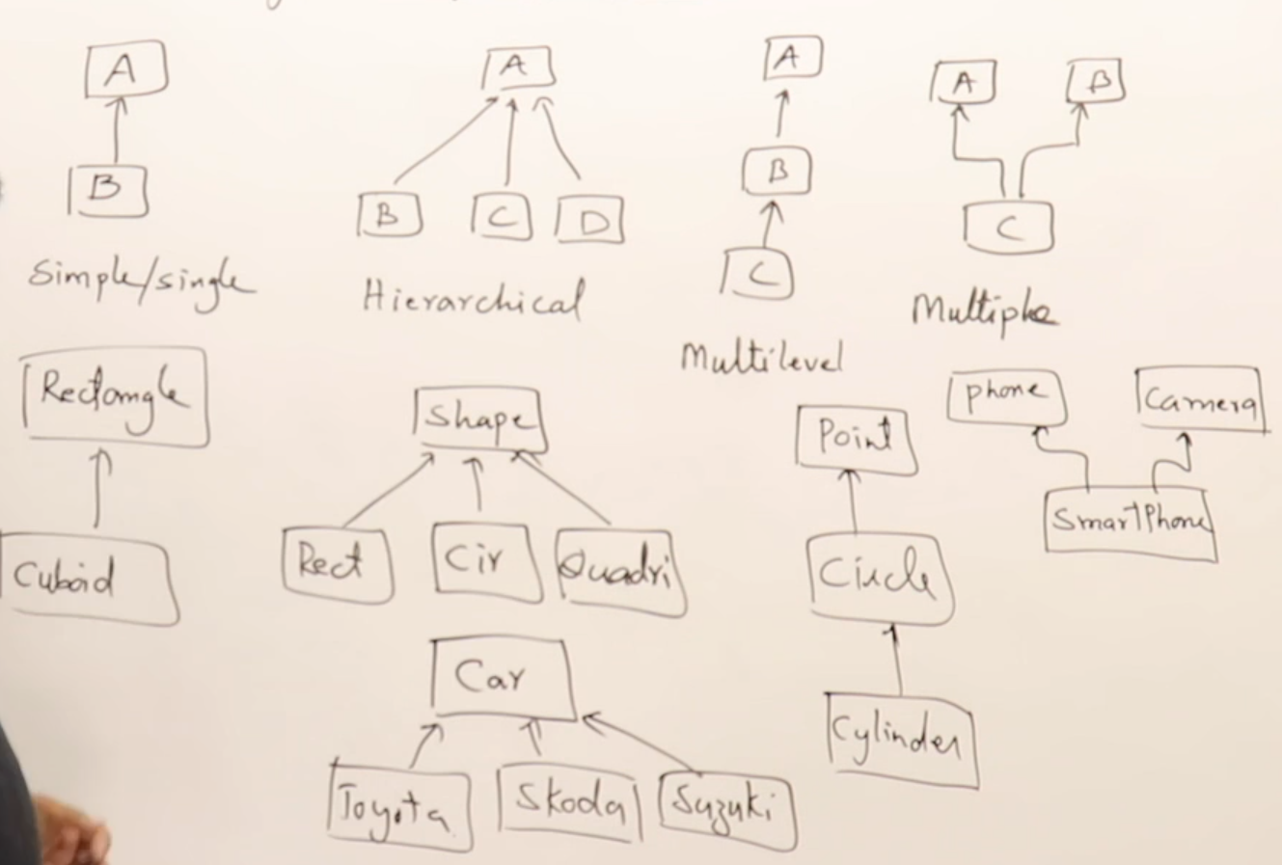
  - Virtual base classes : Used to remove ambiguity in case of Multipath inheritance.
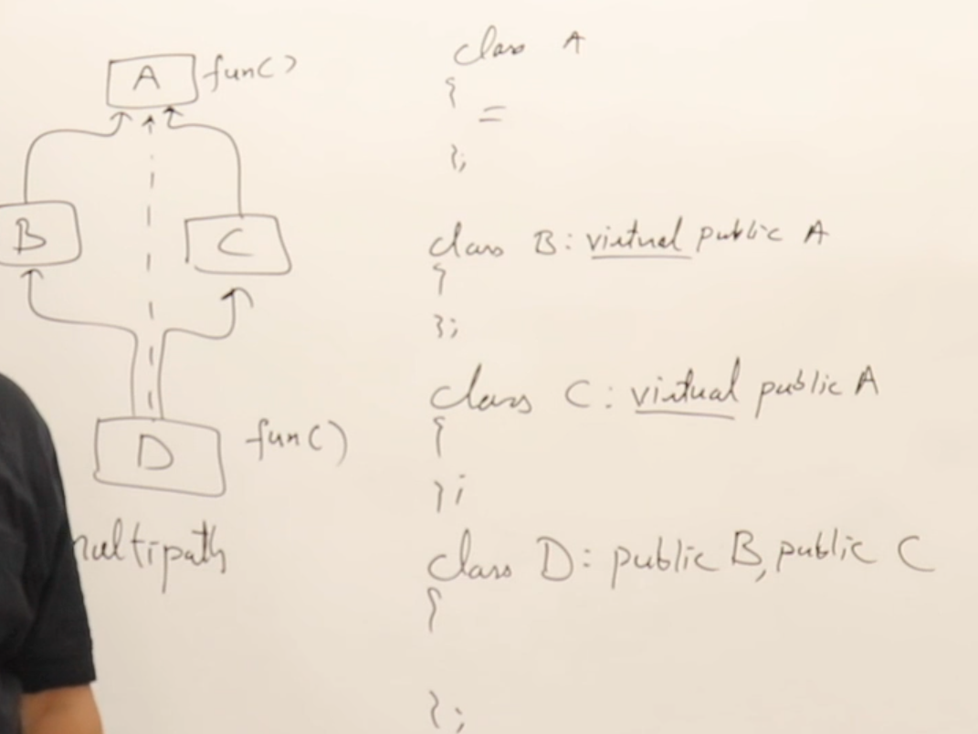
  - Inheriting publically
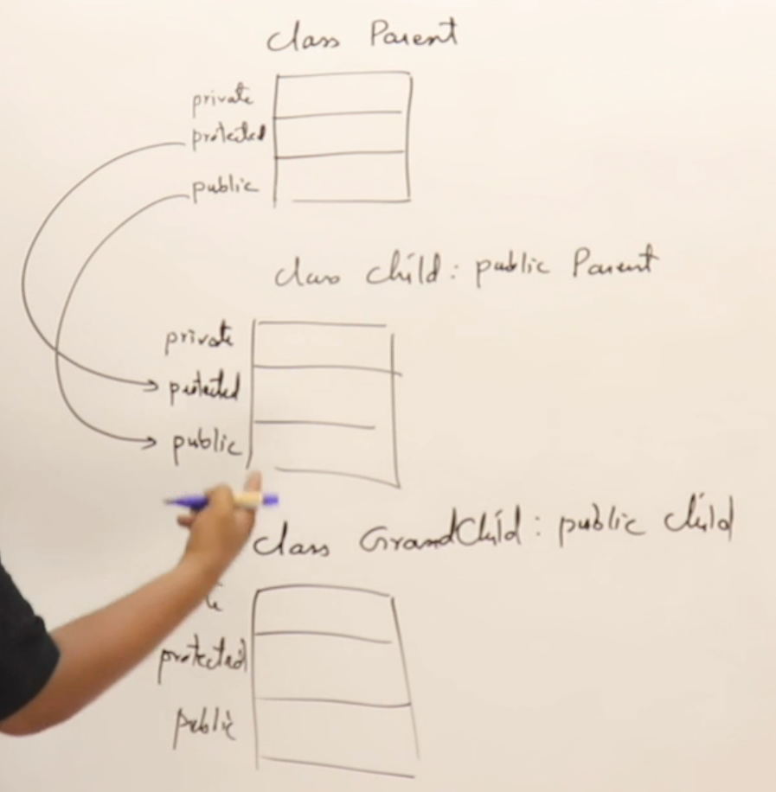
  - Inheriting protectedly
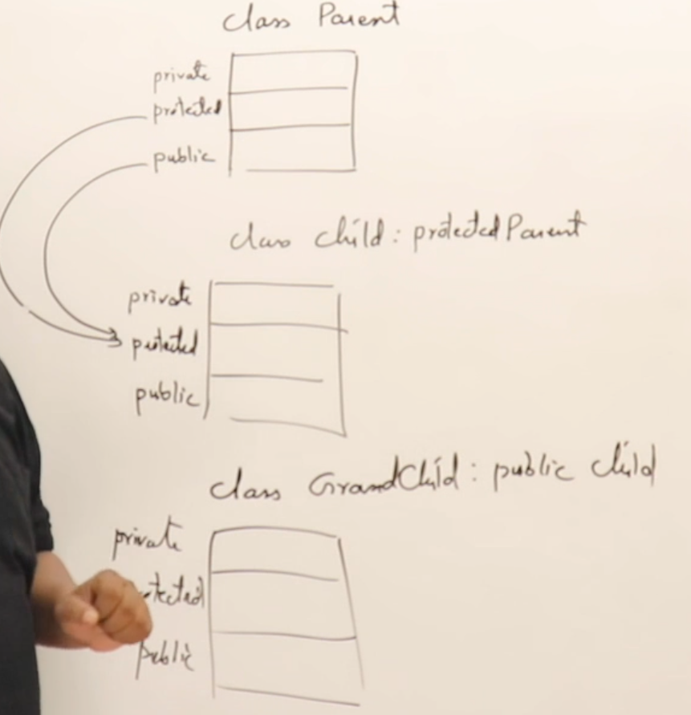
  - Inheriting privately
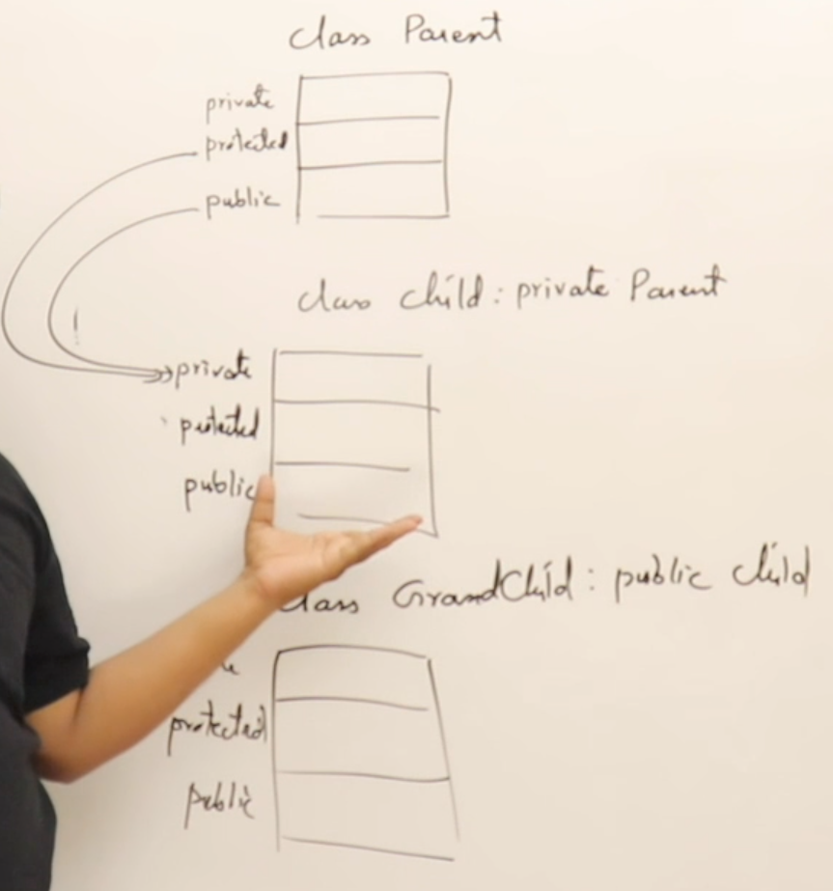

Base class pointer and derived class objects
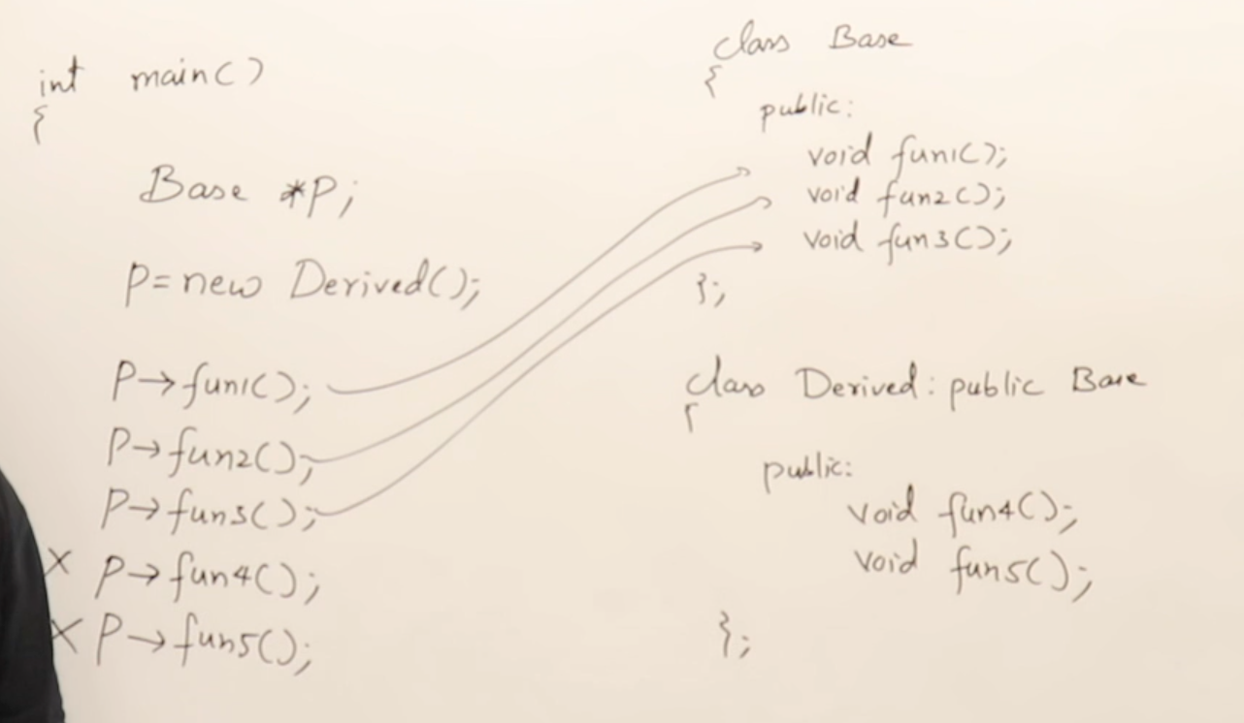
- It is not possible to assign the address of a derived class to the base class’ pointer.
Function overriding
- Function with same prototype if present in derived class is given precedence over the function in base class
- Calling overrided function using base pointer.
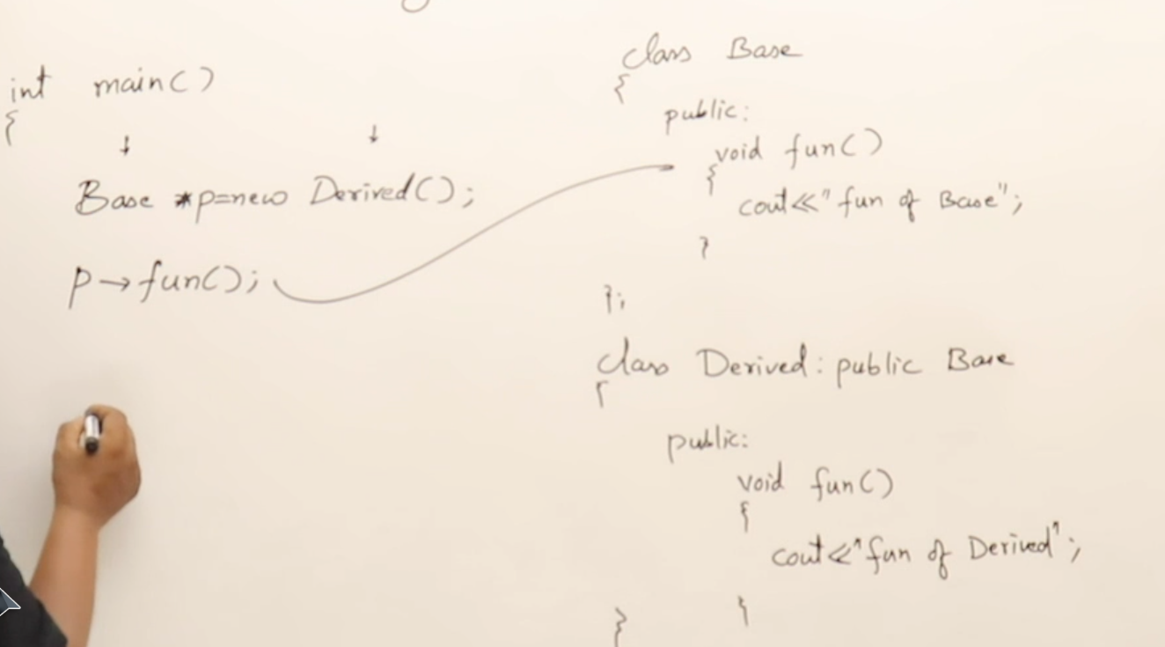
  - Using virtual functions
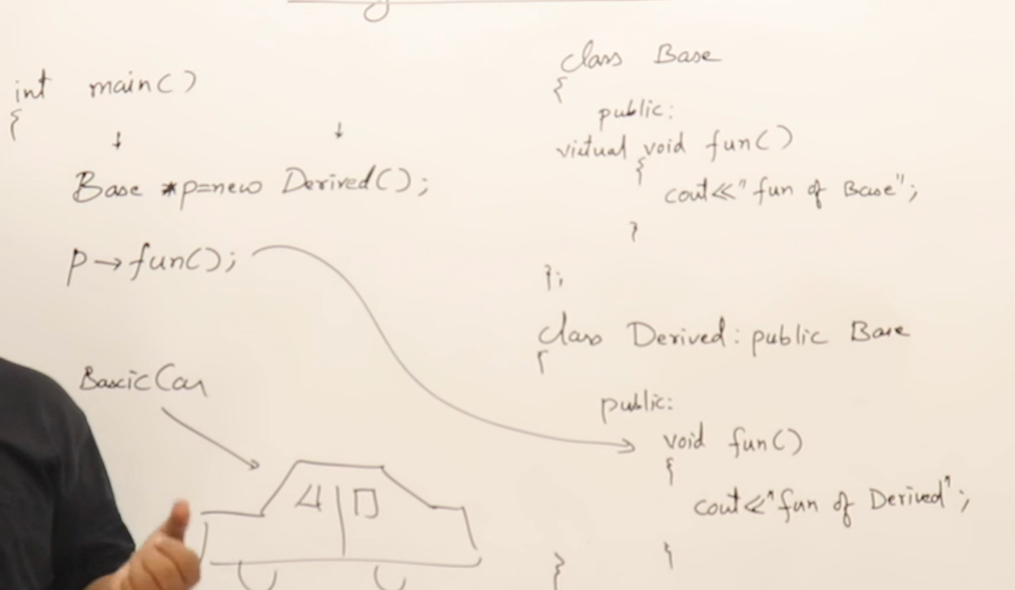
    - It is runtime polymorphism.

Polymorphism
- Pure virtual functions and polymorphism(abstract class)
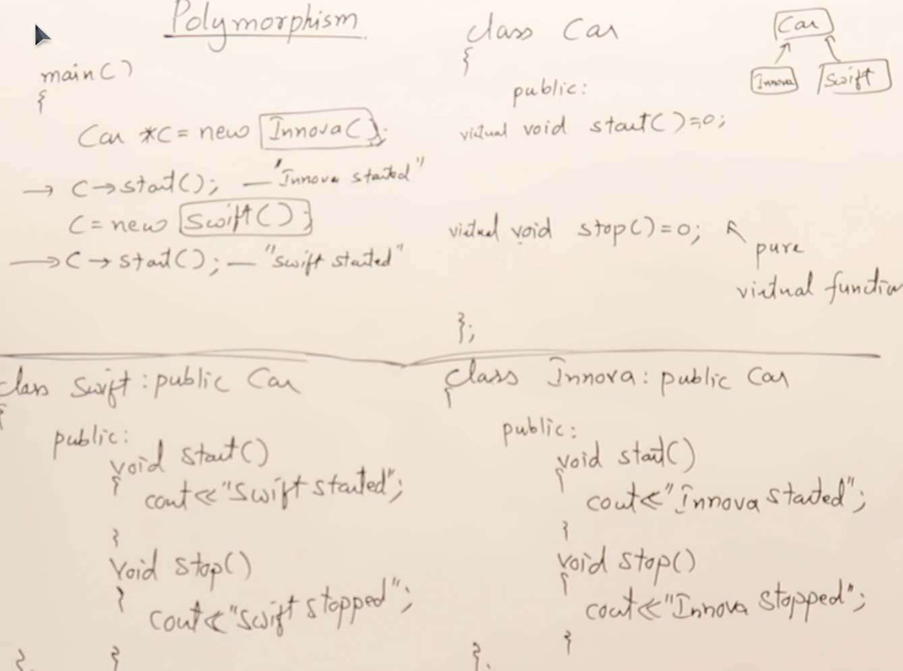
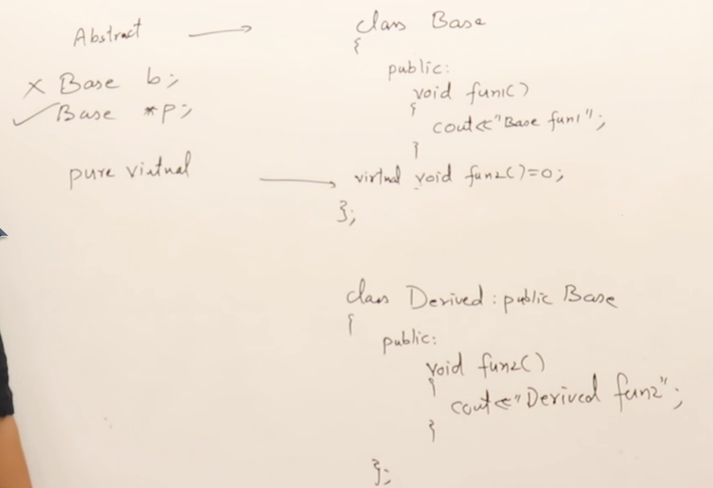
  - Types of classes
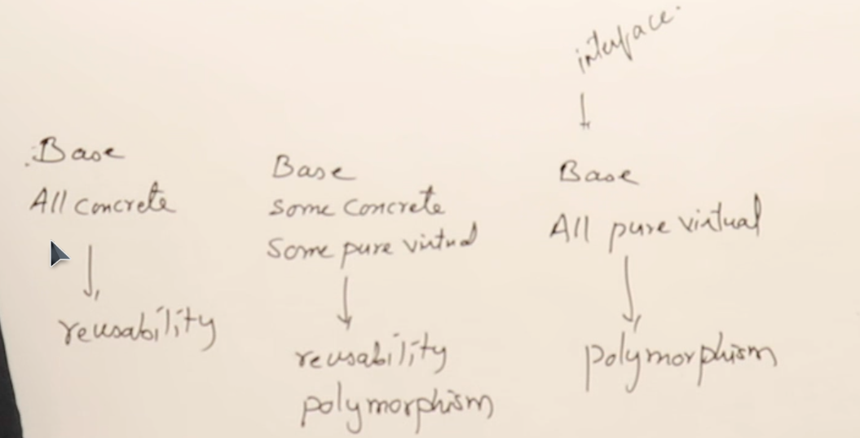
ABSTRACT

Friend functions
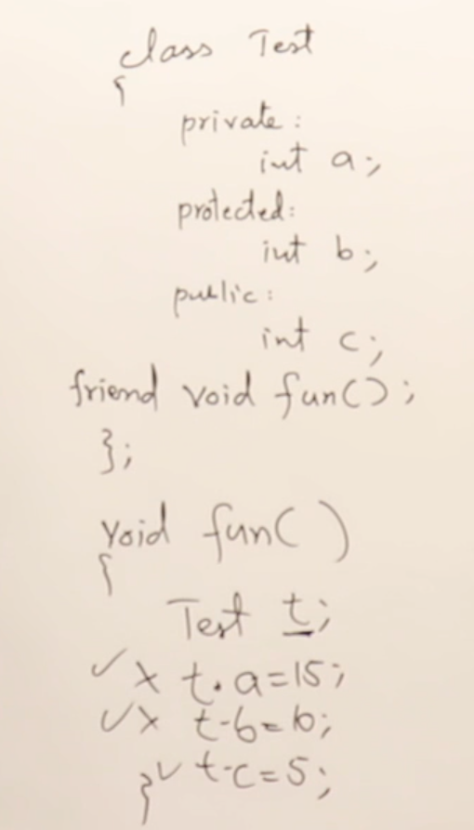
- Friend function
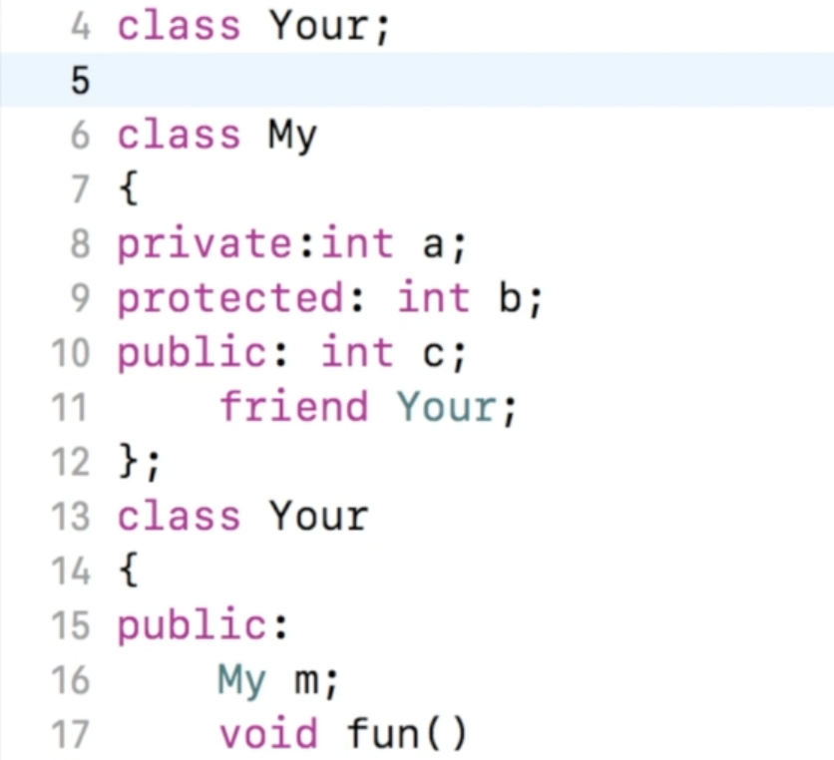
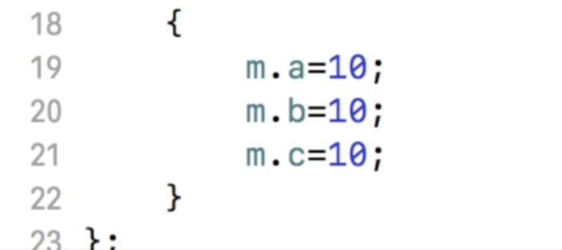
- Friend class
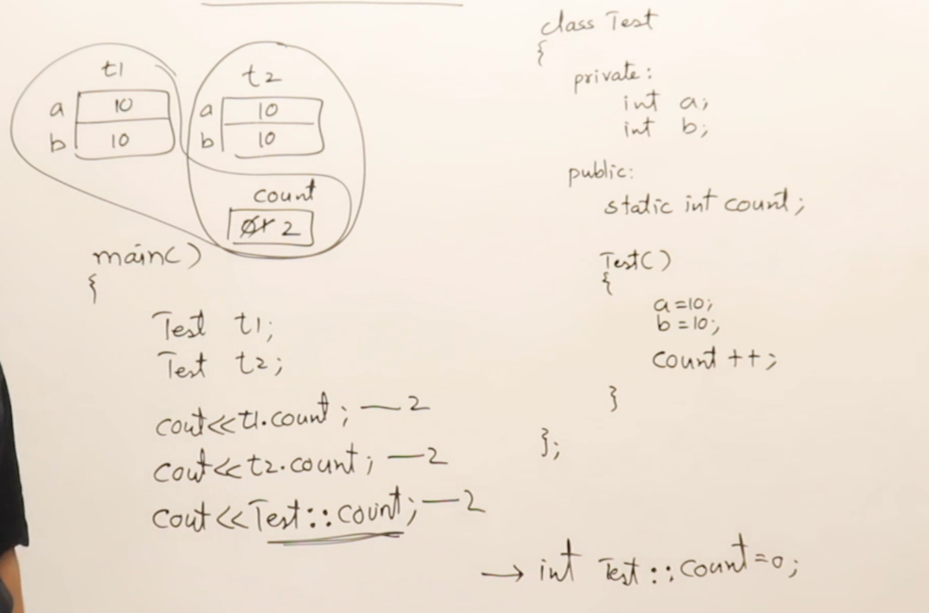
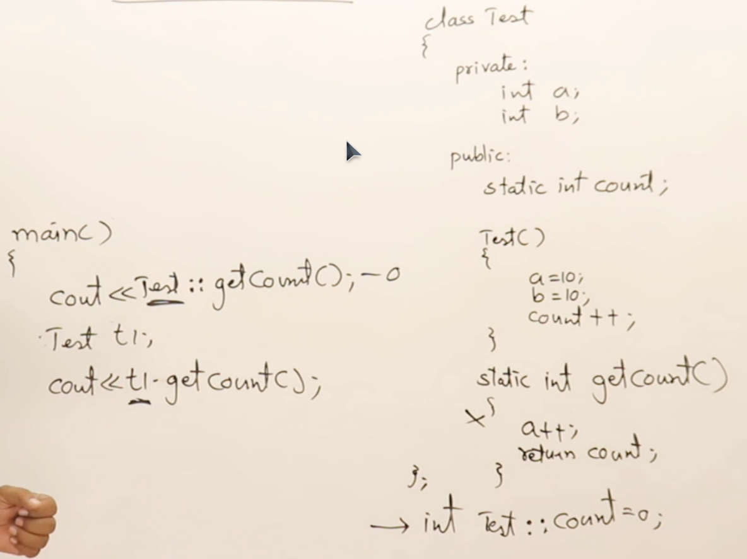
- Nested classes
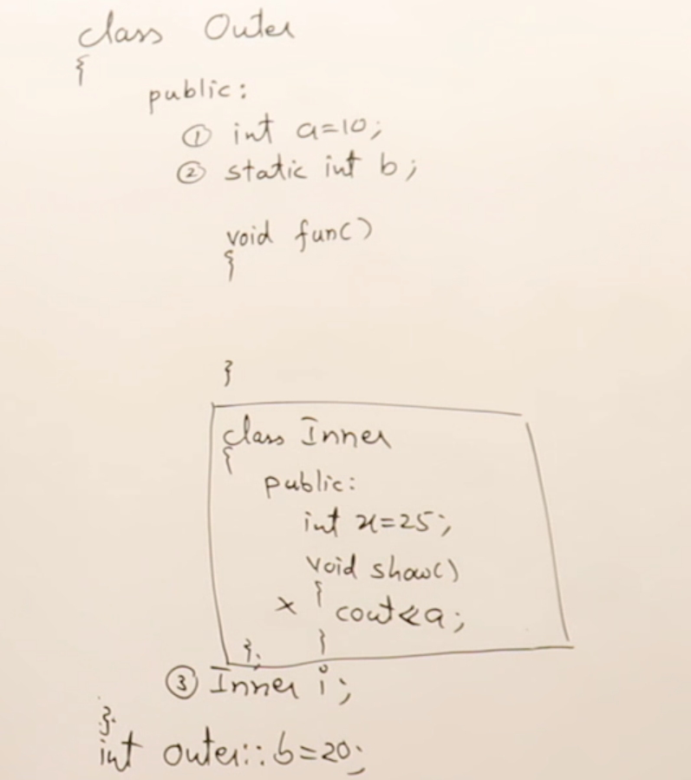
Can’t be accessed, Only the static members can be accessed
Outer class can access only the public members of the inner class.
Exception handling
- Errors
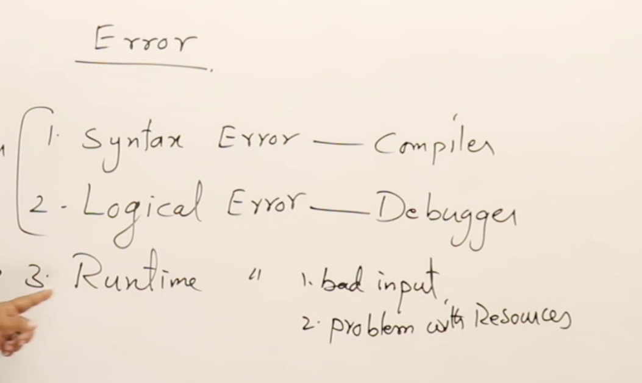
Caused by the programmer
Caused by the user
- We can throw :
  - int, float, double, char, string, class
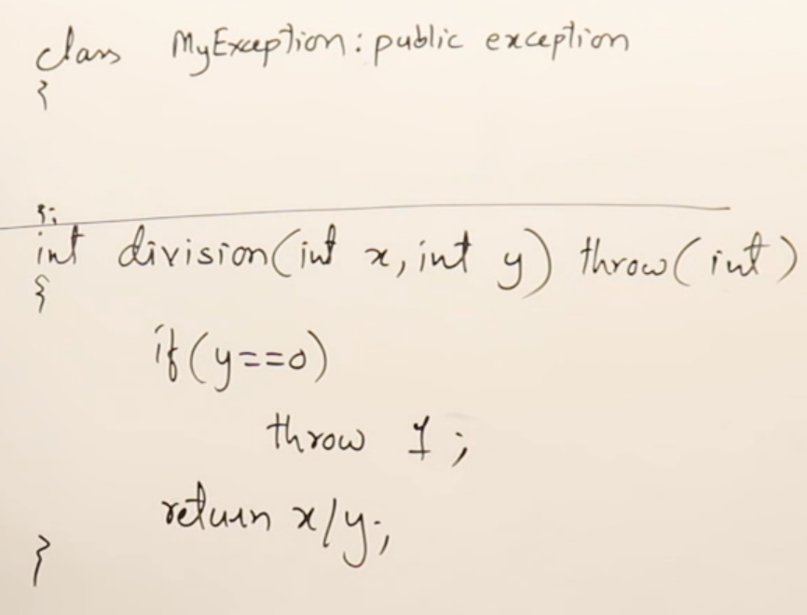
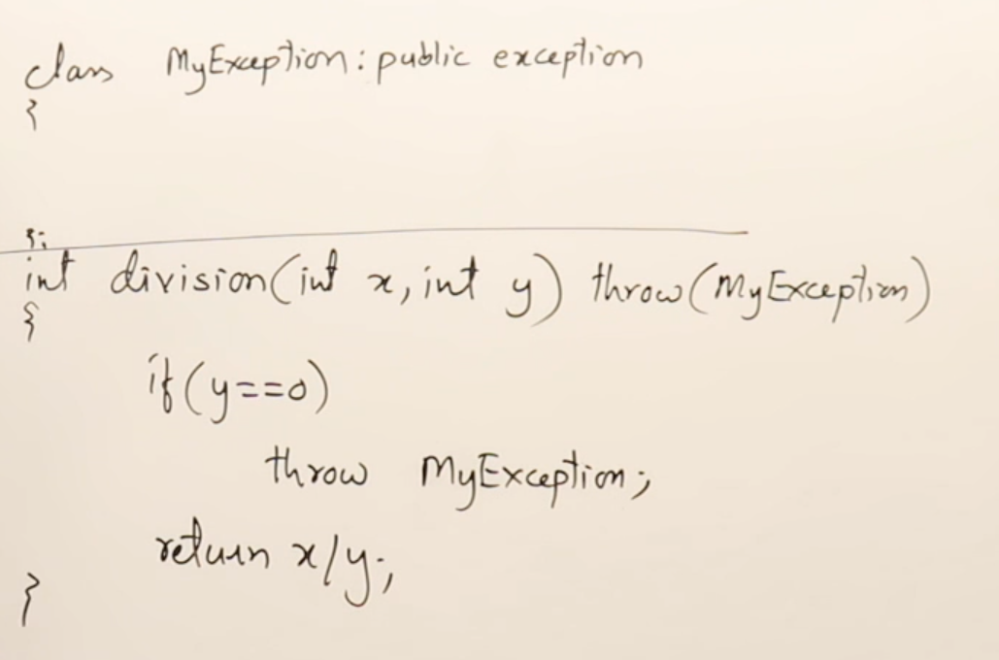
- Multiple catch blocks
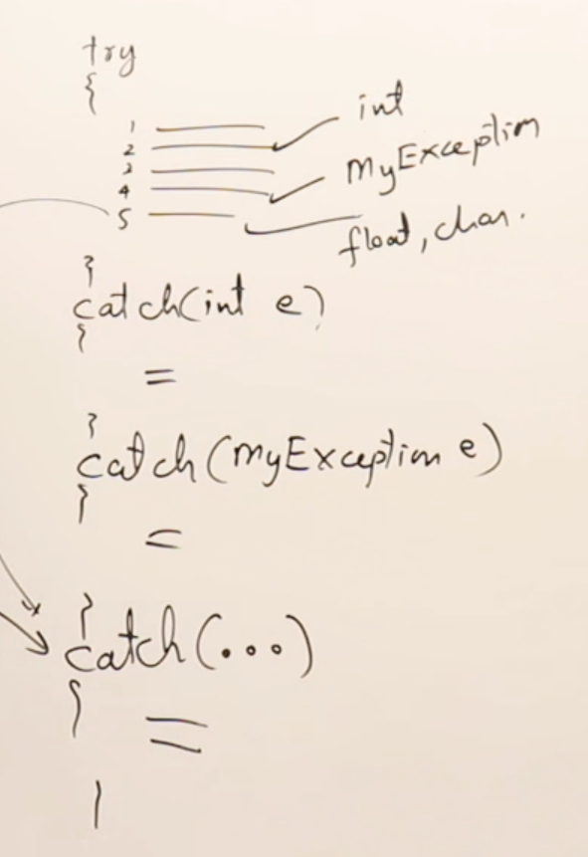
CATCH ALL
  - catch all block must be the last block
- There can be nested try..catch blocks
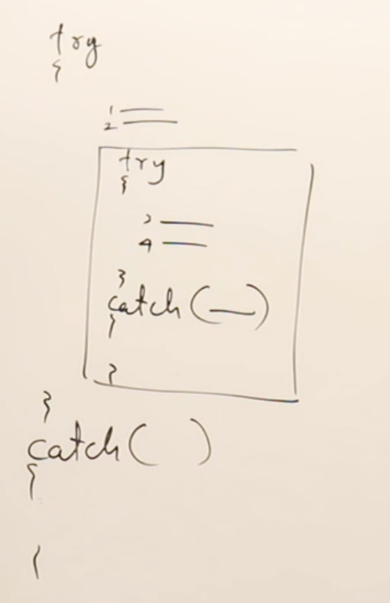
  - First the child catch block must be there before the parent catch block.
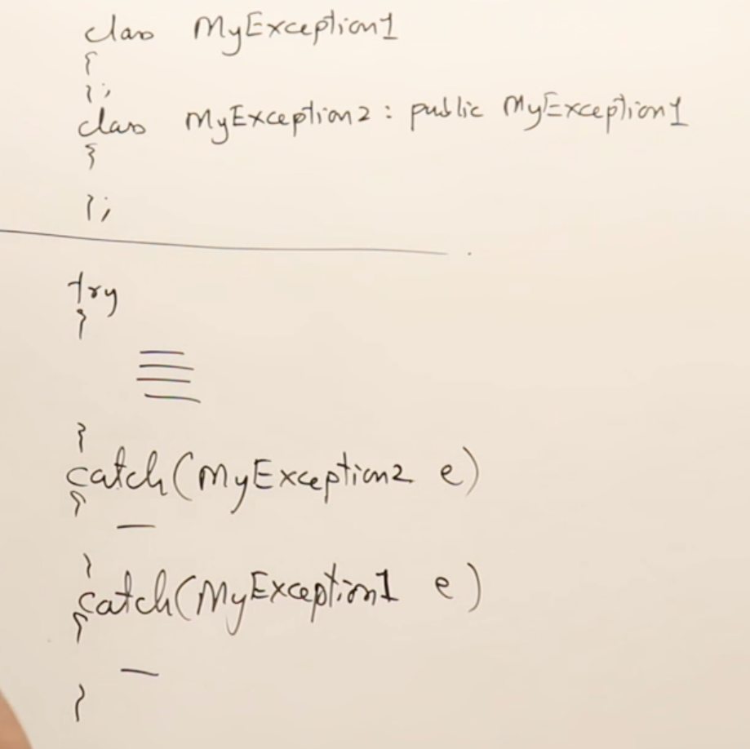

Templates
- To make a function generic we use templates
  - In case we need to use the function for classes then we need to overwrite the required operators to perform the specific operations.
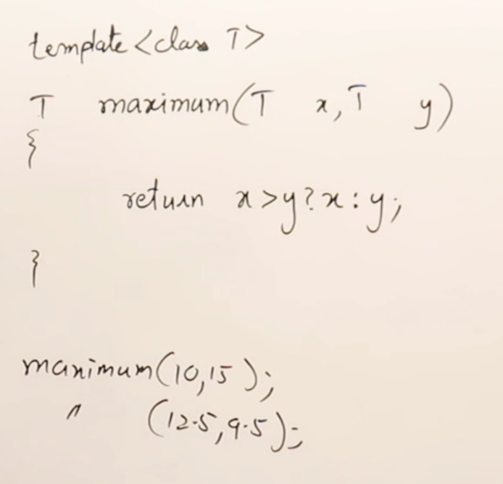
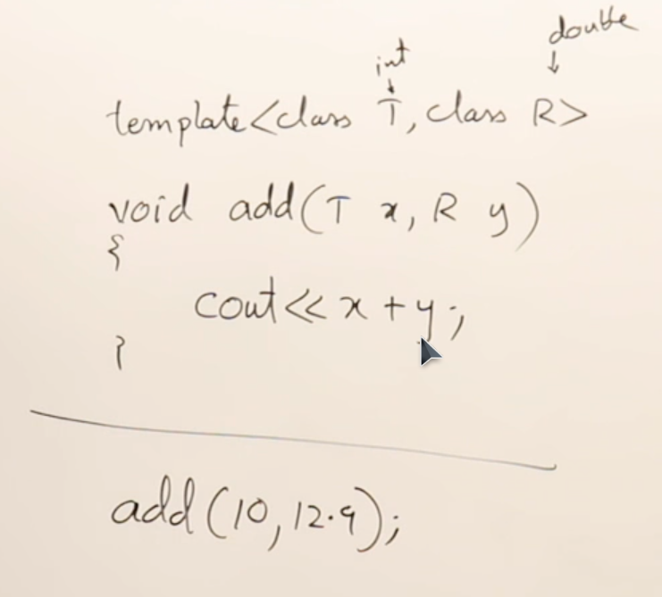
    - Template class
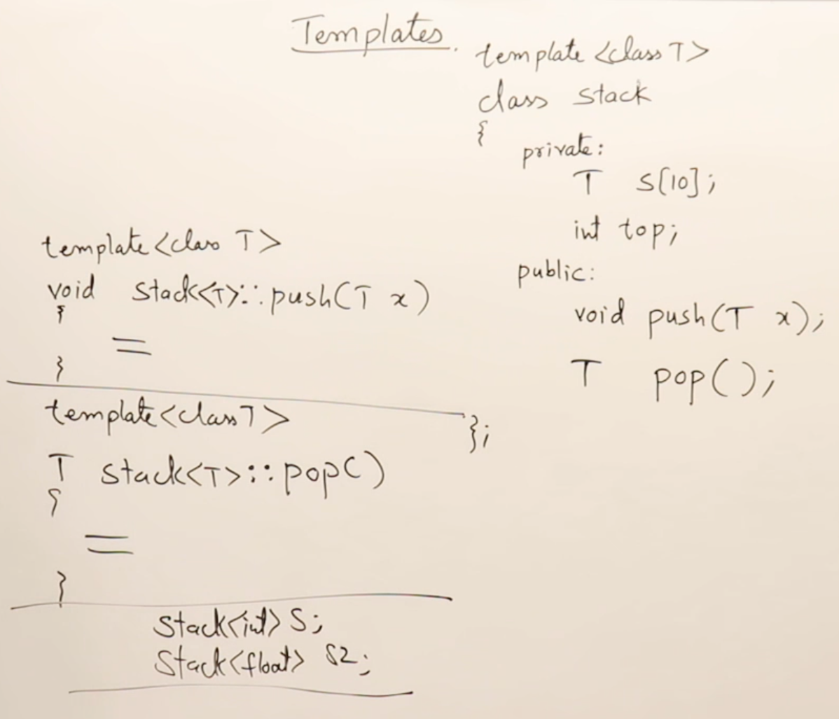
METHODS

Constants, Preproccessor directive
- Constant
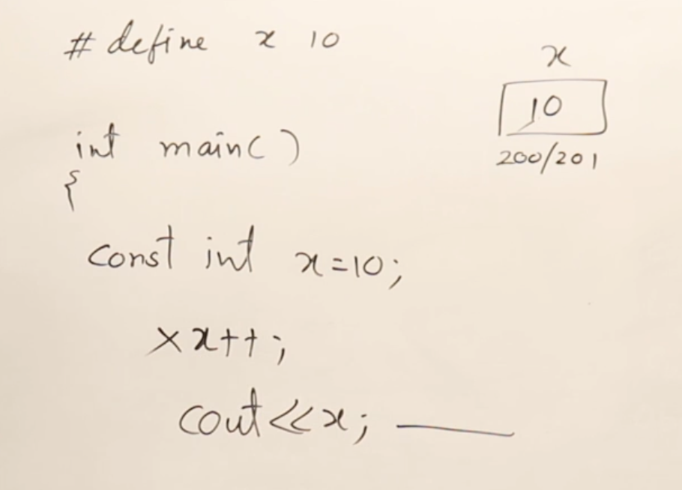
- Constant integer pointer
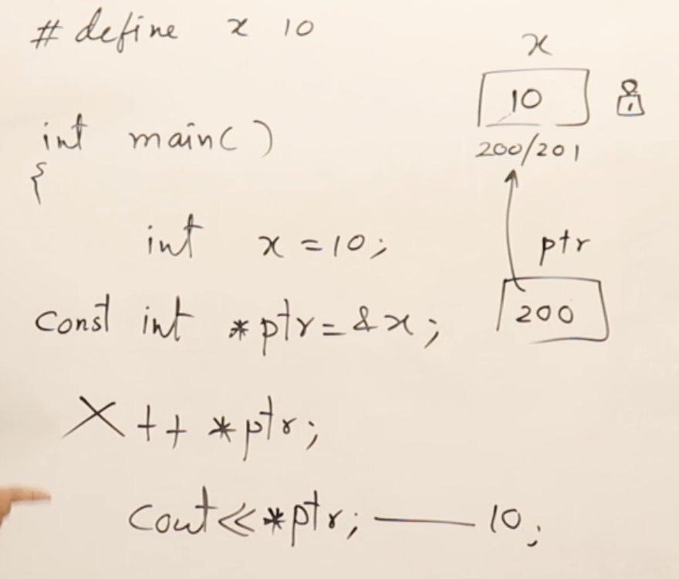
- Constant pointer to an integer
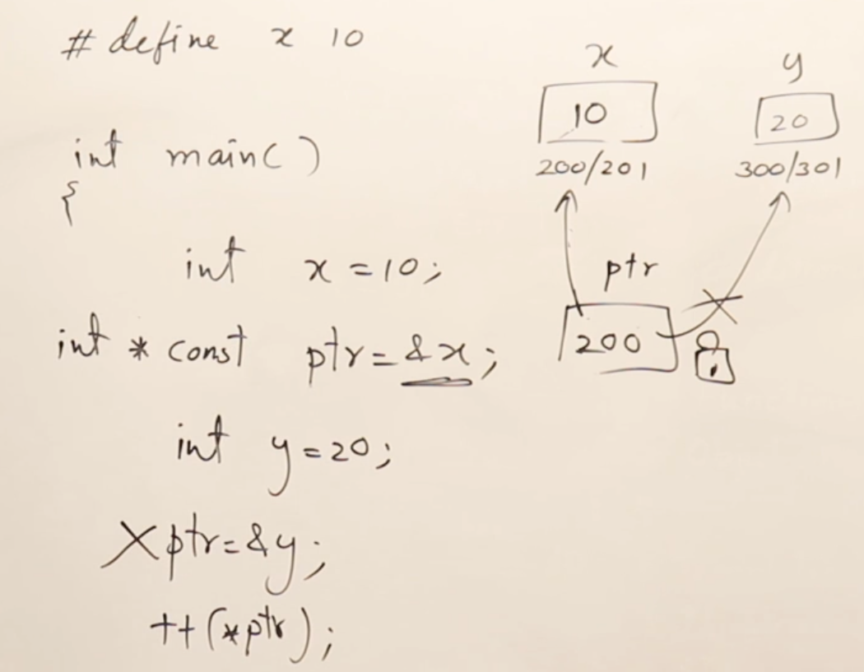
- Constant pointer to constant integer
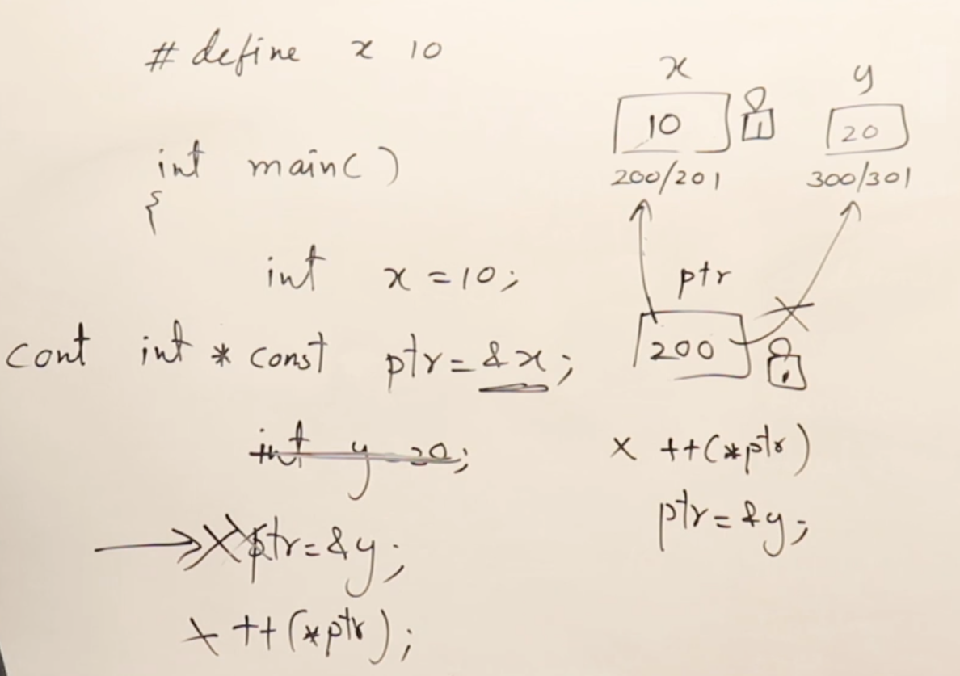
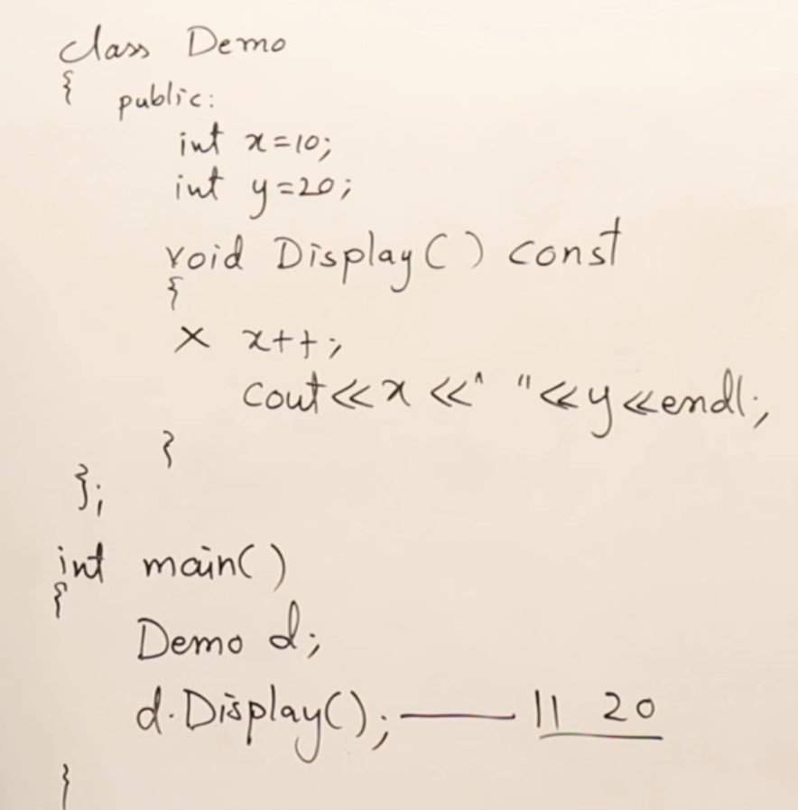
- Restricting a function in a class
- Using constant arguments
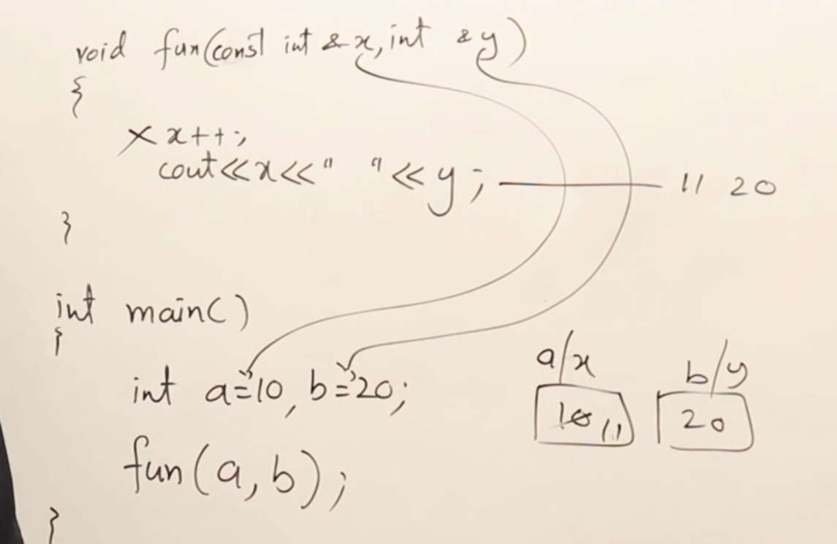
- Preprocessor directives
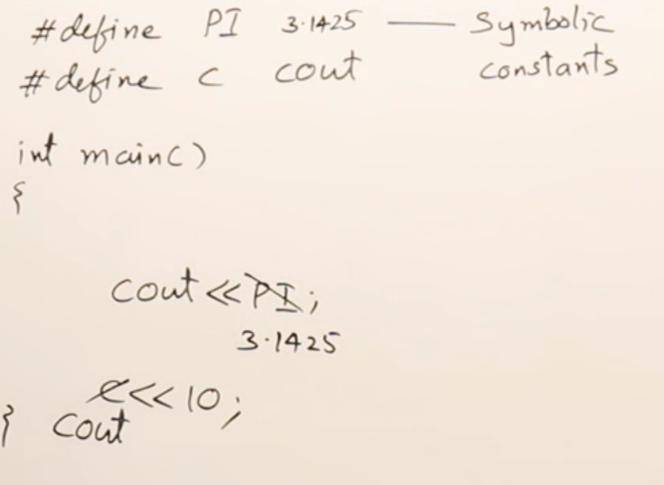
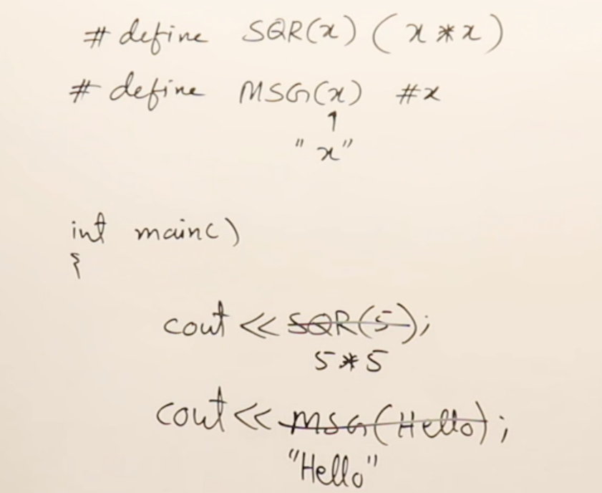
  - #ifndef....#endif
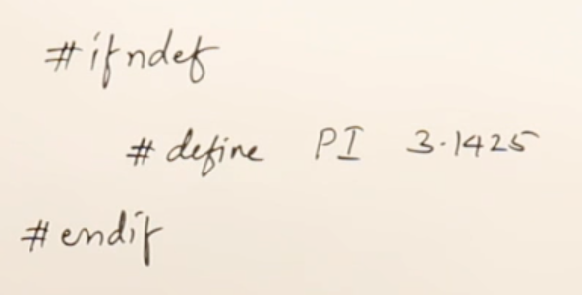
- Namespaces
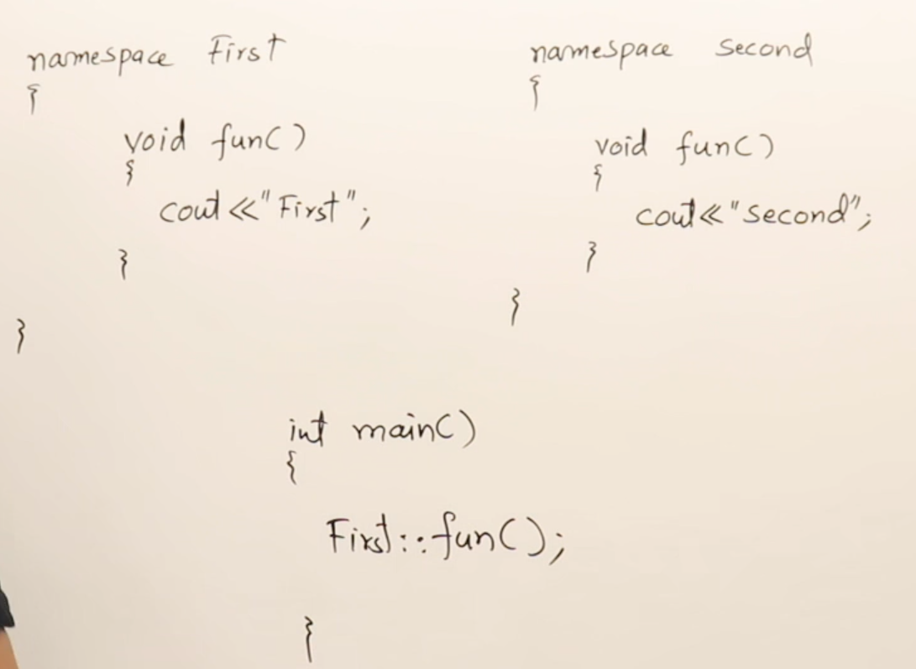
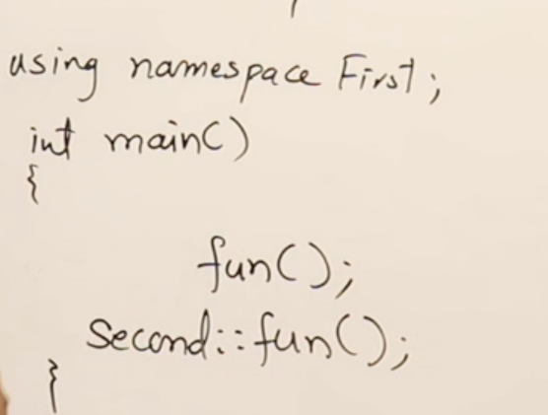
Destructors
- Destructor
- Destructor in Inheritace
- Virtual Destructor
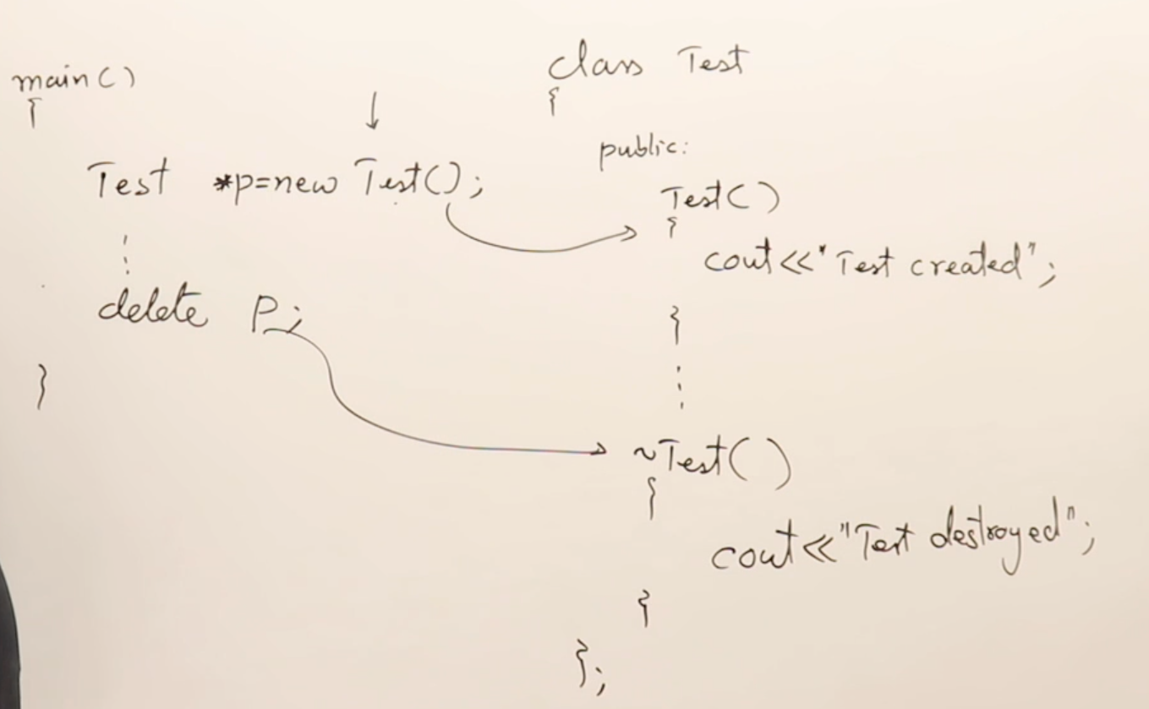
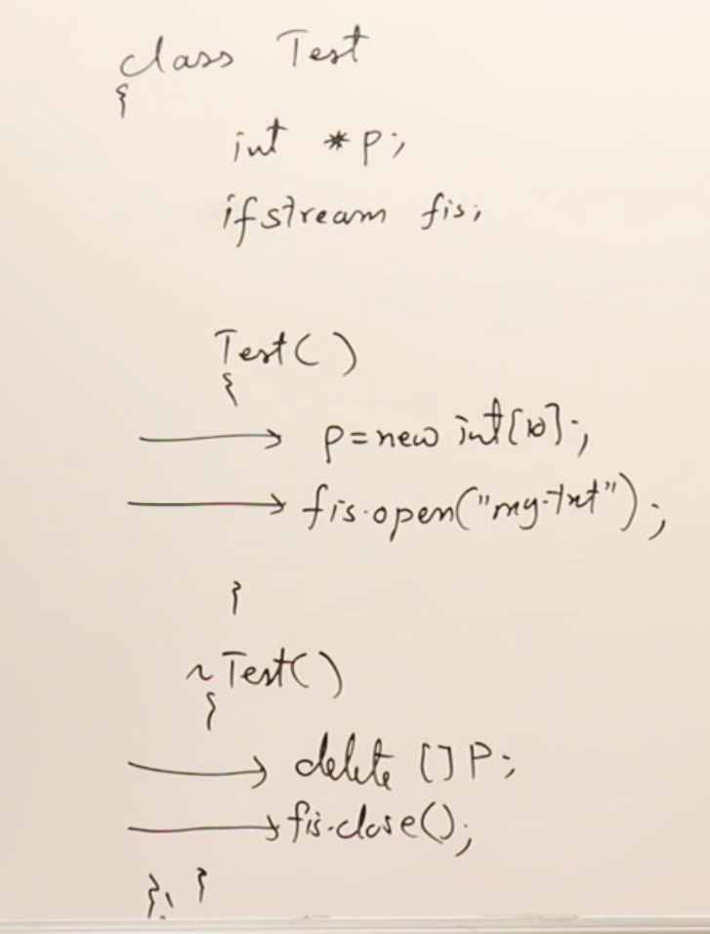
- The destructor function is not called if the memory is allocated in heap, It is called only when the delete ptr; statement is encountered.
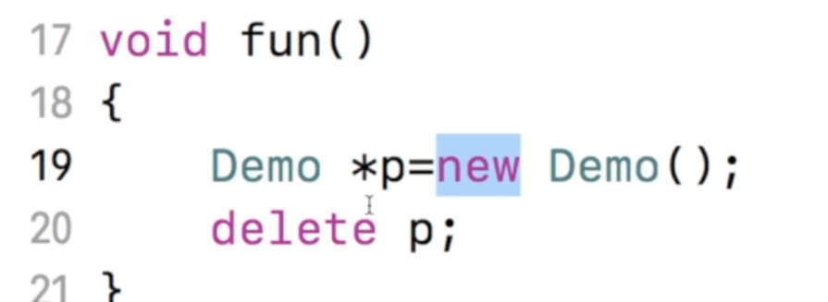
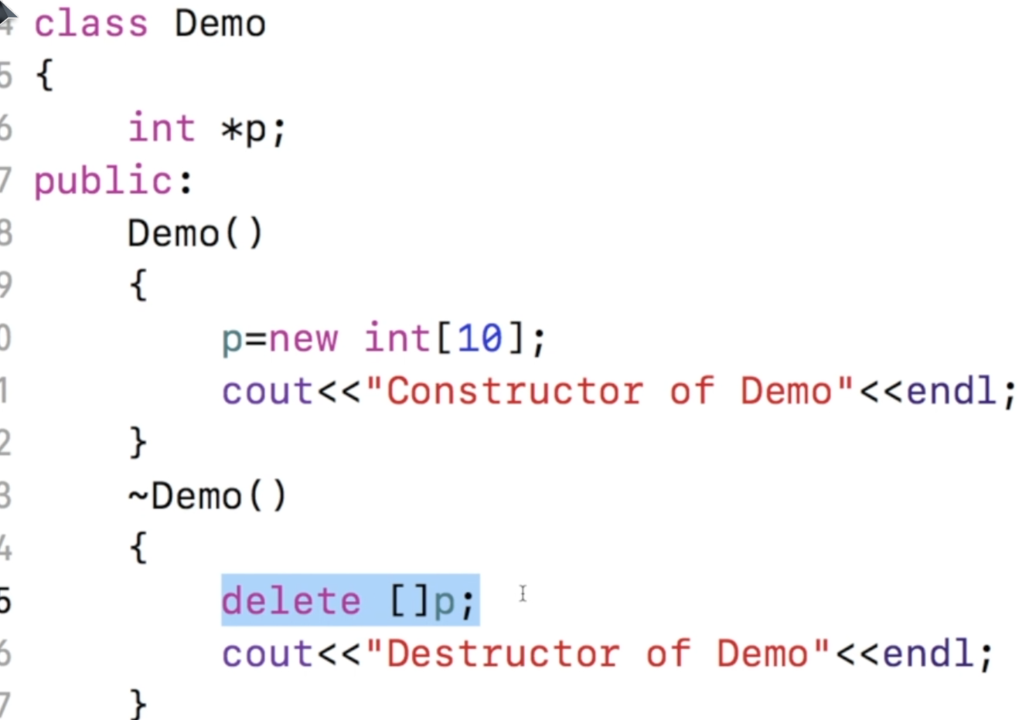
- Destructors in Inheritance
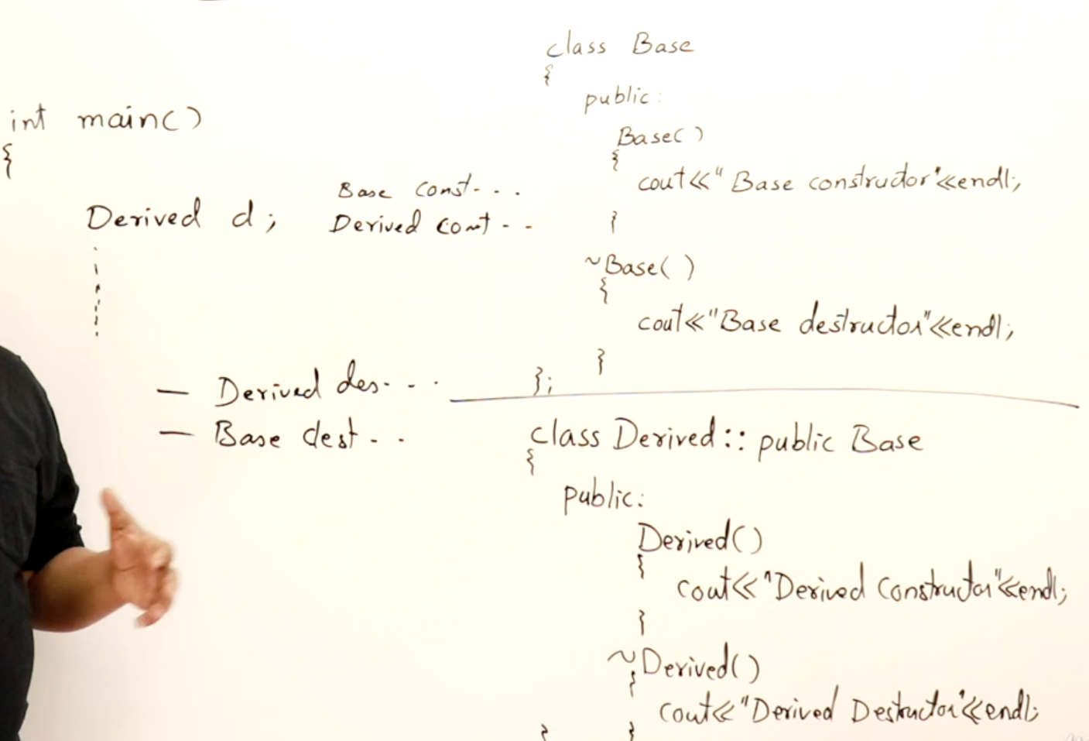
- Virtual Destructors
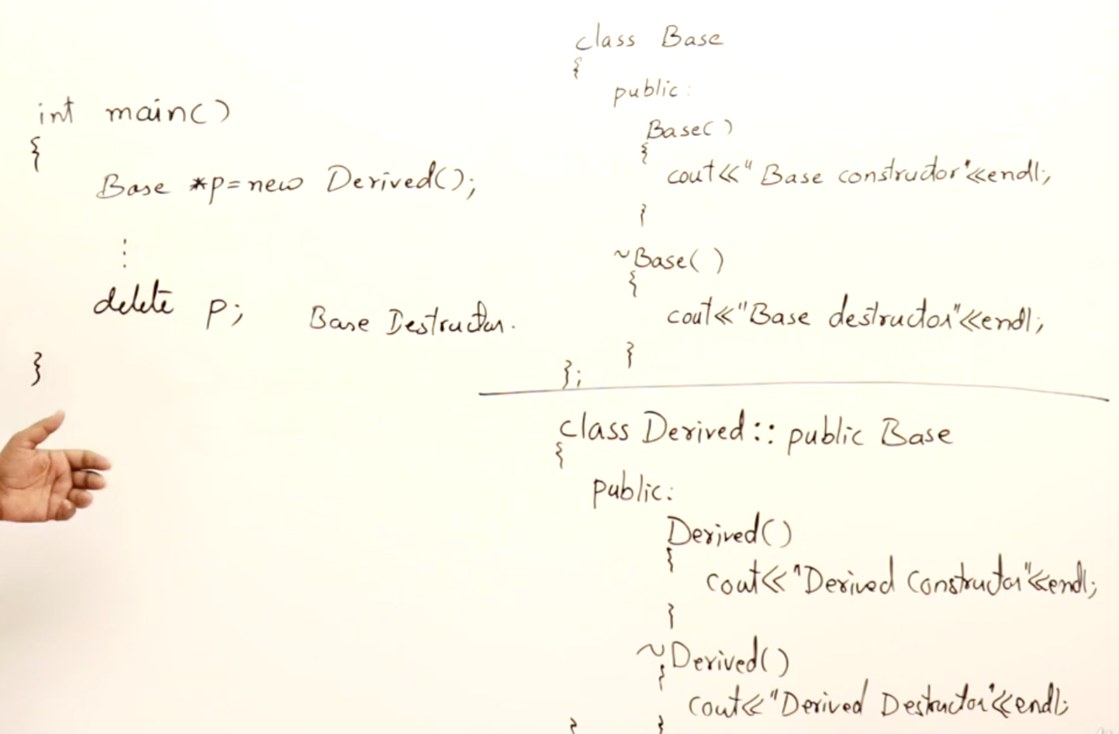
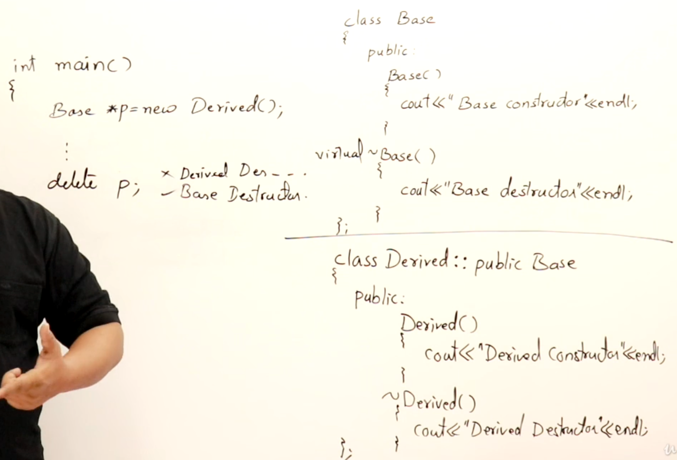

Streams
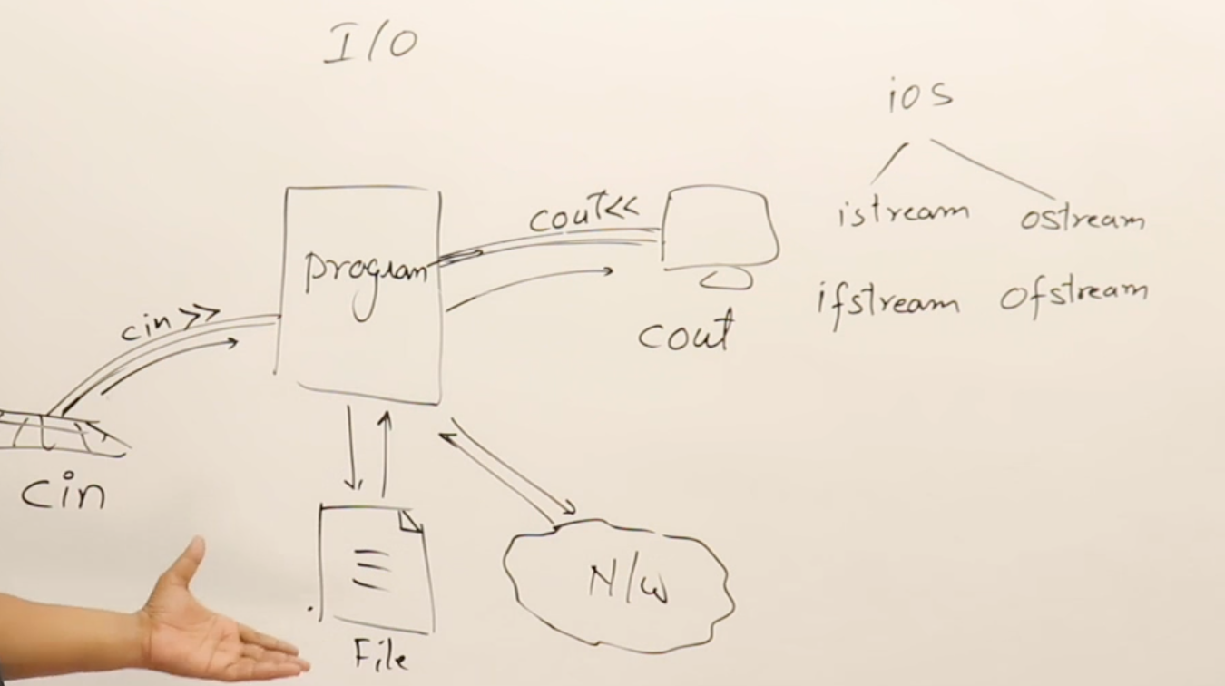
- File handling
(“my.txt”,ios::app) to append
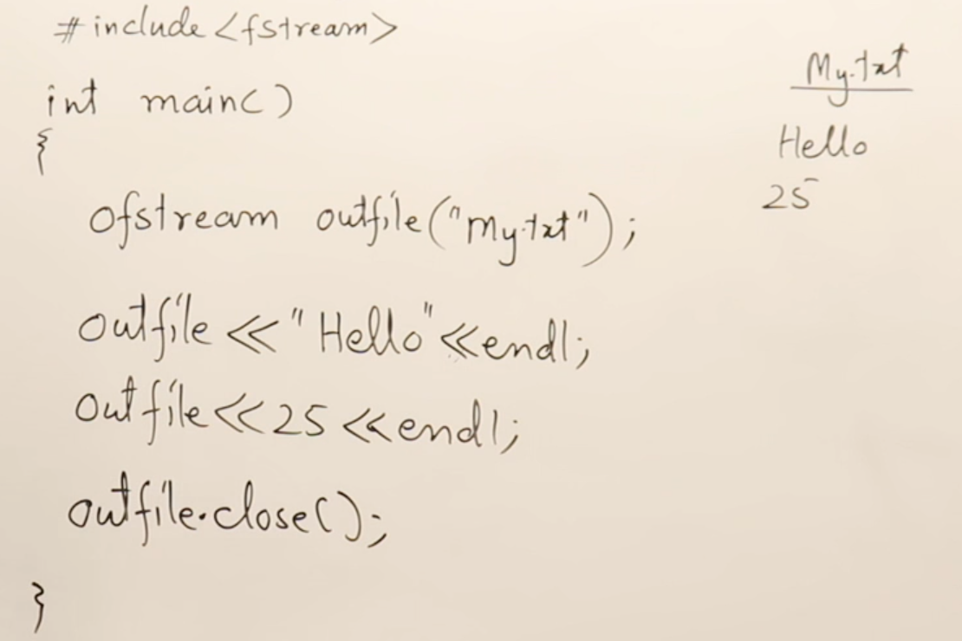
  - Writing to a file
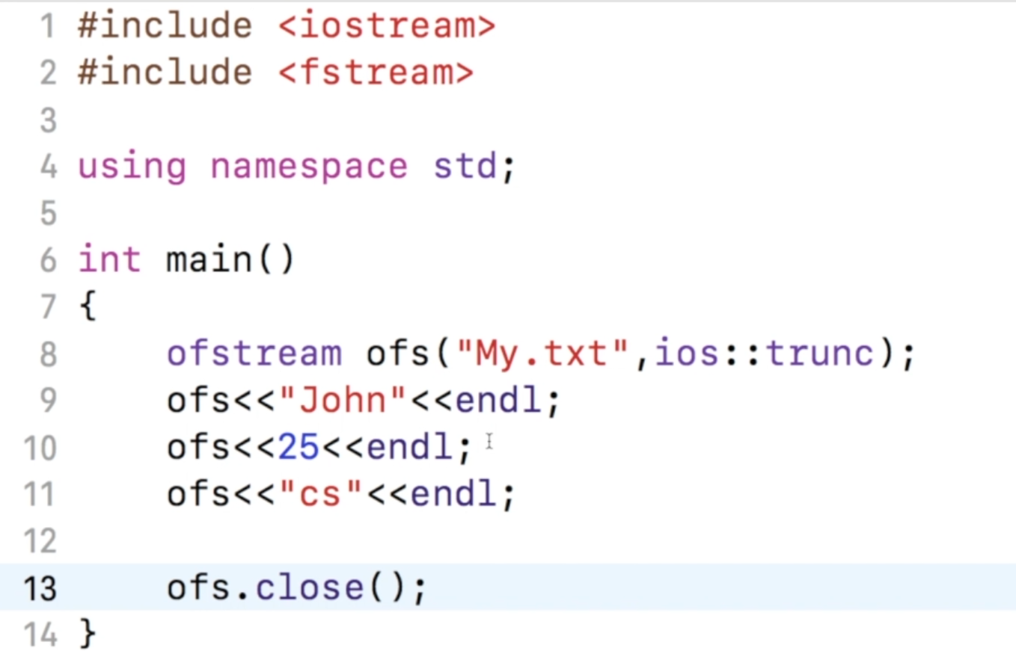
Object of class ofstream
- Reading from a file

infile : gives true when the file is opened
infile.is_open() : gives true if the file is opened
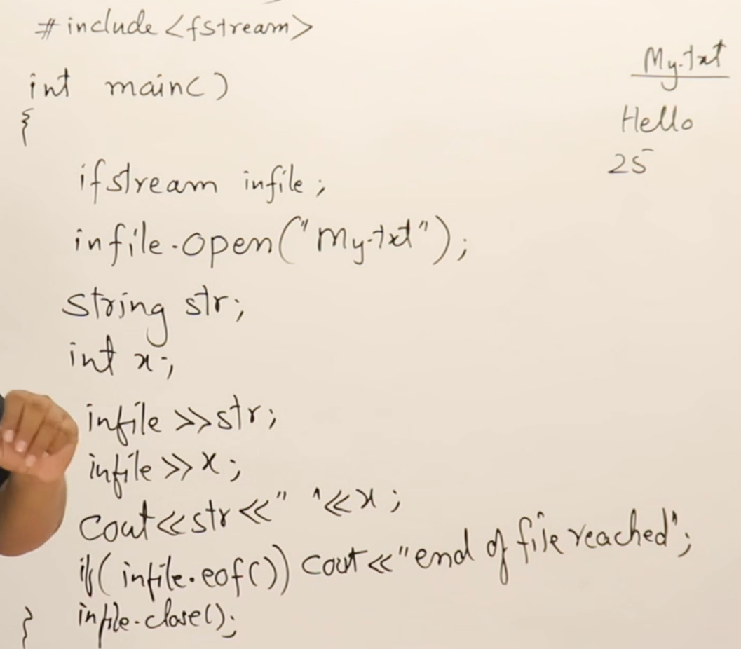
Name of the object
- Serialization : overloading of operators to read or write objects into a file.
- Text vs. Binary files
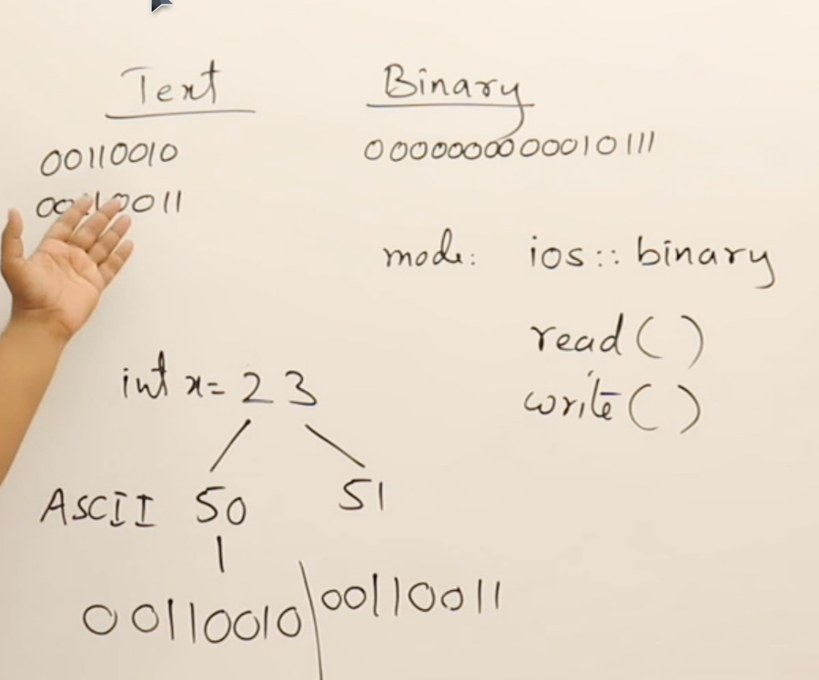
- Manipulators
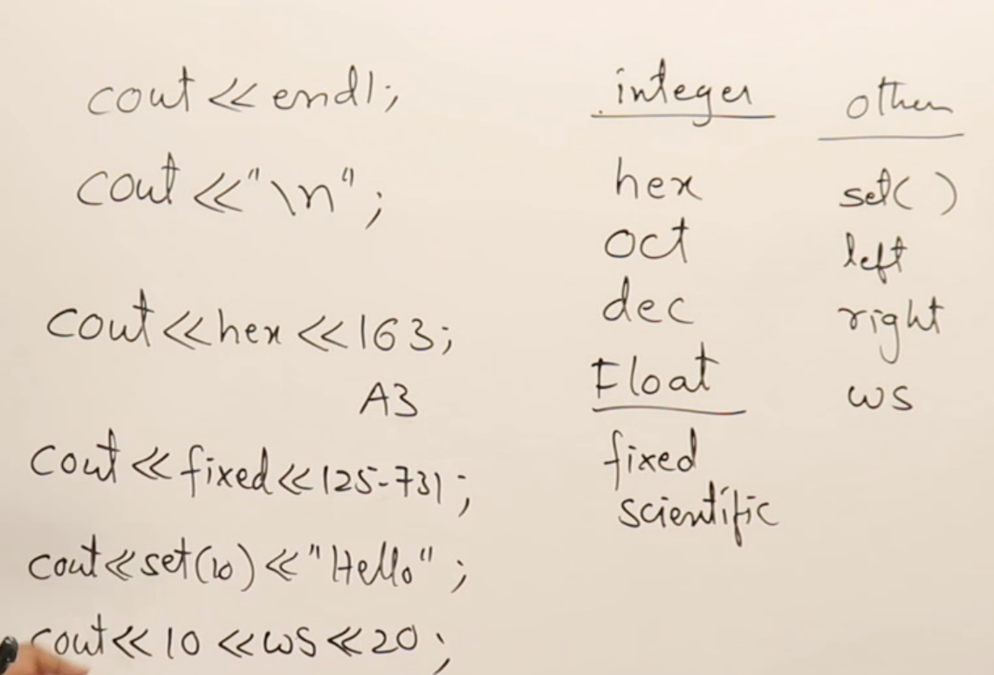
STL
- STL contains :
  - Algorithms
  - Containers
  - Iterators
- Containers
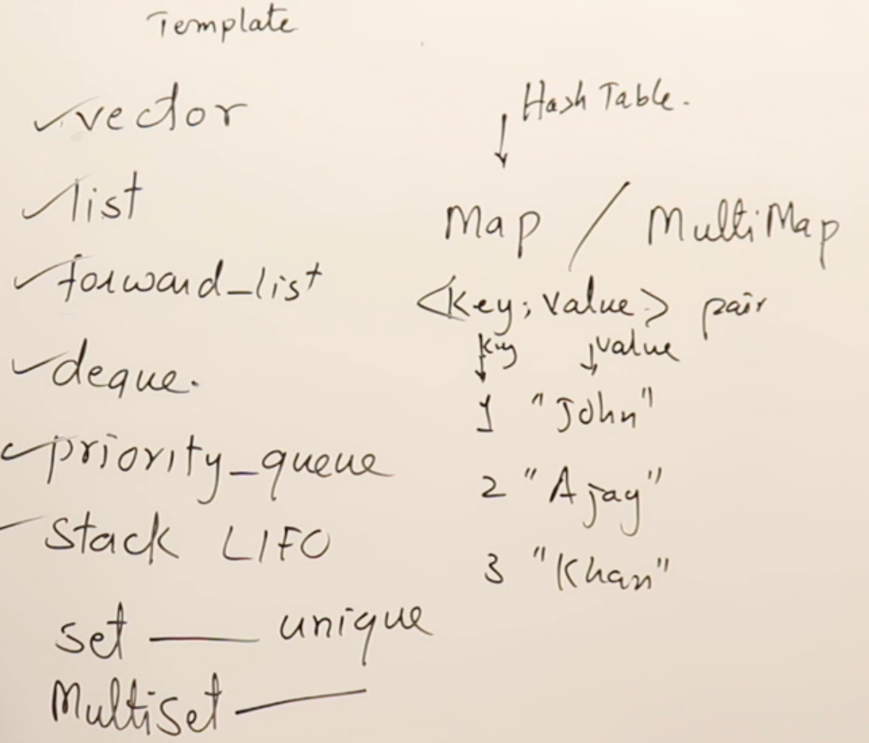
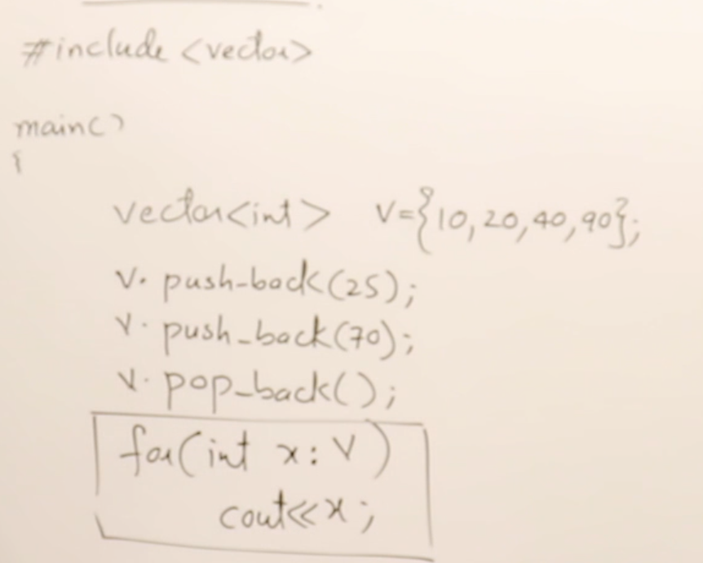
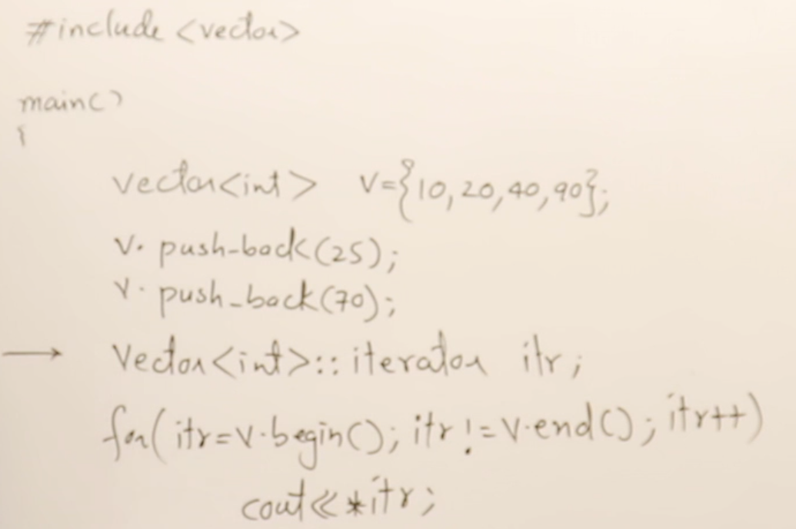
ITERATORS

Some keywords
- auto, decltype()
- final
  - Restricts inheritance
  - Only virtual functions can be marked as final and a final marked function cannot be overrided.
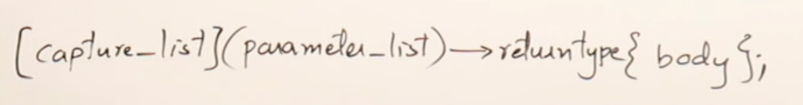
- Lambda expression : used to define unnamed functions
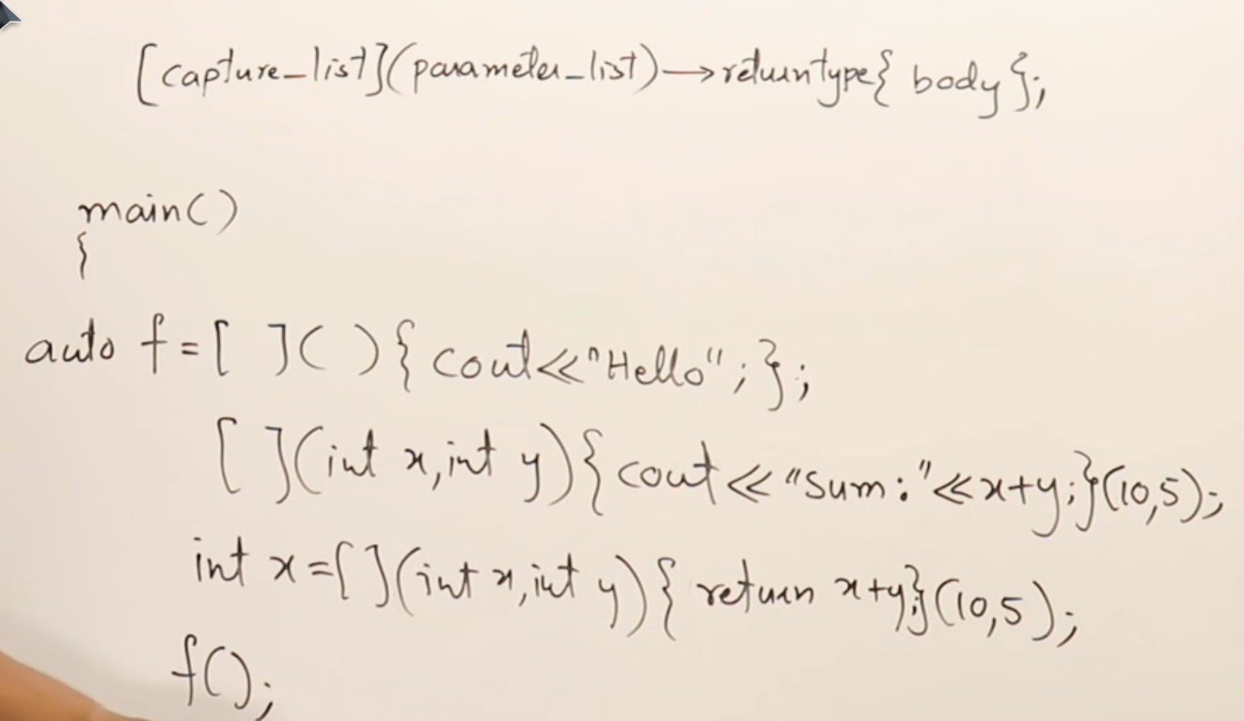
  - syntax :
REFERENCE TO THE FUNCTION
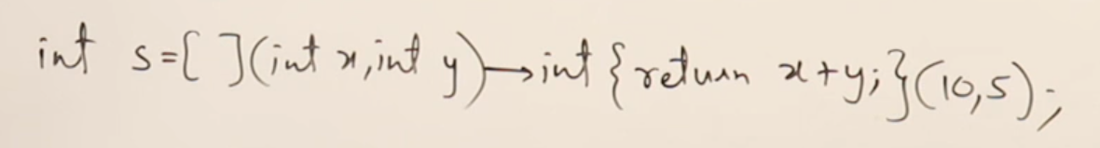
RETURN TYPE
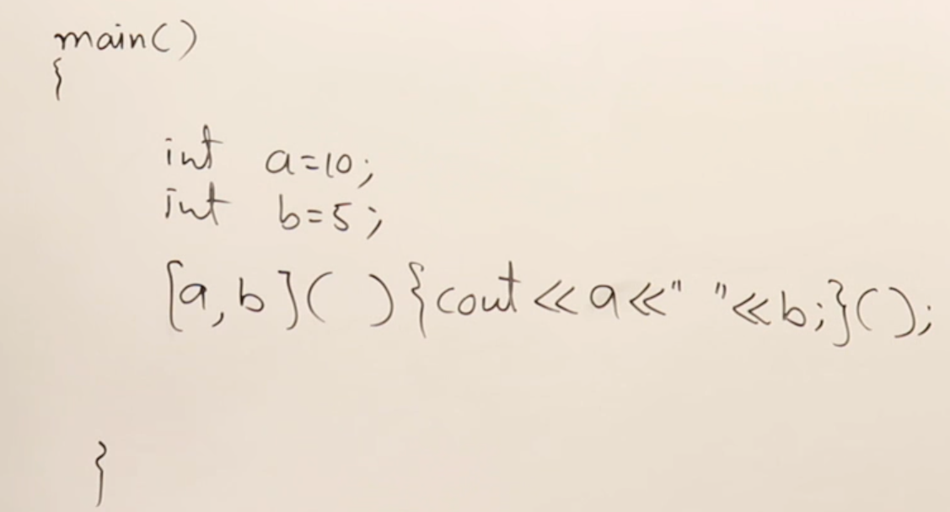
CAPTURE LIST
  - We need to capture the variables as pass by reference to be able to modify them
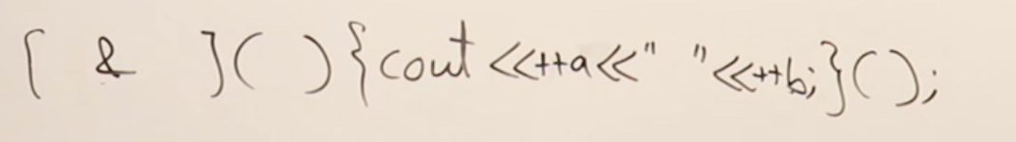
: allows to capture the all local scopes as reference
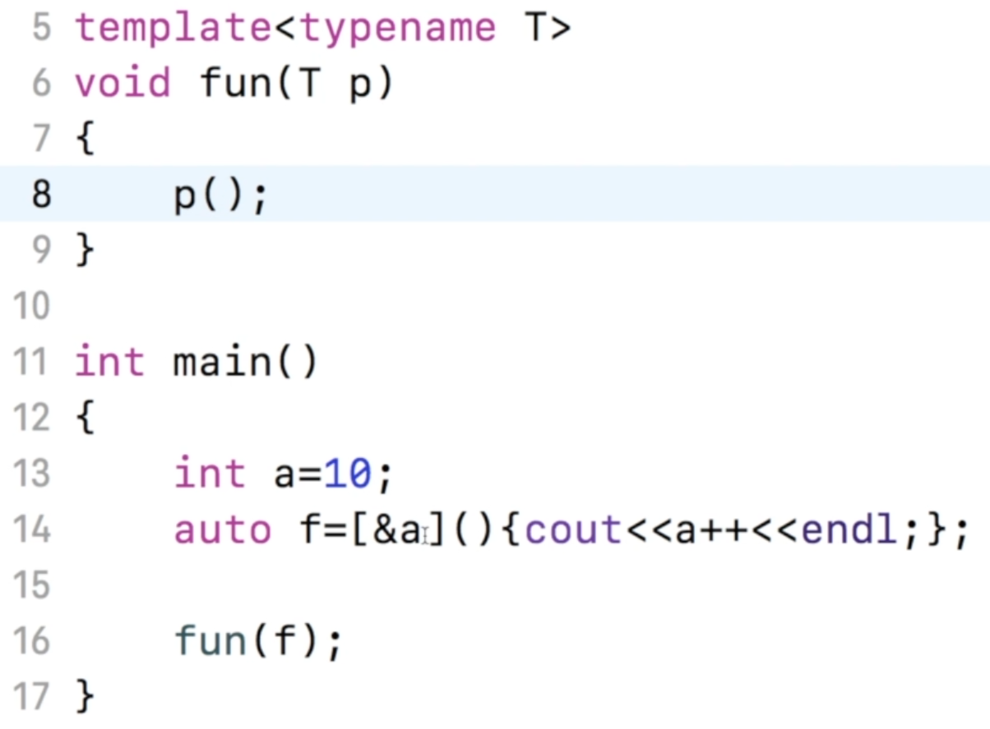
- Smart pointers
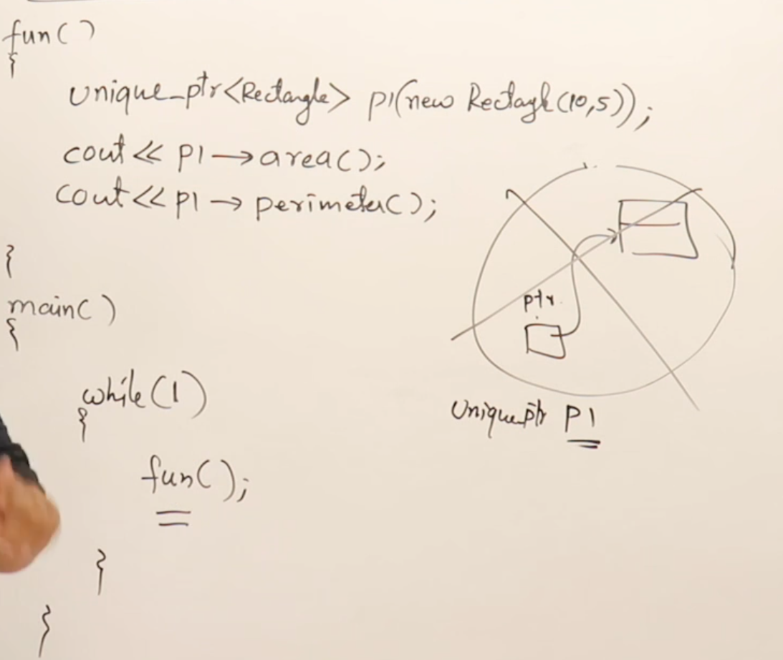
  - unique_pointer : a class, A pointer can only point to a single class
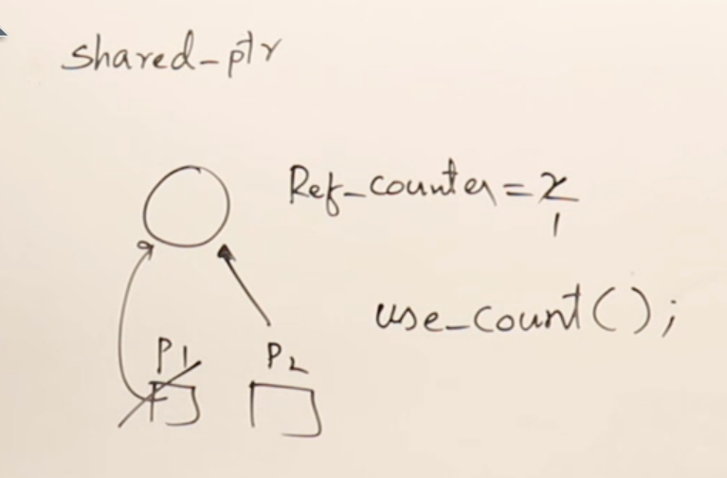
  - shared_pointer :
  - weak_pointer : same as shared pointer but it does not maintains the reference counter.
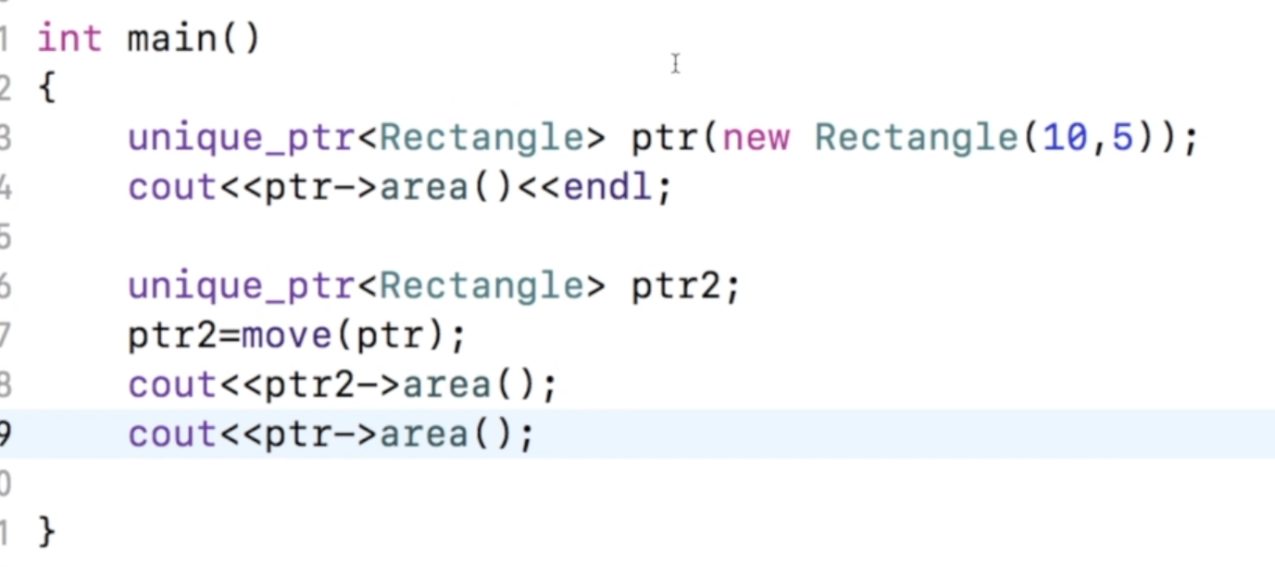
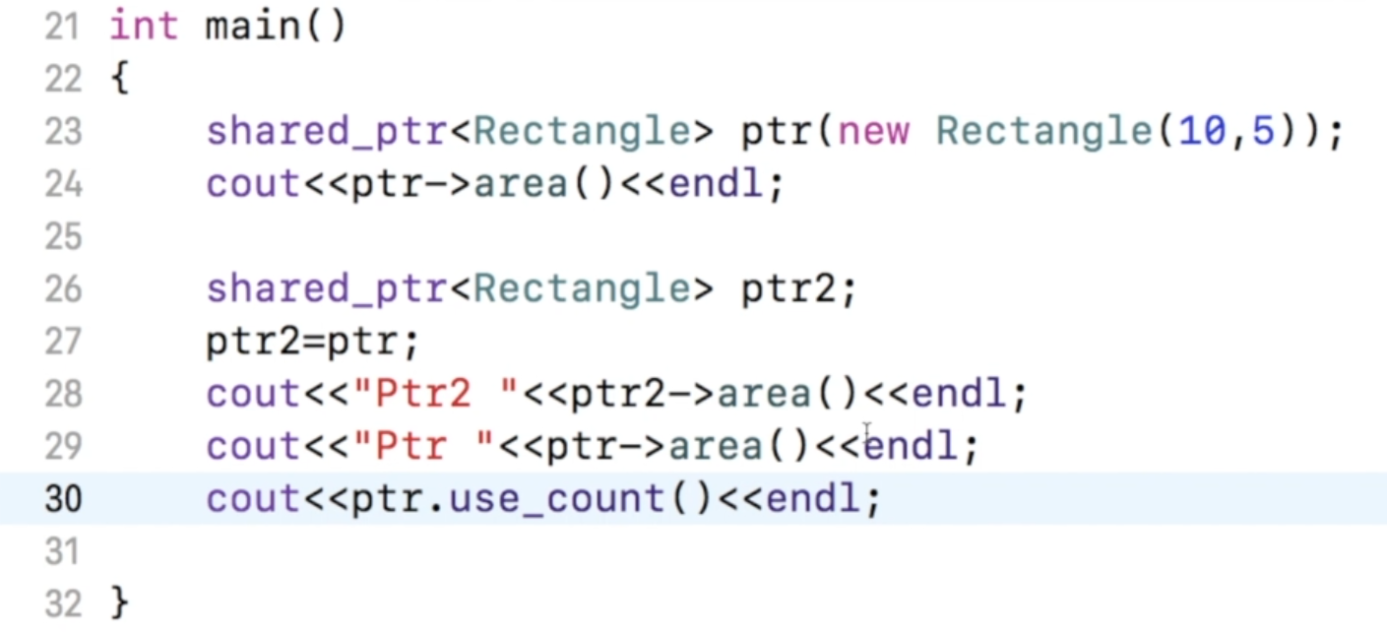
- Inclass initialization
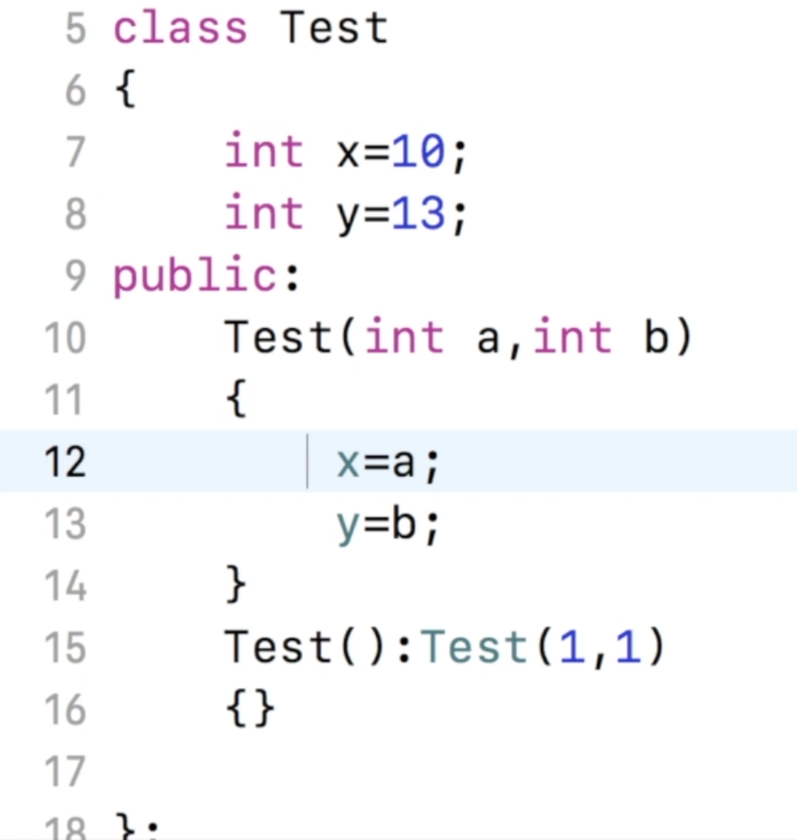
- Ellipsis
  - used to pass multiple arguments to a function


