Docker
index
introduction
- what is docker?

- Reasons why same application may not work in different environment

- container vs VM
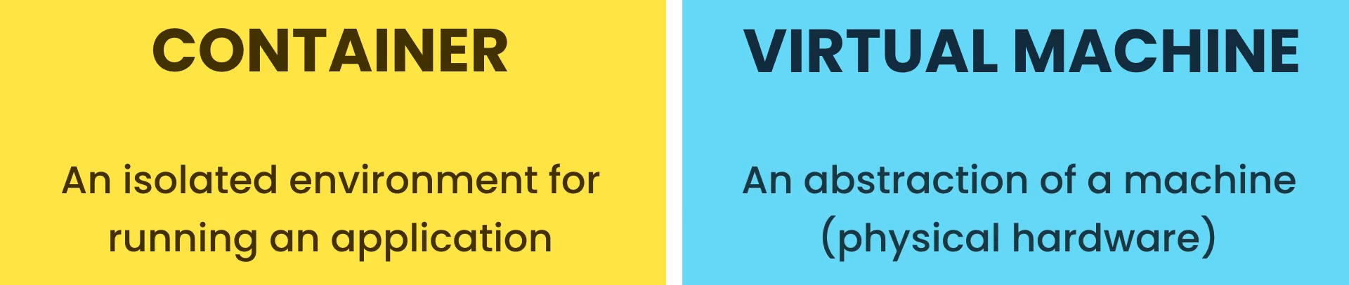
  - Problems with VM

  - Advantages of a container
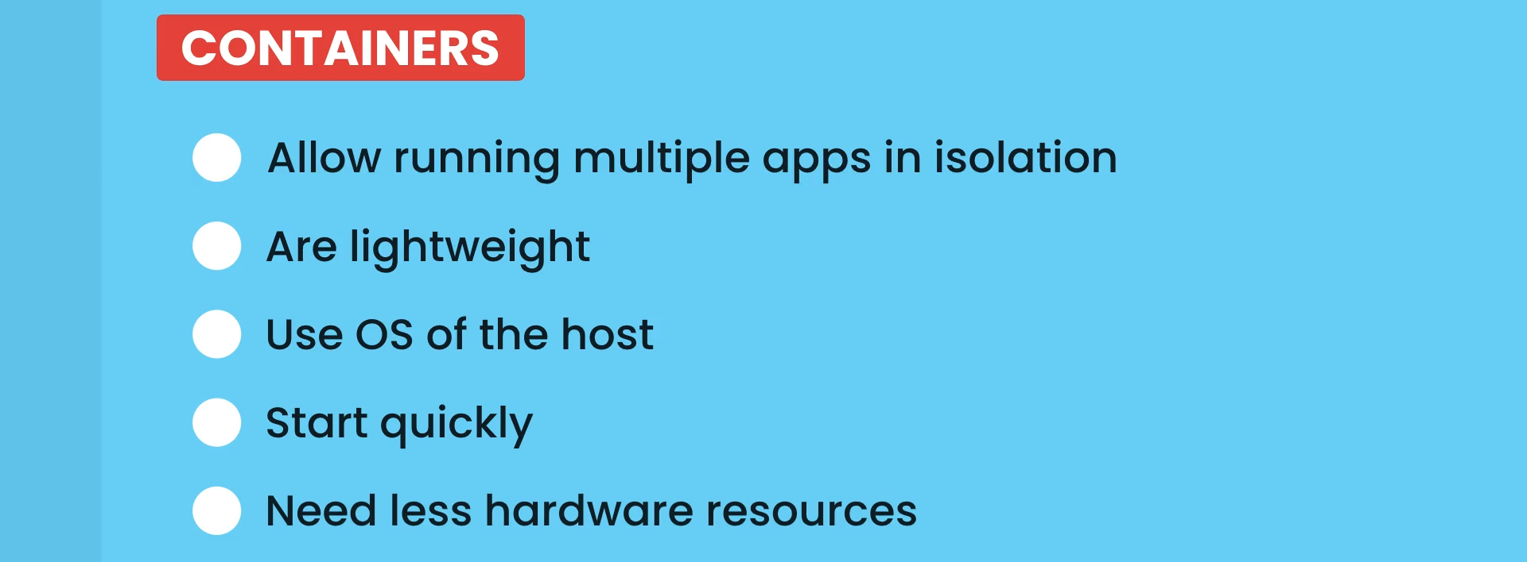
- architecture of docker



- types of containers used on different os


- development workflow
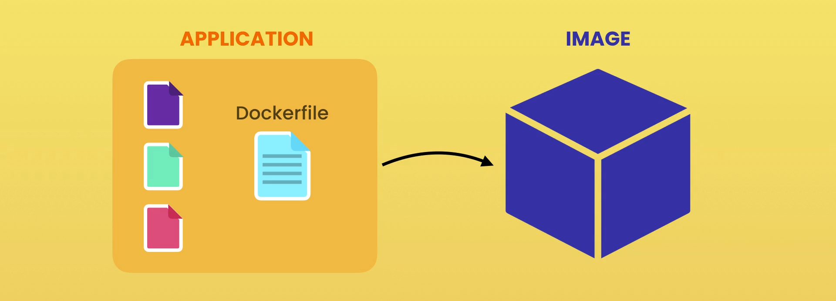
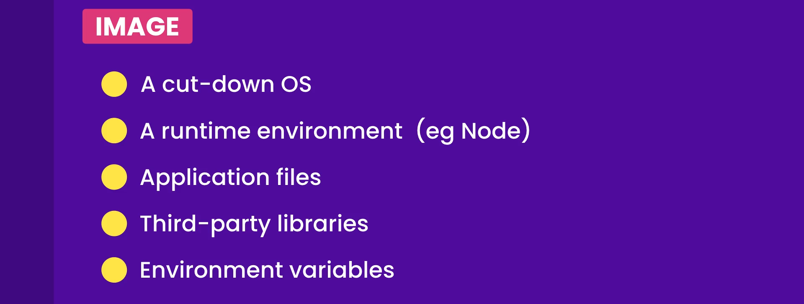
- sharing of docker images
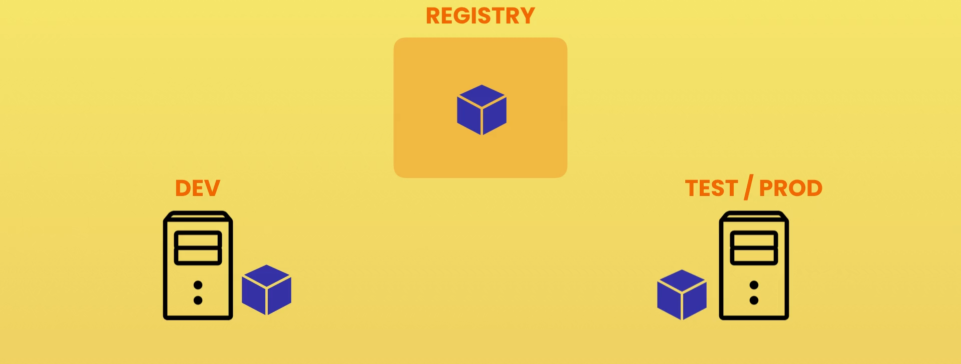

building docker images
- images and containers


- dockerfile

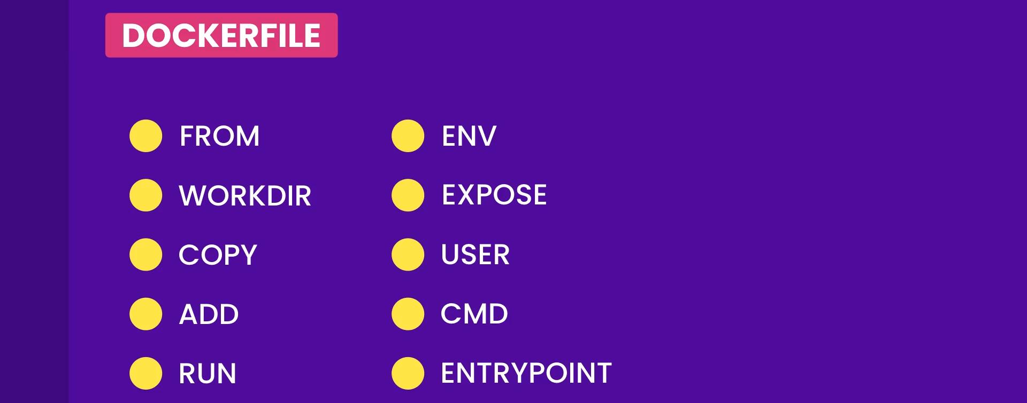

- dockerignore file
  - Files to ignore
//.dockerignore file
node_modules
build

- dockerfile
//Dockerfile
FROM node:18.12.1-alpine3.17
WORKDIR /app
# ADD source dest: can copy files from url and can copy files from a compressed archive
COPY . .
ENV API_KEY="test"
EXPOSE 3000
RUN npm install && npm install -g serve && npm run build
RUN addgroup app && adduser -S -G app app
USER app
# CMD command argument: shell form, Spawns an extra process (shell)
# CMD [ "executable" ]: executable form
CMD [ "serve","-s","build" ]
# ENTRYPOINT [ "executable" ]

- optimizing builds

  - Building images uses the concept of layering; Image: Collection of layers
  - Every instruction is a layer
  - If for new build, Cached layers can be used
  - If any layer is changed then docker has to rebuild all the layers appearing after the changed layer

FROM node:18.12.1-alpine3.17
WORKDIR /app
# ADD source dest: can copy files from url and can copy files from a compressed archive
COPY package*.json ./
RUN npm install && npm install -g serve
ENV API_KEY="test"
EXPOSE 3000
COPY . .
RUN npm run build
RUN addgroup app && adduser -S -G app app
USER app
# CMD command argument: shell form, Spawns an extra process (shell)
# CMD [ "executable" ]: executable form
CMD [ "serve","-s","build" ]
# ENTRYPOINT [ "executable" ]

- removing images
  - Dangling images
    - The images with no name and no tag
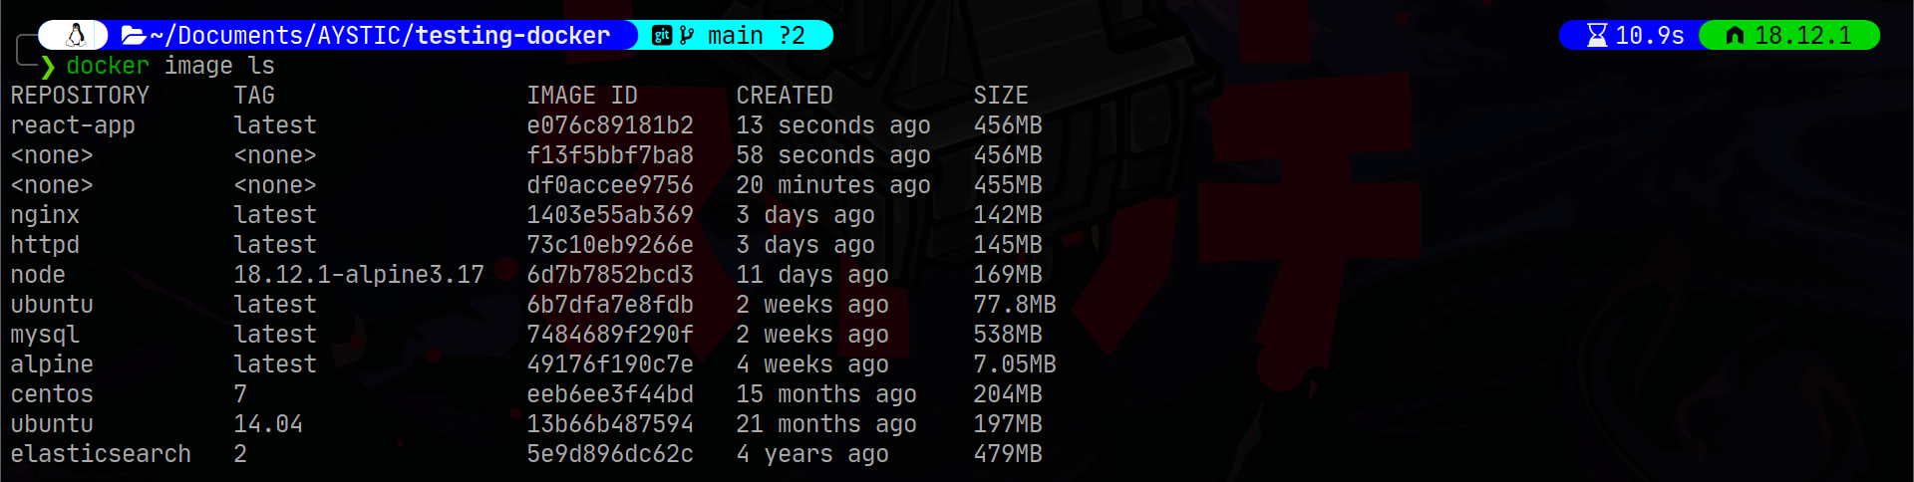
docker image prune
//to remove all the stopped containers
docker container prune

- tagging an image
//during building
docker build -t name:tag .

//after building
docker image tag old-name new-name

  - Latest tag may not point to the latest image. We have to explicitly tag the newer image as latest
- sharing images
docker login
docker image tag <username>/<repo>:tag
docker push <username>/<repo>:tag

- saving and loading images
  - Transfer files without docker hub
docker image save –-output <filename> <image-name>
docker image load –-input <filename>

working with containers
//mapping ports
docker container run -p host:container <name>
//detaching
docker container run -d <name>
//running a container interactively
docker container run -it <name>
//starting a container interactively
docker container start -ia <name>
//executing a command in the running container
docker container exec <name> <command>
//executing a command in the running container in interactive mode
docker container exec -it <name> <command>
//passing env variables to container
docker container run -e <name>=<value> <image>

- persisting data using volumes
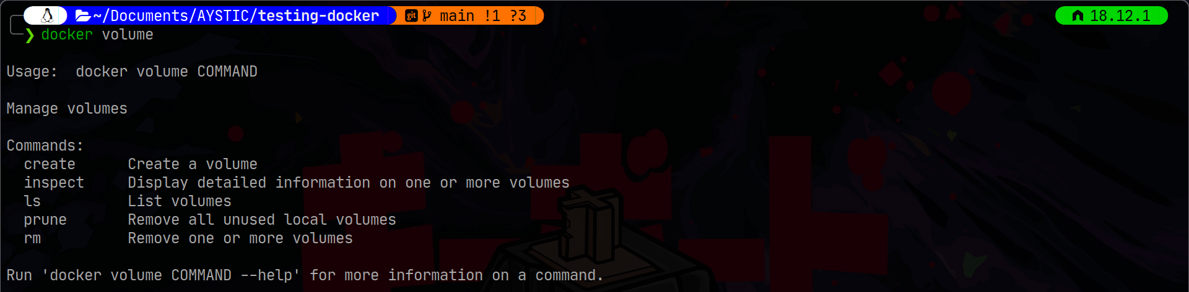
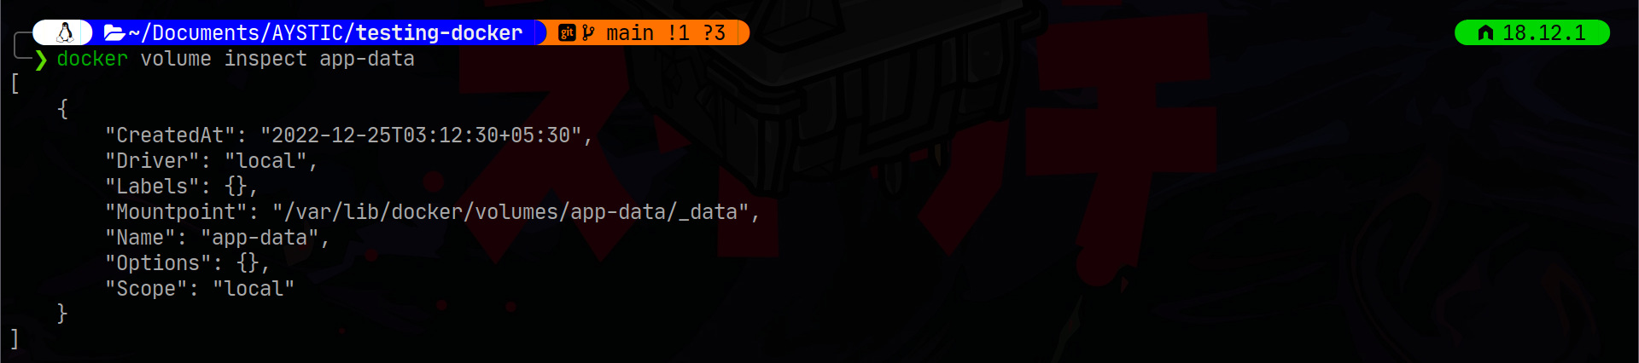

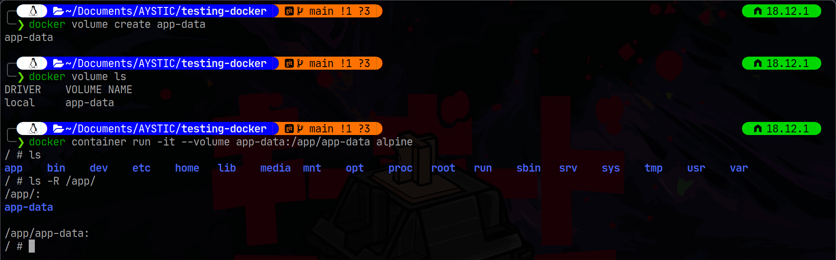
- make sure to include the mkdir command by the same user who will be using the volume as by default it will be created by root
- copying files between container and host
docker cp <name>:<path-on-container> <path-on-host>
docker cp <path-on-host> <name>:<path-on-container>

- publishing changes

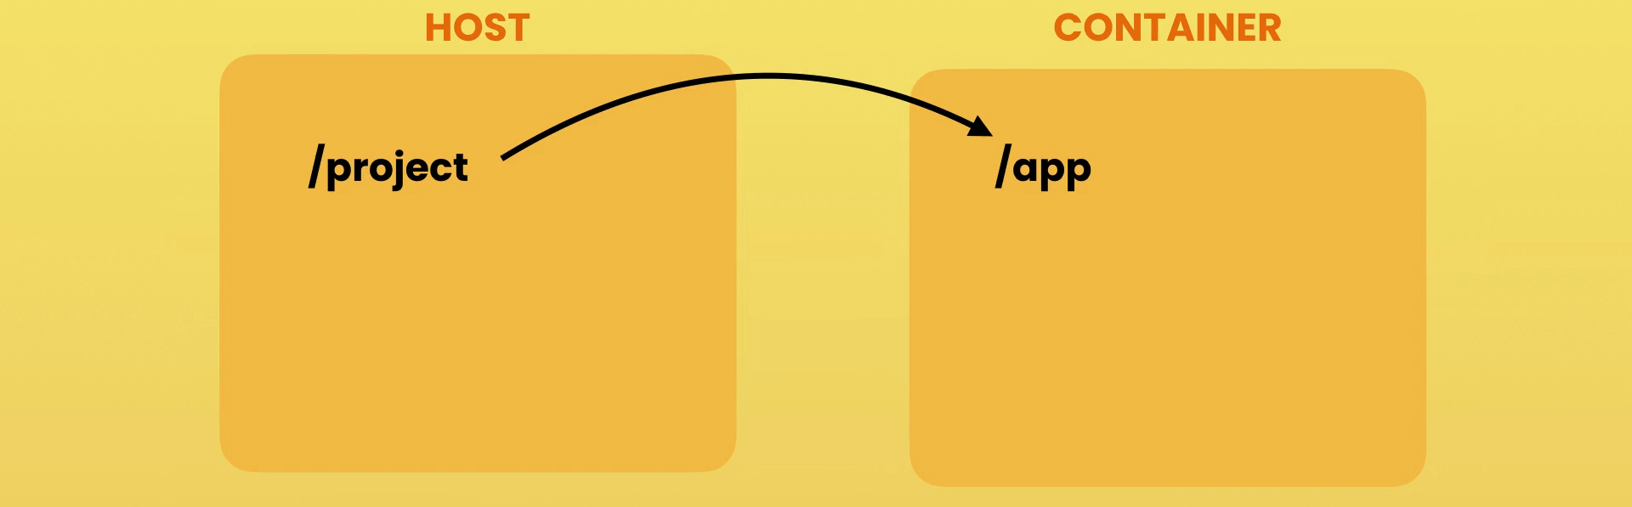
  - create a mapping from host to container
docker container run -v $(pwd):/app <name>

//Dockerfile.dev
FROM node:18.12.1-alpine3.16
WORKDIR /app
COPY package*.json ./
RUN npm install
EXPOSE 3000
CMD npm run start

//Building dev image
docker build -f ./Dockerfile.dev --rm --tag reactapp:dev1 .
//running container from dev image
docker container run -d -p 80:3000 --name reactapp -v $(pwd):/app reactapp:dev1

//Dockerfile.prod
FROM node:18.12.1-alpine3.16
RUN npm install -g serve
RUN addgroup -g 1001 app && adduser -u 1001 -G app -s /bin/sh -D app
WORKDIR /app
COPY package*.json /app/
RUN npm install
COPY . .
EXPOSE 3000
RUN npm run build
USER app
CMD serve -s build

//building production image
docker build -f ./Dockerfile.prod --rm --tag reactapp:prod1 .

//running production container
docker container run -d -p 80:3000 --name reactapp reactapp:prod1

running multi container apps
- cleaning the workspace
docker container rm -f $(docker container ls -q)
docker container rm -f $(docker container ls -a -q)
docker volume rm -f $(docker volume ls -q)
docker image rm -f $(docker image ls -q)

- yaml (yaml ain’t markup language)
  - Data serialization language for all programming languages
  - Other data serialization languages are XML and JSON
  - can store data not commands
  - It is case sensitive
---
apple: fruit
1: roll number
weight: 55.34
---
- first
- second
- third
---
mylist:
- first
- second
- third
---
mylist: [first, second, third]
---
#object
person:
name:
firstname: abc
lastname: xyz
age: 24
...

- Docker compose file is used to compose multi-container application
- docker compose file
  - Specifications🔗
  - Documentation🔗
  - The Compose file is a YAML file defining services, networks, and volumes for a Docker application.
//docker-compose.yaml
services:
frontend:
build: ./frontend
ports:
- 3000:3000
depends_on:
- backend
- db
links:
- backend
backend:
build: ./backend
ports:
- 3001:3001
environment:
- DB_URL=mongodb://db/vidly
depends_on:
- db
db:
image: mongo:4.0-xenial
volumes:
- myvol:/data/db
volumes:
# creats a volume vildly_myvol
myvol:

- Running tests
frontend:
build: ./frontend
ports:
- 3000:3000
depends_on:
- backend
- db
links:
- backend
volumes:
- ./frontend:/app

frontend-test:
image: vidly_frontend
volumes:
- ./frontend:/app
command: npm test

deployment
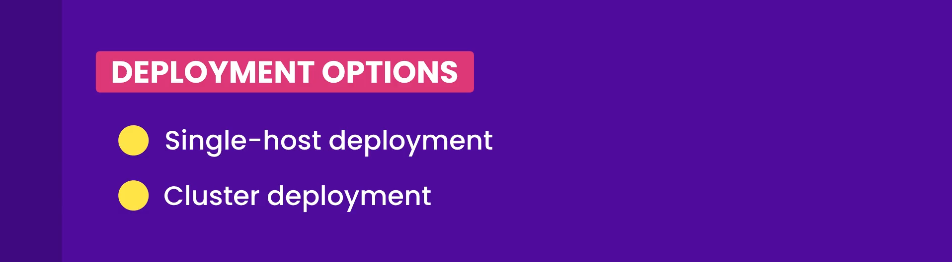
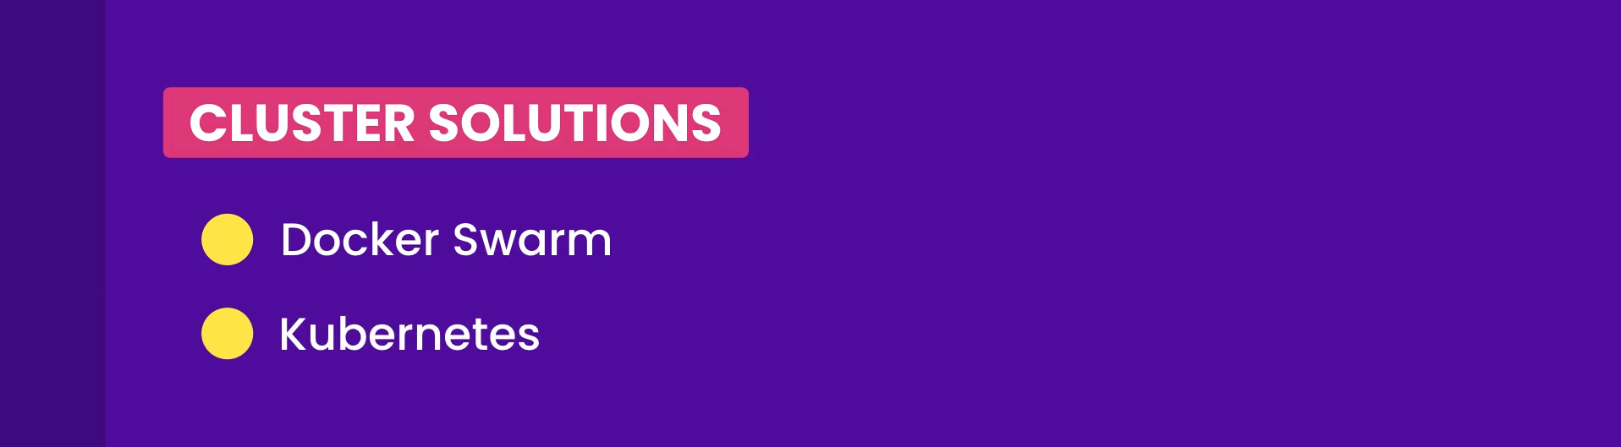


//frontend Dockerfile.prod
# step1: building stage
FROM node:14.16.0-alpine3.13 AS build-stage
RUN addgroup app && adduser -S -G app app
RUN mkdir app && chown app /app
WORKDIR /app
USER app
COPY package*.json ./
RUN npm install
COPY . .
RUN npm run build

# step2: deploying stage
FROM nginx:alpine
COPY --from=build-stage /app/build /usr/share/nginx/html
EXPOSE 80
ENTRYPOINT [ "nginx","-g","daemon off;" ]

