I was required to build a website with HTML, CSS, SVG, Apache Server, MySQL, Python, and any Python Libraries. I need to have a landing page which is has moderately good design, have a login and registration setup for the website, setup a database in phpmyadmin/mysql and have at least 2 tables and the last requirement was to have CRUD operation in the website which is create, read, update and delete where a user can do all of those tasks.

The first and most important thing I had to do was create those two database tables in phpmyadmin using XAMPP control panel.

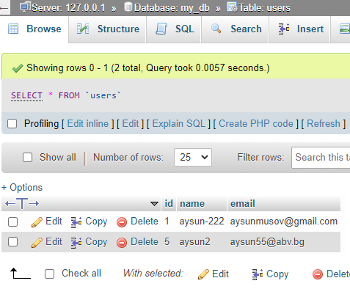

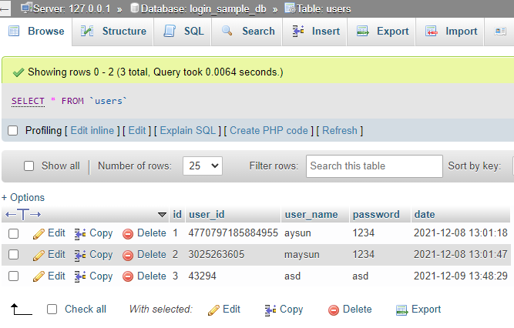

Here you can see that I’ve created 2 databases. One is called login_sample_db which contains the users that register and having this register information they are allowed to login into the website. Without having a registration you can’t login to the website. Here we can see 4 rows which have “id”, “user_id”, “user name”, “password” and “date”. Where the username and password are contained and you can see that every user has a unique id number and the date when it was created.

The second database is called my_db for my database which I use as a check-in for my website. Every student has to check in and write their email and username to contain their data for the teachers to use and everyone can update and view the database.

After that I started working on my login/register part of the site. Here you can see the login code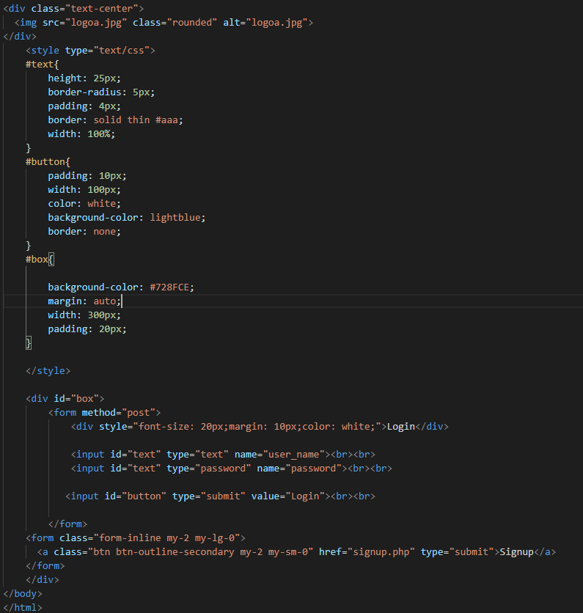

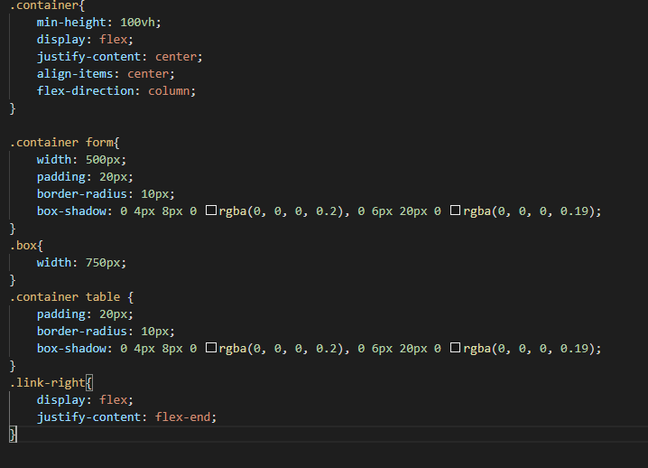

Here you can see the code that I’ve created for the login page and the small container created for it. It was simple and easy to do. The register page has almost the same coding for it too. There is also a link where you can switch between the login page and register page making it easy for the user to use.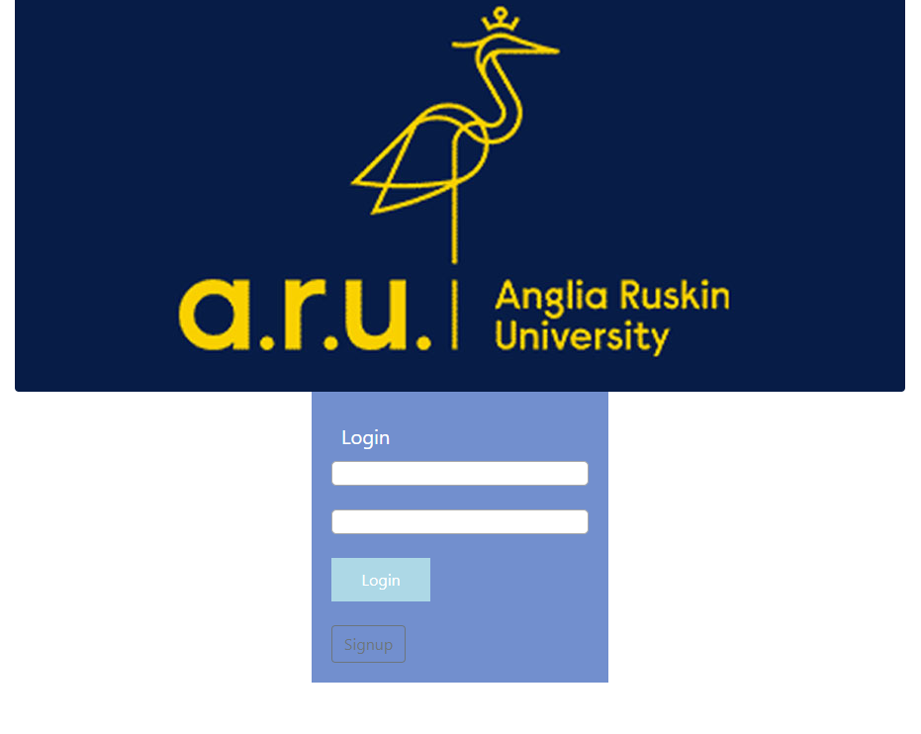

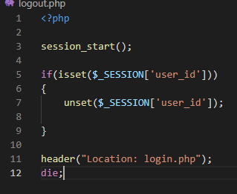

The signup page is literally the same. You just have to enter your username and password to register and you can log in.

After you login there is also a logout button which brings the user to the login page.

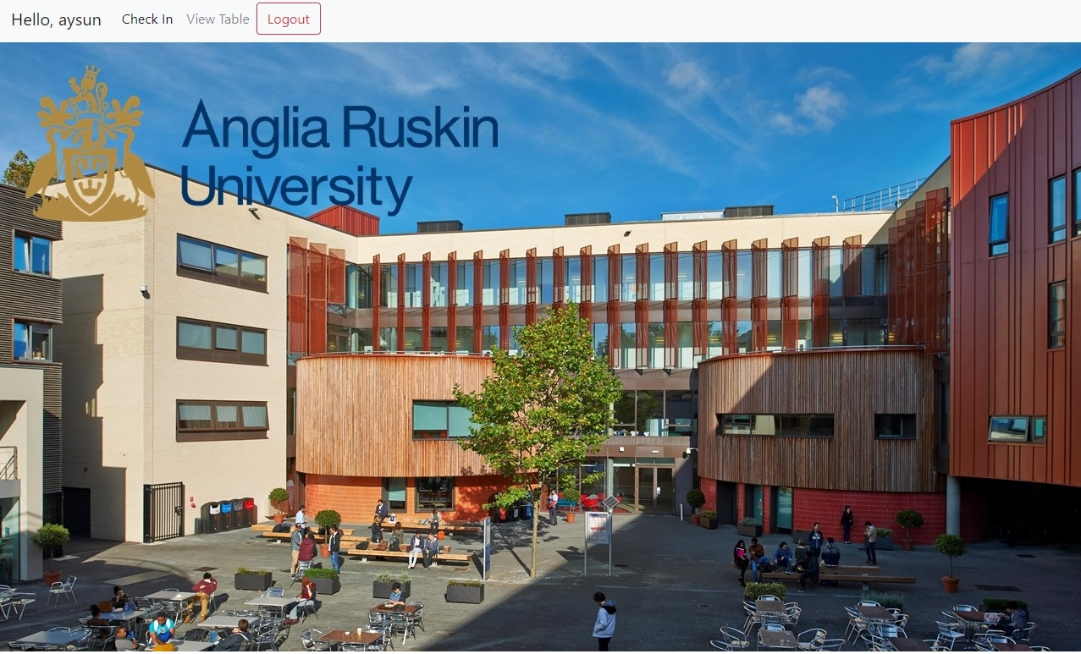

After you log in this is the page that you see. It says Hello,aysun here but it changes to whoever the login user is. There are three extra tabs which are to Check In, View Table and Logout. The check in is where you write down your email and username where it is saved to the database. The view table is where you can check the table and see every student that has set their information for the teachers to use.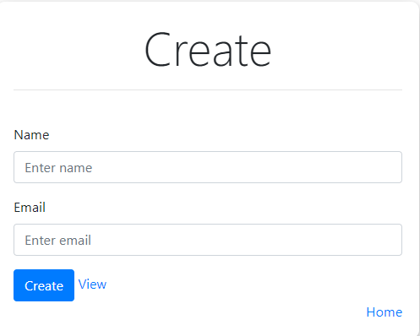

This is the create page where the students are meant to put their information and if you just put the name or only email there is gonna be an error message where it will tell the user that it can’t continue without having both information put down.

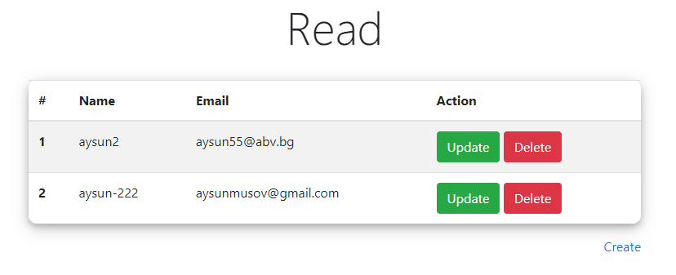

After checking in and having their information put down they can update their information or completely delete it.

All those actions with creation, updating, deleting, registering adds the information into the phpmyadmin/mysql or updates/deletes it which makes the table there be edited from this website directly

For example here it is the delete code that I created for the table: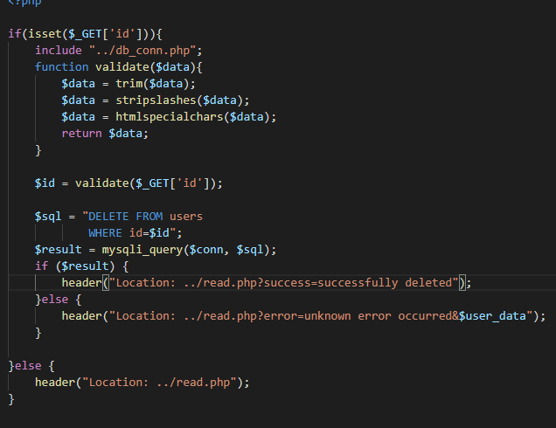

You can see that I’ve used commands with dollar signs and mysql commands like DELETE FROM, WHERE, SET and UPDATE where those actions are done in the phpmyadmin console directly from this code.

Here is also part of the update code which is used to update the table.

