**Predictive Maintenance for Train Components**

## **Introduction**

The integration of Artificial Intelligence (AI) into train systems marks a transformative shift in the transportation industry, aiming to enhance efficiency, safety, and sustainability. By leveraging AI technologies such as predictive maintenance, real-time data analysis, and autonomous operations, train systems can optimize scheduling, reduce delays, and improve passenger experience. AI’s ability to process vast amounts of data allows for smarter decision-making in real-time, offering innovative solutions to complex problems like overcrowding and track management. This collaboration between advanced technology and traditional rail infrastructure is setting the stage for the future of intelligent, connected, and eco-friendly transportation systems.

**Early Detection of Equipment Failures**: Utilize AI-powered sensors and machine learning algorithms to analyze real-time data from train components, enabling the early identification of potential failures or wear before they disrupt operations.

**Optimize Maintenance Schedules**: AI predicts the optimal maintenance time based on historical data and usage patterns, preventing costly downtime.

**Reduce Unscheduled Downtime**: By forecasting when a part is likely to fail, AI helps to schedule repairs or replacements in advance, minimizing the occurrence of unexpected breakdowns and keeping trains in operation longer.

**Extend the Life of Train Components**: AI-driven predictive maintenance can identify areas where specific parts are wearing out prematurely, allowing for targeted interventions that can extend the lifespan of expensive train components.

**Improve Cost Efficiency**: By focusing maintenance efforts on parts that need attention based on AI predictions, rail operators can allocate resources more efficiently, reducing unnecessary repairs and optimizing the overall maintenance budget.

**Enhance Safety**: Predictive maintenance ensures that critical safety systems, such as braking and signaling equipment, are always in optimal condition, reducing the risk of accidents caused by equipment failure.

**\*Real-Time Monitoring and Alerts**: AI systems can continuously monitor the condition of train components in real-time, instantly alerting maintenance teams to potential issues, enabling faster response times and reducing operational disruptions.

**\*Data-Driven Decision Making**: Through data collected from AI systems, rail operators can make informed decisions about asset management, focusing resources where they are most needed and improving overall fleet management.

**Key Components**

1. **Sensors and IoT Devices:** Sensors installed on trains and tracks continuously monitor the condition of components like engines, brakes, and wheels by measuring temperature, vibration, pressure, and wear.
2. **Data Collection and Integration:** Data from sensors, train logs, and maintenance records is integrated into a central database for efficient analysis and decision-making.
3. **Edge Computing:** Data is processed close to its source, reducing latency and enabling real-time monitoring and quick responses.
4. **Machine Learning Models**:AI algorithms analyze past and real-time data to detect patterns, predict failures, and identify potential issues.
5. **Big Data and Cloud Computing:** Large-scale storage and processing infrastructure manage vast amounts of sensor data, ensuring scalability and accessibility.
6. **Data Analytics and Visualization Tools:** Dashboards provide operators and maintenance teams with insights, forecasts, and alerts in an understandable format.
7. **Maintenance Management System (MMS):** AI-driven maintenance scheduling ensures repairs are performed at the right time to minimize downtime.
8. **Communication Networks:** Reliable networks (e.g., 5G, LTE, Wi-Fi) enable seamless data transmission between trains, trackside equipment, and control centers.
9. **Automated Alert and Decision-Making System:** AI-powered notifications inform maintenance teams of predicted failures and suggest preventive actions.
10. **Cybersecurity Measures:** Encryption, secure protocols, and multi-factor authentication protect the system from data breaches and cyber threats.

* **Data collection(sensor installation, data types to collect, data collection techniques)**
* **Data flow and management (data preprocessing, feature engineering, data storage, modelling and prediction, actionable insights)**

**Data flow Diagram**

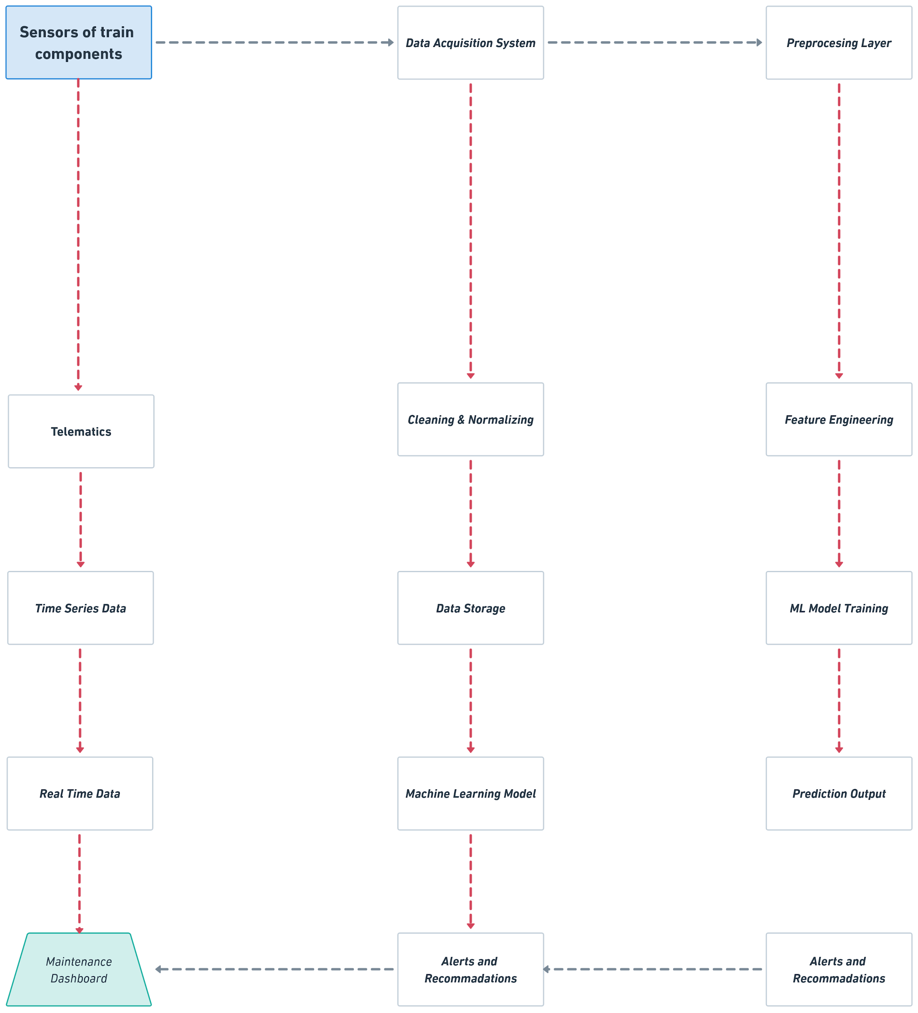

**Machine Learning Model Design (Data labelling and historical data, feature engineering, model selection, model training, model evaluation)**

**Predictive Maintenance System Design (System architecture, key technologies)**

**Expected Outcomes (Early detection of failures, optimized maintenance, improved operational efficiency)**

KPI’s could be :

* **Prediction accuracy and model performance**
  + Prediction accuracy
  + Precision
  + Recall(Sensitivity)
  + F1-Score
  + AUC-ROC (Area Under Curve - Receiver Operating Characteristic)
* **Maintenance optimization**
  + Maintenance Cost Reduction Formula = (Pre-Predictive Maintenance Costs - Post-Predictive Maintenance Costs) / Pre-Predictive Maintenance Costs
  + Average Maintenance Downtime Formula = Total Downtime / Number of Maintenance Events
  + Scheduled vs. Unscheduled Maintenance Formula = Scheduled Maintenance / Total Maintenance
* **Operational efficiency**
  + Mean time between failures (MTBF) Formula = (Total Operating / Number of Failures)
  + Mean time to Repair (MTTR) Formula = (Total Repair Time / Number of Failures)
  + Train Availability Formula : (Total Available Time / Total Scheduled Time) * 100
  + Train Utilization Formula = Total Active Time / Total Scheduled Time
* **System performance and data flow**
  + Data collection coverage ((Formula = Active Sensors / Total Sensors) * 100)
  + Data latency
  + Model response time
  + Data quality (Formula = Clean Data Points / Total Data Points) * 100)
* **Failure prediction outcomes**
  + Failure prediction lead time = The average time in advance that the system predicts a failure before it actually happens. (Formula = Time Between Failure Prediction and Actual Failure)
* **ROI (Return on Investment)** (financial return gained = Cost Savings from Reduced Downtime + Maintenance Cost Reduction - System Implementation Costs) / System Implementation Costs)
* **User and stakeholder satisfaction** 
  + Maintenance team satisfaction
  + train operator satisfaction

**Table of KPI’s**

| **KPI** | **Description** | **Target Goal** |
| --- | --- | --- |
| **Prediction Accuracy** | The percentage of correct predictions | ≥ 90% |
| **Precision** | The proportion of predicted failures that are actual failures | ≥ 85% |
| **Recall** | The ability to identify actual failures | ≥ 85% |
| **F1-Score** | Balance between precision and recall | ≥ 0.85 |
| **MTBF** | Average time between failures | Increase by 20% year-over-year |
| **MTTR** | Average time to repair a component | ≤ 24 hours per failure |
| **Scheduled Maintenance %** | Percentage of planned vs. unplanned maintenance | ≥ 80% scheduled maintenance |
| **Train Availability** | Percentage of time a train is available for operations | ≥ 95% |
| **ROI** | Return on investment for predictive maintenance system | Positive ROI in the first 6-12 months |