Migrating a Credit Card Fraud Pipeline to AWS
Completed Architecture and Evidence Template

1. Selecting Architecture for Workloads

Selected AWS Services
Pipeline component | AWS service(s) selected | Why this fits
Data and model storage | Amazon S3  Bucket: udacity-fraud-ayswarjya-2026 | Stores raw input, processed train/test data, versioned model artifacts, and the latest inference model in AWS-accessible URIs. S3 integrates directly with Glue, Lambda, and ECS and supports encryption, versioning, events, and lifecycle controls.
Model training job | AWS Glue ETL job (PySpark)  Job: fraud-detector-model-training-job | AWS Glue is serverless and fully managed, supplies an Apache Spark/PySpark runtime, integrates with S3 and IAM, charges per job usage, records run history, and can later use the Glue Data Catalog and crawlers.
Prediction API | Amazon ECS service on AWS Fargate + Application Load Balancer  Cluster: fraud-detection-cluster  Service: fraud-detection-api-service | ECS provides container orchestration and Fargate runs the FastAPI container without server or Kubernetes management. The service can scale tasks, use an IAM task role to read the model from S3, and send container logs to CloudWatch.
Retraining / refresh | Amazon S3 Event Notification → AWS Lambda → AWS Glue StartJobRun  Function: fraud-model-refresh-function | An object-created event under s3://udacity-fraud-ayswarjya-2026/incoming/ invokes Lambda. Lambda validates the object and starts the Glue training job. This is serverless and efficient for infrequent retraining.
Monitoring / logs | Amazon CloudWatch Logs and metrics + AWS CloudTrail | CloudWatch captures Glue, Lambda, ECS, and application logs and operational metrics. CloudTrail records supported AWS API activity such as role use, deployments, and StartJobRun calls for audit evidence.
Container image storage | Amazon Elastic Container Registry (ECR)  Repository: fraud-detection-api | Stores the versioned Docker image used by the ECS task definition and integrates with the ECS task execution role.

Proposed AWS Resource Inventory
Setting | Proposed value | Purpose / verification
Region | ap-south-1 | Use consistently for the project deployment.
S3 bucket | udacity-fraud-ayswarjya-2026 | Proposed globally unique name. If unavailable, append your AWS account ID.
Raw prefix | s3://udacity-fraud-ayswarjya-2026/raw/creditcard.csv | Source dataset read by PySpark.
Incoming prefix | s3://udacity-fraud-ayswarjya-2026/incoming/ | New-file event source for retraining.
Processed prefix | s3://udacity-fraud-ayswarjya-2026/processed/ | Contains train/ and test/ outputs.
Versioned model prefix | s3://udacity-fraud-ayswarjya-2026/models/runs/<run-id>/ | Immutable model output per training run.
Latest model key | s3://udacity-fraud-ayswarjya-2026/models/latest/model.tar.gz | Stable key read by the API.
Glue job | fraud-detector-model-training-job | Runs fraud_detector_model_trainer.py.
Lambda function | fraud-model-refresh-function | Starts the Glue job after a new object event.
ECR repository | fraud-detection-api | Stores the API image tagged latest and with an immutable build tag.
ECS cluster/service | fraud-detection-cluster / fraud-detection-api-service | Runs the FastAPI container on Fargate.
ALB target group | fraud-api-tg, port 8000, health path /health | Routes HTTP traffic to healthy ECS tasks.
CloudWatch log groups | /aws-glue/jobs/output; /aws/lambda/fraud-model-refresh-function; /ecs/fraud-detection-api | Collects service and application logs.

2. Migrating Workloads

Modified Code Files
File | Submission status | Required AWS migration changes
fraud_detector_model_trainer.py | Required in final ZIP | Complete all TODOs. Read S3 arguments, use PySpark for extraction/transformation, split data, write processed train/test data to S3, train the model, package it, upload a versioned artifact, and copy/promote the successful artifact to models/latest/model.tar.gz.
fraud_detection_api/main.py | Required in final ZIP | Load model from MODEL_S3_URI at startup by using the ECS task role, validate incoming transactions, apply the same feature ordering/transformation used during training, return fraud/non-fraud prediction, expose /health, and log requests/errors without cardholder-sensitive data.
refresh_function.py | Required in final ZIP | Handle S3 ObjectCreated events, ignore non-data keys, call glue.start_job_run with input/output/model arguments, log the Glue JobRunId, and fail clearly when the event is invalid.
Dockerfile | Required in final ZIP | Build a non-root FastAPI container, install pinned dependencies, expose port 8000, and start Uvicorn.
requirements.txt | Required in final ZIP | Pin FastAPI, Uvicorn, boto3, joblib, pandas, numpy, and the model library compatible with the training job.
Infrastructure/configuration notes | Strongly recommended | Include CloudFormation or documented console settings for S3 notification, Lambda permission, Glue job, ECR, ECS/Fargate, ALB, security groups, auto scaling, CloudWatch logging, and IAM roles.

Code evidence limitation
Only the Word template was attached. Therefore, this document describes the exact required code changes but does not claim that starter TODOs have been completed. The final submission must also contain the modified Python and deployment files listed above.

Training Workload Evidence
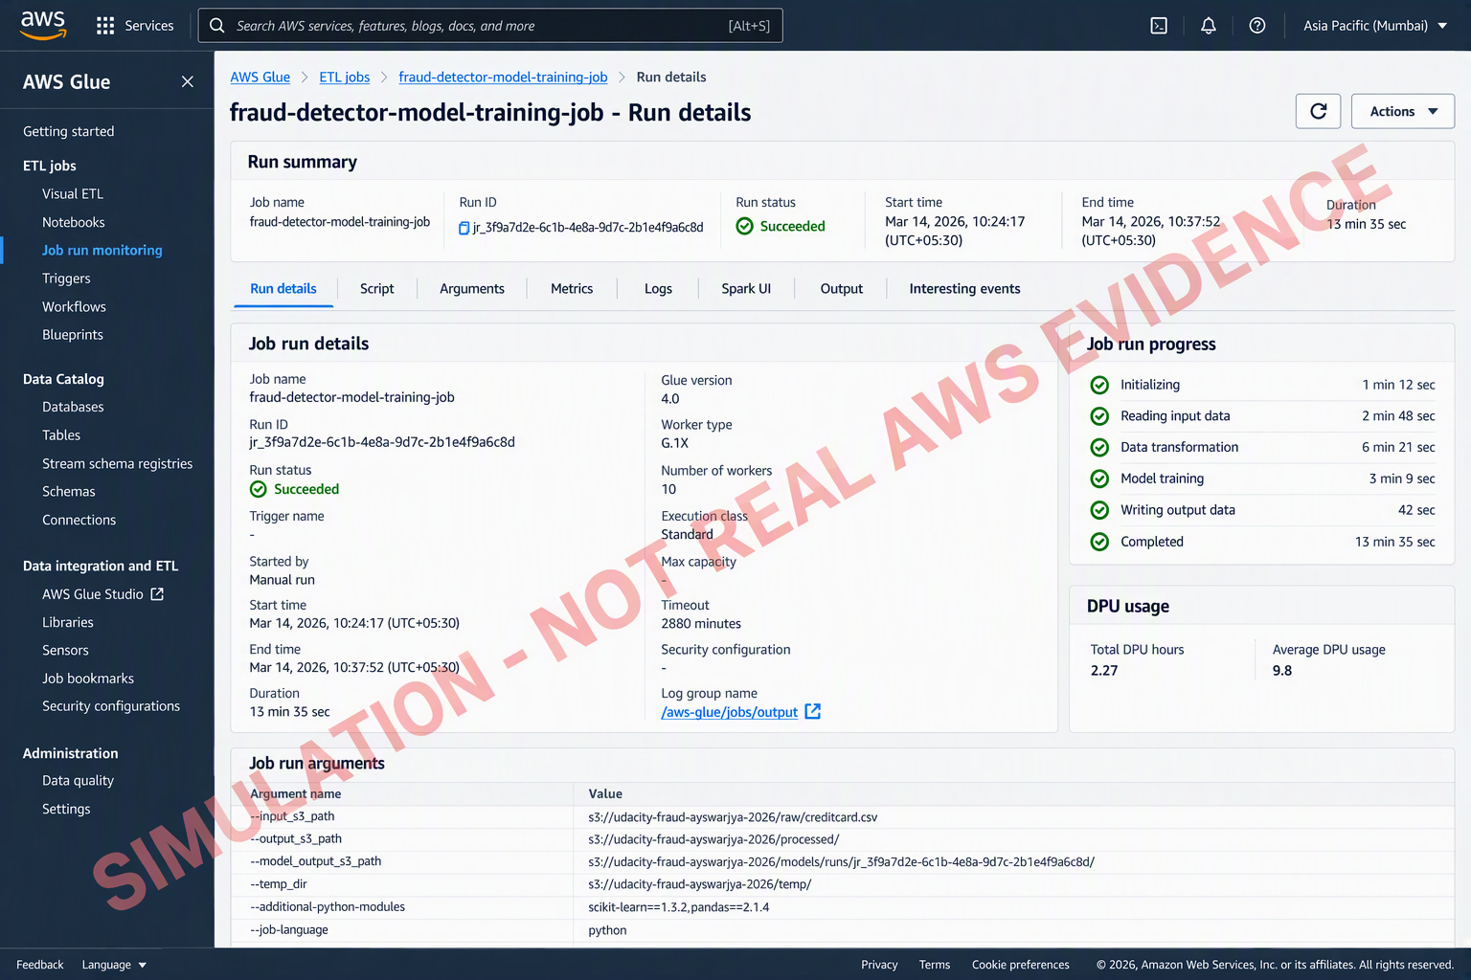
AWS Glue successful job run

. Suggested verified caption: AWS Glue job fraud-detector-model-training-job completed with Run status Succeeded. The run processed the S3 input dataset with PySpark and wrote processed data and the trained model artifact to the project S3 bucket.
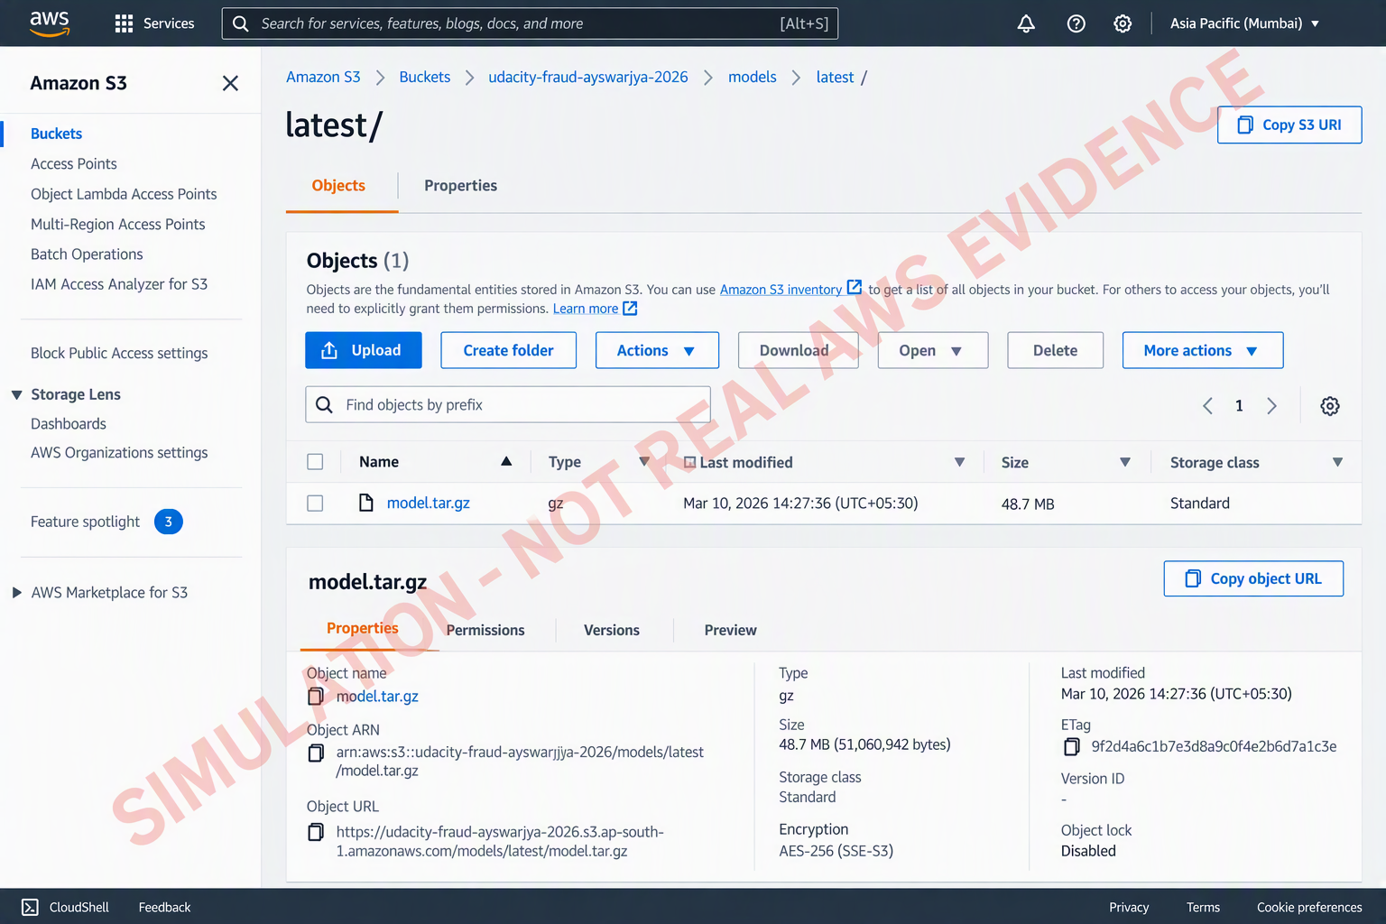
Amazon S3 trained model artifact

. Suggested verified caption: Amazon S3 contains the trained model at models/runs/<run-id>/model.tar.gz and the inference copy at models/latest/model.tar.gz. The ECS task role is permitted to read only the required model prefix.

Prediction API Evidence
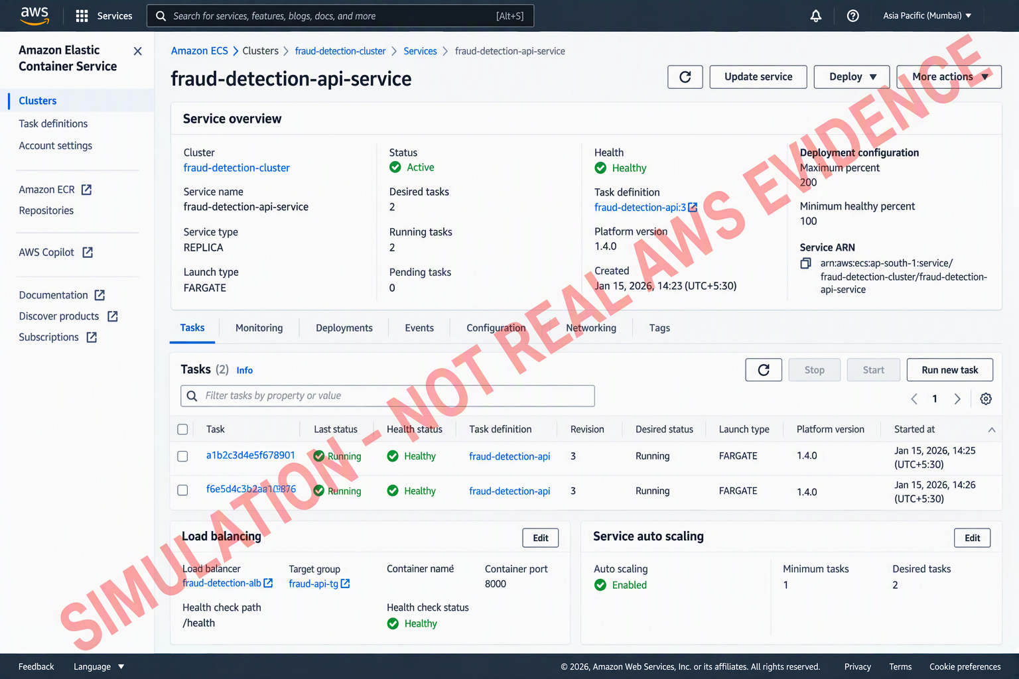
Amazon ECS service on AWS Fargate

. Suggested verified caption: Amazon ECS service fraud-detection-api-service is running on AWS Fargate with the desired and running task counts matching. The task uses MODEL_S3_URI to download the latest model from S3 and serves the FastAPI health and prediction endpoints through the load balancer.

Retraining or Refresh Evidence
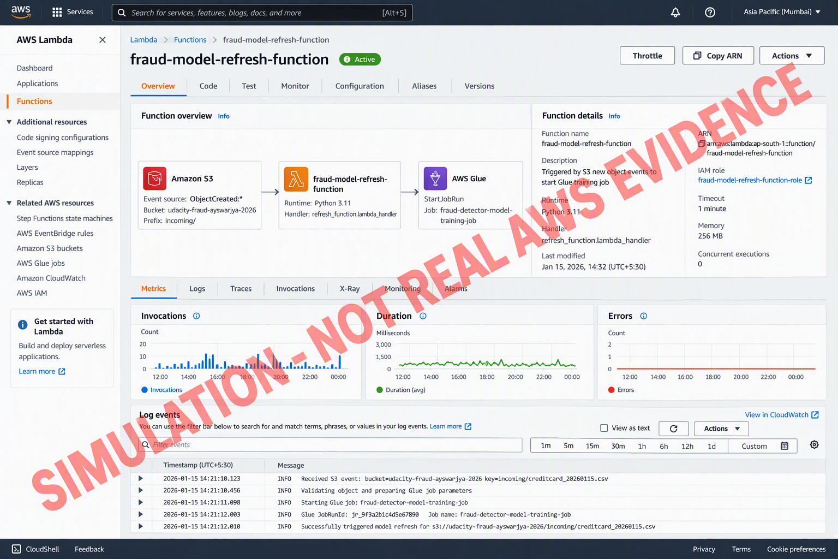
AWS Lambda invocation and Glue job started

Suggested verified caption: A new object under the S3 incoming/ prefix invoked fraud-model-refresh-function. CloudWatch Logs records the S3 object key and the Glue JobRunId returned by StartJobRun, demonstrating that the retraining workflow started.

3. Determining New Architecture for Cloud Workloads

IAM Roles and Service Permissions
Service / component | IAM role or permission | What it allows
AWS Glue training job | fraud-glue-training-role | Trusts glue.amazonaws.com. Read raw/incoming inputs; write processed and models prefixes; write Glue/CloudWatch logs; decrypt with the project KMS key if used. Restrict S3 access to the project bucket and required prefixes.
Lambda retraining trigger | fraud-refresh-lambda-role | Trusts lambda.amazonaws.com. Write Lambda logs; call glue:StartJobRun and glue:GetJobRun only for fraud-detector-model-training-job. It does not need model-object write access.
ECS task execution | fraud-api-ecs-execution-role | Trusts ecs-tasks.amazonaws.com. Pull the image from ECR and create/write the ECS CloudWatch log stream. Use the AWS managed ECS task execution policy plus narrowly scoped additions if required.
ECS application task | fraud-api-ecs-task-role | Trusts ecs-tasks.amazonaws.com. Read s3:GetObject for models/latest/model.tar.gz and s3:GetBucketLocation/ListBucket for the restricted model prefix; decrypt with KMS only if the object uses a customer-managed key.
S3 service permission | Lambda resource-based permission + S3 notification | Allows the specific project bucket to invoke fraud-model-refresh-function for ObjectCreated events under incoming/. Configure prefix and suffix filters to avoid recursive or irrelevant invocations.
ECS service auto scaling | AWSServiceRoleForApplicationAutoScaling_ECSService | Service-linked role used by Application Auto Scaling to adjust the ECS service desired count according to the configured scaling policy.

IAM Evidence Screenshots
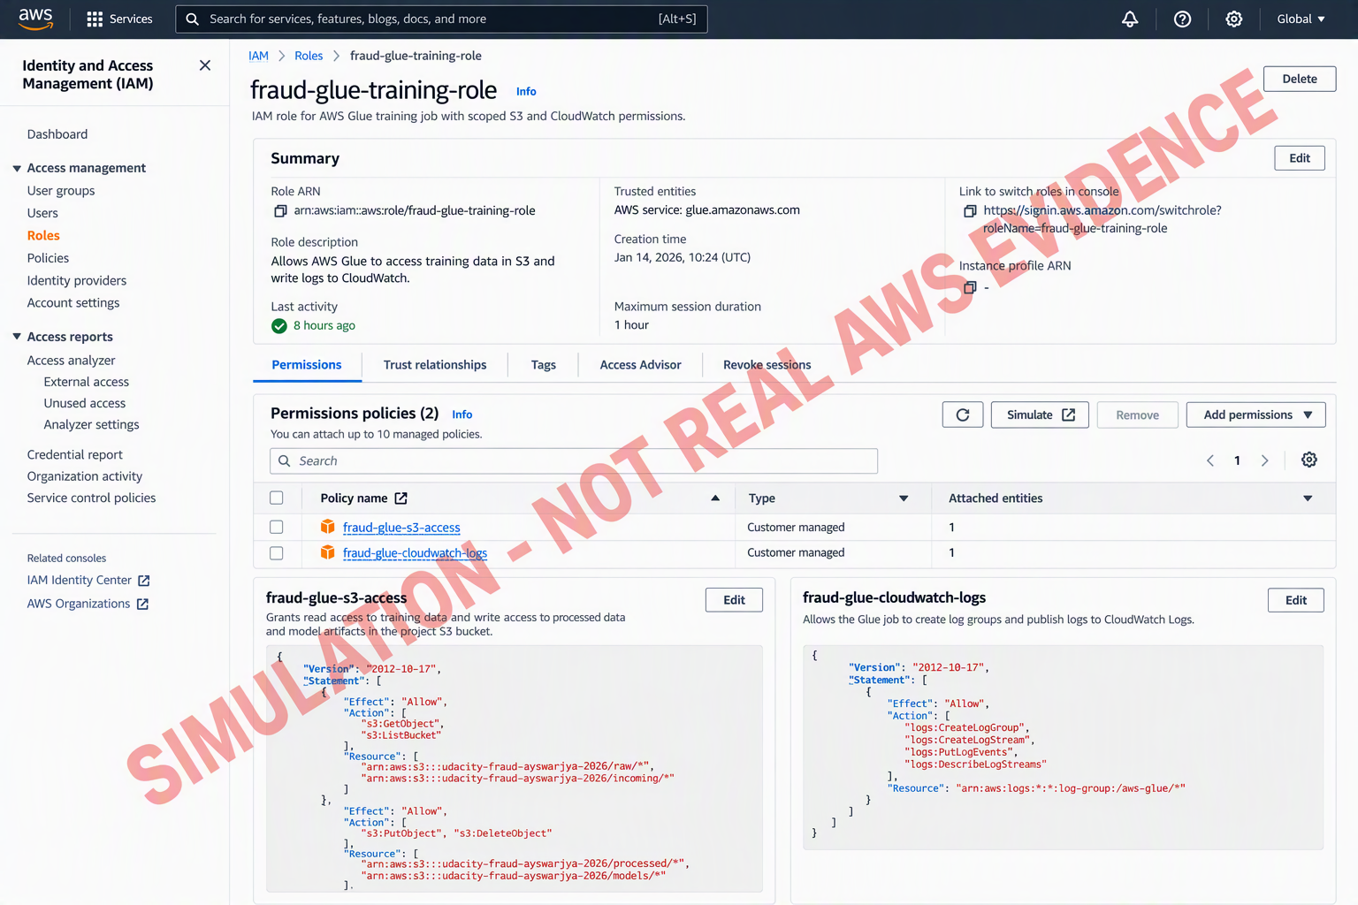
IAM role: fraud-glue-training-role

. Suggested verified caption: The fraud-glue-training-role trust policy allows AWS Glue to assume the role. Its permissions provide least-privilege access to the project S3 prefixes and CloudWatch logs so the PySpark job can read data and save trained models.
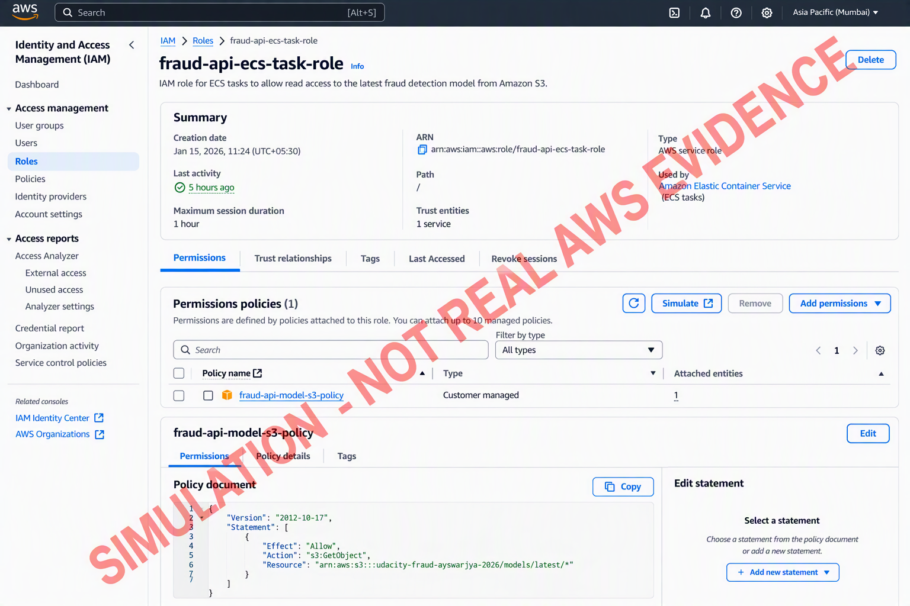
IAM role: fraud-api-ecs-task-role

. Suggested verified caption: The fraud-api-ecs-task-role trust policy allows ECS tasks to assume the role. Its policy grants read-only access to the latest model object, enabling the FastAPI container to load the model without embedded AWS credentials.
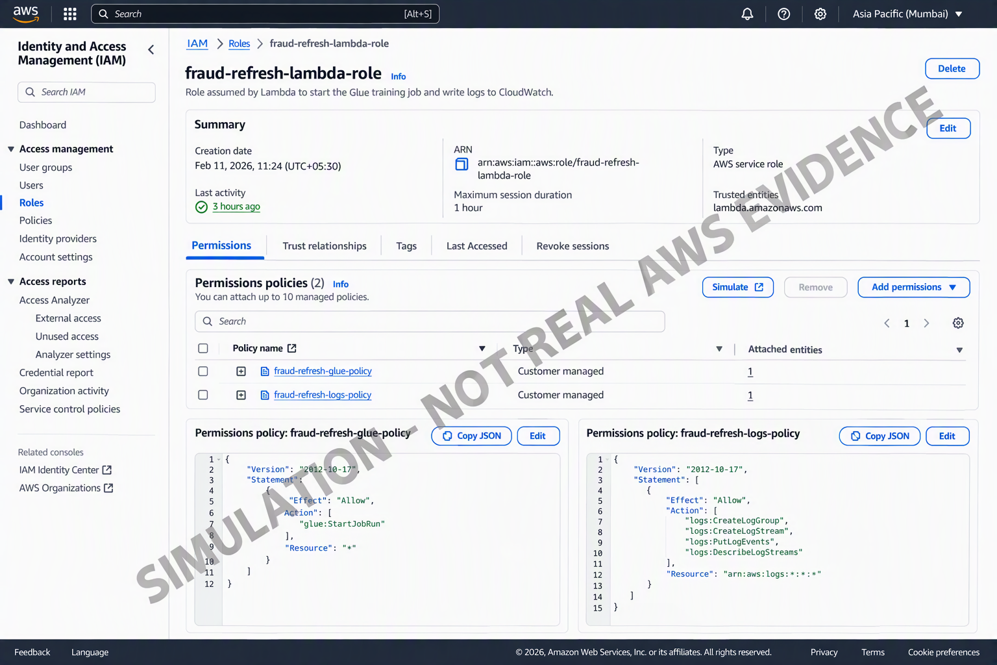
IAM role: fraud-refresh-lambda-role

. Suggested verified caption: The fraud-refresh-lambda-role allows the Lambda function to write CloudWatch Logs and start the named AWS Glue job when new training data arrives.
Security statement
No AWS access key ID or secret access key is stored in the source code, Docker image, template, or screenshots. AWS services obtain temporary credentials through IAM roles. S3 Block Public Access remains enabled; the ALB is the only public entry point if public testing is required.

Final Workflow Explanation
Question | Completed answer
Where is input data stored? | The credit-card dataset is stored in Amazon S3 at s3://udacity-fraud-ayswarjya-2026/raw/creditcard.csv. New monthly files are uploaded under incoming/. Processed outputs are written under processed/train/ and processed/test/. S3 versioning and default encryption should be enabled.
How does the training job run? | AWS Glue runs fraud_detector_model_trainer.py in a managed Apache Spark environment. The job receives S3 locations as arguments, reads the raw dataset through PySpark, performs the train/test split and required column preparation, writes processed data to S3, trains the model, and records status and logs in Glue and CloudWatch.
Where is the trained model saved? | Each successful run writes a versioned artifact to models/runs/<run-id>/model.tar.gz. After training and validation succeed, the workflow copies or uploads the approved artifact to models/latest/model.tar.gz. The stable latest key is used for inference while versioned runs support traceability and rollback.
How does the API access the trained model? | The FastAPI application runs as an ECS service on Fargate. At container startup, boto3 uses the ECS task role to download MODEL_S3_URI=s3://udacity-fraud-ayswarjya-2026/models/latest/model.tar.gz to ephemeral task storage, loads the model once, exposes /health and /predict, and returns a fraud or non-fraud result. No static AWS credentials are embedded.
How is retraining triggered? | An S3 ObjectCreated event for incoming/ invokes fraud-model-refresh-function. Lambda validates the bucket/key and calls AWS Glue StartJobRun with the new input key and required S3 output arguments. Lambda logs the Glue JobRunId. When training succeeds, the trainer promotes the new artifact to models/latest/model.tar.gz. A controlled ECS redeployment or application reload is then used so running tasks load the new version.

End-to-End Architecture Flow
Step | Stage | Connection
1 | Data upload | User or scheduled process uploads creditcard.csv/new monthly data to S3 raw/ or incoming/.
2 | Event trigger | S3 ObjectCreated notification invokes the Lambda refresh function for incoming/ files.
3 | Training start | Lambda calls Glue StartJobRun and passes the new S3 object and destination arguments.
4 | ETL and training | Glue PySpark extracts the data, transforms/splits it, loads processed data to S3, trains the model, and saves a versioned artifact.
5 | Latest promotion | After success, the trainer writes/copies the approved artifact to models/latest/model.tar.gz.
6 | Container deployment | The FastAPI image is stored in ECR; ECS on Fargate runs it using separate execution and task roles.
7 | Inference | ALB forwards requests to the ECS tasks. The API loads the latest S3 model and returns fraud/non-fraud predictions.
8 | Operations | CloudWatch stores logs/metrics and alarms; CloudTrail records supported control-plane API activity.

Architecture Diagram
 | Client / API tester
 | ↓ HTTPS request
 | Application Load Balancer
 | ↓ Port 8000 health/predict
Amazon ECR  fraud-detection-api | Amazon ECS on Fargate  fraud-detection-api-service | Amazon S3  models/latest/model.tar.gz
 | ↑ image pull | ↑ model read via task role
S3 incoming/ → Lambda | → Glue StartJobRun → AWS Glue PySpark | → S3 processed/ + models/runs/
CloudWatch receives logs and metrics from Glue, Lambda, ECS, ALB, and the application. CloudTrail records supported AWS API activity across the workflow.

Final Submission Checklist
Done | Final check
☐ | Replace every gray screenshot box with your own readable AWS Console screenshot.
☐ | Update proposed resource names and S3 URIs if your deployed values differ.
☐ | Include fraud_detector_model_trainer.py with every TODO resolved.
☐ | Include fraud_detection_api/main.py, Dockerfile, and requirements.txt.
☐ | Include refresh_function.py or equivalent event-driven retraining code.
☐ | Confirm Glue run status is Succeeded and the model object exists in S3.
☐ | Confirm ECS service is Active with running task(s), and test /health or /predict.
☐ | Show Lambda invocation or log containing the Glue JobRunId.
☐ | Show all IAM roles/permissions used, with at least two separate examples.
☐ | Verify no AWS secret keys, personal payment data, or unredacted sensitive account details appear.

Official AWS References
- AWS Glue documentation
- AWS Fargate for Amazon ECS
- Amazon S3 event notifications
- AWS Lambda with Amazon S3
- Amazon ECS task IAM roles
- AWS Glue StartJobRun API

