Blue Team | Week 1
Mini-SOC in a Box
Week 1 Report: Build the lab and deploy Wazuh
An isolated virtual lab with Wazuh 4.14.7 on Docker: three virtual machines, two agents and five verified detections for LabShop.
Field | Details
Author | Aytac Dəmirova
Project | LabShop SOC lab (Mini-SOC in a box, 12-week project)
Lab work date | 16–19 October 2026
Platform | Wazuh 4.14.7 single-node (Docker Compose), VMware, Dell laptop
Evidence | Every figure is a screenshot from the lab; originals are in the repository folder evidence/

Table of Contents
1. Summary 3
2. Lab design 3
3. Lab environment 6
3.1 Network 6
3.2 Clocks and time zones 9
3.3 Docker 10
3.4 Snapshots 11
4. Wazuh platform 13
4.1 Deployment and version 13
4.2 Dashboard over HTTPS and the certificate warning 14
4.3 Changing the default administrator password 14
4.4 Persistence test (stop, start, reboot) 16
4.5 Idle memory use 20
5. Agents and telemetry 21
5.1 Linux agent on ubuntu-web (A1) 21
5.2 Windows agent on win-client (A2) 21
5.3 Sysmon on win-client (A3) 22
5.4 Web server on ubuntu-web (A4) 23
6. Verification 24
6.1 Five deliberate events (V1) 24
6.2 The path of one event from the endpoint to the alert (V2) 32
7. Security and hygiene 32
8. Notes and lessons 33
9. Sign-off status 34
Appendix A. Evidence index 35

1. Summary
LabShop is a small online shop with one web server, one staff PC and no security monitoring. Week 1 builds the foundation for the whole project: an isolated virtual lab, and Wazuh as the system that collects what the machines are saying.
I built three virtual machines on my Dell laptop under VMware. siem-host (Ubuntu Server) runs Wazuh 4.14.7 in Docker. ubuntu-web (Ubuntu Server 26.04) is the Linux endpoint and web server (nginx). win-client (Windows 10 Education) is the staff PC with Sysmon. Both agents show Active, Sysmon events reach the dashboard, and I found all five required test events in the dashboard with their rule description and level.
The table shows the status of every requirement, with the section and the figures that prove it. Section 9 lists the sign-off checks.
ID | Requirement | Status | Where
L1 | Three VMs with the required roles and resources | Done | Section 2, Figures 2–4
L2 | Host-only network, static IPs, NAT on siem-host only | Done | Sections 2 and 3.1, Figures 2–4, 6
L3 | VMs reach each other, dashboard opens from Dell, clocks correct | Done | Section 3.1, Figures 8–10
L4 | Docker Engine and Compose from the official repository; kernel setting persists | Done | Section 3.3, Figure 15
L5 | Snapshots w1-clean-install and w1-done | Done | Section 3.4, Figures 16–18
W1 | Wazuh single-node stack up, 4.14.x, version documented | Done | Section 4.1
W2 | Dashboard over HTTPS, certificate warning explained | Done | Section 4.2
W3 | Default admin password changed, not stored in Git | Done | Section 4.3, Figures 23–26
W4 | Stack stop/start and host reboot keep agents and alerts | Done | Section 4.4, Figures 27–36
W5 | Idle memory of each Wazuh container measured | Done | Section 4.5
A1 | Linux agent ubuntu-web Active | Done | Section 5.1
A2 | Windows agent win-client Active | Done | Section 5.2
A3 | Sysmon with community config, events in dashboard | Done | Section 5.3
A4 | Web server on ubuntu-web opens from Dell | Done | Section 5.4
V1 | Five deliberate events found in the dashboard | Done | Section 6.1
V2 | Path of one event from endpoint to alert explained | Done | Section 6.2
S1 | No secrets in Git, .gitignore shown and checked | Done | Section 7, Figures 62, 63
S2 | Only siem-host has a permanent route to the internet | Done | Section 7, Figures 3, 4, 6
D1 | Repository with README, architecture/, evidence/, journal.md | Done | Repository: README.md, architecture/, evidence/, journal.md
D2 | README explains start and stop of the whole lab | Done | README.md
D3 | Journal with at least five entries | Done | journal.md

2. Lab design
Attack tools will be used from Week 3 onward. That is why the lab must be isolated: the machines live on a host-only network that has no route to the internet, so nothing I run in the lab can reach another system, and nothing from outside can reach the deliberately weak machines. Only siem-host has a NAT adapter, because it must download Docker images.
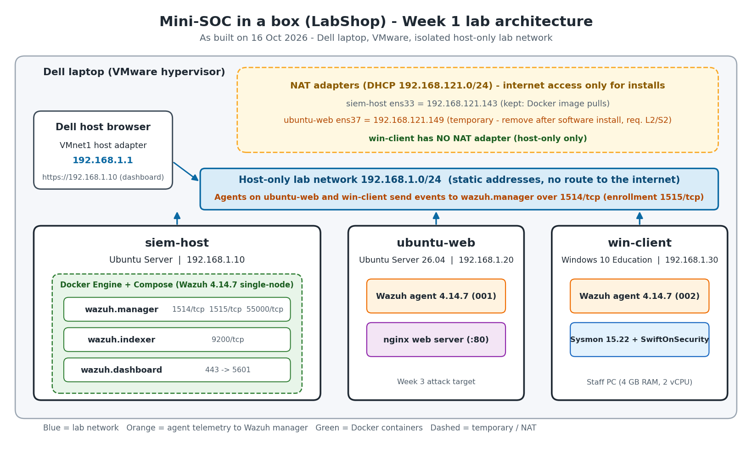
Figure 1. Lab architecture as built (my own diagram; it matches the addresses in the table below).

Address table
Machine | Role | OS | Host-only IP | NAT adapter
siem-host | Runs Wazuh in Docker | Ubuntu Server | 192.168.1.10 | ens33, 192.168.121.143 (DHCP), kept for Docker image pulls
ubuntu-web | Linux endpoint and web server | Ubuntu Server 26.04 LTS | 192.168.1.20 | None (removed after the software installation)
win-client | Windows endpoint (staff PC) | Windows 10 Education 10.0.19045.6456 | 192.168.1.30 | None
Dell host | Hypervisor and browser | Windows, VMware | 192.168.1.1 (VMnet1) | n/a

VM resources
Machine | RAM | vCPU | Disk | Source
siem-host | 16 GB (Docker sees 15.07 GiB) | 8 | 250 GB | VMware settings, Figure 2
ubuntu-web | 2 GB | 2 | 40 GB | VMware settings, Figure 3
win-client | 4 GB | 2 cores | 60 GB (NVMe) | VMware settings, Figure 4
The three VMware “Virtual Machine Settings” screenshots show the final memory, processors, disk and network adapters of each VM. The RAM of the three VMs adds up to 22 GB, as in the brief. siem-host is the only VM with a NAT adapter (VMnet8); ubuntu-web and win-client have a single host-only adapter (VMnet1).
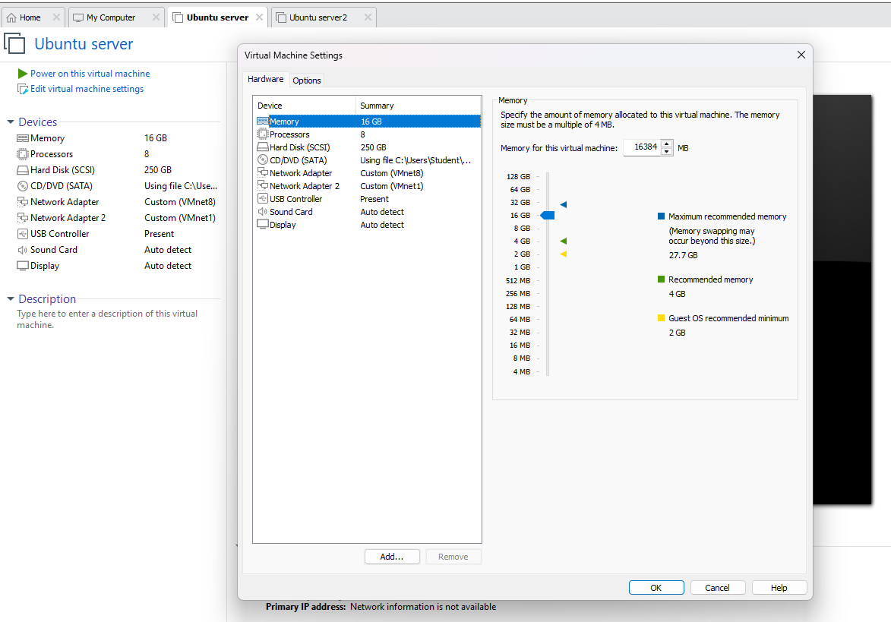
Figure 2. siem-host (VMware “Ubuntu server”): 16 GB RAM, 8 processors, 250 GB disk, Network Adapter on VMnet8 (NAT) and Network Adapter 2 on VMnet1 (host-only).
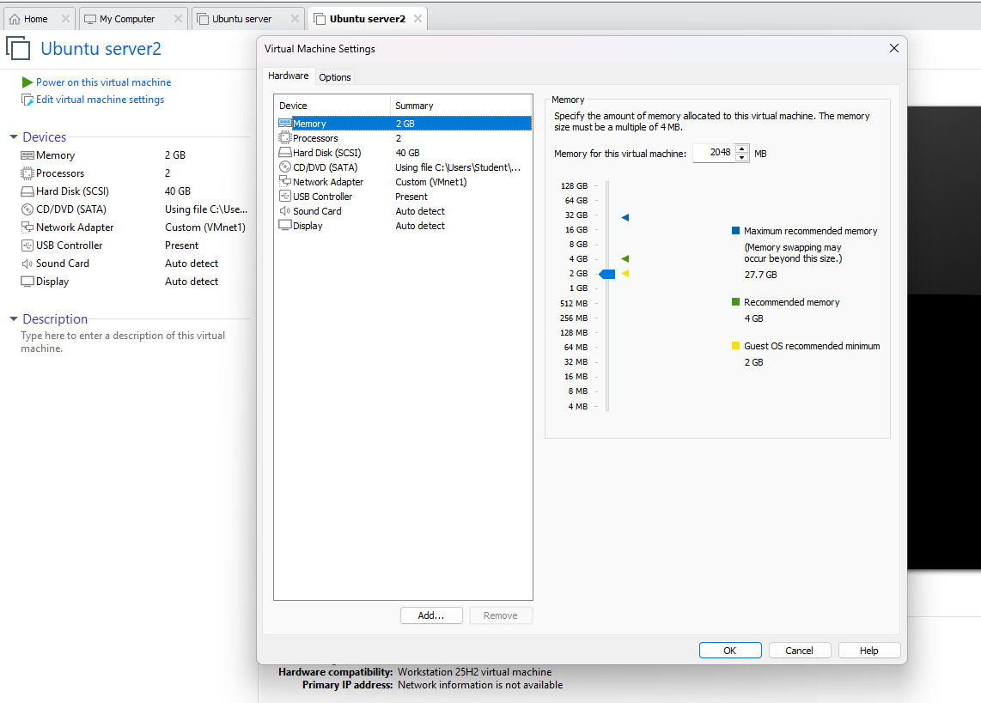
Figure 3. ubuntu-web (VMware “Ubuntu server2”): 2 GB RAM, 2 processors, 40 GB disk, one network adapter on VMnet1 (host-only).
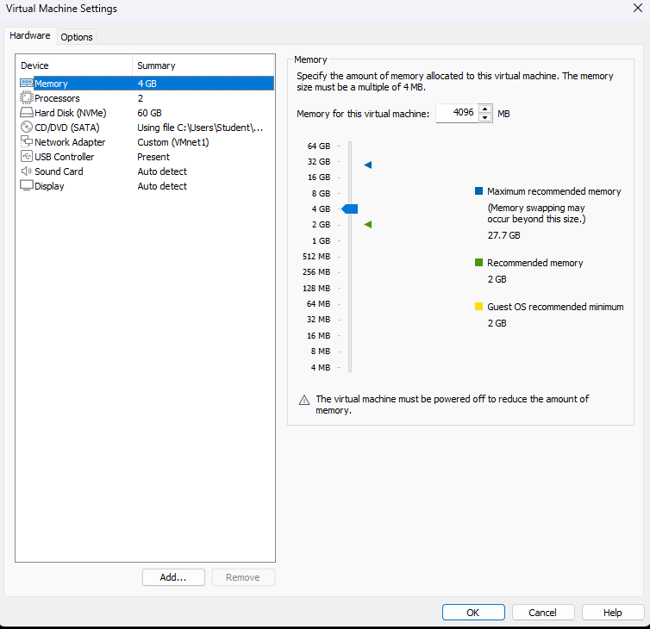
Figure 4. win-client (VMware “Windows 10 x64”): 4 GB RAM, 2 processors, 60 GB NVMe disk, one network adapter on VMnet1 (host-only).

3. Lab environment

3.1 Network
Each VM has a static address on the host-only network 192.168.1.0/24. The ip a output shows the difference: the host-only interface of siem-host (ens37) has no “dynamic” flag, while its NAT interface (ens33) got a DHCP lease in 192.168.121.0/24. ubuntu-web had a NAT adapter only while software was installed; it was removed, so ubuntu-web now has its host-only interface (ens33) only. win-client has one adapter only, with the Dell VMnet1 address 192.168.1.1 as its gateway.
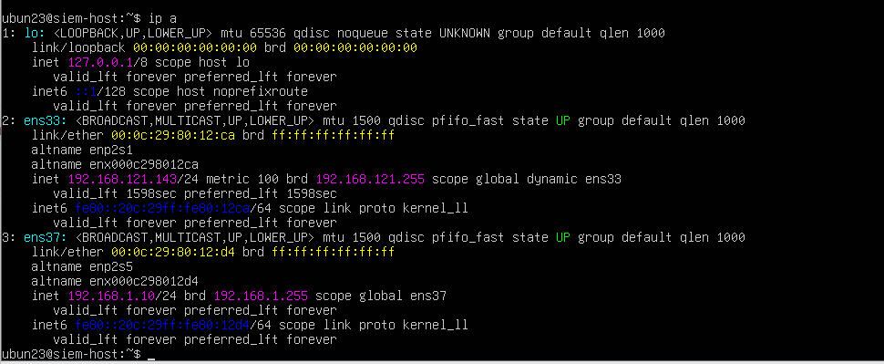
Figure 5. siem-host: ens37 = 192.168.1.10/24 (host-only, static), ens33 = 192.168.121.143 (NAT, DHCP).
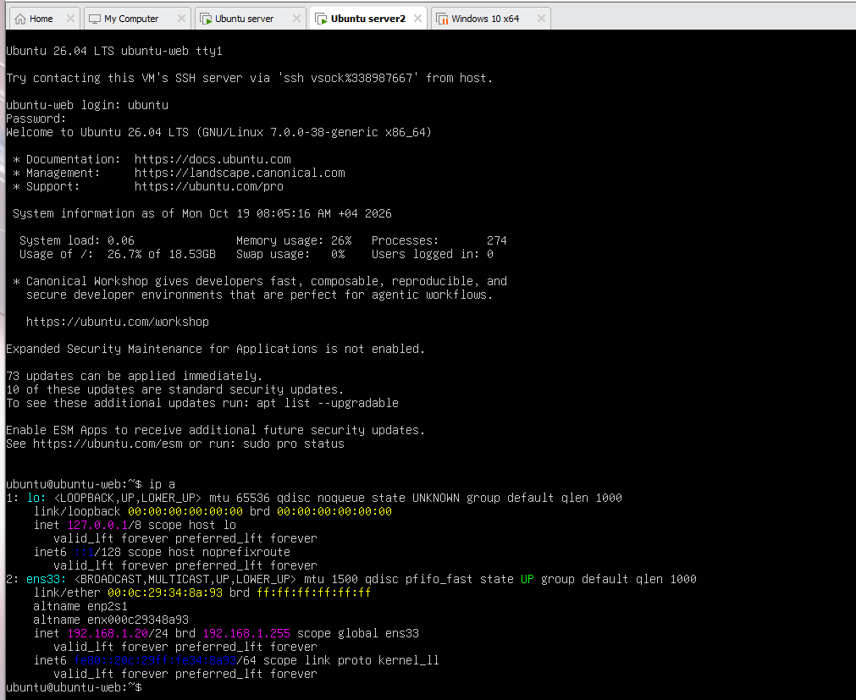
Figure 6. ubuntu-web after the NAT adapter was removed: the only interface is ens33 = 192.168.1.20/24 (host-only, static).
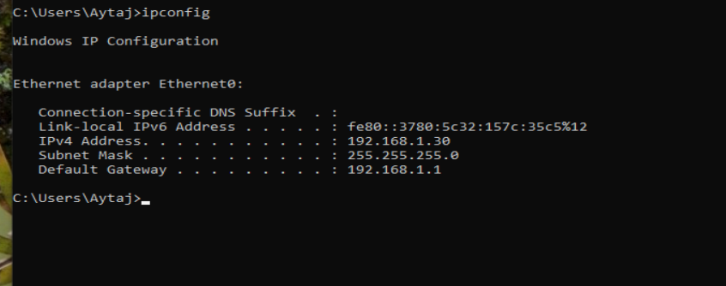
Figure 7. win-client: one Ethernet adapter, 192.168.1.30, gateway 192.168.1.1.
The dashboard on siem-host opens in the browser of my Dell at https://192.168.1.10 (section 4.2), and the nginx page of ubuntu-web opens at http://192.168.1.20 (section 5.4).
L3: every VM reaches the other two with 0% packet loss. siem-host pings 192.168.1.20 and 192.168.1.30, ubuntu-web pings 192.168.1.10 and 192.168.1.30, and win-client pings 192.168.1.10 and 192.168.1.20.
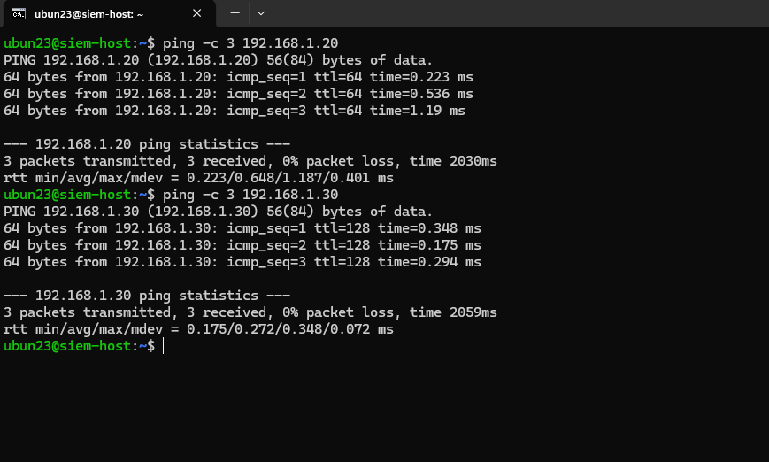
Figure 8. siem-host: ping to ubuntu-web (192.168.1.20) and win-client (192.168.1.30), 0% packet loss.
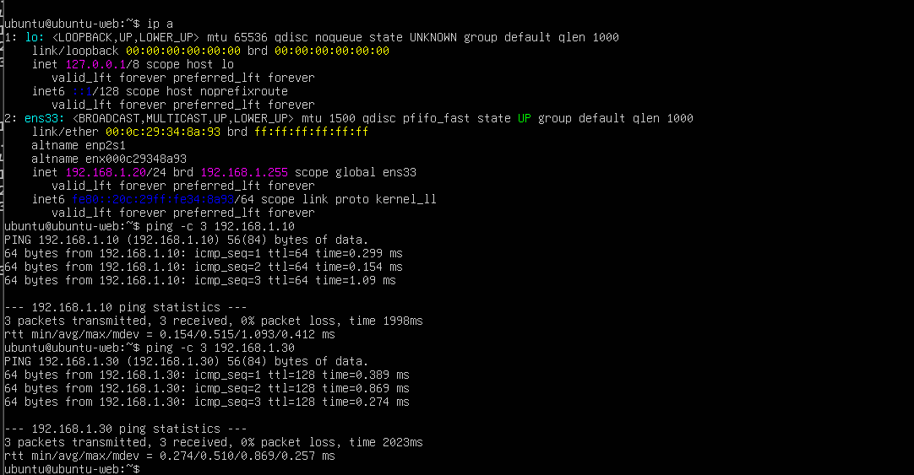
Figure 9. ubuntu-web: ping to siem-host (192.168.1.10) and win-client (192.168.1.30), 0% packet loss.
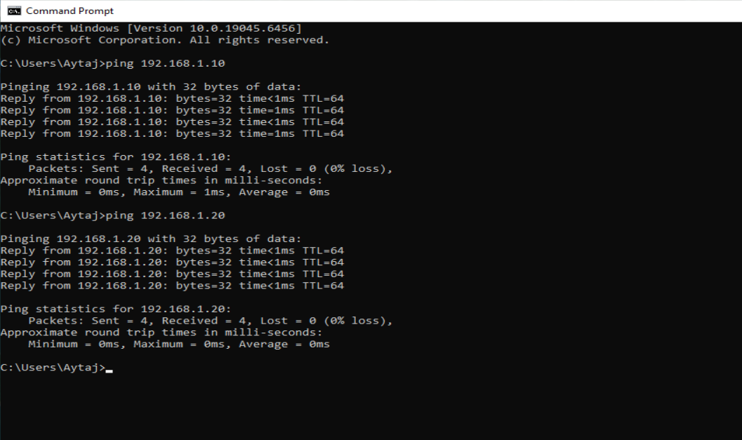
Figure 10. win-client: ping to siem-host (192.168.1.10) and ubuntu-web (192.168.1.20), 0% packet loss.

3.2 Clocks and time zones
Correct clocks matter for a SIEM, because alerts from different machines are correlated by time. All three VMs use the Asia/Baku time zone (UTC+04). On both Linux machines timedatectl reports that the system clock is synchronized and the NTP service is active. Windows is set to set the time automatically in the (UTC+04:00) Baku time zone.
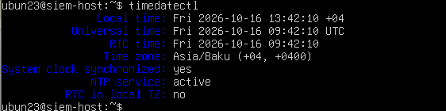
Figure 11. siem-host: Asia/Baku, clock synchronized, NTP active.
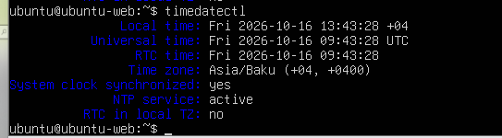
Figure 12. ubuntu-web: Asia/Baku, clock synchronized, NTP active.
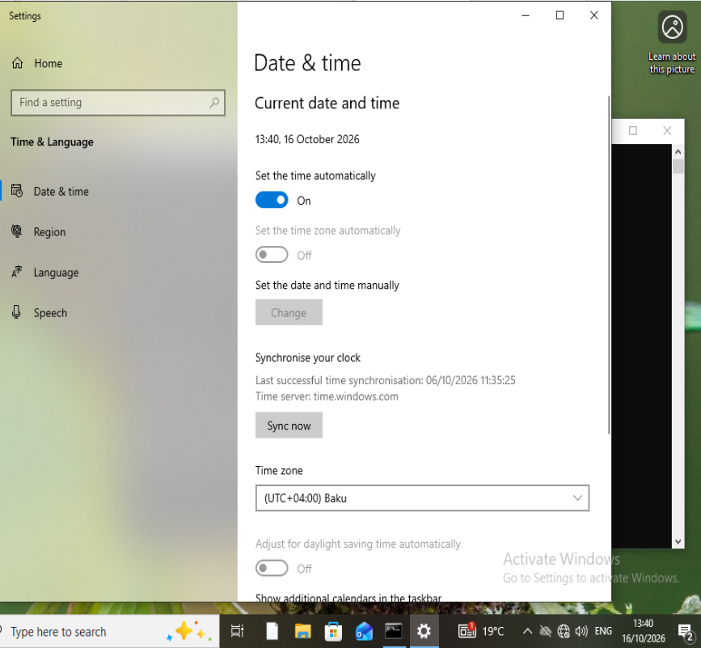
Figure 13. win-client: automatic time on, time zone (UTC+04:00) Baku.
Observation: the Windows page shows its last successful synchronisation on 06/10/2026. This is probably because win-client is host-only and cannot reach time.windows.com any more. The displayed time still matches the Linux machines.

3.3 Docker
Docker Engine and the Docker Compose plugin are installed on siem-host. The hello-world container ran successfully, and docker compose version reports v5.6.0.
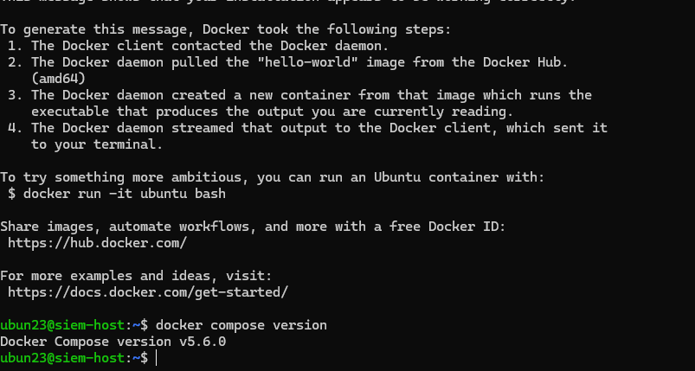
Figure 14. hello-world output and Docker Compose version on siem-host.
The Wazuh indexer needs the kernel setting vm.max_map_count to be at least 262144 on the host. The indexer is running, so the setting is applied.
Proof for L4. docker --version reports Docker 29.9.1. The apt source in /etc/apt/sources.list.d/docker.* points to Docker’s official repository (download.docker.com/linux/ubuntu, suite resolute, stable), signed with /etc/apt/keyrings/docker.asc. sysctl vm.max_map_count returns 262144, and the same line vm.max_map_count=262144 is stored in /etc/sysctl.d/*.conf, so the setting is applied again at every boot. The indexer started by itself after the reboot test (section 4.4).
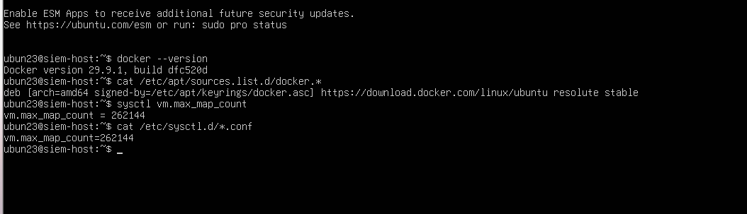
Figure 15. siem-host: docker --version, the Docker apt source, sysctl vm.max_map_count = 262144 and the permanent setting in /etc/sysctl.d/.

3.4 Snapshots
Snapshot w1-clean-install was taken on every VM before any Wazuh work, and w1-done at the end of the week, after the persistence test, on 19 October 2026 (siem-host 08:50, ubuntu-web 08:51, win-client 08:51). In VMware the VMs are named “Ubuntu server” (siem-host), “Ubuntu server2” (ubuntu-web) and “Windows 10 x64” (win-client). siem-host also keeps snapshots after the Docker install and during the Wazuh work (After install docker, Install wazuh, w1-wazuh-up and one named “after changing …”), so I can go back to a known good state.
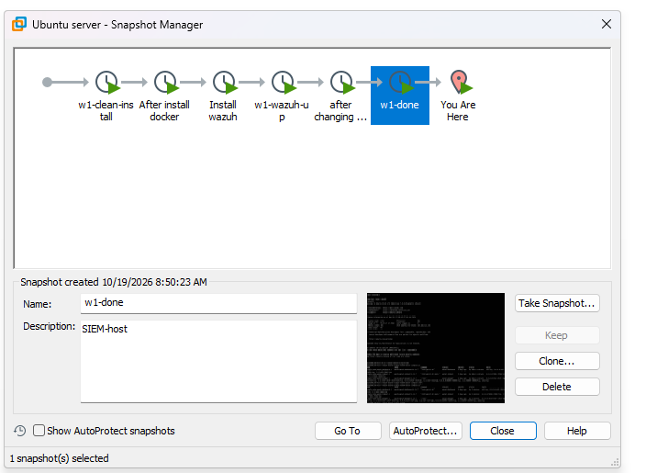
Figure 16. siem-host Snapshot Manager: w1-clean-install, After install docker, Install wazuh, w1-wazuh-up, after changing …, w1-done (created 10/19/2026 8:50 AM).
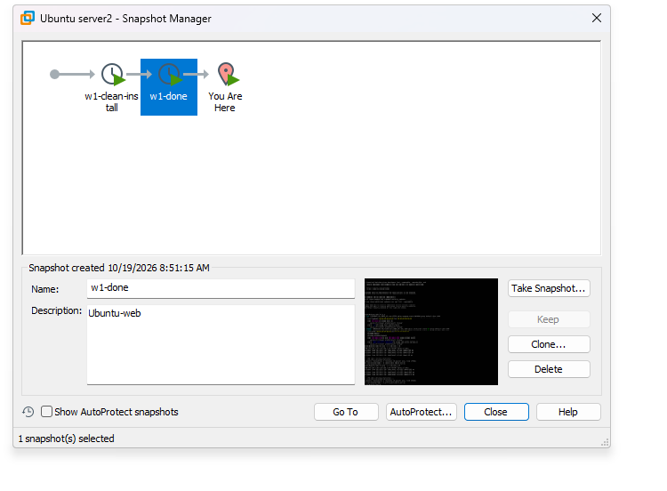
Figure 17. ubuntu-web Snapshot Manager: w1-clean-install and w1-done (created 10/19/2026 8:51 AM).
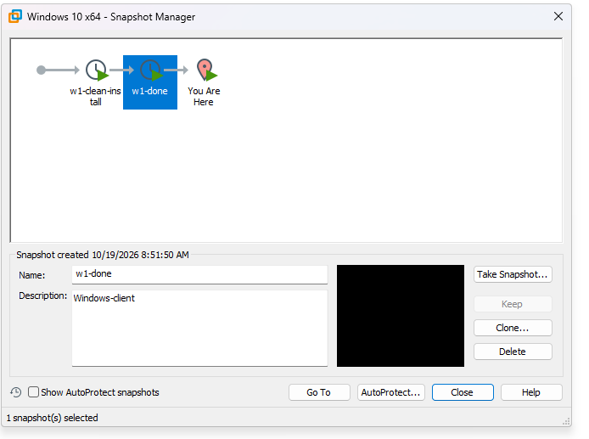
Figure 18. win-client Snapshot Manager: w1-clean-install and w1-done (created 10/19/2026 8:51 AM).
Windows licence state. slmgr /xpr on win-client answers “Windows is in Notification mode”. The installation is therefore not activated and shows no expiry date, so the lab does not depend on a Windows expiry date.
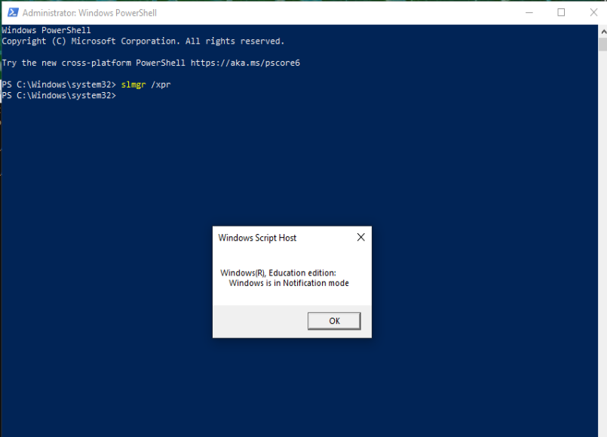
Figure 19. win-client, administrator PowerShell: slmgr /xpr reports “Windows(R), Education edition: Windows is in Notification mode”.

4. Wazuh platform

4.1 Deployment and version
I read the Wazuh Docker deployment page first, then cloned the official wazuh-docker repository at tag v4.14.7 into ~/wazuh-docker and used the single-node folder. The Git repository for my own work, ~/labshop-soc, is separate, so Wazuh certificates and settings never get mixed into it.
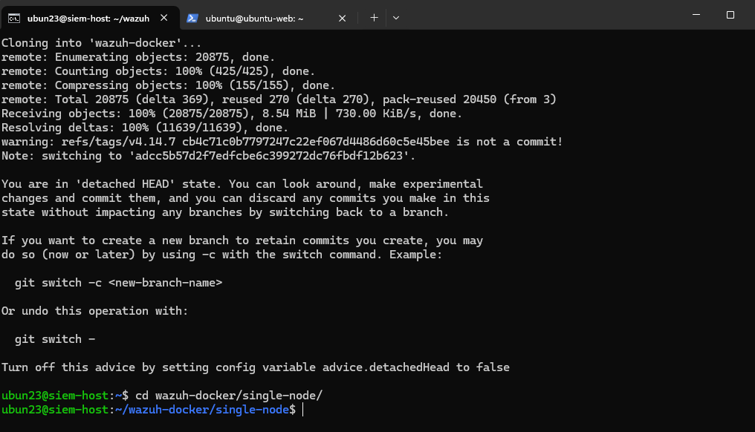
Figure 20. Cloning wazuh-docker at v4.14.7 and entering single-node/.
After docker compose up -d all three containers are up. All images are 4.14.7, so the manager and the agents are on the same version (an agent must not be newer than the manager).
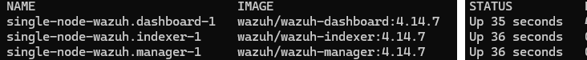
Figure 21. docker compose ps: wazuh.dashboard, wazuh.indexer and wazuh.manager, all 4.14.7 and Up.
Published ports: 443 (dashboard, forwarded to 5601), 9200 (indexer), 1514/tcp (agent events), 1515/tcp (agent enrollment), 514/udp (syslog) and 55000/tcp (Wazuh API).

4.2 Dashboard over HTTPS and the certificate warning
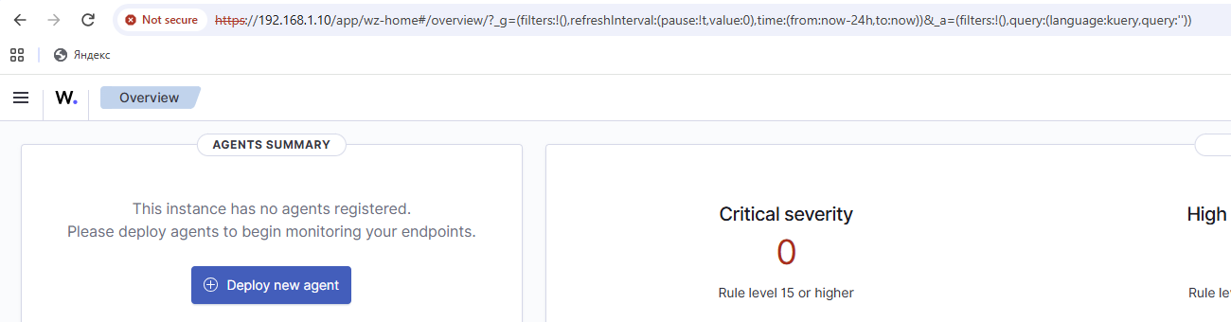
Figure 22. Dashboard opened from my Dell at https://192.168.1.10. Chrome shows "Not secure". No agents are registered yet at this point.
Why the browser warns. The dashboard uses TLS, but its certificate was created inside the lab by Wazuh’s own certificate generator. It is signed by a lab root CA that my browser does not trust, and it is normally issued for the container name (wazuh.dashboard), not for the address 192.168.1.10 that I typed. So the browser cannot verify who it is talking to. The traffic is still encrypted. In this isolated lab I accept the warning because I know the server is my own VM. In production I would use a certificate from a trusted CA, or import the lab root CA into the browser.

4.3 Changing the default administrator password
The default passwords of the Wazuh Docker deployment are public, so I changed the administrator password following the documented procedure for the Docker deployment. The new credentials were applied to the indexer security configuration with securityadmin.sh inside the wazuh.indexer container. The cluster state is GREEN and the tool ends with "Done with success".
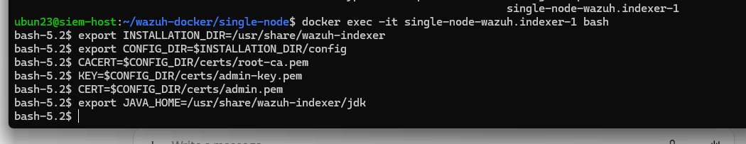
Figure 23. Shell inside the wazuh.indexer container with the variables for securityadmin.sh.
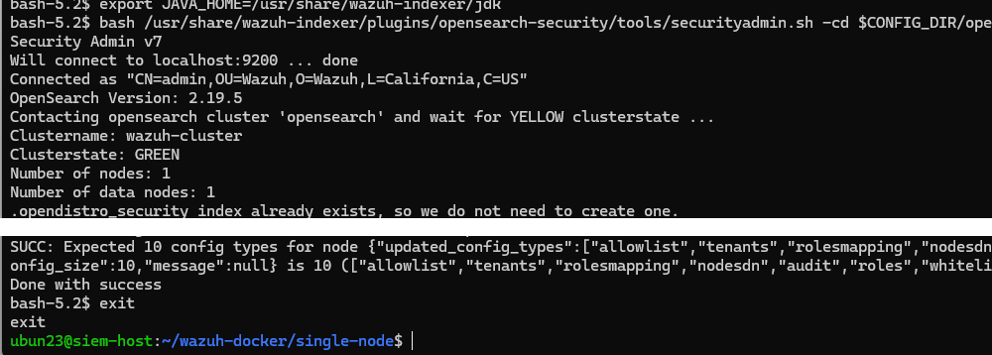
Figure 24. securityadmin.sh: connected, Clusterstate GREEN, configuration updated, "Done with success".
The new password is not stored in Git. The Wazuh files live in ~/wazuh-docker, outside my repository ~/labshop-soc.
The new password works: the screenshots show the dashboard login as admin (the password field is masked) and the Overview page that opens afterwards, with both agents Active. The same steps are in journal.md.
Steps I followed:
- Log out of the dashboard. In ~/wazuh-docker/single-node run docker compose down (without -v, so the volumes stay).
- Create the hash of the new password: docker run --rm -ti wazuh/wazuh-indexer:4.14.7 bash /usr/share/wazuh-indexer/plugins/opensearch-security/tools/hash.sh. The documentation names version 4.14.9, but I use my own version 4.14.7, so no new image is downloaded. The tool asks for the password; the hash it prints is copied.
- Write the hash into config/wazuh_indexer/internal_users.yml, in the hash: line of the admin block. The kibanaserver block is not touched.
- In docker-compose.yml replace every INDEXER_PASSWORD value (manager and dashboard sections) with the new password. A $ in the password must be written twice ($$).
- Start the stack again with docker compose up -d and check it with docker ps.
- Open a shell in the indexer: docker exec -it single-node-wazuh.indexer-1 bash, and set INSTALLATION_DIR, CONFIG_DIR, CACERT, KEY, CERT and JAVA_HOME.
- Wait 1-5 minutes until the indexer is ready, then run securityadmin.sh -cd $CONFIG_DIR/opensearch-security/ -nhnv -cacert $CACERT -cert $CERT -key $KEY -p 9200 -icl, type exit, refresh the browser and log in with the new password.
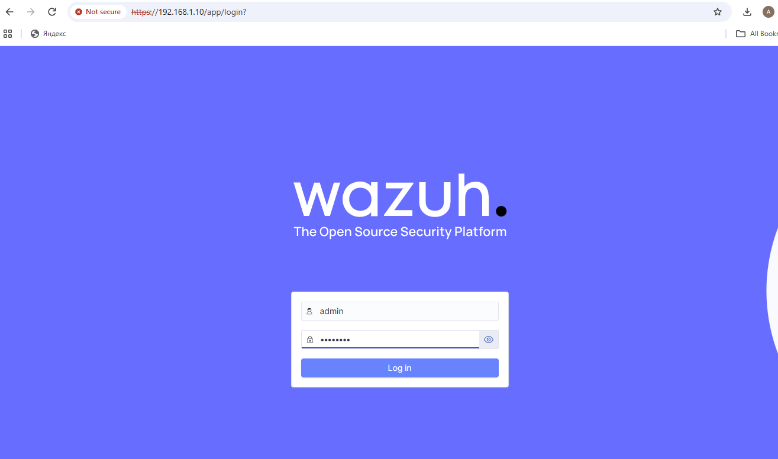
Figure 25. Dashboard login as admin with the new administrator password (masked).
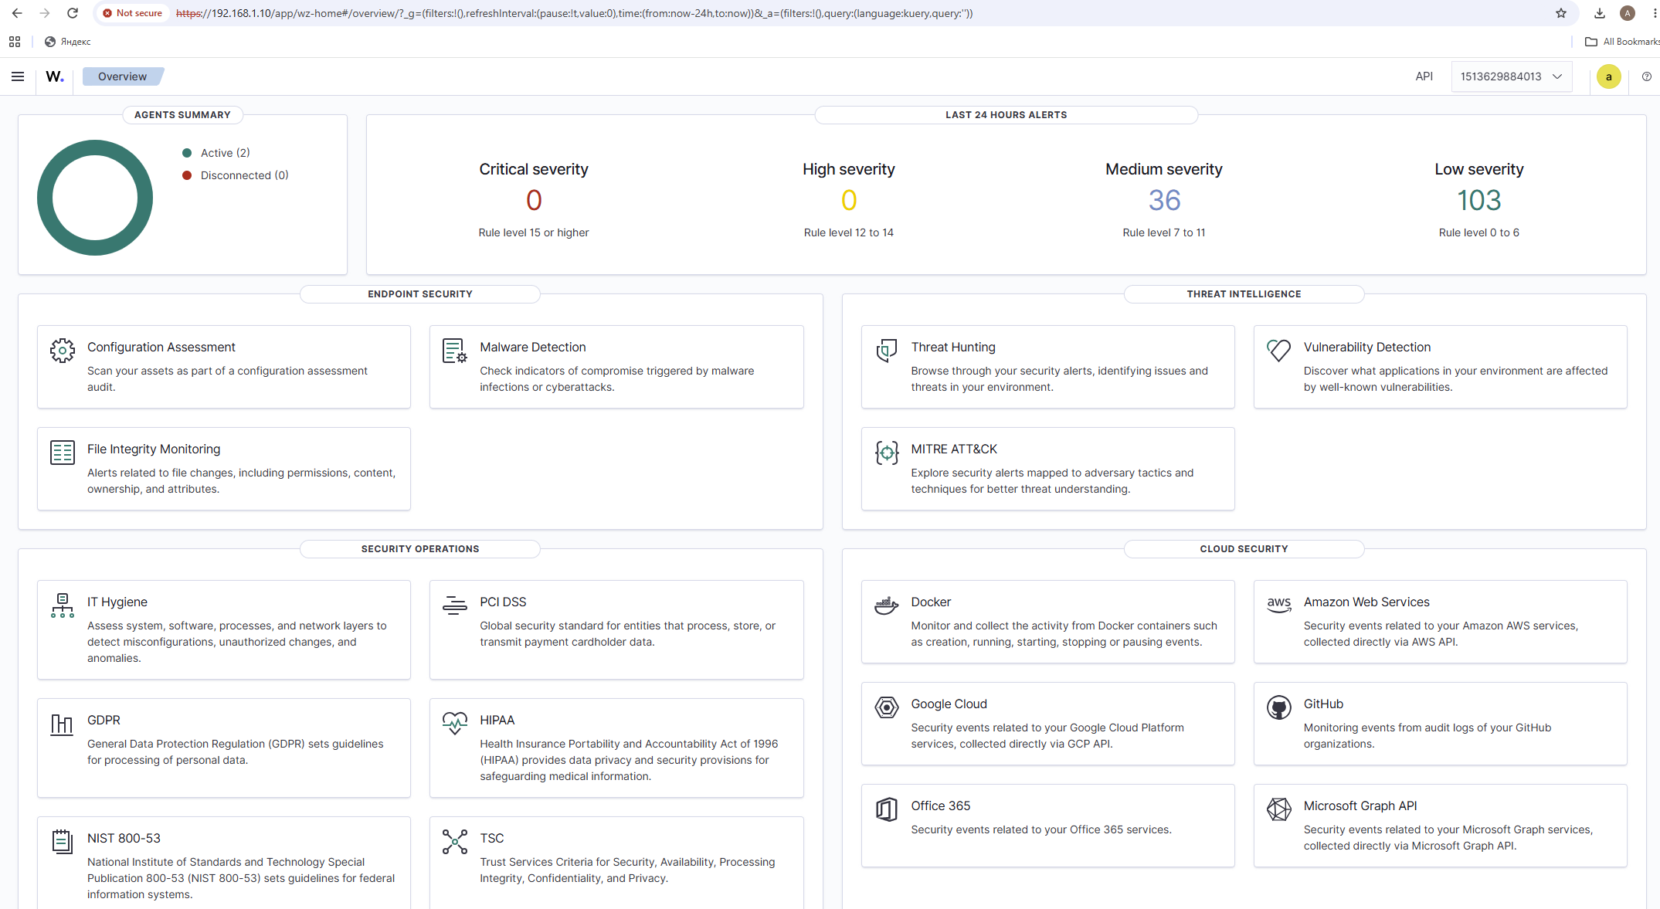
Figure 26. Wazuh Overview after the login with the new password: Agents summary Active (2), Disconnected (0).

4.4 Persistence test (stop, start, reboot)
This test proves that stopping the stack or rebooting siem-host does not lose agents or alerts. I ran it on 19 October 2026, with both agents enrolled and the alerts of 16 October already stored. The table gives what I did and what I saw; the figures follow in the order of the test.
Test | What I did | What I observed
Stop and start the stack | docker compose stop, then docker compose start (in ~/wazuh-docker/single-node) | While the stack was stopped, the browser got ERR_CONNECTION_REFUSED from 192.168.1.10 (Figure 28). After the start, the three containers were Up, the login page came back and both agents were Active (2) (Figures 30–32).
Reboot siem-host | sudo reboot on siem-host, then docker compose ps | About a minute after the boot, docker compose ps already listed the indexer, manager and dashboard as Up, before I ran any command. docker compose start afterwards changed nothing (Figures 33–34).
Agents after reboot | Endpoints page and Threat Hunting (rule.groups: sshd) after the reboot | Both agents were Active (2) (Figure 35). The 18 sshd alerts from 16 October were still stored (Figure 36).
What I had to do: to stop the stack I run docker compose stop, and to start it again docker compose start, both in ~/wazuh-docker/single-node. After a reboot of siem-host nothing had to be run: the containers came back by themselves, and I only had to log in to the dashboard again. Agents and old alerts were kept in every case, because stop, start and reboot do not delete the Docker volumes.
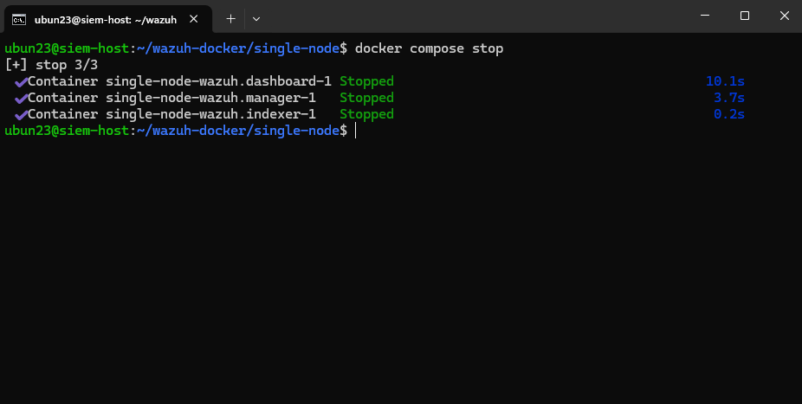
Figure 27. docker compose stop: dashboard, manager and indexer Stopped.
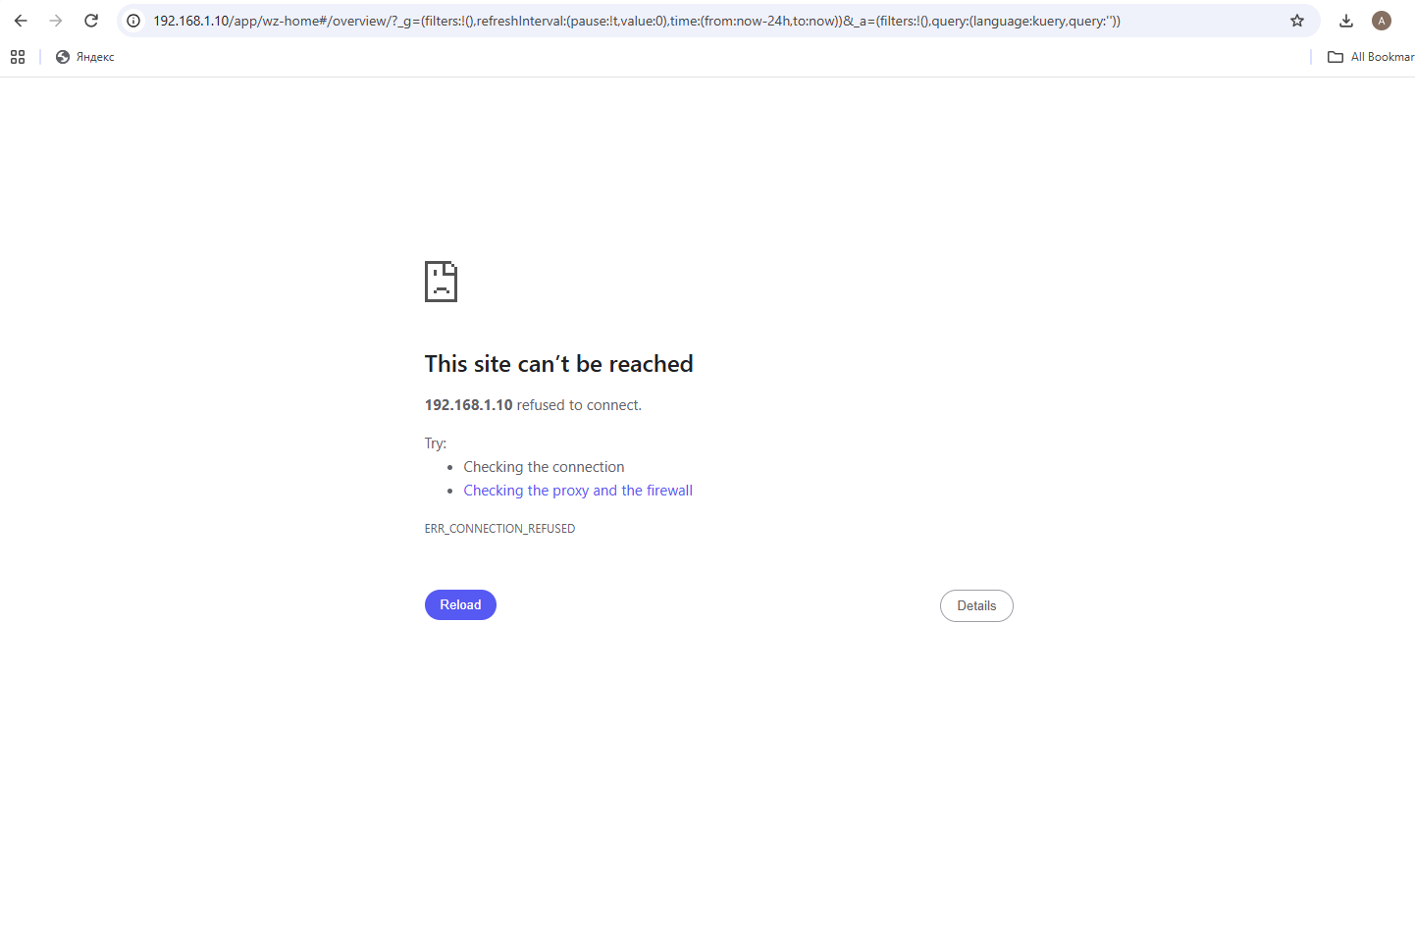
Figure 28. While the stack is stopped, https://192.168.1.10 gives ERR_CONNECTION_REFUSED.
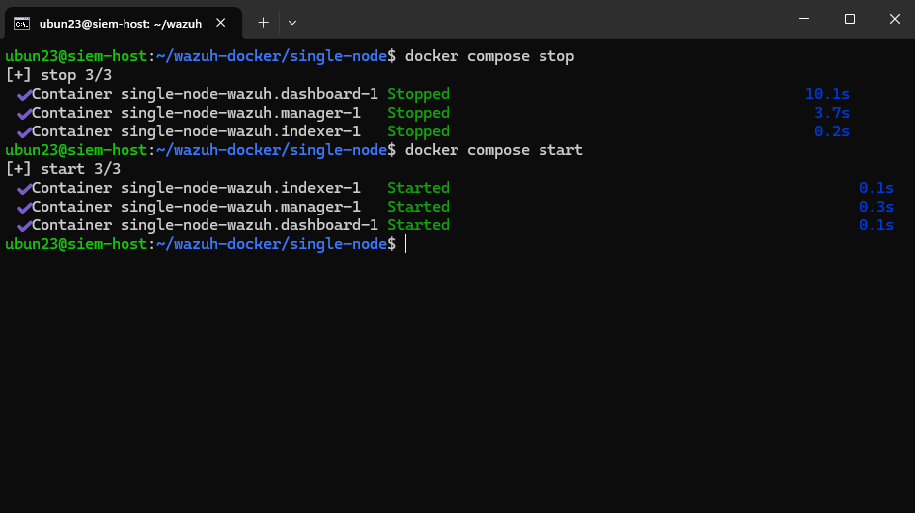
Figure 29. docker compose start: indexer, manager and dashboard Started.
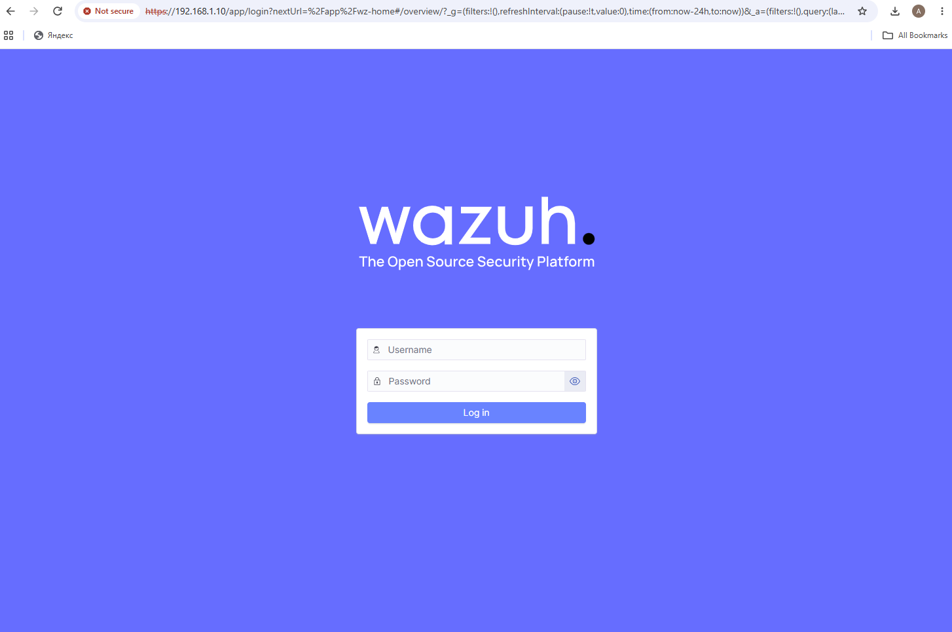
Figure 30. After the start the dashboard answers again with its login page.
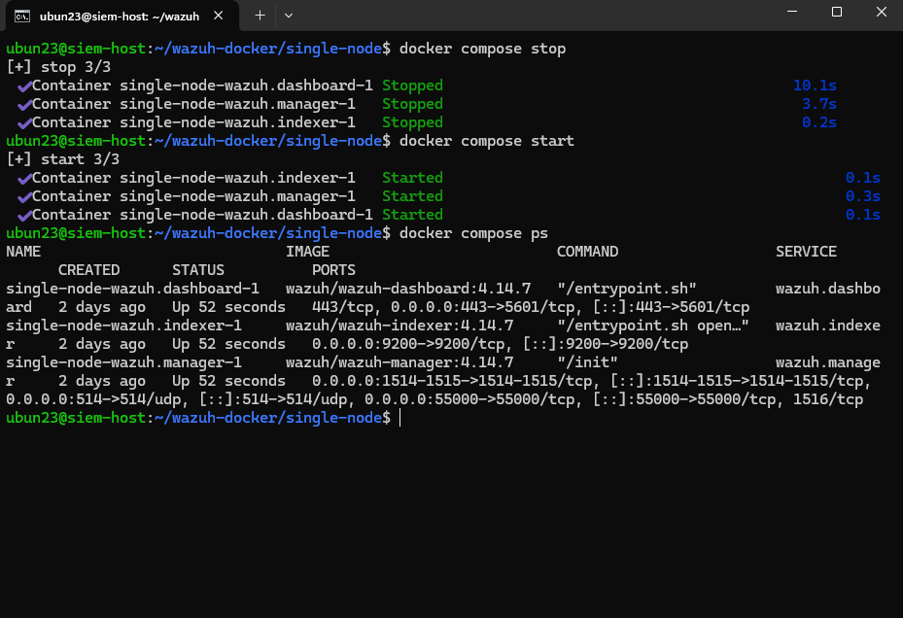
Figure 31. docker compose ps after stop and start: all three containers Up (52 seconds).
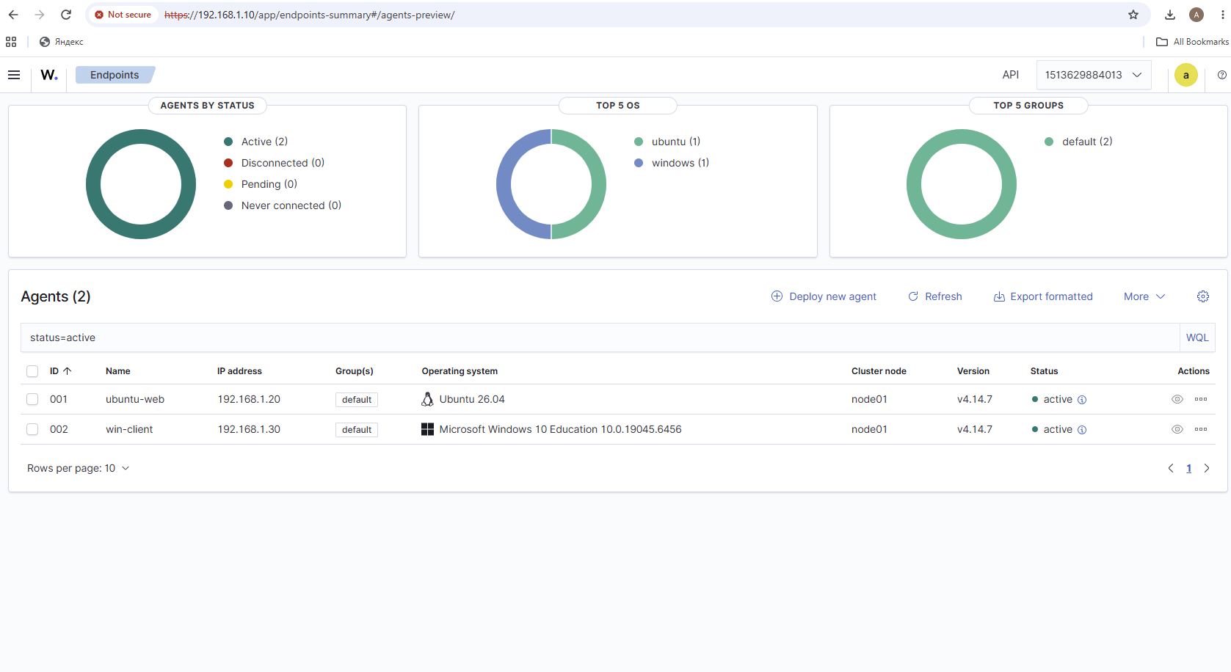
Figure 32. Endpoints after stop and start: Active (2), ubuntu-web (001) and win-client (002).
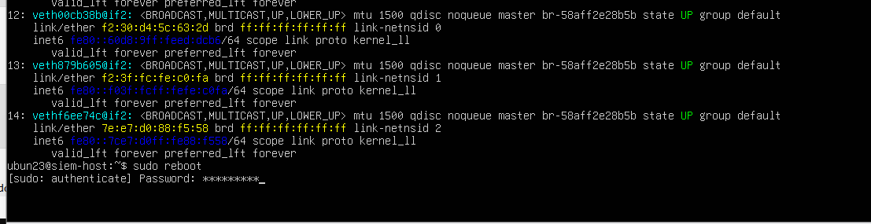
Figure 33. siem-host: sudo reboot.
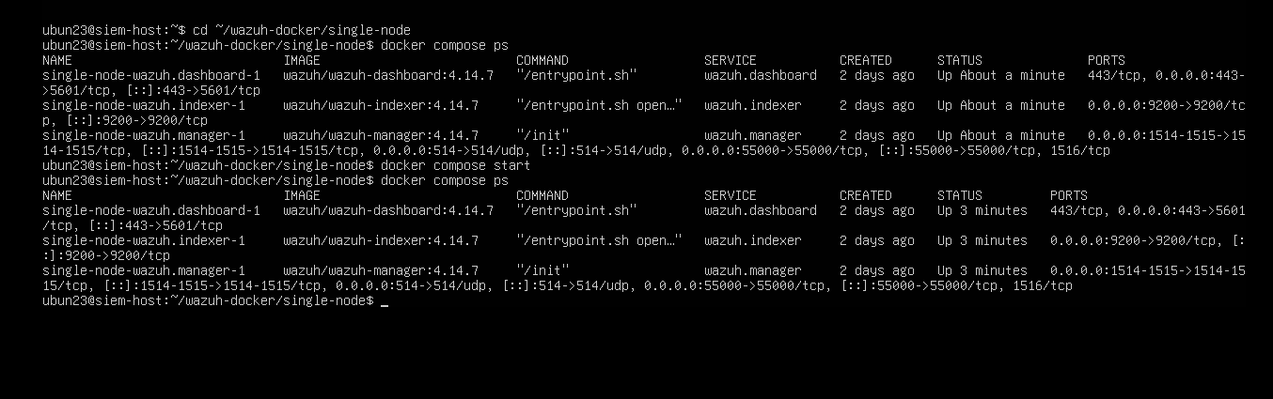
Figure 34. After the reboot, docker compose ps already shows all three containers Up (About a minute) before docker compose start is run; start changes nothing (Up 3 minutes).
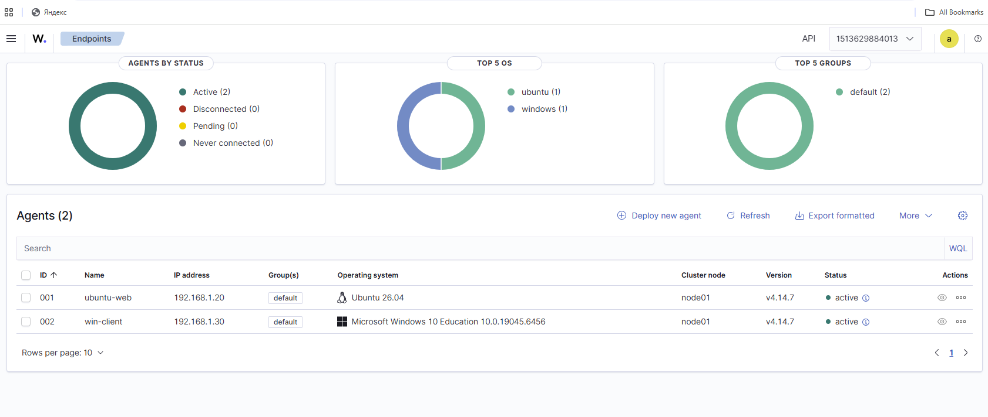
Figure 35. Endpoints after the reboot: Active (2), ubuntu-web and win-client.
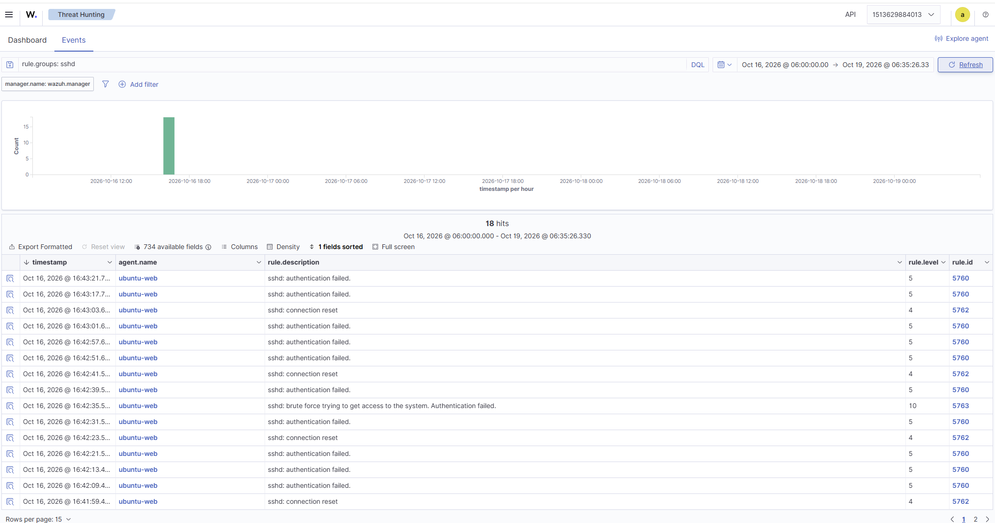
Figure 36. Threat Hunting after the reboot, rule.groups: sshd, 16–19 October: the 18 alerts from 16 October are still stored (rules 5760, 5762 and 5763).

Warning learned from the brief: docker compose down -v deletes the volumes and wipes all data. I use only stop and start (or down without -v).

4.5 Idle memory use
Memory was measured with docker stats about six minutes after the stack was first started and before any agent was enrolled (the first agent was installed at 15:08), so it is the idle footprint.
Container | Memory use | % of Docker limit (15.07 GiB)
single-node-wazuh.dashboard-1 | 203.8 MiB | 1.32%
single-node-wazuh.manager-1 | 744.3 MiB | 4.82%
single-node-wazuh.indexer-1 | 1.515 GiB | 10.06%
Total | ≈ 2.44 GiB | ≈ 16%
Figure 37. docker stats --no-stream on siem-host.
The indexer is the largest consumer. The whole Wazuh stack fits comfortably into the 16 GB given to siem-host, which leaves room for the extra tools of later weeks.

5. Agents and telemetry

5.1 Linux agent on ubuntu-web (A1)
I installed the wazuh-agent 4.14.7 package on ubuntu-web, enabled and started the service. systemctl status shows active (running) with the agent daemons started, and the dashboard lists the agent as 001 ubuntu-web, 192.168.1.20, Ubuntu 26.04, v4.14.7, active.
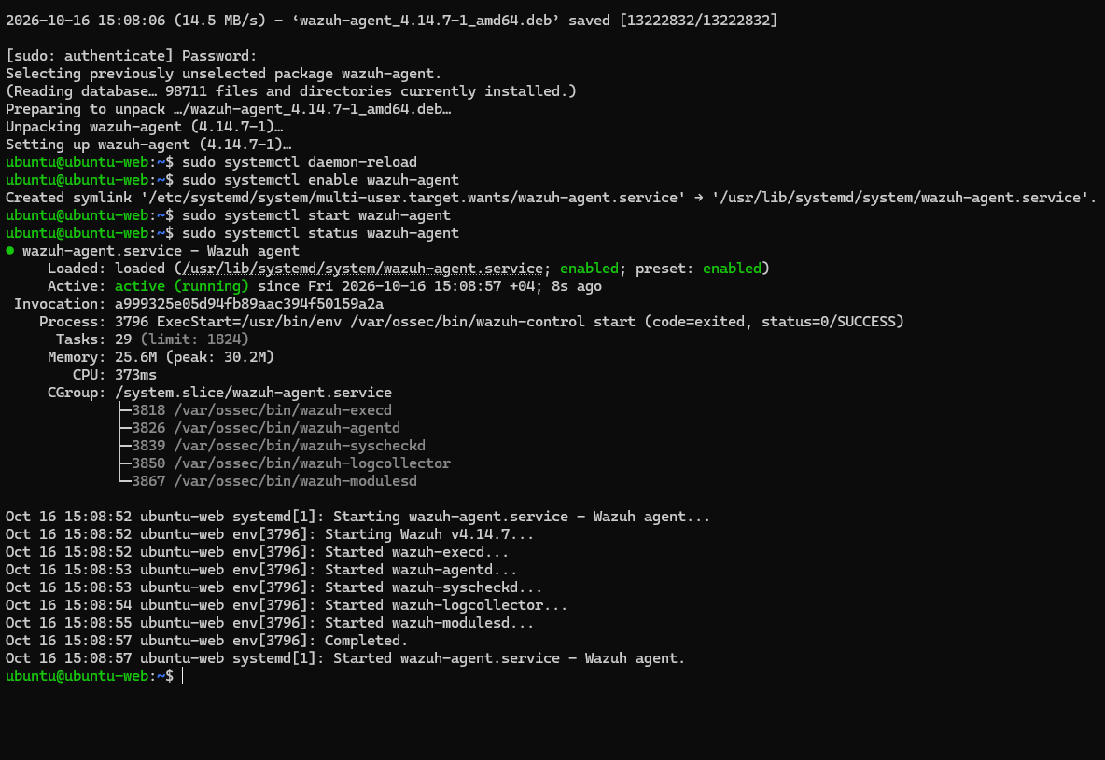
Figure 38. Agent package installed and wazuh-agent service active (running) on ubuntu-web.
Figure 39. Dashboard agent list with the first agent: ubuntu-web, active.

5.2 Windows agent on win-client (A2)
On win-client I downloaded the agent MSI from packages.wazuh.com and installed it with WAZUH_MANAGER='192.168.1.10' and WAZUH_AGENT_NAME='win-client', then started the service (WazuhSvc, Running).
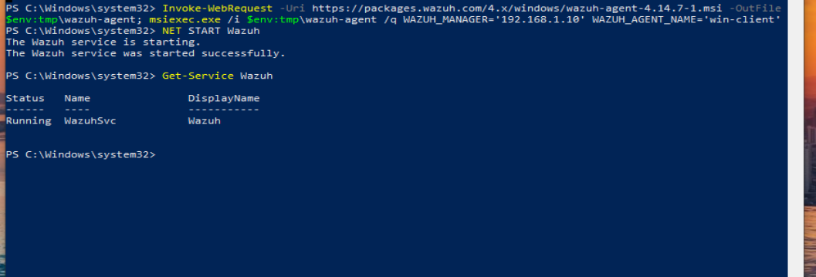
Figure 40. Windows agent installed with msiexec; the Wazuh service is Running.
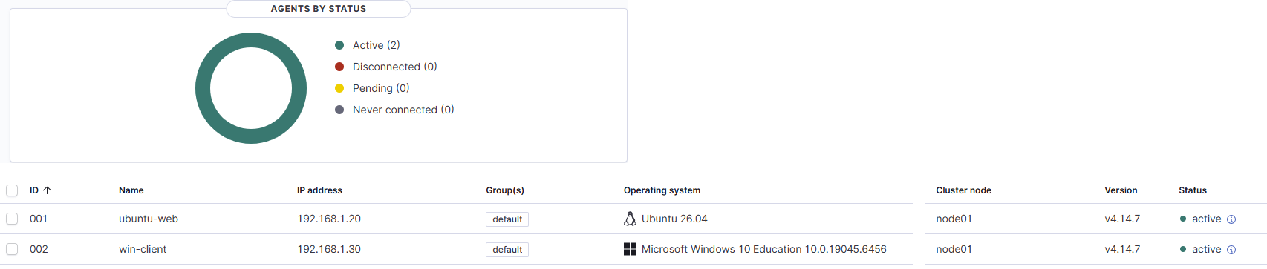
Figure 41. Both agents Active (2): ubuntu-web and win-client, both v4.14.7.
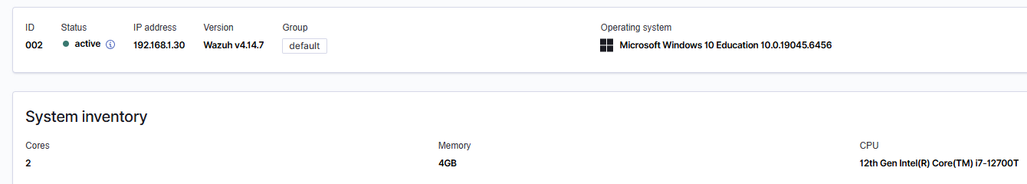
Figure 42. win-client agent 002 overview: active, 192.168.1.30, Windows 10 Education, 2 cores, 4 GB. Registered 16 Oct 2026, 15:33:39.

5.3 Sysmon on win-client (A3)
What Sysmon adds. The normal Windows logs say little about what programs do. Sysmon (System Monitor from Sysinternals) records every process start with its full command line, file hashes and parent process, plus network connections, file creation and other detail. That is the visibility Wazuh needs to detect attacks on Windows.
Sysmon needs two things, and I did both. First, I installed Sysmon 15.22 with the well-known community configuration from SwiftOnSecurity (sysmonconfig-export.xml). Second, I told the Wazuh agent to read the Sysmon event channel by adding the location Microsoft-Windows-Sysmon/Operational to ossec.conf (line 218), and restarted the agent service.
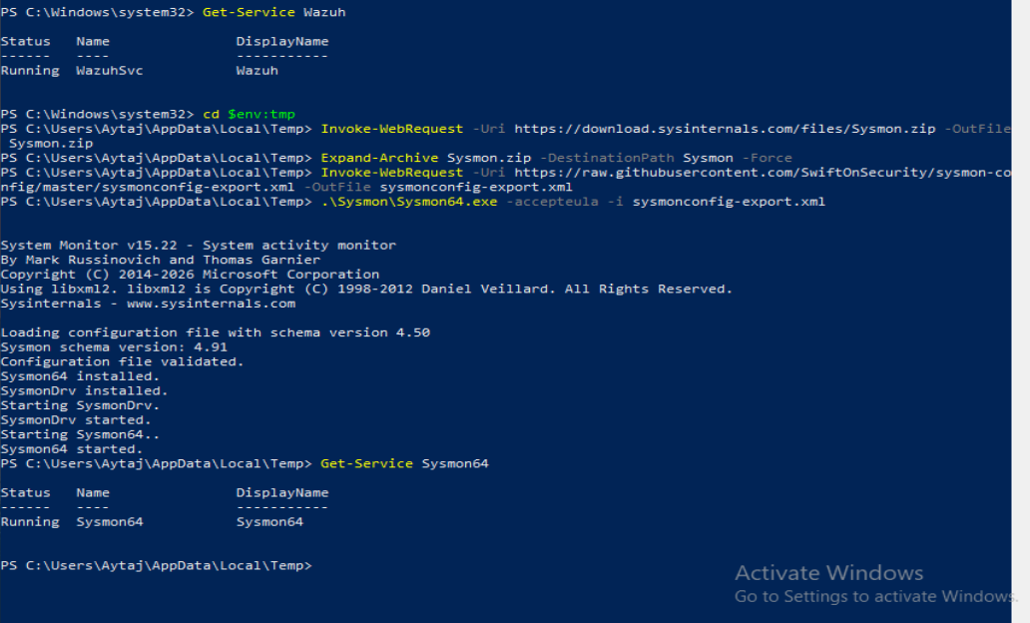
Figure 43. Sysmon downloaded and installed with the SwiftOnSecurity configuration; Sysmon64 is Running.
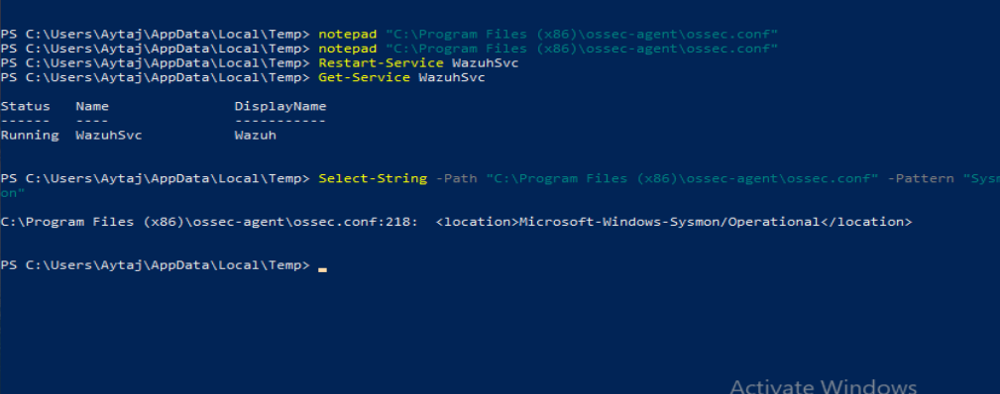
Figure 44. ossec.conf contains the Sysmon event channel (line 218) and the agent was restarted.
Sysmon events reach the dashboard. The Threat Hunting view for agent 002 filtered on the provider Microsoft-Windows-Sysmon shows 28 events in one hour, each with the agent name win-client, a rule description, a rule level and a rule ID (for example 92031 level 3, 92066 level 4, 92205 level 9).
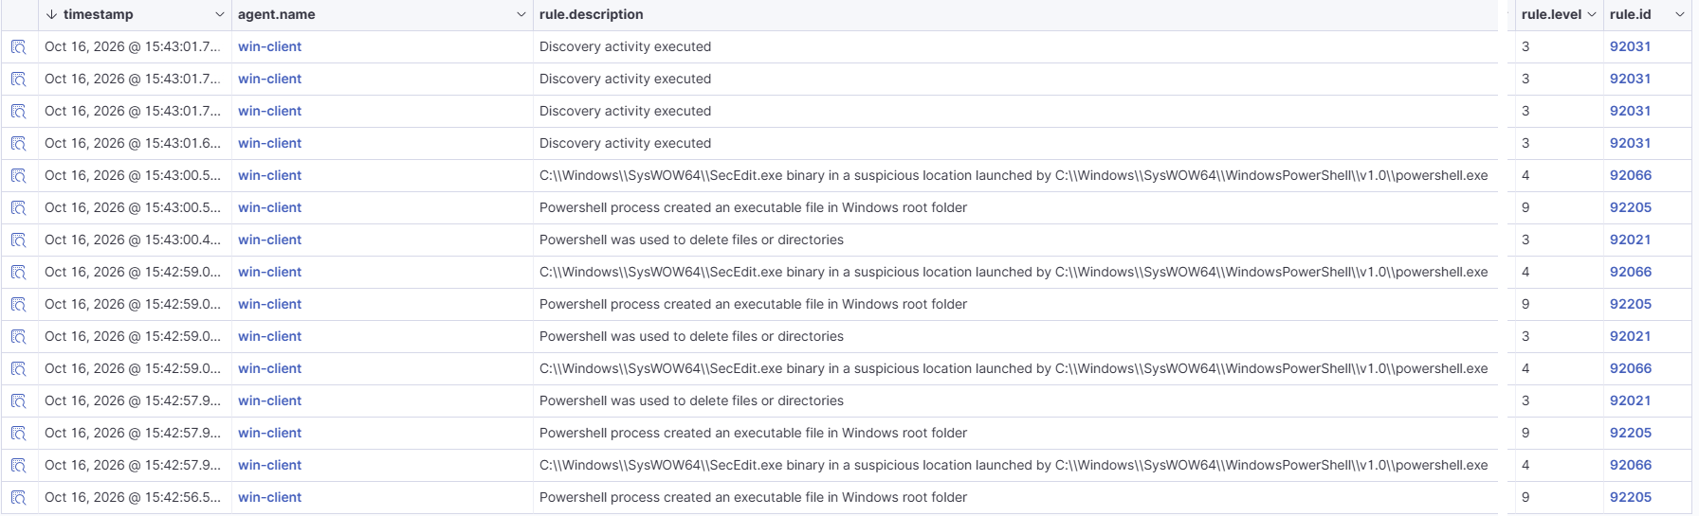
Figure 45. Sysmon events in Threat Hunting (query data.win.system.providerName: "Microsoft-Windows-Sysmon", agent win-client).

5.4 Web server on ubuntu-web (A4)
nginx 1.28.3 is installed from the Ubuntu repository and runs as an enabled service. Its default page opens from the browser of my Dell. This is the machine I will attack in Week 3.
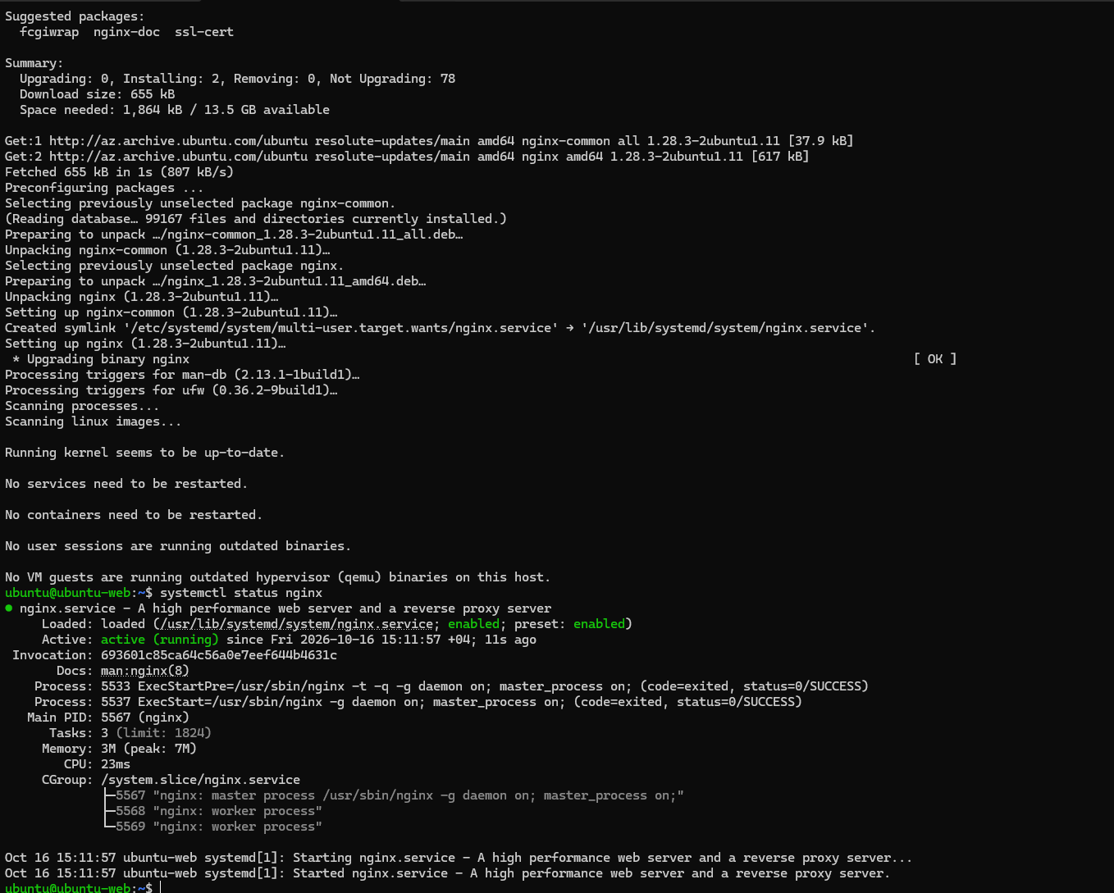
Figure 46. nginx service: enabled, active (running).
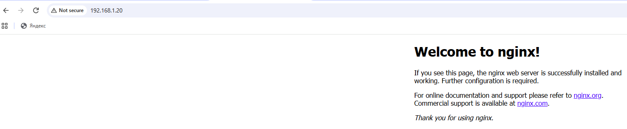
Figure 47. Default "Welcome to nginx!" page opened from the Dell at http://192.168.1.20.

6. Verification

6.1 Five deliberate events (V1)
I caused five events on purpose and found each one in the dashboard (Discover, index wazuh-alerts-*). The table has the rule description, rule level and rule ID. The screenshots follow in the same order.
# | Event | How I caused it | Rule description | Level | Rule ID | Screenshots (evidence/)
1 | Failed SSH login | ssh ubuntu@192.168.1.20 from the Dell with a wrong password | sshd: authentication failed. | 5 | 5760 | Figures 48–50
2 | Command run with sudo | sudo whoami on ubuntu-web | Successful sudo to ROOT executed. | 3 | 5402 | Figures 51–53
3 | New local user on Linux | adduser testuser1 on ubuntu-web | New user added to the system. | 8 | 5902 | Figures 54–55
4 | Program started on Windows (Sysmon) | net user in PowerShell on win-client | Discovery activity executed | 3 | 92031 | Figures 56–58
5 | Failed Windows logon | Wrong password for local user Aytaj on the win-client console | Logon Failure - Unknown user or bad password | 5 | 60122 | Figures 59–61

Event 1: failed SSH login (rule 5760, level 5)
From the Dell I tried to log in to ubuntu@192.168.1.20 with wrong passwords. Each failed attempt became an alert in the sshd group (18 alerts in the hour). The alert shows the target user ubuntu and the source address 192.168.1.1, which is the Dell VMnet1 adapter. MITRE ATT&CK: T1110.001 Password Guessing and T1021.004 SSH.
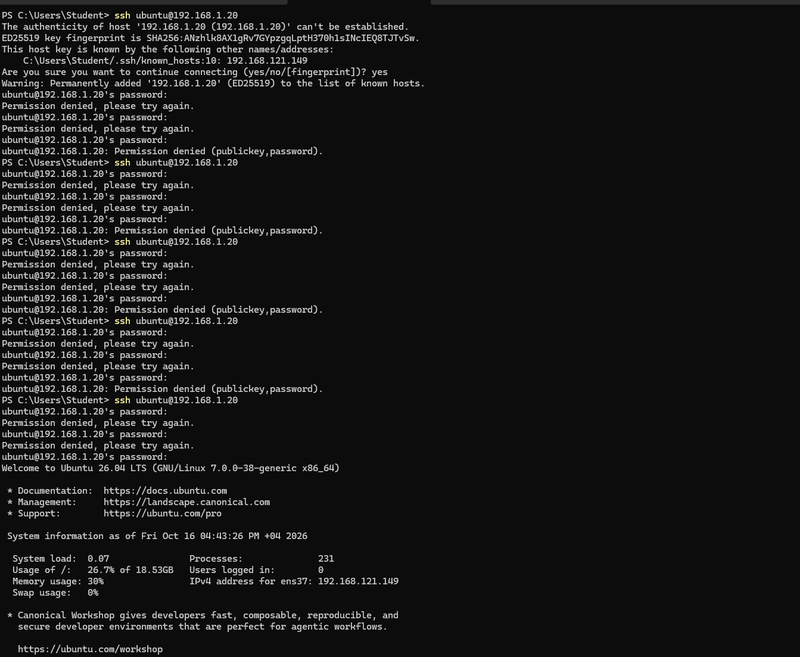
Figure 48. Terminal on the Dell: several "Permission denied" attempts, then a successful login at the end.
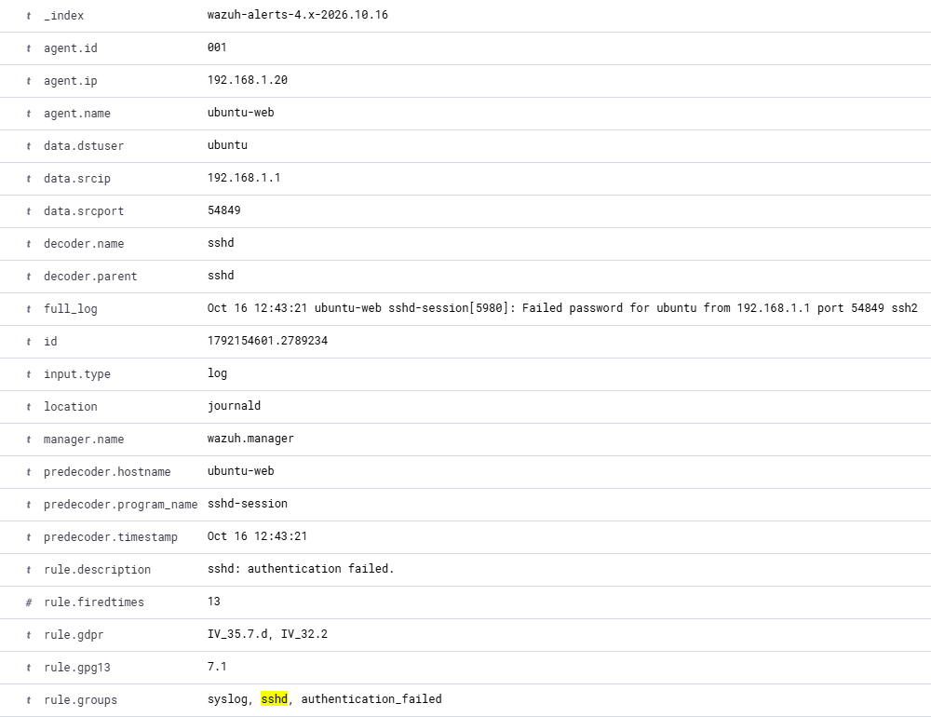
Figure 49. Alert details: agent ubuntu-web, srcip 192.168.1.1, full_log "Failed password for ubuntu from 192.168.1.1", rule.description "sshd: authentication failed.".
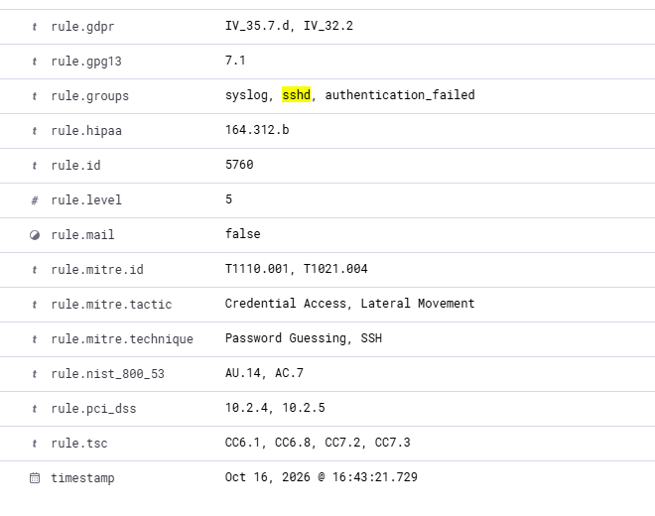
Figure 50. Rule fields: rule.id 5760, rule.level 5, MITRE T1110.001 and T1021.004.

Event 2: command run with sudo (rule 5402, level 3)
On ubuntu-web I ran sudo whoami. The first attempts used a wrong password (three failures and the message about the maximum of 3 incorrect attempts), then the command succeeded and printed root. Wazuh raised "Successful sudo to ROOT executed." with the command /usr/bin/whoami, user ubuntu, target user root. MITRE ATT&CK: T1548.003 Sudo and Sudo Caching.
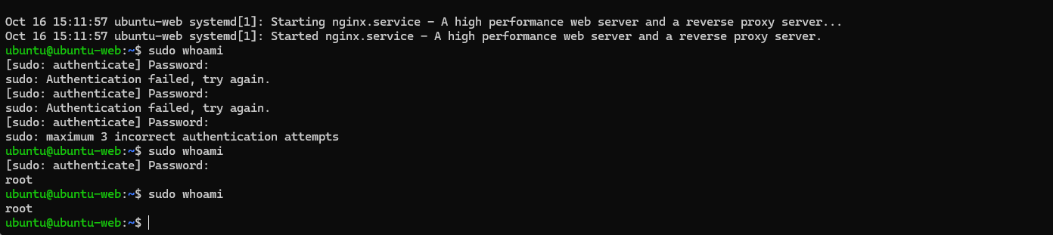
Figure 51. Terminal on ubuntu-web: failed sudo attempts, then sudo whoami returns root.
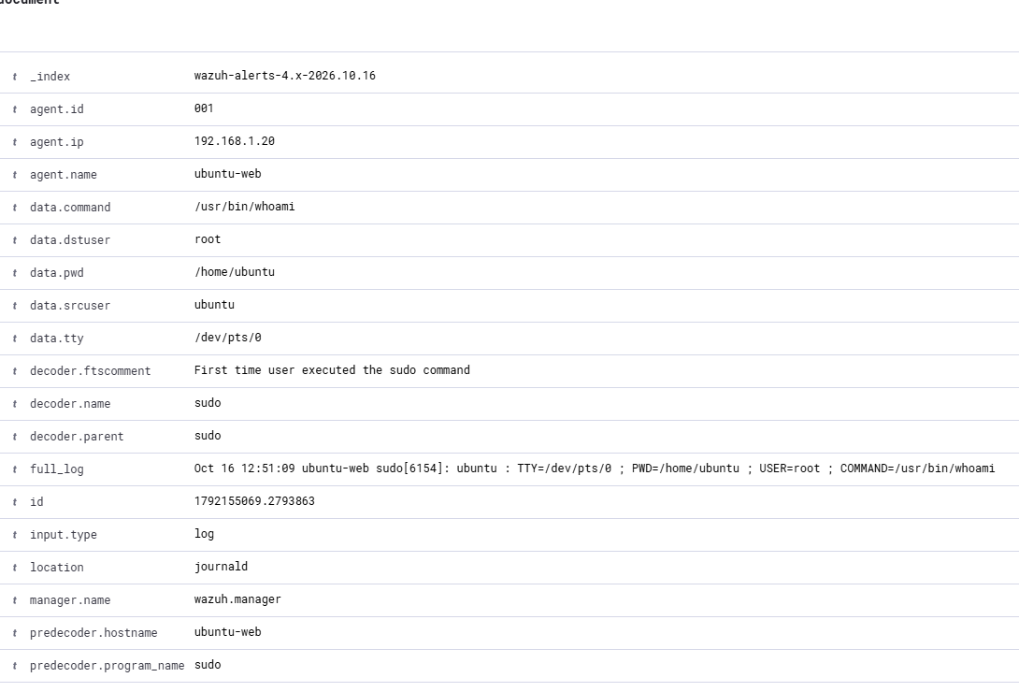
Figure 52. Alert details: data.command /usr/bin/whoami, data.srcuser ubuntu, data.dstuser root, full_log with COMMAND=/usr/bin/whoami.
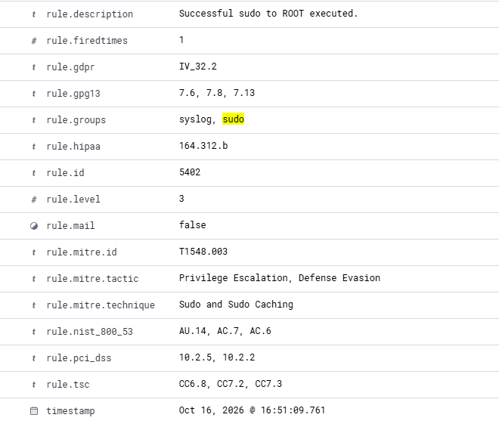
Figure 53. Rule fields: rule.description "Successful sudo to ROOT executed.", rule.id 5402, rule.level 3.

Event 3: new local user on Linux (rule 5902, level 8)
I created the user testuser1 on ubuntu-web with adduser. Three related alerts appeared at the same moment: "New group added to the system." (5901, level 8), "New user added to the system." (5902, level 8) and, a few seconds later, "Information from the user was changed." (5904, level 8). MITRE ATT&CK: T1136 Create Account (Persistence).
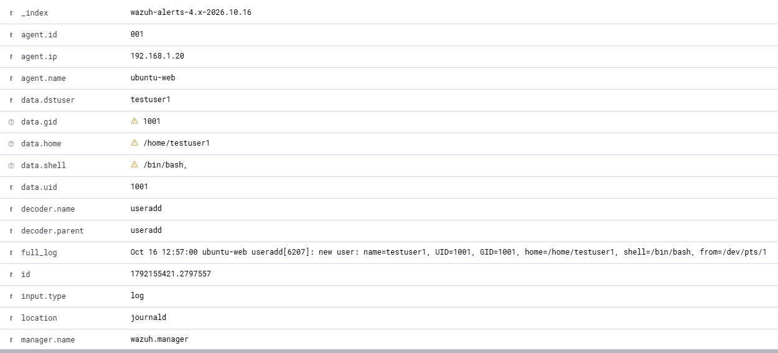
Figure 54. Alert details: useradd created testuser1, UID 1001, home /home/testuser1, shell /bin/bash.
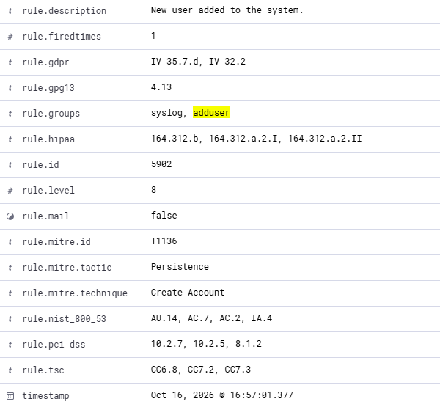
Figure 55. Rule fields: rule.description "New user added to the system.", rule.id 5902, rule.level 8, T1136.

Event 4: program started on Windows, seen through Sysmon (rule 92031, level 3)
On win-client I ran net user in PowerShell. Sysmon event ID 1 (Process Create) recorded net1.exe with the command line "C:\Windows\system32\net1 user", started by net.exe, which was started by powershell.exe, run by DESKTOP-CETN18E\Aytaj with high integrity. The channel is Microsoft-Windows-Sysmon/Operational. Wazuh matched the Sysmon rule "Discovery activity executed" (MITRE T1087 Account Discovery).
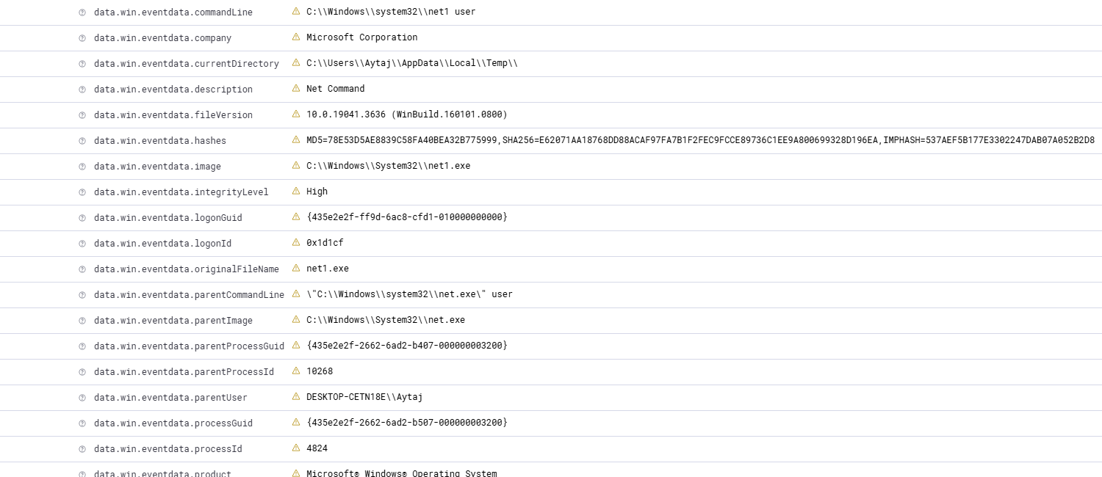
Figure 56. Sysmon event data: commandLine net1 user, image net1.exe, parentImage net.exe, user Aytaj, integrityLevel High.
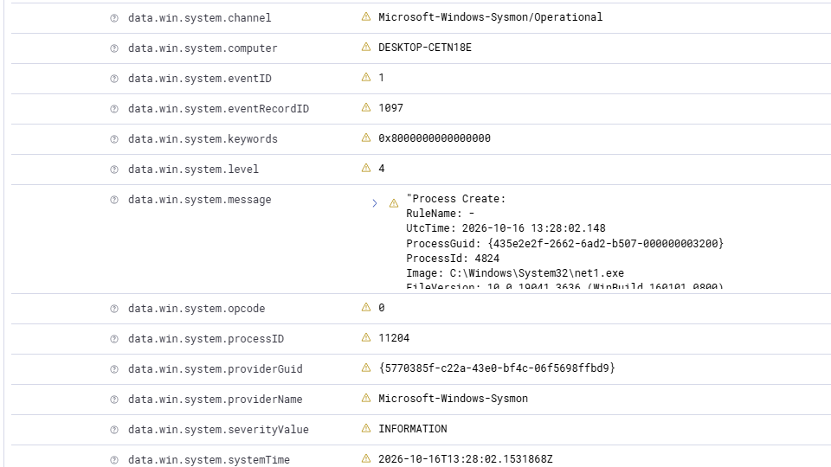
Figure 57. System fields: channel Microsoft-Windows-Sysmon/Operational, eventID 1, providerName Microsoft-Windows-Sysmon, message "Process Create".
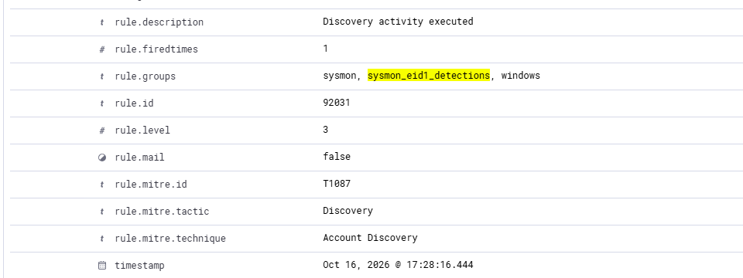
Figure 58. Rule fields: "Discovery activity executed", rule.id 92031, rule.level 3, T1087 Account Discovery.

Event 5: failed Windows logon (rule 60122, level 5)
I entered a wrong password for the local account Aytaj on win-client. Windows logged event 4625 in the Security channel, and the agent sent it to Wazuh. Six failed logons were recorded between 17:12:21 and 17:12:48. The event data shows logon type 2 (interactive), status 0xc000006d and substatus 0xc000006a (wrong password), and the target user Aytaj. Wazuh rule 60122 is "Logon Failure - Unknown user or bad password" (MITRE T1531).
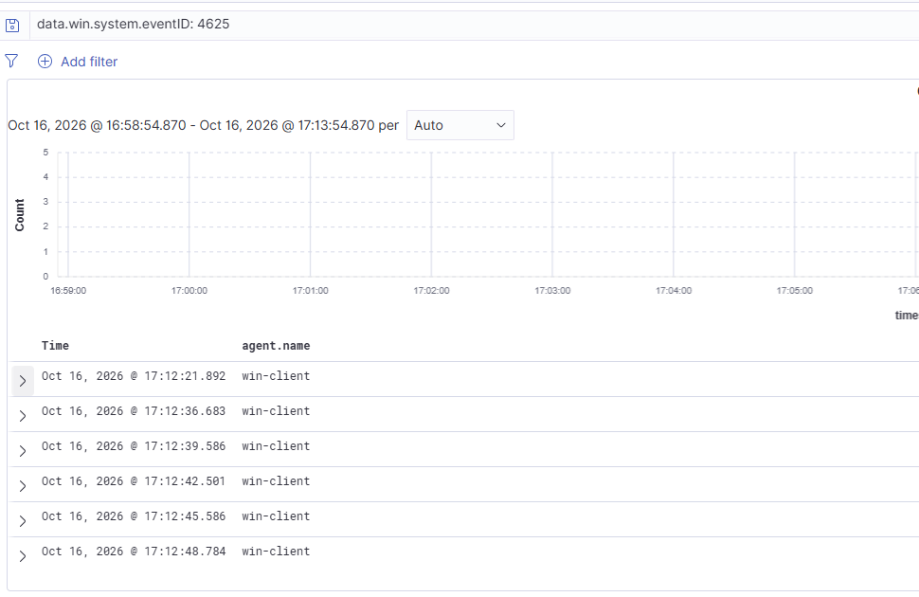
Figure 59. Query data.win.system.eventID: 4625 returns 6 alerts from agent win-client.
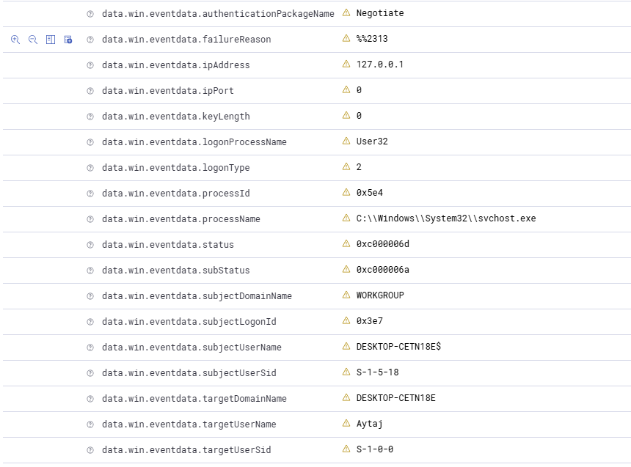
Figure 60. Event data: logonType 2, status 0xc000006d, subStatus 0xc000006a, targetUserName Aytaj.
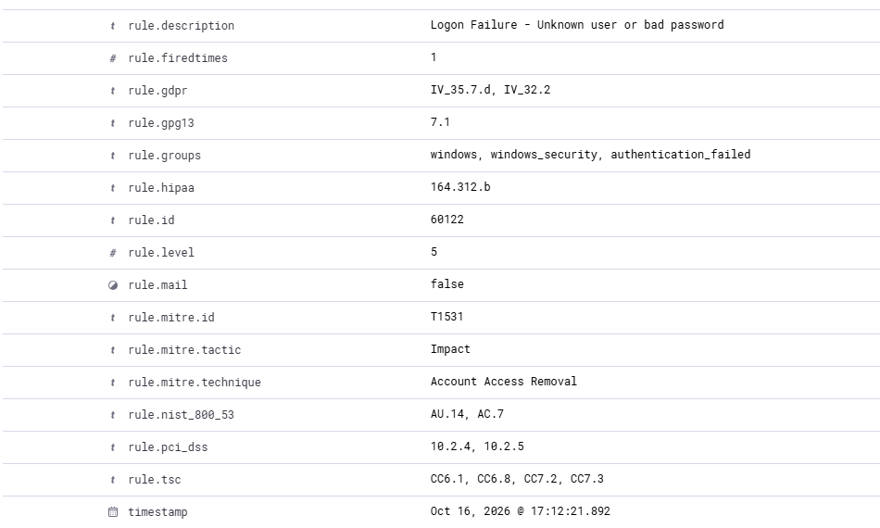
Figure 61. Rule fields: rule.description "Logon Failure - Unknown user or bad password", rule.id 60122, rule.level 5.

6.2 The path of one event from the endpoint to the alert (V2)
Example: a failed SSH login on ubuntu-web (event 1).
- Event happens. sshd on ubuntu-web writes "Failed password for ubuntu from 192.168.1.1" to the system journal (journald).
- Agent collects it. The Wazuh agent on ubuntu-web (its logcollector module) reads the journal. On Windows the agent reads event channels instead (Security and Sysmon).
- Agent sends it. The agent daemon (agentd) sends the event, encrypted, to the manager at 192.168.1.10 on port 1514/tcp. The agent was registered earlier through port 1515.
- Manager decodes and matches rules. In the wazuh.manager container the analysis engine uses a decoder (sshd) to split the log line into fields (user, source IP, port), then compares the event with the rules. Rule 5760 matches and gives it level 5.
- Alert is written. Because the rule level is above the alert threshold, the manager writes an alert with the fields, MITRE mapping and compliance tags.
- Filebeat ships it to the indexer. Filebeat in the manager container sends the alert to the wazuh.indexer (port 9200), which stores it in the daily index wazuh-alerts-4.x-2026.10.16.
- Dashboard shows it. The wazuh.dashboard queries the indexer and displays the alert in Discover and the agent pages. I open it from my Dell at https://192.168.1.10 (port 443).
In short: endpoint log → agent → manager (decoder + rules) → alert → Filebeat → indexer → dashboard.

7. Security and hygiene

S1: no secrets in Git
I created the repository ~/labshop-soc and wrote a .gitignore that keeps *.pem, *.key and .env out of Git. The check git ls-files | grep -E “pem|key|env” returns nothing, so no certificate, key or environment file is tracked. Certificates, keys and passwords belong to the Wazuh deployment in ~/wazuh-docker, which is outside the repository. Its docker-compose.yml holds the passwords in plain text, so that file is never copied into labshop-soc and no screenshot of it is stored in evidence/.
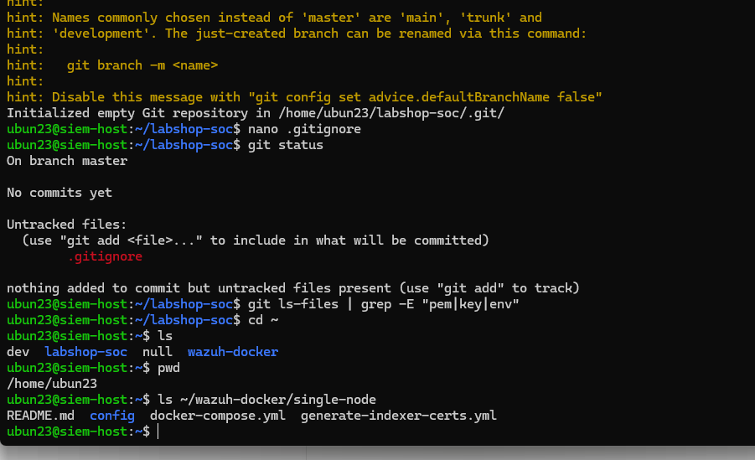
Figure 62. git init, .gitignore created, git status and the git ls-files check.
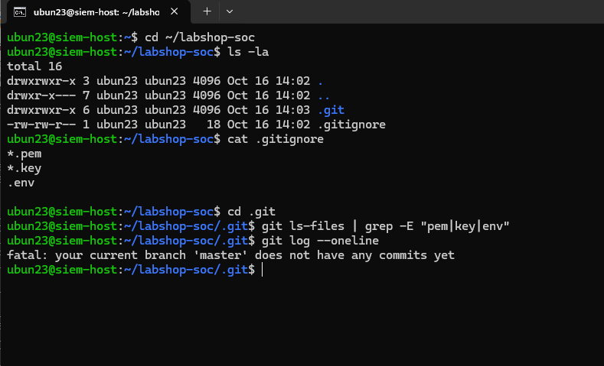
Figure 63. ~/labshop-soc: ls -la, the .gitignore (*.pem, *.key, .env) and the git ls-files check, which returns nothing.

S2: lab isolation
The lab network is host-only. siem-host keeps a NAT adapter (VMnet8) for Docker image pulls. ubuntu-web had a NAT adapter while software was installed; it was removed, and ubuntu-web now has a single adapter on VMnet1 (Figure 3) and a single address, 192.168.1.20 (Figure 6). win-client has a single adapter on VMnet1 (Figure 4). So no VM other than siem-host has a route to the internet, and S2 is met.

8. Notes and lessons
- Build bottom-up and test each layer: VMs, network, time, Docker, Wazuh, agents, Sysmon. Every layer had its own screenshot before I moved on.
- The indexer is the fussy part of the stack. It needs a host kernel setting and enough memory, and it is the biggest memory consumer (1.5 GiB).
- Sysmon does not work with the installation alone. The agent must also be told to read the Sysmon event channel in ossec.conf.
- Different log sources give different rule families: 5xxx for Linux system logs (sshd, sudo, useradd), 60xxx for the Windows Security log and 92xxx for Sysmon detections.
- Alert levels help to prioritise: the failed logons are level 5, creating a user is level 8, ordinary sudo is level 3.
- NAT adapters are for installation only. ubuntu-web still had its NAT adapter after the software was installed; I removed it in VMware and checked with ip a that only 192.168.1.20 remains (S2).
- After the password change, docker-compose.yml contains the Wazuh passwords in plain text. The file stays in ~/wazuh-docker, outside Git, and I did not put any screenshot of it into evidence/.
- Stop, start and reboot keep the data, because the data lives in Docker volumes. Only docker compose down -v would delete it. After a reboot the three containers came back by themselves.

9. Sign-off status
# | Req. | Result
1 | L1, S2 | Done. VMware settings of the three VMs: Figures 2–4.
2 | S2, L2 | Done. ubuntu-web has no NAT adapter any more: Figures 3, 6.
3 | L3 | Done. Ping tests between all three VMs: Figures 8–10.
4 | L4 | Done. Docker repository, version and vm.max_map_count: Figure 15.
5 | W3 | Done. Dashboard login with the new password: Figures 25, 26; steps in journal.md.
6 | W4 | Done. Stop/start and reboot test: Figures 27–36.
7 | S1 | Done. .gitignore and git ls-files check: Figure 63.
8 | D1, D3 | Done. journal.md has more than five entries.
9 | L5 | Done. w1-done on all three VMs: Figures 16–18.
10 | Brief | Done. Windows expiry: slmgr /xpr reports Notification mode, so there is no expiry date (Figure 19); noted in README.md.

Appendix A. Evidence index
Every figure of this report is stored in the repository folder evidence/ as figNN-name.png, with the same number as in the report. evidence/INDEX.md lists all files. No screenshot of docker-compose.yml is stored, because it contains passwords in plain text.
Figures | Shows | Requirement
Figure 1 | Lab diagram (also in architecture/) | L1
Figures 2–4 | VMware settings: RAM, processors, disk and adapters of each VM | L1, L2, S2
Figures 5, 6, 7 | IP addresses of siem-host, ubuntu-web (after NAT removal) and win-client | L2, L3, S2
Figures 8–10 | Ping tests between the three VMs | L3
Figures 11–13 | Time zone and clock on siem-host, ubuntu-web and win-client | L3
Figure 14 | Docker hello-world and Compose v5.6.0 | L4
Figure 15 | Docker version, official apt source, vm.max_map_count and the permanent setting | L4
Figures 16–18 | Snapshot lists of the three VMs with w1-done | L5
Figure 20 | wazuh-docker cloned at v4.14.7 | W1
Figure 21 | docker compose ps, all containers Up | W1
Figure 22 | Dashboard over HTTPS with the “Not secure” warning | W2
Figures 23–24 | securityadmin.sh run, Done with success | W3
Figures 25–26 | Dashboard login with the new password and Overview | W3
Figures 27–36 | Persistence test: stop, start, reboot, agents and alerts afterwards | W4
Figure 37 | docker stats, idle memory per container | W5
Figures 38–39 | ubuntu-web agent installed and Active | A1
Figures 40–42 | win-client agent installed; both agents Active; agent overview | A2
Figures 43–45 | Sysmon install, ossec.conf change, Sysmon events in the dashboard | A3
Figures 46–47 | nginx running and default page from the Dell | A4
Figures 48–50 | Failed SSH login: terminal, alert details, rule and level | V1 (1)
Figures 51–53 | Sudo command: terminal, alert details, rule and level | V1 (2)
Figures 54–55 | New user testuser1: alert details, rule and level | V1 (3)
Figures 56–58 | Sysmon process start (net user): command line, system fields, rule and level | V1 (4)
Figures 59–61 | Failed Windows logon 4625: query, event data, rule and level | V1 (5)
Figure 19 | slmgr /xpr on win-client: Windows in Notification mode, no expiry date | D2
Figures 62, 63 | git init, .gitignore and git ls-files check | S1

