1. The VPC should have a name following this convention <ProjectName>-Network and a CIDR block of 10.0.0.0/16.

1. Create an internet gateway named <ProjectName>-IGW and attach it to the VPC.

Create two public subnets in the VPC:

* *<ProjectName>-PublicSubnet-A* in the first AZ with a CIDR block of *10.0.11.0/24*.

<ProjectName>-PublicSubnet-B in the second AZ with a CIDR block of 10.0.21.0/24.

Make them public and choose Auto-Assign Public IP.

Create a new route table named <ProjectName>-PublicRouteTable. Add a 10.0.0.0/16 – Local route and a route to the <ProjectName> IGW to it.

Associate the subnets with the new route table.

Create private subnet in the VPC:

* *<ProjectName>-PrivateSubnet-A* in the first AZ with a CIDR block of *10.0.12.0/24*.
* Create new route table named *<ProjectName>-PrivateRouteTable-A*. Add a *10.0.0.0/16* – *Local* route to it.
* Associate private subnet with the new route table.

Create DB subnet in the VPC:

* *<ProjectName>-DbSubnet-A* in the first AZ with a CIDR block of *10.0.13.0/24*.

• Create a new route table named *<ProjectName>-DbRouteTable*. Add a *10.0.0.0/16* – *Local* route to it. Associate DB subnet with the new route table.

Create NAT gateway for the private subnet in public subnet:

* *<ProjectName>-NatGateway-A* with an elastic IP for the subnet *<ProjectName>-PrivateSubnet-A*.

* Add the gateway *A* to the route table *<ProjectName>-PrivateRouteTable-A*.

Create security groups:

* To allow inbound SSH traffic only from your IP address. Apply security group to the bastion host.

* To allow inbound HTTP/S traffic from anywhere. Apply security group to the public instance.

* To allow all inbound traffic from other instances associated with this security group. The security group should specify itself as a source security group in its inbound rules. Apply security group to all the instances.

Create a bastion host in the public subnet in the second AZ.

Create EC2 instance in the public subnet in the first AZ. Install the application developed in module 3 on the public instance.

Create one EC2 instance in the private subnet and one EC2 instance in the DB subnet. The instances do not have to have any special contents.

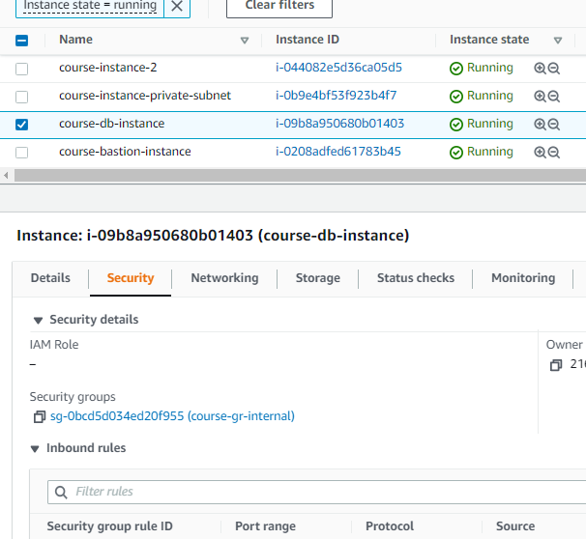

**Instances details(ip)**

1. the application on the public instance is available from anywhere

