Instructions to run the demo for STC 209:

1. Vicon needs to be on and "live"

2. Open a terminal and enter the command:
roslaunch vicon_bridge
You will see something like this:

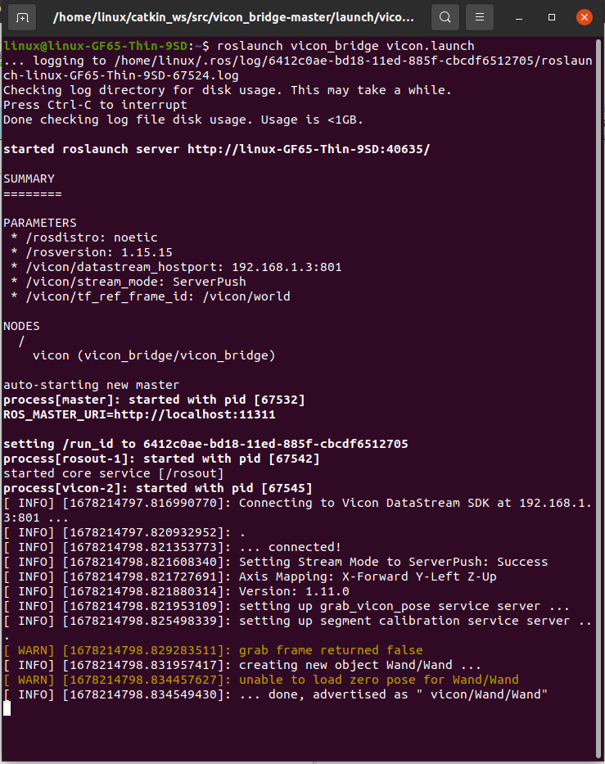

3. Open a new tab on the terminal (ctrl + shift + t) and enter the command:
python3 Desktop/stc209-motioncapture/track_wand.py

