# Relational Databases with MySQL Week 4 Coding Assignment

**Points possible:** 70

|  |  |  |
| --- | --- | --- |
| Category | Criteria | % of Grade |
| Functionality | Does the code work? | 25 |
| Organization | Is the code clean and organized? Proper use of white space, syntax, and consistency are utilized. Names and comments are concise and clear. | 25 |
| Creativity | Student solved the problems presented in the assignment using creativity and out of the box thinking. | 25 |
| Completeness | All requirements of the assignment are complete. | 25 |

**Instructions:** Using a text editor of your choice, write the queries that accomplishes the objectives listed below. Take screenshots of the queries and results and paste them in this document where instructed below. Create a new repository on GitHub for this week’s assignments and push this document, with your Java project code, to the repository. Add the URL for this week’s repository to this document where instructed and submit this document to your instructor when complete.

**Coding Steps:**

Write 5 stored procedures for the employees database.

1. Allows you to collect a list of the first and last names of staff by dept name. I tried to add a paramete r so that you could just get the list for one specific dept but it didn’t work.

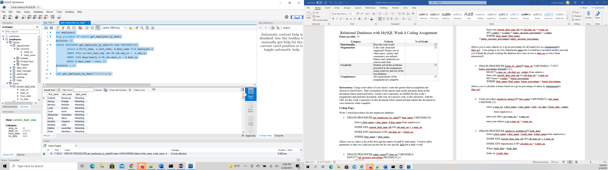

1. Allows you to raise salaries by a given percentage for all employees in a department (by dept_no). I did NOT run this one. Too afraid I’d screw up my database.

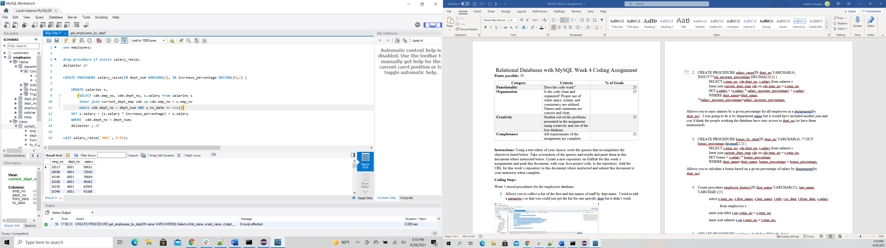

1. Allows you to get an employees history with the company , including title and salaries.

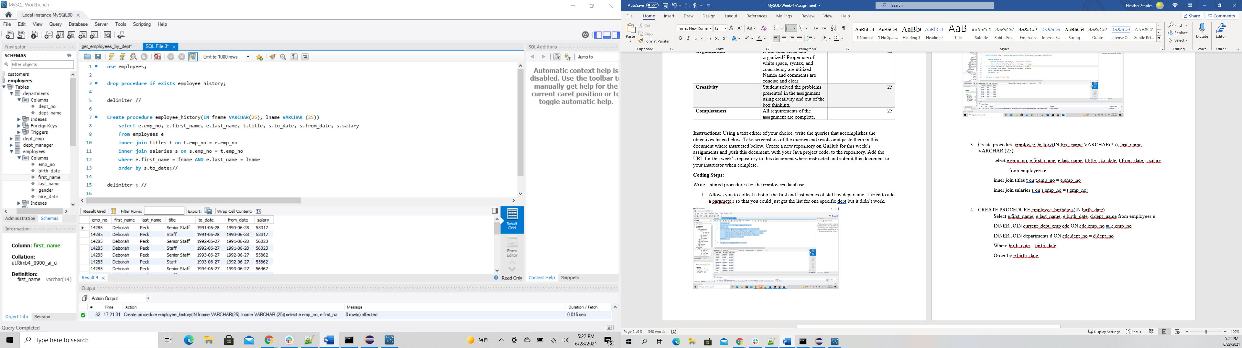Create

1. Allows you to search for an employee by birthdate. When I decided on this procedure, I was thinking about being able to search by date without year so you could print out birthdays for the day. I imagine it’s possible but I don’t know how to do it at this point.

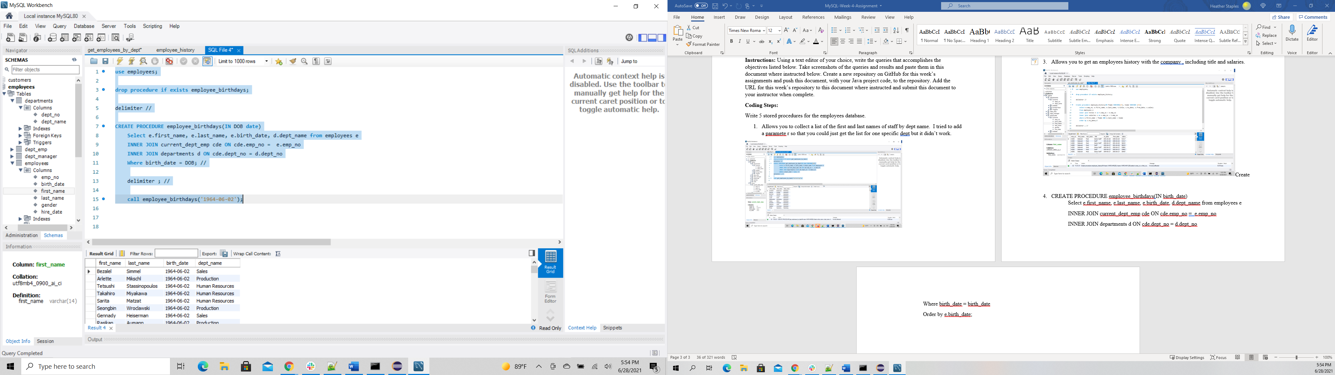

1. Allows you to add an employee (simple, but a stored procedure with parameters).

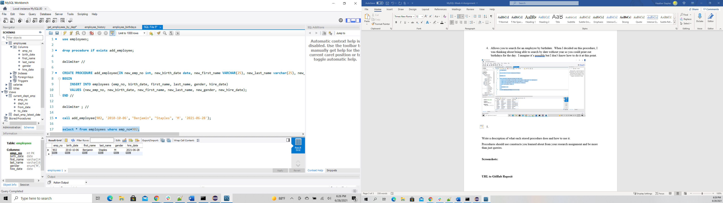

Write a description of what each stored procedure does and how to use it.

Procedures should use constructs you learned about from your research assignment and be more than just queries.

**URL to GitHub Reposit**

**https://github.com/aytch4/MySQL-Wk4**