**NATIONWIDE INSURANCE – TECHNICAL ASSESSMENT**

**Aytekin Yıldızhan**

**1. INTRODUCTION**

In this technical assessment, we analzye the restaurant inspections that took place in the Las Vegas metropolitan area. We have TRAIN_SET_2021.csv and TEST_SET_2021.csv and our aim is to explore the possibility of building a minimally viable product (MVP) model to predict the outcome of a restaurant’s next inspection.

**2. TASKS**

**2.1. DATA ANALYSIS and VISULATION**

There are 15673 records in TRAIN_SET_2021 and 7505 records in TEST_SET_2021. We have 28 columns. These are the columns:

Column Non-Null Count Dtype

--- ------ -------------- -----

0 RESTAURANT_SERIAL_NUMBER 15673 non-null object

1 RESTAURANT_PERMIT_NUMBER 15673 non-null object

2 RESTAURANT_NAME 15608 non-null object

3 RESTAURANT_LOCATION 15473 non-null object

4 RESTAURANT_CATEGORY 15543 non-null object

5 ADDRESS 15603 non-null object

6 CITY 15437 non-null object

7 STATE 15464 non-null object

8 ZIP 15614 non-null object

9 CURRENT_DEMERITS 15457 non-null float64

10 CURRENT_GRADE 15365 non-null object

11 EMPLOYEE_COUNT 15580 non-null float64

12 MEDIAN_EMPLOYEE_AGE 15639 non-null float64

13 MEDIAN_EMPLOYEE_TENURE 15376 non-null float64

14 INSPECTION_TIME 15490 non-null object

15 INSPECTION_TYPE 15452 non-null object

16 INSPECTION_DEMERITS 15419 non-null object

17 VIOLATIONS_RAW 15508 non-null object

18 RECORD_UPDATED 15554 non-null object

19 LAT_LONG_RAW 15658 non-null object

20 FIRST_VIOLATION 15461 non-null float64

21 SECOND_VIOLATION 15588 non-null float64

22 THIRD_VIOLATION 15612 non-null float64

23 FIRST_VIOLATION_TYPE 15527 non-null object

24 SECOND_VIOLATION_TYPE 15406 non-null object

25 THIRD_VIOLATION_TYPE 15500 non-null object

26 NUMBER_OF_VIOLATIONS 15504 non-null object

27 NEXT_INSPECTION_GRADE_C_OR_BELOW 15633 non-null object

print(len(train.RESTAURANT_SERIAL_NUMBER.unique())) = 15673

As you can see, RESTAURANT_SERIAL_NUMBER column is the unique. Let us start with the ouliers and null values. Here is the nul values:

train.isnull().sum().sort_values(ascending=False)

train.isnull().sum().sum()

CURRENT_GRADE 308

MEDIAN_EMPLOYEE_TENURE 297

SECOND_VIOLATION_TYPE 267

INSPECTION_DEMERITS 254

CITY 236

INSPECTION_TYPE 221

CURRENT_DEMERITS 216

FIRST_VIOLATION 212

STATE 209

RESTAURANT_LOCATION 200

INSPECTION_TIME 183

THIRD_VIOLATION_TYPE 173

NUMBER_OF_VIOLATIONS 169

VIOLATIONS_RAW 165

FIRST_VIOLATION_TYPE 146

RESTAURANT_CATEGORY 130

RECORD_UPDATED 119

EMPLOYEE_COUNT 93

SECOND_VIOLATION 85

ADDRESS 70

RESTAURANT_NAME 65

THIRD_VIOLATION 61

ZIP 59

NEXT_INSPECTION_GRADE_C_OR_BELOW 40

MEDIAN_EMPLOYEE_AGE 34

LAT_LONG_RAW 15

RESTAURANT_PERMIT_NUMBER 0

RESTAURANT_SERIAL_NUMBER 0

4027

We have 4027 null values. We have to drop this rows. Then we check the outliers. Figure 1 shows the distribution of null values.

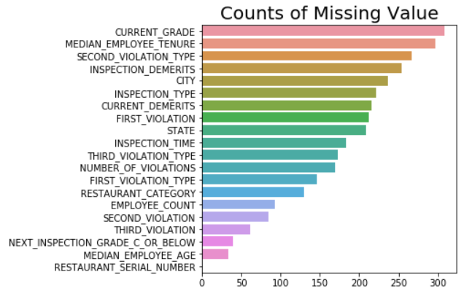

Figure 1. Missing Values

train.NEXT_INSPECTION_GRADE_C_OR_BELOW.value_counts()

0 13143

1 2484

-3 1

Goat 1

7 1

9 1

4 1

3 1

Name: NEXT_INSPECTION_GRADE_C_OR_BELOW, dtype: int64

As you can see, -3, Goat, 7, 9, 4 and 3 are outliers.

train**.**CURRENT_GRADE**.**value_counts()

A 14915

B 215

C 104

X 75

O 32

N 13

7 2

K 1

A+ 1

U 1

I 1

EIEIO 1

UPN 1

VPN 1

NASA 1

.\<><1@#&| 1

Name: CURRENT_GRADE, dtype: int64

As you can see above, other than A, B, C, X, O and N, these are outliers.

train**.**FIRST_VIOLATION_TYPE**.**value_counts()

Critical 7194

Major 6735

Non-Major 1588

Imminent Health Hazard 3

Extra Crispy 1

Major-ish 1

To Infinity and Beyond 1

Not Sure 1

Radical 1

Excellent 1

Bullwinkle 1

Name: FIRST_VIOLATION_TYPE, dtype: int64

As you can see, we just consider the critical, major, non major and Imminent Health Hazard.

After that, we drop some irrelevant columns for building MVP.

train**.**drop('RESTAURANT_PERMIT_NUMBER',axis**=**1,inplace**=True**)

train**.**drop('VIOLATIONS_RAW',axis**=**1,inplace**=True**)

train**.**drop('RESTAURANT_NAME',axis**=**1,inplace**=True**)

train**.**drop('RESTAURANT_LOCATION',axis**=**1,inplace**=True**)

train**.**drop('ADDRESS',axis**=**1,inplace**=True**)

train**.**drop('ZIP',axis**=**1,inplace**=True**)

train**.**drop('RECORD_UPDATED',axis**=**1,inplace**=True**)

train**.**drop('LAT_LONG_RAW',axis**=**1,inplace**=True**)

Then we have 20 columns left. Then we identify the columns. Analyzing the train_set, there   
are 17 features that can affect the prediction results.

identifier_feature **=** ['RESTAURANT_SERIAL_NUMBER']

continuous_features **=** ['MEDIAN_EMPLOYEE_AGE', 'MEDIAN_EMPLOYEE_TENURE']

nominal_features **=** ['RESTAURANT_CATEGORY', 'CITY', 'STATE','CURRENT_GRADE','INSPECTION_TYPE','FIRST_VIOLATION', 'SECOND_VIOLATION','THIRD_VIOLATION', 'FIRST_VIOLATION_TYPE', 'SECOND_VIOLATION_TYPE', 'THIRD_VIOLATION_TYPE']

numeric_feactures **=** ['CURRENT_DEMERITS', 'EMPLOYEE_COUNT','INSPECTION_DEMERITS','NUMBER_OF_VIOLATIONS']

target **=** ['NEXT_INSPECTION_GRADE_C_OR_BELOW']

selected_features **=** nominal_features **+** numeric_feactures **+** continuous_features **+** target

Figure 2 shows that the correlation of train data.

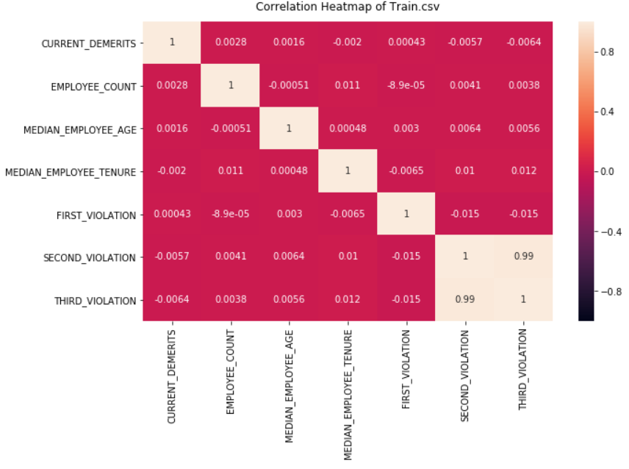

Figure 2. Correlation Map

Next, we combine train and test set because all data must enter the preprocessing section. We drop the null values and we make an assumptions.

df_no_null **=** df**.**dropna() # we drop the null values.

**2.2. ASSUMPTIONS**

Our assumptions are below.

1) df_no_null **=** df_no_null[df_no_null['INSPECTION_TYPE']**.**isin(["Routine Inspection", "Re-inspection"])]

*# "Routine Inspection", "Re-inspection"*

2) df_no_null **=** df_no_null[df_no_null['CURRENT_GRADE']**.**isin(["A", "B", "C", "X", "O", "N"])]

*# "A", "B", "C", "X", "O", "N"*

3) df_no_null **=** df_no_null[df_no_null['NEXT_INSPECTION_GRADE_C_OR_BELOW']**.**isin(["0", "1"])]

# 0 and 1

We filter out the negative values.

4) df_no_null **=** df_no_null[(0 **<** df_no_null['FIRST_VIOLATION']) **&** (df_no_null['FIRST_VIOLATION'] **<** 311)]

df_no_null **=** df_no_null[(0 **<** df_no_null['SECOND_VIOLATION']) **&** (df_no_null['SECOND_VIOLATION'] **<** 311)]

df_no_null **=** df_no_null[(0 **<** df_no_null['THIRD_VIOLATION']) **&** (df_no_null['THIRD_VIOLATION'] **<** 311)]

df_no_null **=** df_no_null[(0 **<=** df_no_null['CURRENT_DEMERITS']) **&** (df_no_null['CURRENT_DEMERITS'] **<** 200)]

df_no_null **=** df_no_null[(0 **<** df_no_null['EMPLOYEE_COUNT']) **&** (df_no_null['EMPLOYEE_COUNT'] **<** 100)]

df_no_null**.**STATE**.**value_counts() # we select ‘Nevada’

Nevada 20237

SK 5

Star Trek 1

Washington 1

New Mexico 1

Montana 1

TT 1

NeVaDa 1

Nevada? 1

Name: STATE, dtype: int64

5) df_no_null **=** df_no_null[df_no_null['STATE']**==**'Nevada']

**2.3. DATA PREPROCESSING**

In this part, we choose MinMaxScaler() for preprocessing.

**from** sklearn **import** preprocessing

df_disc **=** pd**.**DataFrame()

*# Discretization*

**for** i **in** continuous_features:

*# continuous_features = ['MEDIAN_EMPLOYEE_AGE', 'MEDIAN_EMPLOYEE_TENURE']*

disc **=** pd**.**cut(df_no_null[i], bins**=**10, labels**=**np**.**arange(10),right**=False**)

df_disc **=** pd**.**concat([df_disc, disc], axis**=**1)

*# Concatenate numeric features and discretized features*

**for** i **in** numeric_feactures:

*#numeric_feactures = ['CURRENT_DEMERITS', 'EMPLOYEE_COUNT', 'INSPECTION_DEMERITS', 'NUMBER_OF_VIOLATIONS']*

df_disc **=** pd**.**concat([df_disc, df_no_null[i]], axis**=**1)

*# Normalization*

*#x = df_disc.values #returns a numpy array*

*#min_max_scaler = MinMaxScaler()*

*#x_scaled = min_max_scaler.fit_transform(x)*

x **=** df_disc**.**values *#returns a numpy array*

min_max_scaler **=** preprocessing**.**MinMaxScaler()

x_scaled **=** min_max_scaler**.**fit_transform(x)

Then we binarize the nominal features. We use get_dummies function.

""" nominal_features = ['RESTAURANT_CATEGORY', 'CITY', 'STATE', 'CURRENT_GRADE','INSPECTION_TYPE','FIRST_VIOLATION', 'SECOND_VIOLATION', 'THIRD_VIOLATION','FIRST_VIOLATION_TYPE','SECOND_VIOLATION_TYPE','THIRD_VIOLATION_TYPE']

"""

restaurant_category **=** pd**.**get_dummies(df_no_null["RESTAURANT_CATEGORY"], drop_first**=True**)

city **=** pd**.**get_dummies(df_no_null["CITY"], drop_first**=True**)

state **=** pd**.**get_dummies(df_no_null["STATE"], drop_first**=True**)

current_grade **=** pd**.**get_dummies(df_no_null["CURRENT_GRADE"], drop_first**=True**)

inspection_type **=** pd**.**get_dummies(df_no_null["INSPECTION_TYPE"], drop_first**=True**)

first_violation **=** pd**.**get_dummies(df_no_null["FIRST_VIOLATION"], drop_first**=True**)

second_violation **=** pd**.**get_dummies(df_no_null["SECOND_VIOLATION"], drop_first**=True**)

third_violation **=** pd**.**get_dummies(df_no_null["THIRD_VIOLATION"], drop_first**=True**)

first_violation_type **=** pd**.**get_dummies(df_no_null["FIRST_VIOLATION_TYPE"], drop_first**=True**)

second_violation_type **=** pd**.**get_dummies(df_no_null["SECOND_VIOLATION_TYPE"], drop_first**=True**)

third_violation_type **=** pd**.**get_dummies(df_no_null["THIRD_VIOLATION_TYPE"], drop_first**=True**)

Next, we concatenate these new columns to our original train data then we drop nominal_features columns. Finally we drop RESTAURANT_SERIAL_NUMBER column since its type is object.

Our data is ready to train.

**3. ATTEMPTING TO BUILD AN MVP MODEL**

Our data consists of train.csv and test.csv. First of all we split and we use train.csv to train.

df2_test **=** df2[df2['ds_type']**==**'Test']

df2_train **=** df2[df2['ds_type']**==**'Train']

*# drop the ds_type*

df2_train **=** df2_train**.**drop(['ds_type'], axis**=**1)

df2_test **=** df2_test**.**drop(['ds_type'], axis**=**1)

We use 12 classifier machine learning techniques. We consider multiple performance evaluation metrics such as precision, recall, f1-score, and coefficient matrix. Here is our accuracy results. These detailed results are in Nationwide.html file.

**Classifier Accuracy**

1 SVM 0.842270

4 Logistic Regression 0.842270

3 Random Forest 0.840439

5 Gradient Boosting 0.839916

6 Ada Boost 0.839916

8 Linear Discriminant Analysis 0.835470

11 SGD 0.759090

0 Knn 0.741564

10 MLP 0.726654

2 Decision Tree 0.721161

7 Gaussian NB 0.204551

9 Quadratic Discriminant Analysis 0.169500

As you can see, SVM and Logistic Regression is the best accuracy. We choose SVM models to test test.csv.

In this assessment, my recommendation is that because of high number of outliers, none of classifiers cannot be reliable to be used in an MVP. The main reason is that the dataset is imbalance such as NaN (null), zero, negative or different values are inside the data. Therefore almost there are 20% missing value in this dataset.

**4.) Apply Our Model to The Test Set**

We select SVM and our result like this.

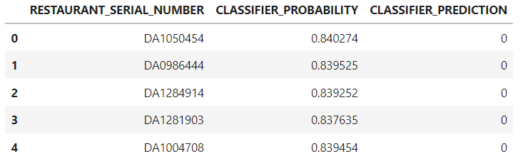

Then we save this result.

results**.**to_csv('predictions_Yildizhan_Aytekin.csv', sep **=** ',',index **=** **False**) *#*

**5. Recommendations**

Based on the dataset, in my opinion MVP model is not recommended. Almost %20 of data is discarded by some reason. In test set, all of SVM classifier prediction is zero. If we have more time, we try to different classifier techniques.

To make the dataset more consistent, one of the way is to collect more data which has both zero and one. (NEXT_INSPECTION_GRADE_C_OR_BELOW). Also according to correlation map, we add the features FIRST_VIOLATION, SECOND_VIOLATION, and THIRD_VIOLATION. These features are more effectively to NEXT_INSPECTION_GRADE_C_OR_BELOW. Also we do not use VIOLATIONS_RAW since there is no information about violation numbers. Having more features like these features can improve the accuracy of the model.