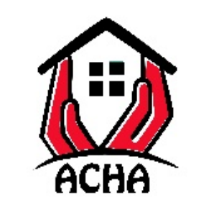
Ayton Community Hall Association

Terms and Conditions of Hire

Once a hire is agreed the hirer will be sent a booking form and an invoice.
Payment for the hire should be made at least one week before the hire date.
The booking form must be returned to aytoncomhall@gmail.com
Once the payment is received and the booking form has been received then a confirmation of booking will be sent out by email.

The hirer must:

Read the ACHA Health & Safety Terms and Conditions of Hire. (A copy kept in a ring binder in the kitchen)
Comply with the statutory regulations regarding Health & Safety, Food Hygiene, Electrical Safety and Fire Safety. This includes having no naked flames in the hall.
Ensure that the correct insurance is in place to conduct the activity the hall is booked for.
Ensure that a responsible adult aged 21 or over is present throughout the duration of the let. This would normally be the hirer.
Ensure that 2 responsible adults are present at all times at children’s events.
Ensure that alcohol is not sold unless an occasional licence has been granted by Scottish Borders Council.
Ensure that the correct licence is displayed for the duration of the let if alcohol is being sold.
Accept responsibility for any breakages or damage.
Inform the hall keeper of any breakages or damage as soon as possible.
Ensure that all areas in the building are left in a clean and tidy state, unless cleaning has been negotiated before the let.
Ensure nobody smokes in any part of the hall.
Ensure that if a group of children or vulnerable adults is involved, an effective PVG policy is in place.

At the end of a let, the hirer must

Check that all lights are switched off.
Check all appliances in the kitchen switched off, apart from the fridge.
Check that the fridge is left empty.
Check that all taps are turned off in the toilets and kitchen.
Ensure that interior doors are closed and the main door is locked securely.
Remove any equipment brought into the hall.
Remove all rubbish. Food must be in sealed bin bags then taken off site or placed in the hall wheelie bin. Recyclable materials should be placed in the hall recycling bin or taken away. Glass must be removed.

Kitchen

All surfaces must be wiped down and cleaned thoroughly after use.
Any kitchen equipment used (cooker, microwave, toaster, dishwasher etc) must be cleaned thoroughly after use.
All appliances must be switched off after use, apart from the fridge.

Outside Area
Litter must be collected and placed in the correct bin.
Cigarette ends must be disposed of in the bins provided.

Replace the keys in the key safe and close the gates.

Signature
By signing the booking form the hirer has agreed to the conditions set out in this notice.

