DEPARTMENT OF [DEPARTMENT NAME]
PROJECT REPORT
ON
SYNCSPACE
PERSONAL PRODUCTIVITY AND HABIT TRACKING DASHBOARD
SUBMITTED BY
[STUDENT NAME] ([ENROLLMENT NUMBER])
[INSTITUTION LOGO - INSERT APPROVED IMAGE]
PROJECT COORDINATOR / GUIDE
[GUIDE NAME]
[ACADEMIC YEAR]
[INSTITUTION NAME]
[UNIVERSITY NAME, IF APPLICABLE]

DECLARATION
I hereby declare that the work presented in this report entitled “SyncSpace: Personal Productivity and Habit Tracking Dashboard” is a record of project work prepared by me for academic purposes. The descriptions of functionality and implementation are based on the project repository available for review. External libraries, services, and documentation are acknowledged in the references. Institutional submission requirements and authorship details must be verified before this declaration is signed or submitted.
The work embodied in this report has not knowingly been submitted by me for the award of another degree or qualification.
Student signature: ______________________________
Student name: [STUDENT NAME]
Enrollment number: [ENROLLMENT NUMBER]
Date: [DATE]

CERTIFICATE
DRAFT FOR INSTITUTIONAL COMPLETION
This page is reserved for the authorized project guide or department to certify that the mini project entitled “SyncSpace: Personal Productivity and Habit Tracking Dashboard,” submitted by [STUDENT NAME], [ENROLLMENT NUMBER], of [DEPARTMENT / PROGRAMME], has been reviewed and completed in accordance with applicable academic requirements.
This draft wording is not an institutional certificate, approval, or confirmation of successful completion. The authorized faculty member should revise it as required and sign only after review.
Date: __________________________
Project guide name and signature: _____________________________________
Department / institution seal: ________________________________________

ABSTRACT
SyncSpace is a personal productivity and habit-tracking web application that combines activity logging, progress review, and task management in one configurable dashboard. It is intended for individuals who want to maintain records across different routines without a separate tracking interface for each activity. Built-in tracker types cover data-structures-and-algorithms practice, gym and diet activity, machine-learning learning sessions, and Kanban-style tasks. Users can also define custom trackers with three configurable fields of text, number, or choice type.
The client is implemented with React and Vite. React Router organizes public and authenticated routes, Redux Toolkit maintains shared application state, and Supabase client services support authentication and persistence for profiles, widgets, activity entries, and to-do items. Tracker-specific forms capture structured entry payloads. Charts, activity heatmaps, streak utilities, and recent logs support review of recorded activity. The application includes profile management and email/password recovery flows, with Google sign-in integration available when enabled in the connected Supabase project.
The repository provides the client application and service calls, but not database migrations, schema definitions, row-level security policies, deployment configuration, or an automated test suite. This report describes implemented client functionality and integration points, while treating hosted configuration, production readiness, and measured user outcomes as unverified. The system demonstrates a modular approach to personal activity tracking and progress visualization in a single web interface.
Keywords: personal productivity, habit tracking, React, Supabase, Redux Toolkit

ACKNOWLEDGEMENT
I would like to express my gratitude to [INSTITUTION NAME] and the [DEPARTMENT NAME] for providing the academic setting in which this project was undertaken.
I would also like to thank [PROJECT GUIDE NAME] for guidance and feedback during the development and documentation of SyncSpace. The project provided an opportunity to apply frontend engineering, state management, authentication, and data-service integration in a practical application.
I am grateful to my classmates, friends, and family for their encouragement and support. Their feedback helped me reflect on how a personal dashboard can bring different activity logs and everyday tasks into one workspace.
This acknowledgement is a draft. Replace bracketed details and revise it to reflect the people and support actually involved.

LIST OF ABBREVIATIONS
1. API - Application Programming Interface
2. CSS - Cascading Style Sheets
3. DOM - Document Object Model
4. HTML - HyperText Markup Language
5. JSON - JavaScript Object Notation
6. OAuth - Open Authorization
7. RLS - Row-Level Security
8. SPA - Single-Page Application
9. SQL - Structured Query Language
10. UI - User Interface
11. UX - User Experience
12. URL - Uniform Resource Locator

TABLE OF CONTENTS
INTRODUCTION 9
1.1 Problem Statement 9
1.2 Motivation 9
1.3 Objectives 9
1.4 Learning Outcomes 10
1.5 Project Scope 10
1.6 Report Organization 10
INTRODUCTION TO PROJECT DOMAIN AND SCOPE 11
2.1 Project Domain 11
2.2 Existing Approach and Limitations 11
2.3 Proposed System 11
2.4 Functional Requirements 11
2.5 Non-Functional Requirements and Design Considerations 12
2.6 Feasibility 12
TOOLS AND TECHNOLOGY USED 13
3.1 React and React DOM 13
3.2 Vite and Build Configuration 13
3.3 React Router 13
3.4 Redux Toolkit 13
3.5 Supabase Auth and JavaScript Client 13
3.6 Styling and User Interface Libraries 14
3.7 Technology Summary 14
3.8 Development and Configuration Requirements 14
INTRODUCTION TO PROJECT AND IMPLEMENTATION 15
4.1 System Architecture 15
4.2 Application Startup and Authentication Flow 16
4.3 Main Modules 16
4.4 Built-In Tracker Workflows 17
4.5 User Workflows 18
4.6 Logical Data Model 18
4.7 Data Flow 19
4.8 Security and Privacy Considerations 19
4.9 Results and Discussion 19
4.10 Testing and Evaluation Status 19
4.11 Limitations and Future Enhancements 20
CONCLUSION 21

If the contents list is not populated when first opened, update the field in Word and choose Update entire table.

CHAPTER - 01

INTRODUCTION

1.1 Problem Statement
Personal routines often span several domains: study, exercise, learning, task planning, and individual interests. When these activities are recorded in separate applications or informal notes, reviewing them together and maintaining a consistent history can be difficult. General-purpose task lists do not provide structured fields for every activity, while single-purpose trackers may not accommodate several different routines in one view.
SyncSpace addresses this organizational problem by providing one dashboard in which a user can add trackers, record dated entries, review summaries, and maintain to-do items. Its purpose is personal organization and progress review. It is not a clinical health-record system, a team collaboration platform, or a substitute for professional advice.

1.2 Motivation
- Unified personal workspace: bring learning, fitness, task, and custom activity records into one dashboard.
- Flexible tracking: support structured built-in trackers while allowing users to define custom fields for other routines.
- Progress visibility: use activity summaries, charts, heatmaps, streak calculations, and recent logs to review recorded behavior.
- Practical application of web development: combine a component-based interface, client-side routing, shared state, and hosted authentication/data services.

1.3 Objectives
1. Develop a responsive React application with landing, account, dashboard, tracker, and profile views.
2. Provide email/password authentication, password recovery, and Google OAuth integration through Supabase Auth.
3. Implement built-in DSA, Gym and Diet, ML Learning, and Kanban trackers, alongside configurable custom trackers.
4. Persist user-associated widgets, entries, profile fields, and to-do items through Supabase client services.
5. Present activity through tracker cards, detail views, charts, heatmaps, streak utilities, and recent logs.
6. Maintain shared state using Redux Toolkit and protect dashboard routes using authenticated session state.

1.4 Learning Outcomes
The project combines practical software engineering concepts. The interface is decomposed into pages, shared components, tracker-specific forms, and detail views. Routing separates public account flows from authenticated dashboard areas. Redux Toolkit provides shared state for authentication, widgets, entries, to-dos, and interface controls. Supabase services encapsulate client queries. Tracker forms illustrate how domain-specific input can be stored in structured JSON payloads while sharing a common entry record.

1.5 Project Scope
The scope described here is the browser client and service integration in the source repository. It includes sign-up and sign-in screens, password recovery, protected dashboard routes, tracker creation and logging, profile management, activity review, and to-do management. The Supabase project, database schema, access policies, provider configuration, and hosting environment are external prerequisites and are not defined in the repository.

1.6 Report Organization
Chapter 1 introduces the problem, motivation, objectives, and scope. Chapter 2 describes the project domain, existing approaches, proposed system, and requirements. Chapter 3 documents the technologies used. Chapter 4 explains the architecture, modules, data flow, logical data model, workflows, implementation evidence, testing status, and limitations. Chapter 5 concludes the report, followed by references.

CHAPTER - 02

INTRODUCTION TO PROJECT DOMAIN AND SCOPE

2.1 Project Domain
SyncSpace belongs to personal productivity and activity tracking. The application organizes repeated user actions as dated entries attached to trackers. A tracker represents a particular routine or activity category, while its entries store activity-specific values for a date. A separate to-do module supports task capture and completion. Summary components present selected views of stored records.

2.2 Existing Approach and Limitations
A person may use a mix of notes, spreadsheets, calendars, and dedicated tracking applications. Such tools can be useful individually, but information may be distributed across interfaces and formats. A generic task list does not naturally represent attributes such as problem difficulty, workout sets, learning duration, or custom choice fields. A single-purpose tracker may not cover unrelated personal routines.
These observations describe the design problem addressed by SyncSpace; they are not the result of a comparative user study. The repository contains no survey or benchmark evidence establishing that the application performs better than other products.

2.3 Proposed System
The proposed system provides a personal dashboard composed of configurable tracker widgets and a to-do panel. A user can add a built-in tracker or create a custom tracker, record an activity through a tracker-specific form, and open a detail view to inspect historical entries and visual summaries. Supabase Auth identifies the signed-in user, and service modules query the corresponding hosted tables. The frontend keeps retrieved and recently changed data in Redux state for use across dashboard components.

2.4 Functional Requirements
ID | Requirement | Implementation evidence
FR-01 | A visitor can create an account or sign in using supported methods. | Supabase Auth wrappers and sign-up/login pages; provider setup is external.
FR-02 | A user can request a password reset and submit a new password. | Forgot-password and reset-password pages call Supabase Auth.
FR-03 | An authenticated user can add a built-in or custom tracker. | Add Tracker route, predefined tracker list, custom field validation, widget service.
FR-04 | A user can create, view, update, and delete activity entries where supported. | Tracker forms, entry service, Redux entries slice; support varies by form.
FR-05 | A user can review tracker summaries and recent activity. | Tracker cards, detail views, chart and heatmap components.
FR-06 | A user can add, complete, edit, and delete to-do items. | To-do service and dashboard components.
FR-07 | A user can update profile details and manage owned trackers. | Profile page and profile/widget service calls.
FR-08 | Unauthenticated users are redirected away from protected routes. | ProtectedRoutes checks initialized auth state and routes to login.

2.5 Non-Functional Requirements and Design Considerations
Area | Consideration
Usability | Keep common tracker actions accessible from dashboard cards and provide tracker-specific entry forms.
Maintainability | Separate route pages, reusable components, tracker modules, Redux slices, hooks, services, and utilities.
Data isolation | Many client queries filter by user_id, but effective authorization depends on correct Supabase row-level security policies, which are not included.
Availability | The application depends on a reachable Supabase project and valid client configuration. No service-level target is specified.
Performance | Vite build configuration separates selected vendor dependencies. No runtime performance measurements are supplied.
Accessibility | Responsive layout classes and form labels are present; a formal accessibility audit is not included.

2.6 Feasibility
The repository demonstrates technical feasibility for a client-side application using React, Vite, and Supabase services. Operational feasibility depends on configuring the required Supabase tables, authentication providers, redirect URLs, and row-level security policies. Economic feasibility cannot be assessed from the source alone because hosting and service usage plans are not documented. No cost estimate or production deployment is included in this report.

CHAPTER - 03

TOOLS AND TECHNOLOGY USED

3.1 React and React DOM
React 19 is the main interface library. Pages and components are implemented as functional components with hooks for local state, effects, and shared store access. React DOM mounts the application into the browser document. Reusable elements such as buttons, inputs, cards, charts, tracker cards, and dialogs keep the interface organized into smaller units [1].

3.2 Vite and Build Configuration
Vite provides the development server and production build workflow. The configuration enables the React and Tailwind CSS plugins and defines manual output chunks for selected charting, Supabase, routing, Redux, icon, calendar, tooltip, and date libraries. The repository includes scripts for development, building, linting, and previewing a build. Their presence does not establish that each command has been run for this report [2].

3.3 React Router
React Router maps paths to application pages. Public paths include the landing page and authentication views. Dashboard, tracker detail, profile, and tracker creation routes are nested under protected routing. The route guard waits for authentication initialization and redirects a visitor without a current user to the login page [3].

3.4 Redux Toolkit
Redux Toolkit and React Redux manage state shared by multiple views. The store is divided into slices for authentication, widgets, entries, to-dos, and UI state. The dashboard loads user-associated records through service functions and dispatches results into the store. Forms dispatch updates after successful writes so visible components can respond to local application state [4].

3.5 Supabase Auth and JavaScript Client
The Supabase JavaScript client is created from Vite environment variables. The authentication service wraps registration, password sign-in, Google OAuth initiation, sign-out, session retrieval, password recovery, and password updates. Other service modules query profiles, widgets, entries, and todos. The browser application uses a publishable client key; database structure and row-level security configuration must be supplied by the project owner [5].

3.6 Styling and User Interface Libraries
Tailwind CSS 4 supplies utility classes through the Vite plugin. Lucide React provides icons. React Hook Form supports form state and validation in selected views. Recharts is used for chart visualizations, while react-activity-calendar supports activity heatmaps. date-fns provides date operations, and react-tooltip supports contextual interface hints [6]-[10].

3.7 Technology Summary
Technology | Purpose in the project
React 19 / React DOM | Component-based browser interface.
Vite | Development server and production bundling.
React Router | Client-side route mapping and nested views.
Redux Toolkit / React Redux | Shared application state.
Supabase JS | Authentication and hosted database client access.
Tailwind CSS 4 | Utility-based styling.
Recharts / activity calendar | Charts and activity visualization.
React Hook Form | Form state and selected input validation.
date-fns, Lucide, react-tooltip | Date helpers, icons, and tooltips.

3.8 Development and Configuration Requirements
The README lists Node.js, npm, and a Supabase project as prerequisites. The application expects VITE_SUPABASE_URL and VITE_SUPABASE_PUBLISHABLE_DEFAULT_KEY in the local environment. The project documentation instructs the operator to configure authentication URLs and providers and to create and secure the tables used by the client. The repository does not include database migration files or server-side application code.

CHAPTER - 04

INTRODUCTION TO PROJECT AND IMPLEMENTATION

4.1 System Architecture
SyncSpace is organized as a browser client that communicates with Supabase through the Supabase JavaScript SDK. The repository does not represent a separate application server or custom REST API. Figure 4.1 shows the client layers and service connections; Table 4.1 summarizes their responsibilities.

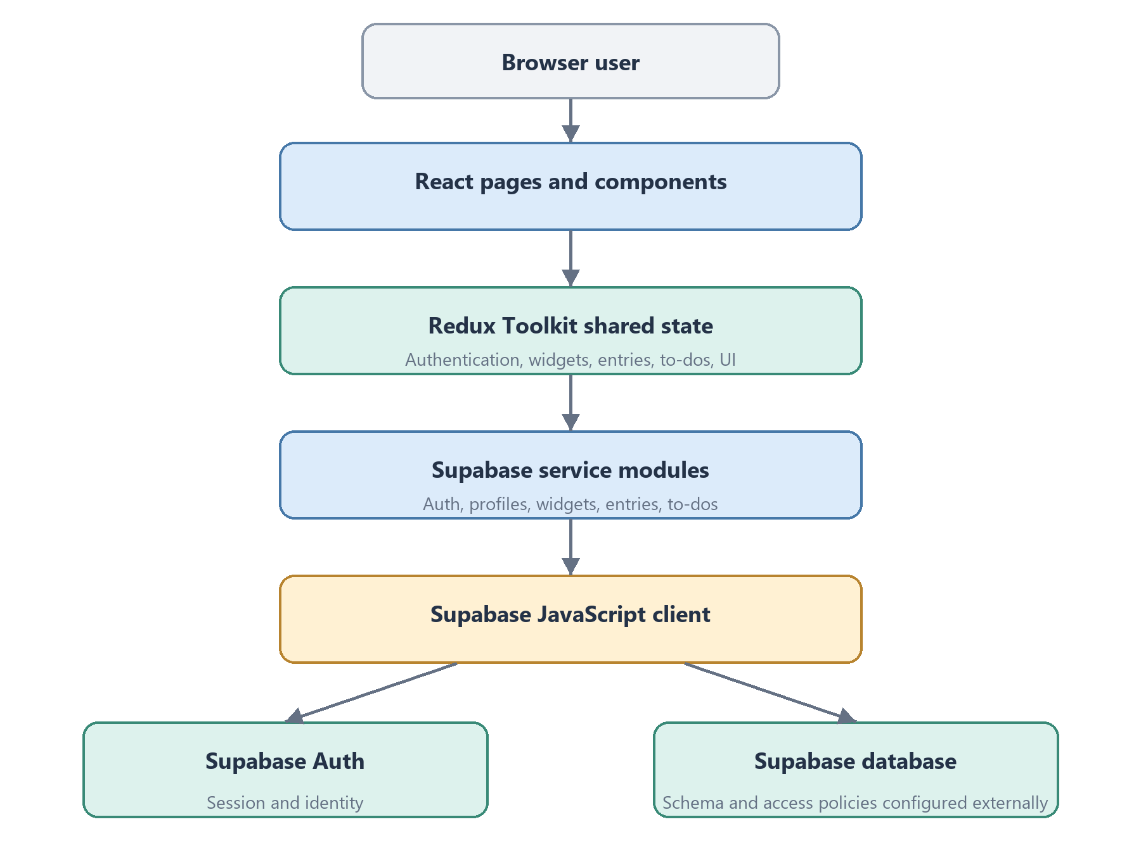
Figure 4.1. Client and data-service flow in SyncSpace.
Layer | Responsibilities
Browser user | Uses public pages, account flows, dashboard, tracker forms, and profile controls.
React application | Renders route pages and reusable UI; protected routes rely on initialized auth state.
Redux Toolkit store | Keeps shared authentication, widget, entry, to-do, and UI data available to components.
Service modules | Encapsulate Supabase Auth and queries for profiles, widgets, entries, and to-dos.
Supabase project | Provides configured authentication and database services; schema and access policies are external setup.

Table 4.1. Responsibilities of the main architecture layers.

4.2 Application Startup and Authentication Flow
1. The entry point creates the Redux store and router, then mounts the application under the Redux provider.
2. The application requests the current Supabase session and listens for sign-in and sign-out events.
3. After authentication state is initialized, protected routes either render their nested page or redirect to login.
4. The dashboard requests the current user’s to-do items, widgets, and entries, then dispatches returned data into Redux slices.
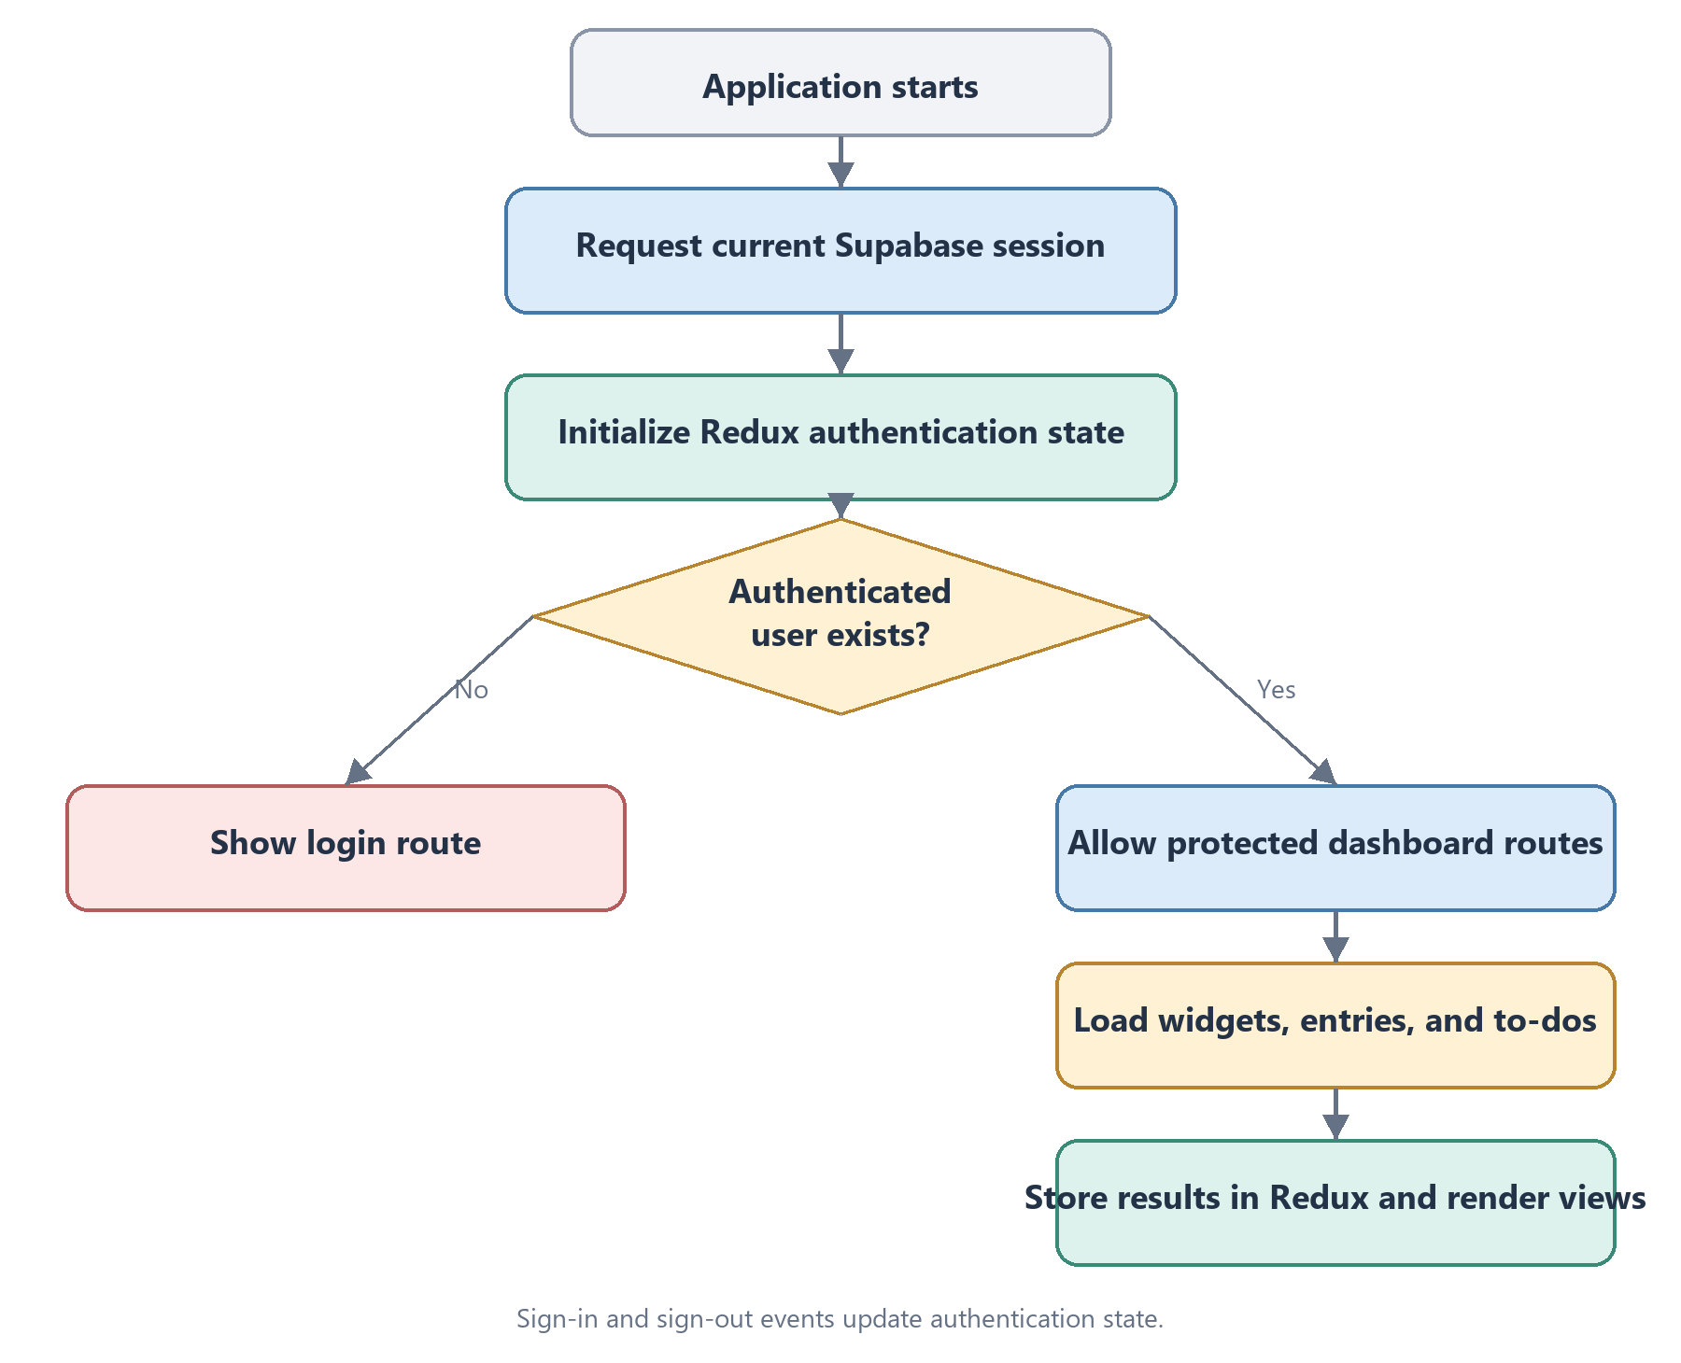
Figure 4.2. Authentication and dashboard loading sequence.

4.3 Main Modules
Module | Description
Authentication | Sign-up, email/password login, Google OAuth initiation, sign-out, session restoration, password recovery, and password update.
Dashboard | Shared shell for navigation, tracker routes, quick-add modal, tracker widgets, and responsive to-do panel.
Built-in trackers | DSA Mastery, Gym and Diet, ML Learning, and Kanban Board, each with specific entry fields and detail views.
Custom trackers | User supplies a name, icon, accent color, and exactly three fields of text, number, or choice type.
Entries and analytics | Entries are associated with a widget and date. Utilities and views support streaks, heatmaps, summary metrics, charts, and recent logs.
To-do list | Users add and edit task text, mark tasks complete, and remove tasks through service calls.
Profile | Display name and password management, plus review and deletion of tracker widgets and associated entries.

4.4 Built-In Tracker Workflows

4.4.1 DSA Mastery
The DSA entry form records a date, topic, difficulty, platform, optional problem title and notes, and bookmark or flag state. Platform choices include LeetCode, Codeforces, GeeksforGeeks, HackerRank, AtCoder, InterviewBit, and Other. The payload is stored as an entry associated with the tracker widget and user.

4.4.2 Gym and Diet
The Gym and Diet tracker provides workout and diet entry forms and a goals view. Workout records include exercise name, muscle group, sets, repetitions, weight, date, and optional notes. Diet records store date, calories, protein, and water. Tracker configuration can store calorie, protein, water, and weekly workout targets.

4.4.3 ML Learning
The ML Learning tracker is intended to record learning activity with topic, source, resource type, duration, and understanding information. The README and form modules establish these fields. Some card summary calculations remain identified as TODOs in the source, so this report does not claim every planned summary is complete.

4.4.4 Kanban Board
The Kanban tracker records tasks with status, priority, due date, and tags, and presents tracker-specific task progress views. Entry forms and deep-dive components provide the user-facing workflow. No claim is made about team collaboration or synchronization between different users.

4.4.5 Custom Trackers
A custom tracker has a user-defined name, icon, color, and three labeled fields. Each field can be text, number, or choice. Choice fields allow a constrained option list. Validation checks non-empty and unique labels, prevents collisions with reserved shared-field labels, and validates unique choice options. The custom tracker flow also supports presets such as reading and guitar practice.

4.5 User Workflows

4.5.1 Account and Dashboard Workflow
A visitor creates an account or signs in using the available authentication interface. Once Supabase returns a session, the client initializes its authentication state. The protected dashboard then loads user-associated widgets, entries, and to-dos. The user can add a tracker, open a quick-add form, or navigate to a tracker detail page.

4.5.2 Activity Logging Workflow
The user opens a tracker card and submits the relevant form. The form validates required values, creates a tracker-specific payload, and calls the entry service with the widget identifier, user identifier, payload, and date. On a successful response, the returned entry is added to Redux state and the quick-add modal closes. Error feedback varies by form implementation.
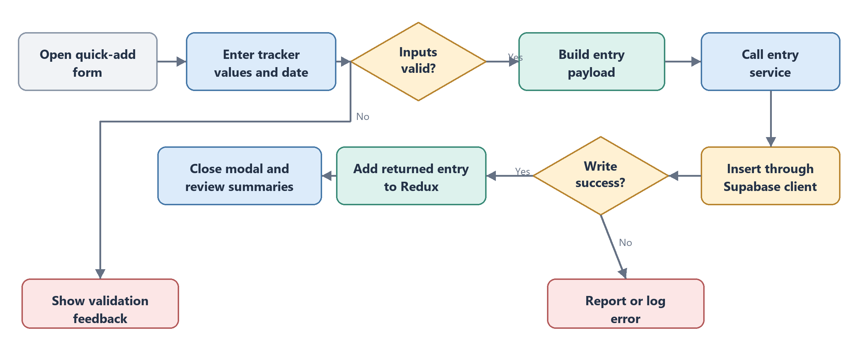
Figure 4.3. Activity entry submission and client state update.

4.5.3 Custom Tracker Workflow
The user selects the custom tab in Add Tracker, enters a name, selects an icon and accent color, defines three fields, and supplies choice options when needed. After validation, the widget service creates the tracker record with its configuration. The dashboard can then render it through shared custom-widget components.

4.6 Logical Data Model
The client service calls reveal the logical records expected by the application. They do not establish database constraints, indexes, triggers, or a complete relational schema. Those definitions must be verified against the connected Supabase project.
Record | Observed fields and relationships
profiles | Profile lookup uses id equal to the authenticated user identifier; username is updated by the profile view.
widgets | user_id, type, name, icon, color, position, and config. A widget organizes its activity entries.
entries | widget_id, user_id, date, and payload. The payload varies by tracker type.
todos | user_id, text, completed, and created_at are used by client operations.
Auth user | Supabase Auth manages identity and metadata such as full name, name, and username.

Table 4.2. Logical data records observed in the service layer; not a verified database schema.

4.7 Data Flow
On dashboard entry, requests for to-dos, widgets, and entries are issued together. Returned results are placed in separate Redux slices. A tracker form writes an entry through the entry service and dispatches the returned record into local state. Widget creation and changes follow a similar service-then-dispatch pattern. To-do operations call their service methods and update the interface. This flow is request/response based in the client code; no Supabase Realtime channel subscription is present in the inspected source.

4.8 Security and Privacy Considerations
Authentication is delegated to Supabase Auth, and the application guards dashboard routes based on client session state. Many database reads filter on user_id. Client-side route protection and query filters are not sufficient substitutes for server-enforced authorization. The README requires row-level security policies that restrict each authenticated user to their own records. Since those policies are not included, their presence and correctness must be verified in the Supabase project before real personal data is stored. The application should use a publishable client key; privileged service-role secrets must not be placed in Vite-exposed variables.

4.9 Results and Discussion
The source repository demonstrates implementation paths for route-based pages, Supabase Auth service calls, tracker configuration, entry services, to-do services, profile operations, and chart or heatmap components. It also contains error boundaries and loading states in relevant views. This report is based on source inspection and project documentation; it does not claim that a hosted instance was tested, deployed, or evaluated with users.

4.10 Testing and Evaluation Status
The package configuration provides a lint command, and the README lists build and preview commands. No automated test files or documented test execution results were present in the inspected project files. The following activities are recommended and do not represent completed test results.
Area | Suggested verification | Available evidence
Authentication | Sign up, sign in, Google provider configuration, sign out, password reset. | Service calls and pages exist; hosted configuration and execution are unverified.
Access control | Confirm unauthenticated redirects and test row-level policies across two accounts. | Client route guard exists; RLS policies are not included.
Trackers | Create each type; validate fields; add, update, and remove entries. | Forms and service methods exist; end-to-end results are unavailable.
Custom fields | Check duplicate/reserved labels, choice limits, and custom entry rendering. | Field validation exists; executed test report unavailable.
To-dos and profile | Add/edit/complete/delete tasks; update profile fields and password. | Client operations exist; backend and manual test results unavailable.
Build and accessibility | Run lint/build; review responsive layouts, keyboard use, and labels. | Scripts are defined; no run logs or formal audit supplied.

4.11 Limitations and Future Enhancements
The repository lacks Supabase schema migrations and row-level security definitions; deployment therefore requires external setup and security review. TODO comments identify unfinished tracker summaries and refinements. The available files contain no automated tests, user evaluation, performance benchmarks, or production deployment evidence. Supabase configuration remains an operational dependency.
Possible future work includes database migrations and access policies, automated tests, completion of remaining summaries, improved error reporting, accessibility review, and deployment documentation. These are recommendations, not implemented functionality.
The custom tracker currently defines exactly three user-created fields, which may not suit every activity. The repository does not show a data export workflow or shared multi-user workspaces. Google sign-in also depends on enabling and configuring the provider in Supabase. These points should be considered when the project scope is extended.

CHAPTER - 05

CONCLUSION
SyncSpace is a personal productivity and habit-tracking web application that brings structured activity logs, progress views, and a to-do list into one configurable dashboard. The implementation combines reusable React components, route-based navigation, Redux Toolkit state, tracker-specific forms, and Supabase client services for authentication and persistence. Built-in trackers cover DSA practice, gym and diet logging, ML learning, and Kanban tasks, while custom trackers allow users to describe additional routines through configurable fields.
The project illustrates how a modular frontend can organize multiple personal tracking workflows around common widget and entry concepts. The repository also makes clear that a complete deployment requires external database schema and row-level security configuration. Further verification should include hosted authentication flows, access policy checks, tracker workflows, and automated testing. This report describes the implementation evidenced by the available project files without asserting measured impact or production readiness.

REFERENCES
[1] React Team, “React Documentation.” https://react.dev/ (accessed 22 October 2026).
[2] Vite Team, “Vite Guide.” https://vite.dev/guide/ (accessed 22 October 2026).
[3] React Router, “React Router Documentation.” https://reactrouter.com/ (accessed 22 October 2026).
[4] Redux, “Redux Toolkit Documentation.” https://redux-toolkit.js.org/ (accessed 22 October 2026).
[5] Supabase, “JavaScript Client Library Reference.” https://supabase.com/docs/reference/javascript/introduction (accessed 22 October 2026).
[6] Tailwind Labs, “Tailwind CSS Documentation.” https://tailwindcss.com/docs (accessed 22 October 2026).
[7] Recharts, “Recharts Documentation.” https://recharts.org/en-US/ (accessed 22 October 2026).
[8] date-fns, “date-fns Documentation.” https://date-fns.org/docs/Getting-Started (accessed 22 October 2026).
[9] React Hook Form, “React Hook Form Documentation.” https://react-hook-form.com/ (accessed 22 October 2026).
[10] Lucide, “Lucide Icons.” https://lucide.dev/ (accessed 22 October 2026).
[11] SyncSpace source repository and README, supplied workspace files, inspected 22 October 2026.

