

**Experiment 2**

**Student Name: Ayush Ranjan UID: 23BCS10187**

**Branch: CSE Section/Group: KRG_2_B**

**Semester: 5th Date of Performance: 28/7/2025**

**Subject Name: ADBMS Subject Code: 23CSP-333**

1. **Aim:**
   1. To generate an employee-manager reporting hierarchy by performing a self-join on the Employee table, enabling the HR department to visualize internal organizational structure.
   2. To retrieve Net Present Value (NPV) data for requested financial instrument-year pairs using SQL joins, substituting missing values with zero to ensure a complete and consistent financial report.
2. **Objective:**
   1. To design and query relational tables for modeling employee-manager hierarchies and financial instrument data.
   2. To apply **self-joins** for mapping internal reporting relationships within a single table.
   3. To use **LEFT JOINs** function to handle missing data gracefully in financial queries.
   4. To generate accurate, ordered reports that support organizational insights and stakeholder decision-making.
3. **DBMS script and output: Q1:**

CREATE TABLE Employee (

    EmpID INT PRIMARY KEY,

    Ename VARCHAR(100),

    Department VARCHAR(100),

    ManagerID INT

);

INSERT INTO Employee (EmpID, Ename, Department, ManagerID) VALUES

(1, 'Alice',   'HR',      NULL),

(2, 'Bob',     'Finance', 1),

(3, 'Charlie', 'IT',      1),

(4, 'David',   'Finance', 2),

(5, 'Eve',     'IT',      3),

(6, 'Frank',   'HR',      1);

SELECT

    E.Ename AS EmployeeName,

    E.Department AS EmployeeDept,

M.Ename AS ManagerName,

    M.Department AS ManagerDept

FROM

    Employee E

LEFT JOIN

    Employee M ON E.ManagerID = M.EmpID;



**Q2:**

CREATE TABLE Year_tbl (

ID INT,

YEAR INT,

NPV INT

);

INSERT INTO Year_tbl (ID, YEAR, NPV) VALUES

(1, 2018, 100),

(7, 2020, 30),

(13, 2019, 40),

(1, 2019, 113),

(2, 2008, 121),

(3, 2009, 12),

(11, 2020, 99),

(7, 2019, 0);

CREATE TABLE Queries_tbl (

ID INT,

YEAR INT

);

INSERT INTO Queries_tbl (ID, YEAR) VALUES

(1, 2019),

(2, 2008),

(3, 2009),

(7, 2018),

(7, 2019),

(7, 2020),

(13, 2019);

SELECT

q.ID,

q.YEAR,

COALESCE(y.NPV, 0) AS NPV

FROM

Queries_tbl q

LEFT JOIN

Year_tbl y

ON

q.ID = y.ID AND q.YEAR = y.YEAR

ORDER BY

q.ID, q.YEAR;



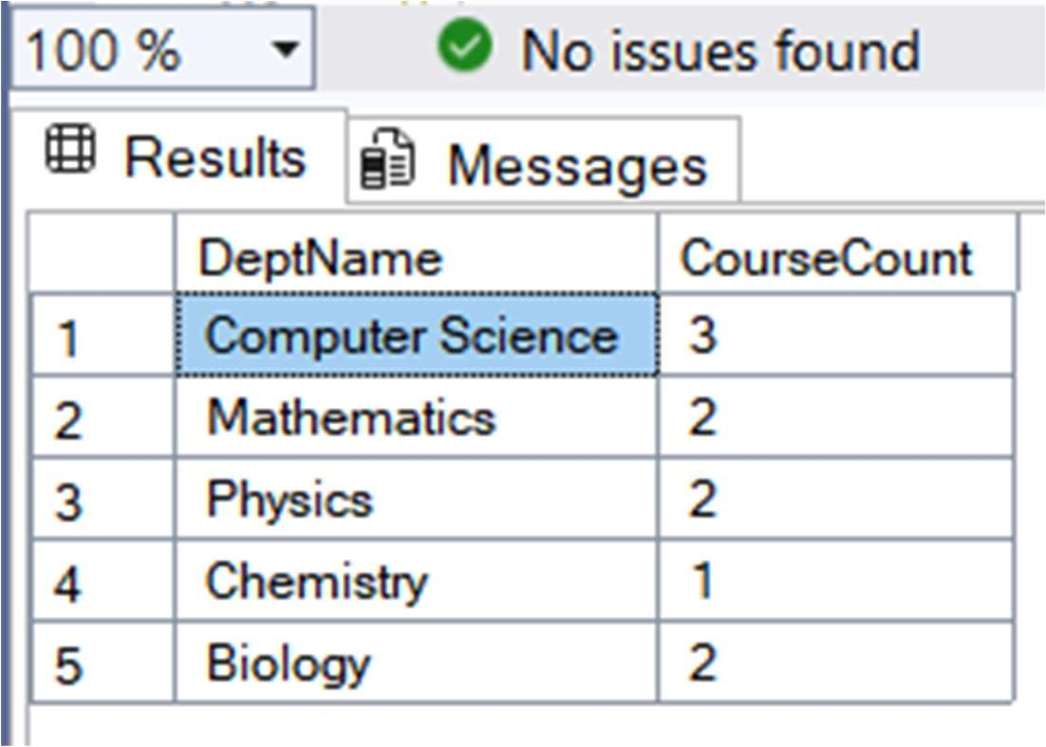

1. **Learning Outcomes:**
   1. Understand how to model hierarchical and financial relationships using relational database concepts.
   2. Learn to perform **self-joins** and **outer joins** for advanced data retrieval across and within tables.
   3. Gain proficiency in handling **missing data** using functions to ensure data completeness.
   4. Develop the ability to generate structured, sorted reports to support business and organizational analysis.