 **Employee Management System**



**By: Mentor:**   
**Ayushi** **Paliwal Sachin Vasav**



* **Purpose of this Project**Provides a **centralized platform** for managing and organizing employee information.
* **Streamlines HR and administrative tasks**, reducing manual effort and improving data accuracy.
* Ensures **secure access** with user registration and login features, allowing only authorized users to access sensitive data.
* Supports **comprehensive employee record management**, including adding, updating, deleting, and viewing records in one place for quick data retrieval.
* Minimizes dependency on **paper records** or manual databases, enhancing record-keeping efficiency.
* Offers **salary analysis tools** that break down salary components (base salary, allowances, provident fund, tax deductions).  
  Includes additional features such as:  
  1. **Tenure calculation** for employees.  
  2. **Department summaries** for team and resource planning.  
  3. **Salary filtering** to support budgeting and financial planning.
* Enhances **data security** and supports **informed decision-making** with easily accessible insights.
* Improves **overall operational efficiency** in employee management, making it an essential tool for organizations.



**System Requirements**

* **Hardware**: 8GB RAM, i5 Processor
* **Software**:
  + Python (Version 3.13)
  + MySQL Database
  + Required Libraries: mysql.connector, getpass, datetime, mysql.connector.python, mysqlclient

**Database Setup**

database = mysql.connector.connect(  
 host="localhost",  
 user="root",  
 passwd="root",  
 database="emp",  
 auth_plugin='mysql_native_password'  
)



**Database Design**

**For user table**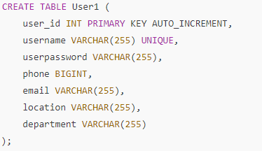

**For Employee Table**

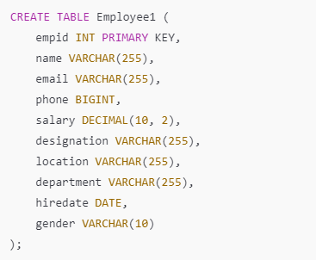



**Code Structure**

**Main Modules:**

**1.** register_user()  
  
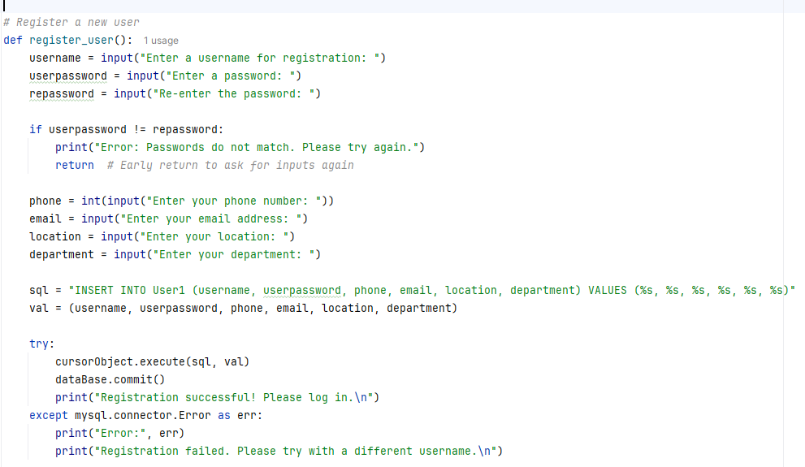

Output





**2.** login_user(): Authenticates existing users.

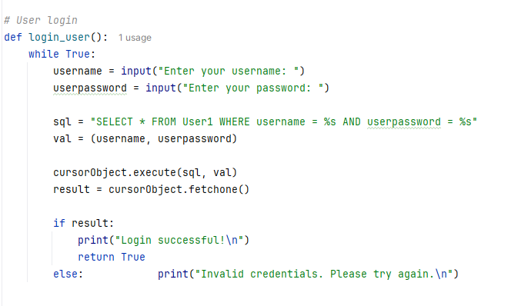

Output

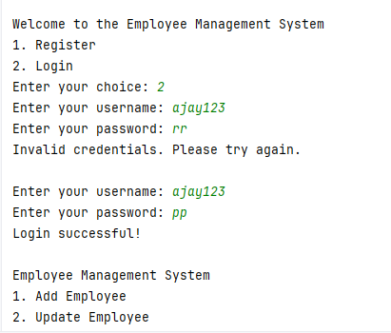



**3**. add_employee()

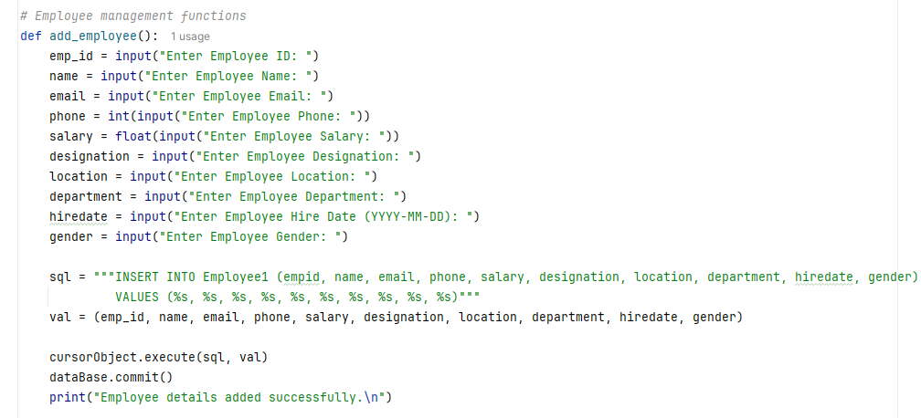

Output

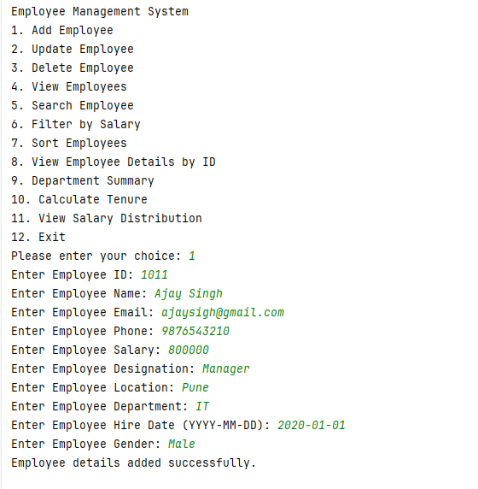



**4.** update_employee()

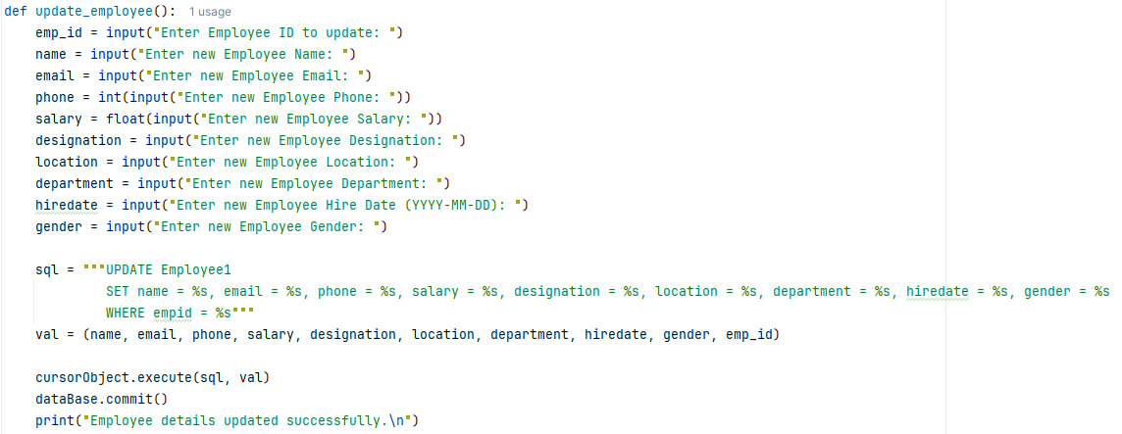

**5. delete_employee()**

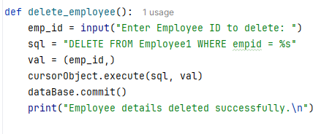



**6. view_employees()**

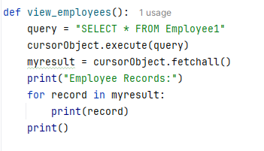

**Supporting Functions**

**1.** search_employee()

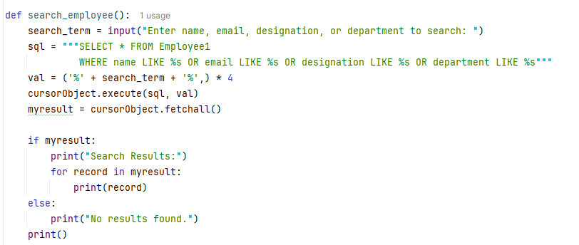

Output

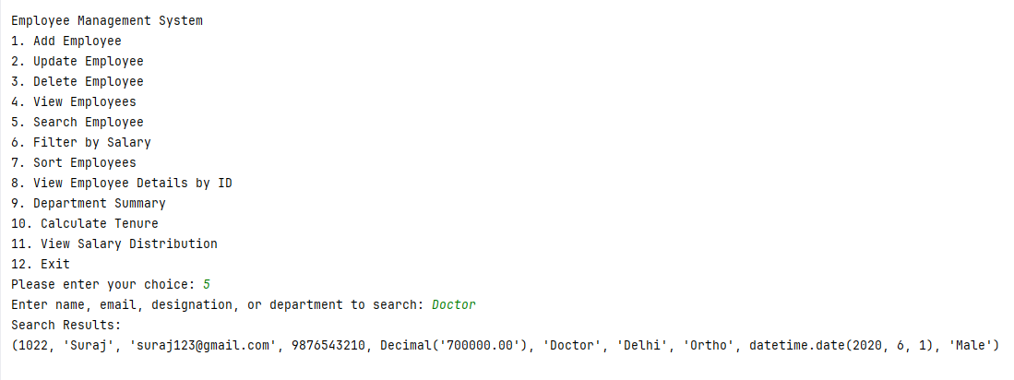

2. filter_by_salary()

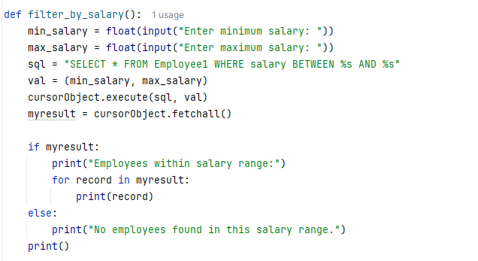

Output

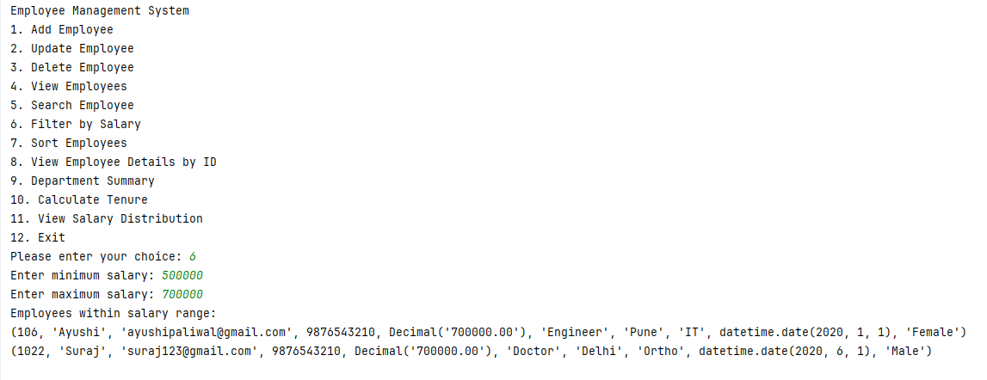



3. sort_employees()

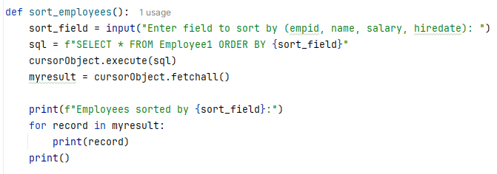

4. view_employee_details()

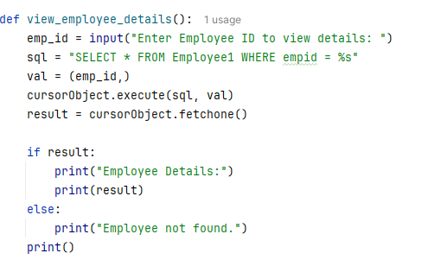

Output

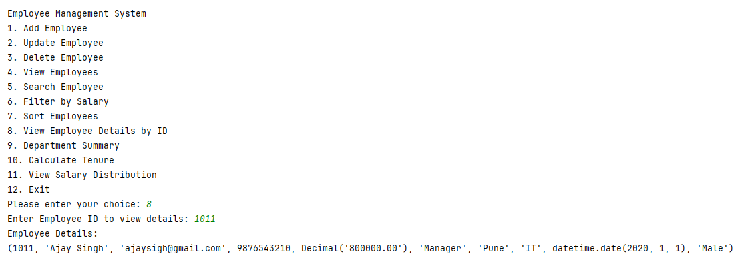

5. department_summary()

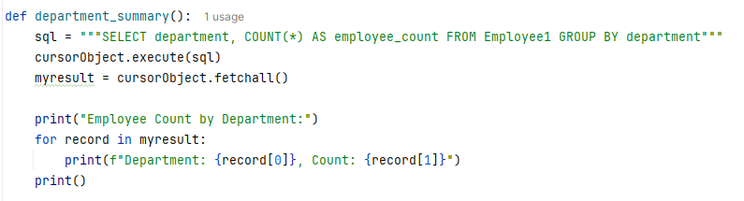

Output

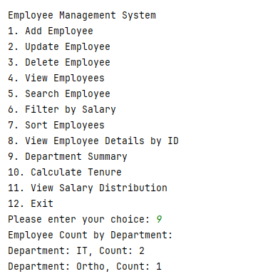

6. calculate_tenure()

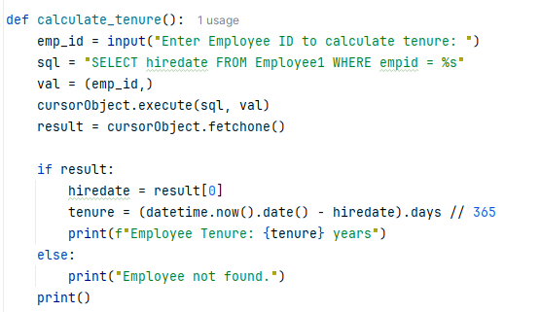

Output

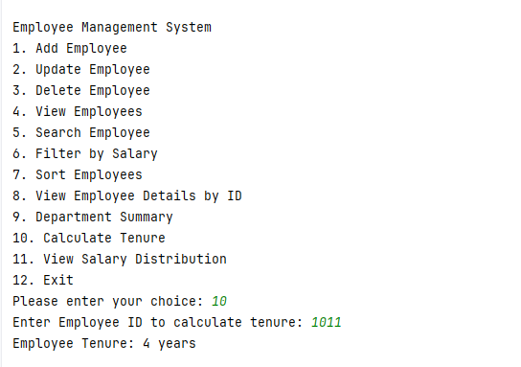

7. salary_distribution()

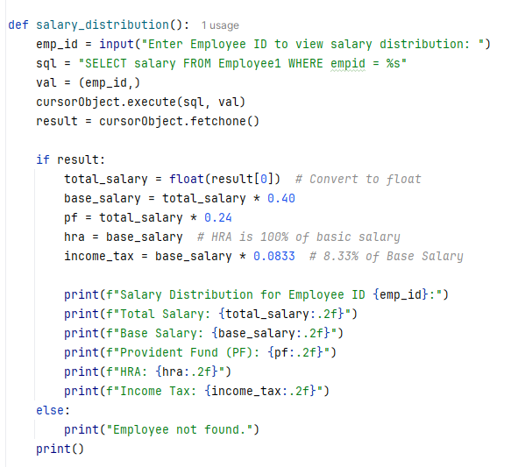



Output

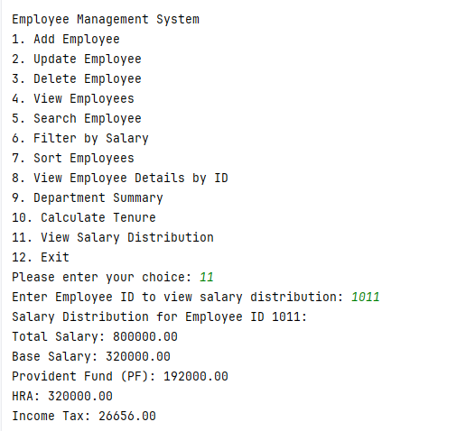

**Driver Code**

