D600 – Statistical Data Mining
Task 3 – Principal Component Analysis
A.
https://gitlab.com/wgu-gitlab-environment/student-repos/ayu20/d600-statistical-data-mining/-/blob/working_branch/D600Task3Code.py?ref_type=heads
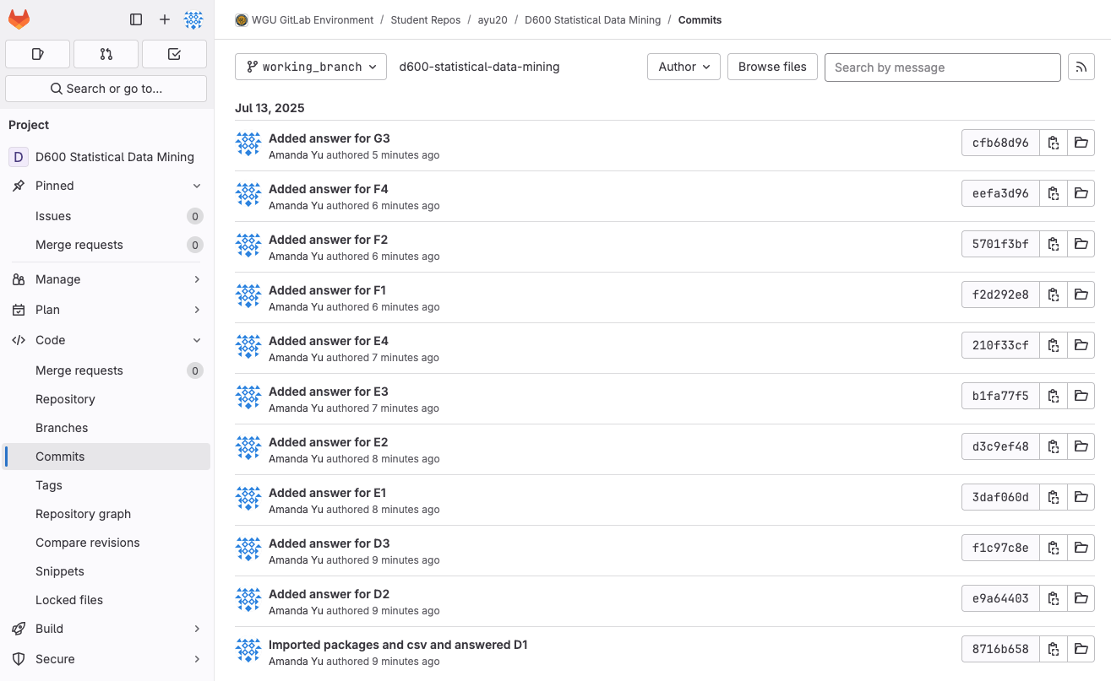
B1.
How accurately can we predict house prices using principal component analysis and multiple linear regression based on property and neighbourhood characteristics?
B2.
The goal for this data analysis is to develop a predictive model that can accurately estimate house prices based on a reduced set of principal components derived from various property and neighborhood characteristics, and to assess the model’s predictive accuracy using metrics such as R², RMSE, and MSE. This will help organizations like real estate companies better understand which factors most influence pricing, which will enable data-driven decisions in pricing, real estate investment, or property valuation.
C1.
Principal Component Analysis (PCA) can prepare the dataset for regression analysis by transforming the original property and neighbourhood characteristics into a smaller set of uncorrelated features called principal components (PCs). This process first involves standardizing the numerical predictors to ensure all features contribute equally (mean = 0, standard deviation = 1), then applying PCA to derive these new components, ordered by the amount of variance they explain. By selecting only the most significant PCs (using the Kaiser rule), the dimensionality of the dataset is reduced, which helps mitigate issues like multicollinearity among predictors and simplifies the regression model. The expected outcomes include reduced multicollinearity, which improves model stability; a simplified model with fewer components, enhancing efficiency; preserved variance, with the retained components explaining most of the original variability; and improved generalization, as a simpler model with reduced noise is likely to perform better on unseen data.
C2.
PCA assumes that the relationships between variables are linear, meaning it captures variance based on linear combinations of features. If the relationships between the variables are highly non-linear, PCA may not be able to effectively capture the most important variance or reduce dimensionality without significant information loss.
D1.
I chose price as the dependent variable because it represents the final outcome of our data analysis. This aligns with the goal of trying to understand and predict house prices based on factors of the property and neighbourhood. Price is also a continuous variable that is appropriate for modelling using multiple linear regression.
I initially selected the following variables as independent variables: SquareFootage, BackyardSpace, CrimeRate, SchoolRating, AgeOfHome, DistanceToCityCenter, EmploymentRate, PropertyTaxRate, RenovationQuality, LocalAmenities', and TransportAccess. These variables capture both property-level and neighborhood-level characteristics that are commonly understood to influence housing prices. All variables are numeric continuous types, making them suitable for PCA and multiple linear regression. After applying PCA and backward stepwise elimination to optimize model performance, the final model retained 4 principal components.
D2.
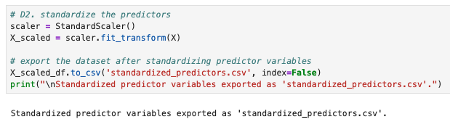
D3.
I calculated descriptive statistics for the numeric variables using the functions count, mean, mode, minimum, and maximum.
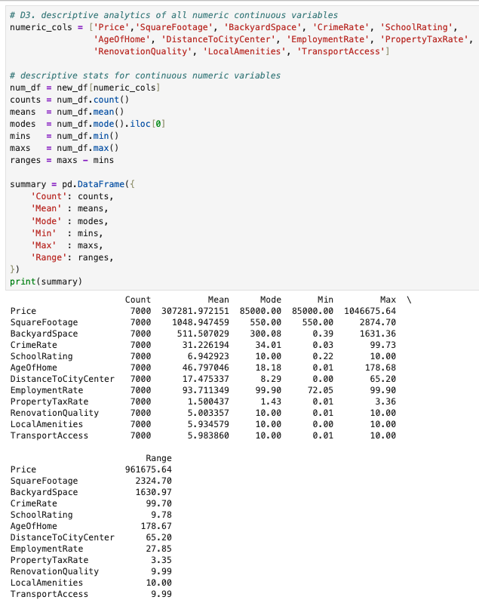
E1.
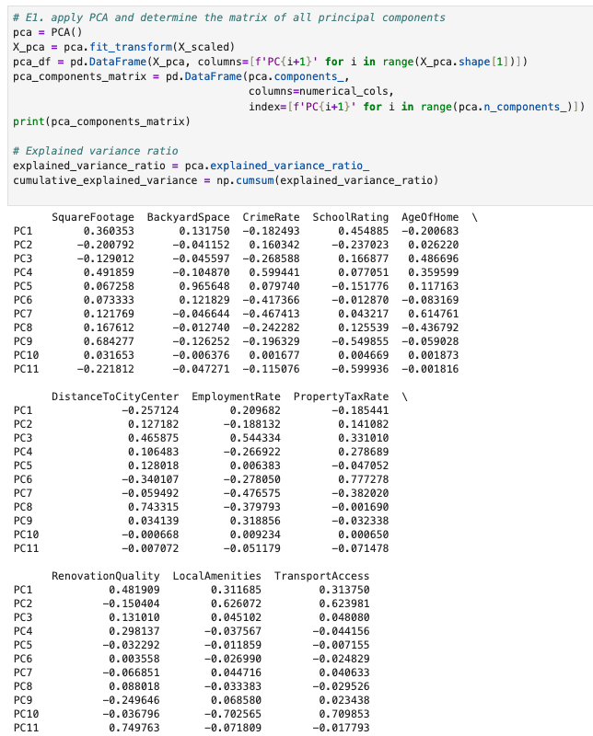
E2.
The total number of principal components retained using the Kaiser rule is 4 components.
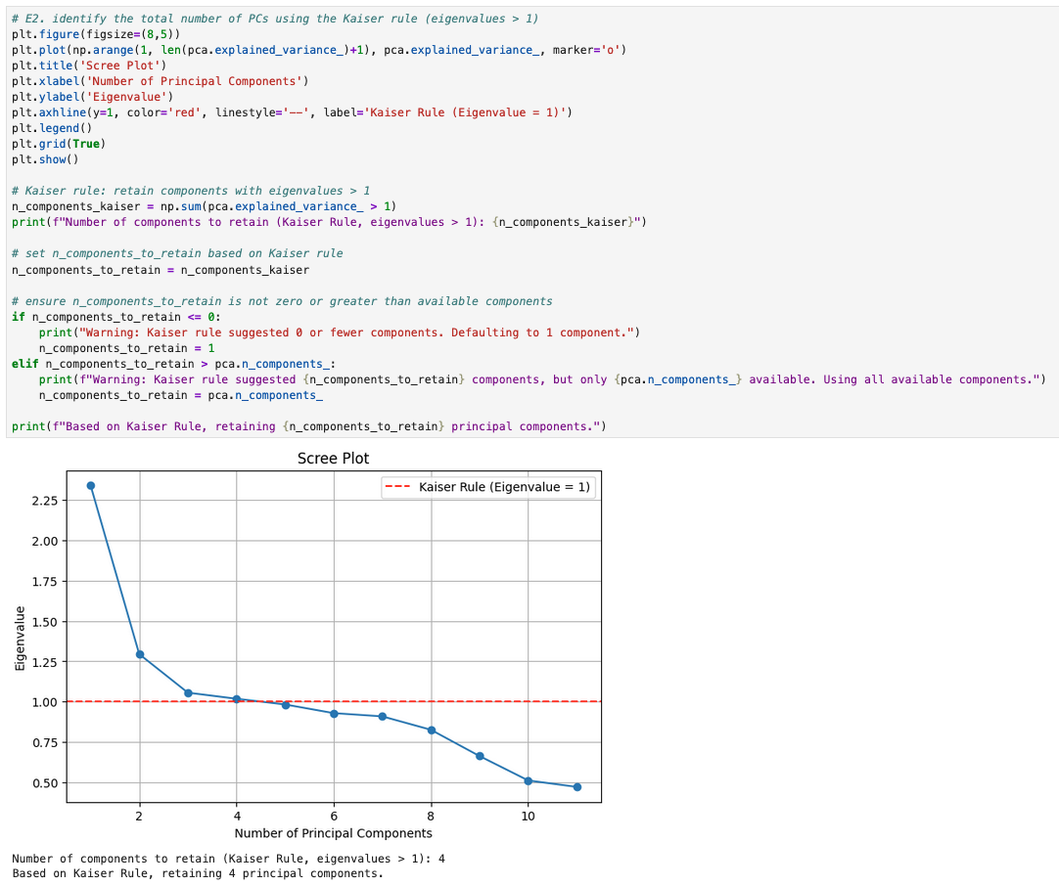
E3.
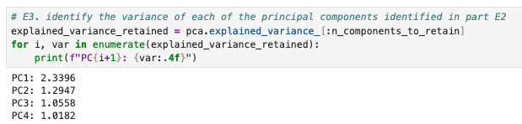
E4.
The original dataset contained 11 features. The explained variance ratios of the first four principal components are: PC1 – 21.27%, PC2 – 11.77%, PC3 – 9.60%, and PC4 – 9.25%. Together, these components account for a cumulative explained variance of 51.89%. This means the four retained principal components capture approximately 51.89% of the total variance in the original dataset.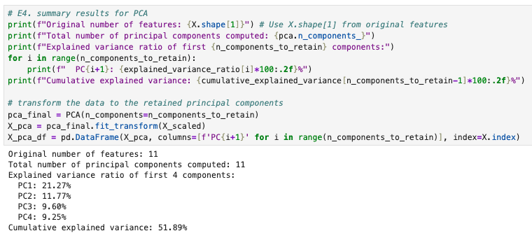
F1.
I used train_test_split from sklearn.model_selection to divide the data into two sets, allocating 60% for training and 40% for validation (Shmueli, Bruce, Gedeck, & Patel, 2019).
F2.
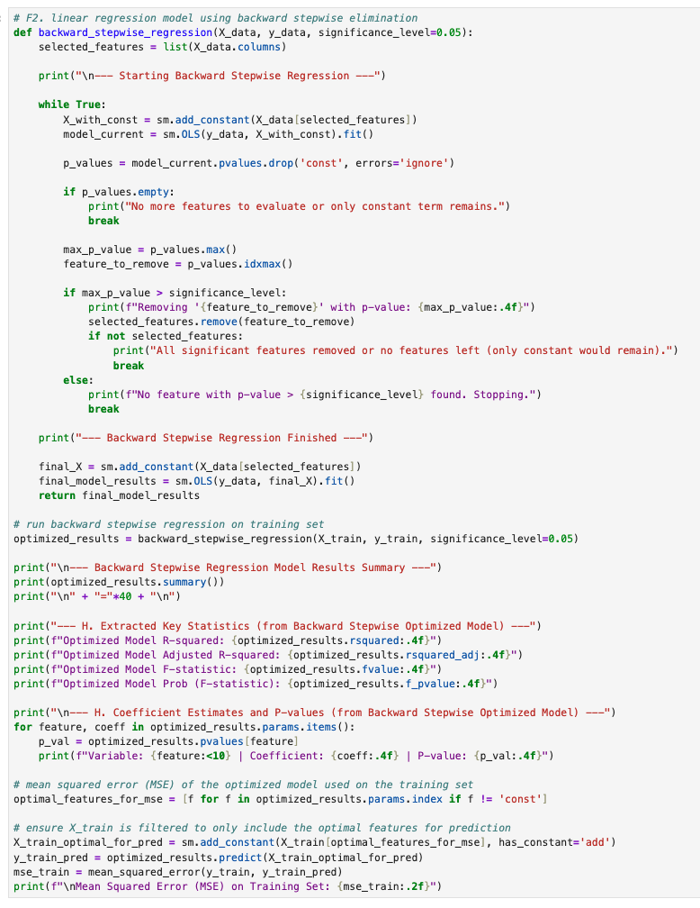
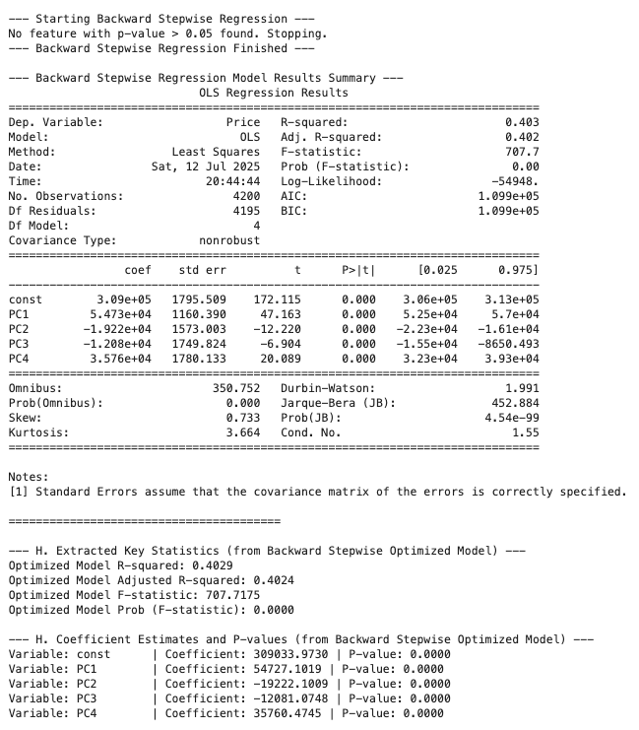
F3.
Mean Squared Error (MSE) on Training Set: 13522383192.48
F4.
Mean Squared Error (MSE) on Validation Set: 13637998389.64
R-squared on Validation Set: 0.3907
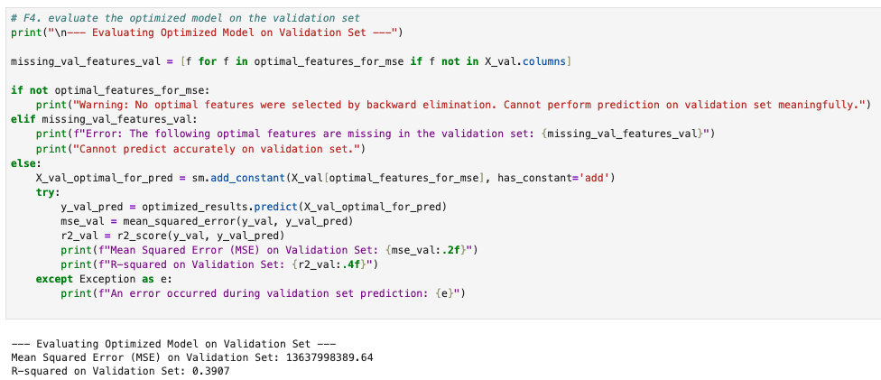
G1.
- import pandas as pd: used to load, clean, and prepare the data for analysis
- import matplotlib.pyplot as plt: used for creating visualizations
- import seaborn as sns: used for creating visualizations
- from sklearn.model_selection import train_test_split: used to split the dataset into separate training and validation sets to evaluate the multiple linear regression model’s performance
- import statsmodels.api as sm: used to build a linear regression model and generate a statistical summary for interpreting the coefficients and model’s significance. It was also used for the backward stepwise elimination method.
- from sklearn.metrics import r2_score, mean_squared_error: used to provide metrics to measure the performance of the multiple linear regression model and how well it predicted the dependent variable.
- import numpy as np: used for numerical computing
- from sklearn.preprocessing import StandardScaler: standardizes data by removing the mean and scaling to unit variance
- from sklearn.decomposition import PCA: reduces dimensionality of the dataset while preserving as much variance as possible
G2.
The model was optimized by applying PCA to reduce the dimensionality of the dataset, transforming the original predictors into a smaller set of uncorrelated principal components. This helped address multicollinearity, improve model interpretability, and retain most of the dataset’s variance using fewer features. After generating the principal components, backward stepwise elimination was applied to select only the most statistically significant components for the final regression model. This process starts with all components and iteratively removes those with the highest p-values if they exceed the significance level of 0.05. This method simplifies the model by keeping only the most relevant predictors for multiple linear regression, improving interpretability and reducing the risk of overfitting. In this case, since all four principal components had p-values less than 0.05, none were removed during the elimination process.
G3.
Linearity appears to be violated based on the residuals vs fitted values plot. The plot shows a funnel shape indicating a non-linear relationship. Since this assumption is violated, we can apply transformations to the independent or dependent variables.
Homoscedasticity (constant variance of residuals) also appears to be violated based on the residuals vs fitted values plot. The residuals vs. fitted values plot shows a slight funnel shape, indicating some heteroscedasticity. Since this assumption is violated, we can apply transformations to the independent or dependent variables.
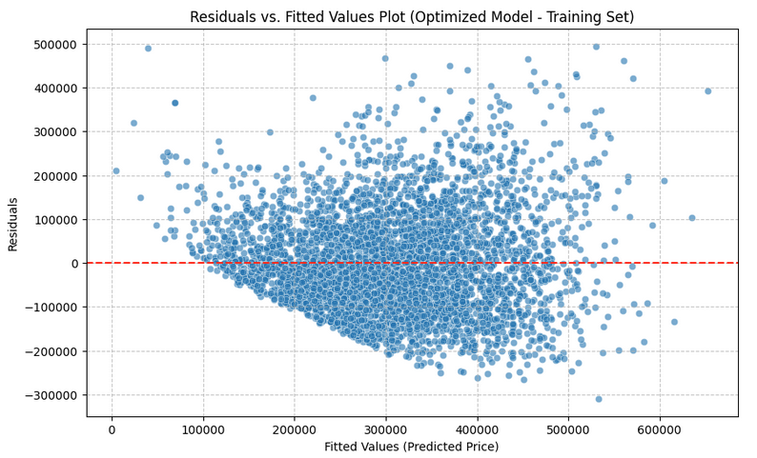
Independence of errors (no autocorrelation) is satisfied. The Durbin-Watson statistic of 1.991 is very close to the ideal value of 2, indicating no significant autocorrelation in the residuals.
Normality of residuals appears to be violated based on the results summary from the regression model. The extremely low p-values from the Omnibus test (0.000) and Jarque-Bera test (4.54e-99) indicate that the residuals significantly deviate from a normal distribution. This is further supported by the positive skew (0.733) and high kurtosis (3.664), which suggest asymmetry and heavy tails. Since this assumption is violated, we can apply transformations to the dependent variable.
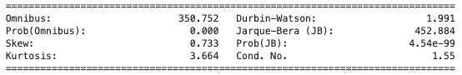
No multicollinearity is satisfied. The correlation heatmap of the 4 principal components shows generally weak relationships, with all correlation coefficients below 0.6, indicating low linear dependence between components.
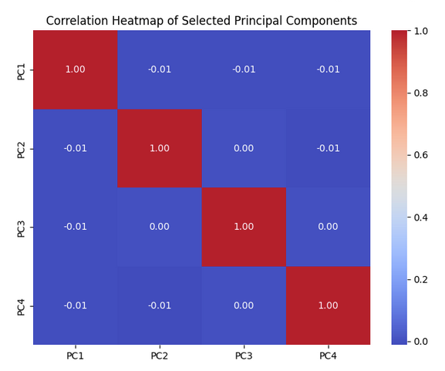
G4.
The regression equation is: Price= 309,000 + (54,730×PC1) + (−19,220×PC2) + (−12,080×PC3) + (35,760×PC4).
The intercept is the baseline price of $309,000 when all principal components (PC) are zero. It represents the predicted price when the PC’s have no effect. For each one-unit increase in PC1, the price increases by $54,730. For each one-unit increase in PC2, the price decreases by $19,220. For each one-unit increase in PC3, the price decreases by $12,080. For each one-unit increase in PC4, the price increases by $35,760.
G5.
The R-squared and adjusted R-squared values for the training set were 0.4029 and 0.4024, indicating that the model explains 40.29% of the variation in house prices. R-squared measures how well the model's predictions align with the actual values, while adjusted R-squared accounts for the number of predictors included. Since both values are close, it suggests that the variables included are meaningful, and the model achieves a good balance between accuracy and simplicity. The mean squared error (MSE) for the training set was 13522383192.48, while the MSE for the validation set was slightly higher at 13637998389.64. This difference suggests that the model is not overfitting and maintains consistent predictive accuracy across both datasets. Overall, this supports the reliability and robustness of the optimized model.
G6.
The R-squared value of 0.4029 indicates that approximately 40.29% of the variance in house prices can be explained by the principal components included in the optimized model. With this low R-squared value, it reflects the trade-off of using PCA for dimensionality reduction. This also implies that some predictive information was lost during the dimensionality reduction process. However, the benefits of PCA, such as addressing multicollinearity and simplifying the model, might outweigh this loss, leading to a more stable and interpretable model, especially if the original features had high correlations. For a real estate valuation firm, this model provides a statistically sound tool for estimating house prices based on the most important underlying dimensions of property and neighborhood characteristics. Further analysis would involve interpreting the individual principal components to understand what aspects of the data are driving these predictions.
G7.
Based on the results, this multiple linear regression can be a reliable method for predicting house prices using property and neighbourhood characteristics, explaining 40.29% of the variation in prices with similar performance across training and validation sets. The organization should consider using this multiple linear regression model as a decision-support tool for setting listing prices, evaluating investments, and advising buyers. To further improve accuracy, it’s recommended to collect more data, address limitations such as non-normal residuals, and explore more advanced models. With regular updates and proper training for users, this model can become an asset for real estate forecasting and pricing strategy.

References
- Shmueli, G., Bruce, P. C., Gedeck, P., & Patel, N. R. (2019). Data Mining for Business Analytics. Wiley Global Research (STMS). https://wgu.vitalsource.com/books/9781119549864

