**A Design review of Smart Stick for the Blind Equipped with Object Detection and Identification using Machine Learning**

Ganesh Agarwal (JIIT,3rd Year Student)

Ayush Sharma (JIIT,3rd Year Student)

Kumari Kajal Jaiswal (JIIT,3rd Year Student)

**ABSTRACT**

Visually impaired individuals find it more challenging to move around independently because of their compromised vision. Moreover, a blind person’s capacity to navigate, along with their ability to organize their daily activities are vital to their health and well-being. The discouraging fact in reality is that there are a huge number of disabled people overall who need to experience such understanding and are subject to others for their security and comfort. The empowering news, is that the quick progression in innovation has seen the advancement of better frameworks for helping the incapacitated, including the visually impaired. This paper review the structure of a stick, i.e., A intelligent stick for the visually impaired, equipped with object detection\classification using Artificial Intelligence(AI) in real time.

**KEY TERMS**

Computer Neural Network (CNN), Global Positioning System (GPS), Global System for Mobile Communication (GSM)

**1.INTRODUCTION**

### Visually impaired people are the people who can't identify smallest detail with healthy eyes. Such people are in need of aiding devices for blindness related disabilities.10% of blind have no usable eyesight at all to help them move around independently and safely. The electronic aiding devices are designed to solve such issues. To record information about the obstacles presence in a road active or passive sensors can be used. In case of a passive sensor the sensor just receives a signal. It detects the reflected emitted or transmitted electromagnetic radiation provided by natural energy sources. In case of using an active sensor, the sensor emits a signal and receives a distorted version of the reflected signal. These kinds of active sensors are capable of sensing and detecting far and near obstacles. In addition, it determines an accurate measurement of the distance between the blind and the obstacle. Overall, in the obstacle detection four different types of active sensors may be used: infrared, laser, ultrasonic, in addition to radar sensors. Thus, these systems responds to user through sound or frequency vibration. Consequently, training is then necessary to help the user understand the signals and to react to them in real time. The smart blind stick will have sensors embedded with it, thereby it senses the objects/intruder, person is alerted with a quick response time using a vibrator.This system also has a feature where in which the person with disability can contact to a specific person whose number is stored in a micro-controller in case of any emergency and can share his live location with the help of GPS module. Designing a cost effective and efficient blind stick is the main aim of the project. In our project Machine Learning has a most significant role of detection of obstacles that the person faces. . Our task is to help a blind person detect the obstacles and get a result in a form of audio. Our Machine Learning model uses TensorFlow and Keras library which are more than useful in image processing. With the help of these libraries we created a CNN (convolution Neural Network) which will be detecting images by using its pixels. We are aiming for a real time detection. If the person wants to get idea of objects around him he can use the stick and appropriate results will be reflected.

**2. A REVIEW OF RELATED WORK**

So far researchers have done significant work for the blind and visually impaired by developing many different kinds of assistive technologies to aid them in navigation. Some of the different designs of the smart cane are discussed below along with their modes of operation.

**2.1 GPS Vision Assistance**

The GPS counterfeit vision help was created by Shruti Kumbhare and A. Sakhore. The gadget highlights object identifications, constant help by means of GPS, fake vision, and a voice circuit. Ultrasonic sensors likewise help with object identification. The GPS guides the user to his/her destination.

**2.2 The Smart Stick**

The brilliant stick was planned by Jacio Jose, Miguel Farrajota, Jose Rodrigues, and Hans du Baf in 2011. The stick utilizes GPS to direct the client to a goal, alongside neighbourhood route to arrange ways, passageways, and walkways and empowers the client to evade still, just as versatile obstructions.The gadget additionally includes a sound system camera that is worn at chest tallness, alongside a convenient PC in a shoulder lashed pocket and a little speaker or a headphone.

**3. COMPONENTS USED IN THIS PROJECT**

**3.1 RASPBERRY-PI**

### Raspberry Pi is the name of a series of single-board computers made by the  [Raspberry Pi Foundation](https://www.raspberrypi.org/about/" \t "_blank).The Raspberry Pi launched in 2012, and there have been several iterations and variations released since then. The original Pi had a single-core 700MHz CPU and just 256MB RAM, and the latest model has a quad-core 1.4GHz CPU with 1GB RAM. The Raspberry Pi is a very cheap computer that runs Linux, but it also provides a set of GPIO (general purpose input/output) pins that allow you to control electronic components for physical computing and explore the Internet of Things (IoT).

**3.2 GPS MODULE**

The GPS module for Raspberry Pi is a small electronic circuit that allows to connect to your Raspberry Pi board to get position and altitude, as well as speed, date and time on UTC (Universal Time Coordinated). The GPS module has a memory chip that will be used to save different locations. **G**PS makes use of signals sent by satellites in space and ground stations on Earth to accurately determine their position on Earth. The GPS itself does not need to transmit any information. The signals received from the satellites and ground stations contain time stamps of the time when the signals were transmitted. By calculating the difference between the time when the signal was transmitted and the time when the signal was received. Using the speed of the signal, the distance between the satellites and the GPS receiver can be determined using a simple formula for distance using speed and time. The GPS receiver module uses UART communication to communicate with controller or PC terminal.

**3.2 GSM MODULE**

GSM is a mobile communication modem; it is stands for global system for mobile communication (GSM). The idea of GSM was developed at Bell Laboratories in 1970.  It is widely used mobile communication system in the world. GSM is an open and digital cellular technology used for transmitting mobile voice and data services operates at the 850MHz, 900MHz, 1800MHz and 1900MHz frequency bands. GSM system was developed as a digital system using time division multiple access (TDMA) technique for communication purpose. A GSM digitizes and reduces the data, then sends it down through a channel with two different streams of client data, each in its own particular time slot. The GSM model will be used to send a message to all the saved numbers in the system in case the user issues an emergency alert call.

A GSM network consists of the following components:

**A Mobile Station:**  It is the mobile phone which consists of the transceiver, the display and the processor and is controlled by a SIM card operating over the network.

* **Base Station Subsystem:** It acts as an interface between the mobile station and the network subsystem. It consists of the Base Transceiver Station which contains the radio transceivers and handles the protocols for communication with mobiles. It also consists of the Base Station Controller which controls the Base Transceiver station and acts as a interface between the mobile station and mobile switching centre.
* **Network Subsystem:** It provides the basic network connection to the mobile stations. The basic part of the Network Subsystem is the Mobile Service Switching Centre which provides access to different networks like ISDN, PSTN etc. It also consists of the Home Location Register and the Visitor Location Register which provides the call routing and roaming capabilities of GSM. It also contains the Equipment Identity Register which maintains an account of all the mobile equipment wherein each mobile is identified by its own IMEI number. IMEI stands for International Mobile Equipment Identity.

**3.4 MACHINE LEARNING**

Machine learning is an application of artificial intelligence (AI) that provides systems the ability to automatically learn and improve from experience without being explicitly programmed. Machine learning focuses on the development of computer programs that can access data and use it learn for themselves. The process of learning begins with observations or data, such as examples, direct experience, or instruction, in order to look for patterns in data and make better decisions in the future based on the examples that we provide. Need of machine learning in our project: The biggest challenge in our project identification of the object That comes ahead of the stick’s user. We Used a Convolution Neural Network (CNN) for classification of the images that the user’s stick captures using R-pi camera. CNN like neural networks, are made up of neurons with learn able weights and biases. Each neuron receives several inputs, takes a weighted sum over them, pass it through an activation function and responds with an output. The whole network has a loss function and all the tips and tricks that we developed for neural networks still apply on CNNs CNN Model consists of an Input layer (in our cases image data sets) ,some hidden layers which learns from data and help us to predict for unknown data , and finally the output layers which provides us with a solution.

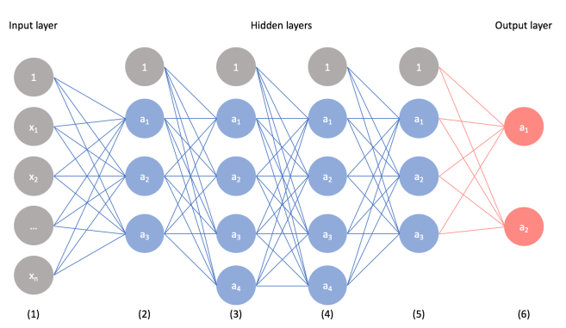

**Fig 1 Convolution neural networks layer**

**4. System’s working and design**

The smart stick will be embedded with a USB camera and GPS and GSM module with switches for user’s convenience.

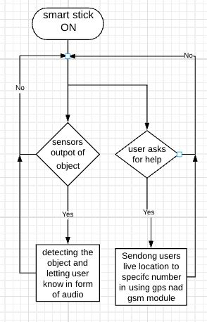

**Fig 2 Basic Flowchart of stick’s working**

**4.1 Powering R pi**

R pi on stick will get power from a battery, And upon powering a will automatically run a python script that will be store in storage.This will be achieved by altering the R pi build in settings.

**4.2 Object Detection and classification**

In the main script continuously sensors output are monitored, In case of object detected a R-pi pin is triggered and side script functions for classifying obstacle using CNN model and which produces output in form of audio signals.

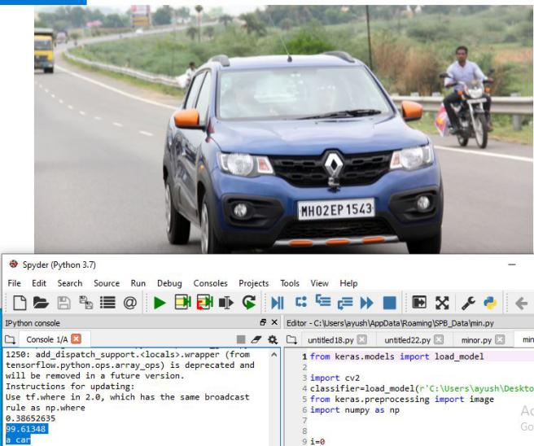

**Fig 3 CNN model detecting a car.**

**4.3 GPS and GSM module**

In case clients decides to share his location, a pin will be triggered and live location will automatically delivered in terms of longitude and latitude provided by GPS module.

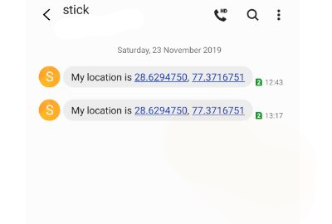

**Fig4 Stick sending message to phone number stored in GSM module**

**5. Performance Analysis**

We trained the model with data sets of multiple categories vehicle, animal persons etc, and it provided accurate results in real time when there was a object of these categories present in front of USB camera implanted on stick . Also sharing of user’s live location in real time with the help of GPS and GSM module worked satisfactory.The model is capable and is expected to work on larger data set.

**5. Conclusion**

In conclusion, the advent of artificial intelligence and sensor technologies have brought about significant changes for betterment in the world, and there are lots of admirable work in developing different kinds of supporting technologies to assist the disabled, and more so the blind and visually impaired to become more self reliant.The previous work were mostly focused on detection of objects presence but not it’s classification . This smart stick is very cost effective and overcomes the problem of classification of obstacles and not only sensor dependent.Thus, the smart blind stick can prove to be a change for good and can revolutionize technology for blind and visually impaired population.

**6. References**

* [https://keras.io/gettingstarted/sequential-model-guide/-19](https://keras.io/getting-started/sequential-model-guide/-19)November 2019
* <https://www.raspberrypi.org/training/online/> 2 October 2019
* <https://www.electronicwings.com/raspberry-pi/gps-module-interfacing-with-raspberry-pi> 17 October 2019
* <https://www.pyimagesearch.com/2017/12/11/image-classification-with-keras-and-deep-learning/> -25October 2019
* WHO- <https://www.who.int/news-room/facts>/detail/blindness-and-visual-impairment -2November 2019
* Swain, K.B.; Patnaik, R.K.; Pal, S.; Raja, R.; Mishra, A.; Dash, C. Arduino based automated stick guide for a visually impaired person. In proceedings of the 2017 IEEE International Conference on Smart Technologies and Management for Computing, Communication, Controls, Energy and Materials (ICSTM), Chennai, India, 10 August 2019
* Mocanu, B.; Tapu, R.; Zaharia, T. When ultrasonic sensors and computer vision join forces for efficient obstacle detection and recognition.Sensors 2016, 16, 1807.
* Therib, M.A. Smart blinding stick with holes, obstacles and ponds detector based on microcontroller. J. Babylon. Univ. Eng. Sci. 2017, 25, 1759–1768..