

**NAME:- ANAS KAPADIA ROLL NO- 22DCO01**

**Experiment No. 03 :- Agile Process Model**

**Aim: To apply agile process model for the selected case study**

**Theory**: In earlier days Iterative Waterfall model was very popular to complete a project. But nowadays developers face various problems while using it to develop software. The main difficulties included handling change requests from customers during project development and the high cost and time required to incorporate these changes. To overcome these drawbacks of traditional models, in the mid1990s the Agile Software Development model was proposed.

The Agile model was primarily designed to help a project to adapt to change requests quickly. So, the main aim of the agile model is to facilitate quick project completion. To accomplish this task agility is required. Agility is achieved by fitting the process to the project, removing activities that may not be essential for a specific project. Also, anything that is a waste of time and effort is avoided. Actually, the Agile model refers to a group of development processes. These processes share some basic characteristics but do have certain subtle differences among themselves. In the Agile model, the requirements are decomposed into many small parts that can be incrementally developed.

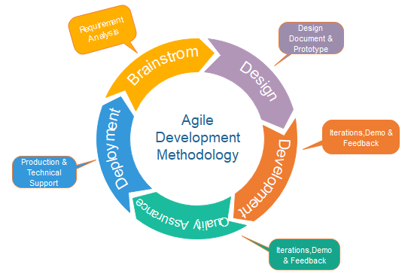

Fig.: Agile Model

**Procedure**:

1. Explain the Agile process model.

Kanban is a very popular framework for development in the agile software development methodology. It provides a transparent way of visualizing the tasks and work capacity of a team. It mainly uses physical and digital boards to allow the team members to visualize the current state of the project they are working on.

Kanban originated in Toyota in the 1940s. Kanban’s meaning in Japanese is “billboards.” The Kanban board has columns and story cards. The columns are nothing, but workflow states and cards are nothing but a demonstration of the actual task a team member is performing.

## Kanban vs Scrum

The following are the differences between Kanban and Scrum board:

| **Kanban** | **Scrum** |
| --- | --- |
| Kanban is an ongoing process. | Scrum sprints have a start and stop dates |
| Kanban has no formal roles. | Role is clearly defined for each team in the scrum (product owner, development team, and scrum master). Both teams are self-organized. |
| A kanban board is used throughout the lifecycle of a project | Scrum board is cleared and recycled after each sprint. |
| This board is more flexible with regards to tasks and timing. Its task can be reprioritized, reassigned, or updated as needed. | This board has the number of tasks and a strict deadline to complete them. |

1. Mention the suitability reasons/justifications for selecting the agile process model.

Agile software development minimizes, if not eliminates, these challenges. In Agile, teams work against a set number of user stories during a time-boxed cycle. During that time, the team focuses on releasing a workable product rather than process and documentation. As such, Agile projects can release new features rapidly and more frequently than a waterfall project.

**Output:-**

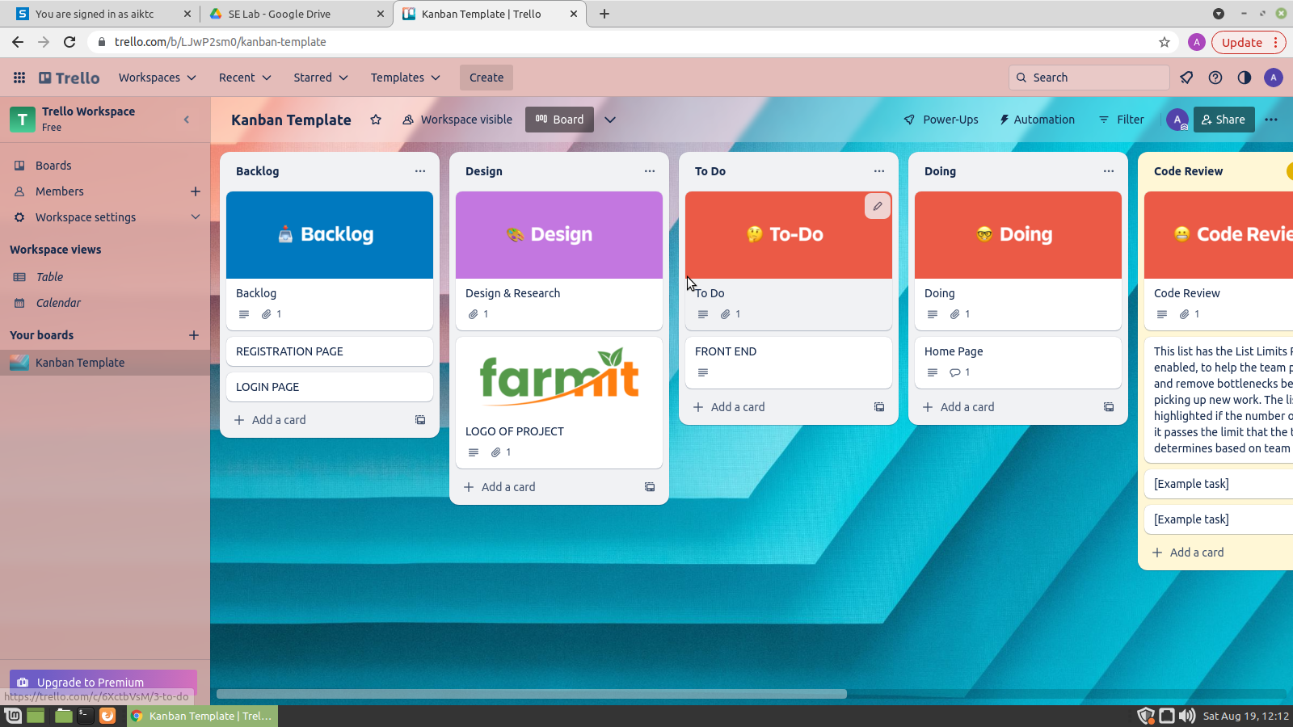

**CONCLUSION:-**

Hence , Kanban is a visual and informative framework to manage your team and optimize work processes.