**NAME:- ANAS KAPADIA   ROLL NO:- 22DCO01 BATCH:- 4**

**EXPERIMENT NO- 4 (USE CASE DIAGRAM)**

**Aim:**

To implement use case diagram for the Smart Farming

**Theory:**

Use case diagram represents the overall scenario of the system. A scenario is nothing but the sequence of steps describing an interaction between a user and a system. Thus the use case is a set of scenario tied together by some goal. To use case diagrams are drawn for exposing the view of the system. Use case diagrams contain following notations:-

1. Actor: An actor is an entity which interacts with the system. Actor carries out the use cases. A single actor may perform many use cases; a use case may have several actors. It is not necessary that the user should be an actor. The external system that gets some values or produces some value can be an actor. Actor is nothing but a role played by a person, system, device, or even an enterprise that has the state in the successful operation of the system.
2. Use cases: The use cases represent the behavior of the system. Typically functions are represented as the use cases. Use cases are represented in an oval shaped circle in which the title of function is given.
3. Association: It identifies an interaction between actors & use cases. Each association represents a dialog.
4. Include relationship: This relationship identifies a reasonable use case that is unconditionally required for execution of another use case. The decision about when and why to use the invented use case should be used is taken by extending use case itself.
5. Extend relationship: This identifies a reusable use case that conditionally interrupts the execution. Decision about when and why to use the invented use case should be used is taken by extending use case itself.
6. Generalization: This identifies an inheritance relationship between actors or between use cases.

**Procedure:**

* 1. Download and Install software tool like StarUML/Dia
  2. List down system capabilities, actors and their relationships.

There can be 5 relationship types in a use case diagram.

* Association between actor and use case
* Generalization of an actor
* Extend between two use cases
* Include between two use cases
* Generalization of a use case
  1. Develop use case diagram.

**Output:**

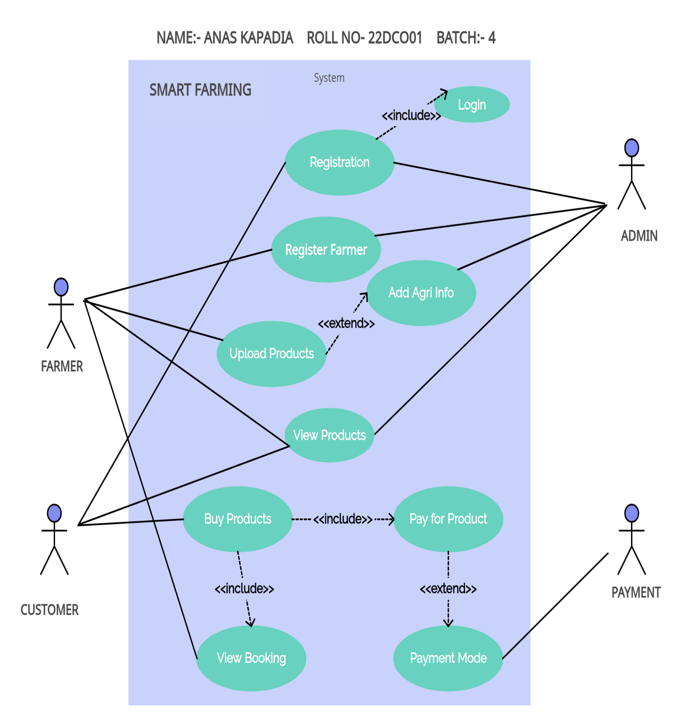

**Conclusion:**

Hence, we have made use case diagram with the help of different system, relationships and actors.