**NAME :PATEL MUSKAN KASIM SHAH.**

**ROLL NO :22DCO04**

**BATCH 01**

**PRACTICAL 05**

**AIM : CREATE DFD DIAGRAM 0,1 AND 2 FOR YOUR SELECTED TOPIC.**

**DFD 0 :**

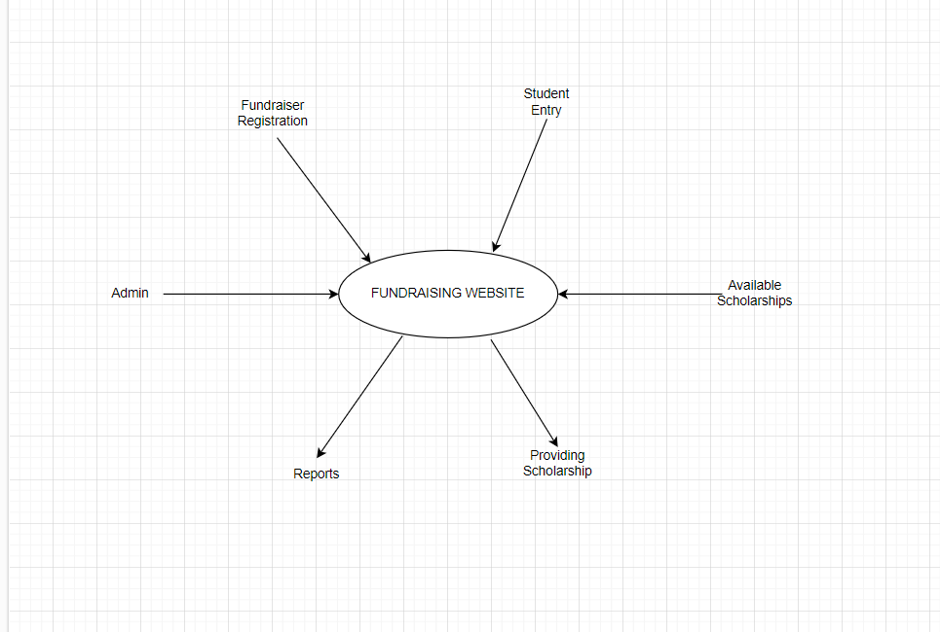

**DFD 01 :**

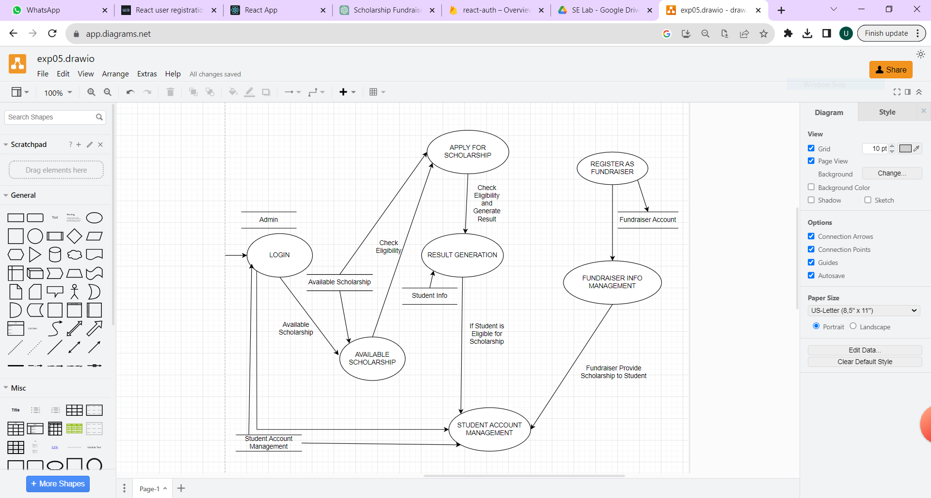

**DFD 02 :**

