**Name: soban wajuddin maruf Roll.no: 21CO58 Batch:4**

**Experiment No. 05 – Data Flow Diagram**

**Aim:**

To perform structured data flow analysis using Data Flow Diagram.

**Theory:**

Data flow diagram is a graphical representation of flow of data in an information system. It can depict incoming data flow, outgoing data flow and stored data. The DFD does not mention anything about how data flows through the system. There is a prominent difference between DFD and Flowchart. The flowchart depicts flow of control in program modules. DFDs depict flow of data in the system at various levels. DFD does not contain any control or branch elements.

**Components of DFD:**

External Entity: an outside system that sends or receives data, communicating with the system being diagrammed. They are the sources and destinations of information entering or leaving the system. They might be an outside organization or person, a computer system or a business system. They are also known as terminators, sources and sinks. They are typically drawn on the edges of the diagram. Process: any process that changes the data, producing an output. It might perform computations, or sort data based on logic, or direct the data flow based on business rules. A short label is used to describe the process, such as “Submit payment.”

**Data**: It store files or repositories that hold information for later use, such as a database table or a membership form. Each data store receives a simple label, such as “Orders.”

Data flow: the route that data takes between the external entities, processes and data stores. It portrays the interface between the other components and is shown with arrows, typically labeled with a short data name, like “Billing details.”

**DFD Rules**

* Each process should have at least one input and an output.
* Each data store should have at least one data flow in and one data flow out.
* Data stored in a system must go through a process.
* All processes in a DFD go to another process or a data store.

**DFD Levels**:

A data flow diagram can dive into progressively more detail by using levels and layers, zeroing in on a particular piece. DFD levels are numbered 0, 1 or 2, and occasionally go to even Level 3 or beyond.

Sample DFD:

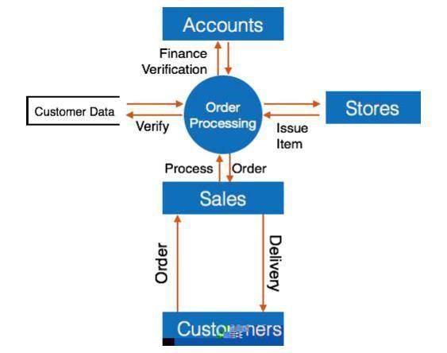

**Procedure:**

* 1. Develop Level-1 and Level-2 DFD model.

**Output:**

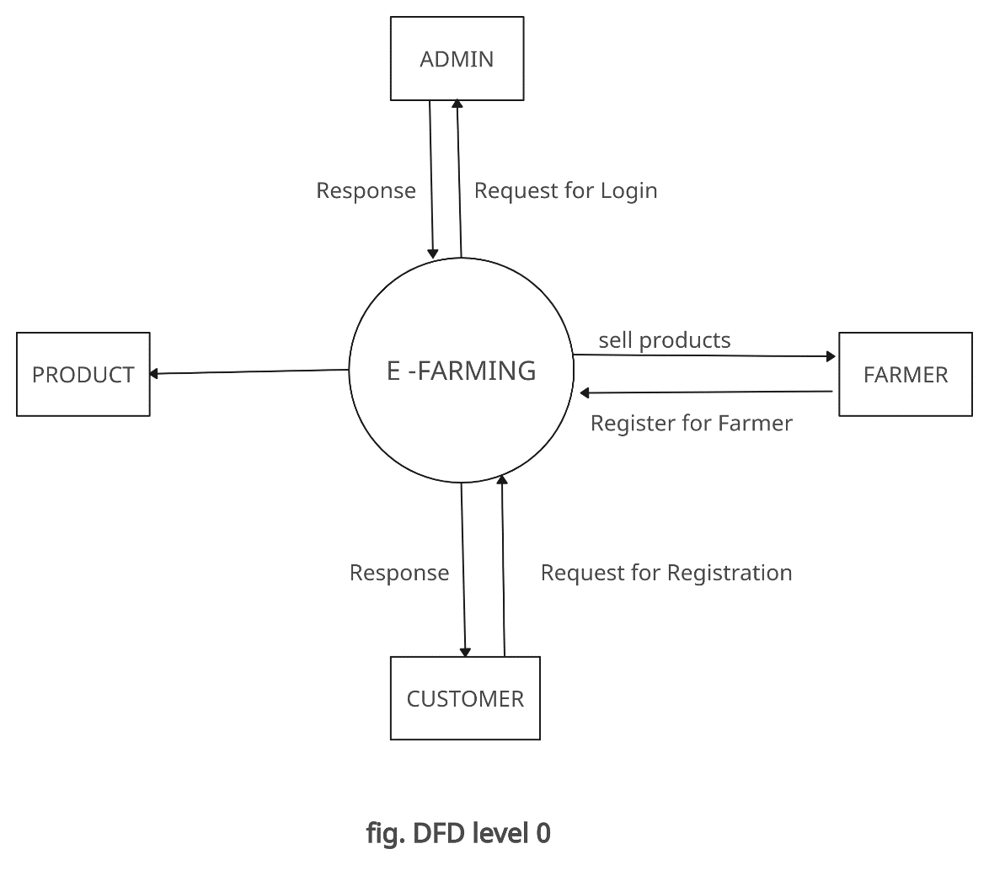

**DFD LEVEL 1**

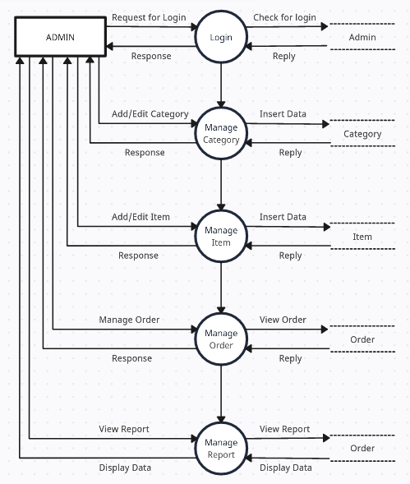

**DFD LEVEL- 2**

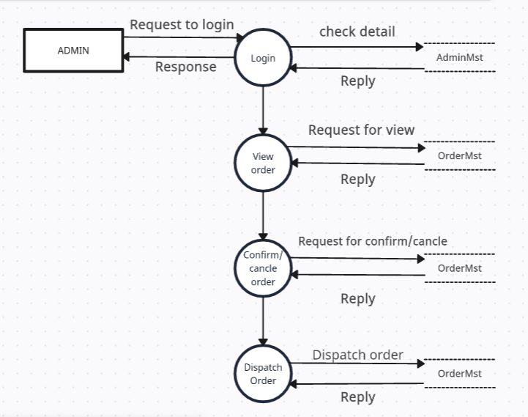

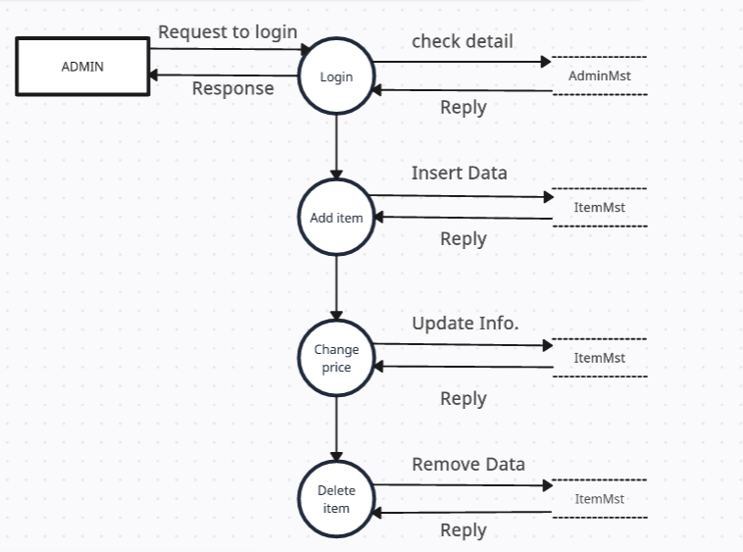

**Conclusion:**

Hence, we have created DFDs at different levels in software engineering is a fundamental practice that enhances the overall quality of the software development process. It helps in understanding, designing, and communicating the system's functionality while promoting modularity and scalability. By breaking down the system into hierarchical levels, DFDs provide a structured approach to system analysis and design, contributing to the success of software projects.