**Name: soban wajuddin maruf Roll.no: 21CO58 Batch:4**



**Experiment No. 08 - Gantt Chart**

**Aim:**

To track the project using Gantt chart

**Theory:**

Gantt project/Project Libre is an open source framework used to perform planning, scheduling and resource allocation activities.

Task creation: First, you create some tasks by using the New Task button or directly from the Tasks menu choose New Task. The tasks appear on the tree on the left pane; you can directly change their name here. Next, you can organize tasks by indenting those forming groups or categories. Tasks can also be re-organized by using the up and down functions. These functions move the selected task up or down in its hierarchy reordering it.

Relationships: Ganttproject allows you to specify a relationship between two tasks. You can set them by dragging directly on the chart. Click and hold on the first task and moving the cursor to the second task. An arrow will appear, following the mouse. Drag the arrowhead to the second task and release the mouse. The second task will be dependent on the first one.

Creating resources: A project is composed of tasks and people (or resources) who are assigned to each task. You can create resources on the Resources panel by specifying the name, the function and contact information (mail or phone by example).

Assign resources to tasks: A resource can be assigned to a task directly on the properties dialog box of the task. Select the third tabbed panel and choose the name of the resource you want to assign. Then, specify a unit for the resources

**Procedure:**

1. Download and Install Gantt Project/Project Libre software.
2. Develop Gantt chart for your project.

**Output:**

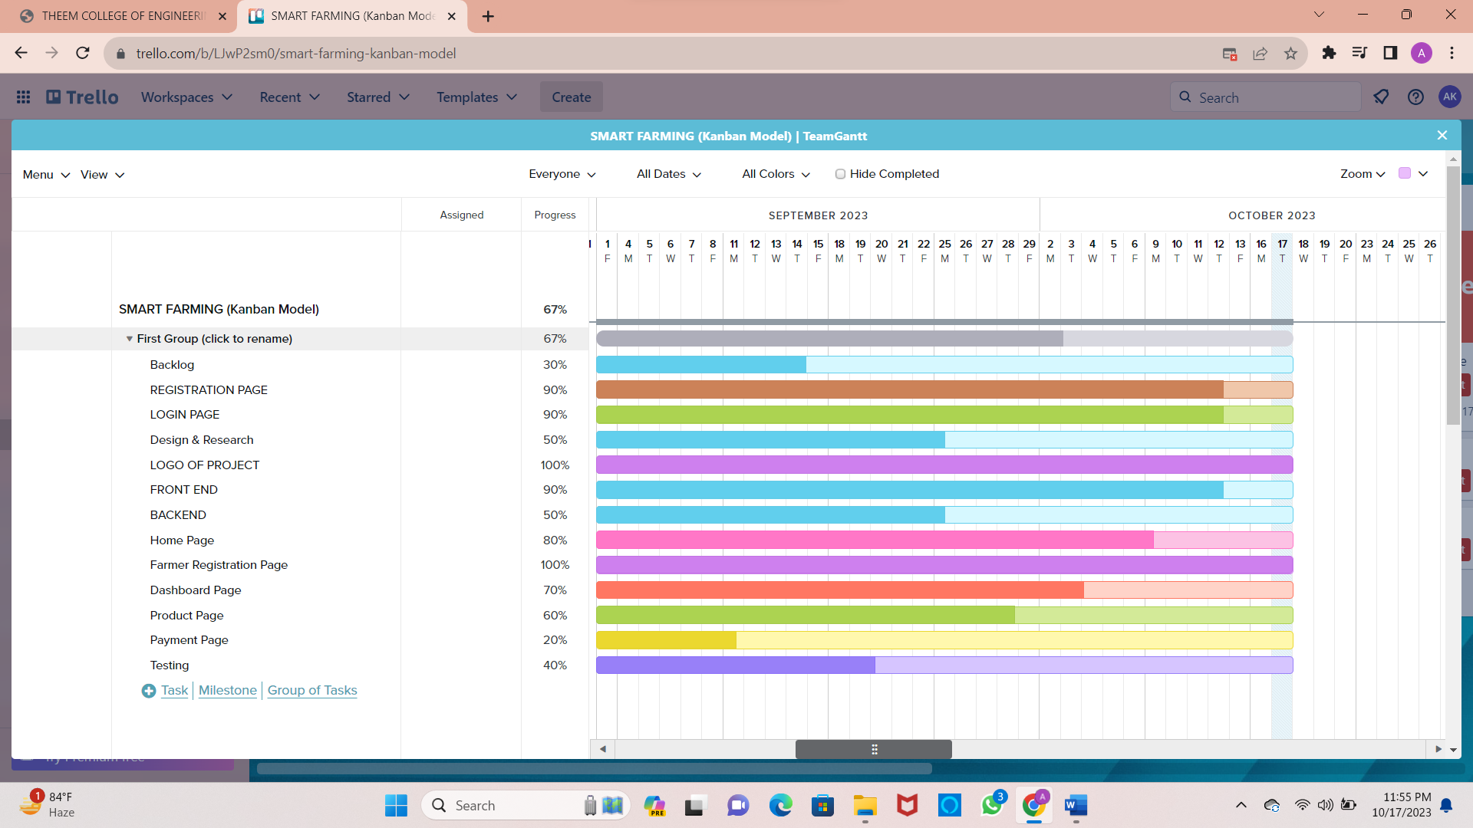

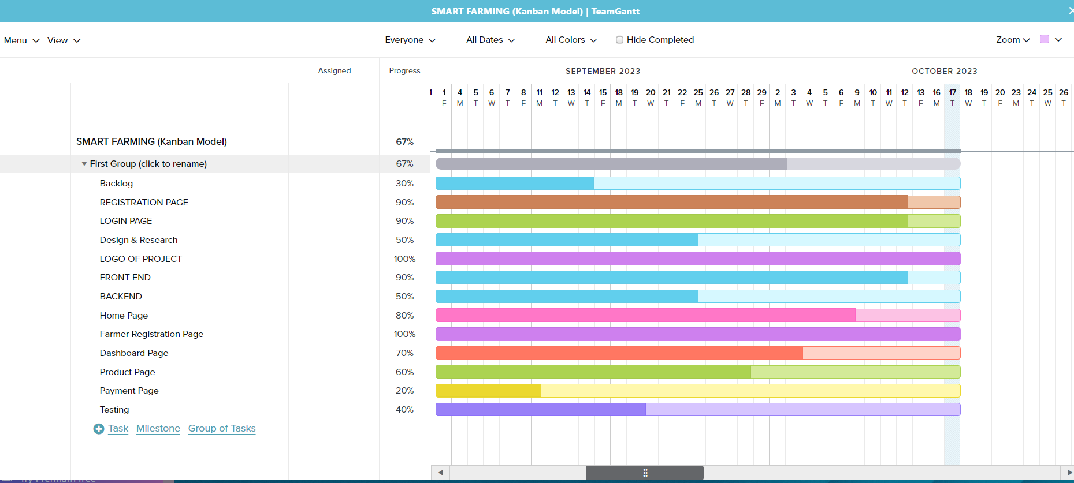

**Conclusion:**

Hence, we have created Gantt Chart using Trello of our Project.