ASSIGNMENT NO: 2
Network Lab Experiments
Name: Akif Ayube
Class: S5 CSA
Roll No: 7
Date: 08/08/2026
Experiment 1: Hello – Client/Server Communication
Aim
To implement a basic TCP client–server application in which the client connects to the server, sends the message “Hello Server”, and receives the reply “Hello Client” from the server. This experiment demonstrates the fundamental TCP socket programming lifecycle — socket creation, binding, listening, accepting connections, and exchanging data.
Commands Used
gcc server.c -o server
gcc client.c -o client
./server (run in Terminal 1)
./client (run in Terminal 2)
Procedure
Client Code
#include <stdio.h>
#include <string.h>
#include <stdlib.h>
#include <unistd.h>
#include <arpa/inet.h>
#include <sys/socket.h>
#define PORT 9001
int main() {
int sock = 0;
struct sockaddr_in serv_addr;
char buffer[1024] = {0};
char *message = "Hello Server";
// 1. Create socket
sock = socket(AF_INET, SOCK_STREAM, 0);
serv_addr.sin_family = AF_INET;
serv_addr.sin_port = htons(PORT);
inet_pton(AF_INET, "127.0.0.1", &serv_addr.sin_addr);
// 2. Connect to server
connect(sock, (struct sockaddr *)&serv_addr, sizeof(serv_addr));
printf("Connected to server.\n");
// 3. Send message to server
send(sock, message, strlen(message), 0);
printf("Message sent to server: %s\n", message);
// 4. Receive reply from server
read(sock, buffer, 1024);
printf("Reply received from server: %s\n", buffer);
close(sock);
return 0;
}
Server Code
#include <stdio.h>
#include <string.h>
#include <stdlib.h>
#include <unistd.h>
#include <arpa/inet.h>
#include <sys/socket.h>
#define PORT 9001
int main() {
int server_fd, new_socket;
struct sockaddr_in address;
int addrlen = sizeof(address);
char buffer[1024] = {0};
char *reply = "Hello Client";
// 1. Create socket
server_fd = socket(AF_INET, SOCK_STREAM, 0);
address.sin_family = AF_INET;
address.sin_addr.s_addr = INADDR_ANY;
address.sin_port = htons(PORT);
// 2. Bind socket to IP/Port
bind(server_fd, (struct sockaddr *)&address, sizeof(address));
// 3. Listen for connections
listen(server_fd, 3);
printf("Server listening on port %d...\n", PORT);
// 4. Accept incoming connection
new_socket = accept(server_fd, (struct sockaddr *)&address, (socklen_t*)&addrlen);
printf("Client connected.\n");
// 5. Receive message from client
read(new_socket, buffer, 1024);
printf("Message received from client: %s\n", buffer);
// 6. Send reply to client
send(new_socket, reply, strlen(reply), 0);
printf("Reply sent to client: %s\n", reply);
close(new_socket);
close(server_fd);
return 0;
}
Output
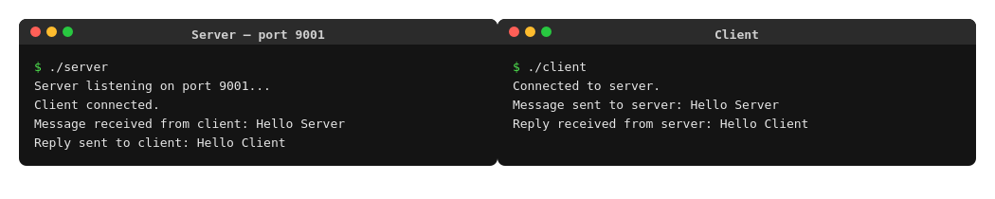
Conclusion
The client–server program was implemented successfully using TCP sockets. The client connected to the server, sent the message “Hello Server”, and received the reply “Hello Client”, confirming that a reliable two-way communication channel was established.
Experiment 2: Arithmetic Server
Aim
To implement a client–server application in which the client sends two integers to the server, and the server computes and returns their sum, difference, product, and quotient.
Commands Used
gcc server.c -o server
gcc client.c -o client
./server (run in Terminal 1)
./client (run in Terminal 2)
Procedure
Client Code
#include <stdio.h>
#include <string.h>
#include <stdlib.h>
#include <unistd.h>
#include <arpa/inet.h>
#include <sys/socket.h>
#define PORT 9002
int main() {
int sock = 0;
struct sockaddr_in serv_addr;
char buffer[1024] = {0};
int nums[2];
printf("Enter first integer: ");
scanf("%d", &nums[0]);
printf("Enter second integer: ");
scanf("%d", &nums[1]);
sock = socket(AF_INET, SOCK_STREAM, 0);
serv_addr.sin_family = AF_INET;
serv_addr.sin_port = htons(PORT);
inet_pton(AF_INET, "127.0.0.1", &serv_addr.sin_addr);
connect(sock, (struct sockaddr *)&serv_addr, sizeof(serv_addr));
printf("Connected to server.\n");
// Send both integers to server
send(sock, nums, sizeof(nums), 0);
printf("Numbers sent to server.\n");
// Receive results from server
read(sock, buffer, 1024);
printf("Results received from server: %s\n", buffer);
close(sock);
return 0;
}
Server Code
#include <stdio.h>
#include <string.h>
#include <stdlib.h>
#include <unistd.h>
#include <arpa/inet.h>
#include <sys/socket.h>
#define PORT 9002
int main() {
int server_fd, new_socket;
struct sockaddr_in address;
int addrlen = sizeof(address);
int nums[2];
char result[256];
server_fd = socket(AF_INET, SOCK_STREAM, 0);
address.sin_family = AF_INET;
address.sin_addr.s_addr = INADDR_ANY;
address.sin_port = htons(PORT);
bind(server_fd, (struct sockaddr *)&address, sizeof(address));
listen(server_fd, 3);
printf("Server listening on port %d...\n", PORT);
new_socket = accept(server_fd, (struct sockaddr *)&address, (socklen_t*)&addrlen);
printf("Client connected.\n");
// Receive two integers from client
read(new_socket, nums, sizeof(nums));
int a = nums[0], b = nums[1];
printf("Received numbers: a = %d, b = %d\n", a, b);
int sum = a + b;
int diff = a - b;
int prod = a * b;
float div = b != 0 ? (float)a / b : 0;
printf("Addition = %d\n", sum);
printf("Subtraction = %d\n", diff);
printf("Multiplication = %d\n", prod);
if (b != 0)
printf("Division = %.2f\n", div);
else
printf("Division = undefined (divide by zero)\n");
snprintf(result, sizeof(result),
"Addition=%d Subtraction=%d Multiplication=%d Division=%.2f",
sum, diff, prod, div);
send(new_socket, result, strlen(result), 0);
printf("Results sent to client.\n");
close(new_socket);
close(server_fd);
return 0;
}
Output
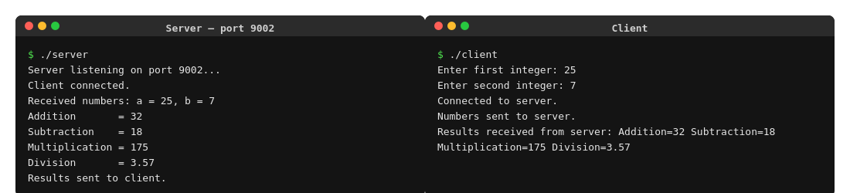
Conclusion
The arithmetic server was successfully implemented. For the input values 25 and 7, the server correctly computed Addition = 32, Subtraction = 18, Multiplication = 175, and Division = 3.57, and returned the results to the client over the socket connection.
Experiment 3: String Processing Server
Aim
To implement a client–server application in which the client sends a string to the server, and the server computes the length of the string, converts it to uppercase, and reverses it, then returns the results to the client.
Commands Used
gcc server.c -o server
gcc client.c -o client
./server (run in Terminal 1)
./client (run in Terminal 2)
Procedure
Client Code
#include <stdio.h>
#include <string.h>
#include <stdlib.h>
#include <unistd.h>
#include <arpa/inet.h>
#include <sys/socket.h>
#define PORT 9003
int main() {
int sock = 0;
struct sockaddr_in serv_addr;
char buffer[1024] = {0};
char str[256];
printf("Enter a string: ");
fgets(str, sizeof(str), stdin);
str[strcspn(str, "\n")] = '\0'; // remove trailing newline
sock = socket(AF_INET, SOCK_STREAM, 0);
serv_addr.sin_family = AF_INET;
serv_addr.sin_port = htons(PORT);
inet_pton(AF_INET, "127.0.0.1", &serv_addr.sin_addr);
connect(sock, (struct sockaddr *)&serv_addr, sizeof(serv_addr));
printf("Connected to server.\n");
// Send string to server
send(sock, str, strlen(str) + 1, 0);
printf("String sent to server.\n");
// Receive processed results from server
read(sock, buffer, 1024);
printf("Results received from server: %s\n", buffer);
close(sock);
return 0;
}
Server Code
#include <stdio.h>
#include <string.h>
#include <stdlib.h>
#include <ctype.h>
#include <unistd.h>
#include <arpa/inet.h>
#include <sys/socket.h>
#define PORT 9003
int main() {
int server_fd, new_socket;
struct sockaddr_in address;
int addrlen = sizeof(address);
char str[256];
char upper[256];
char rev[256];
char result[1024];
server_fd = socket(AF_INET, SOCK_STREAM, 0);
address.sin_family = AF_INET;
address.sin_addr.s_addr = INADDR_ANY;
address.sin_port = htons(PORT);
bind(server_fd, (struct sockaddr *)&address, sizeof(address));
listen(server_fd, 3);
printf("Server listening on port %d...\n", PORT);
new_socket = accept(server_fd, (struct sockaddr *)&address, (socklen_t*)&addrlen);
printf("Client connected.\n");
// Receive string from client
memset(str, 0, sizeof(str));
read(new_socket, str, sizeof(str));
printf("Received string: %s\n", str);
int len = strlen(str);
// Convert to uppercase
for (int i = 0; i <= len; i++)
upper[i] = toupper(str[i]);
// Reverse string
for (int i = 0; i < len; i++)
rev[i] = str[len - 1 - i];
rev[len] = '\0';
printf("Length = %d\n", len);
printf("Uppercase = %s\n", upper);
printf("Reversed = %s\n", rev);
snprintf(result, sizeof(result), "Length=%d Uppercase=%s Reversed=%s",
len, upper, rev);
send(new_socket, result, strlen(result), 0);
printf("Results sent to client.\n");
close(new_socket);
close(server_fd);
return 0;
}
Output
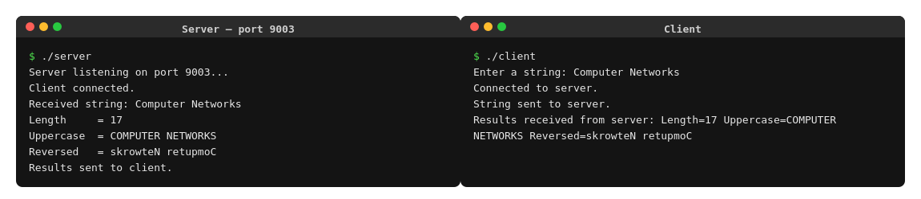
Conclusion
The string processing server was implemented and tested with the input “Computer Networks”. The server correctly returned Length = 17, Uppercase = COMPUTER NETWORKS, and Reversed = skrowteN retupmoC, demonstrating successful string manipulation over a socket connection.
Experiment 4: Array Processing Server
Aim
To implement a client–server application in which the client sends an array of N integers to the server, and the server computes the sum, average, maximum, and minimum of the array elements.
Commands Used
gcc server.c -o server
gcc client.c -o client
./server (run in Terminal 1)
./client (run in Terminal 2)
Procedure
Client Code
#include <stdio.h>
#include <string.h>
#include <stdlib.h>
#include <unistd.h>
#include <arpa/inet.h>
#include <sys/socket.h>
#define PORT 9004
int main() {
int sock = 0;
struct sockaddr_in serv_addr;
char buffer[1024] = {0};
int n;
int arr[100];
printf("Enter number of elements (N): ");
scanf("%d", &n);
printf("Enter %d integers:\n", n);
for (int i = 0; i < n; i++)
scanf("%d", &arr[i]);
sock = socket(AF_INET, SOCK_STREAM, 0);
serv_addr.sin_family = AF_INET;
serv_addr.sin_port = htons(PORT);
inet_pton(AF_INET, "127.0.0.1", &serv_addr.sin_addr);
connect(sock, (struct sockaddr *)&serv_addr, sizeof(serv_addr));
printf("Connected to server.\n");
// Send N followed by the array
send(sock, &n, sizeof(int), 0);
send(sock, arr, n * sizeof(int), 0);
printf("Array sent to server.\n");
// Receive results from server
read(sock, buffer, 1024);
printf("Results received from server: %s\n", buffer);
close(sock);
return 0;
}
Server Code
#include <stdio.h>
#include <string.h>
#include <stdlib.h>
#include <unistd.h>
#include <arpa/inet.h>
#include <sys/socket.h>
#define PORT 9004
int main() {
int server_fd, new_socket;
struct sockaddr_in address;
int addrlen = sizeof(address);
int n;
int arr[100];
char result[512];
server_fd = socket(AF_INET, SOCK_STREAM, 0);
address.sin_family = AF_INET;
address.sin_addr.s_addr = INADDR_ANY;
address.sin_port = htons(PORT);
bind(server_fd, (struct sockaddr *)&address, sizeof(address));
listen(server_fd, 3);
printf("Server listening on port %d...\n", PORT);
new_socket = accept(server_fd, (struct sockaddr *)&address, (socklen_t*)&addrlen);
printf("Client connected.\n");
// Receive N
read(new_socket, &n, sizeof(int));
// Receive array of N integers
read(new_socket, arr, n * sizeof(int));
printf("Received array of %d elements: ", n);
for (int i = 0; i < n; i++) printf("%d ", arr[i]);
printf("\n");
int sum = 0, maxVal = arr[0], minVal = arr[0];
for (int i = 0; i < n; i++) {
sum += arr[i];
if (arr[i] > maxVal) maxVal = arr[i];
if (arr[i] < minVal) minVal = arr[i];
}
float avg = (float)sum / n;
printf("Sum = %d\n", sum);
printf("Average = %.2f\n", avg);
printf("Maximum = %d\n", maxVal);
printf("Minimum = %d\n", minVal);
snprintf(result, sizeof(result), "Sum=%d Average=%.2f Maximum=%d Minimum=%d",
sum, avg, maxVal, minVal);
send(new_socket, result, strlen(result), 0);
printf("Results sent to client.\n");
close(new_socket);
close(server_fd);
return 0;
}
Output
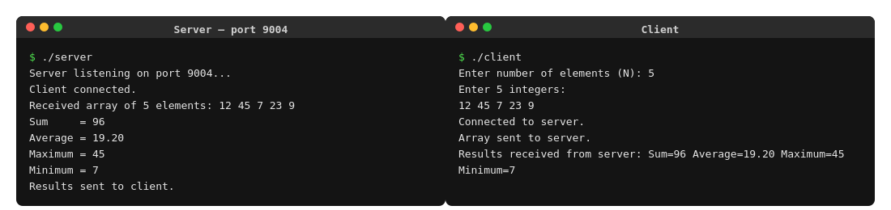
Conclusion
The array processing server was successfully implemented and tested with the array {12, 45, 7, 23, 9}. The server correctly computed Sum = 96, Average = 19.20, Maximum = 45, and Minimum = 7, verifying correct array handling over the client–server model.
Experiment 5: Matrix Analyzer
Aim
To implement a client–server application in which the client sends a square matrix to the server, and the server determines the type of matrix (diagonal, upper triangular, lower triangular, or general), and computes the sum of its elements and its trace.
Commands Used
gcc server.c -o server
gcc client.c -o client
./server (run in Terminal 1)
./client (run in Terminal 2)
Procedure
Client Code
#include <stdio.h>
#include <string.h>
#include <stdlib.h>
#include <unistd.h>
#include <arpa/inet.h>
#include <sys/socket.h>
#define PORT 9005
#define MAXN 20
int main() {
int sock = 0;
struct sockaddr_in serv_addr;
char buffer[1024] = {0};
int n;
int mat[MAXN * MAXN]; // flat array, indexed as mat[i*n + j]
printf("Enter order of square matrix (N): ");
scanf("%d", &n);
printf("Enter %d x %d matrix elements:\n", n, n);
for (int i = 0; i < n; i++)
for (int j = 0; j < n; j++)
scanf("%d", &mat[i * n + j]);
sock = socket(AF_INET, SOCK_STREAM, 0);
serv_addr.sin_family = AF_INET;
serv_addr.sin_port = htons(PORT);
inet_pton(AF_INET, "127.0.0.1", &serv_addr.sin_addr);
connect(sock, (struct sockaddr *)&serv_addr, sizeof(serv_addr));
printf("Connected to server.\n");
// Send N followed by the matrix
send(sock, &n, sizeof(int), 0);
send(sock, mat, n * n * sizeof(int), 0);
printf("Matrix sent to server.\n");
// Receive results from server
read(sock, buffer, 1024);
printf("Results received from server: %s\n", buffer);
close(sock);
return 0;
}
Server Code
#include <stdio.h>
#include <string.h>
#include <stdlib.h>
#include <unistd.h>
#include <arpa/inet.h>
#include <sys/socket.h>
#define PORT 9005
#define MAXN 20
int main() {
int server_fd, new_socket;
struct sockaddr_in address;
int addrlen = sizeof(address);
int n;
int mat[MAXN * MAXN]; // flat array, indexed as mat[i*n + j]
char result[512];
char type[50];
server_fd = socket(AF_INET, SOCK_STREAM, 0);
int opt = 1;
setsockopt(server_fd, SOL_SOCKET, SO_REUSEADDR, &opt, sizeof(opt));
address.sin_family = AF_INET;
address.sin_addr.s_addr = INADDR_ANY;
address.sin_port = htons(PORT);
if (bind(server_fd, (struct sockaddr *)&address, sizeof(address)) < 0) {
perror("bind failed");
exit(EXIT_FAILURE);
}
listen(server_fd, 3);
printf("Server listening on port %d...\n", PORT);
fflush(stdout);
new_socket = accept(server_fd, (struct sockaddr *)&address, (socklen_t*)&addrlen);
printf("Client connected.\n");
// Receive N
read(new_socket, &n, sizeof(int));
// Receive N*N matrix elements (row-major, contiguous)
read(new_socket, mat, n * n * sizeof(int));
printf("Received %dx%d matrix:\n", n, n);
for (int i = 0; i < n; i++) {
for (int j = 0; j < n; j++)
printf("%4d", mat[i * n + j]);
printf("\n");
}
int sum = 0, trace = 0;
int isDiagonal = 1, isUpper = 1, isLower = 1;
for (int i = 0; i < n; i++) {
for (int j = 0; j < n; j++) {
int val = mat[i * n + j];
sum += val;
if (i == j) trace += val;
if (i != j && val != 0) {
isDiagonal = 0;
if (i > j) isUpper = 0; // element below diagonal is non-zero
if (i < j) isLower = 0; // element above diagonal is non-zero
}
}
}
if (isDiagonal)
strcpy(type, "Diagonal Matrix");
else if (isUpper)
strcpy(type, "Upper Triangular Matrix");
else if (isLower)
strcpy(type, "Lower Triangular Matrix");
else
strcpy(type, "General Matrix");
printf("Matrix Type = %s\n", type);
printf("Sum of Elements = %d\n", sum);
printf("Trace = %d\n", trace);
snprintf(result, sizeof(result), "MatrixType=%s Sum=%d Trace=%d",
type, sum, trace);
send(new_socket, result, strlen(result), 0);
printf("Results sent to client.\n");
close(new_socket);
close(server_fd);
return 0;
}
Output
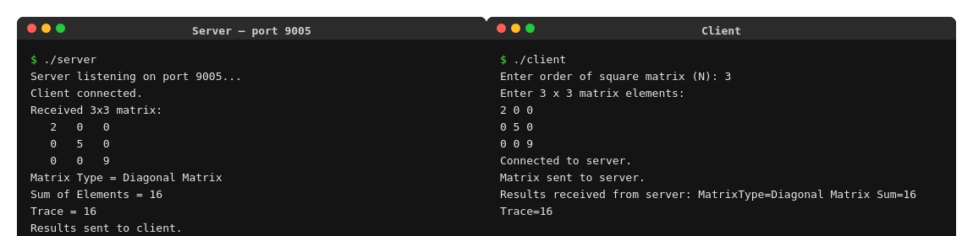
Conclusion
The matrix analyzer server was successfully implemented and tested with a 3x3 diagonal matrix. The server correctly identified the matrix type as “Diagonal Matrix”, and computed Sum of Elements = 16 and Trace = 16, confirming correct matrix analysis over the socket connection.

