

SCHOOL OF COMPUTING AND INFORMATIC
BACHELOR OF SCIENCE IN INFORMATION TECHNOLOGY
UNITE TITLE: ADVANCED WEB DESIGN AND DEVELOPMENT
UNITE CODE: BIT3208
PROJECT TITLE: MOONLIGHT ENTERPRISES
SUBMITTED BY: AYUB HUSSEIN
REG. NO: BSCCS/2024/56898
SUPERVISOR: MR. MICHAEL NYORO

- Database Creation

A MySQL database was created to store system information permanently.

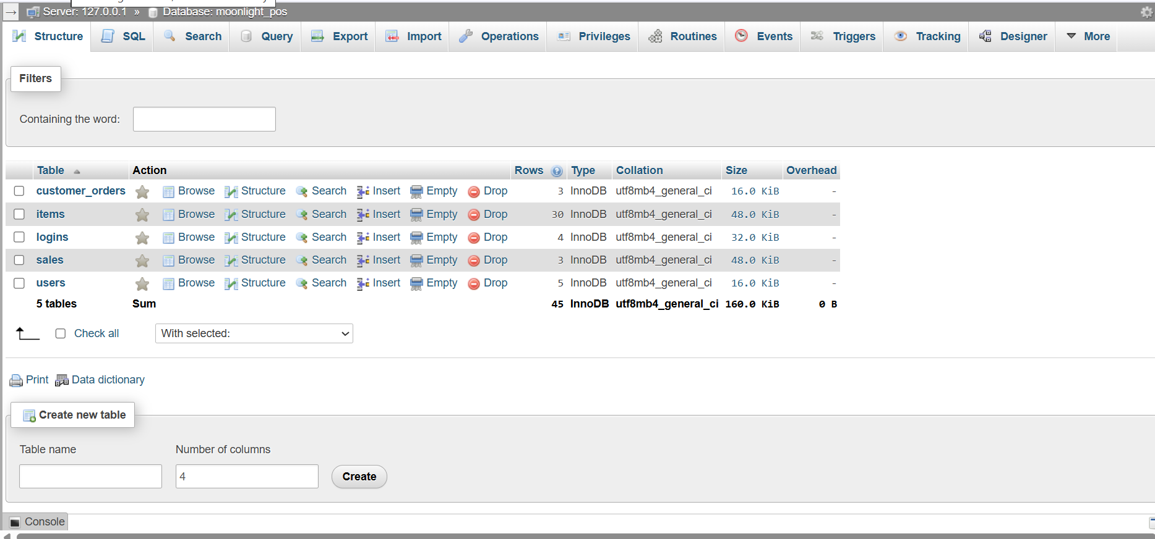
Figure 1:Database Creation
Reflection:
I understood how databases store and organize system data.

Database Connection
PHP was connected to MySQL to allow communication between the system and the database.
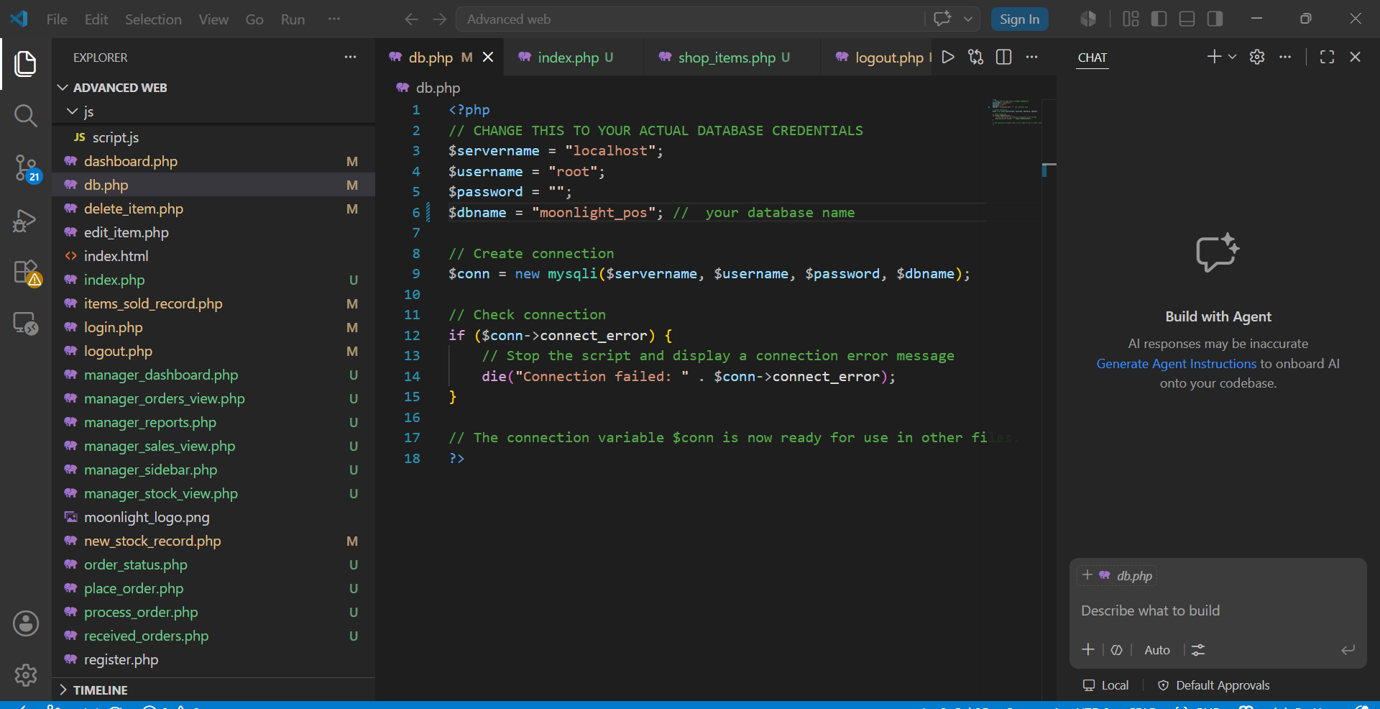
Figure 2:DATABASE CONNECTION
Reflection:
I understood how PHP communicates with MySQL to retrieve and store data.

- CRUD OPERATIONS
The system implements CRUD operations:
- Create -add new products.
- Read -view inventory records.
- Update -edit product information.
- Delete -remove unwanted records.

Add Item
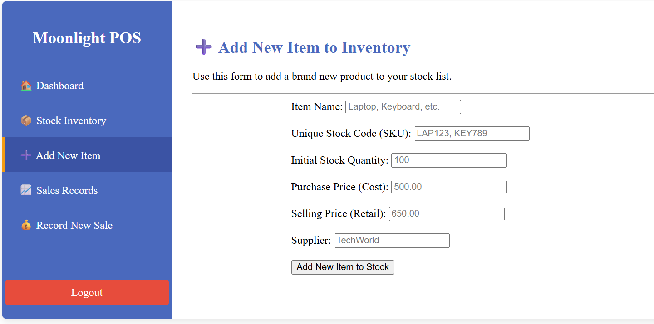
Figure 3:ADD ITEM
Reflection:
I understood how user input can be saved into the database.
READ
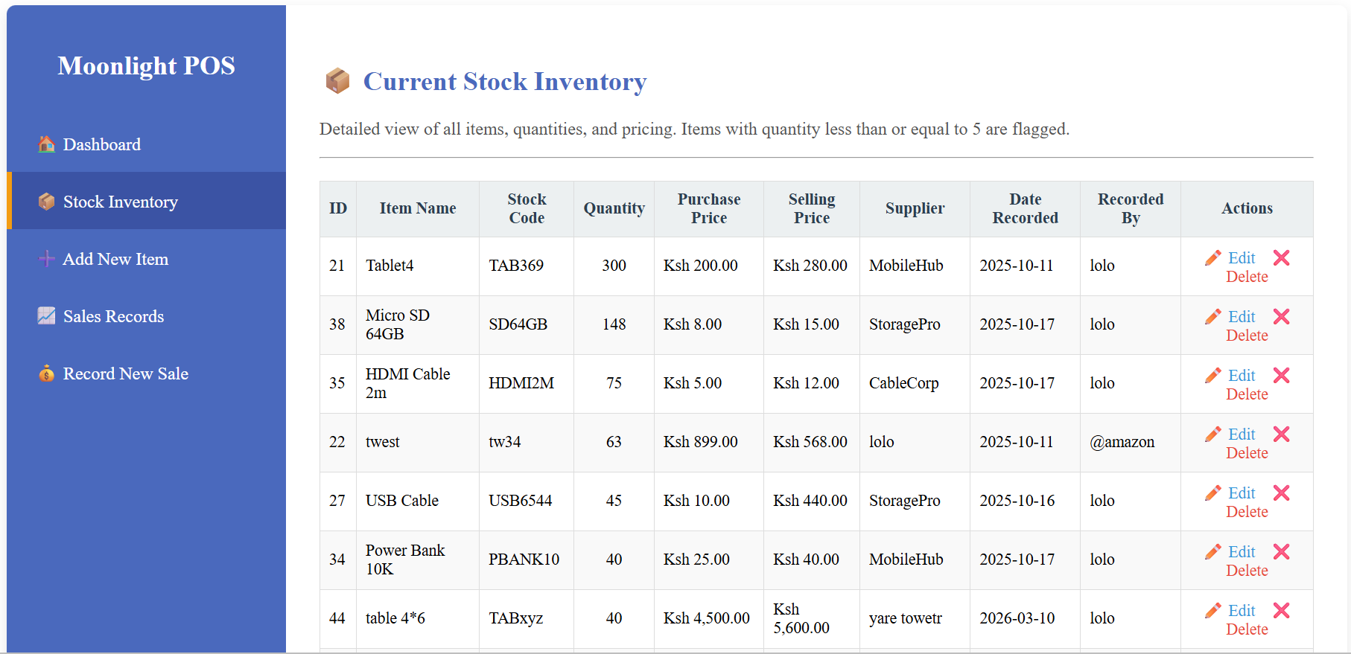
Reflection:
I understood how data can be retrieved and displayed to users.

Delete function
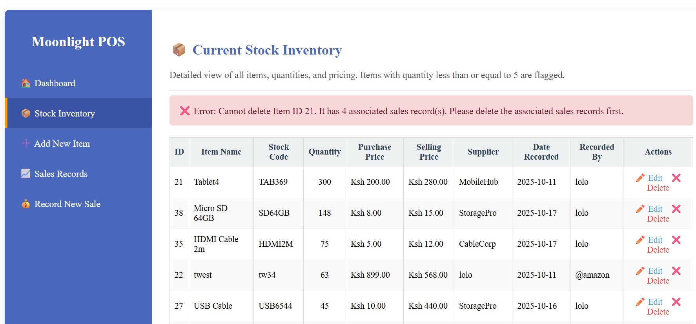
Figure 4:DELETE FUNCTION
Reflection:
I understood how records can be removed from the system when no longer needed.

Update
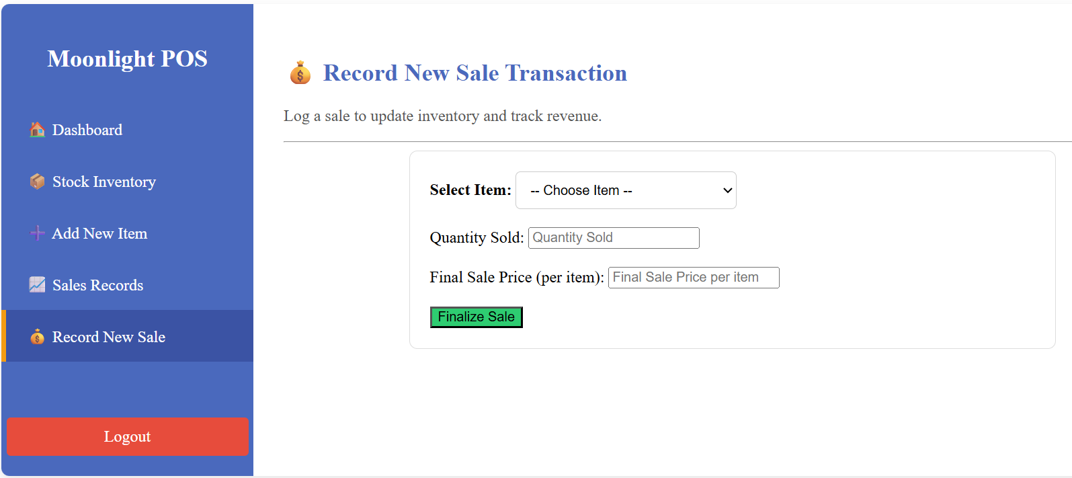
Figure 5:UPDATE
Reflection:
I understood how existing information can be changed without creating a new record.

- SALES MANAGEMENT
Record New Sale
The sales module allows users to record complete sales transactions into the system database.

Figure 6:Record New Sale
Sales Records
The system displays transaction history including quantity sold, sale amount, date and salesperson information.
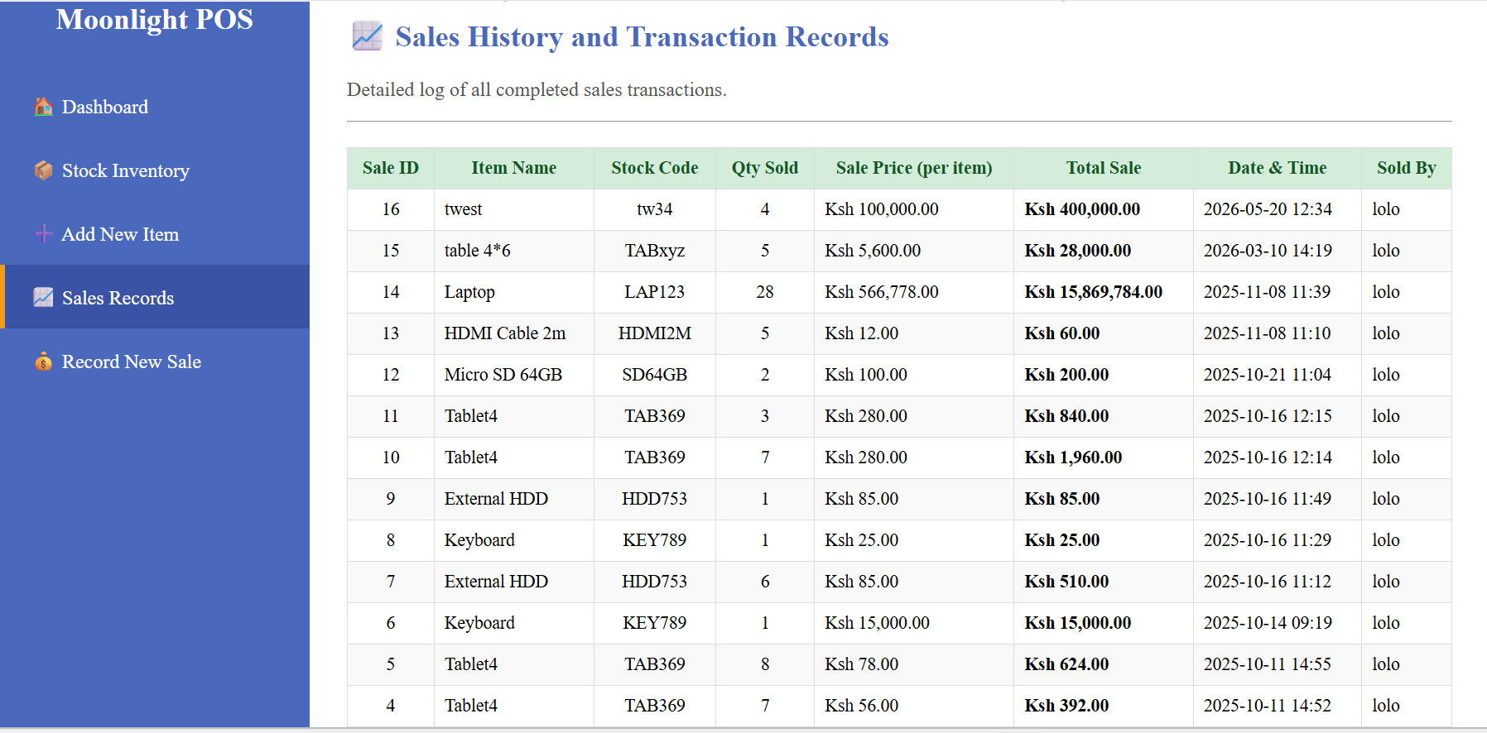
Figure 7:Sales Records

Conclusion
Week 6 helped me understand database integration and CRUD operations. I learned how to connect PHP with MySQL and how to create, read, update, and delete records within a web application. These operations formed the foundation for developing the Moonlight POS Inventory Management System.

