

SCHOOL OF COMPUTING AND INFORMATIC
BACHELOR OF SCIENCE IN INFORMATION TECHNOLOGY
UNITE TITLE: ADVANCED WEB DESIGN AND DEVELOPMENT
UNITE CODE: BIT3208
PROJECT TITLE: MOONLIGHT ENTERPRISES
SUBMITTED BY: AYUB HUSSEIN
REG. NO: BSCCS/2024/56898
SUPERVISOR: MR. MICHAEL NYORO

Week 7: User Authentication and Session Management
- Authentication

Authentication verifies a user's identity before granting access to the system.

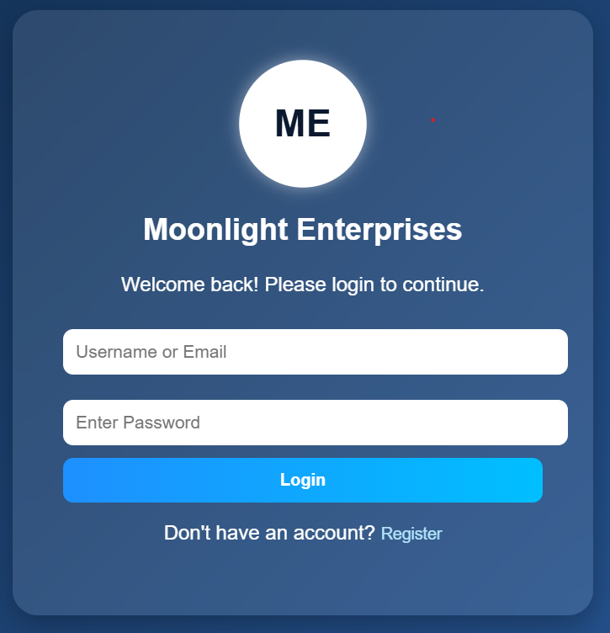
Figure 1:Authentication

Reflection:

I understood that authentication ensures only authorized users can access the system.
- Password Hashing
Password hashing was implemented to secure user passwords before storing them in the database.
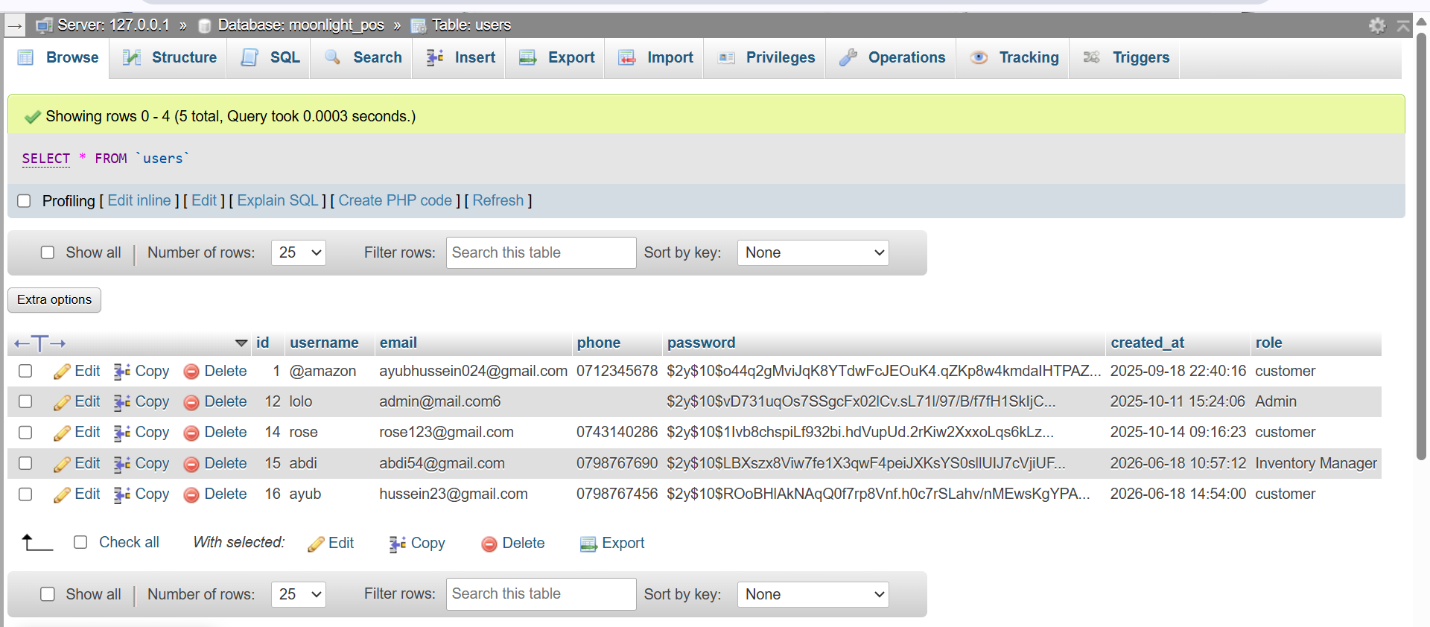
Figure 2:Password Hashing
Reflection:
I understood that password hashing improves security by protecting user passwords from unauthorized access.
- Session Management
Session management was implemented to keep users logged in while they navigate through the system.
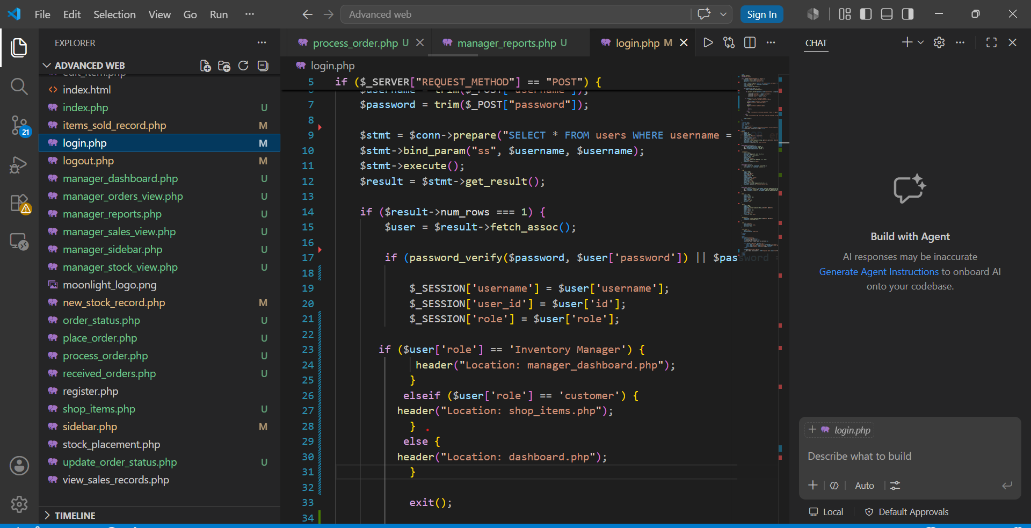
Figure 3:Session Management
Reflection:
I understood that sessions help the system remember users after login without requiring them to enter their credentials repeatedly.
- Customer Authentication and Access

Customers must sign in before accessing the shopping system.

Functions Available:
- View products

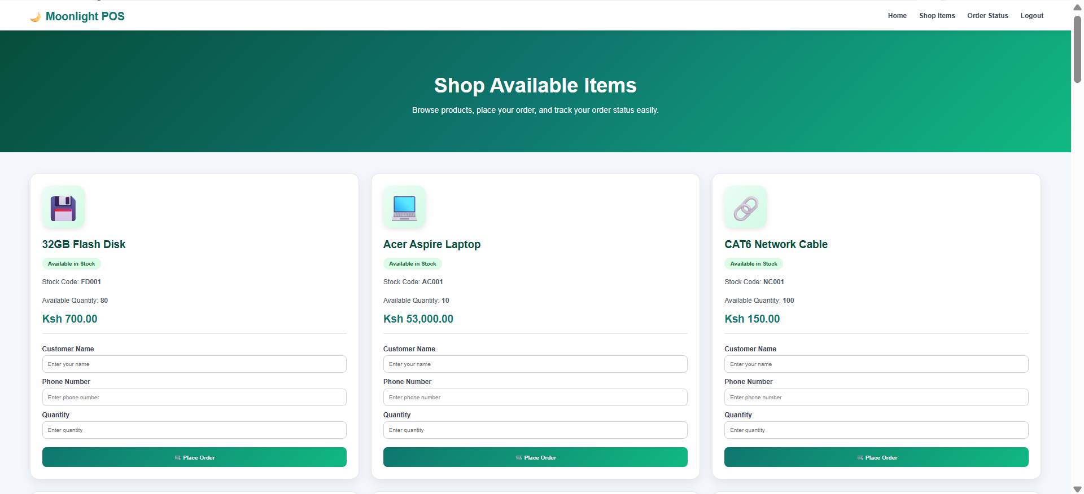
Figure 4:View products

- Place orders

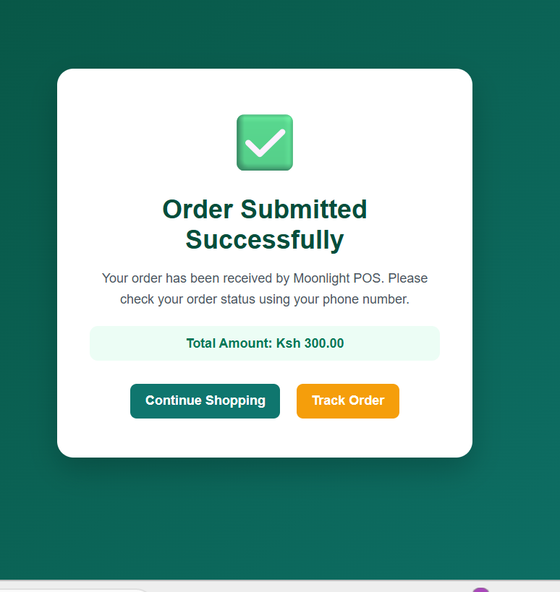
Figure 5:Place orders

- Check order status

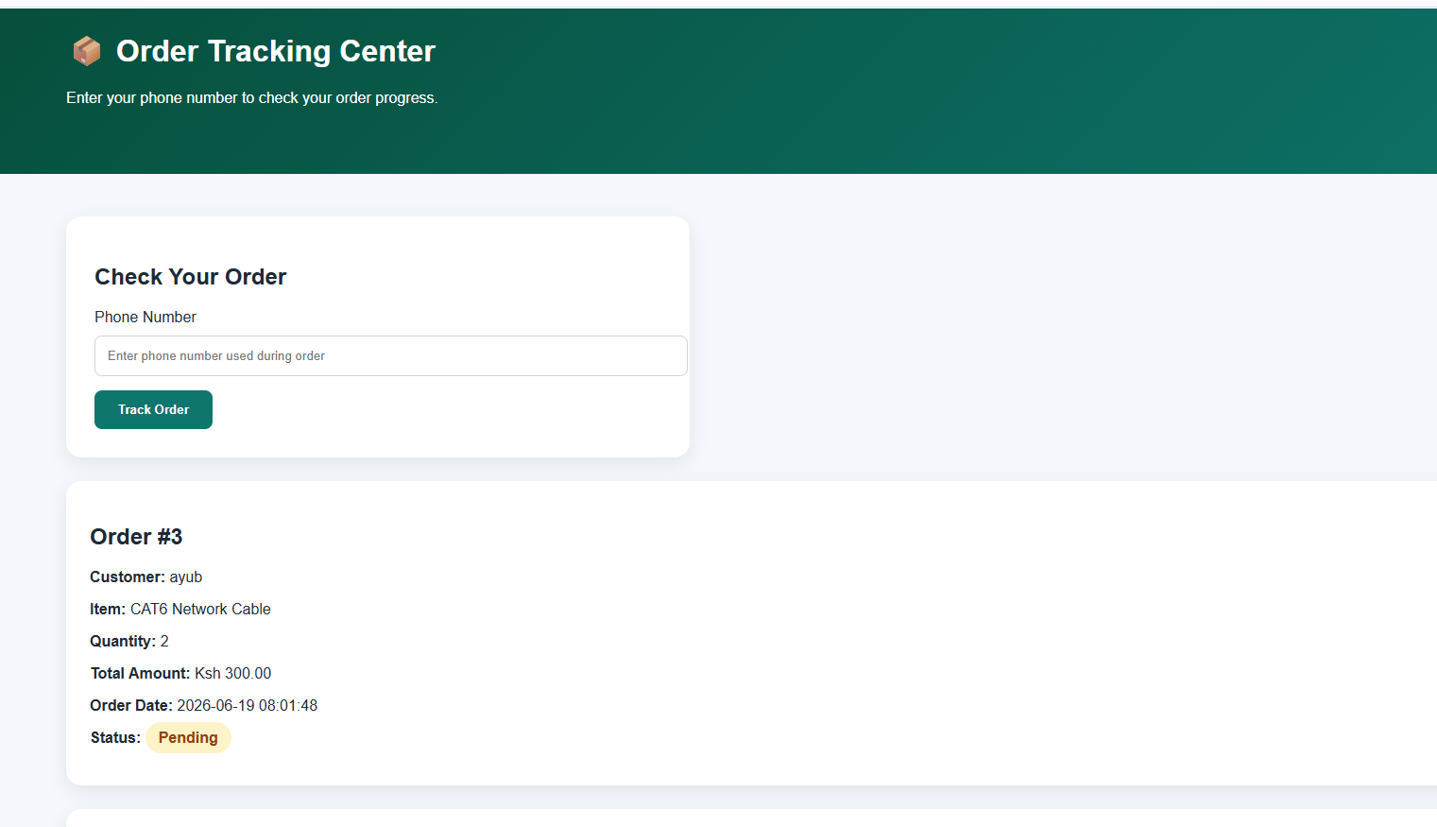
Figure 6:Check order status

- Logout

Reflection:

I understood that authentication helps identify customers and restrict access to authorized users only.
- Inventory Manager Authentication and Access

Inventory Managers sign in using their credentials and are redirected to the Manager Dashboard.

By use of this name as the manager: abdi-(ayub1) as the password

Functions Available:
- View stock inventory
- View sales records
- View customer orders
- View reports and analytics
- Logout

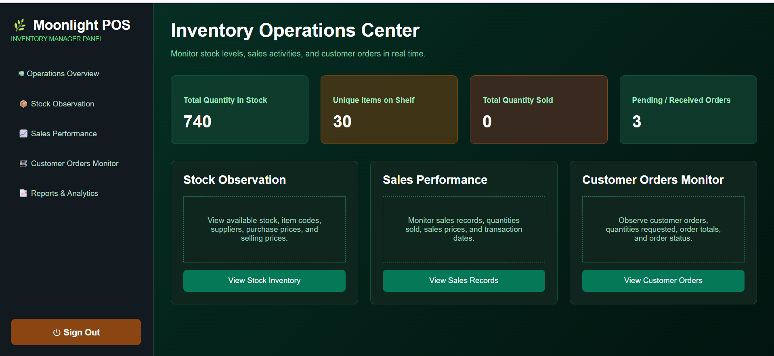
Figure 7:Inventory Manager Authentication and Access

REPORTS AND ANALYSIS

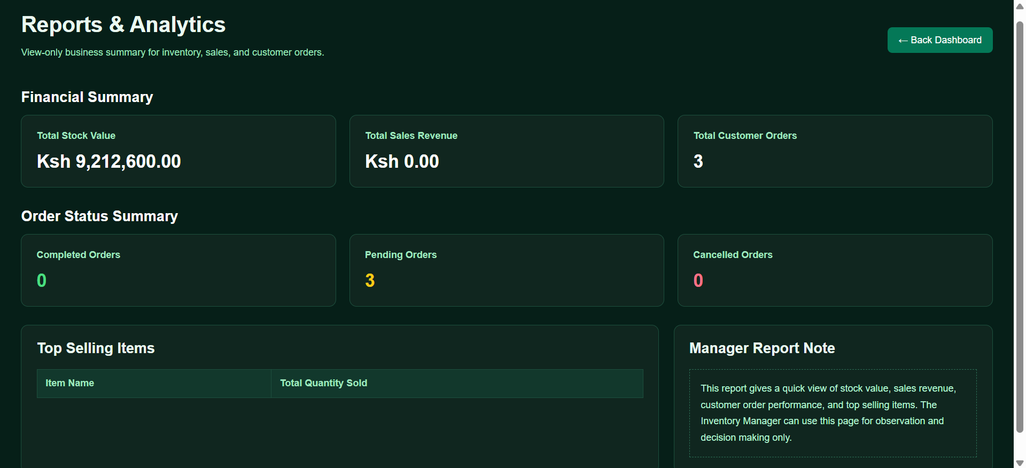
Figure 8:REPORTS AND ANALYSIS

Reflection:

I understood that role-based access allows managers to monitor business activities without modifying records.
- Administrator Authentication and Access

Administrators sign in using their credentials and are redirected to the Admin Dashboard.

By use of this name as the Admin: lolo-(12345) as the password.

Functions Available:
- Add items
- Edit items
- Delete items
- Manage customer orders
- Record sales
- View reports
- Manage inventory
- Logout

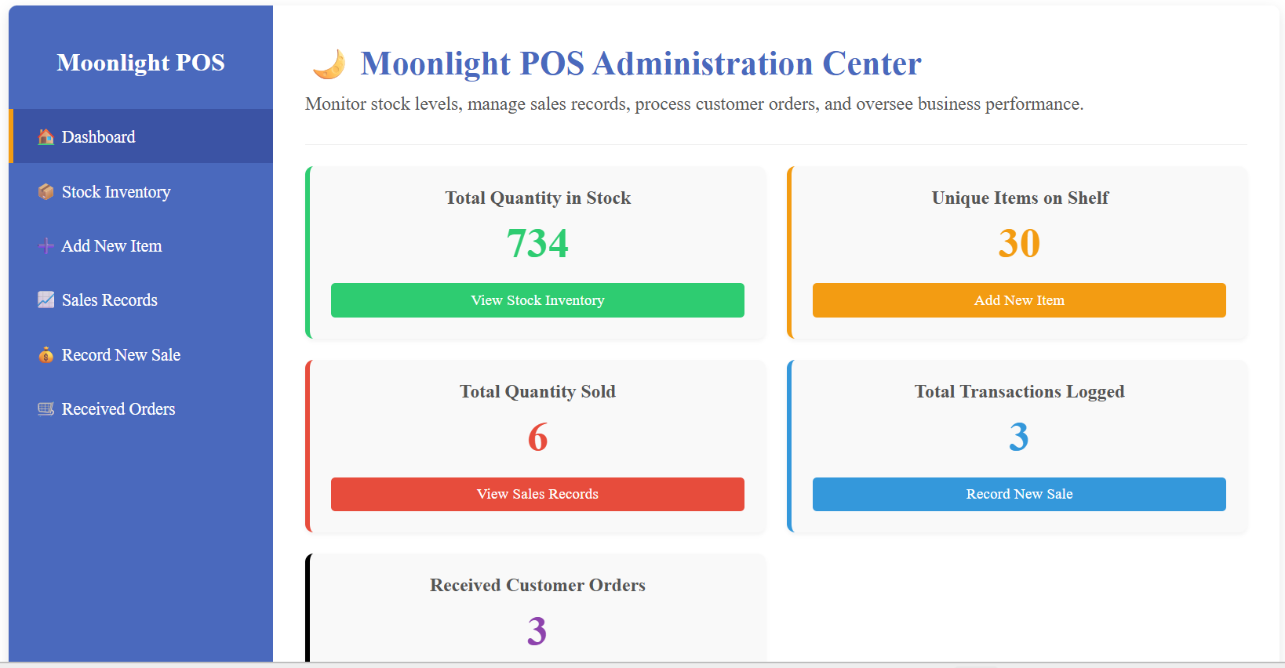
Figure 9:Administrator Authentication and Access

CONTAIN RECEIVED ORDERS

Customer orders are saved in the database and automatically displayed on the administrator's Received Orders page for monitoring and processing.

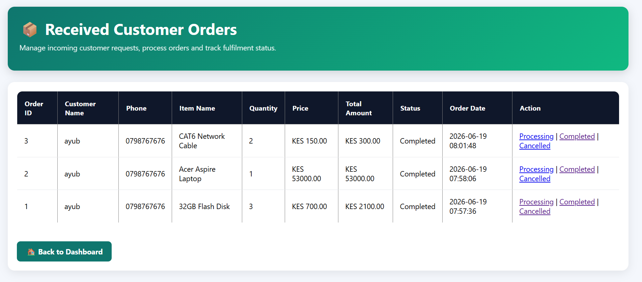
Figure 10:CONTAIN RECEIVED ORDERS

Reflection:

I understood that administrators have full system control and can manage all business operations.

Role-Based Access Control
Role-based access control was implemented to provide different permissions for administrators and inventory managers.
- Admin Dashboard
- Inventory Manager Dashboard
- phpMyAdmin users table showing roles
Reflection:
I understood that different users can be assigned different permissions depending on their responsibilities within the system.
CONCLUSION
Week 7 focused on authentication and session management. I learned how to secure the system using password hashing, sessions, protected dashboards, role-based access, and logout functionality to ensure only authorized users can access system resources.

