

**Tribhuvan University**

**Faculty of Humanities and Social Science**

**GANTABYA: HEAVY LOAD TRANSPORT MANAGEMENT SYSTEM**

**A PROJECT REPORT**

**Submitted to**

**Department of Computer Application**

**Danfe College**

***“In partial fulfillment of the requirements for the Bachelors in Computer Application”***

**Submitted by**

Rojan Dumaru (6-2-920-21-2020)

April, 2023

**Under the Supervision of**

Mr. Bijay Mishra



**Tribhuvan University**

**Faculty of Humanities and Social Science**

**Danfe College**

**Supervisor’s Recommendation**

I hereby recommend that this project prepared under my supervision by **ROJAN DUMARU** entitled “**GANTABYA: HEAVY LOAD TRANSPORT MANAGEMENT SYSTEM”** in partial fulfillment of the requirements for the degree of Bachelor of Computer Application is recommended for the final evaluation.

_______________

Bijay Mishra

SUPERVISOR

Program Coordinator

BCA Department

Sinamangal, Kathmandu



**Tribhuvan University**

**Faculty of Humanities and Social Science**

**Danfe College**

**LETTER OF APPROVAL**

This is to certify that this project prepared by **ROJAN DUMARU** entitled **“GANTABYA: HEAVY LOAD TRANSPORT MANAGEMENT SYSTEM”** in partial fulfillment of the requirements for the degree of Bachelor in Computer Application has been evaluated. In our opinion it is satisfactory in the scope and quality as a project for the required degree.

|  |  |
| --- | --- |
| Supervisor  ___________________________  Bijay Mishra, Program Coordinator  Danfe College  Sinamangal, Kathmandu | HOD/ Coordinator  ___________________________  Bijay Mishra, Program Coordinator  Danfe College  Sinamangal, Kathmandu |
| ___________________________  Internal Examiner | ___________________________  External Examiner |

# **ABSTRACT**

**Gantabya** is a web-based software freelance portal that provides a common platform for consignors and carriers. Gantabya makes it easier for carriers to get jobs as per there capacity. Similarly, consignors can find carrier based on their needs. This system aims to enhance operational efficiency, reduce costs, and improve customer satisfaction. While the system offers numerous benefits, there are limitations to consider, including integration challenges, data accuracy, external dependencies and scalability. Overall, the Gantabya serves as a critical tool for businesses seeking to achieve a seamless and integrated flow of goods throughout the supply chain, ultimately driving improved logistics performance and customer service.

# **ACKNOWLEDGEMENT**

Apart from our efforts, the success of any project depends largely on the encouragement and guidelines of many others. We take this opportunity to express our gratitude to the people who have been instrumental in the successful completion of this project. We would like to show our greatest appreciation to Mr. Bijay Mishra and Mr. Deepak Thakur. We can't say thank them enough for his tremendous support and help. We feel motivated and encouraged every time we attend his meeting. Without their encouragement and guidance, this project would not have materialized. We are grateful for their constant support and help.

**Table of Contents**

**Chapter 1: Introduction** 9

**1.1 Introduction** 9

**1.2 Problem Statement** 10

**1.3 Objectives** 10

**1.4 Scope and Limitations** 11

**1.4.1 Scope of System** 11

**1.4.2 Limitations of System** 11

**1.5 Report Organization** 11

**Chapter 2: Background Study and Literature Review** 12

**2.1. Background Study** 12

**2.2. Literature Review** 12

**Chapter 3: System Analysis and Design** 13

**3.1 System Analysis** 13

**3.1.1 Requirement Analysis** 13

**3.1.2 Feasibility Analysis** 13

**3.1.3 Data Modelling** 14

**3.1.4 Process Modelling** 15

**3.2 System Design** 17

**3.2.1 Architectural Design** 17

**3.2.2 Database Schema Design** 17

**3.2.3 Interface Design** 17

**3.2.4 Physical DFD** 17

**Chapter 4: Implementing and Testing** 18

**4.1 Implementation** 18

**4.1.1 Tools Used** 18

**4.1.2 Implementation Details of Modules** 18

**4.2 Testing** 18

**4.2.1 Test Cases for Unit Testing** 18

**4.2.2 Test Cases for System Testing** 18

**Chapter 5: Conclusion and Future Recommendations** 19

**5.1 Lesson Learnt for Unit Testing** 19

**5.2 Conclusion** 19

**5.3 Future Recommendations** 19

**References** 20

**Appendices** 20

# **Table of Figures**

**Figure 3. 1 Use Case Diagram** 13

**Figure 3. 2 Gantt Chart** 15

**Figure 3. 3 ER- Diagram** 16

**Figure 3. 4 Context Level Diagram** 17

**Figure 3. 5 Level 1 DFD** 18

**Figure 3. 6 Architectural Design** 19

**Figure 3. 7 Database Schema** 20

# **Chapter 1: Introduction**

## **1.1 Introduction**

Transporting heavy loads is a difficult and complicated process that needs a lot of planning and expertise. If something goes wrong, it can be dangerous and costly. That's why it's important to have a system that can make heavy load transport more efficient, and less expensive.

The Heavy Load Transport Management System is a project that wants to create a system to help transport heavy loads. It will use new technology to plan the transport, taking into account things like weight, size of the loads. It will also track the load delivery records with needed remarks of both carrier and consignor.

This system will be easy to use and will make heavy load transport more efficient in time and less expensive. It will also work with other systems to make sure everything runs smoothly. The Heavy Load Transport Management System will be a big help to consignors and carrier that transport heavy loads.

## **1.2 Problem Statement**

Here is the problem statement of the system:

* Lack of an efficient and reliable transport management system often leads to miscalculations, mistakes, and accidents that can be dangerous and costly.
* Heavy load transport companies face several challenges, such as carriers not being able to view full details about load and consignors also not able to know their carrier properly.
* These challenges often lead to increased costs, delayed deliveries, and dissatisfied for both sides.

## **1.3 Objectives**

Some objectives of our system:

* Develop an automated transport management system that will help both carrier and consignor for transporting goods.
* Provide a user-friendly interface that allows users to input transportation details easily, such as load weight, size, and destination.
* Minimize disagreements over prices and other issues between carriers and consignors.
* Enhance efficiency, safety, and cost-effectiveness in heavy load transportation, reducing costs and improving customer satisfaction.

## **1.4 Scope and Limitations**

### **1.4.1 Scope of System**

* Transportation Planning can be done in efficient and optimize way.
* The system enables businesses to manage relationships with carriers, including rate negotiation, carrier selection, and performance tracking.

### **1.4.2 Limitations of System**

* Gantabya heavily relies on accurate and up-to-date data to function optimally. Inaccurate or incomplete data input can result in incorrect output in overall operation.
* The system may require additional resources and infrastructure to handle increased load and maintain performance.
* Gantabya functionality can be affected by external factors such as accidents, traffic congestion or carrier delays which are beyond the system's control.

## **1.5 Report Organization**

**Chapter 1** includes introduction of the system Gantabya with its problem of statement, objective, and its scope and limitation.

**Chapter 2** includes the background study of Gantabya: A Heavy Load Transport Management System.

**Chapter 3** includes the functional and non-functional requirements along with feasibility analysis and architectural design of the Gantabya: Heavy Load Transport Management System.

**Chapter 4** includes the tools used in this system and the testing that is done.

**Chapter 5** includes about the outcome of this system as well as the future recommendations for Gantabya: Heavy Load Transport Management System.

# **Chapter 2: Background Study and Literature Review**

## **2.1. Background Study**

Heavy Load Transport Management System: Gantabya is a comprehensive software solution that plays a pivotal role in the efficient management of transportation operations. This system focuses on streamlining and optimizing the movement of goods from their point of origin to their final destination, encompassing various activities such as planning, execution, tracking, and reporting. It enables businesses to enhance operational efficiency, reduce costs, and improve customer satisfaction by providing automating processes, managing carrier relationships, and facilitating effective coordination between all stakeholders involved in the transportation process. Gantabya is grounded in fundamental theories and concepts of supply chain management and logistics, aiming to create a seamless and integrated flow of goods throughout the supply chain.

## **2.2. Literature Review**

# **Chapter 3: System Analysis and Design**

## **3.1 System Analysis**

The system analysis of the system is done by conducting requirement analysis, feasibility analysis, data modeling and process modeling as follows:

### **3.1.1 Requirement Analysis**

#### **3.1.1.1 Functional Requirements**

A FR is an outline of the service that the GANTABYA must offer. Features the system must provide are refined into use case diagrams. to best capture the functional requirements of the system.

**Use Case Diagram:**

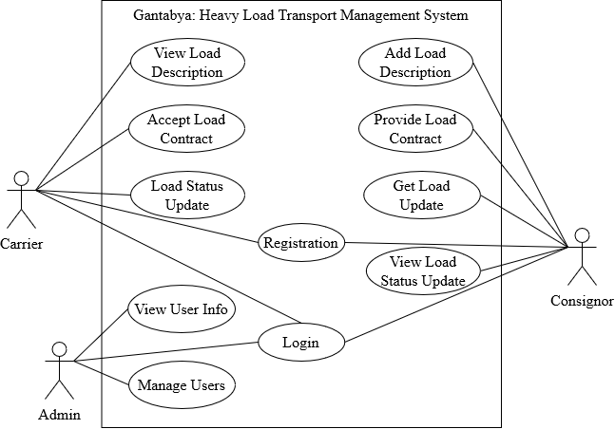

**Figure 3. 1 Use Case Diagram**

**3.1.1.2 Non-Functional Requirements**

1. Performance: The system should be able to handle heavy loads efficiently without any significant decrease in performance. It should be capable of managing a large number of concurrent users, processing heavy data loads, and generating reports in a timely manner.
2. Reliability: The system should be highly reliable, ensuring uninterrupted availability and minimal downtime. It should be able to recover quickly from any failures or errors, and have built-in mechanisms for data backup and disaster recovery.
3. Security: The system should have robust security measures in place to protect sensitive information, such as customer data, financial records, and shipment details. It should incorporate authentication, access control, encryption, and other security protocols to ensure data confidentiality and integrity.
4. Maintainability: The system should be designed and developed with maintainability in mind. It should have modular architecture, well-documented code, and adhere to coding best practices, making it easier for developers to maintain and enhance the system over time.
5. Compliance: The system should comply with relevant industry standards, regulations, and legal requirements, such as data privacy laws, transportation regulations, and financial compliance.

### **3.1.2 Feasibility Analysis**

Feasibility analysis of Gantabya: Heavy Load Transport Management System is done through measuring various Analysis.

#### **3.1.2.1 Technical Analysis**

As Heavy Load Transport Management System is a web-based application it is supported by almost all the technical devices that have a web browser. Being a web-based application, it is made up of HTML, CSS and JS as fronted and PHP, MYSQL as backend support.

#### **3.1.2.2 Operational Analysis**

This project is feasible to operate. The current mode of operation provides adequate throughput and response. So, this project is entirely operational and can be operated many platforms as long as user have browser on their device.

#### **3.1.2.3 Economic Analysis**

This system is quite simple and it does not require extra software and hardware. So, it is economically feasible.

#### **3.1.2.4 Schedule Analysis**

Here is the Gantt chart showing the probability of the project being completed within its scheduled time limits by a planned due date.

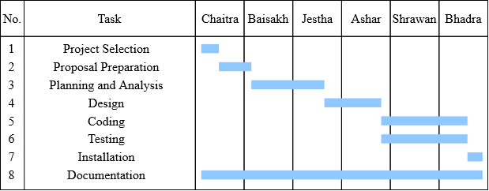

**Figure 3. 2 Gantt Chart**

### **3.1.3 Data Modelling**

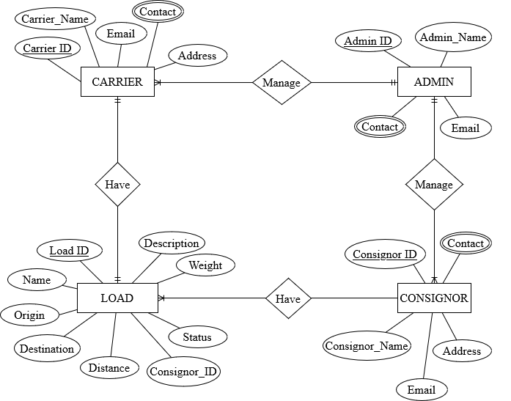

**Figure 3. 3 ER- Diagram**

### **3.1.4 Process Modelling**

#### **3.1.4.1 Context Level Diagram**

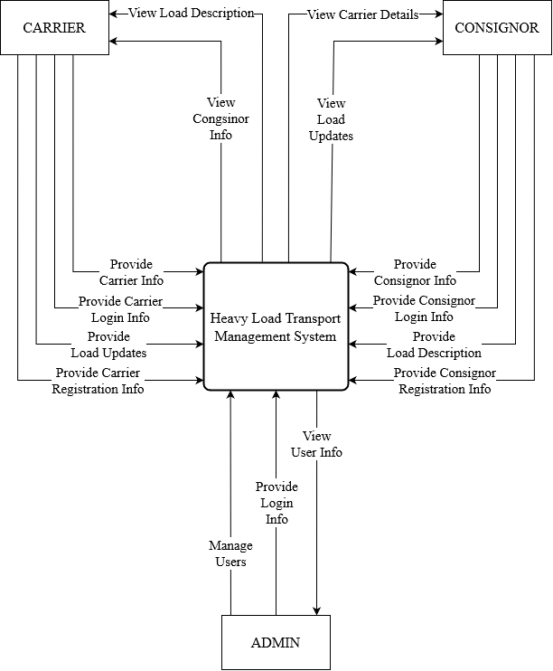

**Figure 3. 4 Context Level Diagram**

#### **3.1.4.2 Level 1 DFD**

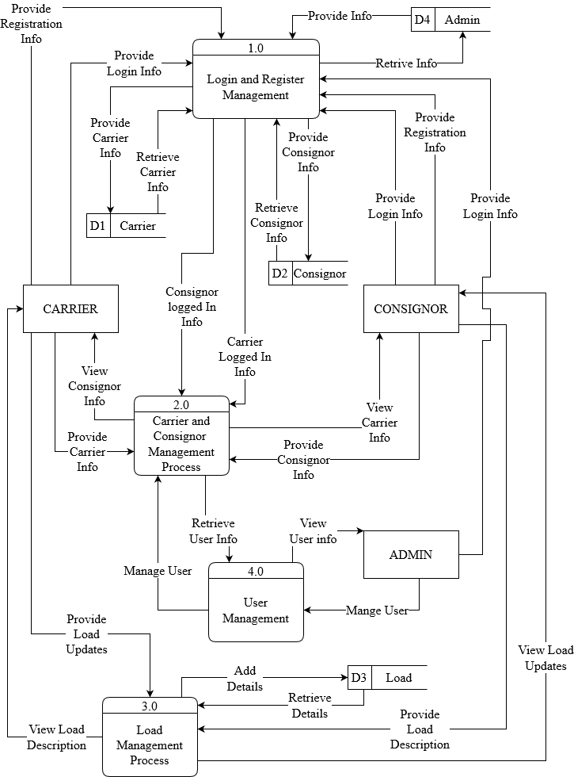

**Figure 3. 5 Level 1 DFD**

# **3.2 System Design**

The system design of ‘GANTABYA: Heavy Load Transport Management System’ that consists of architectural design, database schema design, user interface design and physical DFD are shown as follows:

### **3.2.1 Architectural Design**

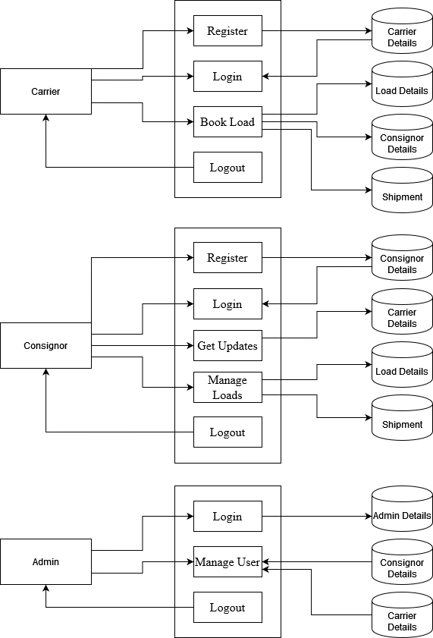

**Figure 3. 6 Architectural Design**

### **3.2.2 Database Schema Design**

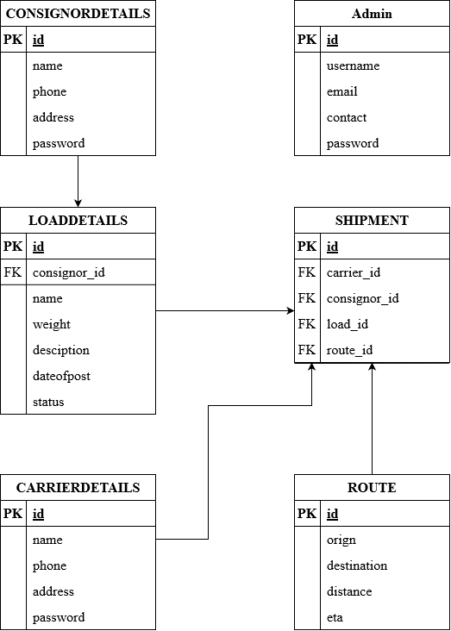

**Figure 3. 7 Database Schema**

### **3.2.3 Interface Design**

### **3.2.4 Physical DFD**

# **Chapter 4: Implementing and Testing**

## **4.1 Implementation**

### **4.1.1 Tools Used**

### **4.1.2 Implementation Details of Modules**

## **4.2 Testing**

### **4.2.1 Test Cases for Unit Testing**

### **4.2.2 Test Cases for System Testing**

# **Chapter 5: Conclusion and Future Recommendations**

## **5.1 Lesson Learnt for Unit Testing**

## **5.2 Conclusion**

## **5.3 Future Recommendations**

# **References**

# **Appendices**