**KATHMANDU UNIVERSITY**

28 KILO, DHURIKHEL, NEPAL



**Report on:**

Amplitude Modulation

**Submitted To:**

Kathmandu University

Department of Physics

**Submitted By:**

Name: Roshani Shrestha

Course: MSc physics (Second semester)

**Table of Contents**

**Abstract** 1

**Introduction** 2

**Methodology** 3

**Results** 4

**Discussion** 5

**Conclusion** 6

**Future Enhancement** 7

**References** 8

**Appendix** 9

# **Abstract**

The objective of the AM lab experiment was to investigate the fundamentals of Amplitude Modulation, a fundamental technique in signal processing and communication. AM signals were generated by altering the amplitude of a carrier wave in proportion to a modulating signal. The key goals were to comprehend the modulation process and its implications. The modulating signal's amplitude was directly impacted by changes in the modulating signal, exhibiting information encoding. This experiment revealed critical insights into AM, which supports radio broadcasting and a variety of communication systems, emphasizing its importance in signal transmission and modulation theory.

# **Introduction**

Amplitude modulation (AM) is a method in which we change the height (amplitude) of a carrier wave to convey information from the baseband or modulating signal. Think of the baseband signal as the message you want to send. We put this message onto the carrier signal by altering the carrier wave's height. So, the information is now encoded in how tall or short the carrier wave becomes. In simpler terms, AM is like changing the volume of a song to send a message. When you turn the volume up or down, you're using amplitude (loudness) to convey information. Among various ways to change a signal, AM is the oldest and most straightforward method, making it a simple way to send a message using radio waves or other forms of communication [1] [2].

In amplitude modulation, the carrier wave is given by the equation,

$$C\left(t\right)=A_{x}*\sin\left(2πf_{x}t\right)……….(i)$$

Where Ax is the carrier amplitude, fx is the carrier frequency and t represent time.

The modulating wave is given by: $M\left(t\right)=A^{m}\sin{(2}πf^{m}t^{2}+ϕ)……….(ii)$

Where A­m is the modulating amplitude, f m is the modulating frequency and µ is a phase offset.

The modulated wave, S(t), is generated through the following formula:

$$S\left(t\right)=(1+µ*M\left(t\right)*C\left(t\right),…….\left(iii\right), where µ represents the modulation index.$$

The diagram of Amplitude modulation is,

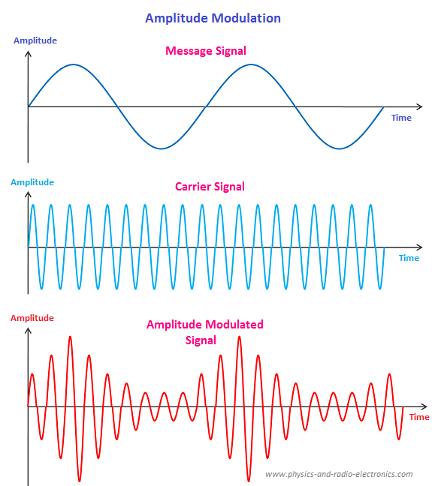

Figure 1:( Amplitude Modulation – Physics and Radio-Electronics, 2018)

# **Methodology**

Matplotlib and Python 3.11.5 were used to simulate the amplitude modulation. The flowchart below depicts a brief step performed during the AM Simulation.

* + Define Modulated wave
  + Creation of Carrier wave
  + Creation of Modulating (Message)wave
  + Setting up the parameters
  + Calculation of Modulated wave
  + Plotting the waves

NumPy and matlotlib.pyplot, two essential libraries, were imported for the simulation. Then, as indicated by Equations (i), (ii), and (iii), modulated carrier waves, carrier waves, and modulating waves were created successively. In addition to the duration and sampling rate for the simulation's resolution, user-adjustable parameters were defined to control the simulation. Plotting these various waves independently against time was done using plt.subplot and plt.plot. Ultimately, manual adjustments were made to the user-adjustable parameters in order to analyze and interpret the outcome.

Some of the main components of this simulation are discussed below.

**Carrier signal:** The carrier signal in Amplitude modulation is a high-frequency, constant radio wave that is used to transmit information. It has a fixed frequency and amplitude. In Amplitude modulation, the carrier signal's amplitude remains unchanged, but it varies in strength to convey the message.

**Message signal:** The signal which have information or data to transmit from one place to another place. **Modulated signal:** The signal which formed after the process of modulation is called modulated signal. It is the result of combining a carrier signal with a message signal.

**Carrier frequency:** It is defined as the frequency of a carrier wave, measured in cycles per second (Hz) i.e., modulated to transmit signals. This frequency remains constant throughout the transmission.

**Phase offset:** It is like frequency offset. It simply represents the delay in the waveform.

**Modulation index:** It is defined as the ratio of the amplitude of the modulating signal to the amplitude of the carrier signal. It describes the amount of modulation in a communication system [3] [4].

# **Results**

The user defined parameters taken initially during the simulation were,

Carrier Amplitude (Ax)= 1.8 m

Carrier frequency (fm) = 1200 Hz

Modulating amplitude (Am)= 1m

Modulating frequency (fm)= 300 Hz

Phase off set (ϕ) = $\frac{m}{4}$

Modulation index (µ) = 0.8

Duration = 0.06 sec

Sampling rate = 48000 per sec

The nature of plot for Carrier, Modulating and Modulated wave with initially specified values of user defined parameters is portrayed below,

# **Discussion**

# **Conclusion**

# **Future Enhancement**

# **References**

1. Sharma, S. (2012). Communication System. S. K. Kataria & Sons. New, Delhi.
2. Amplitude Modulation – Physics and Radio-Electronics (2018). Available at: Amplitude Modulation – Physics and Radio-Electronics (physics-and-radio-electronics.com).
3. Hsu, H.P. (2003). Schaum’s outline of theory and problems of analog and digital communications. New York: McGraw-Hill.
4. Sung-Moon Michael Yang (2018). Modern Digital Radio Communication Signals and Systems. Springer.

# **Appendix**