**KATHMANDU UNIVERSITY**

28 KILO, DHURIKHEL, NEPAL



**Report on:**

Frequency Modulation

**Submitted To:**

Kathmandu University

Department of Physics

**Submitted By:**

Name: Roshani Shrestha

Course: MSc physics (Second semester)

**Table of Contents**

**Abstract** 1

**Introduction** 2

**Methodology** 4

**Results** 6

**Discussion** 9

**Conclusion** 10

**Future Enhancement** 11

**References** 12

**Appendix** 13

# **Abstract**

The purpose of this laboratory experiment was to examine the principles and properties of Frequency Modulation (FM). The primary goals were to investigate the link between the modulation index and signal bandwidth, as well as to assess FM's noise-resistant qualities. Modulation indices were carefully altered and FM signals were evaluated using computer simulation, changing various parameter. The results showed that larger modulation indices resulted in wider bandwidth, confirming the theoretical framework. The experiment also demonstrated FM's extraordinary capacity to reduce amplitude noise, making it a good choice for communication systems where signal fidelity and noise resistance are critical. These findings help to improve our understanding of FM modulation and its practical applications.

# **Introduction**

Frequency Modulation (FM) is a modulation technique used in radio communication and various other applications. It involves encoding information by varying the frequency of a carrier wave. As the amplitude of the carrier remains constant, the signal is represented by changes in the frequency of the wave.

FM has a wide range of applications in radio communication and beyond. FM's resistance to amplitude-related interference and noise is a key advantage, making it particularly useful in high-quality audio transmission, as seen in FM radio broadcasting. FM is also used in two-way communication systems such as walkie-talkies, where clear and interference-free communication is essential. It is also used in applications that require accurate reproduction of signal variations, such as aviation communication, maritime communication, and emergency services.

FM's significance lies in its ability to provide clear, high-fidelity communication, making it an essential technology in various domains, particularly where reliable and accurate transmission of analog information is needed.

In frequency modulation, the carrier wave is given by the equation,

*C*(*t*) = *Ax*(*t*) sin(2*π fxt*)…………..(i)

Where Ax is the carrier amplitude, fx is the carrier frequency and t represent time.

The modulating wave is given by:

*M*(*t*) = *Am* sin(2*π f mt*2 + *ψ*)………….(ii)

Where A­m is the modulating amplitude, f m is the modulating frequency and *ψ* is a phase offset.

The modulated wave, S(t), is generated through the following formula:

*S*(*t*) = *Ax* sin[2*π*( *fx* + *δ f M*(*t*))*t*]…………(iii)

Where, the frequency of the carrier wave is modulated and the amount of modulation determined by the frequency deviation *δ.* Frequency deviation represents the maximum shift away from *fx* in one direction.

The following figure represents frequency modulation:

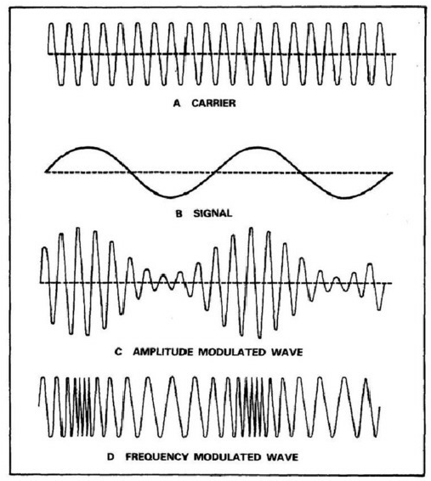

Figure 1:( Frequency Modulation – Physics and Radio-Electronics, 2018)

# **Methodology**

Matplotlib and Python 3.11.5 were used to simulate the frequency modulation. The flowchart below depicts a brief step performed during the AM Simulation.

* + Define Modulated wave
  + Creation of Carrier wave
  + Creation of Modulating wave wewwawave(Message)wave
  + Setting up the parameters
  + Calculation of Modulated wave
  + Plotting the waves

The simulation made use of essential libraries, NumPy and matplotlib.pyplot, to explore Frequency Modulation (FM). It followed a series of equations (i, ii, and iii) to create modulated carrier waves, carrier waves, and modulating waves. The simulation allowed for user-defined parameters, duration, and sampling rate adjustments, and the resulting waves were individually visualized over time using plt.subplot and plt.plot. Fine-tuning of these user-adjustable parameters was performed to scrutinize and interpret the outcomes.

The simulation encompassed several vital elements:

1. Carrier Signal: In FM, the carrier signal, a high-frequency constant radio wave, played the role of transmitting information. It retained a fixed frequency and amplitude, distinguishing it from Amplitude Modulation. In FM, the carrier signal's amplitude remained unchanged while its frequency varied to convey the message.

2. Message Signal: This signal carried the information or data intended for transmission from one location to another.

3. Modulated Signal: The modulated signal emerged from the amalgamation of the carrier signal with the message signal. It bore the information through variations in frequency.

4. Carrier Frequency: The carrier frequency represented the frequency of the carrier wave, measured in cycles per second (Hz). In FM, this frequency remained unaltered during the entire transmission process.

5. Phase Offset: Phase offset, similar to frequency offset, signified a delay in the waveform, affecting the phase relationship between the carrier and modulating signals.

6. Modulation Index: This index was defined as the ratio of the amplitude of the modulating signal to the amplitude of the carrier signal. It quantified the degree of modulation within a communication system [3] [4].

# **Results**

The outcome was achieved by drawing conclusions based on the outcomes of user-defined parameters. To make the report more interesting and the results more reliable, I made several changes to various parameters, including freezing some. This report is centralized by the following user-defined parameters:

Carrier Amplitude=1.5

Carrier Frequency = 1000 Hz

Modulating Amplitude=0.8

Modulating Freq = 200 Hz

Phase Offset=

Frequency Deviation= 500 Hz

Modulation index = 5

Duration = 0.04 seconds

Sampling Rate = 48000 (samples per second)

For a given set of parameters, the simulation of the carrier wave, modulating wave (baseband or message signal), and modulated wave is as follows:

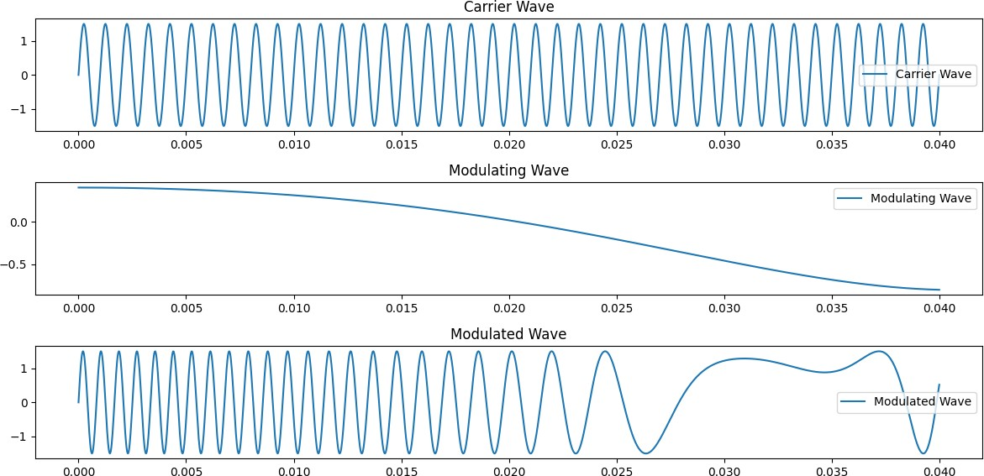

Figure 2: Carrier, Modulating and Modulated waves for the provided sets of parameters

To better understand the nature of frequency modulation, the frequency of the carrier wave was varied while freezing all other parameters. The simulation result is depicted below.

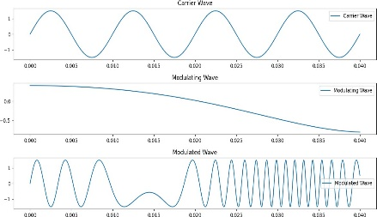

(a) Simulation with carrier frequency 100 Hz

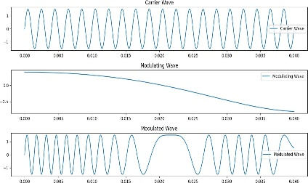

(b) Simulation with carrier frequency 500 Hz

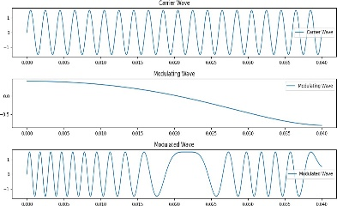

(c) Simulation with carrier frequency 1000 Hz

Figure 3: Plot of modulation on carrier waves with various frequencies, setting all other parameters as frozen.

The relationship between frequency modulation and carrier wave amplitude is obtained again. The output of the nature of modulation while varying the amplitude of the carrier wave while holding all other parameters constant is shown in the figure below.

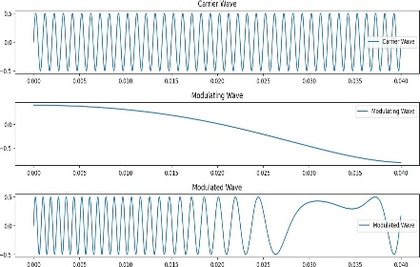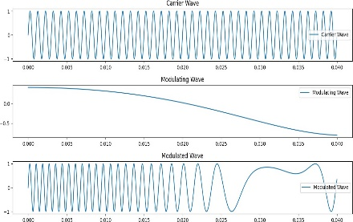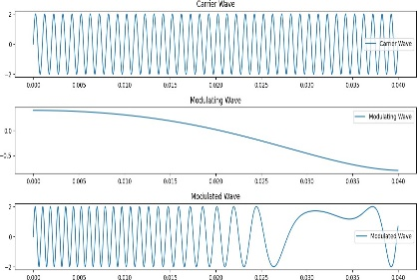

(a) Simulation with carrier amplitude 0.5m

(b) Simulation with carrier amplitude 1m

(c) Simulation with carrier amplitude 2m

Figure 4: Plot of modulation on carrier waves with various amplitudes, setting all other parameters as frozen.

To investigate the relationship between frequency deviation and frequency modulation, simulations were run for various frequency deviation values while leaving the other parameters unchanged.As a result, the following is the outcome:

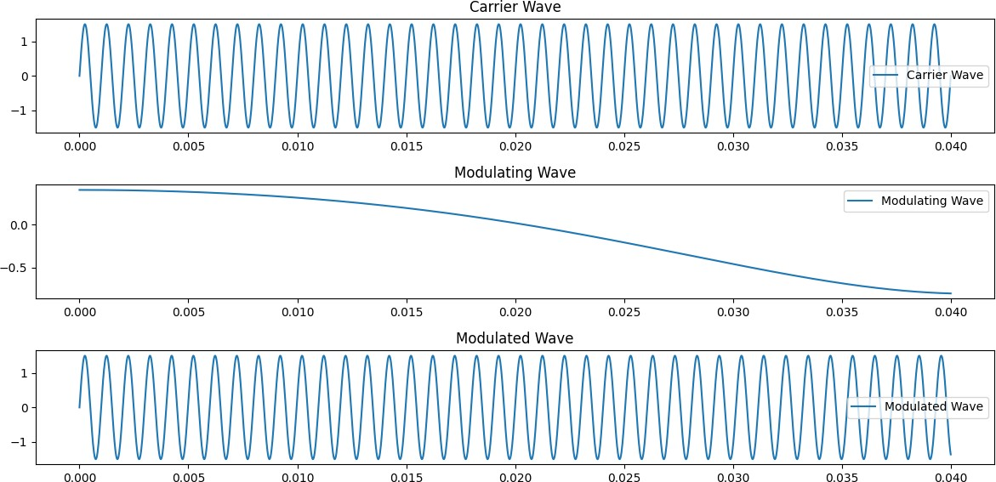

(a) Simulation with frequency deviation of 10Hz

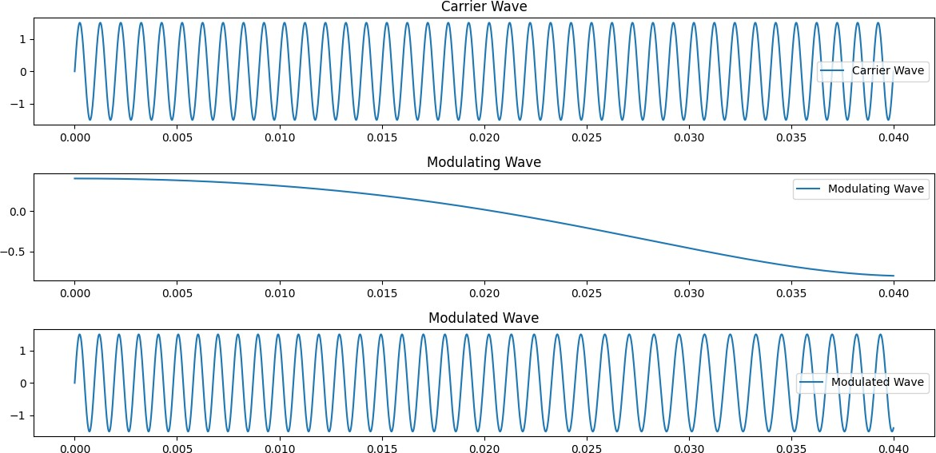

(b) Simulation with frequency deviation of 100Hz

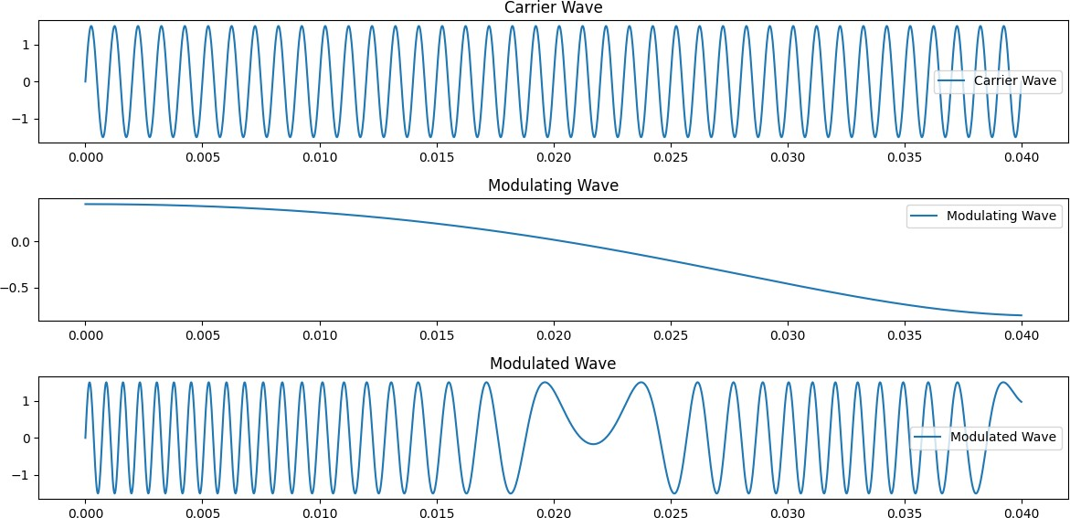

(c) Simulation with frequency deviation of 1000Hz

Figure 5: Plot of modulation on carrier waves with various frequency deviations, setting all other parameters as frozen.

# **Discussion**

The findings and deductions from our previous section highlight how our simulations align seamlessly with the theoretical expectations when it comes to frequency modulation (FM). It's impressive to see how a low-amplitude, low-frequency message signal wave can transform into a high-frequency, high-intensity modulated wave through the aid of a carrier wave. This process successfully blends the plain carrier wave and the message signal wave, yielding a well-structured modulated signal for radio wave communication.

One interesting observation during our experiments was the impact of varying the carrier wave's frequency from 100 Hz to 1000 Hz. As we did so, we noticed that the modulated signal's efficiency increased progressively, paralleling the rise in the carrier wave's frequency. This direct correlation between the frequencies of the modulated and carrier waves is a significant discovery. However, it's essential to be cautious about pushing the carrier wave's frequency too high, as this may necessitate larger antennas to accommodate the wider bandwidth required for higher frequencies.

Similarly, when we adjusted the amplitude of the carrier wave from 0.5m to 2m, it became evident that the amplitude of the modulated wave directly mirrored the changes in the carrier wave's amplitude. This clear relationship between the two variables underscores our alignment with theoretical expectations.

Additionally, our experiments shed light on the influence of frequency deviation. As we varied the frequency deviation from 10 Hz to 1000 Hz, we observed that smaller deviation values had a reduced impact on the carrier wave. To achieve optimal modulation, maintaining a higher frequency deviation is crucial.

In the pursuit of effective communication, the choice of carrier frequency, frequency deviation, and amplitude becomes critical. These decisions play a pivotal role in meeting specific requirements like bandwidth, power, and overall signal quality. Thoughtful consideration of these parameters is essential to ensure the efficiency and reliability of FM communication systems.

# **Conclusion**

In this experiment, we simulated Frequency Modulation (FM) and found results that were consistent with theoretical predictions. Our research found that changing the modulation index has a direct effect on the frequency spectrum of the modulated signal, proving the theoretical principles of FM. Furthermore, the exceptional noise resistance of FM was emphasized, making it ideal for applications needing signal quality in the midst of interference.

Frequency modulation is useful in telecommunications and broadcasting because it allows for high-quality audio and data transmission with reduced amplitude noise. Its versatility to a variety of settings provides consistent signal reception.

It is important to note, however, that this simulation reduces real-world difficulties and does not account for potential issues in true FM systems, such as nonlinear effects and practical constraints.

# **Future Enhancement**

We can learn more about the intriguing field of frequency modulation (FM) and its many uses by extending the simulation. The following are a few directions for further development and improvement:

* Diverse Modulation Techniques: Combining various modulation techniques, such as phase modulation (PM) and amplitude modulation (AM), could be a significant advancement. This would allow a thorough analysis of these methods, providing information on their unique benefits and drawbacks in real-world situations.
* Real-world Signal Realism: The addition of signal distortions and nonlinearities could mirror actual signal characteristics. These real-world complexities can profoundly impact signal quality, making the simulation even more valuable for students and engineers alike.
* Interactive User Interface: An interactive user interface that allows real-time parameter tweaks might turn the simulation into a teaching tool. This hands-on approach can help you learn the subtleties and practical uses of FM..
* Visualization of Power Spectral Density: Including a power spectral density analysis would allow students and researchers to see the frequency components of the modulated signal. This could emphasize the benefits of FM and aid in the understanding of signal characteristics.
* Demodulation Component: It is critical to expand the simulation to incorporate demodulation procedures. This would allow the original message signal to be recovered, offering a comprehensive understanding of an FM communication system.

# **References**

1. Sharma, S. (2012). Communication System. S. K. Kataria & Sons. New, Delhi.
2. Amplitude Modulation – Physics and Radio-Electronics (2018). Available at: Amplitude Modulation – Physics and Radio-Electronics (physics-and-radio-electronics.com).
3. Hsu, H.P. (2003). Schaum’s outline of theory and problems of analog and digital communications. New York: McGraw-Hill.

# **Appendix**

The Python code for simulating Frequency Modulation (FM) is provided below. It enables users to see the modulated signal produced by the interaction of carrier and modulating waves with configurable settings.

import numpy as np

import matplotlib.pyplot as plt

def modulated_wave(carrier_freq, carrier_amplitude,modulating_freq, modulating_amplitude, frequency_deviation , duration, sampling_rate, phase_offset ):

t = np.linspace(0, duration, int(sampling_rate * duration))

carrier_wave = carrier_amplitude * np.sin(2 * np.pi * carrier_freq * t)

modulating_wave = modulating_amplitude * np.cos(2 * np.pi * modulating_freq * t**2 + phase_offset)

modulated_wave = carrier_amplitude * np.sin(2 * np.pi * (carrier_freq + frequency_deviation * modulating_wave) * t)

return t, modulated_wave

# User-defined parameters

carrier_amplitude = 1.5

carrier_freq = 1000 # Hz

modulating_amplitude = 0.8

modulating_freq = 200 # Hz

phase_offset = np.pi/3 #60 in radians

frequency_deviation = 500 #Hz

duration = 0.04 # seconds

sampling_rate = 48000 # samples per second t, modulated_wave = modulated_wave(carrier_freq, carrier_amplitude,modulating_freq, modulating_amplitude, frequency_deviation , duration, sampling_rate, phase_offset )

plt.figure(figsize=(12, 6))

# Plot carrier wave

plt.subplot(3, 1, 1)

plt.plot(t, carrier_amplitude * np.sin(2 * np.pi * carrier_freq * t), label="Carrier Wave", color= 'k')

plt.legend()

plt.title("Carrier Wave")

# Plot modulating wave

plt.subplot(3, 1, 2)

plt.plot(t, modulating_amplitude * np.cos(2 * np.pi * modulating_freq * t**2 + phase_offset), label="Modulating Wave", color= 'k')

plt.legend()

plt.title("Modulating Wave")

# Plot modulated wave

plt.subplot(3, 1, 3)

plt.plot(t, modulated_wave, label="Modulated Wave",color= 'k')

plt.legend()

plt.title("Modulated Wave")

plt.tight_layout()

plt.show()