**KATHMANDU UNIVERSITY**

28 KILO, DHURIKHEL, NEPAL



**Report on:**

Frequency modulation

**Submitted To:**

Kathmandu University

Department of Physics

**Submitted By:**

Name: Roshani Shrestha

Course: MSc physics (Second semester)

**Table of Contents**

**Abstract** 1

**Introduction** 2

**Methodology** 3

**Results** 4

**Discussion** 5

**Conclusion** 6

**Future Enhancement** 7

**References** 8

**Appendix** 9

# **Abstract**

The objective of the AM lab experiment was to investigate the fundamentals of Amplitude Modulation, a fundamental technique in signal processing and communication. AM signals were generated by altering the amplitude of a carrier wave in proportion to a modulating signal. The key goals were to comprehend the modulation process and its implications. The modulating signal's amplitude was directly impacted by changes in the modulating signal, exhibiting information encoding. This experiment revealed critical insights into AM, which supports radio broadcasting and a variety of communication systems, emphasizing its importance in signal transmission and modulation theory.

# **Introduction**

Frequency modulation (FM) is a modulation technique that conveys information by altering the instantaneous frequency of a carrier wave. It is frequently employed in telecommunications and broadcasting, notably in FM radio broadcasts. Unlike amplitude modulation (AM), which adjusts the amplitude of the carrier wave to convey data, FM modifies the carrier wave's frequency to achieve the same purpose.

Here's a breakdown of how frequency modulation operates:

1. **Carrier Wave:** FM commences with a high-frequency carrier wave, typically within the radio frequency (RF) spectrum. This carrier wave serves as the foundation for transmitting information.

2. **Information Signal:** To transmit data or audio, an information signal is utilized. This signal mirrors the waveform of the data or audio that needs to be transmitted.

3. **Frequency Fluctuation:** In FM, the carrier wave's frequency changes continually in sync with the amplitude of the information signal. When the information signal's amplitude is high, the carrier wave's frequency increases, and when the amplitude is low, the frequency decreases. This modulation of frequency is directly linked to the information signal's rate of change.

4. **Frequency Deviation:** The extent to which the carrier frequency shifts is termed the frequency deviation. It is usually quantified in Hertz (Hz) and establishes how much the carrier frequency shifts while encoding the information. Regulatory bodies like the FCC regulate maximum frequency deviation in FM broadcasting to prevent interference between radio stations.

5. **Demodulation:** At the receiving end, the incoming FM signal is demodulated to recover the original information signal. This process entails detecting the instantaneous frequency of the received signal.

The benefits of FM modulation encompass:

- **Enhanced Signal Quality:** FM is less vulnerable to amplitude variations and noise when compared to AM, resulting in superior sound quality and resilience against interference.

- **Consistent Signal Strength:** FM signals maintain a consistent amplitude, ensuring stable signal quality even at distant receiver locations.

- **Broad Frequency Range:** FM can be utilized to transmit a wide array of audio frequencies, making it suitable for high-fidelity audio transmission.

- **Resistance to Electrical Noise:** As FM encodes data through frequency changes, it is less affected by electrical noise and static compared to AM.

FM finds application in FM radio broadcasting, two-way radio communication (e.g., walkie-talkies), select television broadcasts, and wireless microphones. It is also used in areas such as frequency synthesizers, radar systems, and diverse modulation and demodulation techniques in telecommunications. In amplitude modulation, the carrie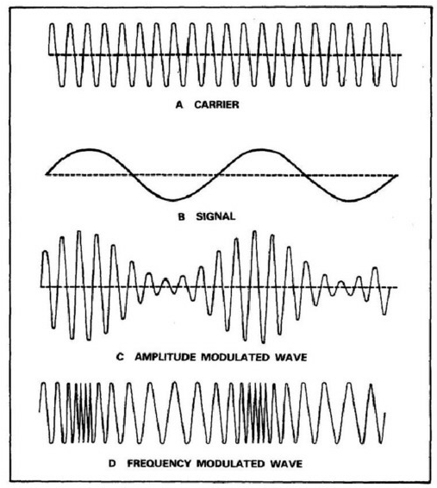r wa

ve is given by the equation,

Where Ax is the carrier amplitude, fx is the carrier frequency and t represent time.

The modulating wave is given by:

Where A­m is the modulating amplitude, f m is the modulating frequency and µ is a phase offset.

The modulated wave, S(t), is generated through the following formula:

The diagram of Amplitude modulation is,

Figure 1: Amplitude Modulation – Physics and Radio-Electronics, 2018.

# **Methodology**

Matplotlib and Python 3.11.5 were used to simulate the amplitude modulation. The flowchart below depicts a brief step performed during the AM Simulation.

* + Define Modulated wave
  + Creation of Carrier wave
  + Creation of Modulating (Message)wave
  + Setting up the parameters
  + Calculation of Modulated wave
  + Plotting the waves

NumPy and matlotlib.pyplot, two essential libraries, were imported for the simulation. Then, as indicated by Equations (i), (ii), and (iii), modulated carrier waves, carrier waves, and modulating waves were created successively. In addition to the duration and sampling rate for the simulation's resolution, user-adjustable parameters were defined to control the simulation. Plotting these various waves independently against time was done using plt.subplot and plt.plot. Ultimately, manual adjustments were made to the user-adjustable parameters in order to analyze and interpret the outcome.

Some of the main components of this simulation are discussed below.

**Carrier signal:** The carrier signal in Amplitude modulation is a high-frequency, constant radio wave that is used to transmit information. It has a fixed frequency and amplitude. In Amplitude modulation, the carrier signal's amplitude remains unchanged, but it varies in strength to convey the message.

**Message signal:** The signal which have information or data to transmit from one place to another place. **Modulated signal:** The signal which formed after the process of modulation is called modulated signal. It is the result of combining a carrier signal with a message signal.

**Carrier frequency:** It is defined as the frequency of a carrier wave, measured in cycles per second (Hz) i.e., modulated to transmit signals. This frequency remains constant throughout the transmission.

**Phase offset:** It is like frequency offset. It simply represents the delay in the waveform.

**Modulation index:** It is defined as the ratio of the amplitude of the modulating signal to the amplitude of the carrier signal. It describes the amount of modulation in a communication system [3] [4].

# **Results**

The outcome was achieved by drawing conclusions based on the outcomes of user-defined parameters. To make the report more interesting and the results more reliable, I made several changes to various parameters, including freezing some. This report is centralized by the following user-defined parameters:

Carrier Amplitude (Ax)= 1.8 m

Carrier frequency (fm) = 1200 Hz

Modulating amplitude (Am)= 1m

Modulating frequency (fm)= 300 Hz

Phase off set (ϕ) =

Modulation index (µ) = 0.8

Duration = 0.06 sec

Sampling rate = 48000 per sec

The simulation of carrier wave, modulating wave (baseband or message signal) and modulated wave for given sets of parameter is obtained as:

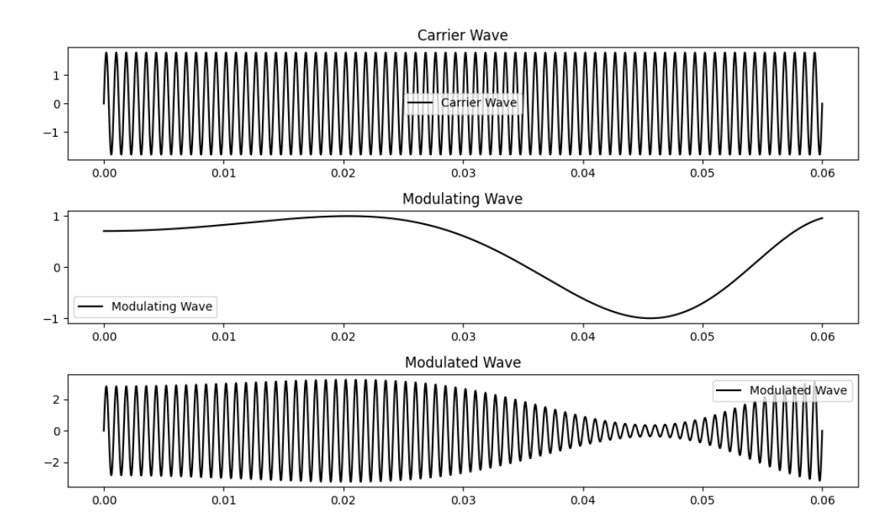

Figure 2: Carrier, Modulating and Modulated waves for the provided sets of parameters.

To better understand the nature of amplitude modulation, the frequency of the carrier wave was varied while freezing all other parameters. The simulation result is depicted below.

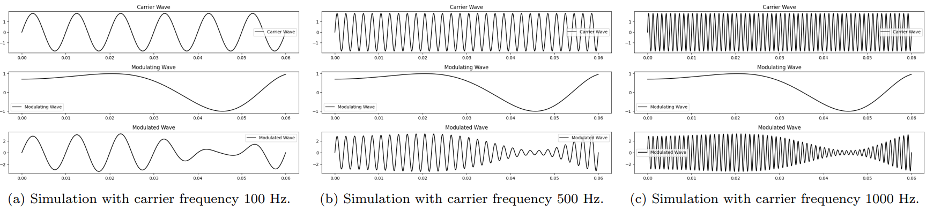

Figure 3: Plot of modulation on carrier waves at different frequencies, with all other parameters frozen.

Once more, the relationship between the carrier wave's amplitude and the amplitude modulation is obtained. The figure below illustrates the output of the modulation process while adjusting the carrier wave's amplitude and holding all other supplied parameter values constant.

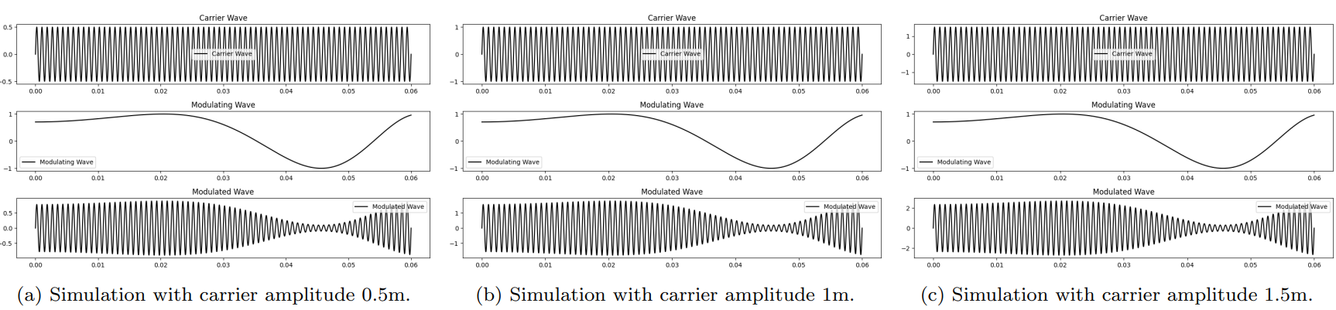

Figure 4: Plot of the modulation with different carrier wave amplitudes, with all other parameters frozen.

To investigate the relationship between the modulating index and amplitude modulation, simulations were run for various values of modulating index without making any changes to the other provided parameters. Hence the outcome is as shown as below:

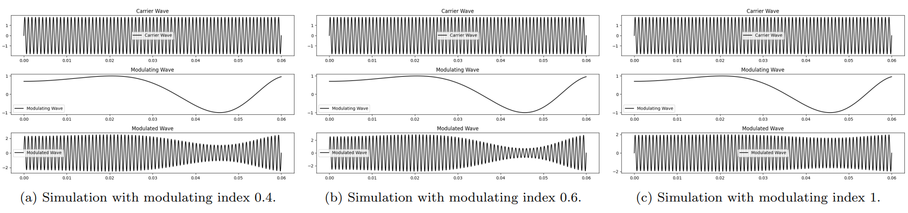

Figure 5: Plot of modulation on carrier waves with various modulating index, setting all other parameters as frozen.

# **Discussion**

We observed that when the carrier wave had no amplitude (zero height), the modulated wave also had zero amplitude. As we gradually increased the amplitude of the carrier wave, the amplitude of the modulated wave increased significantly. This increase in carrier wave amplitude enhanced signal power and signal-to-noise ratio but brought about challenges related to power, bandwidth usage, and regulatory constraints.

Similarly, when the carrier wave had no frequency (no carrier frequency), the modulated wave had zero amplitude and assumed a frequency similar to that of the modulating wave. As we increased the frequency of the carrier wave, both the frequency and amplitude of the modulated wave increased. This higher carrier wave frequency offered greater data capacity and flexibility but raised concerns related to antenna design and bandwidth utilization.

When the modulation index was set to zero, the carrier wave and modulated wave were indistinguishable, having the same amplitude and frequency. This indicated that the carrier wave remained unaffected by the modulating wave. However, with a modulation index of 0.6, we observed a noticeable change in the modulated wave's amplitude and frequency, classifying it as undermodulated. Undermodulated waves are less effective in modulation, leading to lower signal quality and limited information transmission.

Conversely, when the modulation index was set to 1.2, there was a significant change in the amplitude and frequency of the modulated wave, resulting in an overmodulated wave. Overmodulated waves exhibit limitations, including unwanted sidebands, increased bandwidth usage, and potential interference issues.

Selecting appropriate values for carrier wave amplitude, carrier frequency, and modulation index is a nuanced task. It hinges on factors like the specific communication type, available bandwidth, desired signal quality, power efficiency, and other considerations. The right values must be determined based on the unique requirements and constraints of the particular communication system in question.

Applications of Amplitude Modulation:

* Long-distance communication relies on AM.
* AM finds utility in transmitting images on television.
* In AM, the equidistant zero crossings are a notable characteristic.
* Ground wave communication also makes use of AM [5].

# **Conclusion**

Finally, the experiment confirmed the theoretical predictions of amplitude modulation (AM). Variable carrier amplitudes and frequencies changed the amplitude and frequency of modulated waves, proving AM principles. The findings highlighted the importance of AM in long-distance communication and television image transmission. Expected equidistant zero crossings were observed. The simulation, however, has constraints such as idealized settings and simplified parameters, whereas real-world applications are more complex. The practical value of AM remains important, despite the fact that its actual implementation frequently requires detailed parameter adjustment. These findings emphasize AM's long-term relevance and critical role in telecommunications.

# **Future Enhancement**

The potential future enhancements for our lab experiment are:

Include support for various types of modulation. The code currently only supports amplitude modulation (AM). It might, however, be expanded to include additional modulation types, such as frequency modulation (FM) and phase modulation (PM).

Support for multiple carrier waves should be added. Currently, the code only supports a single carrier wave. It might, however, be modified to allow multiple carrier waves for applications like orthogonal frequency-division multiplexing (OFDM).

Add noise and interference support. The code currently assumes that the modulated wave is transmitted in an environment devoid of noise and interference. In real-world applications, however, the modulated pulse is frequently distorted by noise and interference. The code could be expanded to include noise and interference modeling and mitigation support.

Support for digital signal processing (DSP) algorithms should be added. The code could be expanded to include DSP algorithms like filtering, equalization, and demodulation. These methods can be used to improve the modulated wave communication system's performance in the presence of noise and interference.

Incorporate a graphical user interface (GUI). To make it easier for users to interact with the programming, the code could be updated to include a graphical user interface (GUI). The GUI could include options for selecting multiple modulation types, configuring carrier and modulating wave parameters, and seeing the modulated wave in real time.

# **References**

1. Sharma, S. (2012). Communication System. S. K. Kataria & Sons. New, Delhi.
2. Amplitude Modulation – Physics and Radio-Electronics (2018). Available at: Amplitude Modulation – Physics and Radio-Electronics (physics-and-radio-electronics.com).
3. Hsu, H.P. (2003). Schaum’s outline of theory and problems of analog and digital communications. New York: McGraw-Hill.
4. Sung-Moon Michael Yang (2018). Modern Digital Radio Communication Signals and Systems. Springer.
5. Haykin (2006). COMMUNICATION SYSTEMS, 4TH ED. John Wiley & Sons.

# **Appendix**

The following is the code for code for cross-verification and AMI verification: