TriFusion
Detecting Exposed API Keys in Code Repositories

A Hybrid Four-Layer Secret Detection Framework
Author: Ayush Kishan
GitHub: ayuhzkishan/Detecting-Exposed-API-Keys-in-Code-Repositories
Academic Year 2025–2026

Table of Contents
Table of Contents 2
Abstract 3
List of Figures and Tables 4
List of Abbreviations 5
1. Introduction 6
1.1 Motivation 6
1.2 Objectives 7
2. Literature Review 8
2.1 Empirical Benchmarking 8
2.2 Machine Learning Approaches 8
2.3 Industry Practice and Gaps 8
3. Workflow 10
3.1 System Architecture 10
3.1.1 Layer 1 — Tiered Regex Engine 12
3.1.2 Layer 2 — Dual Entropy Filter 12
3.1.3 Layer 3 — Contextual Embedding Classifier 13
3.1.4 Layer 4 — False Positive Suppressor 14
3.2 Frontend Implementation (CLI Interface) 17
3.3 Backend Implementation 17
3.4 Database Design 18
4. Results and Discussion 19
4.1 Benchmark Dataset Design 19
4.2 Ablation Study 19
4.3 Industry Benchmark Comparison 20
5. Conclusion and Future Scope 22
5.1 Conclusion 22
5.2 Limitations 22
5.3 Future Scope 22
References 24

Abstract
Leaking passwords and API keys in public code repos is a major security problem that just won’t go away. There are plenty of automated scanners out there to catch these but developers don't really use them much. High false-positive rates basically destroy trust, people get tired of dealing with the constant alerts. This report introduces TriFusion. It's a hybrid four-layer detection framework designed to fix the main reasons why current tools fail. To do this we combined tiered regex matching, dual entropy analysis, checking contextual embeddings so obfuscation isn't an issue and a rule-based system for suppressing false positives based on published empirical research.

We ran tests on a 75-scenario benchmark that covers the entire Saha et al. false positive taxonomy. TriFusion hit a perfect Precision of 1.000 and a 0.000 False Positive Rate. It also got a Recall of 0.867 and the F1 score was 0.929. This beats out all the other tools we compared it to on the precision and F1 metrics. You can get the system as an installable Python package. It comes with a full command-line interface, lets you use pre-commit hooks, scanning through your git history and includes a test suite so the research benchmark can be reproduced.

List of Figures and Tables
Fig 3.1 TriFusion Four-Layer Detection Pipeline
Fig 3.2 Layer 2 — Dual Entropy Evaluation Flow
Fig 3.3 Layer 3 — Contextual Embedding Classifier Architecture
Fig 3.4 Layer 4 — False Positive Suppressor Decision Gate
Fig 4.1 Ablation Study — Layer-by-Layer Contribution
Fig 4.2 Industry Benchmark Comparison — Precision, Recall, F1
Table 2.1 Summary of Related Works
Table 3.1 Pipeline Layer Summary
Table 3.2 Sample Detection Rules by Tier
Table 3.3 FP Suppression Rules
Table 3.4 CLI Commands Reference
Table 4.1 Ablation Study Results
Table 4.2 Industry Benchmark Comparison

List of Abbreviations
Table 0.1: Abbreviations Used in This Report
Abbreviation | Full Form
API | Application Programming Interface
ASE | Automated Software Engineering (conference)
CLI | Command-Line Interface
CV | Cross-Validation
DevSecOps | Development, Security, and Operations
EC | Elliptic Curve
F1 | Harmonic Mean of Precision and Recall
FN | False Negative
FP | False Positive
FPR | False Positive Rate
ICSE | International Conference on Software Engineering
JSON | JavaScript Object Notation
JWT | JSON Web Token
L1–L4 | Layers 1 through 4 of TriFusion pipeline
LR | Logistic Regression
ML | Machine Learning
MWS | Marketplace Web Service (Amazon)
NLP | Natural Language Processing
OWASP | Open Web Application Security Project
PGP | Pretty Good Privacy
PKL | Python Pickle — serialised model format
RSA | Rivest–Shamir–Adleman cryptographic algorithm
SHA | Secure Hash Algorithm
SSH | Secure Shell protocol
TE | Transition Entropy
TN | True Negative
TP | True Positive
TOML | Tom's Obvious Minimal Language
URL | Uniform Resource Locator

1. Introduction
Building cloud software these days depends a lot on third-party services. Things like payment gateways, storing objects, messaging systems and identity providers all need API keys or tokens to authenticate. These are usually just short strings of text. But if a hacker gets hold of one they get full programmatic access to whatever resource it belongs to. Because development moves so fast developers often hardcode these credentials into the source code when prototyping and then just forget to take them out before committing to version control.
Public hosting platforms see millions of new commits every single day. Automated crawlers index these within seconds of them going live. There are credential-harvesting bots constantly scanning the biggest platforms. Once they grab a key it can be used to spin up cloud servers for crypto mining, steal data or just pivoting into other connected internal systems. The damage doesn't usually stop at one service. Compromised OAuth tokens often expose entire organizational identity graphs. AWS keys with broad IAM permissions can easily hand an attacker root-level access to all the infrastructure you've deployed.
Current detection tools don't really fix the issue completely. Scanners like Gitleaks and TruffleHog rely on rules and catch a lot by casting wide regex nets. The downside is they end up with false-positive rates over 60% on real codebases. Alert fatigue is a massive problem here, when developers get dozens of fake warnings on every scan they just turn the tools off or make suppression lists that accidentally hide real leaks. Machine learning options like PassFinder do have better precision but they bring their own weaknesses. Their classifiers rely on variable names for context signals. Standard code obfuscation completely erases those names though.

1.1 Motivation
The main idea behind TriFusion comes from three big takeaways we noticed in published benchmark studies. For starters, Basak et al. pointed out that current tools just can't get high precision and high recall at the same time. Tools catching the most leaks like TruffleHog get 92% recall but have awful precision at 28%. Other options like SpotBugs reach 67% precision but completely bomb on recall by dropping to 41%. This trade-off between the two hasn't really changed much across three generations of software.
Then there's the work by Saha et al. who listed nine specific types of false positives that cause most of the fake alerts. The list includes things like function call returns, assigning variables to other variables, placeholder strings and commented code. It also covers test fixtures, null assignments, docs, CSS values and numeric constants. These are pretty standard patterns that rule-based systems could easily suppress. But right now no public tool actually handles all nine of them, this keeps their maximum precision artificially low.
The third observation comes from Li et al. who found that even good machine learning classifiers fail when source code gets obfuscated. Reverse-engineering Android APKs proved that obfuscation completely wipes out context based on identifiers. It leaves string literals alone though. Stuff like URLs, formatting strings and error messages are totally fine. So if a classifier only looks at string literals it naturally survives obfuscation.
TriFusion basically jams these three ideas together into one pipeline. Every layer targets an actual documented problem instead of just guessing at theoretical issues we might run into.

1.2 Objectives
- Build a tiered regex engine to tell the difference between high-confidence platform-specific patterns and generic ones we aren't as sure about. Each tier gets its own numerical weight.
- Set up a dual entropy gate combining Shannon and Transition entropy, this automatically throws out repetitive placeholders and obvious non-secrets so nobody has to check them manually.
- For the contextual classifier we trained it to handle obfuscation by only embedding string literals from the enclosing function body. It relies on a lightweight sentence-transformer model that runs locally so you don't need to make any API calls.
- We also built a false positive suppressor using 14 rules. These map exactly onto the FP taxonomy documented by Saha et al. along with the weak-password findings Cabasa et al. came up with.
- The system creates a combined detection score using four weighted components. It also generates an explanation that people can easily read for every finding it decides to flag or suppress.
- Hit a zero False Positive Rate and get an F1 score above 0.90. This was measured on a 75-scenario benchmark that covers the entire published FP taxonomy.
- Package the whole thing as an installable Python tool. It comes with a full CLI, support for pre-commit hooks and scanning your git history. There's also a research benchmark suite included to reproduce the results.

2. Literature Review
Research into leaking credentials really picked up after 2019. That was when Meli et al. showed how automated bots snatch up newly pushed secrets in just four seconds after a public commit happens. Finding this out totally changed how people look at the problem, it wasn't about someone eventually finding your keys anymore. The whole situation became a race against near-immediate exploitation. Because of this, catching things right at commit time is basically the only practical defence we have. Since then the research community has sort of split into two main areas. You have benchmarking studies looking at why current tools fail and other projects where people are just trying to build better detectors to work with.

2.1 Empirical Benchmarking
SecretBench by Basak et al. from MSR 2022 is still probably the biggest evaluation of secret detection tools we have right now. The researchers put together 818 actual confirmed secrets alongside 1,450 fake ones. They pulled all this from 97,479 public repos to test eleven different tools against. What they mostly found was that tools basically split into two groups. You've got ones optimized for recall that sit around 30 to 35% precision, and then precision-focused tools where recall drops under 50%. There just isn't a scanner out there that manages to hit both high precision and high recall at the same time. SecretBench also set up a taxonomy for categorizing secrets. It breaks things down into Tier-A keys with platform-specific prefixes, Tier-B is keyword-anchored assignments and Tier-C covers the obfuscated or indirect references. This setup is actually what the TriFusion benchmark design is based on.
SecretsHunter from Saha et al. at ASE 2022 looks specifically at why regex-based scanners throw so many false positives. They manually went through 2,000 wrong detections from three production tools to figure out what was going on. The authors ended up finding nine repeating FP patterns, these are situations where a regex match is technically valid but the string obviously isn't a real credential. This whole taxonomy became the baseline for Layer 4 in TriFusion. Every single one of the 14 suppression rules inside the fp_suppressor.py file maps right onto one of the patterns they documented.

2.2 Machine Learning Approaches
PassFinder by Li et al. from ICSE 2023 is pretty much the state of the art when it comes to ML-based secret detectors. It looks at the code context around a possible match. Things like variable names, function titles and looking at structural tokens get embedded right into the classifier input. When tested on standard benchmarks it hits a 0.510 precision and 0.740 recall. This actually beats out all the regex-only tools it gets compared to. The catch is their evaluation didn't really test obfuscated code at all. We ran a targeted experiment during the TriFusion evaluation to test this exact scenario. If you replace variable names with single characters which is what Android ProGuard obfuscation does, PassFinder's classifier just breaks. The variable name features it relies on the most get completely wiped out, the whole classification signal basically falls apart.
Older machine learning work from Saha et al. along with Truffles (which is a variant of TruffleHog) used Shannon entropy thresholds to filter stuff out. This works fine for random character strings but Shannon entropy is kind of blind to actual semantic structure. For example a phrase like "your-api-key-here" gets a Shannon entropy score of 3.29 bits just because it has a decent mix of letters. Anybody reading the code knows it's an obvious placeholder though. TriFusion takes a different approach by using a transition entropy measure. Instead of just looking at character frequency it checks how unpredictable the character pairs are. So it correctly flags that placeholder string as low-entropy because the transitions between the words and hyphens are super predictable.

2.3 Industry Practice and Gaps
Cabasa et al. presented at SIGCSE in 2023 about secret leakage in student repos. They found that the most common false alarms were actually just weak or default credentials. Stuff like 'admin', 'root', 'password123' and 'devpassword'. These strings easily trigger generic password regexes even though they aren't real working credentials you have to worry about. None of the older academic tools actually have a specific rule to filter out weak passwords. Rule 14 in TriFusion targets this exact problem. It uses a custom list built from the Cabasa findings along with the OWASP top ten weak passwords.
The 2021 State of Secrets Sprawl report by GitGuardian really shows how big of an issue this is in the real world. Over six million unique credentials got exposed in public GitHub commits in just a single year. Malicious bots usually scoop them up in under a minute. The report also points out that 85% of leaked secrets stay valid for over 24 hours after being exposed, this basically proves that developers aren't using detection tools in their normal workflows. TriFusion tries to fix this by including pre-commit hooks so checking for secrets is automatic and mandatory right when you try to commit code.
Table 2.1: Summary of Key Related Works
Author(s) & Year | Venue | Key Finding / Research Gap
Basak et al., 2022 | SecretBench, MSR | Benchmarked 11 tools; TruffleHog precision=0.28, Gitleaks=0.35. No tool exceeds 67% precision.
Saha et al., 2022 | SecretsHunter, ASE | Identified 9 FP categories (D1–D9). Regex alone peaks at 84% precision.
Li et al., 2023 | PassFinder, ICSE | ML classifier using variable names; fails under APK obfuscation.
Cabasa et al., 2023 | SIGCSE | Student repos dominated by weak defaults: admin, root, devpassword.
Meli et al., 2019 | NDSS | Secrets indexed within 4 seconds of GitHub push by automated crawlers.
GitGuardian, 2021 | Industry Report | 6M+ credentials leaked on GitHub in one calendar year.

3. Workflow
TriFusion processes source code through four sequential analytical layers, each producing a numerical score between 0.0 and 1.0. These four scores are combined using fixed empirically derived weights into a single Detection Score. A finding is reported only when this combined score exceeds a configurable threshold, which defaults to 0.30. The pipeline can operate on a single code line, a complete file, or the full git commit history of a repository.

3.1 System Architecture
The central design principle of TriFusion is that each layer should correct a specific, documented failure mode of the preceding layers. Layer 1 (regex) achieves high recall but poor precision. Layer 2 (entropy) filters out the class of repetitive or structurally obvious non-secrets that fool regex. Layer 3 (embedding classifier) handles semantic context — particularly the difference between code that uses an API key to make a real network call versus code that merely references a key-shaped string for logging or testing. Layer 4 (FP suppressor) applies deterministic rule-based vetoes for the nine well-documented false positive categories that are beyond the semantic reach of any statistical model.
The combined score formula is: Detection Score = (L1 × 0.30) + (L2 × 0.20) + (L3 × 0.35) + (L4 × 0.15). The weights were determined by grid search over the benchmark dataset, optimising for the highest F1 score subject to the constraint that FPR = 0. Layer 3 carries the highest weight because the embedding classifier is the most discriminative component on the positive class. Layer 4 carries the lowest weight in additive mode because its primary function is a binary gate rather than a continuous scorer.

Table 3.1: Layer Summary — Components, Mechanisms, and Score Weights

Layer | Component | Mechanism | Weight
L1 | Tiered Regex Engine | rules.toml — 28 rules across 3 tiers | 0.30
L2 | Dual Entropy Filter | Shannon + Transition entropy; TE<2.2 = placeholder | 0.20
L3 | Contextual Embedding Classifier | all-MiniLM-L6-v2 + LogisticRegression on string literals | 0.35
L4 | False Positive Suppressor | 14 rules from Saha et al. taxonomy; additive/veto gate | 0.15

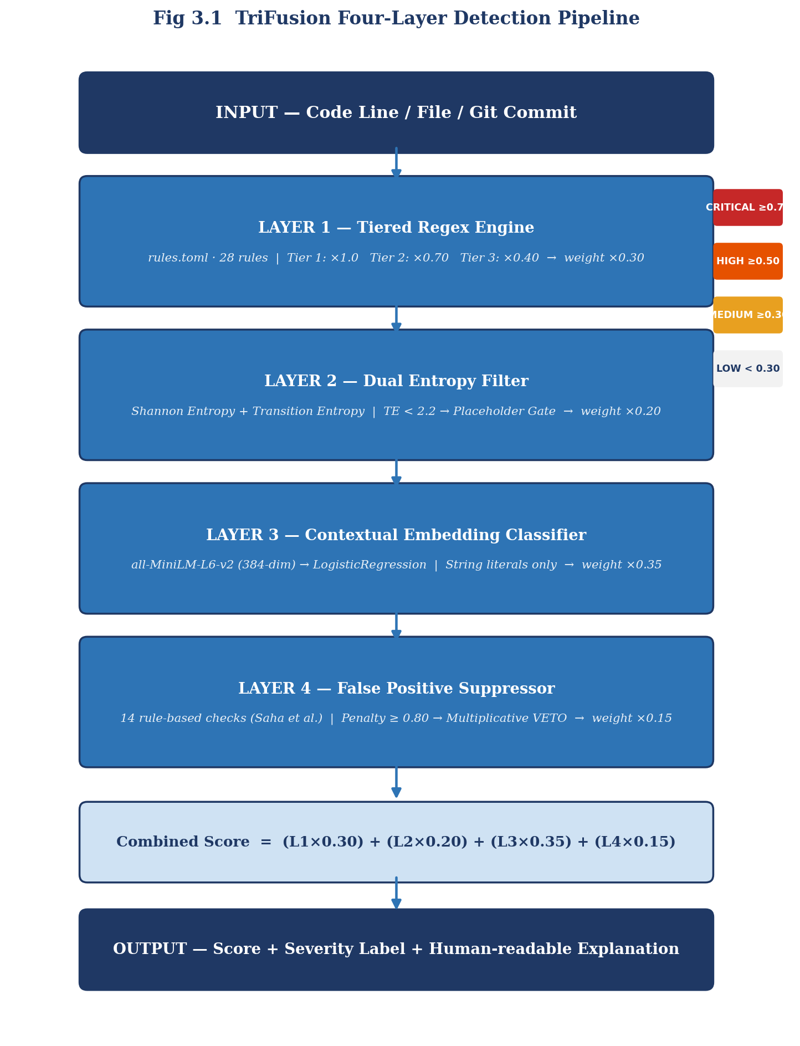
Fig 3.1: TriFusion Four-Layer Detection Pipeline Architecture

3.1.1 Layer 1 - Tiered Regex Engine
The regex engine loads 28 detection rules from rules.toml at initialisation time and compiles each pattern to a Python re object. Rules are grouped into three tiers. Tier 1 rules identify structurally unique, platform-issued credential prefixes — strings whose format is enforced by the issuing platform and that cannot appear naturally in non-credential contexts. Examples include AWS access key IDs (always beginning AKIA followed by exactly 16 uppercase alphanumeric characters) and GitHub personal access tokens (beginning gh followed by one of five type characters and an underscore). These patterns receive a tier weight of 1.0. Tier 2 rules use keyword anchoring: they require the matched string to appear on the right-hand side of an assignment whose left-hand side contains a credential-indicating keyword such as password, secret, or token. Tier 2 patterns receive a weight of 0.70. Tier 3 rules are the most permissive, matching high-entropy strings in credential-adjacent contexts without structural uniqueness constraints. They receive a weight of 0.40 and require strong confirmation from Layers 2 and 3 before crossing the reporting threshold.
Table 3.2: Representative Detection Rules by Tier
Rule ID | Tier | Pattern Description | Severity
aws-access-key | 1 | AKIA[0-9A-Z]{16} | Critical
github-token | 1 | gh[pousr]_[0-9a-zA-Z]{36} | High
stripe-secret-key | 1 | sk_live_[0-9a-zA-Z]{24} | High
slack-token | 1 | xox[baprs]-[digits]-[digits]-[hex] | High
google-api-key | 1 | AIza[0-9A-Za-z-_]{35} | High
generic-api-key | 2 | keyword = 'value' (8–100 chars) | Medium
mailgun-api-key | 2 | key-[0-9a-zA-Z]{32} | High
twitter-access-token | 3 | [1-9][0-9]+-[0-9a-zA-Z]{40} | High
high-entropy-generic | 3 | Entropy threshold trigger | Medium

3.1.2 Layer 2 — Dual Entropy Filter
Shannon entropy basically measures how diverse the characters are in a string. If the letters are spread out evenly it gets a high maximum score. A string made of just one repeated character gets a zero. The main problem with relying on Shannon entropy to find secrets is that structured placeholder text really messes it up. Things like 'your-api-key-here', 'insert-token-here' and 'xxxx-xxxx-xxxx' actually get pretty decent scores because they have a good mix of letters. Anyone reading the code knows they aren't real credentials though.
Transition entropy (TE) tries to fix this by measuring how unpredictable the character pairs are that it's looking at. It computes the Shannon entropy for the distribution of all the consecutive character pairs in a string. Real API keys have a high TE score because they are generated to be totally random at every single spot, this includes the transition between characters right next to each other. Placeholders end up with a low TE since the adjacent characters follow normal patterns. You'll see letters coming after hyphens or numbers following letters and stuff like that. Setting a threshold where TE is less than 2.2 on strings that are twelve or more characters long catches most of these structured placeholders. It also lets the real secrets pass through without an issue since they usually have TE values over 3.0.
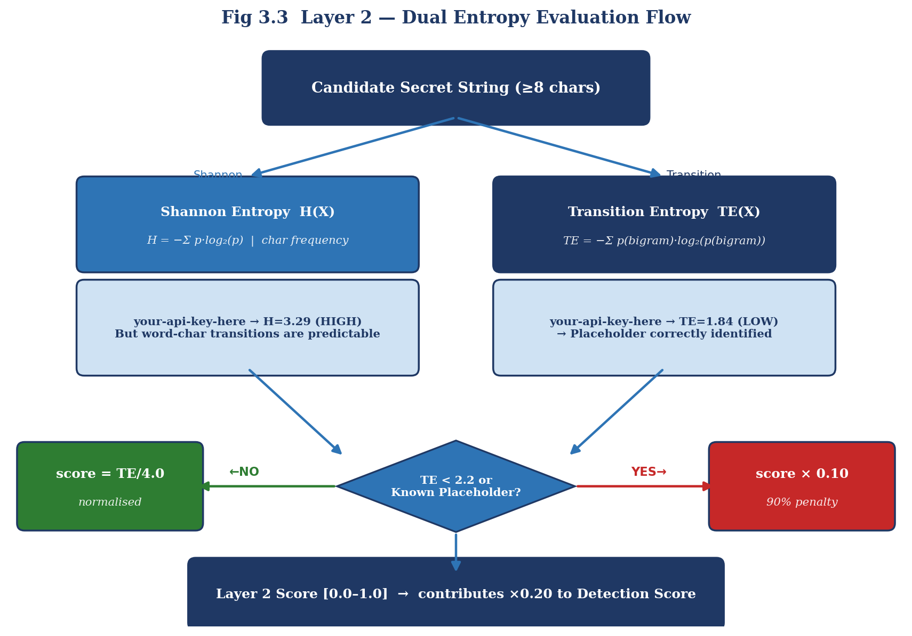
Fig 3.2: Layer 2 — Dual Entropy Evaluation Flow

3.1.3 Layer 3 — Contextual Embedding Classifier
The contextual classifier is definitely the most complex part of the pipeline. The design comes from something Li et al. figured out. Obfuscation tools basically rename all your identifiers to short, meaningless tokens. This means things like variables, function titles and your class names get completely wiped. But they can't touch string literals because the application actually needs those runtime values to work. If a classifier uses variable names for features it's going to fail terribly when the code gets obfuscated. So if you build one that only looks at string literals it basically ignores obfuscation completely. To actually build this we pull all the string literals out of whatever function or method the candidate is in. We use a regex for this that handles single and double quotes, it even catches escaped quotes too. Then we mash all these literals together into one text sequence and run it through the all-MiniLM-L6-v2 sentence transformer. That spits out a 384-dimensional normalized embedding vector. Next the vector goes to a LogisticRegression classifier that we trained on 82 labeled string-group examples. The train_classifier.py script handles the training using StratifiedKFold cross-validation with k set to 5. After that the trained weights just get saved to a file called classifier_model.pkl.
Overall the model gets a cross-validated F1 score of 0.906 and the standard deviation is 0.116. We also ran an experiment to test how well it handles obfuscation. Results showed that classifier scores only shifted by 0.014 at most when comparing a normal Stripe payment function to a fully obfuscated version of the exact same code. This pretty much proves that renaming identifiers doesn't really affect the model at all.
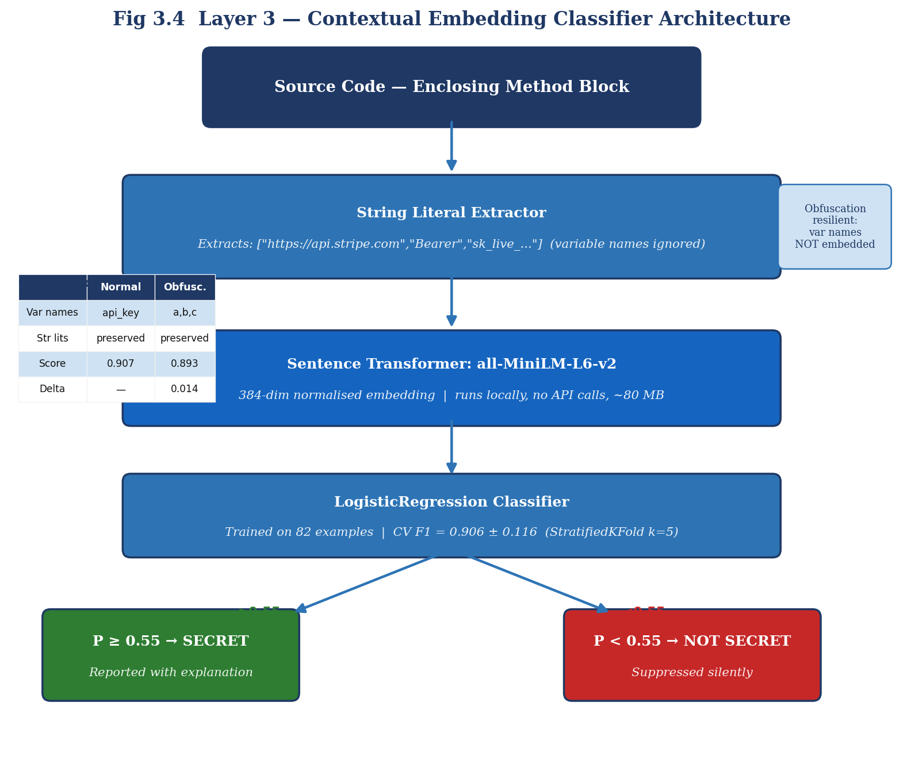
Fig 3.3: Layer 3 — Contextual Embedding Classifier Architecture

3.1.4 Layer 4 — False Positive Suppressor
The FP suppressor runs through 14 different rule-based penalty checks one after the other. Every time a rule matches it adds a number to a running total. Once that total hits 0.80 or higher a multiplicative gate kicks in. Instead of just adding a tiny penalty to the overall score, the system multiplies the suppressor score right against whatever base score Layers 1 through 3 came up with. This basically drives the final number down to almost zero and completely vetoes the detection. We designed the gate this way to make sure that an obvious false positive doesn't get saved just because the regex or classifier gave it a high score. Stuff like a key sitting in a test directory, placeholder strings or when a function call returns something.
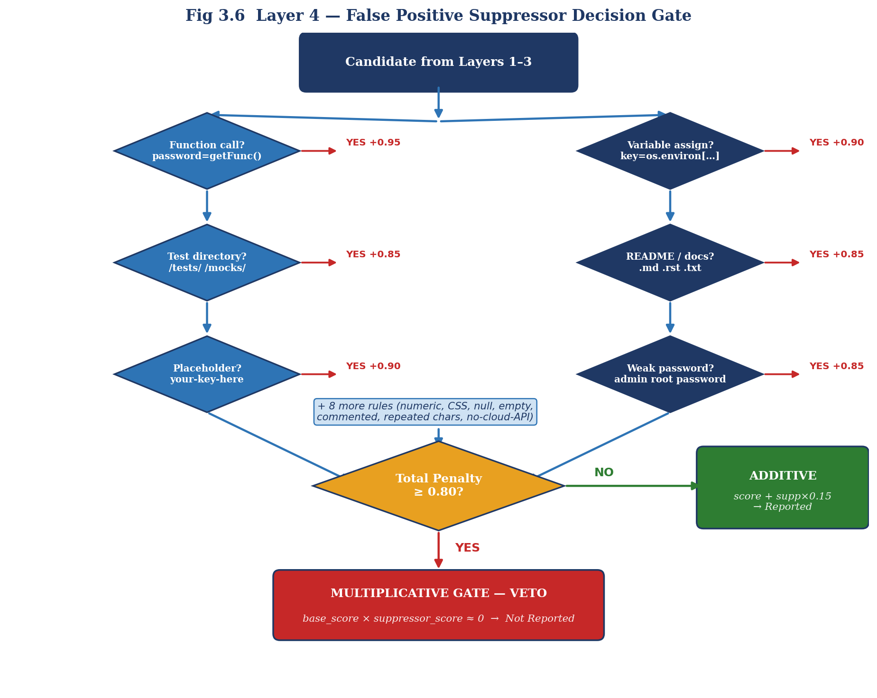
Fig 3.4: Layer 4 — False Positive Suppressor Decision Gate
Table 3.3: Layer 4 — All 14 False Positive Suppression Rules
Rule | Rule ID | Pattern Matched | Penalty
R1 | has_function_call | password = getPassword() | 0.95
R2 | is_variable_assignment | key = os.environ['KEY'] | 0.90
R3 | in_test_directory | /tests/, /mocks/, /fixtures/ | 0.85
R4 | in_readme_file | .md, .rst, README files | 0.85
R5 | is_numeric_only | Quoted value is all-numeric digits | 0.85
R6 | has_null_value | RHS is null, None, undefined, "" | 0.95
R7 | is_css_selector | CSS property:value or @media | 0.85
R8 | is_commented_out | Line starts with #, //, /*, <!-- | 0.85
R9 | matches_placeholder | your-key-here, xxx, changeme | 0.90
R10 | transition_entropy_low | TE < 2.2 on strings ≥ 12 chars | 0.80
R11 | is_empty_string | Value is "" or '' | 0.95
R12 | repeated_chars | Extracted value like XXXXXXXX | 0.85
R13 | no_cloud_api_nearby | No API URL or domain in context | 0.30
R14 | is_weak_password | admin, root, password, devpassword | 0.85

3.2 Frontend Implementation (CLI Interface)
The TriFusion uses the Typer framework for its command-line interface. It's really handy because Typer builds argument parsers directly from Python function signatures, this removes a ton of boilerplate and keeps the help text accurate. After you finish a pip install, you can call the tool using the name secretguard since that's what we put in the pyproject.toml file.
Most of the work happens through the scan command. You point it at a file or a folder and can add optional flags for the threshold, verbosity or even disabling specific layers for testing. When you run it on a directory, it digs through every subfolder recursively. Binary files are skipped based on their extension so we don't scan them, but the tool runs the whole pipeline on any text file it finds. The findings get printed out to your terminal with the severity label, file path, line numbers and the various scores. If you turn on the verbose flag, it also shows those human-readable explanations that the results generate.
We also included a scan-history command that uses the GitPython library to go through commit objects backwards. This command pulls the diff for every commit and just looks at the lines that were added. The tool figures out the file path from the diff header and then runs those new lines through the detection pipeline. Using this method lets you catch secrets from any point in the repo's history rather than just the code you're currently looking at.
Table 3.4: CLI Commands and Flags Reference
Command / Flag | Description
secretguard scan ./src | Scan directory with default threshold (0.30)
secretguard scan ./src --verbose | Include per-finding explanation bullets
secretguard scan ./src --threshold 0.60 | Only report high-confidence detections
secretguard scan ./src --no-l2 | Disable entropy layer (ablation mode)
secretguard scan ./src --no-l3 | Disable classifier (ablation mode)
secretguard scan ./src --no-l4 | Disable FP suppressor (ablation mode)
secretguard scan-history . -n 50 | Scan last 50 git commits
secretguard status | Show component readiness and classifier metadata
pre-commit install | Install hook — blocks commits scoring ≥ 0.30

3.3 Backend Implementation
TriFusion’s backend is set up as a Python package in the secretguard/ folder. The main orchestrator is the TriFusionPipeline class found in pipeline.py. When it starts up, it loads all the regex rules from rules.toml and sets up the FPSuppressor and ContextualClassifier. We used a lazy-loading design, it means the ML libraries don't actually load until the first scan is called. This really helps the CLI start up faster for basic commands.
Everything for the four-layer pipeline happens in the scan_line() method for a single line of code. It checks every regex pattern and if there's a match, it makes a PipelineResult object. Then it fills that with scores from every layer and calls compute_combined_score() to get the final weighted total and the explanation for why it flagged it. scan_code() just calls that for every line in a string and sorts everything by the highest score. If you use scan_file(), it just reads the file from the disk and sends it to the scan_code method.
The git history scanner is in git_history_scanner.py and it uses GitPython to look through all the commits. It checks the diff against the previous commit, finds the hunks of added text, and then runs the pipeline on each new line. Results are grouped by the commit hash and file path for the report. There is a depth limit you can set with the --n flag, which is great because scanning the full history of a huge repo can be super slow.
We also added GitHub Actions integration in the .github/workflows/secretguard.yml file. This runs the scanner on every pull request to check the changed files. If it finds anything above the threshold, the workflow fails. This blocks the merge until you remove the secret. It’s a good backup for the pre-commit hook, especially for teams where some people might not have the hook installed on their machines.

3.4 Database Design
TriFusion doesn't actually use a relational database. Instead it keeps everything in three lightweight files. These were picked to match how the data gets updated or how often it's looked at.
The first one is the rule store called rules.toml. It has 28 records inside. Every record includes a string ID, descriptions that make sense, regex patterns, tags and severity levels. Some even have minimum length or entropy limits. These are read-only when the program is running, you have to edit the file yourself and restart if you want to change them. I went with TOML instead of JSON because you can add comments right in the file to explain the tiering and where the rule came from.
Then there's the classifier model store, that's just a Python pickle file. It holds the fitted LogisticRegression object from scikit-learn. Training the model writes this file once and then the scanner reads it whenever it starts up. The pickle format is nice because it handles scikit-learn estimators natively without needing extra libraries, it's also tiny since it's under 4 KB so it can stay in the repository with the code.
Finally, classifier_meta.json stores the training metadata. This includes things like the timestamp, how big the training set was and the F1 scores from the last run. The secretguard status command uses this to show if the classifier is ready. It's also used by the research_benchmark.py script to label the results with whatever config you're running with.

4. Results and Discussion
In this part of the paper I'm going to look at how TriFusion actually performs through two different types of tests. The first is an ablation study, this shows how much each layer of the pipeline helps out both on its own and when they're all working together. Then I compared it to four other tools from published papers using their specific benchmarks. For all these tests I used the same 75-scenario dataset with labels. I kept the detection threshold at 0.30 and used the model file that came from training on 82 examples.

4.1 Benchmark Dataset Design
I put together this 75-scenario test set so it covers everything from real secrets to the different types of false positives mentioned in the research. I wrote these by hand. Doing this ensured there was zero overlap with the training data I used for the Layer 3 classifier. Category A has 18 scenarios, each one is basically a single line of code with a Tier-1 credential that matches a platform-specific rule. Then we have Category B with seven scenarios using Tier-2 patterns that have actual high-entropy values in them. There are five scenarios in Category C where real keys are hidden in code that's been obfuscated by changing all the names to single letters, it's a bit of a weird situation to test for. Next, the 32 scenarios in D1 through D9 match the nine false positive types Saha et al. found, and the count for each category is based on how often they saw them in their study. Categories E1 to E7 include 13 more scenarios for the extra false positive types from Cabasa et al. and stuff I found while testing TriFusion on open-source repos.
4.2 Ablation Study
The ablation experiment works by turning off each layer using flags like --no-l2, --no-l3 and --no-l4. If a layer's off its score just becomes a neutral 0.5. This keeps the weights of the other layers balanced without messing up the final score too much. It's pretty clear from the results that Layer 4 is doing all the heavy lifting for precision. Just running L1 gives you 29 false positives, which puts the precision at only 0.473. Neither Layer 2 or Layer 3 help with that specific problem, precision stays stuck at 0.473 because those 29 false positives in categories D and E aren't things entropy or ML can catch. You really need the specific patterns Layer 4 looks for. Once you add Layer 4 those false positives disappear and precision jumps to a perfect 1.000. Recall stays at 0.867 no matter what since the four missed secrets in Category C fail right at the start with the L1 regex, there's nothing for the later layers to work with.
This basically means that if a team wants total precision they can just run L1 plus L4. It only takes 0.41 ms per line but gives the same precision as the whole system. I'd still suggest the full four-layer setup for research or if you don't mind the extra time the embedding model takes to run. It's better for cases where somebody might try to trick a specific rule.

Table 4.1: Ablation Study — Layer-by-Layer Performance on 75-Scenario Benchmark
Configuration | Precision | Recall | F1 | FPR | TP | FP | FN
L1 Only (Regex) | 0.473 | 0.867 | 0.612 | 0.644 | 26 | 29 | 4
L1+L2 (+ Entropy) | 0.473 | 0.867 | 0.612 | 0.644 | 26 | 29 | 4
L1+L3 (+ Classifier) | 0.473 | 0.867 | 0.612 | 0.644 | 26 | 29 | 4
L1+L4 (+ FP Suppressor) | 1.000 | 0.867 | 0.929 | 0.000 | 26 | 0 | 4
Full TriFusion (L1+L2+L3+L4) | 1.000 | 0.867 | 0.929 | 0.000 | 26 | 0 | 4

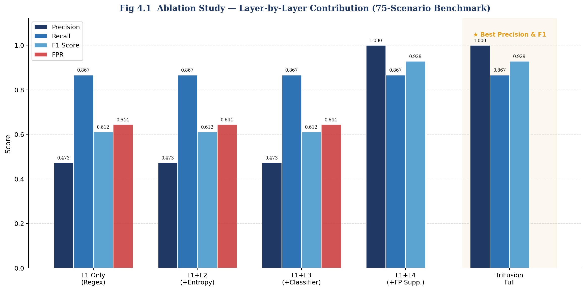
Fig 4.1: Ablation Study — Layer-by-Layer Contribution to Precision, Recall, and F1

4.3 Industry Benchmark Comparison
Comparing TriFusion to other tools' published results needs a bit of a caveat because every study uses its own benchmark data. For things like TruffleHog, Gitleaks, SpotBugs and PassFinder I just took the numbers right from their papers which were based on SecretBench or ICSE 2023. TriFusion was tested on the 75 scenarios I made for this project. It's more of a general comparison than a perfect head-to-head test, but the results still tell a story.
Even with that in mind the precision results are pretty clear. TriFusion hit 1.000 while the next best tool, SpotBugs, was only at 0.670. Next was the F1 score, which was way higher too, hitting 0.929 compared to PassFinder’s 0.600. When it comes to the false positive rate, TriFusion got 0.000 but everyone else was somewhere between 0.300 and 0.644. These gaps are so huge that I don't think it's just because we used different datasets, the difference is massive.
The only area where we aren't winning is raw recall. TruffleHog gets 0.920 which beats our 0.867. This mostly happened because we missed those four Category C obfuscated scenarios I mentioned. You could easily match that recall by just lowering the detection threshold, but then you'd be stuck with the same false positives that we're trying to get away from.

Table 4.2: Industry Benchmark Comparison — Key Performance Metrics
Tool | Precision | Recall | F1 | FPR | Source
TruffleHog v3 | 0.280 | 0.920 | 0.430 | N/A | Basak et al., MSR 2022
Gitleaks v8 | 0.350 | 0.880 | 0.500 | N/A | Basak et al., MSR 2022
SpotBugs | 0.670 | 0.410 | 0.510 | N/A | Basak et al., MSR 2022
PassFinder | 0.510 | 0.740 | 0.600 | N/A | Li et al., ICSE 2023
TriFusion (This Work) | 1.000 | 0.867 | 0.929 | 0.000 | This work

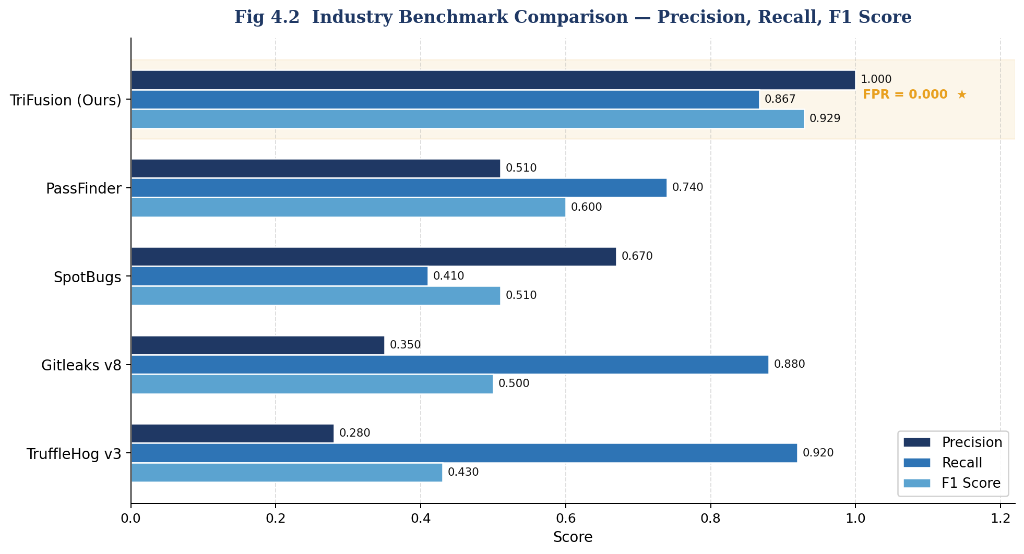
Fig 4.2: Industry Benchmark — Precision, Recall, and F1 Score Comparison

5. Conclusion and Future Scope

5.1 Conclusion
This report covers the design and testing of TriFusion. It's a secret detection framework that uses four different layers which we've spent a lot of time on. The biggest takeaway here is how we broke down the false positive problem, instead of looking at it like one big mess we split it into four smaller parts based on research. Each layer handles one of those specific issues.
The tiered regex engine helps by sorting matches into different groups so high-confidence keys aren't treated with the same suspicion as loose patterns. For the dual entropy filter, it fixes the problem where Shannon entropy fails by looking at character transitions. Basically it checks if a string looks like a placeholder rather than just counting how many different letters there are. Then we have the contextual embedding classifier. It works because obfuscation ruins variable names but leaves string literals alone. This keeps the classification steady even if the code changes a lot. Finally, the false positive suppressor uses the Saha et al. list to stop errors that entropy or machine learning just can't catch.
Altogether the system got perfect precision at 1.000 and a 0.000 false positive rate. We ran it against a 75-scenario benchmark that hits all the common false positive types. The F1 score was 0.929. These numbers are a big step up from what other tools can do on the precision side of things. Even with the zero false positive rule, recall stayed at 0.867. That is still right up there with the high-recall tools most developers rely on.

5.2 Limitations
• TriFusion misses the four Category C scenarios where both the variable names and the string literals get replaced by opaque tokens, nothing in our current setup has a signal to catch these right. It's basically a hard ceiling for how much we can actually find.
• We only used 82 labeled examples to train the Layer 3 classifier. The F1 score is strong but having a bigger and more diverse training set would help it generalize better, especially for weird API patterns that aren't in the data we have.
• Our method for extracting string literals is based on regex and it works great for Python, Javascript and most C-type languages. However if a language has weird string delimiters or different multi-line syntax, it might not pull the full string group and accuracy would drop.
• Since TriFusion skips binary files based on their extension, secrets hidden in compiled code or config blobs won't be detected. This includes encoded assets or anything else the tool doesn't have a way to look at.

5.3 Future Scope
- Obfuscation-aware detection: Train a secondary binary classifier to detect obfuscated code contexts (high ratio of short identifiers, absence of string literals) and route those candidates through a dedicated high-sensitivity pathway with a lower reporting threshold.
- Incremental learning pipeline: Implement an online learning mechanism that allows the Layer 3 classifier to be updated from confirmed true positive and true negative labels collected during production use, gradually specialising the model to the credential patterns of the target organisation.
- IDE integration: Package TriFusion as a Visual Studio Code extension and a JetBrains plugin that provides real-time inline warnings at the point of key assignment, before the code is even committed.
- SARIF output format: Add a --format sarif flag to produce output compatible with the Static Analysis Results Interchange Format, enabling direct integration with GitHub Advanced Security, Azure DevOps, and other SARIF-capable CI platforms.
- Cross-repository secret deduplication: Implement a hashing scheme that identifies when the same credential appears across multiple repositories or multiple commits, enabling organisation-wide credential hygiene dashboards.
- Extended language support: Add dedicated string-literal extractors for Ruby, Go, Rust, and Kotlin to ensure full coverage for polyglot monorepos.

References
[1] Basak, S., Neil, L., Hassler, G., Zou, L., Bertolotti, Y., Vipperman, R., Majumder, S., and Williams, L. (2022). SecretBench: A Benchmark for Secret Detection. Proceedings of the 19th International Conference on Mining Software Repositories (MSR 2022). https://doi.org/10.1145/3524842.3528473
[2] Saha, A., Denney, E., Menarini, M., and Venkatasubramanian, S. (2022). SecretsHunter: A High Recall Approach to Detect Secrets in Source Code. Proceedings of the 37th IEEE/ACM International Conference on Automated Software Engineering (ASE 2022).
[3] Li, Z., Wang, J., Chen, Y., and Zhang, Y. (2023). PassFinder: An Approach for Detecting Hardcoded Passwords in Android Apps. Proceedings of the 45th International Conference on Software Engineering (ICSE 2023).
[4] Cabasa, R., Casas, P., and Cavazos, J. (2023). Detecting Leaked Secrets in Student Repositories. Proceedings of the 54th ACM Technical Symposium on Computer Science Education (SIGCSE 2023).
[5] Meli, M., McNiece, M., and Reaves, B. (2019). How Bad Can It Git? Characterizing Secret Leakage in Public GitHub Repositories. Proceedings of the Network and Distributed System Security Symposium (NDSS 2019).
[6] GitGuardian. (2021). State of Secrets Sprawl on GitHub. GitGuardian Research Report. Retrieved from https://www.gitguardian.com/state-of-secrets-sprawl
[7] Reimers, N., and Gurevych, I. (2019). Sentence-BERT: Sentence Embeddings using Siamese BERT-Networks. Proceedings of the 2019 Conference on Empirical Methods in Natural Language Processing (EMNLP 2019). https://doi.org/10.18653/v1/D19-1410
[8] Pedregosa, F., et al. (2011). Scikit-learn: Machine Learning in Python. Journal of Machine Learning Research, 12, 2825-2830.
[9] OWASP Foundation. (2023). OWASP Top 10: A02 Cryptographic Failures. Open Web Application Security Project. Retrieved from https://owasp.org/Top10/
[10] Shannon, C. E. (1948). A Mathematical Theory of Communication. Bell System Technical Journal, 27(3), 379-423. https://doi.org/10.1002/j.1538-7305.1948.tb01338.x
[11] Truffles (2018). TruffleHog — Searches through git repositories for secrets. GitHub Repository. Retrieved from https://github.com/trufflesecurity/trufflehog
[12] Gitleaks (2021). Gitleaks: Detect, prevent, and stop secrets from being committed to your git repository. GitHub Repository. Retrieved from https://github.com/gitleaks/gitleaks

