

**Artificial Intelligence Project Sample Proposal**

Scroll down to read the first part of this sample. When purchased, the complete sample is 17 pages long and is written using these Proposal Pack chapters:

Cover Letter, Title Page, Table of Contents, Problem Statement, Executive Summary, Cost Summary, Next Steps, Goals and Objectives, Staffing, Applications, Project Management, Time Line, Internet of Things, Machine Learning, Artificial Intelligence, Compatibility, Back Page

This sample was created using **Proposal Pack Computers #5**. In the retail Proposal Pack you get the entire collection of samples (including this one) plus thousands of editable templates for creating an unlimited variety of custom proposals and other business documents.

[Click here to purchase Proposal Pack Computers #5](https://www.proposalkit.com/cgi-bin/checkout.cgi?pcode=446)

The sample below **does not** include all of the sample’s content. The complete version is included in every retail Proposal Pack product and must be purchased to see the rest of the content and to get the editable Word format version.

Read this article for more help - [How to Write an Information Technology Business](https://www.proposalkit.com/htm/how-to-write-an-information-technology-proposal.htm) [Proposal](https://www.proposalkit.com/htm/how-to-write-an-information-technology-proposal.htm)

Melanie and David Nakamura 111 Garden Drive

Palo Alto, CA 94022

Ms. and Mr. Nakamura,

Thank you for showing our team around your beautiful home. It’s a showpiece of sophisticated tastes, and we certainly understand why you entertain prospective clients and friends there. We know you also want it to also be a showcase for how smart technology can enrich your life.

You have already invested in smart devices, but right now, these devices don’t communicate well. That’s kind of like having a large household staff where the servants don’t really talk to each other. You need a manager to take control of them all.

That manager is Asa, our artificial intelligence system. Asa doesn’t take up space in your home, but resides on our servers. You’ll find Asa is a loyal friend and willing servant, able to respond to your needs twenty-four hours a day, seven days a week. And the best thing about Asa is that it learns. The more time you spend with your smart devices and Asa, the more it will be able to anticipate your needs. Information will flow easily between all your devices and Asa, allowing your home to blend seamlessly into the internet of things, where endless data and entertainment is available with voice commands or at the touch of a finger.

We will call you in a few days to set up our next meeting and finalize our contract and schedule. Thank you for contacting AI Now, LLC.

Sincerely,

Logan Black

Residential Project Lead AI Now, LLC.

650-555-5290

[logan@AINow.com](mailto:samples@proposalkit.com) [www.AINow.com](https://www.proposalkit.com/)

PROPOSAL

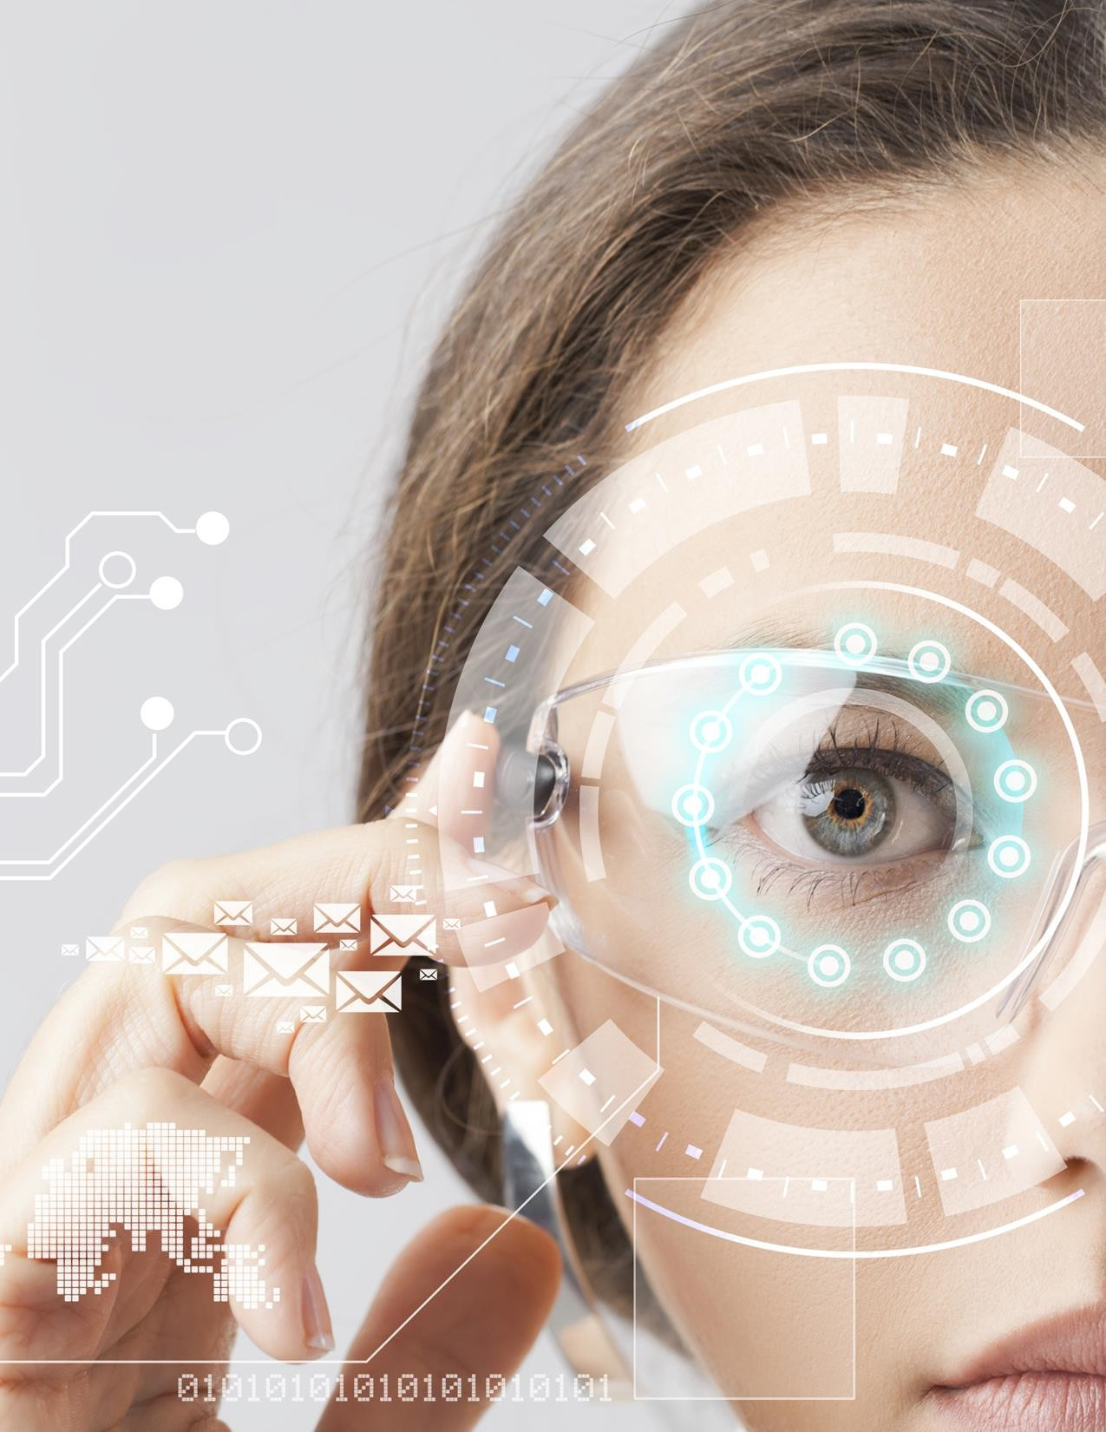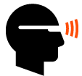

## Proposal to Develop a State-of-the-Art Smart Home with Artificial Intelligence

Prepared for: Melanie Nakamura Homeowners

Prepared by: Logan Black

Residential Project Lead



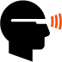TABLE OF CONTENTS

Executive Summary 2

Problem Statement 3

Goals and Objectives 4

Internet of Things 5

Artificial Intelligence 6

Machine Learning 7

Applications 8

Compatibility 9

Staffing 10

Project Management 11

Time Line 12

Cost Summary 13

Next Steps 14

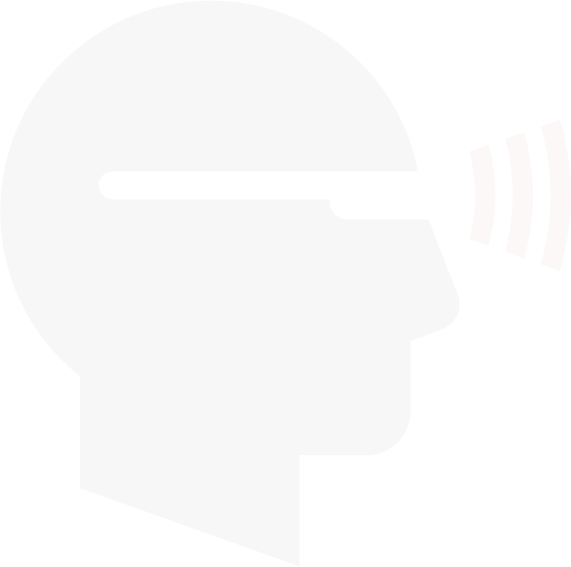



# Page LogoEXECUTIVE SUMMARY

A team from AI Now, LLC. met with homeowners Melanie Nakamura to tour their exquisite home and understand their needs. The following sums up our findings.

### The Objective…

Melanie Nakamura want to create a smart home that doesn’t just wait for their

commands but truly interacts with them. They have the following needs: * Link all smart systems to a central application that can control them. * Provide faster data retrieval of all types of information.

* Use a system that is able to troubleshoot problems and learn what is needed or wanted before being asked.

### The Opportunity…

Asa can meet all the needs listed above.

* Asa will interface with all smart systems to provide one central entity for the homeowners to interact with.

* Through machine learning, Asa will deduce from experience what the homeowners are most likely to need and want.

* Asa will track operations of all smart devices as well as the homeowners’ habits and preferences, and will alert Melanie Nakamura to potential problems and options that have changed or been forgotten.

### The Solution…

Asa, the cloud-based artificial intelligence assistant from AI Now, LLC., can fill the

homeowners’ needs.

* Contract with AI Now, LLC. to link to Asa and set up your initial personal profiles. * Link all smart devices in the home and use Asa as a central control.

* Use Asa to provide all information and record all activity for future reference.



# Page LogoPROBLEM STATEMENT

Entrepreneurs and modern homeowners like Melanie Nakamura need smart devices that make their busy lives easier and more enjoyable, and because they work in the hi-tech world and often entertain prospective clients at home, they want their house to be a showcase for modern technology.

They want all their smart devices to work together to control the household environment, provide entertainment and information, and allow them to order products easily with voice commands or touch screens.

Melanie Nakamura have already purchased and used multiple smart devices for lighting and climate control, security and entertainment, as well as hub devices and listening devices, including Amazon Echo and Google Home.

They have found the smart listening devices to be limited in supplying information, and the hubs don’t always work well with other devices or signal the homeowners when something is wrong. Melanie Nakamura want a system that will learn their habits, identify problems, and generally make their lives easier.





# Page LogoGOALS AND OBJECTIVES

AI Now, LLC. plans to meet the following goals and objectives.

*…we are committed to improving and adapting our artificial intelligence programs and services to keep up with the industry…*

### * Link all smart devices in a central network that can be controlled through cloud- based artificial intelligence

To do this, we will compile a list of all devices to be connected and controlled and

determine the software needed for Asa to monitor and control them all.

### * Set up Asa to automatically control all devices in the home

We will do any customized programming necessary to set up our artificial intelligence system to monitor all devices, make changes when necessary, and to communicate with homeowners Melanie Nakamura.

### * Monitor the project

Our engineers and technicians will continuously monitor the project to study how

well it serves the clients’ needs and to see how Asa is learning.

### * Adapt and improve as needed

Asa is both a research project and a service for clients. We can expect rapid change in technology in coming years, and we are committed to improving and adapting our artificial intelligence programs and services to keep up with the industry.

### Summary

Your commitment to our service will help in the continuing development of artificial intelligence.



# Page LogoINTERNET OF THINGS

The modern world cannot function without the internet. Internet connectivity and functionality is no longer an option in business, education, or everyday life; it’s absolutely essential. Consider the following:

### * People interact more often over the internet now than in person

We’re not talking about just online dating, but also interacting with friends and family through social media, and conducting business meetings and communications over the internet.

### * Most electronic devices today can use internet connections

With modern cameras and microphones and the ability to connect a variety of smart devices to computers, all sorts of data are constantly being uploaded and transmitted through the internet. Even the field of medicine is being revolutionized by the ability to connect a wide array of medical testing devices to computers and transmit data to doctors.

### * Most information is accessed via the internet now

Printed information is expensive and nearly impossible to keep current. All modern teachers and students and commercial enterprises rely on the internet now for most of their information.

### * The internet is becoming the primary source for entertainment and purchasing

Although individuals still go to movie theatres and concerts, those same individuals usually first seek information about movies and music from the internet. They watch and listen to video and audio there, and purchase tickets or download products on the internet. A huge proportion of all shopping is accomplished over the internet now, with even advance orders for groceries going online now. This saves consumers travel time and often saves money, too, as consumers can easily compare prices and see what is in stock before visiting a store.



# Page LogoARTIFICIAL INTELLIGENCE

Can a machine ever be considered intelligent? If it can store data, sort, remember and retrieve information, learn to predict future events, and make a plan for the future, it certainly can. But personality counts, too. Asa shows off its intelligence and personality in the following ways.

### * Asa accesses the entire internet in a flash to find your information

Many smart devices are programmed to act only according to specific instructions, and can provide only the information stored within their programming. Asa listens to all your words, asks questions for clarifications if necessary, then provides answers for you.

### * Asa points out discrepancies and errors in information

Asa not only finds data, but analyzes it for you. For example, many businesses keep standard information static on their web sites, and list temporary changes on their Facebook pages. If you ask Asa about the hours a restaurant is open, it will report the standard hours but also may tell you that according to the restaurant’s more recent update on their Facebook page, the restaurant is currently closed due to a kitchen fire. If statistics in a survey don’t add up, Asa will tell you that, too.

### * Asa can track the operations of hundreds of applications and devices

Asa is an omniscient manager for your home or business. Asa can read much of the code that controls linked devices, so it not only can tell you that a specific device has malfunctioned, it can probably tell you what’s wrong with that device, too.

### * Asa records and learns

Learning is truly the hallmark of artificial intelligence. Asa remembers common sequences of events in your house, so it will query you when there’s a variation. This can alert you to something you forgot or to a developing problem.

### Summary

Asa processes and analyzes information in flash, and it learns from experience. It’s a

state-of-the-art example of modern artificial intelligence.



# Page LogoMACHINE LEARNING

Asa is a prime example of machine learning, which essentially means that Asa can learn on its own by processing data. What can you expect Asa to learn?

### * Common sequences of questions and tasks

For example, if you have asked for a restaurant’s hours and then made a reservation at that restaurant, Asa will remember that. The next time you ask about a restaurant’s hours, Asa will provide that information and then ask if you’d like to make a reservation.

### * Omissions and additions

If you commonly subtract or add items, Asa will remember that. For example, if you order a Cowboy pizza without onions but with extra cheese, the next time you order a pizza, Asa will ask if you want to subtract the onions and add extra cheese.

### * Individual preferences

Asa can learn to distinguish between users, and keep track of what each user prefers. For example, if Melanie has ordered lemon cookies and David has ordered chocolate chip, just tell Asa “Order Melanie’s cookies” and it will verify that you want lemon.

### * Your terminology

You don’t have to learn Asa’s language; it will learn yours. For example, the first time you tell Asa to “Turn down the heat,” it may ask if you mean the hot water temperature or the household thermostat. When you clarify that you mean the thermostat, Asa remembers and will assume that’s what you mean the next time you ask to turn down the heat, clarifying only with a reply like “Reducing thermostat temperature five degrees.”

### Summary

Asa’s ability to learn is what makes it the perfect assistant for you.

The rest of this sample is included in the retail Proposal Packs and Proposal Kit Professional bundle. Purchase any Proposal Pack in the design theme of your choice and you will have everything you need.

## How do I customize or create my own version of this sample?

Using the included Proposal Pack Wizard is the best way to make customized versions of the samples. Using the Wizard and any Proposal Pack you can recreate any of the samples in the visual design theme you purchased as well as branding it with your own logo and design.

1. After purchasing, downloading, and installing your Proposal Pack and Wizard software add a new project in the Wizard.
2. Click the Pick Documents button then click the View Samples tab.
3. Select the title of this (or any other) sample and click the Import Content from Selected Sample button.
4. Customize the chapter list as needed to suit your situation. You can add additional chapters from the library of 2000+ topics, reorder chapters, remove chapters.
5. When you save your project, the Wizard will build you a custom version of this sample in the visual design theme Proposal Pack you purchased applying all your customizations (logos, font types, color schemes, contact information, etc.).
6. Open and edit the Word document to complete your work.

This sample is included in the [Proposal Kit Professional](https://www.proposalkit.com/htm/business-proposal-kit-professional.htm) and [Proposal Pack](https://www.proposalkit.com/htm/business-proposal-templates.htm) products.

This sample has been truncated to only show the first few pages. The complete version of this sample including an editable Word version is included with all Proposal Kit Professional and Proposal Pack products found at:

[ProposalKit.com/htm/proposal-software-products.htm](https://www.proposalkit.com/htm/proposal-software-products.htm)





***Copyright © Proposal Kit, Inc. All rights reserved.***