FREE · THE CONTENT NOTES · AYUMI & MIKE

30 Reel Formats for Coaches
Pick one. Post it every day.
How to use this
- Click File → Make a copy, so this doc is yours to edit.
- Pick ONE format that feels easy for you. Not five. One.
- Fill in the [brackets] with your own clients, numbers and words.
- Post it every day for 30 days. Same format, new topic each day. Tick it off on the tracker at the end.
- After 30 days, look at your top 3 posts. Keep what worked, then add a second format.
Why one format? Your viewers learn what to expect, and you stop wasting time deciding what to film. Filming gets faster every day.

Part 1 · Your day & personality
Let people get to know you. These build trust fastest.

01 What I Eat in a Day
Best for: fitness coaches · Easy · 15 min across the day  FORMULA Time stamp → meal → one tip  Shots One 2-second clip of each meal, with the time on screen.  Text “[7:30 a.m.] [meal] · tip: [one simple tip].”  End “Comment [WORD] for my [grocery list / meal plan].”  Daily “What I eat in a day, Day [X]”, a different tip each day.  Example: “6:45 a.m. Greek yogurt + berries. Tip: get 30 g of protein before 10.” | 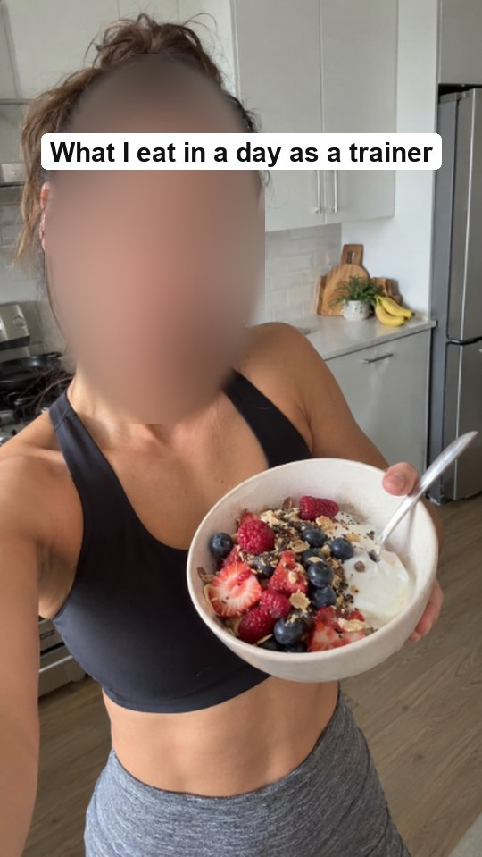  Example frame

02 Workday Eats
Best for: busy fitness coaches · Easy · 10 min  FORMULA Clock time → where you are → what you grab  Shots Real moments between clients: car, gym desk, quick lunch.  Text “[5:00 a.m.] first client. [9:30 a.m.] [snack]. [1:00 p.m.] [lunch].”  End “Busy days still count. [One rule you follow].”  Daily “Coach workday eats, Day [X]”: show the real days, even the messy ones.  Example: “5 a.m. first client in Uptown Dallas. 9:30 protein shake in the car. 1 p.m. chicken bowl.” | 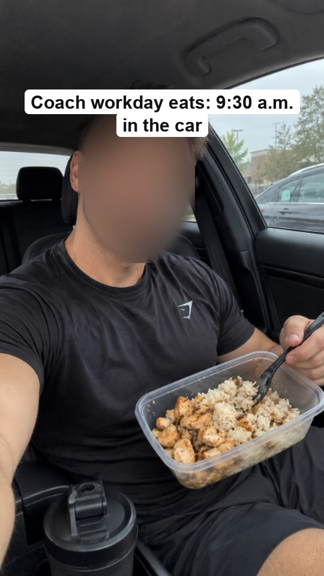  Example frame

03 Car Talk
Best for: both · Easy · 5 min  FORMULA One client question → a straight answer, filmed in the car  0–3s “A client asked me: [real question].”  3–25s Your honest answer in plain words. One reason. One example.  End “Got a question? Comment it and I'll answer it here tomorrow.”  Daily “Car talk #[X]”. The comments give you tomorrow's question.  Example: “A client asked me if she has to quit drinking to lose weight. Here's my honest answer.” |   Example frame

04 Meet the Coach
Best for: both · Easy · 10 min  FORMULA Name + why you coach + you coaching  0–3s “I'm [name], a [type of coach] in [city].”  3–15s B-roll of you coaching. “I help [who] [result].”  15–25s “[Certification / years / clients helped]. [One fun fact].”  Daily Repost it monthly, or do “Meet the coach, part [X]” with one new fact each time.  Example: “I'm Jess, a strength coach in Dallas. I help busy moms get strong in 3 hours a week.” | 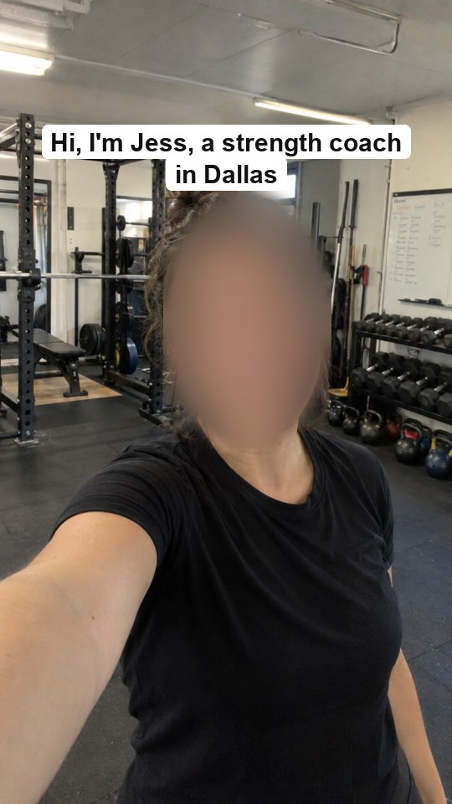  Example frame

05 The “I Build…” Belief Reel
Best for: both · Easy · 10 min  FORMULA 3 bold beliefs over gym B-roll  Text 1 “I don't build [what others sell].”  Text 2 “I build [what you actually build].”  Text 3 “Because [the belief behind it].”  Daily One new belief per day: “What I believe, #[X]”.  Example: “I don't build six-week shreds. I build people who still train at 60.” | 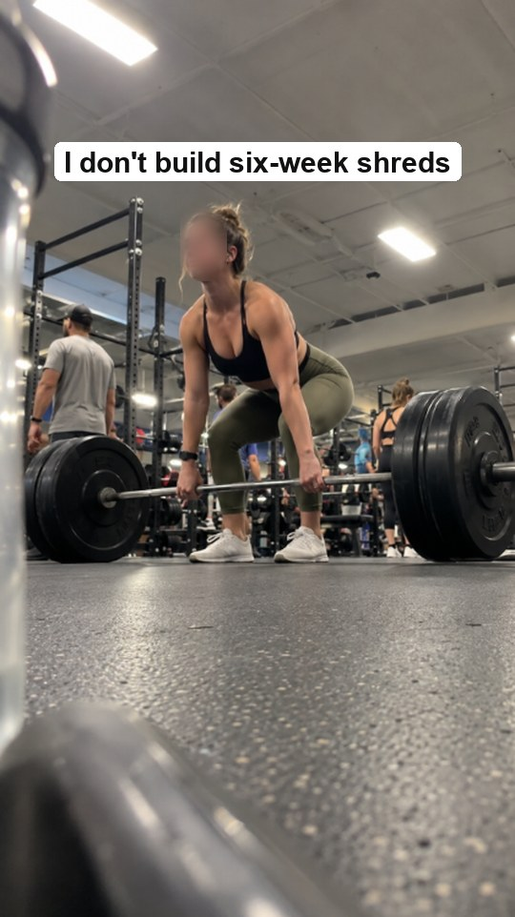  Example frame

Part 2 · Teach something
Useful posts get saved and shared. Saves tell the app to show it to more people.

06 Doing It Wrong → Do This
Best for: fitness coaches · Easy · 10 min  FORMULA Hook (the mistake) → show it → fix it → result  0–3s “If your [exercise] looks like this, [what it's costing you].”  3–12s Show the wrong way, then the right way, side by side.  End “Save this for your next [leg day].”  Daily One exercise a day: “Fix your form, Day [X]”.  Example: “If your squat looks like this, your knees are doing your glutes' job.” | 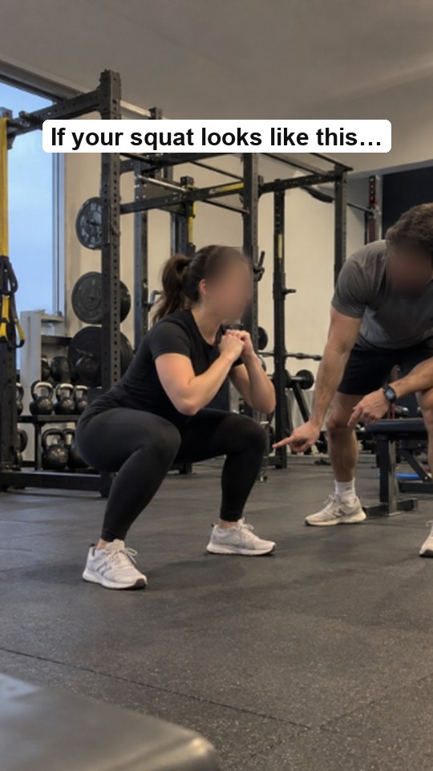  Example frame

07 One Exercise, Three Mistakes
Best for: fitness coaches · Easy · 10 min  FORMULA Name the exercise → mistake 1, 2, 3 → the clean rep  0–3s “3 mistakes I see on [exercise] every week.”  3–20s Show each mistake for 3 seconds with a one-line fix.  End One perfect rep. “Tag your gym partner.”  Daily A new exercise each day for 30 days.  Example: “3 mistakes I see on the Romanian deadlift every single week.” | 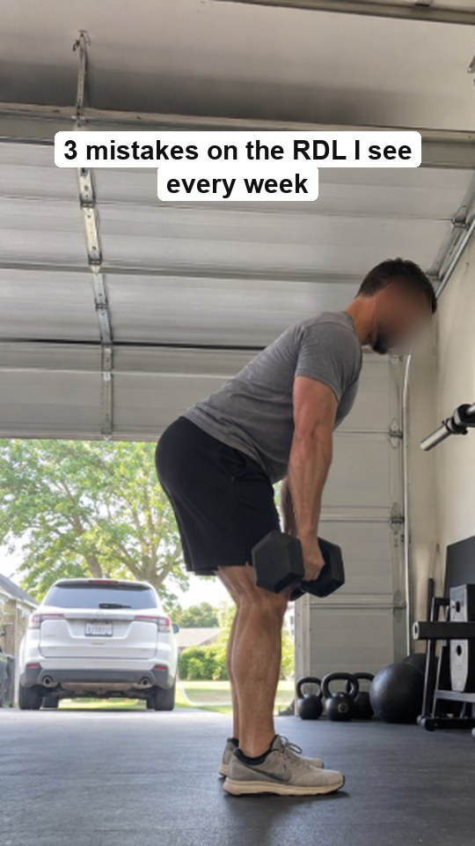  Example frame

08 Swap This for This
Best for: fitness coaches · Easy · 15 min  FORMULA Common choice → better swap → the difference in numbers  0–3s Hold both items. “Swap this… for this.”  3–15s “[Calories / protein] difference: [numbers].”  End “Same taste, [result]. Save this for your next grocery run.”  Daily “Swap of the day #[X]”: grocery store, coffee shop, drive-thru.  Example: “Swap your caramel latte for this. Same sweet hit, 210 fewer calories.” | 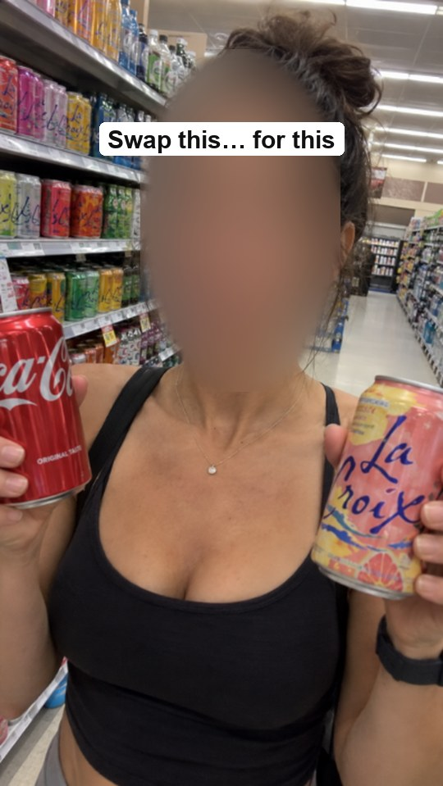  Example frame

09 Reply to a Comment
Best for: both · Easy · 10 min  FORMULA Show the comment on screen → answer it → ask for the next one  0–3s Use the “reply with video” feature so the comment shows.  3–25s Answer like you're talking to that one person.  End “Keep them coming. I answer one every day.”  Daily One comment answered every day. You never run out of ideas.  Example: Comment: “Is cardio a waste of time?” → “Not if you do it like this.” | 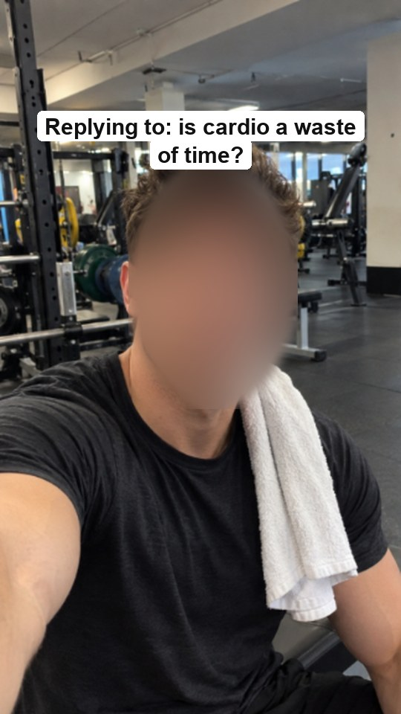  Example frame

10 If I Had to Start Over
Best for: both · Easy · 10 min  FORMULA “If I were starting over today, I'd…” → 3 steps  0–3s “If I had to [lose 20 lb / get my first 10 clients] again, here's exactly what I'd do.”  3–25s Step 1, step 2, step 3, one line each.  End “Follow for the full plan.”  Daily “Starting over, step [X] of 30”: one deeper step each day.  Example: “If I had to get my first 10 coaching clients again, I wouldn't post a single workout.” |   Example frame

Part 3 · Bust a myth
A little pushback gets comments. Keep it kind, and always give the better answer.

11 Myth vs Truth
Best for: both · Easy · 10 min  FORMULA “Myth: [belief].” → “Truth: [reality].” → proof  0–3s Text: “Myth: [what people believe].”  3–15s “Truth: [what's real].” One study, number or client story.  End “What myth should I bust next?”  Daily “Myth #[X] of 30”.  Example: “Myth: lifting makes women bulky. Truth: it takes years of trying to get bulky.” | 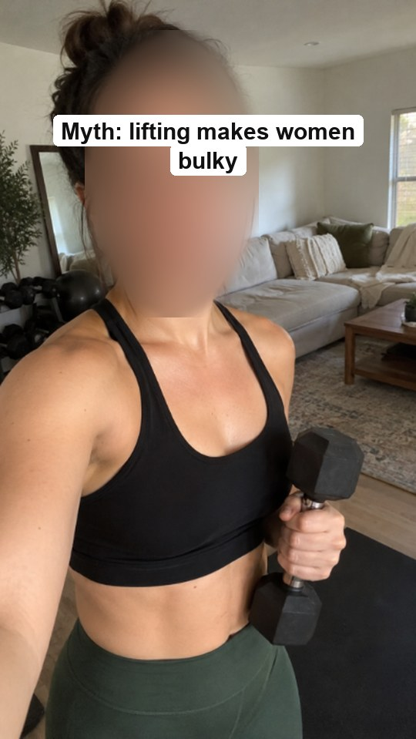  Example frame

12 The Reframe
Best for: both · Easy · 10 min  FORMULA “[Thing people blame] isn't the problem. [Real reason] is.”  0–3s Say the hook.  3–20s A client story that proves it.  End “Send this to someone who still blames [thing].”  Daily A new “it's not X, it's Y” each day.  Example: “Your metabolism isn't broken. Your weekends are.” |   Example frame

13 React to Viral Advice
Best for: both · Medium · 15 min  FORMULA Viral clip behind you (green screen) → rate it → better advice  0–3s “This went viral. Is it true?”  3–20s Pause the clip. Say what's right, what's wrong.  End “Here's what I'd tell my clients instead: [advice].”  Daily “Coach reacts, Day [X]”. There's always new advice to react to.  Example: “Over 2 million people saw this ‘no-carb’ tip. Here's why my clients don't do it.” |   Example frame

14 Unpopular Opinion
Best for: both · Easy · 5 min  FORMULA “Unpopular opinion: [take].” → why → what to do  0–3s Text and voice: “Unpopular opinion: [take].”  3–20s Your reason, from real coaching.  End “Agree or disagree? Tell me below.”  Daily One opinion a day. The debate in the comments helps the post spread.  Example: “Unpopular opinion: you don't need to work out every day to see results.” |   Example frame

15 Things I'd Never Do as a Coach
Best for: both · Easy · 10 min  FORMULA “Things I'd never do as a [coach]:” → 3 quick ones  0–3s Say the hook.  3–20s 3 things, a short reason for each, over B-roll of you working.  End “What would you add?”  Daily “Things I'd never do, #[X]”: one a day, with more detail.  Example: “Things I'd never do as a trainer: sell you fat burners.” |   Example frame

Part 4 · Proof & client stories
Results sell coaching. Always ask your clients first before you show them.

16 Numbered Client Series
Best for: both · Easy · 5 min a day  FORMULA “One client, one transformation, Day [X]”  0–3s Text: “[Client first name], Day [X].”  3–15s Today's session or check-in, plus one number (weight, reps, steps, revenue).  End “Follow to see Day [X + 1].”  Daily This IS the daily series. Viewers come back to see what happens next.  Example: “Maria, Day 12. Deadlift up from 95 to 135 lb. She cried. I cried.” | 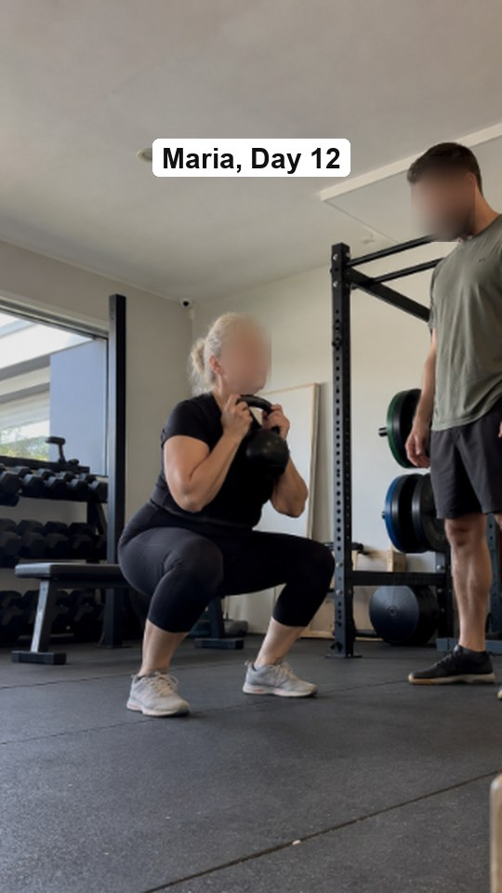  Example frame

17 Class Recap
Best for: fitness coaches · Easy · 10 min  FORMULA Real session clips → client name tags → tomorrow's class  Shots 5–6 quick clips of the class, with first names on screen (ask first).  Text “[Day]'s [class name]: [the workout in one line].”  End “Join us [day, time] at [place].”  Daily Recap every class you teach. It's free proof that people show up.  Example: “Saturday 8 a.m. bootcamp at White Rock Lake: 14 people, 400 burpees, zero quitters.” | 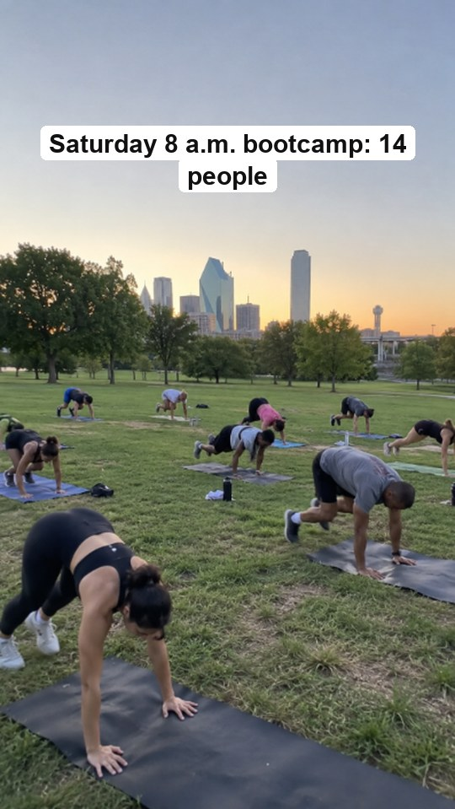  Example frame

18 Read a Client Message
Best for: both · Easy · 5 min  FORMULA Client text on screen → your reaction → what led to it  0–3s Show the message (name hidden or with permission).  3–20s “Here's what we changed to get here: [one thing].”  End “Want messages like this? Link in bio.”  Daily “Client win of the day”.  Example: “‘I fit into my wedding dress from 2015.’ Here's the one habit that did it.” | 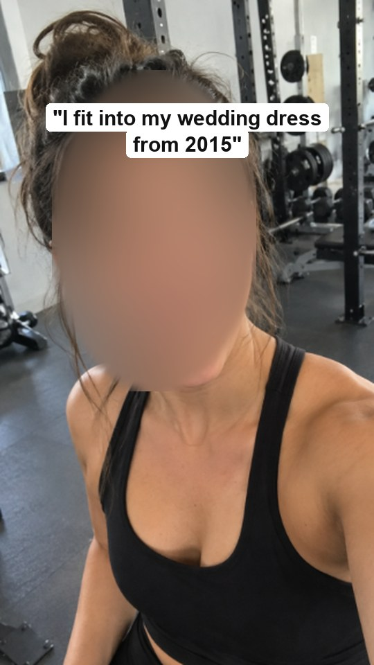  Example frame

19 Day 1 vs Day 90
Best for: both · Easy · 10 min  FORMULA Day 1 clip → Day 90 clip → the one thing that changed  0–3s Day 1 clip: same exercise, same angle.  3–8s Day 90 clip.  End “The difference: [the change].”  Daily Film Day 1 of every new client now, so you have 30 of these later.  Example: “Day 1: couldn't do one push-up. Day 90: 15. The difference: 5 push-ups every morning.” | 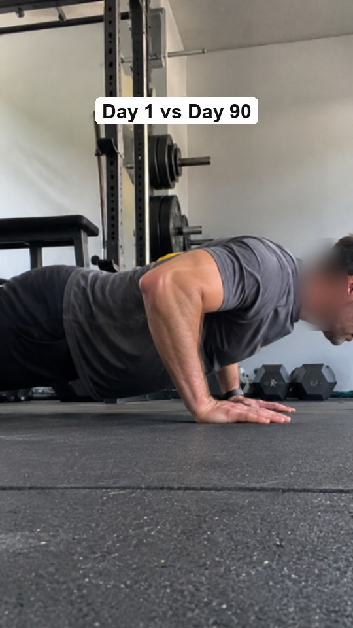  Example frame

20 Client Wins Friday
Best for: both · Easy · 15 min  FORMULA “This week's wins:” → 3–5 quick wins → CTA  0–3s “3 client wins from this week.”  3–25s One line each, over photos or clips.  End “Next week could be you. Link in bio.”  Daily A weekly anchor. On other days, post one win a day.  Example: “This week: Tom ran his first 5K, Lisa hit 100 kg, Sam slept 8 hours for a whole week.” | 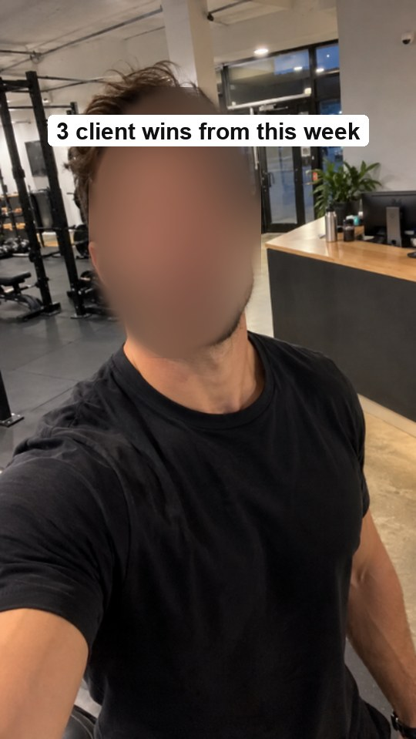  Example frame

Part 5 · Local & community
Local posts reach people who can actually train with you. Say your city and the place's name.

21 Spot of the Week
Best for: fitness coaches · Easy · 15 min  FORMULA Local place → why you love it → a quick workout there  0–3s “The best [park / trail / stairs] for a workout in [city].”  3–20s A 3-move workout you can do there.  End “Where should I go next?”  Daily “[City] workout spots, #[X]”.  Example: “The best stairs in Dallas for a workout: Reverchon Park. Try this 10-minute finisher.” | 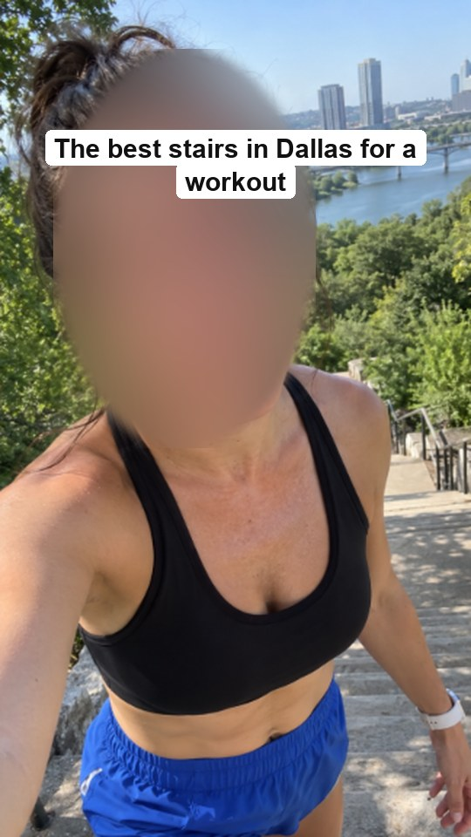  Example frame

22 Run Club or Group Recap
Best for: fitness coaches · Easy · 10 min  FORMULA Meet-up → the run or workout → the hangout after  Shots Arriving, warm-up, the run, coffee after.  Text “[Number] people, [distance], [day, time], [place].”  End “Free to join. See you [next day].”  Daily Recap every meet-up. Each one shows newcomers it's friendly.  Example: “42 people, 5K at Katy Trail, then tacos. Every Thursday, 6:30 p.m.” | 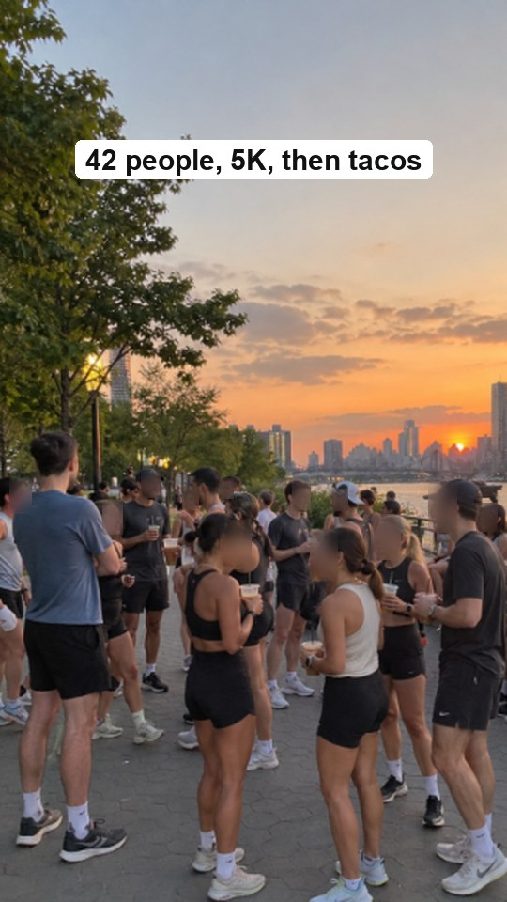  Example frame

23 Local Event Countdown
Best for: both · Easy · 10 min  FORMULA “[X] days until [local event]” → today's prep tip  0–3s “[X] days until [the race / event].”  3–20s One tip for today.  End “Training for it too? Comment ‘me’.”  Daily Count down daily: you get 30 posts out of one event.  Example: “30 days until the Dallas Turkey Trot. Today: buy your shoes now, not race week.” | 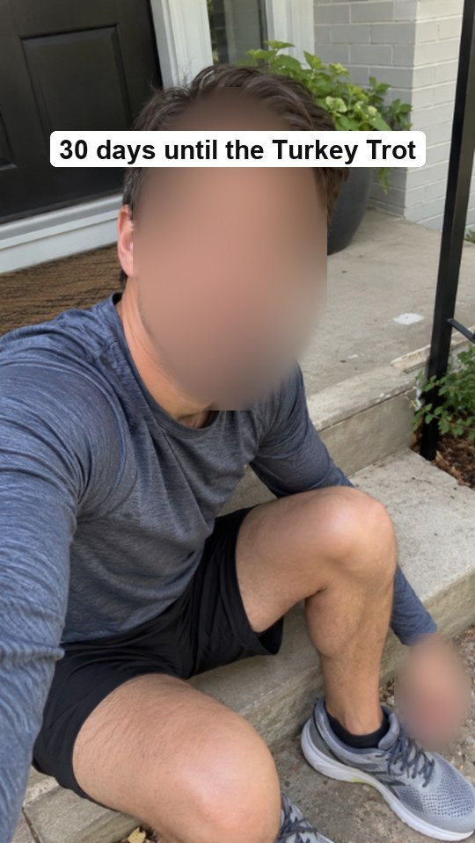  Example frame

24 Studio or Gym Walkthrough
Best for: both · Easy · 10 min  FORMULA Walk in the door → 3 spots → what happens there  0–3s “Come inside [gym name] with me.”  3–20s 3 spots, one line each.  End “Your first session is [offer]. Link in bio.”  Daily “A corner of my gym, #[X]”: one spot, one story a day.  Example: “Come inside our studio in Deep Ellum. This is the corner where 60-year-olds deadlift.” |   Example frame

25 Local Business Shout-out
Best for: both · Easy · 10 min  FORMULA A local spot you love → why → tag them  0–3s “My go-to [meal / smoothie] in [city] after training.”  3–15s Show it, and say why it fits your plan.  End Tag them. They'll often share it with their followers.  Daily One local favorite a day: food, physio, shoes, coffee.  Example: “My go-to post-workout bowl in Dallas, and why it has the protein my clients need.” | 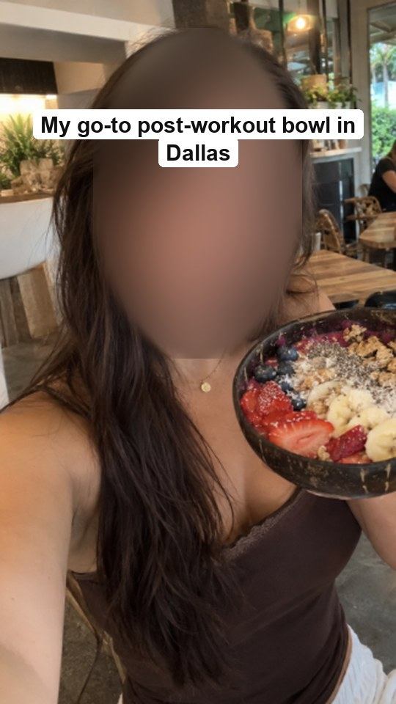  Example frame

Part 6 · Soft-sell your coaching
Selling works best as help, not as an ad. Post these about once a week alongside the other formats.

26 What a Session Really Looks Like
Best for: both · Easy · 10 min  FORMULA Arrival → warm-up → main work → check-out, in 20 seconds  Shots One clip of each part of a real session (ask first).  Text Name each step in a few words.  End “This is what [price / week] gets you. Questions? DM me.”  Daily “A real session, Day [X]”: a different client or goal each day.  Example: “What a 45-minute session with me actually looks like. No yelling, I promise.” | 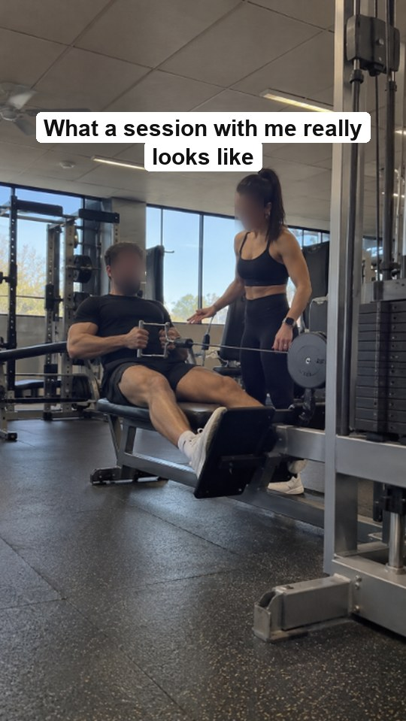  Example frame

27 Spots Open
Best for: both · Easy · 5 min  FORMULA “I have [X] spots for [month].” → who it's for → how to apply  0–3s Say the hook.  3–15s “It's for [who]. You'll get [what].”  End “Comment ‘SPOT’ and I'll send you the details.”  Daily Count down the spots: “3 left… 2 left…”, and keep it honest.  Example: “I have 3 coaching spots for January, for busy dads who want to drop 20 lb.” |   Example frame

28 Comment for the Plan
Best for: both · Easy · 10 min  FORMULA A useful tip → “Comment [WORD] for the full [plan]”  0–3s Tease the result: “The [plan] that [result].”  3–20s Show part 1 for free.  End “Comment [WORD] and I'll DM you the rest.”  Daily One freebie a week, and daily tips from inside it.  Example: “The 4-week plan that got my client to 10 pull-ups. Comment PULL for the full plan.” | 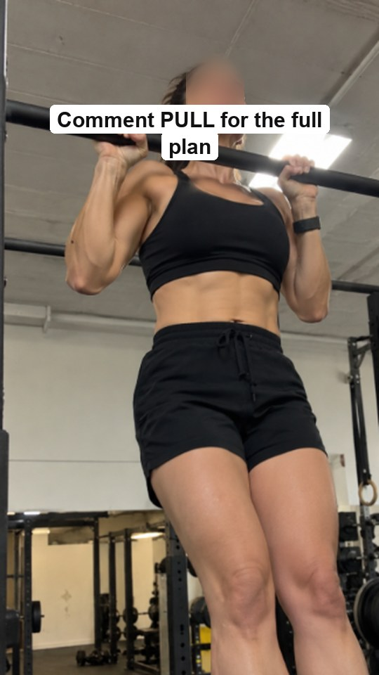  Example frame

29 Who This Is NOT For
Best for: both · Easy · 5 min  FORMULA “Don't hire me if…” → 3 points → who it IS for  0–3s “Don't hire me if you want [quick fix].”  3–15s 2 more “not for you if…” points.  End “But if you want [real result], we'll get along.”  Daily Swap in one new “not for you if” each day.  Example: “Don't hire me if you want to lose 20 lb in 2 weeks.” |   Example frame

30 Ask Me Anything
Best for: both · Easy · 15 min  FORMULA Question box in Stories → answer 3 on Reels  Before Post a question box in Stories in the morning.  0–25s Answer 3 quick questions, one line each.  End “Ask me anything for tomorrow's round.”  Daily Daily Q&A: your followers write your content.  Example: “You asked, I answered: Is creatine safe? Do I need a gym? How long until I see abs?” | 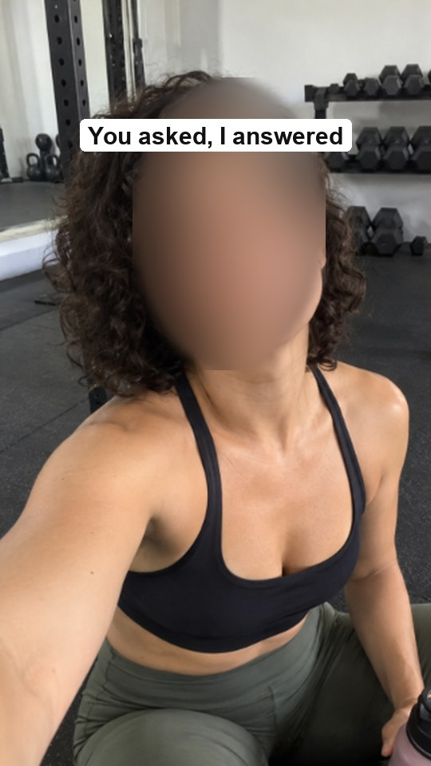  Example frame

Your 30-day tracker
My format: _______________________________
Tick each day you post. Write the topic and views after 48 hours.
Day | ✓ | Topic | Views | Saves
1
2
3
4
5
6
7
8
9
10
11
12
13
14
15
16
17
18
19
20
21
22
23
24
25
26
27
28
29
30
Made with care by Ayumi & Mike · The Content Notes · @ayumiandmike

