公共地域政策論

Ayumu Tanaka

2022-06-14

# 棒グラフと散布図

library(readxl)  
asia <- read_excel("asia.xlsx")  
barplot(asia$ctfp,names.arg = asia$countrycode)

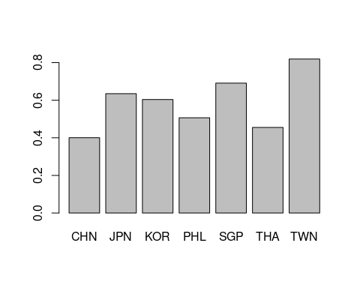

barplot(asia$pop,names.arg=asia$countrycode)

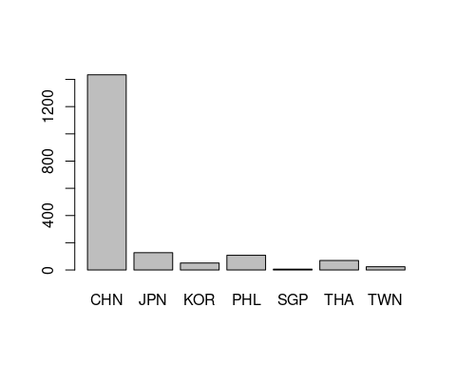

plot(asia$pop,asia$rgdpe)

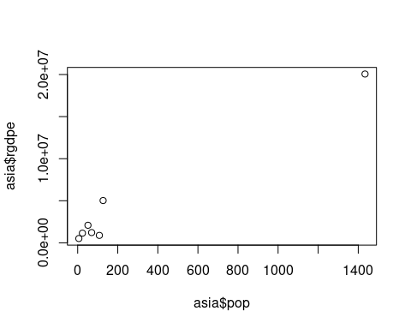

plot(asia$pop,asia$rgdpe,log="xy")

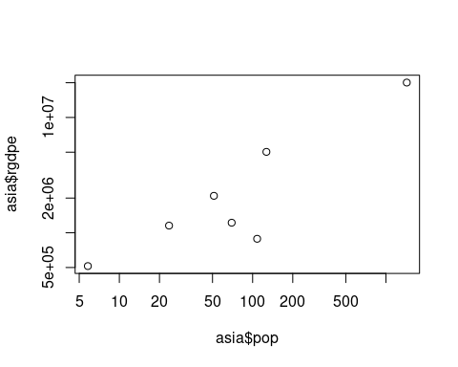

plot(asia$pop,asia$rgdpe,log="xy",pch=4)

