公共地域政策論（国際）

田中 鮎夢

2023-04-10

# 四則演算

3+3

## [1] 6

3-3

## [1] 0

3*3

## [1] 9

3/3

## [1] 1

# データ読み込み

library(readxl)  
asia <- read_excel("asia.xlsx")  
head(asia)

## # A tibble: 6 × 10  
## countrycode country year rgdpe pop ctfp percapitaGDP oecd G7 asia  
## <chr> <chr> <dbl> <dbl> <dbl> <dbl> <dbl> <dbl> <dbl> <dbl>  
## 1 CHN China 2019 2.01e7 1.43e3 0.400 13988. 0 0 1  
## 2 JPN Japan 2019 5.03e6 1.27e2 0.635 39637. 1 1 1  
## 3 KOR Republic… 2019 2.09e6 5.12e1 0.604 40819. 1 0 1  
## 4 PHL Philippi… 2019 8.87e5 1.08e2 0.507 8205. 0 0 1  
## 5 SGP Singapore 2019 5.14e5 5.80e0 0.691 88619. 0 0 1  
## 6 THA Thailand 2019 1.22e6 6.96e1 0.455 17558. 0 0 1

# 棒グラフ（人口と生産性）

barplot(asia$pop, names.arg=asia$countrycode)

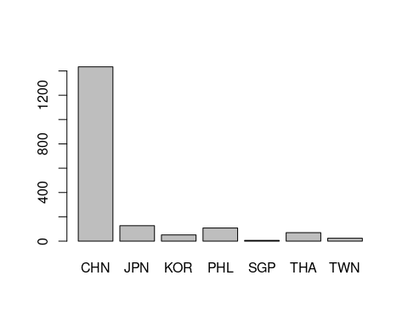

barplot(asia$ctfp,names.arg = asia$countrycode)

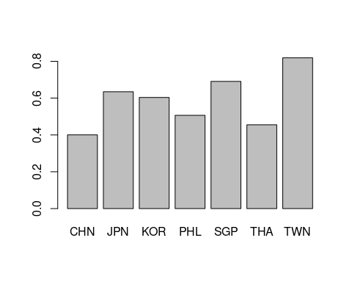

# 散布図（人口とGDP）

plot(asia$pop,asia$rgdpe,log = "xy",xlab="Population",ylab="GDP")

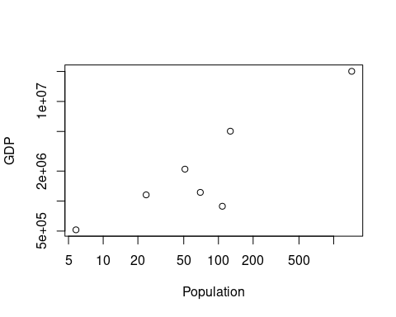

ols<-lm(asia$rgdpe ~ asia$pop)  
summary(ols)

##   
## Call:  
## lm(formula = asia$rgdpe ~ asia$pop)  
##   
## Residuals:  
## 1 2 3 4 5 6 7   
## -78765 2386665 461636 -1503740 -506974 -653091 -105731   
##   
## Coefficients:  
## Estimate Std. Error t value Pr(>|t|)   
## (Intercept) 943660 572257 1.649 0.16   
## asia$pop 13385 1047 12.785 5.21e-05 ***  
## ---  
## Signif. codes: 0 '***' 0.001 '**' 0.01 '*' 0.05 '.' 0.1 ' ' 1  
##   
## Residual standard error: 1332000 on 5 degrees of freedom  
## Multiple R-squared: 0.9703, Adjusted R-squared: 0.9644   
## F-statistic: 163.5 on 1 and 5 DF, p-value: 5.208e-05

plot(asia$pop,asia$rgdpe,xlab="Population",ylab="GDP")  
abline(ols)

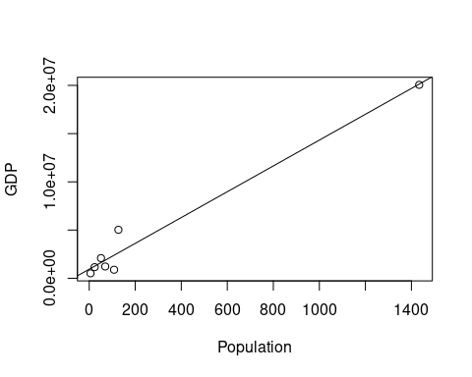

# 回帰分析

model <- lm(asia$rgdpe ~ asia$pop)  
summary(model)

##   
## Call:  
## lm(formula = asia$rgdpe ~ asia$pop)  
##   
## Residuals:  
## 1 2 3 4 5 6 7   
## -78765 2386665 461636 -1503740 -506974 -653091 -105731   
##   
## Coefficients:  
## Estimate Std. Error t value Pr(>|t|)   
## (Intercept) 943660 572257 1.649 0.16   
## asia$pop 13385 1047 12.785 5.21e-05 ***  
## ---  
## Signif. codes: 0 '***' 0.001 '**' 0.01 '*' 0.05 '.' 0.1 ' ' 1  
##   
## Residual standard error: 1332000 on 5 degrees of freedom  
## Multiple R-squared: 0.9703, Adjusted R-squared: 0.9644   
## F-statistic: 163.5 on 1 and 5 DF, p-value: 5.208e-05

library(modelsummary)  
library(ggplot2)  
library(flextable)  
modelsummary(model, stars = TRUE)

|  | (1) |
| --- | --- |
| (Intercept) | 943659.767 |
|  | (572257.202) |
| asia$pop | 13384.984*** |
|  | (1046.895) |
| Num.Obs. | 7 |
| R2 | 0.970 |
| R2 Adj. | 0.964 |
| AIC | 220.9 |
| BIC | 220.8 |
| Log.Lik. | -107.470 |
| RMSE | 1125766.22 |
| + p < 0.1, * p < 0.05, ** p < 0.01, *** p < 0.001 | |

modelplot(model)

