Vaidya AI
RAG SYSTEM · TECHNICAL HANDOVER
03

Software Architecture Document
System structure, technology choices and component interactions
DOCUMENT / APPLICATION Version 1.0 / VedAI 0.7.0
PREPARED 11 November 2026
AUDIENCE Architecture & engineering
STATUS Handover draft · source verified
Repository: github.com/AmRitJain0442/vedai
Source revision: 73beef60490f97bfbd2902db152ff99a6484456d

Contents
1. Purpose and document control
2. System overview and scope
3. Architecture and trust boundaries
4. Technology stack
5. Repository and component structure
6. Frontend architecture
7. Ingestion and data-build architecture
8. Request processing and RAG interactions
9. Retrieval modes and ranking decisions
10. Runtime topology, security and state
11. Quality attributes and operational constraints
12. Verification and receiving-team actions
13. Source references and change map
Prepared from the pinned implementation. Local corpus, default retrieval and UI were verified. Live hosting and paid model generation were not revalidated. See the verification record for scope.

1. Purpose and document control
This document describes the implemented architecture of Vaidya AI, the reading-room application maintained in the VedAI repository. It supports technical handover, change impact analysis, operational ownership, and onboarding. Product branding is Vaidya AI; the Python package, CLI, deployment paths, and systemd units retain the name vedai.
Control | Value
Document ID | VAI-HO-03
Document version | 1.0 — implementation-based handover draft
Prepared | 11 November 2026
Application version | 0.7.0
Repository | https://github.com/AmRitJain0442/vedai
Inspected commit | 73beef60490f97bfbd2902db152ff99a6484456d
Intended audience | Maintainers, architects, backend/frontend engineers, operations
Evidence boundary | Source inspected and local retrieval verified; hosted infrastructure and paid generation not revalidated
Acceptance | Repository owner and receiving maintainer review required; no approval is implied

The other documents in this package cover API contracts (04), data storage (05), installation and operations (06), and user workflows (07). Implementation statements describe the pinned commit. Items explicitly called recommendations or future work are not shipped capabilities.

2. System overview and scope
Vaidya AI searches a pinned collection of historical Sanskrit Ayurveda texts, retrieves complete source units, and optionally asks a hosted language model to produce structured, cited readings and translations. It is a single-process application with a batch ingestion pipeline. The browser, Python API, local data files, and optional external model services form the principal boundaries.
The default retrieval mode is vocabulary-expanded BM25 over a normalized trigram index. Consequently, a configured language model or vector database is not required to search the collection. Semantic and hybrid modes are implemented as optional experimental alternatives. Hosted generation uses an OpenRouter adapter; local Ollama supplies embeddings only when vector features are used.
The application implements source browsing, English/Hindi/Sanskrit answer selection, search preferences, query-topic display, browser sessions, bounded follow-ups, and asynchronous job polling. The repository does not implement corpus upload through the UI, user registration, per-user server history, a distributed queue, token streaming, or a clinical decision engine. Historical statements and generated interpretations remain subject to expert review.

3. Architecture and trust boundaries
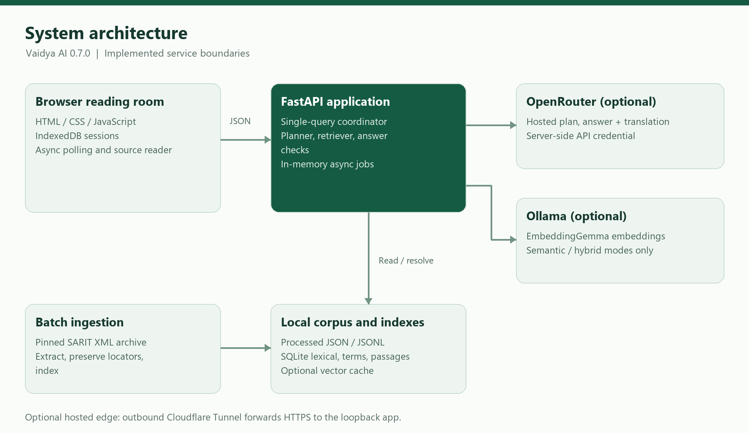
Figure 3.1 — The browser stores sessions locally. FastAPI coordinates retrieval, source resolution, and optional generation. The data build pipeline runs separately from normal reading requests.
Boundary | Responsibilities | Data crossing the boundary
Browser ↔ FastAPI | Serve UI; ask questions; return readings and source data; poll jobs | Question, filters, answer language, up to four prior questions/summaries; reading JSON
FastAPI ↔ local files | Search indexes; resolve exact source units; validate build manifests | SQL queries, source hashes, stored Sanskrit and locator payloads
FastAPI ↔ OpenRouter | Optional planning and answer/translation generation | Current question, bounded conversation, search topics, selected source text
Retriever ↔ Ollama | Optional embedding creation and semantic query embedding | Source-title/text batches or prefixed query text; numeric vectors
Ingestion ↔ SARIT | Download pinned archive and retain provenance | Upstream corpus archive, XML files, per-file hashes
Deployment ↔ Cloudflare | Outbound demo tunnel to loopback application | HTTPS user traffic forwarded to 127.0.0.1:8765

API credentials stay on the server. Browser session records do not become a server-side history database. A follow-up nevertheless transmits selected prior user questions and bounded answer summaries to the API and, when configured, its model provider.

4. Technology stack
Area | Implemented technology | Version or constraint | Role
Runtime | Python | ≥3.10 | Pipeline, retrieval, API, model adapters
Package/build | setuptools; pyproject.toml | setuptools ≥61 | Wheel/build metadata and CLI entry point
API | FastAPI | ≥0.115,<1 | Routes and request validation
Validation | Pydantic | Transitive dependency of FastAPI | Field bounds and request models; not directly pinned
HTTP server | Uvicorn | ≥0.30,<1 | Loopback ASGI server
Search storage | SQLite FTS5, JSON functions | Supplied by Python SQLite build | Lexical/trigram retrieval; JSON metadata filters
Numerical retrieval | NumPy | ≥1.26,<3 | Normalized float32 matrices; exact cosine scoring
Script conversion | indic-transliteration | ≥2.3,<3 | Devanagari/IAST normalization and display
Frontend | HTML, CSS, JavaScript | Browser native; no npm build | Responsive reading room and session UI
Browser storage | IndexedDB and sessionStorage | Browser native | Full session records; current-tab session selection
Hosted generation | OpenRouter chat-completions HTTP API | Model configurable | Strict JSON-schema planning and answers
Optional embeddings | Ollama; EmbeddingGemma | Model family checked by code | Local embedding build and query embedding
Tests | unittest, httpx, optional Playwright | httpx ≥0.27,<1 | Unit/API tests and browser checks
Documented hosting | Debian 12, systemd, GCP VM, cloudflared | cloudflared 2026.9.1 in bootstrap script | Recorded deployment arrangement

There is no dependency lockfile in this snapshot. These constraints describe repository requirements, not a guarantee of compatibility with every future dependency release. There is no React/Next.js service, Node build, PostgreSQL instance, or hosted vector service in the implemented architecture.

5. Repository and component structure
Path | Responsibility | Important interaction
vedai/__main__.py | CLI commands; Uvicorn startup | Dispatches batch tasks or creates the web app
vedai/corpus.py | Archive download, TEI extraction, chunk construction | Creates manifests and processed JSON/JSONL artifacts
config/ayurveda.json | Selected works and titles | Controls the 15-work ingestion selection
vedai/search.py | FTS5 lexical index and baseline search | Reads normalized chunk rows and original JSON payloads
vedai/terminology.py | Script normalization, draft vocabulary, trigram search | Reads ayurveda_terms.json; maintains terms manifest
vedai/retrieval.py | Retrieval modes, embeddings, rank fusion | Uses SQLite/NumPy and optional Ollama
vedai/passages.py | Complete verse/prose grouping and source lookup | Maps segment IDs to full passages; calculates term overlap
vedai/query_planner.py | Local/hosted search planning; search fan-out | Merges topic, original-question, and source-guide candidates
vedai/source_guides.json | Topic-specific navigation ranges | Selects stored adjacent passages without inventing evidence
vedai/answers.py | Provider adapter, structured answer contract, citation/translation validation | Resolves model-selected IDs to stored Sanskrit
vedai/clinical.py | Question types, claim bases, findings validation, output guidance | Separates textual evidence, interpretation, and case context
vedai/scripts.py | Deterministic Devanagari rendering | Adds display text without modifying stored citation text
vedai/server.py | HTTP API, middleware, single-query gate, ephemeral jobs | Coordinates all runtime components
vedai/settings.py | Restricted .env parser | Loads only three supported OpenRouter keys
vedai/static/ | UI markup, styles, artwork and browser scripts | Same-origin calls; no separate frontend runtime
vedai/evaluation.py, vedai/verify.py | Retrieval metrics and artifact integrity | Produce machine-readable reports
deploy/ | Package, bootstrap, install, update and service files | Operates a dedicated Linux VM deployment
tests/, eval/, reports/ | Regression checks, draft evaluations, recorded results | Review material rather than runtime evidence sources

6. Frontend architecture
index.html defines the question composer, search-preferences popover, landing suggestions, search-topic area, answer/source panels, sessions dialog, and source-reader dialog. style.css supplies the viewport-contained desktop layout and narrow-screen switches. app.js owns view state, input handling, request polling, result rendering, source navigation, and follow-up construction. sessions.js encapsulates IndexedDB persistence with a memory fallback.
At startup the browser concurrently requests /works and /health and opens vedai-sessions. It populates the work selector, restores or creates a session, and enables the composer. A submitted question is saved as a pending turn, sent to /ask with Prefer: respond-async, and polled through /jobs/{id}. The completed response is saved in its originating session before being rendered. A reading that completes after a session switch remains associated with its original session.
Full answers, citations, translations, locators, preferences, and job IDs reside in browser session records. Only the last four completed turns provide follow-up context; each outgoing answer summary is capped at 2,000 characters. Reopening an older reading does not move the context window back to that reading. Rendering uses DOM nodes and textContent rather than interpreting model text as HTML.

7. Ingestion and data-build architecture
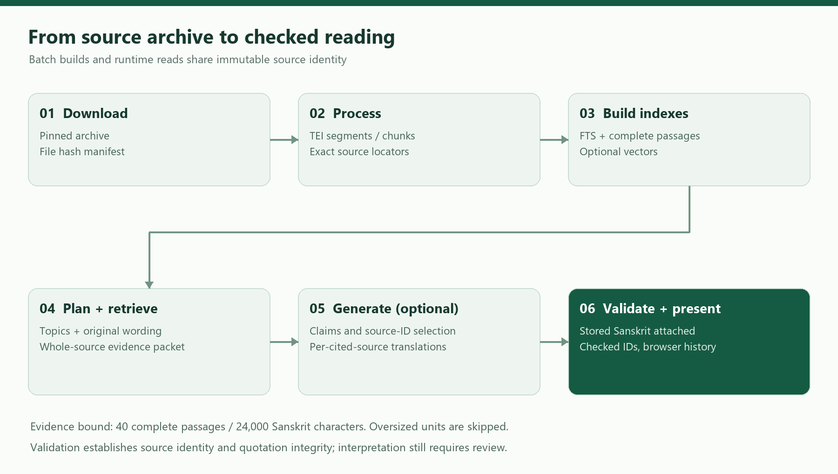
Figure 3.2 — Batch ingestion preserves locators and source text; runtime retrieval supplies bounded evidence to generation.
- Download: fetch the archive for SARIT revision 1eac9ee0b055c8d11147edac4a75c76008ccc363, validate archive paths and record hashes. The full archive contains 110 files, including 88 XML files.
- Process: parse the 15 selected works, retain TEI headers, section ancestry, XML IDs, page markers and language/layer tags. Prefer lemmas over variant readings and retain gaps under the extraction policy. Verify normalized body-text coverage.
- Segment: emit 145,600 nonempty units, including headings and notes. Missing source language remains und.
- Chunk: exclude headings and notes, split at a maximum of 1,800 characters, and preserve work, section, language and layer boundaries. Every reference records segment offsets. The verified snapshot contains 26,585 chunks.
- Index: create lexical FTS5 and normalized trigram databases. Build full passage units and segment-to-passage mappings. The passage snapshot contains 111,195 complete source units.
- Optional embed: call local EmbeddingGemma in batches, normalize vectors, cache completed rows, and record corpus/model/prompt identity. Manifest incompatibility requires an explicit rebuild into a consistent dataset.
Segment IDs depend on pinned revision, filename, and XPath; chunk IDs depend on serialized references; passage IDs depend on passage version and member segment IDs. They are 24-character SHA-256 prefixes, not verse numbers. Reprocessing after source or grouping changes can change IDs.

8. Request processing and RAG interactions
- Validate question, work filter, language, limits, and conversation shape. Acquire the nonblocking, process-local query lock. A concurrent /ask receives HTTP 429.
- Lazily construct Retriever and PassageStore. Constructors validate relevant manifests and source hashes. The passage store may create a source-locator expression index.
- Build a local plan. If generation and enhancement are enabled and a provider is configured, request a strict hosted plan of one to four topics and one to six terms per topic. Invalid/unavailable planning falls back locally without an automatic paid retry.
- Search each topic with unchanged filters. When no layer is selected, interleave base-text candidates. After successful hosted enhancement, independently search the original question. Local planning operates on the current question.
- Resolve chunk references into complete passages. Source guides may add exact stored adjacent passages and reserve up to 24 candidate slots before the final fair merge. Guides provide navigation context, not proof of relevance.
- Deduplicate by passage ID and combine search topics. Assemble at most 40 complete passages within 24,000 Sanskrit characters. Oversized units are skipped rather than clipped. The API limit controls retrieval breadth per search; it does not cap a successful generated reading to that many citations.
- If generation is disabled or unconfigured, return retrieved sources and a descriptive generation status. Otherwise send the evidence packet and bounded conversation to OpenRouter for structured claims, findings and per-cited-source translations.
- Resolve selected evidence IDs to exact stored Sanskrit. Reject unknown IDs, malformed claims, unsupported citation structure, invalid findings, and missing/duplicate/uncited translation entries. Return withheld-generation states when validation fails.
- Attach deterministic Devanagari display, stored locators, query-plan coverage and stage timings. Persist only the temporary async result on the server; the browser saves its own complete reading.
The provider timeout defaults to 180 seconds for each HTTP call. A fully enhanced generated reading normally makes two sequential hosted calls, so clients should not assume a 180-second total deadline. There is no token streaming or cancellation endpoint. “Stop waiting” aborts browser waiting while server/model work may continue.

9. Retrieval modes and ranking decisions
Mode | Candidate source | Requirements | Interpretation
lexical | Unicode-normalized FTS5 BM25 | Lexical database | Original OR-token baseline
expanded | Vocabulary-expanded normalized trigram BM25 | Terms database + compatible manifest | Default; finds Sanskrit forms inside compounds
semantic | Exact cosine scoring over float32 vectors | Complete vector build + matching Ollama model | Experimental; matrix loaded into process memory
hybrid | Expanded vocabulary ranking plus semantic ranking | Terms and vector requirements | Reciprocal rank fusion with k=60

Final hits deduplicate normalized exact text. Work, layer, language and section-number filters constrain candidates. The displayed percentage is unique normalized query-term coverage, not semantic similarity, model confidence, medical probability or correctness. Source quotations and identity checks establish provenance; they do not mechanically establish that an interpretation follows from a verse.
Recorded draft natural-question recall@10 was 12.5% lexical, 6.25% semantic, 45.8% hybrid and 85.4% expanded over 48 work-filtered cases. These are historical development results predating later query enhancements, not scores measured for this handover and not general answer accuracy. The committed evaluation material requires expert review.

10. Runtime topology, security and state
The CLI binds Uvicorn to 127.0.0.1; its own default port is 8000. Repository examples and service files explicitly use 8765. A single process owns a query lock and a dictionary of opaque jobs. Completed jobs expire based on age since creation after 900 seconds, and capacity management evicts completed jobs as the dictionary approaches 20 entries. Running jobs are not expired by that sweep. Cleanup occurs on job creation/polling; this is not durable queue infrastructure.
Optional HTTP Basic authentication is enabled by a nonempty VEDAI_ACCESS_PASSWORD. VEDAI_REQUIRE_AUTH=1 without a password fails startup. VEDAI_ALLOWED_HOSTS extends the built-in loopback/test hosts. All routes pass through authentication middleware, and application responses receive CSP, no-store cache policy, no-referrer policy and nosniff headers. The OpenAPI endpoint remains enabled at /openapi.json; interactive docs pages are disabled.
The recorded deployment uses one Debian/GCP VM, an unprivileged service account at the operating-system level, a root-owned /etc/vedai.env, and an outbound Cloudflare Quick Tunnel. Repository deployment notes describe public access; current live access and VM state were not inspected. A changed Quick Tunnel hostname creates a different browser-storage origin. The app disables Uvicorn access logging but infrastructure/provider logging remains outside this assurance.

11. Quality attributes and operational constraints
Attribute | Existing mechanism | Limitation / handover implication
Source integrity | Pinned archive, SHA-256 manifests, offsets and locator verification | Interpretation and translation still require expert review
Availability | Local retrieval survives absent generation credentials | Corrupt/missing indexes can fail asks even if /health returns HTTP 200
Performance | Prebuilt FTS indexes; source-locator expression index | Exact semantic scoring and one-query gate limit scale
Concurrency | One in-flight ask per process | Multiple workers would split locks/jobs and break assumptions without redesign
Recoverability | Deterministic rebuild; resumable vector cache; code rollback archive | Browser history has no implemented portable backup/export UI
Privacy | Browser-local history; server-side keys; no application access logs | Follow-up context and evidence go to the configured hosted provider
Deployment control | Archive checksum; systemd sandbox; staged unit tests for code update | No committed CI/CD workflow or infrastructure-as-code plan

12. Verification and receiving-team actions
For this handover, a clean clone was installed, the full pinned corpus was processed, all three default-runtime indexes were regenerated, and the integrity verifier was run. All 57 repository unit tests passed. Actual local API responses and nine UI screenshots (seven full views and two detail captures) were collected with hosted generation disabled. See Reference/verification.json for counts and scope.
Receiving maintainers should assign ownership of corpus updates, provider credentials/billing, VM operations, browser-history communication, and Sanskrit review. Recommended next work is to freeze deployment dependencies, replace the temporary hostname if stable access is needed, establish backup/restore drills and external availability monitoring, and redesign shared jobs/auth before introducing multiple workers. These are handover recommendations, not completed changes.

13. Source references and change map
All paths below refer to the inspected commit. Reference/source-register.json records source hashes and top-level symbol line numbers.
Topic | Authoritative repository source
App composition, middleware, routes and jobs | vedai/server.py (create_app, line 53)
Answer orchestration and validation | vedai/answers.py (answer, line 254; resolve_citations, line 215)
Topic planning and evidence merge | vedai/query_planner.py (retrieve_plan, line 103)
Retrieval modes and vector identity | vedai/retrieval.py (Retriever, line 111)
Complete source units | vedai/passages.py (PassageStore, line 91)
Corpus provenance and extraction | vedai/corpus.py, config/ayurveda.json
Browser state/persistence | vedai/static/app.js, vedai/static/sessions.js
Dependency and service configuration | pyproject.toml, deploy/*.service, docs/DEPLOYMENT.md

Pinned repository snapshot

