  - AYURNIDAAN ADMIN PORTAL

Software Architecture Document
  - System architecture, technology stack, services and component interactions
Document control | Value
Document | 03
Version | 1.0
Prepared | 11 November 2026
Audience | Engineering, operations, support and implementation teams
System | Production admin portal at admin-control-pi.vercel.app

Confidentiality
This handover set describes security-sensitive administration functions. It intentionally excludes passwords, service-role keys, access tokens and personal identity document values.

Document control
Item | Details
Purpose | Provide a maintainable technical view of the Ayurnidaan Admin Portal.
Scope | Browser application, Vercel serverless API, Supabase services, security boundaries, deployment topology and cross-application limitations.
Source baseline | Admin portal source, deployed Vercel configuration and customer-app Supabase migrations reviewed on 11 November 2026
Owner | To be assigned by the receiving organization
Review cycle | Review after each material release, security change, schema migration or hosting change

Contents
The numbered headings form the controlled structure of this document. In Word, use References and Table of Contents if a generated page index is required.

1. Executive overview
The Ayurnidaan Admin Portal is a responsive single-page administration application for the customer wellness platform. It provides controlled access to customer profiles, doctor verification, appointments, catalogue inventory, orders and operational summaries. The browser authenticates with Supabase Auth. All privileged reads and mutations pass through a same-origin Vercel serverless API; the Supabase service credential is never embedded in the frontend bundle.
Important system boundary: Doctor verification updates the customer application database and public doctor catalogue. The separately deployed Vaidya IPD Care doctor workspace uses another Supabase project and a physicians table; verified doctors are not automatically provisioned there.
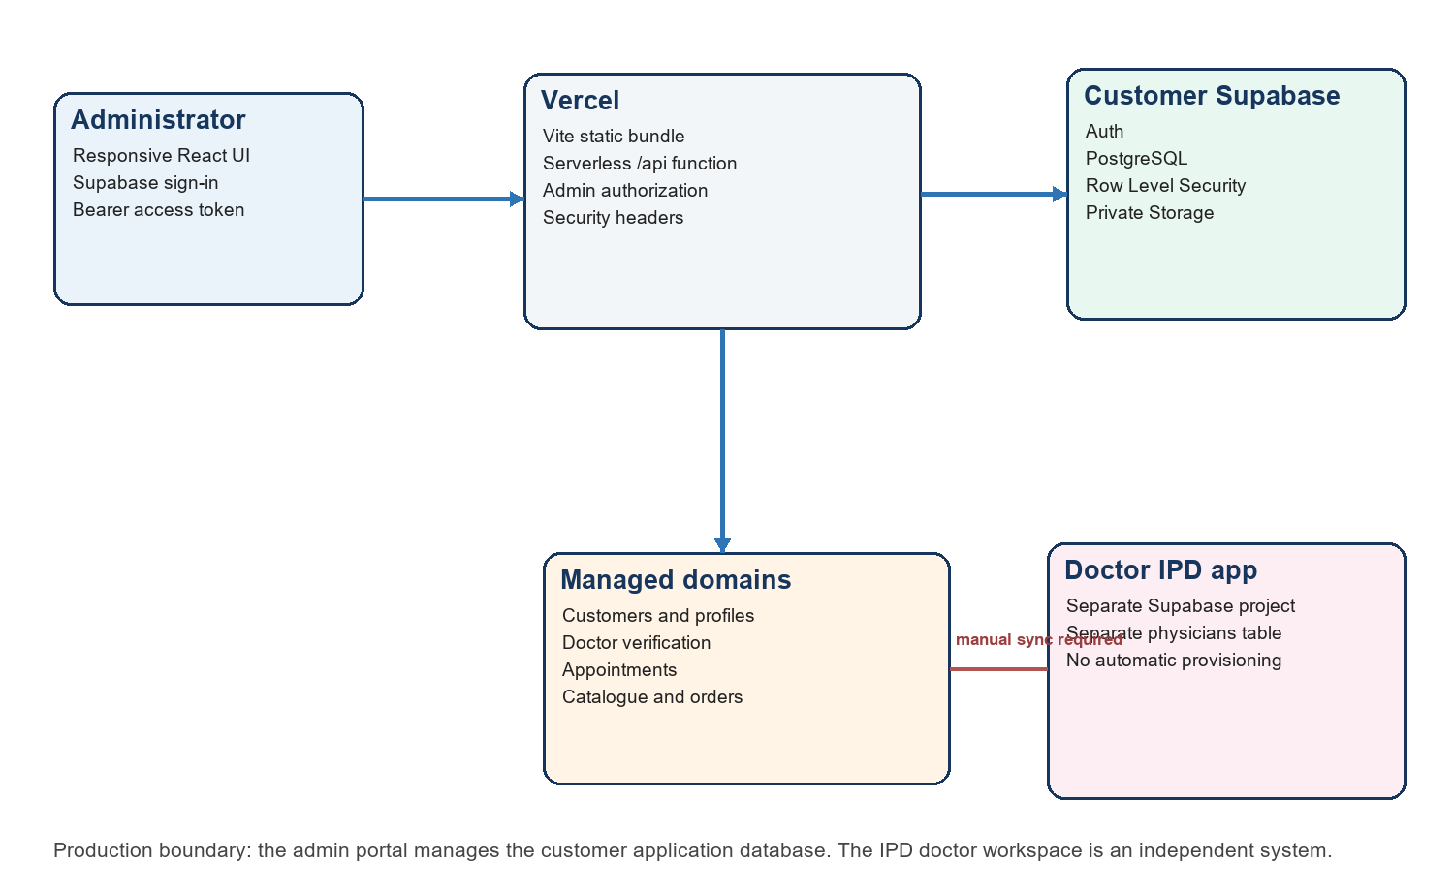
Figure 1 - Production architecture and application boundary

2. Architecture goals
Goal | Architectural response
Central oversight | One administration shell presents customer, doctor, appointment, inventory and order modules.
Credential isolation | Supabase service-role access remains in Vercel production environment variables and server execution only.
Least privilege at the portal edge | A valid Supabase user must also have an admin app role or an allowlisted email.
Operational simplicity | A Vite static bundle and one catch-all serverless API deploy as one Vercel project.
Data-source integrity | The API uses allowlisted resources and fields instead of accepting arbitrary table or column names.
Failure containment | Page loading clears stale data, API errors are shown in place and a React error boundary offers recovery.
Responsive operation | Desktop navigation collapses to a mobile drawer while tables remain horizontally scrollable.

3. Technology stack
Layer | Technology | Purpose
Frontend | React 19.2.3 and React DOM | Component rendering, local UI state and module navigation
Language | TypeScript 6.0.3 | Typed frontend, API handler and build-time verification
Build | Vite 6 | Development server and optimized production bundle
UI | Lucide React and CSS | Icons, responsive layout and Vaidya-inspired visual system
Authentication | Supabase Auth | Email/password session creation and access tokens
Backend | Vercel Node serverless function | Authorization, validation and privileged data operations
Data | Supabase PostgreSQL | Customer, doctor, appointment, commerce and payment records
Client library | @supabase/supabase-js 2.112.4 | Browser session and server administration clients
Hosting | Vercel | Static assets, /api routing, environment secrets and deployment protection
Runtime | Node.js 22.13 or later | Local tooling and Vercel function execution

4. Repository structure
admin-control/
|- src/
| |- App.tsx Shell, pages, interactions and recovery boundary
| |- api.ts Authenticated browser-to-server request helper
| |- supabase.ts Browser Supabase Auth client
| |- types.ts Page payload contracts
| `- styles.css Responsive Vaidya-inspired design system
|- api/index.ts Catch-all Vercel serverless API
|- public/ Static public assets when present
|- vercel.json Build, function, rewrites and security headers
|- vite.config.ts Vite and local API proxy settings
|- package.json Dependencies, scripts and Node requirement
`- .env.example Environment-variable names without values

5. Frontend architecture
The frontend is a state-driven React single-page application. It does not use a URL router; the selected module is held in the Page state and rendered inside a stable application shell. Supabase Auth supplies the browser session. The API helper retrieves the current access token and sends it as a Bearer token on every administration request.
Component | Responsibility
Login | Email/password sign-in and optional first-time Supabase registration. Production operations use the pre-provisioned administrator account.
App shell | Sidebar, top bar, search field, operator identity, refresh action and responsive mobile drawer.
Overview | Operational metrics, pending doctor reviews, recent orders and consultations.
Customers | Searchable profile directory combined with selected Supabase Auth metadata.
Doctors | Pending application review and verified-doctor visibility management.
Appointments | Consultation listing and supported status transitions.
Inventory | Catalogue view, product creation and active/inactive control.
Orders | Order and item summary with fulfilment status changes.
Settings | Authenticated operator, database host and hosting-runtime status.
AppErrorBoundary | Prevents uncaught rendering errors from producing a permanent white screen.

6. Frontend state and data flow
1. Supabase restores the browser session from local storage and refreshes the token when required.
2. Selecting a sidebar module clears the previous payload and displays loading placeholders.
3. adminApi obtains the current access token and calls the corresponding same-origin /api resource.
4. A successful response is stored and rendered only for the selected module.
5. A failed response produces an in-page error with a retry action; stale payloads are not reused.
6. Mutations disable the affected row/card, call the API and reload the selected module after success.

7. Backend architecture
api/index.ts is a catch-all serverless handler. Vercel rewrites /api/:path* to the function and supplies the resource path through the path query parameter. The handler creates a non-persistent Supabase administration client for each invocation, validates the caller, dispatches to a fixed resource handler and returns JSON with no-store caching.
Backend concern | Implementation
Authentication | Extract Bearer token and call Supabase Auth getUser.
Administrator authorization | Allow app_metadata.role admin or super_admin, app_metadata.is_admin true, or email in ADMIN_EMAILS.
Read dispatch | Explicit handlers for overview, customers, doctors, appointments, inventory, orders and settings.
Mutation dispatch | Resource-to-table mapping with per-resource field allowlists.
Input handling | JSON body parsing; product values normalized before insertion.
Database access | Server-side Supabase service credential bypasses end-user RLS for authorized administration.
Missing optional tables | Known missing-table errors can fall back to empty results for compatibility.
Error handling | Consistent JSON error envelope; internal code/name/message logged without returning stack traces.

8. Authentication and authorization sequence
1. Administrator submits email and password directly to Supabase Auth through the browser client.
2. Supabase returns an access token and refresh token; the browser client persists and refreshes the session.
3. The browser calls /api with Authorization: Bearer access_token.
4. The server validates the token with Supabase Auth and loads the authoritative user record.
5. The server checks admin role metadata or ADMIN_EMAILS. A valid non-admin user receives HTTP 403.
6. Only after both checks does the server use the service-role client for the requested operation.

9. Principal interaction sequences

9.1 Doctor verification
1. Doctors page loads doctor_applications and verified_doctors.
2. The review area displays only submitted and under_review applications.
3. Verify sends PATCH /api/applications/:id with status verified and a review note.
4. The API adds reviewed_by and reviewed_at, then updates doctor_applications.
5. The database sync_verified_doctor trigger inserts or reactivates the verified_doctors record.
6. The page reloads: the application card disappears and the doctor remains in the verified list.

9.2 Inventory activation
1. Inventory loads shop_products including inactive products through the server credential.
2. The operator toggles product visibility.
3. PATCH /api/inventory/:id accepts only the configured catalogue fields.
4. The customer app RLS policy continues to expose only active products to authenticated customers.

9.3 Order fulfilment
1. Orders loads shop_orders with nested shop_order_items.
2. The operator selects placed, packed, shipped, delivered or cancelled.
3. PATCH /api/orders/:id updates only status; database constraints reject unsupported values.
4. The customer can read the updated status through the customer app's owner-scoped policy.

10. Data architecture
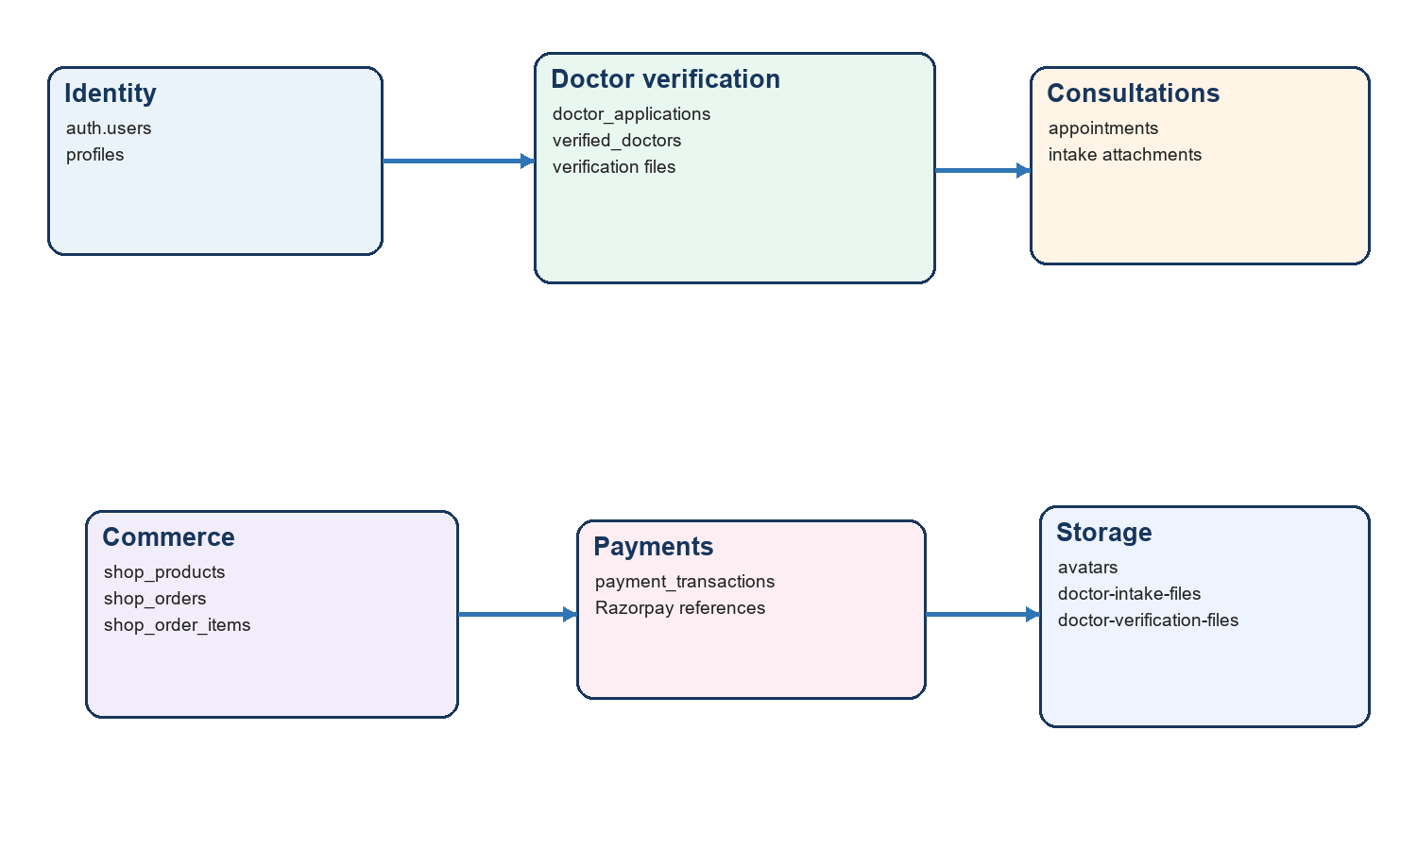
Figure 2 - Admin portal data domains and principal relationships
The administration API works primarily with public-schema tables that are also used by the customer application. Auth identities remain in auth.users. Storage objects are private and controlled by owner-folder policies; the current admin portal does not expose document download or identity-document review controls.

11. Security architecture
Control | Current implementation
Secret separation | VITE variables contain only public Supabase values. SUPABASE_SERVICE_ROLE_KEY is a protected Vercel server secret.
Dual authorization | A valid Supabase session is necessary but not sufficient; an admin claim or allowlist match is required.
Field allowlisting | Mutation resources expose a fixed set of writable columns.
Transport | Production is HTTPS through Vercel and Supabase.
Browser hardening | nosniff, frame denial, strict referrer policy and a restrictive permissions policy.
Caching | API responses use Cache-Control: no-store.
Database protection | Customer-facing access remains governed by RLS; service-role access exists only in the server function.
Sensitive display | Admin lists avoid returning raw service secrets; identity numbers remain private database fields and are not rendered.

12. Deployment topology
- Vercel project: admin-control; production alias admin-control-pi.vercel.app.
- Build: npm run build, producing dist with index.html and hashed assets.
- Serverless entry: api/index.ts with a 30-second maximum duration.
- SPA rewrite: non-API routes return index.html.
- Deployment protection: Vercel Authentication is enabled in the reviewed baseline.
- Supabase project: customer application development/operational project configured through environment variables.

13. Cross-application boundary
The customer application and admin portal share the same customer Supabase project. Therefore, changes to verified_doctors, appointments, shop_products and shop_orders are visible to the customer application subject to its RLS policies and refresh behavior. The Vaidya IPD Care doctor workspace is not the same doctor application data source: it has a separate Supabase project and a physicians table. A synchronization or provisioning workflow must be designed before admin verification can create doctor-workspace access.

14. Availability and failure behavior
Failure | Visible behavior | Recovery
Expired access token | API returns 401 and the page shows a sign-in/session error. | Sign out and sign in again.
Authenticated but unauthorized user | API returns 403. | Confirm admin metadata or ADMIN_EMAILS.
Missing server environment | API returns 503. | Restore Vercel variables and redeploy.
Schema mismatch | API returns a database error; current page shows retry. | Compare deployed migrations with API column names.
Unexpected render exception | Recovery page replaces the blank screen. | Reload; review browser console and API response.
Vercel protection | Vercel access screen precedes application login. | Use an authorized Vercel team account.

15. Recommended evolution
- Replace email allowlisting with a managed admin_users table or claims-management process and require MFA for privileged users.
- Add structured audit records for every admin mutation, including actor, before/after values, request ID and timestamp.
- Introduce server-side schema validation for every request body and explicit transition rules for appointments and orders.
- Add pagination, sorting and server-side search before datasets grow beyond current limits.
- Design an approved doctor provisioning integration rather than writing directly into the separate IPD database.
- Add automated browser tests covering login, each navigation module, doctor verification and error recovery.

