  - AYURNIDAAN ADMIN PORTAL

Database Documentation
  - Schema, tables, relationships, fields, indexes and database policies
Document control | Value
Document | 05
Version | 1.0
Prepared | 11 November 2026
Audience | Engineering, operations, support and implementation teams
System | Production admin portal at admin-control-pi.vercel.app

Confidentiality
This handover set describes security-sensitive administration functions. It intentionally excludes passwords, service-role keys, access tokens and personal identity document values.

Document control
Item | Details
Purpose | Describe the data model used by the Admin Portal and the controls that protect it.
Scope | Supabase Auth, public-schema tables used by the portal, storage buckets, RLS policies, triggers, constraints and operational notes.
Source baseline | Admin portal source, deployed Vercel configuration and customer-app Supabase migrations reviewed on 11 November 2026
Owner | To be assigned by the receiving organization
Review cycle | Review after each material release, security change, schema migration or hosting change

Contents
The numbered headings form the controlled structure of this document. In Word, use References and Table of Contents if a generated page index is required.

1. Database overview
The Admin Portal uses the same Supabase PostgreSQL project as the Ayurnidaan customer application. The portal server connects with a protected service credential after authenticating and authorizing the administrator. Customer-facing clients continue to use anon or authenticated roles and are restricted by Row Level Security.
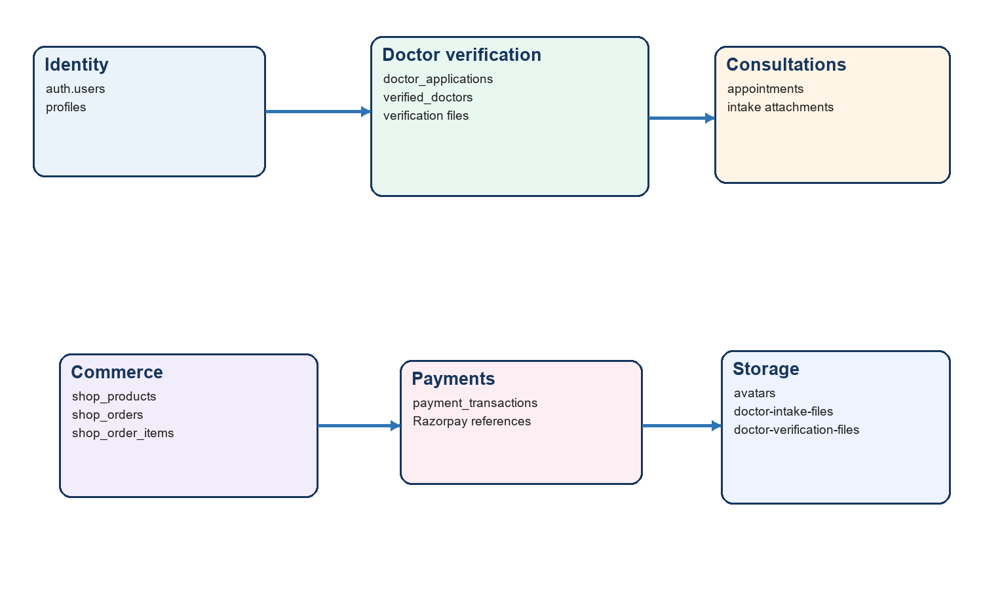
Figure 1 - Admin portal database domains

2. Schema and ownership
Schema or service | Purpose | Access pattern
auth.users | Supabase identities, email, phone, metadata and sign-in timestamps | Supabase Auth APIs; admin listUsers on server only
public | Profiles, doctor verification, appointments, catalogue, orders and payments | Customer via RLS; admin via server service role
storage.objects | Private avatar, appointment intake and doctor verification files | Owner-folder policies; not exposed in current portal

3. Relationship summary
- auth.users 1 to 0..1 profiles through profiles.user_id.
- auth.users 1 to many appointments, shop_orders, shop_order_items and payment_transactions through user_id.
- doctor_applications 1 to 0..1 verified_doctors through verified_doctors.application_id.
- shop_orders 1 to many shop_order_items through shop_order_items.order_id.
- shop_products 1 to many shop_order_items through product_id.
- user_addresses 1 to many shop_orders through optional delivery_address_id.
- auth.users may link to doctor_applications as applicant_user_id and to review records as reviewed_by.

4. Table profiles
Field | Type | Description
user_id | uuid PK FK | References auth.users; cascades on user deletion
full_name | text | Customer display name
date_of_birth | date | Customer birth date
sex | text | male or female in current check constraint
height_cm | numeric(5,2) | 30 to 300 cm
weight_kg | numeric(6,2) | 1 to 500 kg
terms_accepted_at | timestamptz | Terms acceptance evidence
profile_completed_at | timestamptz | Profile completion time
avatar_url | text | Private avatar reference
notifications_enabled | boolean | Customer notification preference
diet_preference | text | vegetarian, non-vegetarian, vegan or pescatarian
health_personalisation | boolean | Personalisation preference
ai_context_enabled | boolean | Consent/configuration for AI context
doctor_sharing_enabled | boolean | Customer doctor-sharing preference
created_at / updated_at | timestamptz | Lifecycle timestamps

RLS policies allow authenticated users to select, insert and update only the row whose user_id equals auth.uid(). A new-auth-user trigger creates the profile row.

5. Table doctor applications
Field group | Fields | Description
Identity | id, reference_code | UUID primary key and generated AYN-year-sequence reference
Applicant | applicant_user_id, mobile_number, full_name, age | Applicant identity and contact linkage
Practice | specialisations | Non-empty text array
Protected identity | aadhaar_hash, aadhaar_last_four, pan_hash, pan_last_four | HMAC fingerprints and last four characters; raw columns are nullable and cleared by hardening migration
Documents | degree_document_provided, aadhaar_document_provided, pan_document_provided and path fields | Submission completeness and private object references
Consent | consent_accepted_at | Required timestamp
Review | status, review_notes, reviewed_at, reviewed_by | submitted, under_review, verified or rejected
Lifecycle | submitted_at, created_at, updated_at | Operational timestamps

Index or constraint | Purpose
reference_code unique | Human-readable application tracking
doctor_applications_active_aadhaar_hash_idx | Prevents multiple active applications for one Aadhaar fingerprint
doctor_applications_active_pan_hash_idx | Prevents multiple active applications for one PAN fingerprint
status check | Restricts the review state machine
age check | 18 through 100
specialisations cardinality | Requires at least one specialisation

The table is private to trusted administration. The public submission path is the validated submit_doctor_application security-definer function. Verification files are stored in a private owner-folder bucket.

6. Table verified doctors
Field | Type | Description
id | uuid PK | Verified doctor record
application_id | uuid unique FK | References doctor_applications; delete restricted
auth_user_id | uuid unique FK | Optional doctor Auth identity
full_name | text | Public doctor name
specialisations | text[] | Public specialisations
qualification | text | Defaults BAMS
registration_number | text | Professional registration
focus_areas | text[] | Public focus areas
experience_years | smallint | Non-negative experience
about | text | Biography
consultation_fee | numeric(10,2) | Non-negative fee
rating | numeric(2,1) | 0 through 5
rating_count | integer | Non-negative review count
photo_url | text | Public-safe profile photo URL
is_active | boolean | Customer catalogue visibility
verified_at / created_at / updated_at | timestamptz | Lifecycle timestamps

The Active verified doctors are publicly readable policy permits anon and authenticated selection only when is_active is true. Other operations remain revoked from browser roles. The sync_verified_doctor trigger inserts/updates this table when an application becomes verified and deactivates it when verification is withdrawn.

7. Table appointments
Field group | Fields | Description
Identity | id, user_id | Appointment UUID and owning customer
Doctor display | doctor_name, doctor_initials, doctor_photo_url | Snapshot displayed by the customer app
Schedule | appointment_date, appointment_time, consultation_type | Consultation schedule and channel
State | status | booked, completed or cancelled
Clinical | discussion_summary, prescription, patient_notes, symptom_tags | Consultation and intake context
Files | attachments jsonb | Array of private intake attachment metadata
Lifecycle | created_at | Creation timestamp

Index appointments_user_date_idx supports customer/date history. Customer RLS permits select, insert and update only for the owning user. A security-hardening migration adds clinical audit behavior and tightens sensitive updates; review the migration before exposing additional admin clinical controls.

8. Table shop products
Field | Type | Description
id | text PK | Stable product slug
name | text | Product name
weight | text | Pack size
price | integer | Selling price in rupees; non-negative
mrp | integer | MRP, constrained to be at least price
icon | text | Short visual label
categories | text[] | Catalogue filters
tags | text[] | Recommendation/search tags
description | text | Customer-facing description
rating | numeric(2,1) | 0 through 5
rating_count | integer | Non-negative count
active | boolean | Customer visibility
sort_order | integer | Catalogue order
created_at / updated_at | timestamptz | Lifecycle timestamps

Authenticated customers receive SELECT only and only where active is true. The admin server can see and update inactive rows. Product creation must preserve mrp >= price.

9. Tables shop orders and order items
Table | Fields | Notes
shop_orders | id, user_id, total_amount, status, delivery_postcode, delivery_address_id, delivery_address_label, delivery_address_snapshot, created_at | Status: placed, packed, shipped, delivered or cancelled
shop_order_items | id, order_id, user_id, product_id, quantity, unit_price | Order cascade delete; product reference; positive quantity

Index | Purpose
shop_orders_user_created_idx | Customer order history by user and newest creation
shop_order_items_user_product_idx | Customer/product history

Customers can read and insert their own orders and items. The item insert policy also verifies that the referenced order belongs to auth.uid(). The portal updates only order status.

10. Table payment transactions
Field | Type | Description
id | uuid PK | Payment transaction
user_id | uuid FK | Owning customer
purpose | text | appointment or shop
amount_paise | integer | Positive amount in paise
currency | text | INR
status | text | created, paid, failed or cancelled
razorpay_order_id | text unique | Gateway order reference
razorpay_payment_id | text unique | Gateway payment reference
checkout_token | uuid unique | Checkout correlation token
redirect_url | text | Approved return URL
payload | jsonb | Gateway/request metadata
resource_id | uuid | Related domain record
error_message | text | Failure detail
created_at / paid_at / updated_at | timestamptz | Lifecycle timestamps

Index payment_transactions_user_created_idx supports customer history. Customer RLS allows owner-only SELECT. Portal Overview counts revenue only where status is paid and converts amount_paise to rupees.

11. Storage buckets
Bucket | Privacy and limits | Policy pattern
avatars | Private; 5 MB; JPEG, PNG, WebP | Authenticated user folder equals auth.uid()
doctor-intake-files | Private; 10 MB; PDF and common images | Authenticated user folder equals auth.uid()
doctor-verification-files | Private; 10 MB; PDF and common images | First path segment equals auth.uid()

12. RLS and service-role model
RLS is the customer-data boundary, but the Admin Portal intentionally uses a service-role client after application-layer authorization. The service role bypasses RLS. Consequently, requireAdmin must run before every query or mutation, and only fixed resources/fields may be exposed. A client-side service key would compromise the full database and must be rotated immediately if disclosed.
Data | Customer/browser policy | Admin portal
profiles | Owner select/insert/update | Read directory
doctor_applications | No direct general table access; validated submission function | Review and status update
verified_doctors | Active rows publicly readable | Read all and update approved profile fields
appointments | Owner select/insert/update | Read all and update schedule/status fields
shop_products | Authenticated select active only | Read all, create and update
shop_orders/items | Owner select/insert | Read all orders/items; update order status
payment_transactions | Owner select | Aggregate paid revenue

13. Triggers and functions
Object | Behavior
handle_new_user | Creates public.profiles after auth.users insert.
touch_doctor_record_updated_at | Maintains doctor application/profile updated_at.
sync_verified_doctor | Creates/reactivates verified doctor on verification and deactivates when verification is removed.
submit_doctor_application | Validates and writes doctor applications without granting direct table access.
doctor_identity_fingerprint | Produces keyed HMAC fingerprints for sensitive identity values.
purge_user_data / verify_user_data_erased | Supports account erasure and verification in later migrations.

14. Migration and backup guidance
- Treat the ordered files under supabase/migrations as the schema history and apply them through an authenticated Supabase workflow.
- Never edit an already-applied production migration; add a forward migration.
- Test API column selections against the target schema before deployment. The white-screen incident was caused by selecting amount instead of amount_paise.
- Confirm Supabase backup and point-in-time recovery settings according to the subscribed plan.
- Back up storage objects and database metadata together when recovery requires file consistency.
- Record migration version, deployment ID, operator and validation evidence for each release.

15. Known separation from doctor IPD database
The Vaidya IPD Care doctor workspace has a separate Supabase project and its own physicians table. No foreign key, trigger, replication job or API currently connects verified_doctors to that table. The reviewed doctor-workspace physicians table contained no matching provisioned record. Any future synchronization must define identity mapping, consent, conflict handling, credential creation, retries, revocation and audit evidence.

