  - AYURNIDAAN ADMIN PORTAL

User Manual
  - Step-by-step administration of customers, doctors, appointments, inventory and orders
Document control | Value
Document | 07
Version | 1.0
Prepared | 11 November 2026
Audience | Engineering, operations, support and implementation teams
System | Production admin portal at admin-control-pi.vercel.app

Confidentiality
This handover set describes security-sensitive administration functions. It intentionally excludes passwords, service-role keys, access tokens and personal identity document values.

Document control
Item | Details
Purpose | Help authorized administrators operate the Ayurnidaan Admin Portal safely and consistently.
Scope | Access, navigation, every administration module, routine workflows, troubleshooting and operational boundaries.
Source baseline | Admin portal source, deployed Vercel configuration and customer-app Supabase migrations reviewed on 11 November 2026
Owner | To be assigned by the receiving organization
Review cycle | Review after each material release, security change, schema migration or hosting change

Contents
The numbered headings form the controlled structure of this document. In Word, use References and Table of Contents if a generated page index is required.

1. Before you begin
- Use a current supported browser on a trusted device and network.
- Use only the administrator account assigned by the system owner.
- Never share the password, browser session, access token or screenshots containing customer information.
- Confirm the action and target record before changing doctor, appointment, product or order status.
- The portal manages the customer application database; it does not automatically provision the separate Vaidya IPD doctor workspace.

2. Access and sign in
1. Open https://admin-control-pi.vercel.app.
2. If Vercel Authentication appears, sign in with an authorized Vercel team account.
3. On the Ayurnidaan Administration sign-in screen, enter the approved administrator email and password.
4. Select Sign in securely.
5. Wait for the Overview page. If an authorization message appears, confirm the account's admin role or allowlist entry with the owner.
Password safety: Use a strong unique password and rotate any temporary or shared credential immediately. Do not record the password in this manual or browser notes.

3. Screen layout and navigation
The left sidebar contains the seven modules. The top bar contains the current path, module search, refresh action and signed-in administrator. On smaller screens, open the menu button to reveal the sidebar.
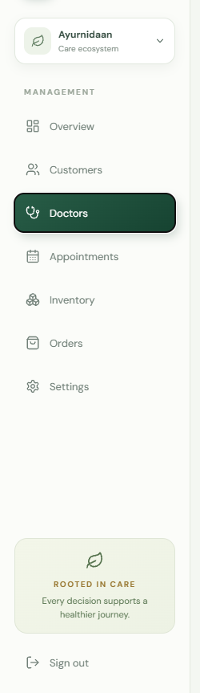
Figure 1 - Administration sidebar and sign-out control
Module | Primary purpose
Overview | Operational metrics and recent activity
Customers | Customer profile directory and search
Doctors | Application review and verified doctor visibility
Appointments | Consultation status management
Inventory | Product creation and catalogue activation
Orders | Order fulfilment status
Settings | Current administrator, database and hosting health

4. Overview
1. Select Overview.
2. Review customer, active doctor, pending review, open order, active product and captured revenue metrics.
3. Review Doctor applications for pending submissions and Recent orders for fulfilment activity.
4. Review Upcoming consultations for recently booked appointments.
5. Use View all, Manage or Open calendar to move to the relevant module.
6. Select Refresh data when another operator or app may have changed records.
Revenue: Captured revenue is calculated from payment transactions whose status is paid. It is an operational summary, not an accounting reconciliation statement.

5. Customers
1. Select Customers.
2. Use Search customers to search across the loaded customer fields.
3. Review name, short user ID, profile details, contact, last sign-in and join date.
4. Use customer data only for authorized operational support. The current module is read-only.
5. Select Refresh data to retrieve changes made through the customer app.
The directory combines public.profiles with selected Supabase Auth metadata. A missing email or phone may indicate that the identity uses another sign-in method or that the metadata is unavailable; it does not necessarily mean the customer record is invalid.

6. Doctors

6.1 Review a submitted application
1. Select Doctors.
2. Under Application review, confirm the applicant name, reference code, age, specialisations and submission date.
3. Review required documents through the approved verification process. The current portal card does not provide a document viewer.
4. Choose Verify doctor only after all checks are complete, or Reject when the application does not meet requirements.
5. Wait for the page to reload. A verified or rejected application must disappear from Application review.
6. For verification, confirm the doctor appears in Verified doctors.
Irreversible impact: Verification publishes or reactivates the doctor in the customer doctor catalogue through a database trigger. Rejection stores the standard review note. Confirm evidence before acting.

6.2 Manage verified doctor visibility
1. Locate the doctor in Verified doctors.
2. Use the Visibility switch to activate or deactivate the profile.
3. Refresh the page and confirm the switch state.
4. Confirm the customer app doctor catalogue reflects the intended state after its next refresh.
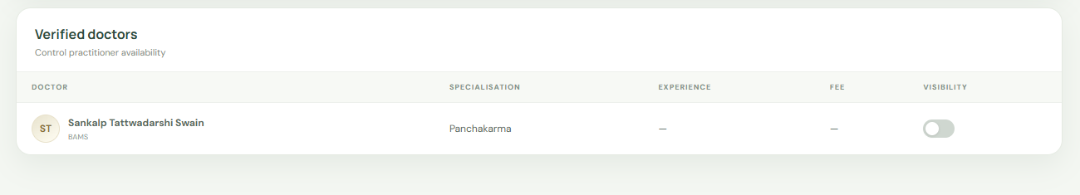
Figure 2 - Verified doctors table and visibility control
Doctor app boundary: A verified customer-app doctor is not automatically added to the separate Vaidya IPD Care physicians directory or given an IPD login.

7. Appointments
1. Select Appointments.
2. Confirm the appointment date/time, doctor, customer ID and consultation type.
3. Open the Status list for the intended appointment.
4. Choose Booked, Completed or Cancelled.
5. Wait for the module to refresh and confirm the saved state.
Cancellation: Changing status to cancelled affects what the customer sees. Confirm cancellation authority and communication requirements outside the portal before changing the record.

8. Inventory

8.1 Add a product
1. Select Inventory and search visually for an existing product to avoid duplicates.
2. Select Add product.
3. Enter product name, pack size, category, selling price and MRP.
4. Confirm that MRP is not less than the selling price.
5. Select Add to catalogue and wait for refresh.
6. Confirm the product card, price, category and Active state.

8.2 Activate or deactivate a product
1. Locate the product card.
2. Use the toggle at the bottom of the card.
3. Refresh and confirm Active or Inactive.
4. Verify the customer app shows only active products after refresh.
Historical orders: Deactivating a product prevents current customer browsing but does not remove historical order-item references.

9. Orders
1. Select Orders.
2. Confirm the order short ID, customer short ID, date, item quantity, value and delivery postcode.
3. Select the new status: Placed, Packed, Shipped, Delivered or Cancelled.
4. Wait for the module reload and confirm the state.
5. Coordinate physical packing, dispatch, delivery and customer communication according to operations policy; the portal status does not perform those actions.
Status | Use
Placed | Order received but not prepared
Packed | Items prepared and packaged
Shipped | Handed to carrier or dispatched
Delivered | Delivery confirmed
Cancelled | Order will not proceed; follow refund/communication policy

10. Settings
1. Select Settings.
2. Confirm Administrator shows the expected signed-in email and role.
3. Confirm Database displays connected and the expected Supabase host.
4. Confirm Hosting shows Vercel production and the runtime region.
5. Review Access policy when troubleshooting authorization.
Settings is an operational health view. It does not edit secrets, roles or infrastructure. Use Supabase and Vercel administration tools for those changes.

11. Search and refresh

Figure 3 - Module search, refresh and administrator identity
- Search applies within the selected module where implemented; Customers performs broad text matching across loaded profile data.
- Refresh data reloads the selected module from the server.
- After a successful mutation the portal automatically reloads the current module.
- If another operator is working simultaneously, refresh before making a consequential decision.

12. Sign out
1. Select Sign out at the bottom of the sidebar.
2. Confirm the sign-in page is displayed.
3. If using a shared computer, also close the browser and sign out of any Vercel access session according to policy.

13. Error recovery
Message or symptom | Action
Sign in to continue | The API did not receive a token. Sign out/in and retry.
Session is no longer valid | Token expired or was revoked. Sign in again.
No administrator access | Use the approved account; contact the owner to review role/allowlist.
Server credentials not configured | Stop; contact the deployment owner. Do not enter secrets in the browser.
Red error with Try again | Select Try again once. If repeated, record module/time and contact support.
Recovery page | Select Reload admin console. Report repeated occurrences with the module and action.
Blank or old page after release | Use Ctrl+Shift+R for a hard refresh.
Verified application still visible | Refresh. Current release displays only submitted/under_review applications.
Doctor missing from IPD app | Expected current limitation; separate provisioning is required.

14. Security and privacy rules
- Do not export, copy or share customer data unless an approved process requires it.
- Do not include customer or doctor identity data in public support channels.
- Do not inspect or change records out of curiosity; administrator access is for assigned duties.
- Never paste Supabase keys, access tokens or Vercel secrets into forms or screenshots.
- Immediately report suspected unauthorized access, wrong-record changes or credential exposure.
- Use least privilege and sign out when administration work is complete.

15. Daily operator checklist
- Review pending doctor applications and leave none in an unexplained state.
- Review open orders and confirm operational status matches physical fulfilment.
- Check appointment exceptions and customer support requests.
- Review catalogue visibility for stock or compliance changes.
- Record and escalate repeated API errors or unexpected counts.
- Sign out and secure the workstation.

16. Support information to capture
When reporting a problem, capture the date/time with timezone, module, action, browser/version, whether refresh was attempted, visible error text and a non-sensitive record reference. Do not send passwords, access tokens, full customer medical information or identity documents.

