  - AYURNIDAAN CUSTOMER APPLICATION

Software Architecture Document
  - Customer mobile application architecture, services, components and data flows
Document control | Value
Document | 03
Version | 1.0
Prepared | 11 November 2026
Audience | Engineering, product, operations, support and implementation teams
System status | Customer mobile application handover baseline

Confidentiality: Contains technical and operational information for authorized recipients. Secret values, personal health information and payment credentials are intentionally excluded.

Document control
Item | Details
Purpose | Provide the receiving team with a maintainable technical model of the customer application.
Scope | Expo client, Supabase services, Edge Functions, external providers, security boundaries, deployment environments and operating constraints.
Source baseline | Customer repository dev commit da24049dc33ec6c1d9193e94919c637d486c0699; Expo SDK 57 application and migrations reviewed on 11 November 2026
Owner | To be assigned by the receiving organization
Review cycle | After every material release, security change, schema migration or external-service change

Contents
The numbered headings form the controlled structure. Word can generate a page-number table of contents from these heading styles when required.

1. Executive overview
Ayurnidaan is a cross-platform customer wellness application built with Expo SDK 57 and React Native. The mobile client uses Supabase Auth for Google OAuth, PostgREST for user-scoped data, Storage for private files, and Edge Functions for AI-assisted assessments, recommendations, payments and account deletion. Security depends on short-lived Supabase JWTs, Row Level Security, function-side user validation and per-user storage policies.
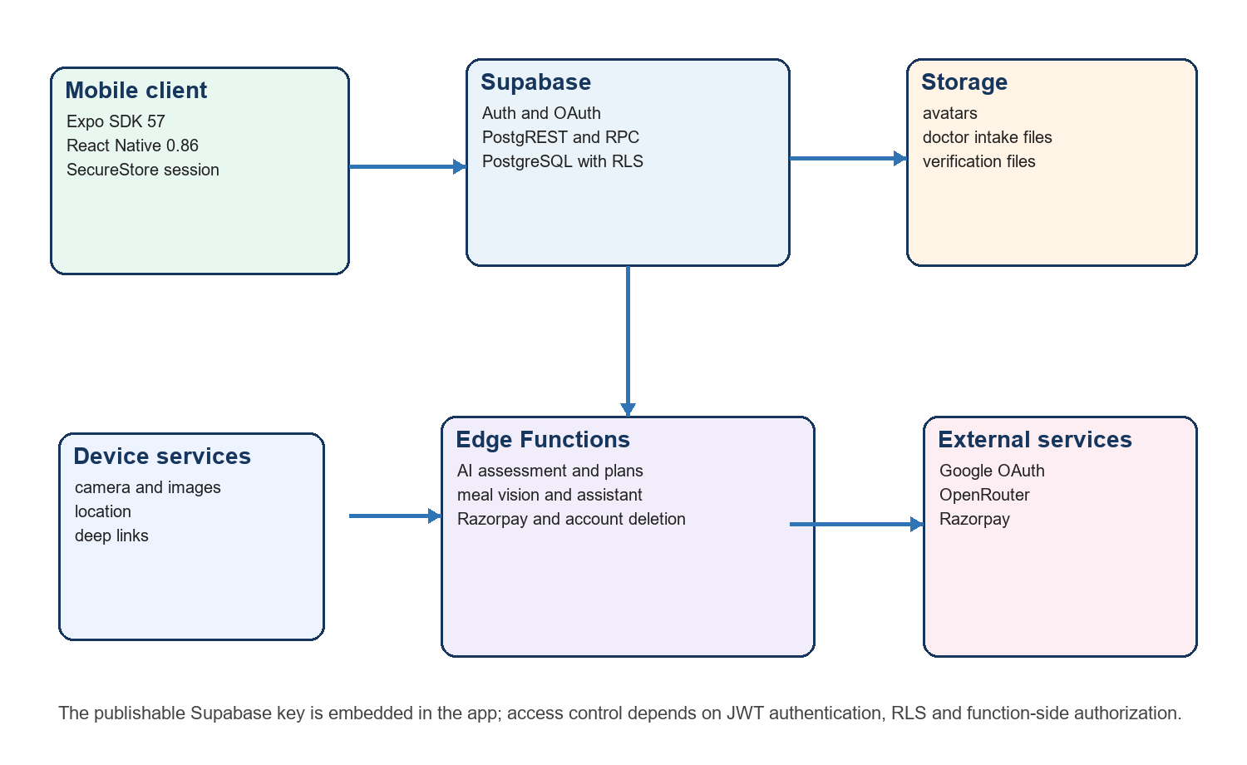
Figure 1 Customer application runtime architecture

2. Scope and system boundaries
Area | Implemented boundary
Customer identity | Google OAuth through Supabase Auth. Session state is persisted in SecureStore on native platforms.
Wellness assessments | Prakriti questionnaire and conversational current-health assessment with stored results.
Recommendations | Food, yoga and supplement plans generated through authenticated Edge Functions and stored per user.
Doctor access | Verified doctor directory, intake details, attachments, appointment booking and payment fulfilment.
Commerce | Product catalog, cart, addresses, Razorpay checkout, orders and order history.
Out of scope | Clinical emergency care, provider back-office operations, prescription fulfilment and the separate Vaidya IPD doctor workspace.

3. Technology stack
Layer | Technology | Role
Application | Expo 57.0.24 | Cross-platform runtime, development workflow and native configuration.
UI | React 19.2.3 and React Native 0.86.3 | Screen state, native controls and responsive web rendering.
Web | React Native Web 0.21.2 | Browser build of the same application.
Language | TypeScript 6.0.3 | Compile-time contracts.
Identity and data | Supabase JS 2.112.4 | Auth, PostgREST, RPC, Storage and Edge Function calls.
Device storage | Expo SecureStore | Encrypted native persistence for chunked Supabase session payloads.
Device services | Camera, Image Picker, Location, Linking, AuthSession | Meal capture, avatars, address assistance, OAuth and payment callbacks.
Payments | Razorpay | Hosted/native checkout and server-side verification.
AI | OpenRouter through Edge Functions | Assessment dialogue, plans, assistant and image interpretation.
Build and release | EAS Build | Development, preview, APK and production profiles.

Expo SDK 57 targets React Native 0.86, React 19.2.3 and Node.js 22.13.x. The repository package versions match that compatibility line.

4. Repository structure
app-build/
├─ App.tsx Screen state machine and feature UI
├─ src/config/env.ts Public environment validation
├─ src/lib/supabase.ts Supabase client and native secure session storage
├─ src/lib/razorpay.* Platform payment adapters
├─ assets/ Brand, onboarding, assessment, food and yoga artwork
├─ supabase/migrations/ Versioned database, RLS, RPC and storage policies
├─ supabase/functions/ Edge Functions and shared security controls
├─ app.config.ts Expo application identity, plugins and permissions
├─ eas.json Build profiles and EAS environments
└─ package.json Scripts and pinned runtime dependencies

5. Frontend component model
App.tsx currently acts as the composition root and contains the screen state machine. The Screen union controls splash, onboarding, authentication, profile setup, assessments, home, food, yoga, doctor, appointments, shop, profile and AI modules. Feature screens call Supabase directly through the shared client and use local state for transient forms, navigation and progress.
Module | Primary components and behavior
Onboarding and identity | Brand splash, introduction, Google sign-in, profile, health goals, terms and consent.
Prakriti | 25-question assessment, percentage calculation, result explanation and validation feedback.
Current health | Complaint classification, adaptive follow-up, Guna-based final assessment and generated plan requests.
Home | Assessment status, personalized summary, appointment reminder and plan shortcuts.
Food and yoga | Stored recommendation plans, daily tracking, meal scanning, practice timer and completion state.
Doctor | Intake notes/files, verified doctors, calendar/slots, consultation type, payment and confirmation.
Shop | Products, recommendations, cart, delivery addresses, Razorpay payment and order history.
Profile and privacy | Health profile, personal details, avatar, preferences, consent controls, orders, appointments and account deletion.
AI assistant | Authenticated chat with health-context consent and emergency red-flag response.

6. Backend service model
Supabase service | Responsibilities
Auth | Google OAuth, JWT issuance/refresh, user metadata and user deletion.
PostgREST | CRUD for profiles, assessments, plans, appointments, orders, intake and history under RLS.
RPC | Consent recording and privacy-setting updates with server-side validation.
Storage | Private per-user avatars, doctor intake attachments and doctor verification files.
Edge Functions | AI orchestration, rate limiting, Razorpay order/verification, account erasure and privileged operations.
Database | PostgreSQL constraints, relationships, indexes, triggers, RLS and audit records.

7. Principal interaction sequences

7.1 Google sign in
1. The app starts an OAuth flow with a platform-specific redirect URI.
2. Supabase completes Google authentication and returns an access and refresh token.
3. The native app stores the session in SecureStore; web uses the Supabase browser session mechanism.
4. Auth state selects onboarding or home based on profile completion.

7.2 Current health and recommendation generation
1. The user submits a complaint and patient context to current-health-chat.
2. The function validates the JWT, consumes the database-backed rate limit and calls the configured model.
3. The app stores the final assessment under the authenticated user.
4. Food, yoga and supplement functions load the assessment, enforce ownership and upsert generated plans.
5. The home and feature modules read the latest user-owned plan through RLS.

7.3 Paid appointment or shop order
1. The app calls razorpay-payment with purpose and validated appointment or cart input.
2. The function calculates the amount from server-side product/doctor data and creates a payment transaction.
3. Razorpay checkout completes through hosted or native flow.
4. The function verifies the captured payment and atomically creates the appointment or order.
5. The app polls status only when callback completion is uncertain.

8. Security architecture
Control | Implementation
Client secrets | Only the public Supabase URL and publishable/anon key are embedded. Service-role, AI and Razorpay secrets remain in Edge Function secrets.
Authentication | Bearer JWT is validated against Supabase Auth before protected function work.
Authorization | RLS scopes user records by auth.uid(); catalog tables expose only intended active rows.
Session storage | Native tokens are split into SecureStore chunks using AFTER_FIRST_UNLOCK_THIS_DEVICE_ONLY.
CORS | Shared function helper restricts web origins and allows required authorization headers.
Rate limiting | Database-backed quotas protect AI, scan and payment functions.
Files | Storage policies require a user-owned path prefix; buckets remain private.
Sensitive doctor data | Applications store hashes/last-four values and private verification documents; direct client reads are restricted.
Account deletion | Privileged Edge Function removes storage objects, verifies cascaded data deletion and deletes the Auth user.

9. Environments and application identities
Environment | App identifier | Supabase | Use
Development | com.ayurnidaan.wellness.dev | ayurnidaan-dev | Local work and internal development builds.
Production | com.ayurnidaan.wellness | ayurnidaan-prod | Store releases and real users.

The development and production projects must have independent databases, Auth users, Storage objects, URLs and keys. Migrations keep their structures aligned; data must not be copied between them without an approved migration and privacy review.

10. Reliability and operating considerations
- OpenRouter and Razorpay are external dependencies. Handle timeout, provider error and retry paths without creating duplicate plans, payments, appointments or orders.
- Plan-generation functions upsert by assessment, which supports safe retries. Payment fulfilment uses transaction state and unique resource constraints.
- The app should remain usable for profile/history views when AI providers are unavailable; generation features should show a clear retry state.
- Monitor Supabase Auth, database, Storage and Edge Function logs together because a single customer flow crosses these services.
- Treat health, doctor-intake and payment records as sensitive. Do not send full payloads to client analytics or general support channels.

11. Known limitations and handover recommendations
Priority | Constraint | Recommended action
High | App.tsx contains most screen and feature logic | Split by feature and introduce navigation/data-access boundaries before major team scaling.
High | External AI produces wellness content | Maintain safety prompts, red-flag behavior, model review, monitoring and human clinical governance.
High | Production recovery process is not encoded in the app | Assign backup, retention, restore testing and incident owners for both Supabase projects.
Medium | Direct PostgREST access expands the RLS attack surface | Run automated RLS regression tests for every new table, view, RPC and policy.
Medium | OAuth and payment callbacks depend on redirect configuration | Maintain a controlled redirect inventory for dev, preview, production and store builds.
Medium | Customer and doctor applications are separate systems | Document the approved integration boundary before sharing clinical records across them.

12. Change impact checklist
- Update architecture, API, database, deployment and user documentation.
- Add a versioned migration for every schema, policy, RPC or bucket change.
- Test native and web OAuth redirects, session refresh and logout.
- Test RLS with two users and anonymous access.
- Test AI red flags, rate limits, payment idempotency, account deletion and storage cleanup.
- Build development and production variants and verify package identity before promotion.

